**EXPT-7**

**Write a Servlet program to store a user preferences (like theme or language) using cookies. Retrieve and display these preferences on subsequent visits.**

**AIM:**

To write a Servlet program to store a user preferences (like theme or language) using cookies and retrieve and display these preferences on subsequent visits.

**CODE:**

Servlet:

<!DOCTYPE html>

<html lang="en">

<head>

<meta charset="UTF-8">

<meta name="viewport" content="width=device-width, initial-scale=1.0">

<title>User Preferences</title>

<style>

body {

font-family: Arial, sans-serif;

background-color: #f4f4f4;

text-align: center;

padding: 50px;

}

.container {

background: #fff;

width: 40%;

margin: auto;

padding: 30px;

border-radius: 10px;

box-shadow: 0px 0px 10px rgba(0, 0, 0, 0.1);

}

h2 {

color: #333;

}

label {

font-size: 18px;

font-weight: bold;

display: block;

margin-top: 15px;

}

select, input[type="submit"] {

width: 100%;

padding: 10px;

margin-top: 10px;

border: 1px solid #ddd;

border-radius: 5px;

font-size: 16px;

}

input[type="submit"] {

background-color: #007BFF;

color: white;

font-weight: bold;

cursor: pointer;

border: none;

}

input[type="submit"]:hover {

background-color: #0056b3;

}

.link {

margin-top: 20px;

display: block;

font-size: 16px;

text-decoration: none;

color: #007BFF;

}

.link:hover {

text-decoration: underline;

}

</style>

</head>

<body>

<div class="container">

<h2>Select Your Preferences</h2>

<form action="PreferenceServlet" method="post">

<label for="theme">Choose Theme:</label>

<select name="theme" id="theme">

<option value="Light">Light</option>

<option value="Dark">Dark</option>

</select>

<label for="language">Choose Language:</label>

<select name="language" id="language">

<option value="English">English</option>

<option value="Spanish">Spanish</option>

<option value="French">French</option>

</select>

<input type="submit" value="Save Preferences">

</form>

<a href="PreferenceServlet" class="link">View Saved Preferences</a>

</div>

</body>

</html>

HTML:

<!DOCTYPE html>

<html lang="en">

<head>

<meta charset="UTF-8">

<meta name="viewport" content="width=device-width, initial-scale=1.0">

<title>User Preferences</title>

<style>

body {

font-family: Arial, sans-serif;

background-color: #f4f4f4;

text-align: center;

padding: 50px;

}

.container {

background: #fff;

width: 40%;

margin: auto;

padding: 30px;

border-radius: 10px;

box-shadow: 0px 0px 10px rgba(0, 0, 0, 0.1);

}

h2 {

color: #333;

}

label {

font-size: 18px;

font-weight: bold;

display: block;

margin-top: 15px;

}

select, input[type="submit"] {

width: 100%;

padding: 10px;

margin-top: 10px;

border: 1px solid #ddd;

border-radius: 5px;

font-size: 16px;

}

input[type="submit"] {

background-color: #007BFF;

color: white;

font-weight: bold;

cursor: pointer;

border: none;

}

input[type="submit"]:hover {

background-color: #0056b3;

}

.link {

margin-top: 20px;

display: block;

font-size: 16px;

text-decoration: none;

color: #007BFF;

}

.link:hover {

text-decoration: underline;

}

</style>

</head>

<body>

<div class="container">

<h2>Select Your Preferences</h2>

<form action="PreferenceServlet" method="post">

<label for="theme">Choose Theme:</label>

<select name="theme" id="theme">

<option value="Light">Light</option>

<option value="Dark">Dark</option>

</select>

<label for="language">Choose Language:</label>

<select name="language" id="language">

<option value="English">English</option>

<option value="Spanish">Spanish</option>

<option value="French">French</option>

</select>

<input type="submit" value="Save Preferences">

</form>

<a href="PreferenceServlet" class="link">View Saved Preferences</a>

</div>

</body>

</html>

Web.xml:

<?xml version="1.0" encoding="UTF-8"?>

<web-app xmlns="http://java.sun.com/xml/ns/javaee"

xmlns:xsi="http://www.w3.org/2001/XMLSchema-instance"

xsi:schemaLocation="http://java.sun.com/xml/ns/javaee

http://java.sun.com/xml/ns/javaee/web-app_3_0.xsd"

version="3.0">

<display-name>User Preferences Application</display-name>

<!-- Servlet Configuration -->

<servlet>

<servlet-name>PreferenceServlet</servlet-name>

<servlet-class>com.example.PreferenceServlet</servlet-class>

</servlet>

<!-- Servlet Mapping -->

<servlet-mapping>

<servlet-name>PreferenceServlet</servlet-name>

<url-pattern>/PreferenceServlet</url-pattern>

</servlet-mapping>

<!-- Welcome File -->

<welcome-file-list>

<welcome-file>preferences.html</welcome-file>

</welcome-file-list>

</web-app>

**OUTPUT:**

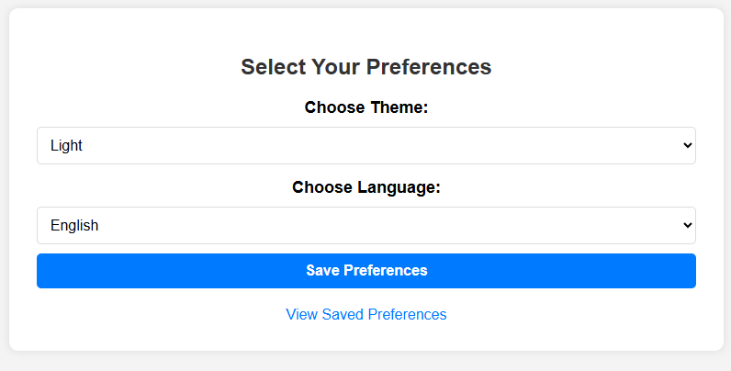

**RESULT:**

Thus the Theme and Language preferences can be saved and ae created with cookies using apache netbeans.