EXPT-9

Develop an Android application using controls like Button, TextView, EditText for designing a calculator having basic functionality like Addition, Subtraction, multiplication, and Division.

AIM:

To develop an Android application using controls like Button, TextView, EditText for designing a calculator having basic functionality like Addition, Subtraction, multiplication, and Division.

CODE:

**Activity_main.xml:**

<?xml version="1.0" encoding="utf-8"?>

<LinearLayout xmlns:android="http://schemas.android.com/apk/res/android"

android:layout_width="match_parent"

android:layout_height="match_parent"

android:orientation="vertical"

android:padding="16dp">

<!-- Display result -->

<TextView

android:id="@+id/resultTextView"

android:layout_width="match_parent"

android:layout_height="wrap_content"

android:text="0"

android:textSize="48sp"

android:gravity="end"

android:layout_marginBottom="20dp"/>

<!-- Input fields for numbers -->

<EditText

android:id="@+id/firstNumberEditText"

android:layout_width="match_parent"

android:layout_height="wrap_content"

android:hint="Enter first number"

android:inputType="numberDecimal"

android:textSize="18sp"

android:layout_marginBottom="10dp"/>

<EditText

android:id="@+id/secondNumberEditText"

android:layout_width="match_parent"

android:layout_height="wrap_content"

android:hint="Enter second number"

android:inputType="numberDecimal"

android:textSize="18sp"

android:layout_marginBottom="20dp"/>

<!-- Buttons for operations -->

<GridLayout

android:layout_width="match_parent"

android:layout_height="wrap_content"

android:columnCount="4"

android:orientation="horizontal">

<!-- Buttons for basic operations -->

<Button

android:id="@+id/addButton"

android:layout_width="wrap_content"

android:layout_height="wrap_content"

android:text="+"

android:textSize="24sp"

android:layout_gravity="center"/>

<Button

android:id="@+id/subtractButton"

android:layout_width="wrap_content"

android:layout_height="wrap_content"

android:text="-"

android:textSize="24sp"

android:layout_gravity="center"/>

<Button

android:id="@+id/multiplyButton"

android:layout_width="wrap_content"

android:layout_height="wrap_content"

android:text="*"

android:textSize="24sp"

android:layout_gravity="center"/>

<Button

android:id="@+id/divideButton"

android:layout_width="wrap_content"

android:layout_height="wrap_content"

android:text="/"

android:textSize="24sp"

android:layout_gravity="center"/>

</GridLayout>

<!-- Equals Button -->

<Button

android:id="@+id/equalButton"

android:layout_width="match_parent"

android:layout_height="wrap_content"

android:text="="

android:textSize="24sp"

android:layout_marginTop="20dp"/>

</LinearLayout>

**MainActivity.kt:**

package com.example.lolcalculator

import android.os.Bundle

import android.view.View

import android.widget.Button

import android.widget.EditText

import android.widget.TextView

import androidx.appcompat.app.AppCompatActivity

class MainActivity : AppCompatActivity() {

private lateinit var firstNumberEditText: EditText

private lateinit var secondNumberEditText: EditText

private lateinit var resultTextView: TextView

private lateinit var addButton: Button

private lateinit var subtractButton: Button

private lateinit var multiplyButton: Button

private lateinit var divideButton: Button

private lateinit var equalButton: Button

override fun onCreate(savedInstanceState: Bundle?) {

super.onCreate(savedInstanceState)

setContentView(R.layout.activity_main)

// Initialize UI components

firstNumberEditText = findViewById(R.id.firstNumberEditText)

secondNumberEditText = findViewById(R.id.secondNumberEditText)

resultTextView = findViewById(R.id.resultTextView)

addButton = findViewById(R.id.addButton)

subtractButton = findViewById(R.id.subtractButton)

multiplyButton = findViewById(R.id.multiplyButton)

divideButton = findViewById(R.id.divideButton)

equalButton = findViewById(R.id.equalButton)

// Set button click listeners

addButton.setOnClickListener { performOperation('+') }

subtractButton.setOnClickListener { performOperation('-') }

multiplyButton.setOnClickListener { performOperation('*') }

divideButton.setOnClickListener { performOperation('/') }

equalButton.setOnClickListener { performCalculation() }

}

private fun performOperation(operator: Char) {

val firstInput = firstNumberEditText.text.toString()

val secondInput = secondNumberEditText.text.toString()

if (firstInput.isNotEmpty() && secondInput.isNotEmpty()) {

val firstNumber = firstInput.toDouble()

val secondNumber = secondInput.toDouble()

var result = 0.0

when (operator) {

'+' -> result = firstNumber + secondNumber

'-' -> result = firstNumber - secondNumber

'*' -> result = firstNumber * secondNumber

'/' -> {

if (secondNumber != 0.0) {

result = firstNumber / secondNumber

} else {

resultTextView.text = "Error"

return

}

}

}

resultTextView.text = result.toString()

}

}

private fun performCalculation() {

val firstInput = firstNumberEditText.text.toString()

val secondInput = secondNumberEditText.text.toString()

if (firstInput.isNotEmpty() && secondInput.isNotEmpty()) {

val firstNumber = firstInput.toDouble()

val secondNumber = secondInput.toDouble()

// Update the result based on the last operator used

// You could implement more advanced logic if needed, like handling the equal button separately

}

}

}

**Build.gradle:**

plugins {

id 'com.android.application'

id 'kotlin-android'

}

android {

compileSdk 33

defaultConfig {

applicationId "com.example.lolcalculator"

minSdk 21

targetSdk 33

versionCode 1

versionName "1.0"

}

buildTypes {

release {

minifyEnabled false

proguardFiles getDefaultProguardFile('proguard-android-optimize.txt'), 'proguard-rules.pro'

}

}

}

dependencies {

implementation 'androidx.core:core-ktx:1.9.0'

implementation 'androidx.appcompat:appcompat:1.6.1'

implementation 'androidx.constraintlayout:constraintlayout:2.1.4'

implementation 'androidx.activity:activity-ktx:1.7.2'

::contentReference[oaicite:0]{index)

**OUTPUT:**

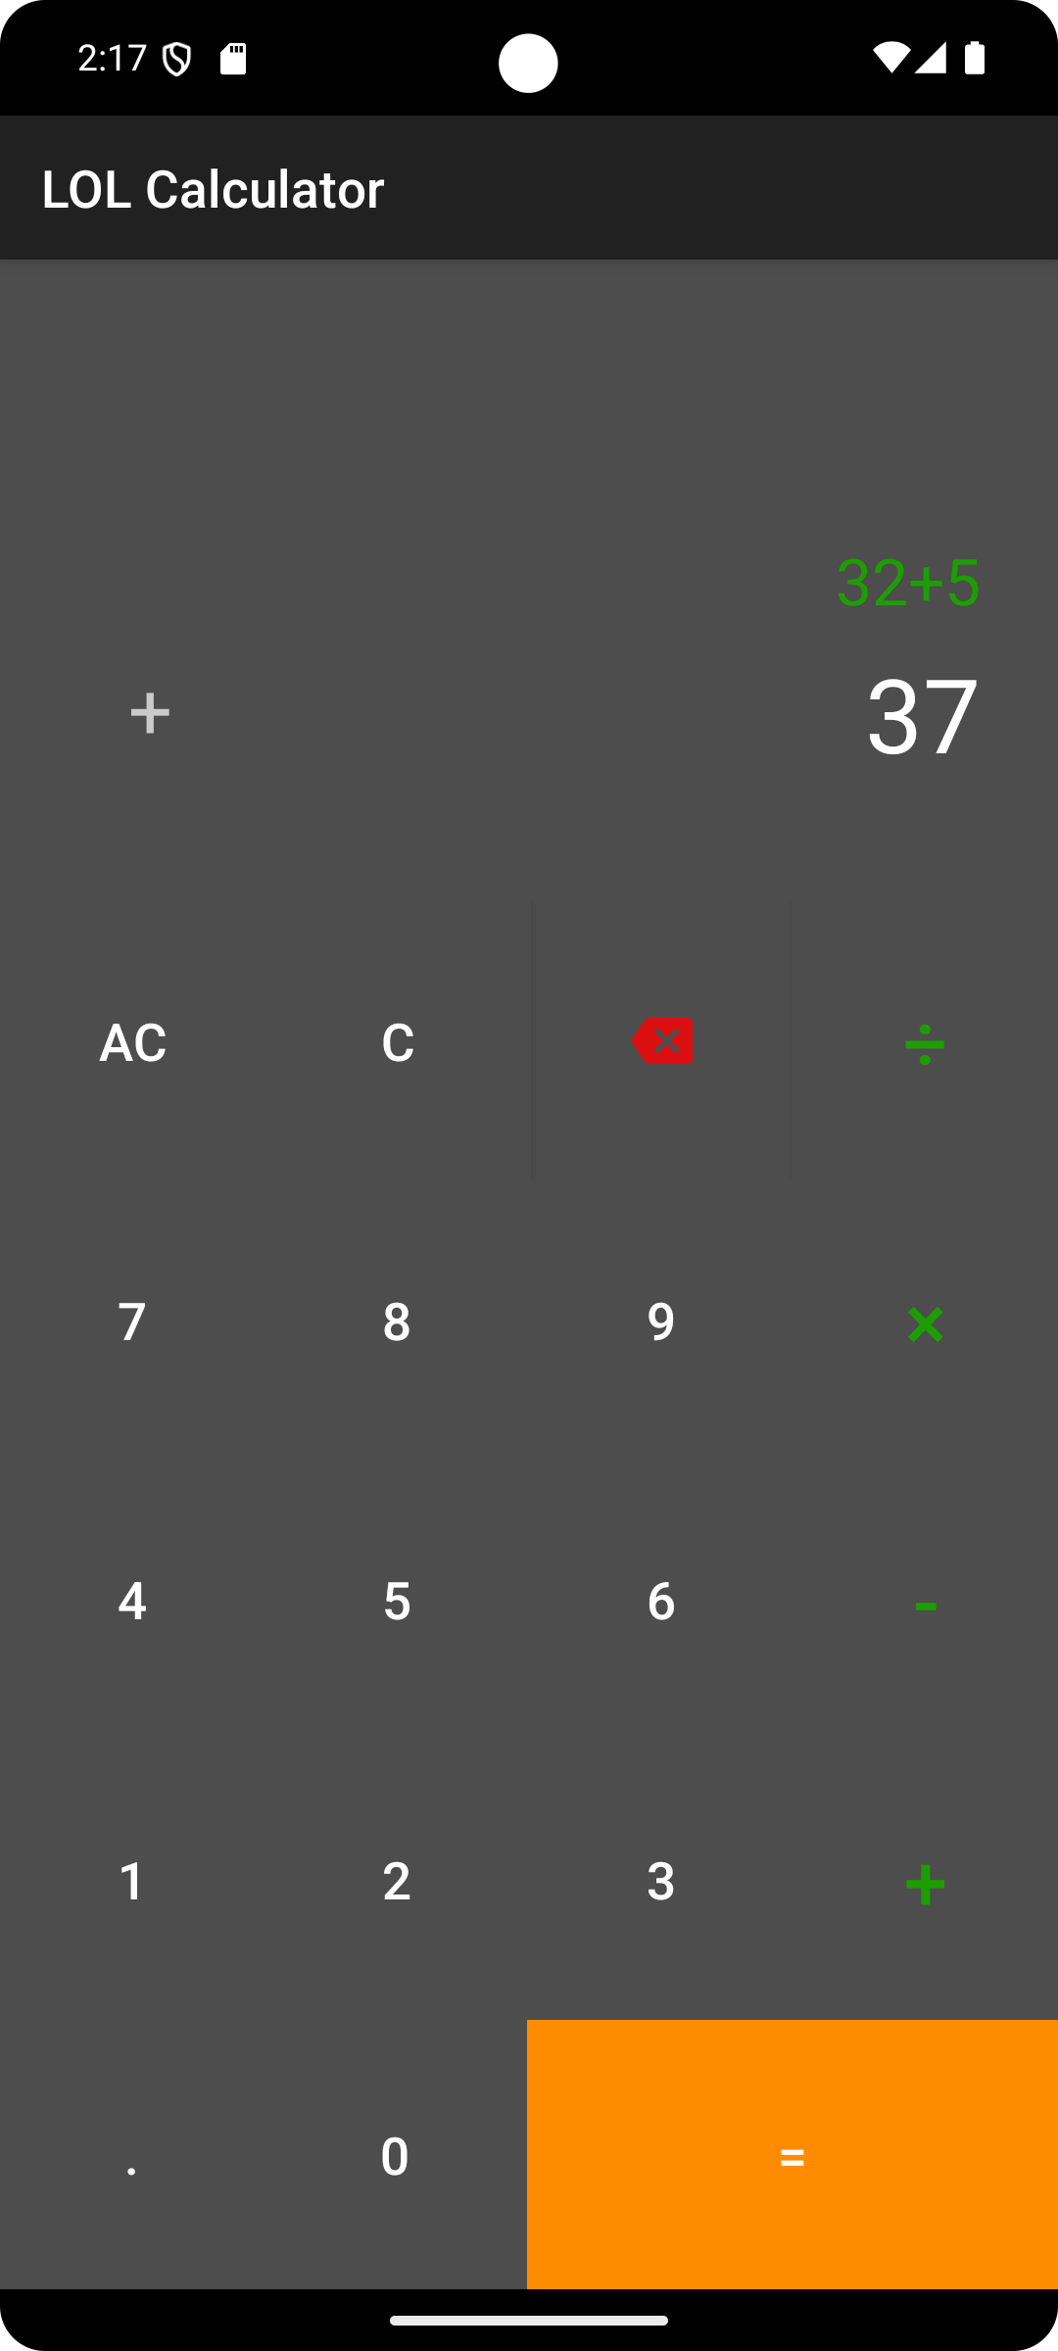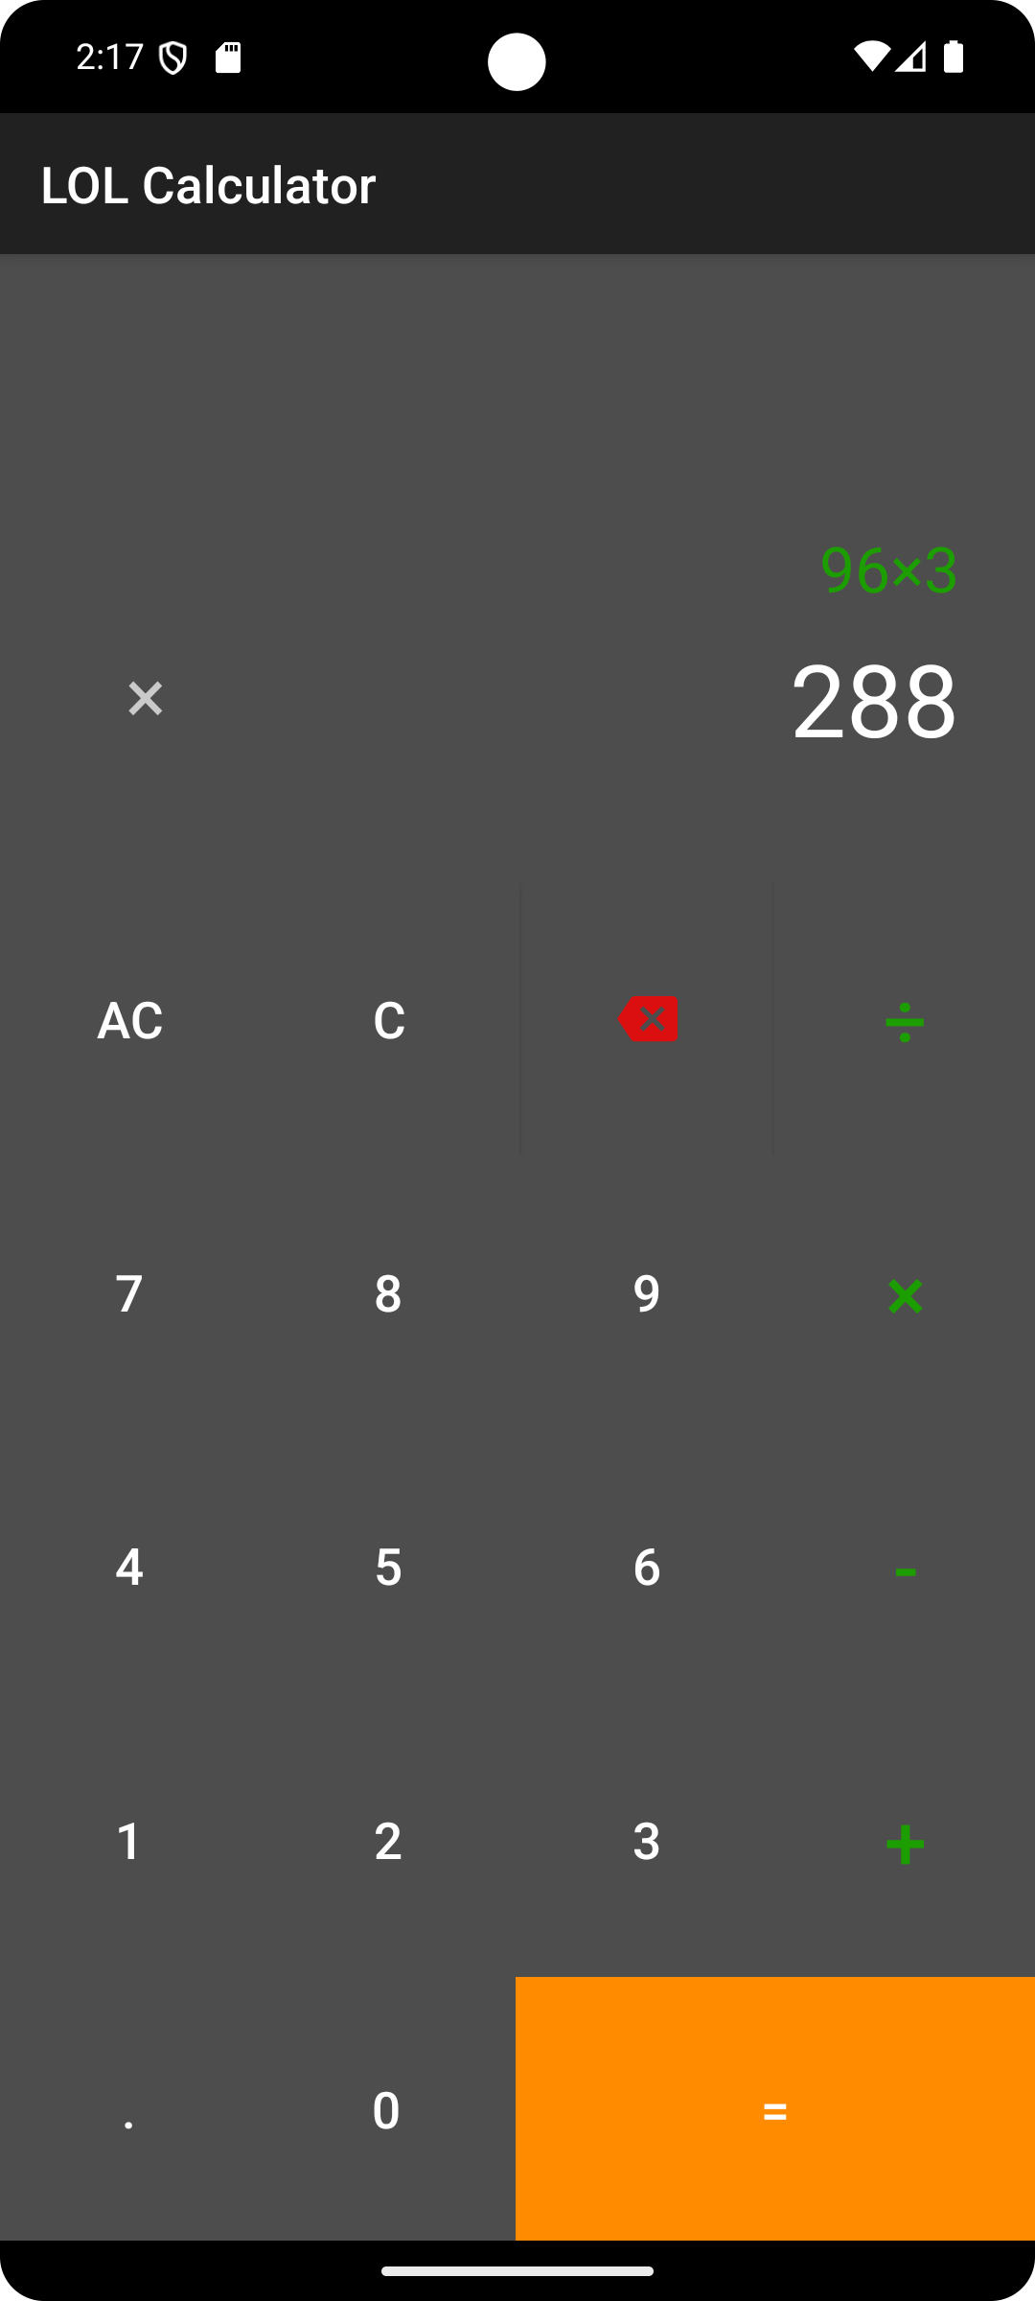

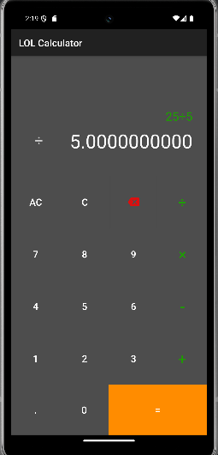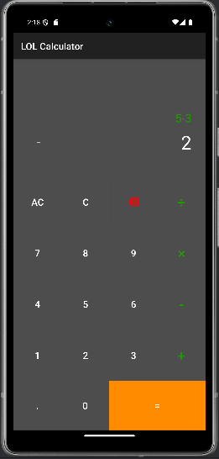

**RESULT:**

Thus calculator app has been made using android studio with operations like addition , subtraction, multiplication and division.