1. Create a EC2 Instance in N. California with the Docker and AWS Command Line Tools

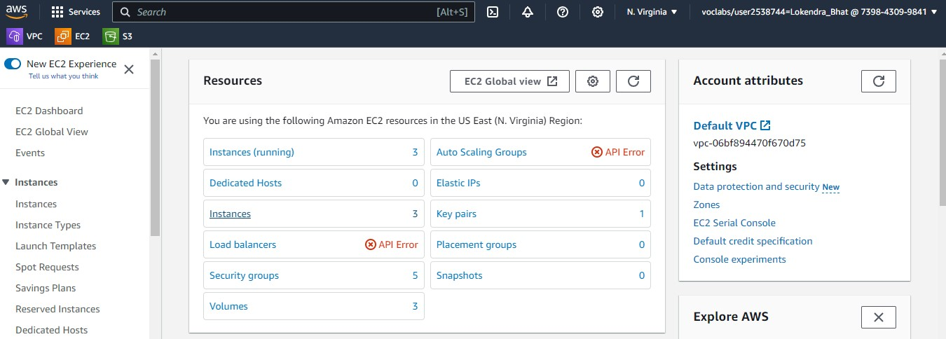

1. Create DockerFile that describe the Docker Image

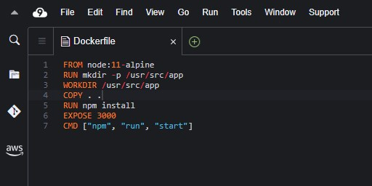

1. Build Docker Image

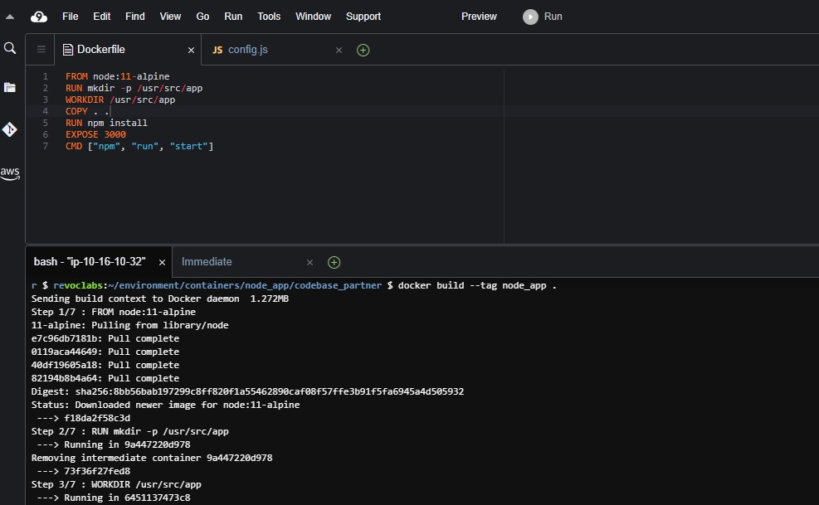

1. Run/Test Docker Image

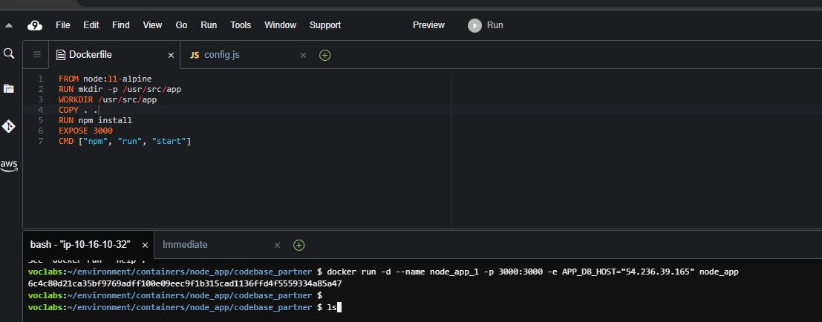

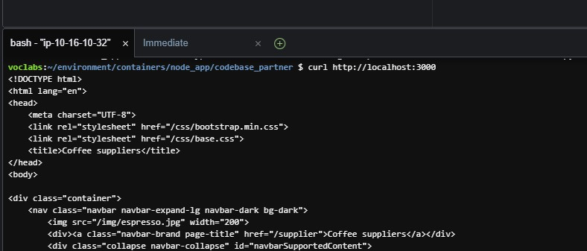

1. Create Container Repository on ECR N. Virgina.

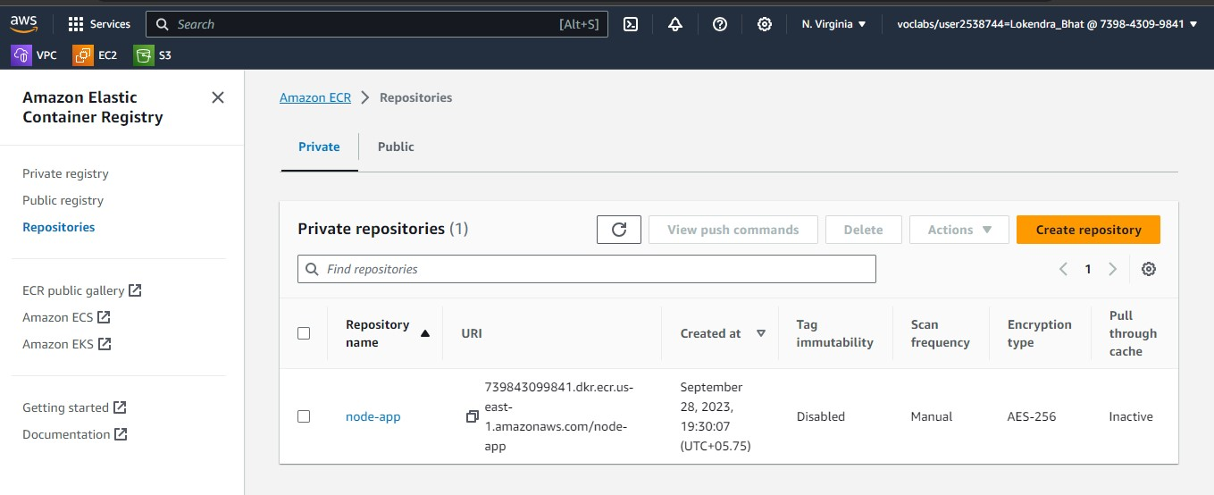

1. Tag Docker Image

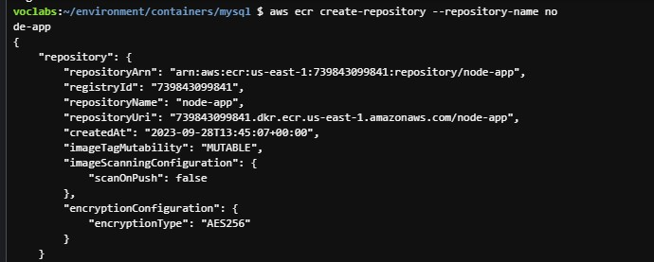

1. Get AWS Login for your Docker Command Line.

* aws ecr get-login - no-include-email
* Copy and Paste provided Docker Command.

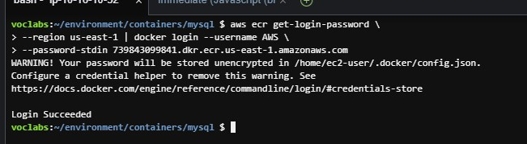

1. Push Docker Image to ECR

