生化题目：
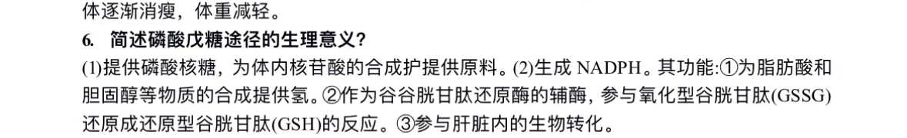
6. Briefly describe the physiological significance of the pentose phosphate pathway?

(1) Provides ribose-5-phosphate, serving as a raw material for nucleotide synthesis in the body.
(2) Generates NADPH, whose functions include:
(a) Supplying hydrogen for the synthesis of substances such as fatty acids and cholesterol.
(b) Acting as a coenzyme for glutathione reductase, participating in the reduction of oxidized glutathione (GSSG) to reduced glutathione (GSH).
(c) Involvement in biotransformation processes in the liver.

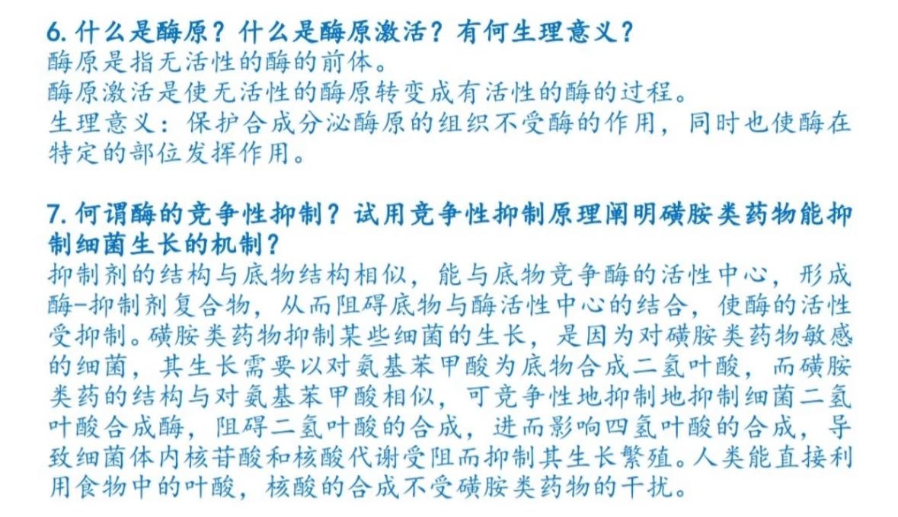
6\. What is a zymogen? What is zymogen activation? What is its physiological significance?

A zymogen is an inactive precursor of an enzyme.

Zymogen activation is the process of converting inactive zymogens into active enzymes.

**Physiological significance**: It protects tissues that synthesize and secrete zymogens from enzymatic action while ensuring enzymes become active only at specific sites.

---

7\. What is competitive inhibition of enzymes? Explain the mechanism by which sulfonamide drugs inhibit bacterial growth using the principle of competitive inhibition.

Competitive inhibition occurs when an inhibitor (with a structure similar to the substrate) competes with the substrate for binding to the enzyme's active site, forming an enzyme-inhibitor complex and reducing enzymatic activity.

**Sulfonamide drugs** inhibit bacterial growth because:
- Sensitive bacteria require *para*-aminobenzoic acid (PABA) to synthesize dihydrofolic acid.
- Sulfonamides structurally resemble PABA and competitively inhibit bacterial **dihydrofolate synthetase**, blocking dihydrofolic acid production.
- This disrupts tetrahydrofolate synthesis, impairing nucleotide/nucleic acid metabolism and halting bacterial proliferation.
- **Selective toxicity**: Humans directly utilize dietary folate, so their nucleic acid synthesis remains unaffected by sulfonamides.

生糖氨基酸的英文是 glucogenic amino acids。

关键概念解析：
- 定义：
生糖氨基酸是指在代谢过程中可转化为 葡萄糖前体（如丙酮酸、α-酮戊二酸、琥珀酰CoA等）的氨基酸，最终通过糖异生（gluconeogenesis）生成葡萄糖。
空腹或饥饿状态：生糖氨基酸通过糖异生维持血糖水平。
肝衰竭：糖异生能力下降→需补充生糖氨基酸（如丙氨酸、谷氨酰胺）。
糖尿病：过量生糖氨基酸可能加剧高血糖（需平衡摄入）。
1. **Definition:**
Glucogenic amino acids are amino acids that can be metabolized into glucose precursors (e.g., pyruvate, α-ketoglutarate, succinyl-CoA) and ultimately contribute to glucose production via gluconeogenesis.

2. **Physiological Significance:**
- **Fasting or starvation:** Glucogenic amino acids maintain blood glucose levels through gluconeogenesis.
- **Liver failure:** Impaired gluconeogenesis necessitates supplementation with glucogenic amino acids (e.g., alanine, glutamine).
- **Diabetes:** Excessive glucogenic amino acids may exacerbate hyperglycemia (requiring balanced intake).

DNP（2,4-二硝基苯酚）是一种经典的线粒体解偶联剂，其作用机制和生物学效应可以从多个层面进行深入阐述。从分子机制来看，DNP作为一种脂溶性小分子，能够自由穿透线粒体内膜，通过其独特的化学结构充当质子载体。在正常生理状态下，电子传递链泵出的质子形成的电化学梯度是ATP合成的驱动力，而DNP的介入使得质子可以不经过ATP合酶直接回流至线粒体基质，从而破坏了氧化磷酸化的偶联关系。这种解偶联作用导致两个重要的生物学后果：一方面使得质子梯度消散，ATP合成受阻，细胞内能量供应急剧下降；另一方面导致电子传递链持续运转，加速底物氧化，但产生的能量以热能形式释放。
DNP (2,4-Dinitrophenol), a classic mitochondrial uncoupler, exerts its effects through multi-level mechanisms. At the molecular level, this lipophilic small molecule freely traverses the inner mitochondrial membrane, functioning as a protonophore. Under physiological conditions, the electrochemical gradient generated by proton pumping through the electron transport chain (ETC) drives ATP synthesis. DNP disrupts this coupling by shuttling protons back into the matrix independently of ATP synthase, bypassing oxidative phosphorylation. This uncoupling produces two critical biological consequences: (1) dissipation of the proton gradient halts ATP production, causing acute cellular energy depletion; (2) continued ETC operation accelerates substrate oxidation while dissipating energy as heat.
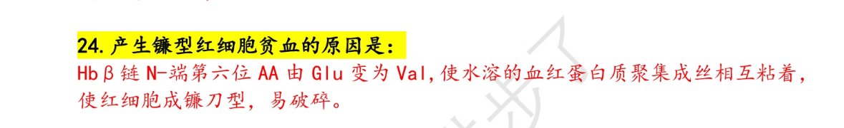
The substitution of glutamic acid (Glu) with valine (Val) at the sixth amino acid position of the hemoglobin β-chain (Glu6Val) transforms hemoglobin's physicochemical properties. This single-point mutation:

**Beta-oxidation** breaks down fatty acids in mitochondria via four steps per cycle: (1) dehydrogenation (FADH₂), (2) hydration, (3) oxidation (NADH), (4) thiolysis (acetyl-CoA). CPT-I regulates entry, inhibited by malonyl-CoA. Key for energy (106 ATP/palmitate). Defects cause disorders (e.g., MCAD deficiency). Recent roles include epigenetic regulation (acetyl-CoA) and signaling (β-hydroxybutyrate). Targeted by drugs (e.g., fibrates). Links to cancer and apoptosis. Vital for metabolism and cell function.

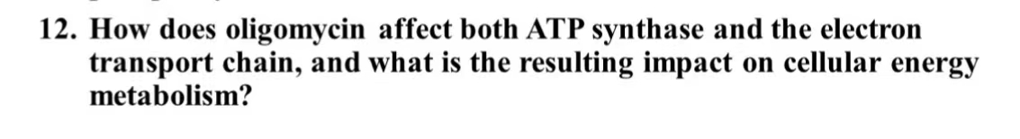
Oligomycin disrupts cellular energy metabolism by binding to ATP synthase's Fo subunit, blocking proton flow and halting ATP production. This inhibition causes proton gradient buildup, impairing electron transport chain (ETC) function and increasing membrane potential. The resulting ETC stagnation elevates reactive oxygen species (ROS) generation while forcing cells to rely on anaerobic glycolysis, leading to lactate accumulation. These effects - combining energy depletion, oxidative stress, and metabolic shift - make oligomycin valuable for studying mitochondrial respiration while demonstrating how single-target inhibition can collapse entire bioenergetic systems. The compound effectively uncouples ATP production from electron transport, serving as a key tool to analyze mitochondrial coupling efficiency.

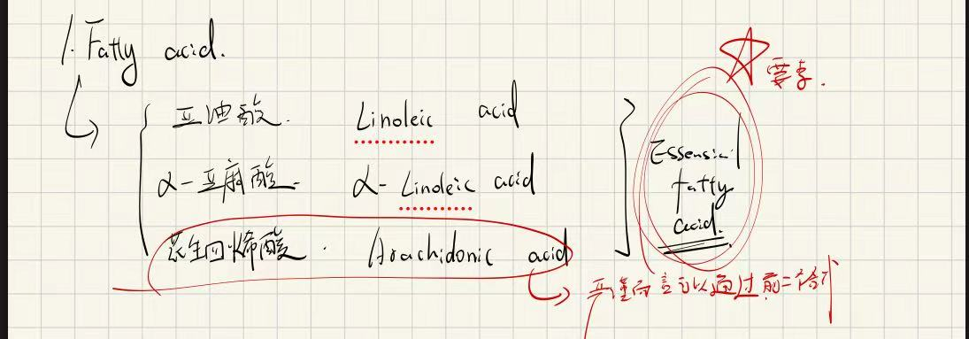

Enzyme inhibitors are widely used in clinical applications, including ACE inhibitors for hypertension, protease inhibitors for HIV, COX-2 inhibitors for inflammation, and chemotherapy agents targeting key metabolic enzymes in tumors.

VitaminD——ricket
VitaminA——night blindness
VitaminB3——diarrhea

Dna ——Watson crick

半保留复制
Semi-Conservative Replication
This replication model produces daughter DNA molecules each containing one original parental strand and one newly synthesized strand, as demonstrated by Meselson-Stahl experiments, ensuring genetic continuity while allowing error correction.

Isoelectric point (pl)
The isoelectric point is the pH at which a molecule carries no net electrical charge, causing minimal solubility and potential precipitation, important for protein purification and analysis techniques like isoelectric focusing.

Denaturation
Denaturation is the disruption of a protein's native structure by heat, pH changes, or chemicals, leading to loss of biological activity while the primary structure remains intact, often irreversible.

Gout在p208

G6PD deficiency在p104

Complex I——Co Q——Complex III——cytochrome c——Complex IV

**Hyperchromic effect** refers to the significant increase in ultraviolet (UV) absorption at 260nm when double-stranded DNA (dsDNA) denatures into single strands, caused by unstacked bases exhibiting enhanced π→π* electron transitions. This phenomenon serves as a hallmark of DNA denaturation (induced by heat, pH changes, etc.), typically showing a 30-40% absorbance rise. It enables determination of melting temperature (Tm) via melting curves and is widely applied in nucleic acid purity assessment, PCR product specificity verification, and drug-DNA interaction studies. The effect is reversible with the hypochromic effect observed during DNA renaturation.

Nomenclature——p52
Very-low-density lipoproteins——p155
The primary structure (amino acid sequence) is fundamental to protein function for five key reasons: (1) It directly encodes genetic information, determining folding patterns and functional potential (e.g., insulin processing). (2) Side-chain interactions drive proper folding - hydrophobic residues guide core formation while specific cysteines form disulfide bonds. (3) Active sites and binding domains require precise residue arrangements (e.g., catalytic triads in enzymes). (4) Sequence features (salt bridges, metal-binding sites) confer stability and enable post-translational regulation. (5) Evolutionary conservation of critical sequences (e.g., cytochrome c's heme-binding region) underscores their functional necessity. Pathological mutations (HbS Glu6Val, CFTR ΔF508) demonstrate how single changes disrupt function. This sequence-function relationship underpins structural biology and protein engineering.

