名词解释：

A

Abscess：
A localized collection of pus (dead neutrophils, tissue debris, and bacteria) within a tissue, cavity, or organ. It results from intense localized purulent inflammation and is usually surrounded by a fibrous capsule, helping to contain the infection.

Acute nephritic syndrome：
This is a clinical syndrome that presents with sudden onset of hematuria, mild to moderate proteinuria, oliguria, edema, and hypertension. It is commonly seen in post-infectious glomerulonephritis and indicates acute inflammation of the glomeruli.

Adaptation：
The reversible adjustment of cells, tissues, or organs in response to environmental changes (e.g., stress, injury, or altered function) to maintain homeostasis. Common forms include atrophy, hypertrophy, hyperplasia, and metaplasia.

AIDS：
Acquired Immunodeficiency Syndrome (AIDS) is the final stage of HIV infection, characterized by severe immune suppression and increased susceptibility to opportunistic infections and certain cancers. Diagnosis is based on CD4+ T cell count and the presence of AIDS-defining illnesses.

Alcoholic liver disease:
A spectrum of liver damage caused by chronic alcohol consumption, ranging from fatty liver (steatosis), alcoholic hepatitis (inflammation and necrosis), to alcoholic cirrhosis (fibrosis and regenerative nodules).

Alteration：
The first phase of inflammation, referring to the degenerative changes in cells and tissues caused by injurious agents. It includes structural and functional damage, such as necrosis or dystrophy, and can serve as a trigger for subsequent inflammatory reactions.

Angina Pectoris：
A clinical syndrome characterized by chest pain or discomfort due to transient myocardial ischemia without necrosis, usually triggered by exertion or emotional stress and relieved by rest or nitroglycerin.

Anuria：
The absence or near-absence of urine output, typically defined as less than 100 mL/day. It is a severe clinical sign indicating complete renal shutdown or urinary tract obstruction and requires urgent investigation.

Aneurysm：
A localized abnormal dilation of a blood vessel or the heart, usually due to a weakening of the vessel wall. Aneurysms can rupture, leading to life-threatening hemorrhage.

Arteriosclerosis：
A general term describing the thickening and loss of elasticity of arterial walls, which includes atherosclerosis, arteriolosclerosis, and Monckeberg’s medial sclerosis. It leads to increased vascular resistance and contributes to hypertension.

Ashcoff Body:
A pathognomonic lesion of rheumatic fever found in the heart, consisting of foci of T lymphocytes, plasma cells, and activated macrophages (Anitschkow cells) in the myocardium during acute rheumatic carditis.

Asymptomatic hematuria or proteinuria：
This refers to the presence of blood (hematuria) or protein (proteinuria) in the urine without accompanying symptoms. It can be a benign finding or an early indicator of glomerular disease, such as IgA nephropathy or thin basement membrane disease.

Atherosclerosis：
A progressive disease characterized by the accumulation of lipids, inflammatory cells, and fibrous elements in the large and medium-sized arteries, forming plaques that narrow the vessel lumen and reduce blood flow, potentially leading to ischemic events.

Atrophy：
Shrinkage in the size of a cell, tissue, or organ due to loss of cellular substance, resulting in decreased function.

Atypia：
Atypia refers to abnormal cellular morphology often seen under the microscope. This includes nuclear enlargement, hyperchromasia, irregular nuclear contours, and increased mitotic activity, which may be present in both pre-malignant and malignant lesions.

Azotemia：
A medical condition characterized by elevated levels of nitrogenous waste products (such as urea and creatinine) in the blood due to reduced kidney function. It can be classified as prerenal, renal, or postrenal based on the underlying cause.

B

Bacteremia:
The presence of viable bacteria circulating in the bloodstream. It can be transient (as after brushing teeth) or pathological, potentially progressing to septicemia if the immune system fails to eliminate the microbes.

Bowman’s capsule：
Bowman’s capsule surrounds the glomerulus and collects the filtrate that passes through the glomerular filtration barrier. The capsule has two layers: an inner visceral layer (made of podocytes) and an outer parietal layer. The filtrate enters the proximal tubule from Bowman’s space.

Bridging necrosis：
Coalescent necrosis of hepatocytes forming bridges between portal tracts or between portal tracts and central veins, seen in severe or chronic hepatitis.

Bronchopneumonia (Lobular pneumonia)：
Also known as bronchopneumonia, it is a bacterial infection characterized by patchy inflammation centered on bronchi and bronchioles that spreads to surrounding alveoli, commonly caused by Staphylococcus, Klebsiella, or Pseudomonas species.

C

Caseous necrosis：
Is a distinctive form of necrosis associated with granulomatous inflammation, particularly in tuberculosis. The necrotic tissue appears as a friable, white-yellow, cheese-like material, completely devoid of cellular structure, and is surrounded by epithelioid macrophages and lymphocytes.

Cast urine：
Urinary casts are cylindrical structures formed by coagulated protein (mainly Tamm-Horsfall protein) and cellular elements in the distal tubules and collecting ducts. They are important diagnostic tools; for example, red cell casts suggest glomerulonephritis, while white cell casts indicate pyelonephritis.

Carcinoma:
A malignant tumor derived from epithelial cells. It includes subtypes such as squamous cell carcinoma and adenocarcinoma and is the most common type of cancer in humans.

Carcinoma in situ:
A pre-invasive form of carcinoma where malignant epithelial cells are confined to the epithelium and have not breached the basement membrane. It has high potential to become invasive if left untreated.

Cellular Swelling (Hydropic Degeneration)：
First sign of reversible injury, caused by water influx due to ATP depletion (failure of Na⁺/K⁺ pump). Microscopy: Pale, vacuolated cytoplasm.

Central chromatolysis：
Central chromatolysis is a reaction of neurons to axonal injury, characterized by dispersion and dissolution of Nissl substance around the nucleus, which is displaced to the periphery. It represents an attempt at neuronal repair and regeneration.

Cervical Carcinoma in situ：
Cervical carcinoma in situ, equivalent to CIN III, is a high-grade lesion where atypical squamous epithelial cells involve the entire thickness of the epithelium but do not breach the basement membrane. It is considered the final stage before the development of invasive cervical cancer.

Cervical Intraepithelial Neoplasia (CIN)：
CIN is a precancerous lesion of the cervical epithelium caused primarily by persistent infection with high-risk human papillomavirus (HPV). It is characterized by abnormal proliferation and dysplasia of squamous cells and is histologically graded as CIN I (mild), CIN II (moderate), or CIN III (severe or carcinoma in situ).

Chemotaxis：
The movement of immune cells, particularly neutrophils and macrophages, toward the site of infection or tissue injury in response to chemical signals such as cytokines, chemokines, or bacterial products. This process ensures targeted immune defense.

Choriocarcinoma：
Choriocarcinoma is a highly malignant tumor of trophoblastic origin composed of cytotrophoblasts and syncytiotrophoblasts without villous formation. It may follow a normal pregnancy, abortion, or molar pregnancy and commonly metastasizes to the lungs, brain, and liver. It is associated with very high serum HCG levels.

Chronic Cor Pulmonale：
A condition of right-sided heart failure resulting from chronic pulmonary hypertension due to diseases affecting the structure or function of the lungs, especially COPD, leading to right ventricular hypertrophy and eventual failure.

Chronic nephritic syndrome：
A long-term condition involving persistent hematuria, proteinuria, hypertension, and gradual loss of kidney function. It may result from unresolved acute glomerulonephritis or progressive glomerular damage and may eventually lead to chronic kidney disease.

Chronic Obstructive Pulmonary Diseases (COPD)：
A group of progressive and irreversible lung diseases, including chronic bronchitis and emphysema, characterized by airflow limitation, chronic inflammation, and respiratory symptoms such as dyspnea and chronic cough.

Cirrhosis：
A chronic, progressive liver disease characterized by widespread fibrosis, regenerative nodules, and distortion of the hepatic architecture, often resulting from chronic hepatitis, alcohol abuse, or metabolic disorders.

Coagulative necrosis：
Is a specific type of necrosis where the underlying tissue architecture is preserved despite cell death, primarily due to protein denaturation and enzyme inactivation. This form is commonly seen in ischemic conditions such as myocardial infarction or renal infarction, where the affected tissue appears firm and pale, retaining ghost outlines of dead cells before being replaced by scar tissue.

Colorectal carcinoma：
A malignant epithelial tumor of the colon or rectum, often developing from adenomatous polyps through the adenoma-carcinoma sequence. It is influenced by diet, genetics, and chronic inflammation such as in ulcerative colitis.

Congestion：
A passive process resulting from impaired venous outflow from a tissue, causing accumulation of deoxygenated blood, often seen in conditions such as heart failure or venous obstruction.

Concentric Hypertrophy：
A form of cardiac hypertrophy where the ventricular wall thickens without an increase in chamber size, often due to pressure overload, such as in systemic hypertension or aortic stenosis.

Cor Villosum：
A descriptive term for the appearance of the pericardial surface in fibrinous pericarditis, where the pericardium becomes covered with shaggy fibrinous exudate, giving it a “hairy” or “villous” appearance—often referred to as “hairy heart.”

Crescentic GN：
This is a type of rapidly progressive glomerulonephritis characterized histologically by the presence of crescents—accumulations of proliferating epithelial cells and infiltrating leukocytes in Bowman’s space. It is associated with severe glomerular damage and can lead to renal failure within weeks or months if not treated promptly.

Cutaneous wound healing：
Is the complex biological process of skin repair, involving sequential stages of hemostasis, inflammation, proliferation (formation of granulation tissue and re-epithelialization), and remodelling (collagen maturation and scar formation).

D

Differentiation：
The degree to which neoplastic cells resemble their normal counterparts in structure and function. Well-differentiated tumors closely mimic the tissue of origin, while poorly differentiated or undifferentiated tumors show little to no resemblance.

Diffuse proliferative GN：
A severe form of glomerulonephritis where more than 50% of glomeruli show increased numbers of mesangial and endothelial cells. This type is often associated with systemic diseases like lupus nephritis (Class IV), and it often presents with hematuria, proteinuria, and renal dysfunction.

E

Early gastric carcinoma：
A type of gastric cancer limited to the mucosa and/or submucosa, regardless of lymph node metastasis, with a better prognosis than advanced forms.

Early hepatocellular carcinoma：
A well-differentiated, small (usually <2 cm) liver cancer limited to the liver parenchyma, often without vascular invasion, and typically discovered during surveillance in cirrhotic patients.

Eccentric Hypertrophy：
A form of cardiac hypertrophy characterized by an enlarged ventricular chamber with relatively thin walls, typically caused by volume overload, such as in valve regurgitation or heart failure.

Embolism：
The process of obstruction of a blood vessel by a detached intravascular mass (embolus) that is carried by the circulation from its origin to a distant site.

Embolus：
Any detached intravascular solid, liquid, or gaseous mass that is carried by the blood to a site distant from its origin, potentially causing vessel occlusion.

Emphysema:
A form of COPD marked by the abnormal, permanent enlargement of airspaces distal to the terminal bronchioles with destruction of alveolar walls, leading to reduced surface area for gas exchange and loss of lung elasticity.

Encapsulation：
Refers to the walling-off of necrotic or infected tissue by fibrous connective tissue to prevent further spread. Examples include encapsulated tuberculous granulomas or abscesses surrounded by a fibrous capsule.

Erosion：
Describes the superficial loss of epithelial tissue, such as skin or mucosa, without penetration of the basement membrane. Common examples include gastric erosions due to NSAID use or cervical erosions where columnar epithelium replaces squamous epithelium.

External hemorrhage:
Blood loss that occurs outside the body, often visible through wounds, mucosal surfaces, orifices, or trauma.

Exudation：
The escape of fluid, proteins (especially fibrinogen), and blood cells (such as leukocytes) from the bloodstream into the interstitial tissue or body cavities. This occurs due to increased vascular permeability during inflammation and contributes to edema and the delivery of immune components to the affected area.

F

Fatty Change (Steatosis)：
Abnormal lipid accumulation in parenchymal cells (e.g., liver, heart). Causes: Alcohol abuse, obesity/diabetes, or hypoxia. Microscopy: Clear vacuoles in cytoplasm (fat dissolves during processing).

Feedback adjustment：
Feedback adjustment refers to the regulatory mechanism by which hormone levels are controlled through negative or positive feedback loops within the endocrine system. In negative feedback, rising levels of a hormone inhibit further secretion, maintaining homeostasis. Positive feedback, though less common, amplifies hormonal output in specific physiological situations (e.g., oxytocin during labor).

Fibrinous inflammation / Transcytosis：
• Fibrinous inflammation: Involves the exudation of fibrinogen, which polymerizes into fibrin outside the blood vessels, forming a thick, fibrin-rich exudate. It often occurs in body cavities like the pleura, pericardium, and peritoneum and can lead to adhesions or scarring.
• Transcytosis: A process in which large molecules are transported across endothelial cells via vesicular transport. In inflammation, this mechanism can contribute to increased vascular permeability independent of endothelial injury.

Fibrinoid necrosis：
Involves the deposition of immune complexes and fibrin within the walls of blood vessels or connective tissue, giving a bright pink, amorphous appearance on histology. It is characteristic of autoimmune vasculitides such as polyarteritis nodosa and malignant hypertension.

Fistula：
Represents an abnormal communication between two epithelial-lined surfaces, such as between the intestine and skin (enterocutaneous fistula) or between the rectum and vagina (rectovaginal fistula), often resulting from chronic inflammation or surgical complications.

G

Gangrene：
Refers to necrosis with superimposed bacterial infection and putrefaction. It is classified into dry gangrene, which is coagulative necrosis without infection (e.g., diabetic foot), and wet gangrene, which involves liquefactive necrosis with bacterial involvement (e.g., bowel strangulation). Gas gangrene, caused by Clostridium perfringens, is a severe form marked by gas bubble formation in tissues.

Gastric carcinoma：
A malignant tumor originating from the epithelial cells of the stomach, most commonly adenocarcinoma, which can present as early or advanced types and is often associated with H. pylori infection, dietary factors, and genetic predisposition.

Ghon complex：
The Ghon complex refers to the combination of a primary tuberculous lesion in the lung (Ghon focus) and the associated caseous lymph node involvement in the hilar region. It is typically seen in primary pulmonary tuberculosis and represents the initial site of infection and lymphatic spread.

Glomerular Nephritis：
Glomerular nephritis refers to a group of diseases characterized by inflammation of the glomeruli. It may result from immune complex deposition or autoimmune mechanisms, leading to hematuria, proteinuria, reduced glomerular filtration rate, and sometimes hypertension and edema.

Glomerulus：
The glomerulus is a tuft of fenestrated capillaries situated within the renal corpuscle. It is responsible for the ultrafiltration of blood. Blood pressure forces water and solutes across the filtration membrane (endothelium, basement membrane, and podocytes), producing filtrate while retaining blood cells and most proteins.

Goiters：
Goiters are abnormal enlargements of the thyroid gland, often visible as swelling at the neck. They can be caused by iodine deficiency, autoimmune diseases (such as Graves’ disease or Hashimoto’s thyroiditis), or nodular hyperplasia. Goiters may be associated with normal, increased, or decreased thyroid hormone production.

Granulation tissue：
Is the vascular-rich connective tissue that forms during healing, composed of proliferating capillaries, fibroblasts, and inflammatory cells. It serves as a scaffold for wound closure and eventual scar formation.

Granuloma：
A chronic inflammatory structure formed in response to persistent non-degradable irritants, consisting mainly of activated macrophages (epithelioid cells), Langhans giant cells, and lymphocytes. Common in diseases like tuberculosis, sarcoidosis, and certain fungal infections.

Graves’ disease：
Graves’ disease is an autoimmune disorder and the most common cause of hyperthyroidism. It is characterized by the presence of thyroid-stimulating immunoglobulins (TSI) that mimic TSH, stimulating the thyroid gland to produce excessive hormones. Clinical features include goiter, exophthalmos (proptosis), and pretibial myxedema.

Growth pattern of tumor：
Describes the structural arrangement and expansion of tumor cells. Benign tumors usually grow expansively with clear borders, while malignant tumors grow invasively and infiltrate surrounding tissues with ill-defined borders.

Ground glass hepatocyte：
A hepatocyte with a finely granular, eosinophilic cytoplasm seen in chronic hepatitis B infection due to the accumulation of hepatitis B surface antigen (HBsAg).

H

HCG：
Human chorionic gonadotropin (HCG) is a glycoprotein hormone produced by syncytiotrophoblasts during pregnancy. It supports the corpus luteum and maintains progesterone secretion. In pathology, elevated HCG levels are used as a marker for gestational trophoblastic diseases such as hydatidiform mole and choriocarcinoma.

Healing by first intention：
Occurs in clean, surgically closed wounds with closely approximated edges. This process involves minimal granulation tissue formation, rapid re-epithelialization, and results in a thin, linear scar.

Healing by second intention：
Takes place in larger wounds with significant tissue loss, where the edges cannot be directly opposed. This involves extensive granulation tissue formation, wound contraction mediated by myofibroblasts, and results in a broader, more noticeable scar.

Hematuria：
The presence of red blood cells in the urine. It may be microscopic (only seen under the microscope) or gross (visible to the naked eye). Causes include glomerular diseases, urinary tract infections, stones, or tumors.

Hematoma：
A localized collection of blood outside blood vessels, usually clotted, within tissues or organs, caused by trauma or vessel rupture.

Hemorrhage：
The escape of blood from the vascular system into surrounding tissues, body cavities, or externally, due to vessel rupture or injury.

Hemorrhagic infarction:
An infarction in which there is bleeding into the necrotic tissue, typically occurring in organs with dual blood supply or loose tissues such as the lungs or intestines.

Hepatic failure：
A severe impairment of liver function due to massive hepatocyte loss or dysfunction, characterized by jaundice, coagulopathy, hepatic encephalopathy, and multi-organ dysfunction.

Hepatocellular carcinoma：
The most common primary liver cancer, arising from hepatocytes, often associated with chronic liver diseases such as hepatitis B or C infection, cirrhosis, and aflatoxin exposure.

HIV：
Human Immunodeficiency Virus (HIV) is a retrovirus that infects CD4+ T lymphocytes and impairs immune function, eventually leading to acquired immunodeficiency syndrome (AIDS). It is transmitted through blood, sexual contact, and vertical transmission from mother to child.

Hyaline Degeneration：
Glass-like eosinophilic material accumulation in cells or extracellular space. Examples: Intracellular (e.g., Mallory bodies in alcoholic liver disease) and extracellular (e.g., hyaline arteriolosclerosis in hypertension/diabetes).

Hydatidiform mole：
A hydatidiform mole is a type of gestational trophoblastic disease characterized by abnormal proliferation of trophoblastic tissue and hydropic swelling of chorionic villi. It can be complete (with no embryo) or partial (with some fetal tissue), and is associated with elevated HCG levels and a risk of malignant transformation.

Hydrocephalus：
Hydrocephalus is the pathological accumulation of cerebrospinal fluid (CSF) within the ventricles of the brain, leading to increased intracranial pressure. It may result from obstruction of CSF flow, impaired absorption, or overproduction, and can be congenital or acquired.

Hyperemia：
An increased volume of blood within the vessels of an organ or tissue, often due to arteriolar dilation, leading to an active process commonly seen in inflammation or increased metabolic activity.

Hypertensive crisis：
An emergency condition involving extremely elevated blood pressure (usually >180/120 mmHg) with or without acute target organ damage (e.g., brain, heart, kidneys), requiring immediate medical intervention.

Hypertensive encephalopathy：
A clinical syndrome resulting from sudden, severe elevation in blood pressure leading to cerebral edema, headache, confusion, seizures, and sometimes coma, due to dysfunction of cerebral autoregulation.

Hyperplasia：
Increase in cell number due to proliferation of cells in response to stimuli. Types: Physiological (e.g., breast hyperplasia during pregnancy) and pathological (e.g., endometrial hyperplasia due to excess estrogen). Mechanism: Growth factor-driven cell division.

Hypertrophy：
Increase in cell size (not number), leading to enlargement of an organ or tissue. Types: Physiological (e.g., muscle hypertrophy in athletes) and pathological (e.g., cardiac hypertrophy due to hypertension). Mechanism: Increased synthesis of structural proteins and organelles.

I

Infarction：
An area of ischemic necrosis in a tissue or organ resulting from obstruction of the local blood supply, typically due to thrombotic or embolic events.

Infection：
The invasion, colonization, and multiplication of pathogenic microorganisms such as bacteria, viruses, fungi, or parasites in host tissues, which often induces inflammation as part of the host immune response.

Inflammation：
A complex biological response of vascularized tissues to harmful stimuli such as pathogens, damaged cells, or irritants. It aims to eliminate the initial cause of cell injury, clear out necrotic cells and tissues, and initiate tissue repair. It involves vascular changes, leukocyte infiltration, and the release of inflammatory mediators, and presents clinically with redness, heat, swelling, pain, and loss of function.

Internal hemorrhage：
A type of hemorrhage where blood escapes into body cavities such as the thorax, abdomen, or joints, without external bleeding.

Invasive mole (malignant mole)：
An invasive mole is a type of gestational trophoblastic neoplasia in which the molar tissue invades the myometrium or adjacent structures. It usually follows a hydatidiform mole and can cause uterine rupture or metastasis, though it is generally responsive to chemotherapy.

Ischemic infarction：
A type of infarction characterized by coagulative necrosis due to a lack of arterial blood supply, commonly seen in solid organs like the heart or kidney.

K

Koilocyte：
A koilocyte is an epithelial cell that shows specific cytopathic effects due to HPV infection. It is characterized by nuclear enlargement, irregular nuclear contour, hyperchromasia, and a clear perinuclear halo. Koilocytes are considered a hallmark of HPV-related epithelial lesions.

Krukenberg tumor：
A metastatic ovarian tumor, usually bilateral, that originates from a primary gastric carcinoma and contains mucin-producing signet-ring cells.

L

Lipiduria：
The presence of lipids in the urine, often associated with nephrotic syndrome. Under the microscope, lipids appear as oval fat bodies and can form fatty casts, reflecting glomerular damage and leakage of lipoproteins.

Liquefactive necrosis：
Occurs when dead tissue undergoes rapid enzymatic digestion, resulting in a soft, liquefied mass. This is typical in brain infarcts due to the high lipid and low protein content of neural tissue, as well as in bacterial abscesses where neutrophil-derived enzymes contribute to tissue liquefaction, forming cystic cavities.

Lobular pneumonia：
Also known as bronchopneumonia, it is a bacterial infection characterized by patchy inflammation centered on bronchi and bronchioles that spreads to surrounding alveoli, commonly caused by Staphylococcus, Klebsiella, or Pseudomonas species.

Lobar pneumonia：
An acute bacterial infection of a large and continuous area of a lobe of the lung, typically caused by Streptococcus pneumoniae, characterized by four classical stages: congestion, red hepatization, gray hepatization, and resolution.

Lung cancer：
A malignant neoplasm originating from the epithelial cells of the respiratory tract, most commonly bronchogenic carcinoma. It is strongly associated with smoking and includes major subtypes such as squamous cell carcinoma, adenocarcinoma, small cell carcinoma, and large cell carcinoma.

Lymphocytes perivascular cuffs：
This term describes the accumulation of lymphocytes around blood vessels in the central nervous system, commonly seen in viral encephalitis and other neuroinflammatory diseases, indicating an immune response within the brain.

M

Mallory bodies：
Eosinophilic, cytoplasmic inclusions of damaged intermediate filaments (cytokeratin) found in hepatocytes, commonly seen in alcoholic liver disease and non-alcoholic steatohepatitis (NASH).

Metaplasia：
Replacement of one differentiated cell type with another, often due to chronic irritation.
Examples: Squamous metaplasia (e.g., in bronchial epithelium of smokers) and intestinal metaplasia (e.g., in Barrett’s esophagus due to acid reflux).
Risk: May progress to dysplasia and cancer.

Metastasis：
The spread of malignant tumor cells from the primary site to distant locations via lymphatic, hematogenous, or transcoelomic routes, resulting in the formation of secondary tumors.

Mucoid Degeneration (Myxoid Change)：
Accumulation of mucopolysaccharides, making tissues gelatinous.
Examples: Myxomatous mitral valve (in mitral valve prolapse) and myxoid tumors (e.g., myxoma).

N

Nabothian cyst：
A Nabothian cyst is a benign, mucus-filled cyst that forms on the cervix when the endocervical glands are obstructed by overlying squamous epithelium, leading to mucus retention. It typically appears as a smooth, yellowish-white nodule and is often discovered incidentally during pelvic examination.

Necrosis：
Refers to the pathological death of cells or tissues due to irreversible injury, often caused by factors such as ischemia, toxins, or infections. It is characterized by cell swelling, membrane rupture, and the release of intracellular contents, which trigger an inflammatory response.

Neoplasm / Atypia：
A neoplasm is an abnormal mass of tissue resulting from uncontrolled and uncoordinated cell proliferation, which continues even after the initiating stimulus is removed. It can be benign or malignant.
Atypia refers to structural abnormalities in cells, including variations in size, shape, and nuclear features, often seen in pre-cancerous or neoplastic lesions.

Nephron：
The nephron is the microscopic structural and functional unit of the kidney. Each kidney contains about 1 to 1.5 million nephrons. It consists of the renal corpuscle (which includes the glomerulus and Bowman’s capsule) and the renal tubules (proximal tubule, loop of Henle, distal tubule, and collecting duct). The nephron is responsible for filtering blood, reabsorbing essential substances, and excreting waste products to form urine.

Nephrotic syndrome：
A clinical condition marked by massive proteinuria (>3.5 g/day), hypoalbuminemia, generalized edema, hyperlipidemia, and lipiduria. It is caused by increased permeability of the glomerular capillary wall, often due to minimal change disease, focal segmental glomerulosclerosis, or membranous nephropathy.

Neuronophagia：
Neuronophagia is the process by which phagocytic cells, such as microglia, engulf and digest dying or dead neurons. It is typically observed in viral infections of the CNS and is a marker of acute neuronal injury.

Non-neoplastic proliferation:
An increase in cell number that is regulated, reversible, and usually in response to a physiological stimulus (e.g., hyperplasia). Unlike neoplasia, it does not persist after removal of the stimulus and the architecture remains orderly.

O

Oliguria：
A reduced urine output, usually defined as less than 400 mL/day in adults. It may result from dehydration, acute kidney injury, or obstruction of the urinary tract.

Organization：
Is the process by which necrotic tissue or thrombi are replaced by granulation tissue and eventually scar tissue. This involves macrophage-mediated debris clearance, fibroblast proliferation, and collagen deposition to restore structural integrity.

P

Pathological Calcification：
Abnormal deposition of calcium salts in soft tissues.
Types: Dystrophic calcification (occurs in dead/dying tissues, e.g., atherosclerotic plaques) and metastatic calcification (due to hypercalcemia, e.g., chronic kidney disease).

Peptic ulcer：
A chronic mucosal ulceration usually occurring in the stomach or the duodenum, caused by an imbalance between mucosal defense mechanisms and aggressive factors such as gastric acid, pepsin, Helicobacter pylori infection, and NSAIDs.

Phlegmonous inflammation：
A type of diffuse, spreading purulent inflammation without clear boundaries, commonly affecting soft tissues. It is usually caused by streptococcal infection and can progress rapidly, often requiring surgical intervention.

Piecemal necrosis：
Also known as interface hepatitis, it refers to hepatocyte necrosis at the interface between the portal tract and the parenchyma, often seen in chronic hepatitis.

Portal hypertension:
An increase in blood pressure within the portal venous system, usually caused by cirrhosis, leading to complications such as ascites, splenomegaly, esophageal varices, and hepatic encephalopathy.

Precancerous diseases：
Conditions or lesions that harbor an increased risk of developing into cancer. Examples include adenomatous polyps, chronic atrophic gastritis, or cervical intraepithelial neoplasia.

Primary carcinoma of the liver：
A malignant tumor arising from the liver parenchyma, bile ducts, or blood vessels, with hepatocellular carcinoma being the most common type.

Primary Granular Atrophy of the Kidney：
A condition associated with chronic hypertension, where the kidneys appear shrunken with a finely granular surface due to nephrosclerosis and loss of nephrons, leading to renal insufficiency.

Proliferation:
The stage of inflammation that involves the multiplication of various cells—especially fibroblasts, endothelial cells, and epithelial cells—to repair damaged tissue. It includes angiogenesis (formation of new blood vessels) and granulation tissue formation, essential for wound healing.

Proteinuria：
The abnormal excretion of protein in the urine, indicating kidney damage, especially of the glomeruli. Persistent proteinuria is a hallmark of nephrotic syndrome and a risk factor for progressive kidney disease.

Proto-oncogene：
A normal gene involved in cell growth and differentiation that can become an oncogene through mutation or overexpression. When activated, it promotes unregulated cell proliferation.

Pseudo-erosion of cervix：
Pseudo-erosion, also known as cervical ectropion, is a physiological condition in which columnar epithelium from the endocervical canal extends onto the ectocervix, mimicking cervical erosion. It is commonly observed in adolescents, pregnant women, and oral contraceptive users, and it is not considered a pathological lesion.

Pseudolobule：
A histological feature of cirrhosis where regenerative nodules of hepatocytes are surrounded by fibrous septa, replacing the normal lobular architecture of the liver.

Pseudomembranous inflammation：
An inflammatory reaction characterized by the formation of a pseudomembrane composed of fibrin, necrotic epithelial cells, and inflammatory exudate on mucosal surfaces. It is classically associated with Clostridium difficile infection of the colon.

Psammoma bodies：
Psammoma bodies are microscopic, round, concentric calcified structures seen in certain tumors and pathological conditions. They are commonly associated with papillary thyroid carcinoma, serous papillary ovarian carcinoma, and meningiomas. Their presence suggests chronic, organized tissue changes and often aids in tumor diagnosis.

Pulmonary carnification:
A condition where lung tissue becomes firm and liver-like (similar to liver consistency) due to the organization of exudates in unresolved pneumonia, leading to permanent fibrosis and loss of normal lung architecture.

Purulent inflammation：
Inflammation characterized by the production of pus, mainly composed of dead neutrophils, cellular debris, and bacteria. This type of inflammation is typically caused by pyogenic (pus-forming) bacteria such as Staphylococcus aureus.

Pyemia：
A form of septicemia resulting from the spread of pyogenic bacteria through the bloodstream, leading to multiple metastatic abscesses in various organs. It often results from an infected thrombus (septic thrombus).

Pyelonephritis：
An infection and inflammation of the kidney parenchyma and renal pelvis, most commonly caused by ascending bacterial infection from the lower urinary tract. It presents with fever, chills, flank pain, dysuria, and pyuria, and can be acute or chronic.

R

Rapidly progressive nephritic syndrome：
A syndrome characterized by a rapid decline in renal function (usually over days to weeks), often due to crescentic glomerulonephritis. Symptoms include severe hematuria, proteinuria, oliguria, and signs of uremia. It is a medical emergency requiring aggressive treatment.

Reactive gliosis：
Reactive gliosis is the proliferation and hypertrophy of glial cells, particularly astrocytes, in response to central nervous system injury or infection. It is a nonspecific indicator of CNS damage and can result in glial scar formation.

Red neuron：
A red neuron is an early histological marker of acute neuronal injury, typically due to hypoxia or ischemia. It appears as a shrunken neuron with intensely eosinophilic cytoplasm and pyknotic nucleus, commonly seen in brain infarctions.

Regeneration：
Is the replacement of damaged tissue with identical, functional cells, occurring in labile tissues (e.g., skin, gastrointestinal epithelium) and stable tissues (e.g., liver) but not in permanent tissues (e.g., neurons, cardiac muscle).

Renal corpuscle：
The renal corpuscle is in the renal cortex and is the site of the initial stage of urine formation. It includes the glomerulus, a network of capillaries, and Bowman’s capsule, a double-walled epithelial cup. The blood is filtered through the glomerular capillaries into Bowman’s space, forming the glomerular filtrate (primary urine).

Repair：
Encompasses the body’s response to tissue injury, combining regeneration of parenchymal cells (where possible) and scar formation to restore tissue integrity and function.

Reversible Injury：
Early-stage cell damage can be repaired if the stressor is removed. Features: Cellular swelling (due to Na⁺/K⁺ pump failure), fatty change (lipid accumulation), and reduced ATP production.

Rheumatic Endocarditis：
An inflammation of the endocardium, especially heart valves, associated with rheumatic fever. It leads to vegetations along the line of valve closure and may result in chronic valvular deformities.

Rheumatic Fever：
An acute, immune-mediated, systemic inflammatory disease that occurs as a complication of untreated group A streptococcal pharyngitis, mainly affecting the heart, joints, skin, and central nervous system.

S

Sarcoma：
A malignant tumor that arises from mesenchymal (connective) tissues such as bone, muscle, fat, or blood vessels. Sarcomas are less common than carcinomas and tend to be more aggressive.

Satelliteosis：
Satellitosis refers to the clustering of glial cells, particularly oligodendrocytes, around damaged neurons. It is a histopathological feature commonly seen in neurodegenerative conditions and viral infections affecting the brain.

Scar：
Is the dense, collagenous tissue that replaces normal parenchyma after significant injury. While it restores structural continuity, it lacks the original tissue’s functionality. Scars may be hypertrophic (raised but confined) or keloid (excessive growth beyond the wound margins).

Septicemia：
A serious and life-threatening systemic response to infection where bacteria actively multiply in the blood, releasing toxins and causing widespread inflammation, fever, hypotension, and potential organ dysfunction (sepsis).

Serous inflammation：
A mild form of acute inflammation marked by the accumulation of thin, watery, protein-poor fluid derived either from plasma or mesothelial cell secretions. It commonly occurs in response to viral infections, burns, or early stages of bacterial infections.

Sinus：
Is an abnormal, blind-ended tract that connects an infected cavity to an epithelial surface, allowing drainage. A classic example is a pilonidal sinus, which forms near the tailbone due to hair follicle infection.

Softening of Brain：
Also called cerebral infarction, it refers to localized necrosis of brain tissue due to interrupted blood supply, commonly resulting from thrombosis, embolism, or severe atherosclerosis.

Spotty necrosis：
Focal necrosis of individual hepatocytes scattered throughout the liver lobule, often seen in acute viral hepatitis and early stages of drug-induced liver injury.

Subacute Bacterial Endocarditis：
A form of infective endocarditis caused by low-virulence organisms (e.g., Streptococcus viridans), typically affecting previously damaged heart valves, with slow onset symptoms like fever, fatigue, and murmurs.

Subendocardial Infarct：
A type of myocardial infarction limited to the inner third or half of the ventricular wall, usually due to partial or temporary coronary artery occlusion, and typically presents without ST-elevation (NSTEMI).

T

Thrombosis：
The pathological formation of a blood clot (thrombus) within the vascular system during life, obstructing blood flow.

Thromboembolus：
A type of embolus that originates from a thrombus and travels through the bloodstream to block a vessel at a different location.

Thrombus：
A solid mass of blood constituents (fibrin, platelets, red and white blood cells) formed in the vascular system during life.

Thyrotoxicosis / Hyperthyroidism：
Thyrotoxicosis refers to the clinical syndrome resulting from excess thyroid hormones in the blood, regardless of the source. Hyperthyroidism specifically describes overproduction of thyroid hormones by the thyroid gland. Common symptoms include weight loss, heat intolerance, tachycardia, tremor, and anxiety.

Transcoelomic metastasis：
A form of tumor spread where malignant cells disseminate across body cavities (e.g., peritoneal, pleural, pericardial) by direct seeding, often seen in ovarian or gastric cancers.

Transmural Infarct：
A myocardial infarction that affects the full thickness of the ventricular wall, typically caused by prolonged coronary artery occlusion, and associated with ST-elevation on ECG (STEMI).

TSH：
Thyroid-stimulating hormone (TSH), also known as thyrotropin, is a hormone secreted by the anterior pituitary gland. It stimulates the thyroid gland to synthesize and release thyroid hormones (T3 and T4). TSH levels are inversely related to circulating thyroid hormone levels and serve as a key diagnostic marker for thyroid function.

Tubercle：
A tubercle is a small granulomatous lesion formed in response to Mycobacterium tuberculosis infection. It consists of epithelioid cells, Langhans giant cells, lymphocytes, and central caseous necrosis, representing the histological hallmark of tuberculosis.

Tuberculosis：
Tuberculosis (TB) is a chronic infectious disease caused by Mycobacterium tuberculosis, primarily affecting the lungs but capable of involving any organ. It is characterized by granulomatous inflammation with caseous necrosis and typically spreads through airborne droplets.

Tumor parenchyma：
The neoplastic cells that make up the essential functional component of the tumor. These are the proliferating cells that determine the tumor’s biological behavior.

Tumor stroma：
The supportive framework of a tumor, consisting of connective tissue, blood vessels, inflammatory cells, and extracellular matrix. It is essential for tumor nourishment and interaction with the host environment.

Tumor suppressor gene：
A gene that inhibits cell division, repairs DNA damage, or promotes apoptosis. Loss or inactivation of tumor suppressor genes (e.g., p53, Rb) contributes to uncontrolled cell growth and cancer development.

Tumor’s heterogeneity：
The presence of diverse cell populations within a single tumor. These differences can be genetic, phenotypic, or behavioral and may influence the tumor’s growth, resistance to therapy, and prognosis.

Tumor’s progression：
The stepwise development of a tumor from initial transformation to increased malignancy, characterized by genetic and phenotypic changes that enhance growth rate, invasiveness, and metastatic potential.

Toxemia：
A condition where bacterial toxins, rather than the bacteria themselves, are present in the blood and cause systemic effects such as fever, hypotension, or organ damage. It is seen in diseases like diphtheria or toxic shock syndrome.

Typhoid nodule：
Typhoid nodules are specific granulomatous lesions found in the intestinal lymphoid tissues during typhoid fever. They consist of macrophages, lymphocytes, and necrotic debris, and are a characteristic pathological feature of Salmonella typhi infection.

U

Ulcer：
Denotes a deeper defect that extends through the epithelium into the underlying connective tissue, often resulting from chronic inflammation, ischemia, or trauma. Examples include peptic ulcers in the stomach or duodenum and venous stasis ulcers in the lower limbs.

V

Virchow’s node：
An enlarged left supraclavicular lymph node often considered a clinical sign of metastatic spread from abdominal malignancies, especially gastric carcinoma.

病理每章要点
分12个units
1～5为总论
6～12为不同系统中的详解疾病

UNIT 1 cell injury (细胞结构上的损伤)

UNIT 2 Irreversible injury & repair （不可逆伤害与修复）

UNIT 3 Hemodynamic disorder（血流动力学障碍）

UNIT 4 Inflammation（炎症）

UNIT 5 Neoplasm（肿瘤）

UNIT 6 Cardiovascular disease（心血管疾病）

UNIT 7 Respiratory disease（呼吸系统疾病）

UNIT 8 Digestive disease（消化系统疾病）

UNIT 9 Urinary disease（泌尿系统疾病）

UNIT 10 Female genital system disease（女性生殖系统疾病）

UNIT 11 Endocrine System Disease（内分泌系统疾病）

UNIT 12 Infectious disease（感染性疾病）

UNIT 1 cell injury (细胞结构上的损伤)：

对于细胞而言有四种适应方式
1. Atrophy
2. Hypertrophy （肥大——注意，指的仅为实质细胞parenchymal cells）
（1）代偿性肥大（Compensatory Hypertrophy）
定义：器官或组织为适应功能需求增加或部分组织损伤，导致剩余细胞体积增大（而非数量增多）
（2）荷尔蒙性肥大（Hormonal Hypertrophy）
定义：由激素或生长因子过度刺激引起的细胞体积增大（An increase in cell size caused by excessive stimulation from hormones or growth factors.）。
3. Hyperplasia
4. Metaplasia

细胞的适应（发生轻度改变）是为了适应轻度损伤
而harmful stimulus（有害刺激）引起 metabolism（代谢）改变，进而导致 morphology（形态）变化，最终影响 function（功能）

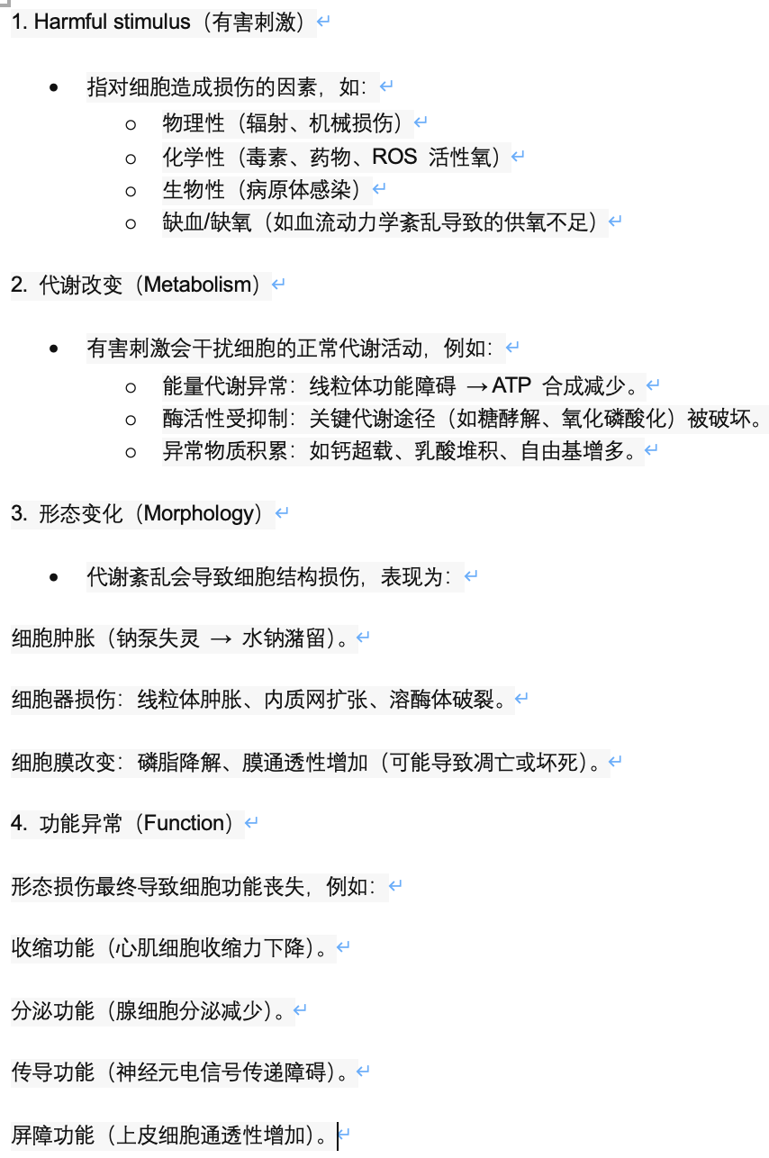

可逆性变性（reverse degeneration）：

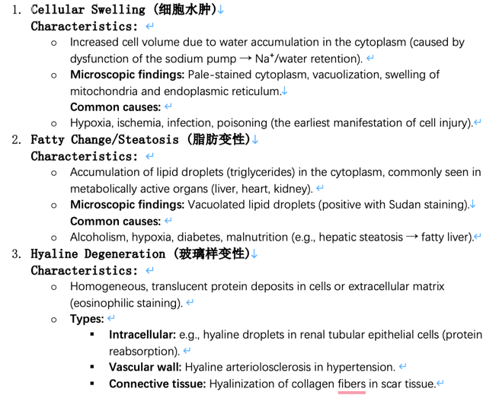
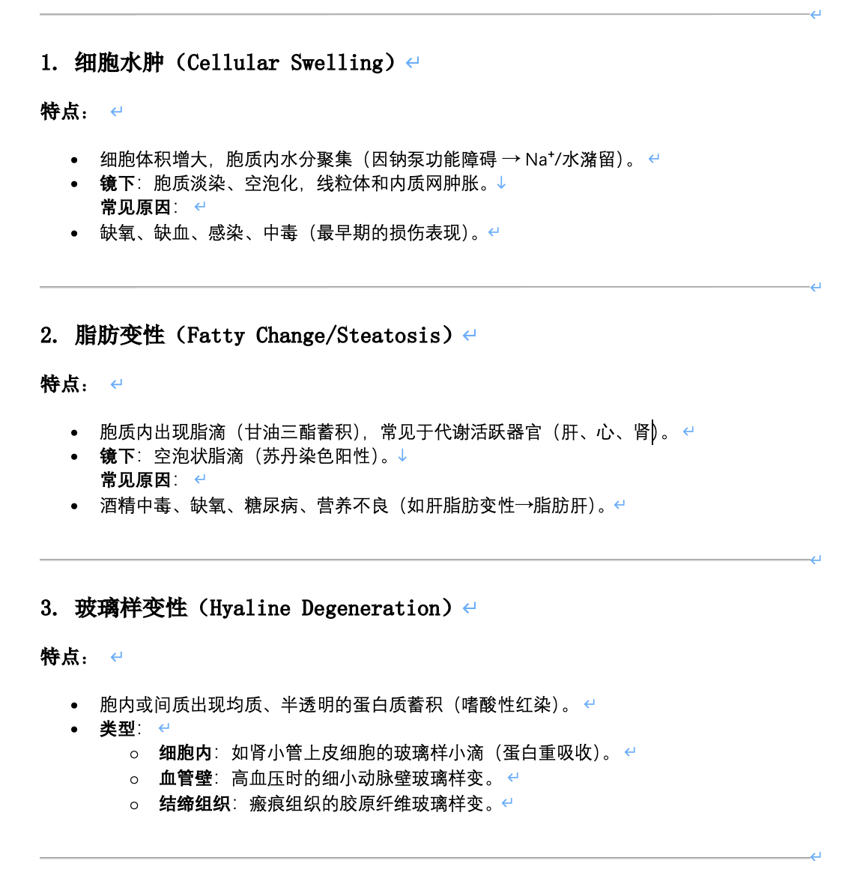

还有一个黏液样变性（应该不做重点考察）

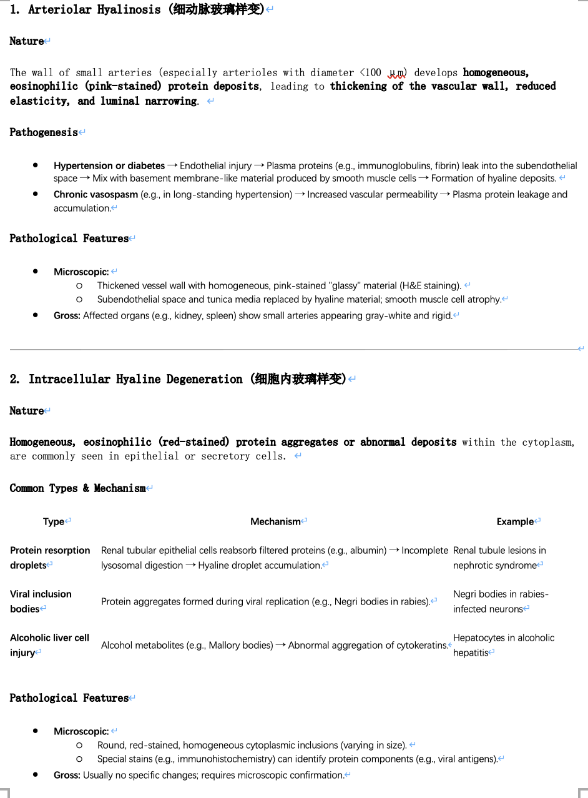
两个课上

提及的玻璃样变

UNIT 2 Irreversible injury & repair （不可逆伤害与修复）

Nuclear change ：
- normal

- pyknosis（核固缩）

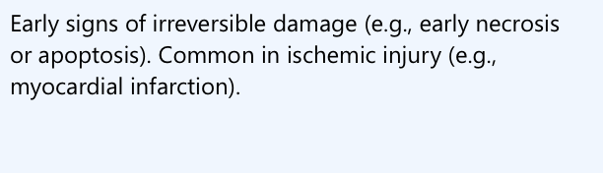
不可逆损伤的早期标志（如坏死或凋亡早期）。

常见于缺血性损伤（如心肌梗死）。

3.karyorrhexis（核碎裂）

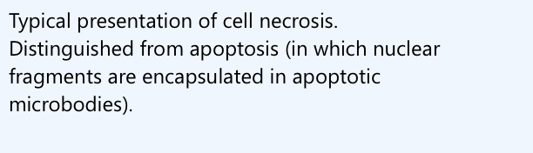
细胞坏死（necrosis）的典型表现。

区别于凋亡（凋亡时核碎片包裹在凋亡小体内）。


4.karyolysis（核溶解）

坏死的终末阶段

接着为坏死：坏死是指 活体内局部组织或细胞的病理性死亡，是一种不可逆的损伤形式，常由强烈致病因素（如缺血、感染、毒素等）引发，表现为细胞代谢停止、结构破坏和炎症反应。
Necrosis refers to the pathological death of local tissues or cells in the living body, which is an irreversible form of damage, often triggered by strong pathogenic factors (such as ischemia, infection, toxins, etc.), manifested by the cessation of cell metabolism, structural destruction and inflammatory response.

坏死：

1. 凝固性坏死（Coagulative Necrosis）
定义：
细胞死亡后蛋白质变性凝固，组织架构保留数天，是最常见的坏死类型。
机制：
- 缺血缺氧 → ATP耗竭 → 蛋白质变性（酶解被抑制）。
病理特点：
- 肉眼：坏死区灰白、干燥，与周围分界清楚（如心肌梗死）。
- 镜下：细胞轮廓存在，胞质嗜酸性增强，核固缩/碎裂/溶解。
常见部位：
- 心（心肌梗死）、肾（肾梗死）、脾（脾梗死）。

2. 液化性坏死（Liquefactive Necrosis）
定义：
坏死组织被酶解液化，形成液态腔隙。
机制：
- 富含水解酶（如中性粒细胞释放的蛋白酶）或脂质（如脑组织）。
病理特点：
- 肉眼：软化、液化，可形成囊腔（如脑梗死→“软化灶”）。
- 镜下：细胞结构完全溶解，充满坏死碎片和液体。
常见部位：
- 脑（缺血/出血性梗死）、脓肿（化脓菌感染）、胰腺（急性胰腺炎）。

3. 干酪样坏死（Caseous Necrosis）
定义：
一种特殊类型的凝固性坏死，坏死区呈黄色、颗粒状奶酪样。
机制：
- 结核分枝杆菌感染 → 激发IV型超敏反应 → 组织彻底破坏。
病理特点：
- 肉眼：松软、黄白色，状似干酪（如肺结核灶）。
- 镜下：无结构颗粒状坏死物，周围有上皮样细胞和朗汉斯巨细胞（肉芽肿）。
临床关联：
- 结核病（肺、淋巴结、肾等）。

4. 脂肪性坏死（Fat Necrosis）
定义：
脂肪组织分解导致的局部坏死，分为 酶解性 和 创伤性。
机制：
- 酶解性：胰酶泄漏（如急性胰腺炎）→ 脂肪细胞膜被胰脂肪酶分解 → 脂肪酸 + 甘油 → 皂化（钙沉积）。
- 创伤性：乳腺等脂肪组织机械损伤。
病理特点：
- 肉眼：灰白色结节或斑块，质硬（钙盐沉积）。
- 镜下：脂肪细胞轮廓模糊，周围可见泡沫细胞和钙盐沉积。
常见部位：
- 胰腺周围、乳腺、皮下脂肪。

5. 纤维素样坏死（Fibrinoid Necrosis）
定义：
血管壁或结缔组织的纤维蛋白样物质沉积，伴免疫复合物浸润。
机制：
- 免疫复合物沉积（如SLE）或恶性高血压 → 血管壁损伤 → 血浆蛋白（纤维蛋白）渗出。
病理特点：
- 镜下：血管壁呈强嗜酸性、均质状，类似纤维蛋白染色（PAS阳性）。
临床关联：
- 风湿病（风湿性动脉炎）、恶性高血压、系统性红斑狼疮（SLE）。

6. 坏疽（Gangrenous Necrosis）
定义：
大范围坏死合并腐败菌感染，分为 干性、湿性 和 气性 坏疽。
类型对比：
类型 | 特点 | 常见部位 | 病因
干性坏疽 | 坏死区干燥、黑色（血红蛋白分解），与健康组织分界清 | 四肢末端（足/指） | 动脉阻塞（如糖尿病、动脉硬化）
湿性坏疽 | 坏死区湿润、肿胀、恶臭，分界不清 | 肠、肺、子宫 | 动静脉双重阻塞 + 厌氧菌感染
气性坏疽 | 坏死区含气体（产气荚膜梭菌感染） | 深部肌肉（创伤后） | 产气菌感染

坏死类型 | 核心特征 | 典型疾病
凝固性坏死 | 组织架构保留，蛋白质凝固 | 心肌梗死
液化性坏死 | 酶解液化，形成囊腔 | 脑梗死、脓肿
干酪样坏死 | 黄色奶酪样，结核相关 | 肺结核
脂肪性坏死 | 脂肪皂化 + 钙化 | 急性胰腺炎
纤维素样坏死 | 血管壁纤维蛋白沉积 | SLE、恶性高血压
坏疽 | 坏死 + 腐败菌感染，分干/湿/气 | 糖尿病足、肠扭转

English ver

1. Coagulative Necrosis (凝固性坏死)
Definition:
Tissue architecture is preserved for days after cell death due to protein denaturation and coagulation, making it the most common type of necrosis.
Mechanism:
- Ischemia/hypoxia → ATP depletion → Protein denaturation (enzymatic digestion inhibited).
Pathological Features:
- Gross: Necrotic area appears gray-white, dry, and well-demarcated (e.g., myocardial infarction).
- Microscopic: Cell outlines remain intact; eosinophilic cytoplasm; pyknosis/karyorrhexis/karyolysis.
Common Sites:
- Heart (myocardial infarction), kidney (renal infarction), spleen (splenic infarction).

2. Liquefactive Necrosis (液化性坏死)
Definition:
Necrotic tissue is digested by enzymes, forming a liquid-filled cavity.
Mechanism:
- Abundant hydrolytic enzymes (e.g., proteases from neutrophils) or high lipid content (e.g., brain tissue).
Pathological Features:
- Gross: Softened, liquefied tissue; may form cystic spaces (e.g., cerebral infarction → "encephalomalacia").
- Microscopic: Complete dissolution of cellular structures; debris and fluid-filled space.
Common Sites:
- Brain (ischemic/hemorrhagic infarction), abscess (pyogenic infection), pancreas (acute pancreatitis).

3. Caseous Necrosis (干酪样坏死)
Definition:
A special form of coagulative necrosis where the necrotic area appears yellow, granular, and cheese-like.
Mechanism:
- Mycobacterium tuberculosis infection → Type IV hypersensitivity → Tissue destruction.
Pathological Features:
- Gross: Soft, yellow-white, resembling cottage cheese (e.g., pulmonary tuberculosis).
- Microscopic: Amorphous granular debris surrounded by epithelioid cells and Langhans giant cells (granuloma).
Clinical Association:
- Tuberculosis (lungs, lymph nodes, kidneys).

4. Fat Necrosis (脂肪性坏死)
Definition:
Localized necrosis of fat tissue, classified as enzymatic or traumatic.
Mechanism:
- Enzymatic: Pancreatic enzyme leakage (e.g., acute pancreatitis) → Lipase breaks down fat cell membranes → Fatty acids + glycerol → Saponification (calcium deposition).
- Traumatic: Mechanical injury to fat tissue (e.g., breast).
Pathological Features:
- Gross: Gray-white nodules or plaques, firm (due to calcification).
- Microscopic: Blurred fat cell borders; foamy macrophages and calcium deposits.
Common Sites:
- Peripancreatic fat, breast, subcutaneous tissue.

5. Fibrinoid Necrosis (纤维素样坏死)
Definition:
Deposition of fibrin-like material in vessel walls or connective tissue, often with immune complex infiltration.
Mechanism:
- Immune complex deposition (e.g., SLE) or malignant hypertension → Vascular damage → Plasma protein (fibrin) leakage.
Pathological Features:
- Microscopic: Vessel walls show bright eosinophilic, homogeneous staining (PAS-positive).
Clinical Association:
- Rheumatic diseases (rheumatic arteritis), malignant hypertension, SLE.

6. Gangrenous Necrosis (坏疽)
Definition:
Extensive necrosis complicated by bacterial infection, subdivided into dry, wet, and gas gangrene.
Types:
Type | Features | Common Sites | Causes
Dry gangrene | Dry, black necrotic tissue (hemoglobin breakdown); clear demarcation. | Extremities (toes/fingers) | Arterial occlusion (e.g., diabetes, atherosclerosis).
Wet gangrene | Moist, swollen, foul-smelling; poorly demarcated. | Intestine, lung, uterus | Arterial + venous obstruction + anaerobes.
Gas gangrene | Gas bubbles in necrotic tissue (Clostridium perfringens). | Deep muscle (post-trauma) | Gas-producing bacteria.
Clinical Significance:
- Dry gangrene progresses slowly; wet gangrene requires urgent intervention (risk of sepsis).

Summary: Key Features
Necrosis Type | Hallmark | Classic Examples
Coagulative necrosis | Preserved tissue architecture | Myocardial infarction
Liquefactive necrosis | Enzymatic liquefaction | Cerebral infarction, abscess
Caseous necrosis | Cheese-like granulomatous necrosis | Tuberculosis
Fat necrosis | Fat saponification + calcification | Acute pancreatitis
Fibrinoid necrosis | Fibrin deposition in vessel walls | SLE, malignant hypertension
Gangrene | Necrosis + bacterial infection | Diabetic foot, bowel ischemia

erosion（糜烂）、ulcer（溃疡）、sinus（窦道）、fistula（瘘管） 描述 组织损伤/缺损的不同形态和病理过程

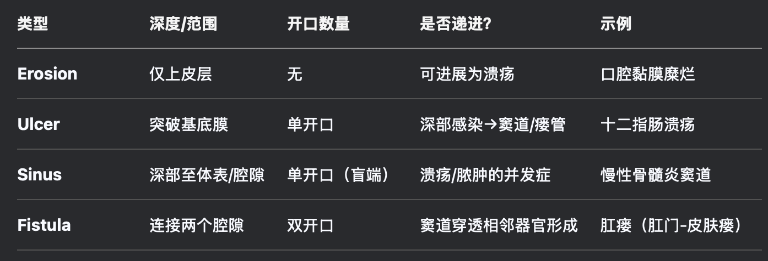

再生能力的细胞分类

### **1. Labile Cells**

- **Definition**: Continuously dividing cells with high regenerative capacity.

- **Examples**: Epithelial cells (skin, gastrointestinal tract, urinary tract)；Hematopoietic cells (bone marrow) ； Cells of mucous membranes

### **2. Stable Cells**

- **Definition**: Cells with low proliferation under normal conditions but can divide in response to injury.

- **Examples**: Hepatocytes (liver) ；Renal tubular cells (kidney) ；Fibroblasts, smooth muscle cells, endothelial cells

### **3. Permanent Cells**

- **Definition**: Non-dividing cells with no regenerative capacity; if lost, they are replaced by scar tissue.

- **Examples**: Neurons (central nervous system) ；Cardiac myocytes (heart muscle) ；Skeletal muscle cells (limited regeneration via satellite cells)

肉芽组织（Granulation Tissue）
肉芽组织是 修复组织损伤（如创伤、溃疡、炎症）的关键成分，主要由 新生毛细血管、成纤维细胞和炎性细胞构成，最终成熟为瘢痕组织。它既是机体修复的必经阶段，也可能因过度增生导致病理问题（如瘢痕疙瘩）。

Granulation tissue is a key component in repairing tissue damage (e.g., trauma, ulcers, inflammation) and is mainly composed of neo capillaries, fibroblasts, and inflammatory cells, which eventually mature into scar tissue. It is both an essential stage of the body's repair and can also lead to pathological problems (e.g., keloids) due to excessive hyperplasia.

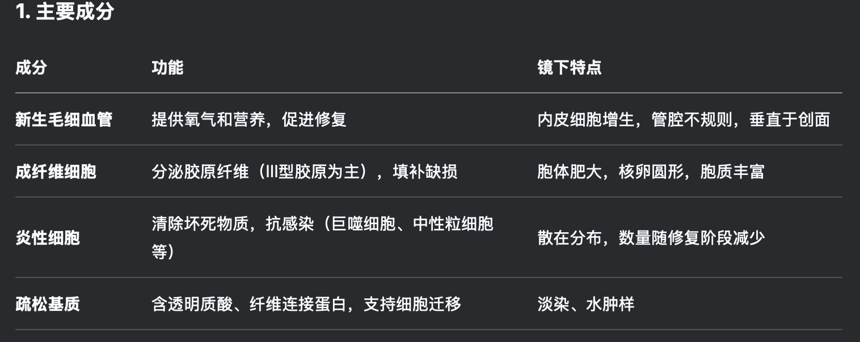

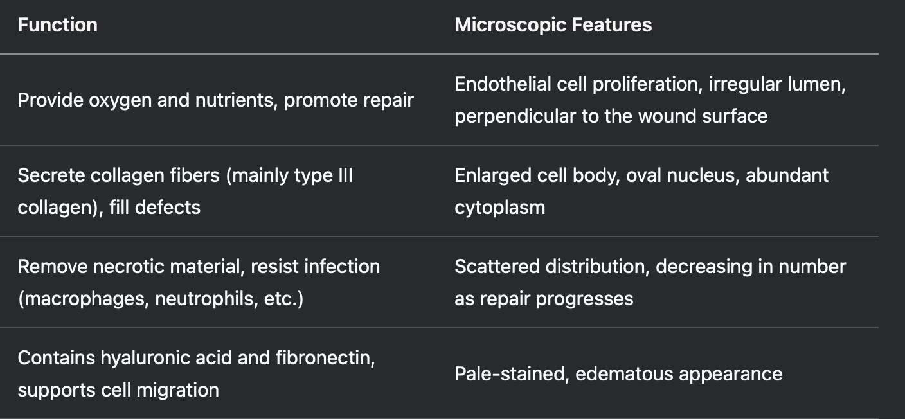

UNIT 3 Hemodynamic disorder（血流动力学障碍）

充血（Hyperemia）

1. 定义
充血是指局部组织或器官的血管内血液含量异常增多，分为生理性充血Physiologic hyperemia和病理性充血Pathologic hyperemia。

2. 分类及特点
类型 | 原因 | 特点 | 举例
动脉性充血（Active Hyperemia） | 小动脉扩张，血流增加（神经或体液调节） | 组织鲜红、温度升高、代谢活跃 | 运动时肌肉充血、炎症早期、情绪激动时面部潮红
静脉性充血（Passive Hyperemia / Congestion） | 静脉回流受阻，血液淤积 | 组织暗红/紫绀、肿胀、温度降低、可导致淤血性水肿、缺氧 | 心衰导致肝淤血、静脉受压（如肿瘤压迫）、肝硬化门静脉高压

3. 病理变化
- 动脉性充血：The microcirculation blood vessels dilate, blood flow accelerates, oxyhemoglobin increases, and the tissue is bright red.
- 静脉性充血：Slow blood flow, increased reduced haemoglobin due to hypoxia, dark red tissue colour; Long-term congestion can lead to fibrosis (e.g., "Betel nut liver").

4. 临床意义
- 动脉性充血：It is usually temporary and promotes tissue repair (e.g., early inflammation).
- 静脉性充血：The cause of obstruction needs to be relieved, otherwise, organ function may be compromised (eg, pulmonary congestion, cirrhosis).

5. 相关术语
- 淤血（Congestion）：即静脉性充血，强调血液淤滞和回流障碍。
- 缺血（Ischemia）：与充血相反，指局部血流不足。

淤血（Congestion）

1. 定义

淤血（静脉性充血，Passive Hyperemia / Congestion）是指静脉血液回流受阻，导致局部组织或器官内静脉血淤积，进而引发组织缺氧、代谢障碍及结构损伤的病理过程。

Congestion (venous hyperemia / congestion) refers to the pathological process of obstruction of venous blood return, resulting in venous blood stasis in local tissues or organs, which in turn leads to tissue hypoxia, metabolic disorders and structural damage.

4. 重要器官淤血举例
器官 | 临床关联 | 特征性表现
肺 | 左心衰竭 | The alveolar wall capillaries dilate, and "heart failure cells" (hemosiderin-containing macrophages) appear in the alveolar cavity. In advanced stages, the lungs become brown and hardened.
肝 | 右心衰竭（如慢性肺心病） | hepatic lobular central vein congestion, atrophy and necrosis of hepatocytes → "betel nut liver"; Long-term progress to cardiogenic cirrhosis.
脾 | 门静脉高压（如肝硬化） | Splenic sinus dilation and congestion, splenomegaly (megasplenomegaly), fibrous tissue hyperplasia.

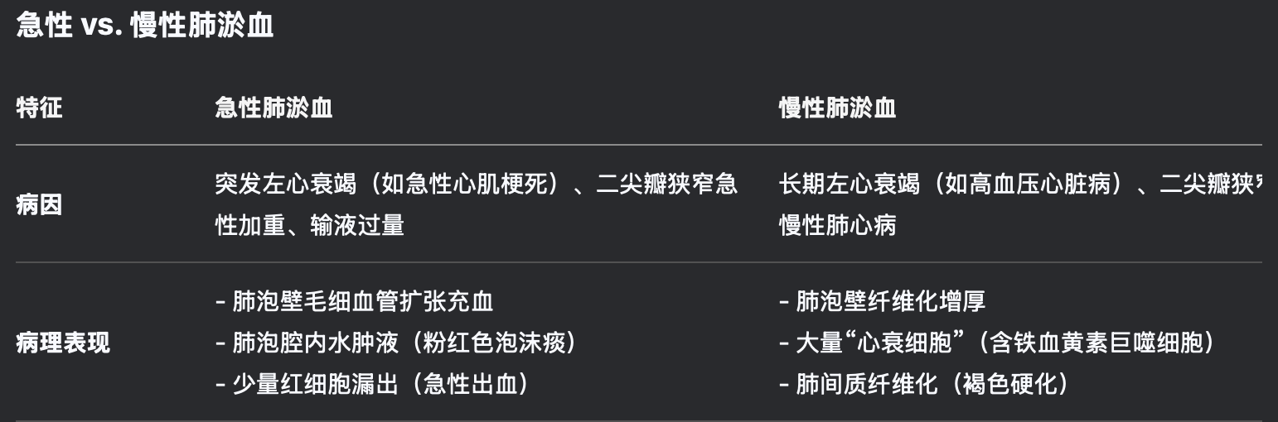

血栓形成（Thrombosis）

1. 定义
Thrombosis is the process by which blood components agglutinate to form a solid mass (thrombosis) in the cardiovascular system of a living body, which is associated with activation of the coagulation system, abnormal blood flow, or damage to the vascular endothelium.

2. 血栓形成的三大条件（Virchow三联征）很重要（three facts）
因素 | 机制 | 举例
血管内皮损伤 | 内皮细胞脱落→胶原暴露→血小板黏附、凝血系统激活 | 动脉粥样硬化、高血压、炎症（如血管炎）、机械损伤（导管置入）
血流异常 | 血流缓慢或涡流→血小板聚集、凝血因子局部堆积 | 静脉淤血（如久卧、心衰）、动脉瘤内涡流、瓣膜狭窄
血液高凝状态 | 凝血因子增多/抗凝机制减弱→凝血倾向增强 | 遗传性（如Leiden V因子突变）、获得性（妊娠、肿瘤、口服避孕药、DIC）

3. 血栓类型及特点
类型 | 形成部位 | 组成特点 | 临床关联
白色血栓 | 动脉、心瓣膜 | 血小板+纤维蛋白为主（头部） | 心肌梗死、动脉血栓
混合血栓 | 静脉、心房/室壁 | 分层结构（血小板+纤维蛋白+红细胞） | 深静脉血栓（DVT）、房颤附壁血栓
红色血栓 | 静脉（延伸部分） | 大量红细胞+纤维蛋白（尾部） | 静脉血栓栓塞（如肺栓塞）
透明血栓 | 微循环（毛细血管） | 纤维蛋白为主（微血栓） | DIC、休克

4. 血栓的结局
- 溶解吸收：Activation of the fibrinolytic system (e.g., small thrombus may disappear completely).
- 机化再通：Granulation tissue grows in→ fibrosis → partial blood flow is restored.
- 钙化：Venous thrombosis → "phleboliths" (such as pelvic veins).
- 脱落栓塞：Thrombus rupture→ blocking of distal blood vessels with blood flow (eg, pulmonary embolism, cerebral infarction)。

2. Virchow's Triad (Three Key Factors)
Factor | Mechanism | Examples
Endothelial Injury | Exposure of subendothelial collagen → platelet adhesion and coagulation activation | Atherosclerosis, hypertension, vasculitis, mechanical injury (e.g., catheters)
Abnormal Blood Flow | Stasis or turbulence → platelet aggregation and local accumulation of clotting factors | Venous stasis (immobility, heart failure), arterial aneurysms, valvular stenosis
Hypercoagulability | Increased procoagulant factors or decreased anticoagulants → enhanced clotting tendency | Genetic (e.g., Factor V Leiden), acquired (pregnancy, malignancy, oral contraceptives, DIC)

3. Types of Thrombi
Type | Location | Composition | Clinical Association
White Thrombus | Arteries, heart valves | Platelets and fibrin (predominant in head) | Myocardial infarction, arterial thrombosis
Mixed Thrombus | Veins, heart chambers | Layered (platelets, fibrin, RBCs) | Deep vein thrombosis (DVT), mural thrombi in atrial fibrillation
Red Thrombus | Veins (tail portion) | RBCs and fibrin (predominant in tail) | Venous thromboembolism (e.g., pulmonary embolism)
Hyaline Thrombus | Microcirculation | Fibrin-rich microthrombi | DIC, shock

提一句：vein更容易形成血栓的原因是因为其血流缓慢，有Venous valves，同时缺少氧气

栓塞（Embolism） It refers to the pathological process in which an intravascular embolus moves with the bloodstream and blocks the smaller blood vessels distal, resulting in tissue ischemia or necrosis. Embolus can be solid (such as a blood clot), liquid (such as a fat droplet), gas (such as air), or other foreign bodies.

常见类型：

血栓栓塞（Thromboembolism）

最常见，栓子为血栓（如深静脉血栓脱落导致 肺栓塞）。

脂肪栓塞（Fat embolism）

见于骨折或脂肪组织损伤后，脂肪滴进入血流阻塞血管。

气体栓塞（Gas embolism）

如空气进入血液循环（手术、潜水病）。

羊水栓塞（Amniotic fluid embolism）

During childbirth, amniotic fluid enters the mother's blood circulation and is extremely dangerous.

其他（肿瘤细胞、细菌团等）。

在栓塞（embolism）的分类中，根据栓子来源和运行路径的不同，可以分为 **左心栓子、右心栓子、门脉系统栓子、交叉栓子（反常栓塞）和逆行性栓子**。

### **1. 左心栓子（Left-sided cardiac emboli）**

**来源**：左心系统（如左心房、左心室、二尖瓣或主动脉瓣）。

**栓塞部位**：

- **体循环动脉**（如脑、肾、脾、肠系膜动脉、下肢动脉等）。

### **2. 右心栓子（Right-sided cardiac emboli）**

**来源**：右心系统（如右心房、右心室、三尖瓣或肺动脉瓣）。

**栓塞部位**：

- **肺动脉** → 导致 **肺栓塞（PE）**，严重者可猝死。

- 若栓子较小，可能阻塞远端肺动脉分支，引起肺梗死（胸痛、咯血）。

### **3. 门脉系统栓子（Portal vein emboli）**

**来源**：门静脉系统（肠系膜静脉、脾静脉等）。

**栓塞部位**：

- **门静脉分支**（如肝内门静脉），导致 **门静脉高压**（腹水、脾大、食管静脉曲张）。

- 若栓子来自肠系膜静脉，可致 **肠缺血/梗死**（剧烈腹痛、血便）。

### **4. 交叉栓子（反常栓塞，Paradoxical embolism）**

**机制**：栓子从静脉系统 **通过右向左分流** 进入动脉系统，绕过肺循环。

### **5. 逆行性栓子（Retrograde embolism）**

**机制**：栓子因血流动力学改变（如重力、血管痉挛或逆向血流）向 **相反方向移动**。

**常见情况**：

- **主动脉粥样硬化斑块脱落**，在血流冲击下逆行至颈动脉或椎动脉（导致脑栓塞）。

- **胸腹主动脉瘤** 内血栓脱落，逆行栓塞肾动脉或肠系膜动脉。

- **Valsalva 动作**（如举重、排便）导致短暂血流逆转，使栓子逆行。

梗死（infarction）根据病理形态和机制可分为以下三种主要类型，其分类依据主要包括组织特点、血管阻塞类型和有无感染：

1. 白色梗死（贫血性梗死，White Infarct）
- 特点：
  - The tissue is pale or yellowish white with well-defined borders.
  - It is more common in organs with dense tissue structures such as the heart, spleen, and kidney, and less collateral circulation.
- 形成条件：
  - Arterial blockage (eg, thrombosis, embolism) and venous return is usually patencious.
  - Blood is squeezed out of the tissue (eg, in myocardial infarction, a coronary artery is blocked and causes myocardial ischemia and necrosis, and blood is drained from the necrotic area into the surrounding blood vessels).

2. 红色梗死（出血性梗死，Red Infarct）
- 特点：
  - The infarct area is dark red with significant hemorrhage (tissue necrosis with vascular rupture or reperfusion).
  - It is more common in organs with loose tissue structures such as lungs and intestines or double blood supply.
- 形成条件：
  - Blockage of a vein (such as a pulmonary vein) or blockage of an artery with abundant collateral circulation (bleeding of blood from collateral branches into a necrotic area).
  - Tissue is loose and cannot effectively compress bleeding (e.g., pulmonary infarction).

3. 败血性梗死（Septic Infarct）
- 特点：
  - Bacterial infection may result in the formation of an abscess or sepsis in the infarct area.
  - Inflammatory cell infiltration and purulent necrosis of tissues can be seen in the infarct area.
- 形成条件：
  - Emboli contain pathogens (e.g., infectious emboli in bacterial endocarditis).
  - Secondary infection after infarction (e.g., intestinal infarction leading to bacterial translocation).

UNIT 4 Inflammation（炎症）

最简单的表现形式

Heat；redness；swelling；pain；loss of function（红，肿，热，痛，功能障碍）

炎症（inflammation）的基本病理形态学改变（morphological patterns）可分为三类核心变化：
① 变质（Alteration）、② 渗出（Exudation）、③ 增生（Proliferation）。

1. 变质（Alteration）
定义：局部组织/细胞的变性和坏死，由致炎因子直接损伤或血液循环障碍引起。
特点：
- Morphological manifestations:
  - Cellular edema, steatosis, coagulative necrosis, or liquefaction necrosis.
  - Swelling and rupture of interstitial collagen fibers (e.g., fibrinoid necrosis in rheumatism).

2. 渗出（Exudation）
定义：血管内成分（液体、蛋白质、白细胞）通过血管壁进入炎症灶的过程，是急性炎症的标志。
关键环节：
- Vascular reactions:
  - Transient vasoconstriction → vasodilation (hyperemia) → slowing of blood flow → plasma exudation (edema).
- Exudative Ingredients:
  - Fluid exudate: formation of exudate (high protein content, specific gravity > 1.020).
  - Cell exudation:
    - Leukocytes swim (neutrophils, macrophages, etc.) → chemotaxis to inflammatory foci (eg, neutrophils predominantly in purulent inflammation).
    - Leakage of red blood cells (when blood vessel damage is severe).

3. 增生（Proliferation）
定义：实质细胞和间质细胞（如成纤维细胞、血管内皮细胞）的增殖，常见于慢性炎症或修复过程。
特点：
- 参与细胞：
  - Parenchymal cells: such as hepatocyte regeneration in hepatitis.
  - Mesenchymal cells:
    - Fibroblasts → collagen fibers (fibrosis).
    - Vascular endothelial cells → new capillaries (granulation tissue).
  - Immune cells: macrophages, lymphocytes (e.g., lymph follicles formed by chronic inflammation).

急性炎症（Acute Inflammation） vs. 慢性炎症（Chronic Inflammation）

1. 急性炎症（Acute Inflammation）

特点：
- 起病急（数分钟至数小时）、病程短（通常持续数小时至数天）。
- Exudation and neutrophil infiltration are predominant. （以渗出（Exudation）和中性粒细胞浸润为主。）
- 主要功能：清除病原体、坏死组织，启动修复过程。

病理改变（Triple Response）：
- 血管改变（Vascular Changes）
  - Transient vasoconstriction → vasodilation (hyperemia) → slowing of blood flow → plasma exudation (edema).
- 渗出（Exudation）
  - Fluid (rich in protein) and white blood cells (mainly neutrophils) enter tissues from blood vessels.
- 白细胞迁移（Leukocyte Recruitment）
  - Neutrophils (dominant within 24 to 48 h) → monocytes (later transformed into macrophages).

常见类型：
- 浆液性炎（Serous）：Thin exudate (e.g., scalded blisters).
- 纤维素性炎（Fibrinous）：Rich in fibrin (e.g., lobar pneumonia)。
- 化脓性炎（Purulent）：Large number of neutrophils + necrotic tissue (e.g., abscess).
- 出血性炎（Hemorrhagic）：Severe damage to blood vessels (e.g., plague).

结局：
- Complete recovery (e.g., mild infection).
- Toward chronic inflammation (e.g., persistent infection or injury that has not cleared).
- Abscess formation (e.g., Staphylococcus aureus infection).
- Systemic reactions (e.g., fever, leukocytosis).

2. 慢性炎症（Chronic Inflammation）

特点：
- The course of the disease is long (weeks to years).
- Proliferation and monocyte infiltration (macrophages, lymphocytes, plasma cells).
- Often associated with tissue destruction and fibrosis (e.g., cirrhosis, rheumatoid arthritis).

病理改变：
- Monocyte infiltration
  - Macrophages (major cells that can form multinucleated giant cells or epithelioid cells).
  - Lymphocytes (T/B cells, involved in the immune response).
  - Plasma cells (which produce antibodies, such as chronic gingivitis).
- Tissue destruction (e.g., caseous necrosis of tuberculosis).
- Fibrous tissue hyperplasia (repair response, but excessive hyperplasia can lead to organ sclerosis).
- Granuloma formation (e.g., tuberculous nodules, foreign body granulomas).

常见类型：
- 非特异性慢性炎（如慢性胆囊炎）。
- 肉芽肿性炎（如结核、结节病）。
- 自身免疫性炎（如类风湿关节炎）。

UNIT 5 Neoplasm（肿瘤）

4大特征

1. not for request by body

2. immature, loss of normal tissue structure & function more or less

3. infinite

4. monoclone

Tumor Atypia（肿瘤异型性）
Atypia（异型性） It refers to the degree of difference between tumor cells and normal cells in terms of morphology, structure, function, etc., and is an important basis for judging benign vs. malignant tumors in pathological diagnosis. The higher the atypia, the higher the degree of malignancy of the tumor.

1. 异型性的表现

（1）细胞学异型性（Cellular Atypia）
- Abnormal cell size and morphology:
  - Cells vary in size (pleomorphism), with giant cells and multinucleated cells.
  - Irregular cell morphology (e.g., spindle, star, etc.).
- 核异型性（Nuclear Atypia）：
  - Enlarged nuclei (increased nucleocytoplasmic ratio)
  - 核深染（hyperchromatic，DNA 增多）
  - 核仁明显（prominent nucleoli）
  - Increased mitotic figures, including abnormal mitoses (e.g., tripolar and multipolar fissions)
- Cytoplasmic changes:
  - Staining abnormalities (e.g., increased basophilia).
  - Secretion of abnormal products (e.g., mucus, keratin, etc.).

（2）组织结构异型性（Architectural Atypia）
- Arrangement disorders: loss of normal tissue hierarchy (e.g., loss of squamous epithelial polarity).
- Abnormal growth patterns:
  - Invasive growth (e.g., "crab-footed" invasion of cancer cells).
  - Structural disorders of the glands (e.g., in adenocarcinoma, the glands are different in size and shape, and arranged back to back).
- Interstitial reactions:
  - Fibroproliferative (desmoplasia, as in breast cancer).
  - Secondary changes such as necrosis and hemorrhage.

2. 异型性的分级
病理学上通常根据异型性程度对肿瘤进行分级（如低、中、高级别）：
- 低级别（Low-grade）：异型性较轻，接近正常组织，生长较慢。
- 高级别（High-grade）：异型性显著，细胞极不规则，增殖活跃，侵袭性强。

Tumor Growth Patterns（肿瘤的生长方式）

肿瘤的生长方式主要分为 膨胀性生长、浸润性生长 和 外生性生长

Expansive growth, infiltrative growth, and exophytic growth

转移方式

1 lymphatic spread

2 hematogenous spread

3 seeding spread

4 direct invasion

三个书上的表说的是会考

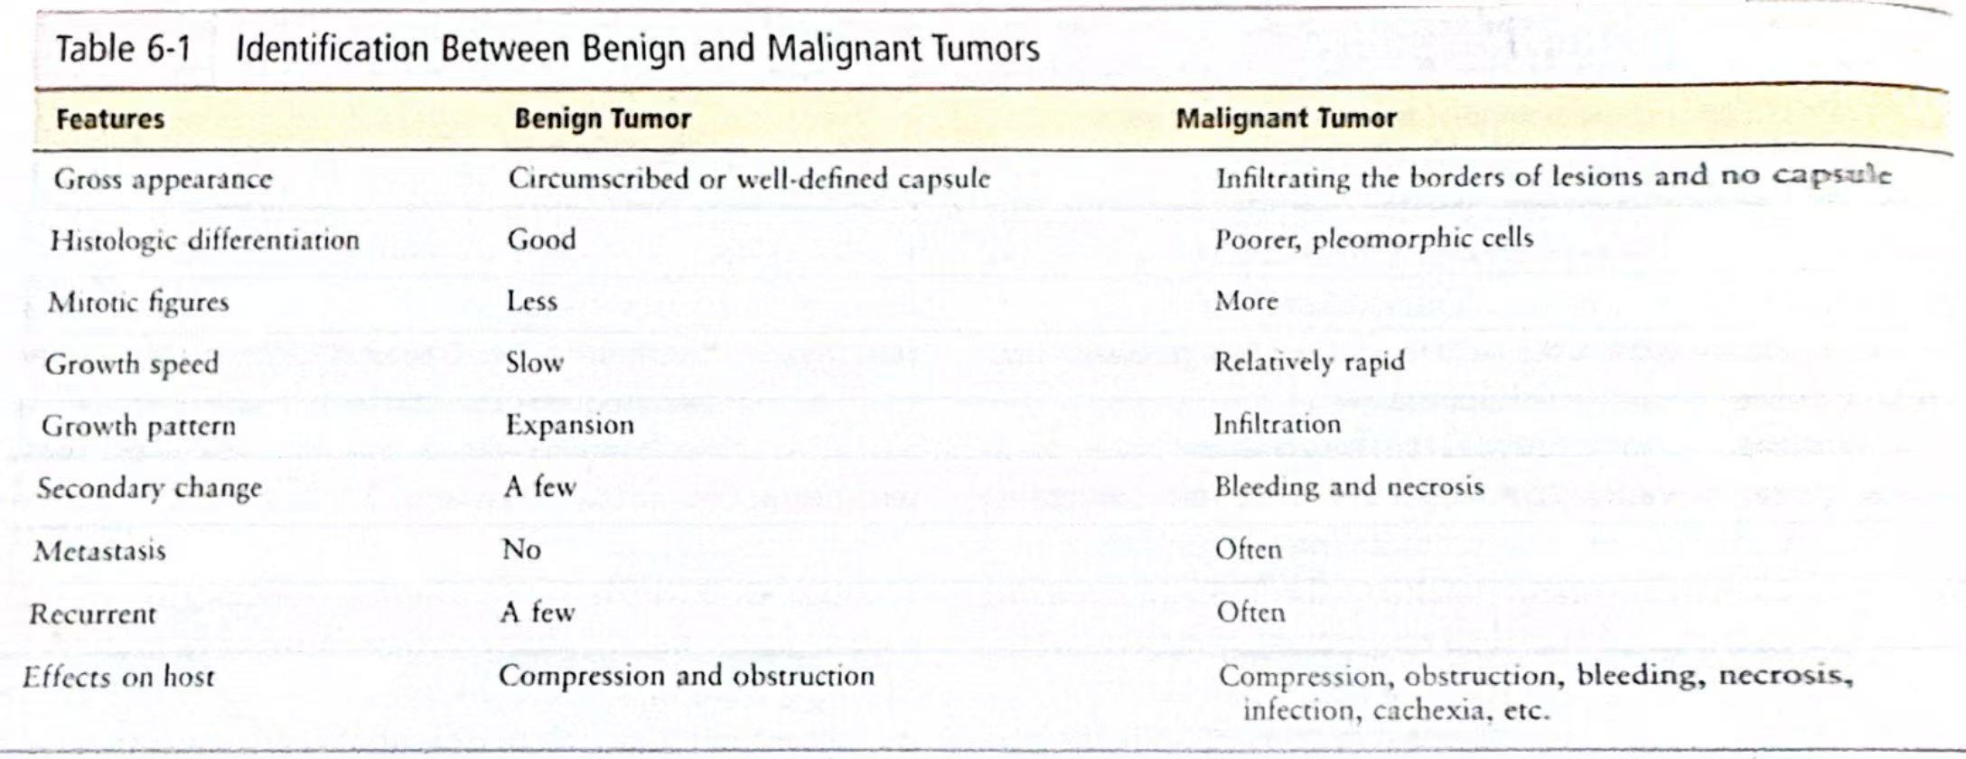

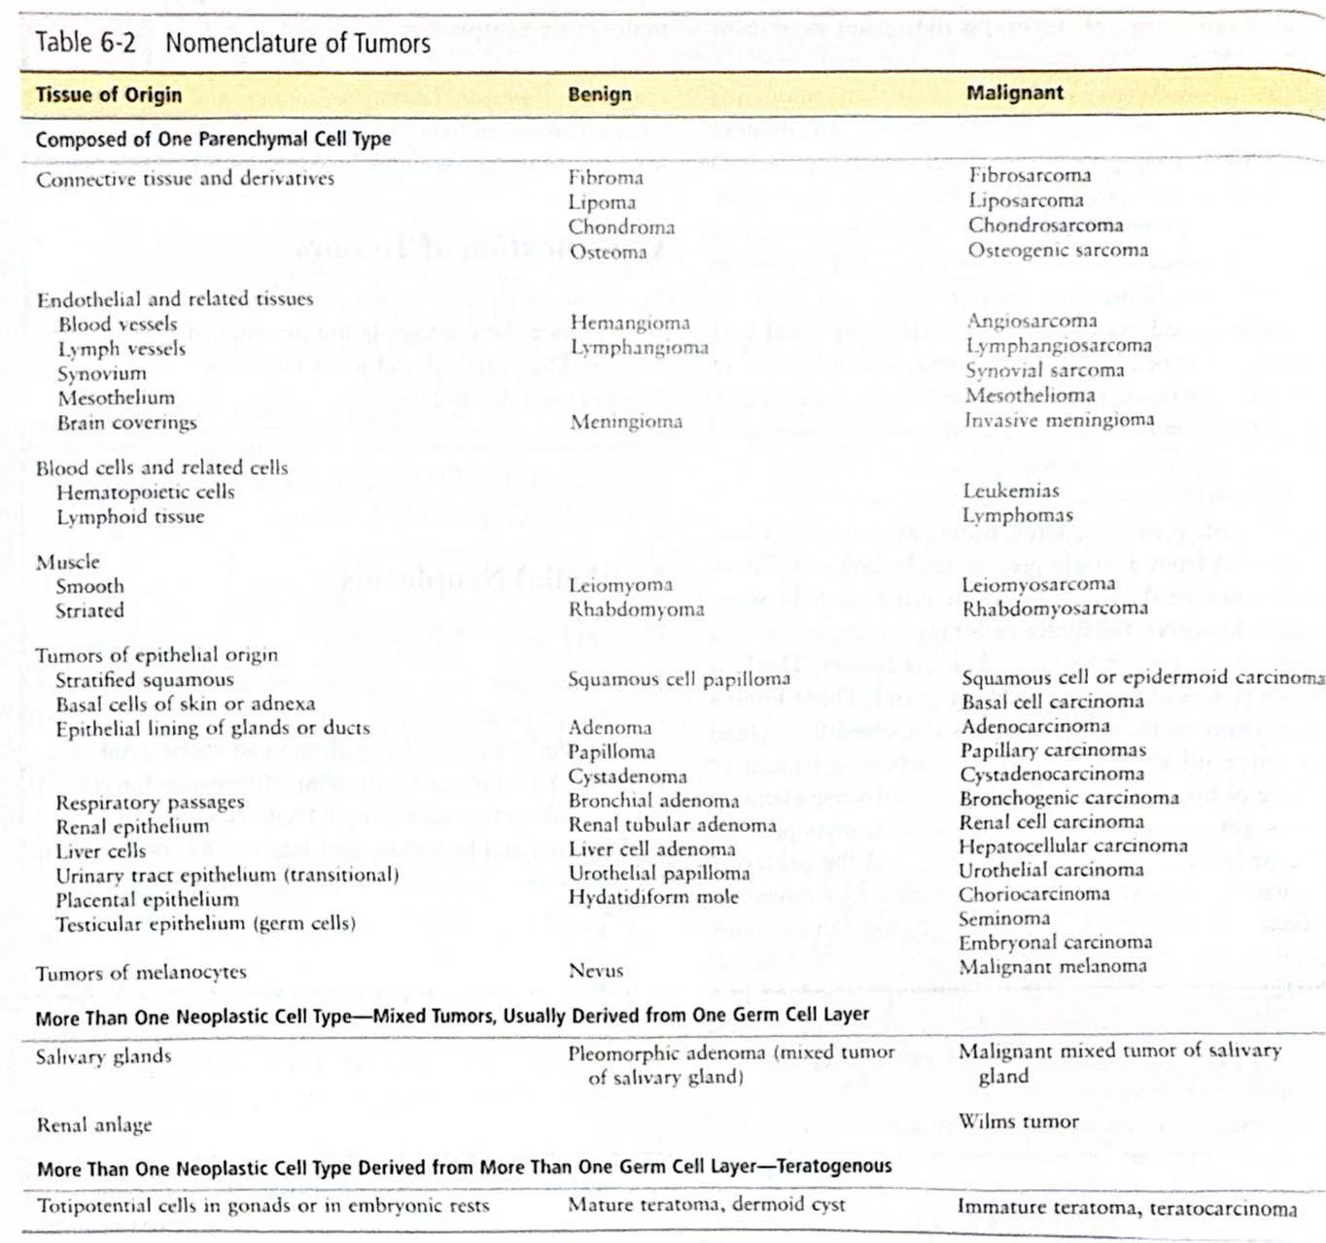

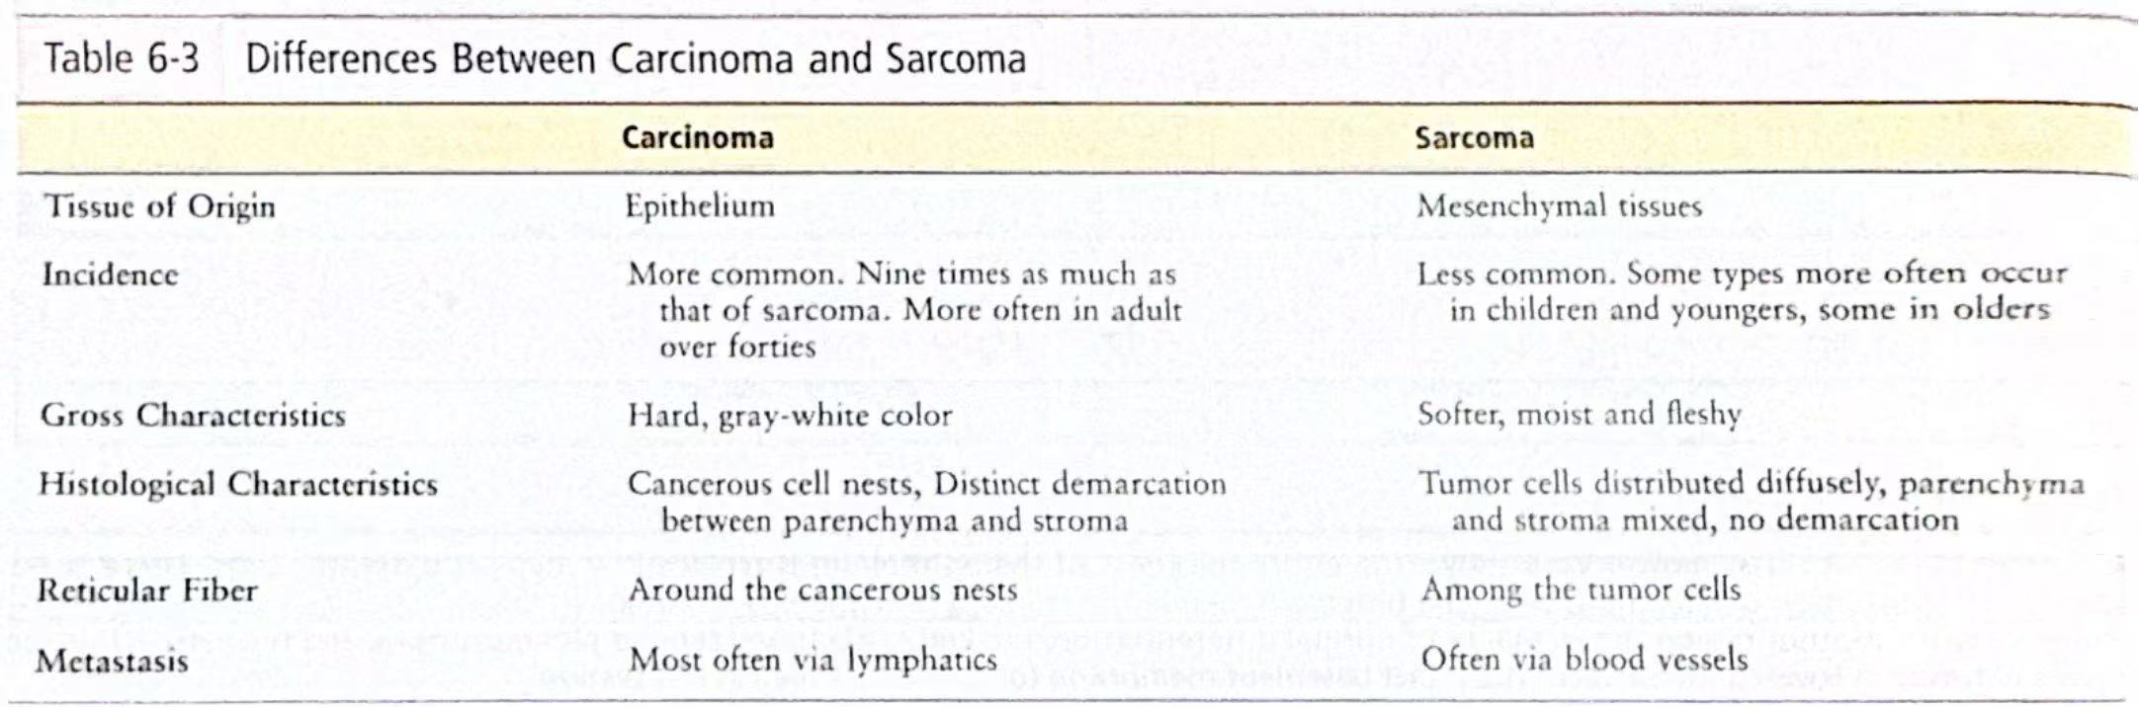

UNIT 6 Cardiovascular disease（心血管疾病）

这个单元主要集中讲了这么几个病
    - Atherosclerosis
    - Ischemic heart disease
    - Hypertension
    - Rheumatic fever & heart disease
    - Infective endocarditis
    - Valve disease

Atherosclerosis (动脉硬化的广义特点是：管壁增厚，弹性下降而且还只会发生在大中动脉上（Arteriosclerosis is characterized by thickening of the wall and decreased elasticity and occurs only in the large and middle arteries）)

1. Atherosclerosis（动脉粥样硬化）
Definition
Atherosclerosis is a chronic inflammatory disease of the arterial wall characterized by the accumulation of lipids, cholesterol, calcium, and cellular debris within the intima of large and medium-sized arteries, forming atheromatous plaques.
动脉粥样硬化是一种慢性炎性动脉疾病，主要表现为脂质、胆固醇、钙盐和细胞残骸在中大动脉内膜沉积，形成粥样斑块。

Pathogenesis（四大诱因）
1. Endothelial injury（内皮损伤）
Caused by hypertension, smoking, hyperlipidemia, or diabetes.
由高血压、吸烟、高脂血症或糖尿病等因素引起。
2. Lipid accumulation（脂质沉积）
Low-density lipoprotein (LDL) enters the vessel wall and becomes oxidized.
低密度脂蛋白（LDL）进入血管壁并被氧化。
3. Inflammation and foam cell formation（炎症反应与泡沫细胞形成）
Monocytes migrate into the intima, become macrophages, and ingest oxidized LDL to become foam cells.
单核细胞进入内膜转变为巨噬细胞，吞噬氧化LDL后形成泡沫细胞。
4. Plaque formation（斑块形成）
Smooth muscle cells proliferate and secrete extracellular matrix, forming a fibrous cap over a lipid core.
平滑肌细胞增生并分泌基质，在脂质核心表面形成纤维帽。

Morphology（病理形态）对应这个病发展的早，中，后期
• Fatty streaks（脂纹）：泡沫细胞组成的黄色条纹（Yellow streaks made up of foam cells）。
• Atheromatous plaques（粥样斑块）：有纤维帽和坏死性脂质核心（There is a fibrous cap and a necrotic lipid core）。
• Complicated plaques（并发性斑块）：可发生破裂、出血、钙化或血栓形成（Rupture, hemorrhage, calcification, or thrombosis may occur）。

Clinical Consequences（临床后果）
• Ischemia（缺血）：如冠状动脉粥样硬化导致心绞痛（Such as coronary atherosclerosis leads to angina）。
• Thrombosis（血栓）：斑块破裂后可引起血栓形成，导致心肌梗死或中风（Plaque rupture can cause thrombosis, leading to myocardial infarction or stroke）。
• Aneurysm（动脉瘤）：动脉壁变薄，形成扩张，可能破裂出血（The walls of the arteries become thinner, form dilated, and may rupture and bleed）。
• Peripheral artery disease（外周动脉病）：下肢缺血导致间歇性跛行（Ischemia of the lower extremities leads to intermittent claudication）。

Risk Factors（危险因素）
• Modifiable（可控）：高血脂、高血压、吸烟、糖尿病、肥胖（High blood lipids, high blood pressure, smoking, diabetes, obesity）。

缺血性心脏病（Ischemic Heart Disease, IHD）

1. 病因与危险因素
- 动脉粥样硬化：占90%以上病例，冠状动脉内斑块形成导致管腔狭窄。In more than 90% of cases, intracoronary plaque formation leads to luminal stenosis.
- 非动脉粥样硬化原因：冠状动脉痉挛（如变异型心绞痛）、栓塞、炎症（如血管炎）、先天畸形等。Coronary artery spasm (e.g., variant angina), embolism, inflammation (e.g., vasculitis), congenital malformations, etc.
- 主要危险因素：
  - 不可控：年龄（男性＞45岁，女性＞55岁）、性别（男性风险更高）、家族史。Age (45 years for males>> 55 years for females), gender (higher risk for males), family history.
  - 可控：高血压、高脂血症、糖尿病、吸烟、肥胖、缺乏运动、高同型半胱氨酸血症等。Hypertension, hyperlipidemia, diabetes, smoking, obesity, lack of exercise, hyperhomocysteinemia, etc.

2. 病理生理
- 心肌缺血机制：冠状动脉狭窄或痉挛→血流减少→氧供需失衡（如运动时需氧增加或贫血时供氧减少）。Coronary artery stenosis or spasm → decreased blood flow → imbalance in oxygen supply and demand (e.g., increased oxygen demand during exercise or decreased oxygen supply during anemia).
- 急性冠脉综合征（ACS）：斑块破裂引发血小板聚集和血栓形成，导致血管急性闭塞。Plaque rupture triggers platelet aggregation and thrombosis, resulting in acute occlusion of blood vessels.
- 慢性缺血：长期狭窄引起心肌重构、冬眠心肌（持续低灌注导致功能抑制）或顿抑心肌（短暂缺血后恢复延迟）。Long-term stenosis causes myocardial remodeling, hibernating myocardium (functional suppression due to persistent hypoperfusion), or abortion of the myocardium (delayed recovery after transient ischemia).

3. 临床表现（以下四个是常见的）

1. Angina Pectoris（心绞痛）

定义
由于心肌缺血引起的胸痛或不适，通常表现为胸骨后压迫感、紧缩感或烧灼感，可放射至左肩、下颌或背部。Chest pain or discomfort due to myocardial ischemia, usually presenting as retrosternal pressure, tightness, or burning, radiating to the left shoulder, jaw, or back.

分类与特点
类型 | 触发机制
稳定型 | 劳力诱发（如运动、情绪激动）Labor-induced (e.g., exercise, agitation)
不稳定型（ACS范畴） | 静息发作或轻微活动诱发Resting episodes or mild activity induced
变异型（Prinzmetal） | 冠状动脉痉挛Coronary artery spasm

2. Acute Myocardial Infarction（AMI，急性心肌梗死）

核心机制
冠状动脉斑块破裂→血栓形成→血管完全闭塞→心肌坏死。
Coronary plaque rupture→ thrombosis→ complete occlusion of blood vessels→ myocardial necrosis.

3. Sudden Cardiac Death（SCD，心源性猝死）

病因
- IHD相关（占80%）：急性心肌缺血→恶性心律失常（室颤/室速）。
- IHD-associated (80%): acute myocardial ischemia→ malignant arrhythmias (ventricular fibrillation/ventricular tachycardia).

4. Chronic IHD - Heart Failure following MI（心肌梗死后心力衰竭）

发生机制
- 大面积心肌梗死→收缩功能下降 Massive myocardial infarction → decreased systolic function
- 长期缺血→心肌纤维化→舒张功能障碍Long-term ischemia→ myocardial fibrosis→ diastolic dysfunction

2高血压（Hypertension）概述
定义：静息状态下，收缩压≥140 mmHg 和/或 舒张压≥90 mmHg（基于多次测量）。

1. 分类与分级

（1）按病因分类
类型 | 占比 | 特点 | 常见原因
原发性高血压 | 90-95% | 无明确病因，多与遗传、环境因素相关 | 肥胖、高盐饮食、吸烟、缺乏运动、压力
继发性高血压 | 5-10% | 由特定疾病引起，需排查潜在病因 | 肾动脉狭窄、嗜铬细胞瘤、原发性醛固酮增多症、Cushing综合征

（2）血压分级（WHO/ISH标准）
分类 | 收缩压（mmHg） | 舒张压（mmHg）
正常血压 | <120 | <80
正常高值 | 120-139 | 80-89
高血压 | ≥140 | ≥90
- 1级（轻度） | 140-159 | 90-99
- 2级（中度） | 160-179 | 100-109
- 3级（重度） | ≥180 | ≥110

3. 临床表现

（1）无症状期
- 多数患者无明显症状，仅在体检时发现（“沉默的杀手”）。
- 偶见表现：头痛（枕部）、头晕、耳鸣、视力模糊（高血压视网膜病变）。

（2）靶器官损害（长期未控制）
器官 | 并发症
心脏 | 左心室肥厚（LVH）、冠心病、心力衰竭  Left ventricular hypertrophy (LVH), coronary heart disease, heart failure
脑 | 脑卒中（出血性/缺血性）、TIA、Stroke (hemorrhagic/ischemic), TIA
肾脏 | 蛋白尿→慢性肾病（CKD）→肾衰竭  Proteinuria→ chronic kidney disease (CKD) → kidney failure
血管 | 主动脉夹层、外周动脉疾病（PAD）Aortic dissection, peripheral arterial disease (PAD)
眼底 | 高血压视网膜病变（动静脉交叉征、出血）  Hypertensive retinopathy (arteriovenous cross, hemorrhage)

3风湿热（Rheumatic Fever）

1. 风湿性心内膜炎（Rheumatic Endocarditis）

（1）病理特点
- 主要累及瓣膜（尤其是二尖瓣，其次是主动脉瓣）。
- 形成疣状赘生物（Verrucous Vegetations）：
  - 位于瓣膜闭合线（与感染性心内膜炎的赘生物不同，后者随机分布）。Located at the line of valve closure (unlike growths in infective endocarditis, which are randomly distributed)
  - 由纤维蛋白、血小板和炎症细胞组成，无菌性（无细菌感染）。
- 慢性期：瓣膜纤维化、钙化→瓣膜狭窄/关闭不全（如二尖瓣狭窄）。Composed of fibrin, platelets, and inflammatory cells, it is sterile (no bacterial infection). Chronic phase: valvular fibrosis, calcifications→ valvular stenosis/insufficiency (e.g., mitral stenosis)

2. 风湿性心肌炎（Rheumatic Myocarditis）

（1）病理特点
- 局灶性心肌炎症（Aschoff小体形成）最典型：
  - 特征性病理改变：Anitschkow细胞（巨噬细胞，核呈“毛虫样”）。 Characteristic pathological changes: Anitschkow cells (macrophages with "caterpillar-like" nuclei)
  - 心肌间质水肿、淋巴细胞浸润。
- 可导致心肌收缩力下降，但罕见心肌坏死（与病毒性心肌炎不同）。May cause decreased myocardial contractility but rarely (unlike viral myocarditis)

3. 风湿性心包炎（Rheumatic Pericarditis）

（1）病理特点
- 纤维素性心包炎：心包表面覆盖纤维蛋白渗出（“面包黄油样”外观）。 Fibrinous pericarditis: The pericardial surface is covered with fibrin exudate ("bread-buttery" appearance).
- 通常无大量心包积液（与病毒性或尿毒症性心包炎不同）。There is usually no large pericardial effusion (unlike viral or uremic pericarditis).

4感染性心内膜炎（Infective Endocarditis, IE）
定义：由微生物感染（细菌、真菌等）引起的心内膜（尤其是心脏瓣膜）炎症，常伴随赘生物形成，可导致瓣膜破坏、栓塞和全身感染。
Inflammation of the endocardium (especially heart valves) caused by microbial infections (bacterial, fungal, etc.), often accompanied by vegetation formation, can lead to valve destruction, embolism, and systemic infection.

1. 病因与分类

（1）按病程分类
类型 | 病原体 | 特点
急性IE | 金黄色葡萄球菌（S. aureus） | 进展快（数天至数周），高热，瓣膜迅速破坏
亚急性IE | 草绿色链球菌（S. viridans） | 进展慢（数周至数月），低热，多伴基础心脏病

（2）常见病原体
- Bacteria (more than 90%)
  - Streptococci (Streptococcus viridans, Streptococcus bovis).
  - Staphylococci (Staphylococcus aureus, coagulase-negative staphylococci).
  - Enterococci (urinary tract/gastrointestinal source).
- Fungi (e.g., Candida, Aspergillus): more common in immunosuppressed or prosthetic valve patients.

5心脏瓣膜病（Valvular Heart Disease）概述
定义：心脏瓣膜（二尖瓣、主动脉瓣、三尖瓣、肺动脉瓣）因结构或功能异常导致血流动力学障碍，分为狭窄（开放受限）和关闭不全（反流）。Heart valves (mitral valve, aortic valve, tricuspid valve, pulmonary valve) are classified as stenosis (limited opening) and regurgitation (regurgitation) due to structural or functional abnormalities that cause hemodynamic derangement.

1病理生理与临床表现

（1）二尖瓣狭窄（MS）
- 病因：风湿热（占90%），女性多见。
- 病理生理：
  - 左房血流流入左室受阻→左房压↑→肺静脉淤血→肺动脉高压→右心衰。Left atrial blood flow is obstructed into the left ventricle→ left atrial pressure ↑→ pulmonary venous congestion→ pulmonary hypertension→ right heart failure.
- 症状：
  - 劳力性呼吸困难（最早出现）、咯血（肺静脉破裂）、房颤（左房扩大）。dyspnea on exertion (first onset), hemoptysis (rupture of pulmonary veins), atrial fibrillation (enlargement of the left atrium).

（2）二尖瓣关闭不全（MR）
- 病因：Mitral valve prolapse (MVP), rheumatic, ischemic papillary insufficiency.
- 病理生理：
  - Systolic left ventricular blood regurgitates to the left atrium → left atrium/left ventricular volume load ↑ → left heart failure.
- 症状：
  - chronic: fatigue, decreased activity tolerance; Acute: pulmonary edema, shock.

（3）主动脉瓣狭窄（AS）
- 病因：Geriatric calcification (most common), congenital bicuspid valve, rheumatic.
- 病理生理：
  - Left ventricular ejection obstruction→ left ventricular pressure load↑→ concentric hypertrophy→ myocardial ischemia/heart failure.
- 症状：“经典三联征”
  - Angina pectoris (imbalance in myocardial oxygen supply and demand), syncope (cerebral hypoperfusion), heart failure.

（4）主动脉瓣关闭不全（AR）
- 病因：Aortic root dilation (Marfan syndrome), infective endocarditis, rheumatic fever.
- 病理生理：
  - Diastolic aortic blood regurgitates to the left ventricle → left ventricular volume load↑ → centrifugal hypertrophy → heart failure.
- 症状：
  - chronic: palpitations (increased pulse pressure difference), angina; Acute: pulmonary edema, shock.

UNIT 7 Respiratory disease（呼吸系统疾病）

大叶性肺炎 vs. 小叶性肺炎（Lobar Pneumonia vs. Lobular Pneumonia/Bronchopneumonia）对比

1. 基本概念
特征 | 大叶性肺炎 | 小叶性肺炎（支气管肺炎）
定义 | 炎症累及整个肺叶或肺段 | 炎症累及肺小叶（以细支气管为中心）
病原体 | 肺炎链球菌（90%）、肺炎克雷伯菌等 | 金黄色葡萄球菌、肺炎链球菌、流感嗜血杆菌等
好发人群 | 青壮年 | 婴幼儿、老年人、免疫力低下者
病变范围 | 局限，单侧肺叶（如右肺上叶） | 散在、多灶性，可双肺分布

2. 病理特点

（1）大叶性肺炎
- 病理分期（经典4期）：
  - 充血期（1-2天）：肺泡壁充血，浆液性渗出。
  - 红色肝样变期（3-4天）：肺泡内充满红细胞+纤维素（肺叶变硬，切面如肝）。
  - 灰色肝样变期（5-6天）：红细胞溶解，中性粒细胞浸润。
  - 溶解消散期（7-10天）：渗出物被吸收，肺组织修复。
- 特征：
  - 病变均匀一致，累及整个肺叶。
  - 胸膜常受累（导致胸痛）。
  - Pathologic stage (classic stage 4): Congestive phase (1-2 days): Alveolar wall congestion, serous exudation.
  - Red hepatic stage (3-4 days): The alveoli are filled with red blood cells + fibrin (the lobes of the lungs harden and are cut like liver).
  - Gray hepatic phase (5-6 days): erythrocyte lysis, neutrophil infiltration.
  - Dissolution phase (7-10 days): The exudate is absorbed and the lung tissue is repaired. Features: The lesions are uniform and involve the entire lobe. The pleura is often affected (causing chest pain).

（2）小叶性肺炎
- 病理特点：
  - 以细支气管为中心的化脓性炎症，周围肺泡内脓性渗出。
  - 病灶大小不一，散在分布（可融合成片，称“融合性支气管肺炎”）。
- 特征：
  - 无明确分期，病变轻重不一。
  - 易合并肺脓肿、脓胸（尤其金葡菌感染）。
  - Pathological features: Purulent inflammation centered on the bronchioles with purulent effusion from the surrounding alveoli.
  - Lesions vary in size and are scattered (may coalesce into patches, called "confluent bronchopneumonia").
  - Features: There is no clear stage, and the severity of the lesion varies. It is easy to be complicated with lung abscesses and empyema (especially Staphylococcus aureus infection).

肺癌：
- 中央型肺癌Central （bronchogenic）carcinoma：
好发：1鳞状细胞癌；2小细胞癌

- 周围型肺癌peripheral carcinoma：
主要好发：1腺癌

- 弥漫型 diffuse type（非常少见）

分类：
Adenocarcinoma
Squamous cell carcinoma
这上面两个预后较差
Small cell lung carcinoma
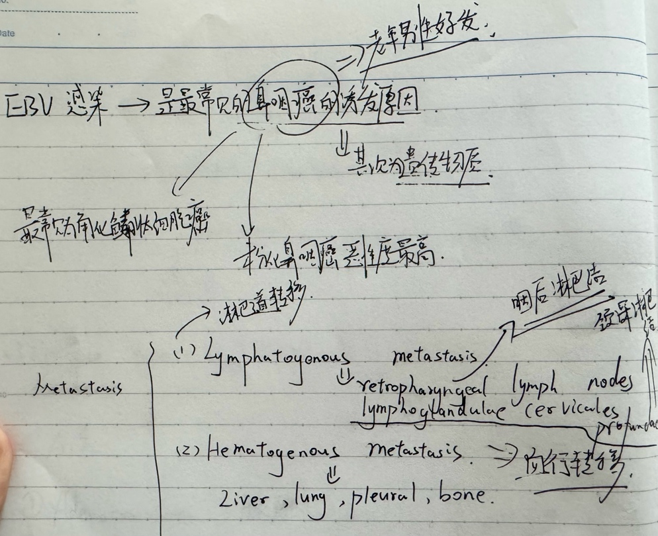

UNIT 8 Digestive disease（消化系统疾病）

Part 1：幽门螺杆菌相关胃炎

1. 急性幽门螺杆菌胃炎（Acute Helicobacter Gastritis）
- 病因：由幽门螺杆菌（H. pylori）初次感染引起，通过口-口或粪-口传播，细菌定植于胃黏膜。
- 病理特点：
  - 胃窦部为主，中性粒细胞浸润为主的急性炎症反应。
  - 黏膜充血水肿，可能伴微小糜烂。

2. 慢性幽门螺杆菌胃炎（Chronic Helicobacter Gastritis）
- 病因：H. pylori长期感染（未治疗或治疗失败）。
- 病理特点：
  - 淋巴细胞和浆细胞浸润，胃窦部为主（可扩展至全胃）。
  - 腺体萎缩、肠上皮化生（可能进展至胃癌）。

Part 2：急性胃炎（Acute Gastritis）
- 病因：
  - 感染性：除H. pylori外，病毒（如CMV）、细菌（如葡萄球菌）或毒素。
  - 化学性：NSAIDs、酒精、胆汁反流、腐蚀性物质（如强酸/碱）。
  - 应激性：严重创伤、烧伤（Curling溃疡）。
- 病理：黏膜充血、水肿、糜烂，中性粒细胞浸润。
- 症状：突发上腹痛、恶心呕吐，严重者呕血或黑便（应激性溃疡出血）。
- 分类：
- 1. Acute irritated gastritis 2. Acute hemorrhagic gastritis 3. Acute infective gastritis

Part 3：慢性胃炎（Chronic Gastritis）
- 分类：
  - 非萎缩性（旧称“浅表性”）：胃窦为主，H. pylori常见病因。
  - 萎缩性：腺体减少，分自身免疫性（A型，autoimmune chronic gastritis）和多灶性（B型，HP-associated gastritis）。
- 此类的特征为：1. Mucosal atrophy & epithelial metaplasia 2.glands 减少

Part 4：消化性溃疡病（Peptic Ulcer Disease）

急性和慢性胃炎的患者后期大概率都有这个

1. 概述
- 定义：胃或十二指肠黏膜深层缺损（突破黏膜肌层），与胃酸/胃蛋白酶消化相关。
- 常见部位：1.duodenal ulcer 2.gastric ulcer 3.esophogeal ulcer

Part 5:胃癌（Gastric carcinoma）

分类：1.early gastric carcinoma 2.advanced gastric carcinoma

转移方式；1 直接转移至其他organ 2血道转移

接着是disease of liver
以下是 病毒性肝炎（Viral Hepatitis）、酒精性肝病（Alcoholic Liver Disease）、肝硬化（Cirrhosis）和肝脏肿瘤（Liver Tumors）

1. Viral Hepatitis（病毒性肝炎）

概述
由肝炎病毒（A、B、C、D、E型）引起的肝脏炎症，分为 急性 和 慢性。
主要传播途径：
- A/E型：粪-口传播（污染食物/水）。
- B/C/D型：血液、母婴、性接触传播。

各型特点
类型 | 病毒特征 | 慢性化风险 | 特殊点
HAV | 单链RNA病毒 | 无 | 自限性，不导致慢性肝炎
HBV | 双链DNA病毒（部分环状） | 5-10% | 可整合宿主DNA，增加肝癌风险
HCV | 单链RNA病毒 | 70-85% | 隐匿感染，易肝硬化/肝癌
HDV | 缺陷RNA病毒（需HBV辅助） | 高（依赖HBV） | 与HBV共感染时病情更重
HEV | 单链RNA病毒 | 无（孕妇除外） | 孕妇感染易重症

病理特征
- Acute hepatitis: hepatocyte ballooning, punctate necrosis, Councilman bodies (apoptotic hepatocytes).
- Chronic hepatitis (B/C): lymphocytic infiltration in the portal area, fibrosis (→ cirrhosis).
- Diagnosis: serological tests (HBsAg, anti-HCV, etc.) + liver biopsy (to assess for fibrosis).

2. Alcoholic Liver Disease（酒精性肝病）

三个阶段
- 脂肪肝（Steatosis）
  - Hepatocyte fat deposits (bullous steatosis), reversible.
- 酒精性肝炎（Alcoholic Hepatitis）
  - Hepatocyte necrosis, neutrophil infiltration, and Mallory bodies (keratin aggregation) may be seen.
- Alcoholic cirrhosis
  - The fibrous septum divides the lobules of the liver, forming tiny nodules (similar to other cirrhosis morphologies).

关键机制
- Ethanol metabolism: ethanol→ acetaldehyde (toxicity) → acetic acid, consumes NAD+ → fat accumulation.
- Oxidative stress: Acetaldehyde promotes free radical damage.

3. Cirrhosis（肝硬化）

定义
Extensive fibrosis of the liver + regenerative nodule formation, leading to structural destruction and functional failure.

病因
- 常见：酒精、HBV/HCV、NAFLD（非酒精性脂肪肝）。
- 其他：Autoimmune hepatitis, hemochromatosis、Wilson病。

病理特点
- 纤维间隔：胶原沉积（I型为主），分割肝小叶。
- 结节类型：
  - 小结节型（<3mm，酒精性多见）。
  - 大结节型（>3mm，病毒性多见）。

临床表现
- 代偿期：Asymptomatic or fatigue.
- 失代偿期：
  - 门脉高压：splenomegaly, ascites, esophageal varices.
  - 肝功能衰竭：Jaundice, hepatic encephalopathy, coagulopathy.

并发症
- Esophageal variceal bleeding (most urgent).
- Hepatic encephalopathy (elevated blood ammonia).
- HCC (hepatocellular carcinoma) (annual risk 1-5%).

4. Liver Tumors（肝脏肿瘤）

（1）良性肿瘤
- 肝血管瘤：最常见，无症状，超声示高回声团块。
- 肝腺瘤：与口服避孕药相关，可出血/恶变。

（2）恶性肿瘤

肝细胞癌（HCC）
- 高危人群：肝硬化、HBV/HCV感染。
- 病理：
  - Well differentiated: similar to hepatocytes, bile deposition can be seen.
  - Poor differentiation: atypia is obvious, invades blood vessels。

胆管细胞癌（Cholangiocarcinoma）
- 起源于胆管上皮，AFP通常正常，CA19-9升高。
- 预后差，手术切除率低。

转移性肝癌
- 常见原发灶：结肠癌、胃癌、乳腺癌。
Disease of the liver 笔记图片比ai梳理的要清晰一点，建议先看笔记
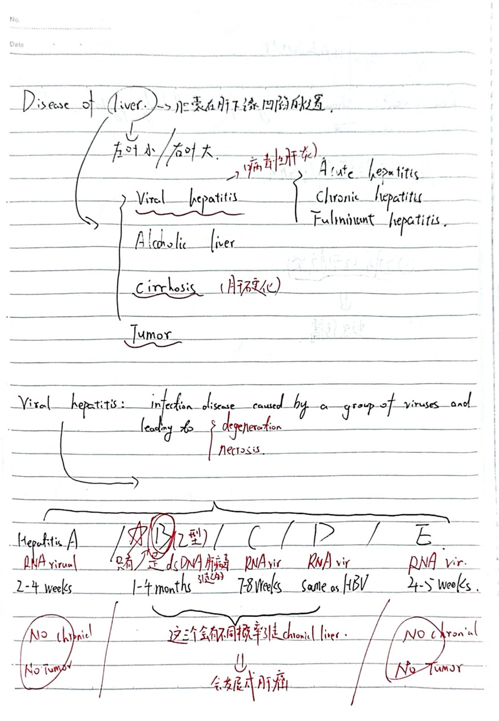

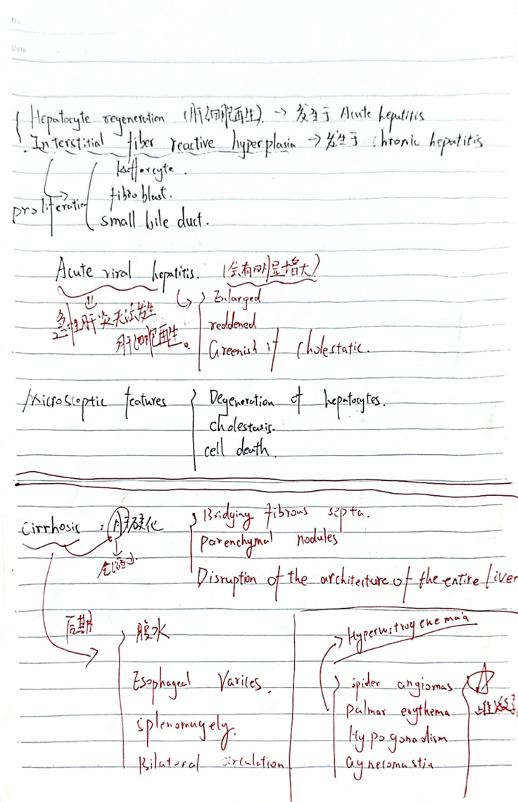
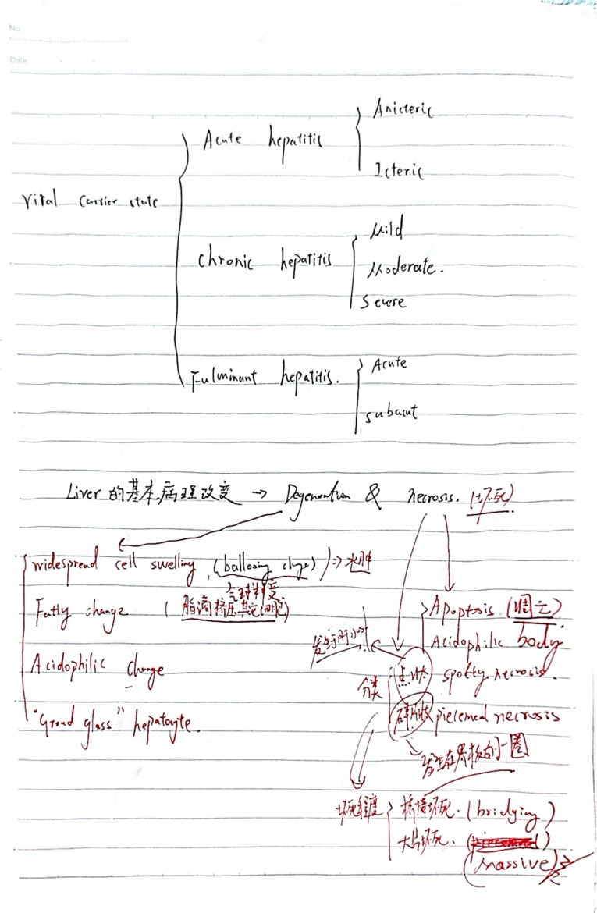

UNIT 9 Urinary disease（泌尿系统疾病）

1. 急性增生性肾小球肾炎（Acute Proliferative GN）
- 病因：
  - It is most commonly seen after a streptococcal infection (eg, group A β-hemolytic streptococcus) and is called postinfectious GN.
  - Other infections (eg, staphylococci or viruses) or noninfectious agents (eg, SLE) can also cause.
病理特征：
  - Capillary endothelial and mesangial cell proliferation ("proliferative" changes on light microscopy).
  - Immunofluorescence showed granular deposits (IgG, C3), and electron microscopy showed subepithelial hump-like deposits.
  - Adults may progress to chronic GN.

2. 快速进展性肾小球肾炎（Rapidly Progressive GN, RPGN）
- Core features:
  - Crescent formation (proliferation of parietal epithelial cells, filling the Bowman cyst), leading to a sharp deterioration of renal function (weeks to months).
- Classification and etiology:
  - Type I: anti-GBM antibody disease (e.g., Goodpasture syndrome, linear IgG deposition).
  - Type II: immune complex-mediated (eg, SLE, post-infectious GN, granular deposition).
  - Type III: ANCA-associated (e.g., microscopic polyangiitis, absence of immunodeposition, i.e., "oligoimmune").

3. 急性肾盂肾炎（Acute Pyelonephritis）
- 病因：
  - Retrograde infection (common in Escherichia coli), urinary tract obstruction, vesicoureteral reflux (VUR), or diabetes mellitus predisposes.
- 病理特征：
  - Neutrophil infiltrates of the renal interstitium and tubules, and abscess formation (cortical wedge-shaped yellowish-white lesions).
- 临床表现：
  - fever, chills, flank pain (costovertebral angle tenderness), pyuria, bacteriuria.
  - May have concomitant systemic symptoms (e.g., sepsis).

4. 慢性肾盂肾炎（Chronic Pyelonephritis）
- 病因：
  - Recurrent infections + structural abnormalities of the urinary tract (e.g., VUR, obstruction).
- 病理特征：
  - Renal scarring (cortical depression), calyceal deformity, thyroidoid tubules (colloidal casts).
  - Interstitial fibrosis and lymphocytic infiltration.
- 临床表现：
  - Slowly progressive renal insufficiency, hypertension, polyuria (concentrating dysfunction).
  - Imaging (IVP) shows deformation of the renal pelvis and calyceses.

1. 肾病综合征（Nephrotic Syndrome）
- 病理核心：
  - Glomerular filtration barrier damage leads to massive proteinuria (>3.5 g/day), hypoalbuminemia, edema, and hyperlipidemia.
- 常见病理类型：
  - Minimal change disease (MCD): foot fusion (electron microscopy), normal light microscopy, more common in children.
  - Membranous nephropathy (MN): thickening of the basement membrane and deposition of subepithelial immune complexes ("spike"-like changes).
  - Focal segmental glomerulosclerosis (FSGS): partial glomerulosclerosis, podocyte damage.
  - Diabetic nephropathy: thickening of the basement membrane, dilation of the mesangial stroma (Kimmelstiel-Wilson nodules).

2. 急性肾炎综合征（Acute Nephritic Syndrome）
- 病理核心：
  - The glomerular inflammatory response leads to hematuria, proteinuria, edema, and hypertension (often with decreased renal function).
- 典型疾病：
  - GN after acute streptococcal infection: mesangial and endothelial cell proliferation, neutrophil infiltration.
  - IgA nephropathy: IgA deposition in the mesangial area, focal proliferative changes.
- 临床特点：
  - gross hematuria (cola chromuria), oliguria, transient azotemia, decreased complement C3 (after streptococcal infection).

3. 急性肾损伤综合征（Acute Kidney Injury, AKI）
- 病理核心：
  - Tubular necrosis (ATN) is most common, or glomerulal/vascular lesions leading to a dramatic deterioration in kidney function.
- 病因分类：
  - Prerenal: hypoperfusion (e.g., dehydration, heart failure).
  - Nephral: ATN (ischemia/toxin), acute GN, interstitial nephritis.
  - Post-renal: urinary tract obstruction。
- 病理表现：
  - ATN: renal tubular epithelial cell shedding, cast-type formation, interstitial edema.

4. 慢性肾脏病综合征（Chronic Kidney Disease, CKD）
- 病理核心：
  - Irreversible destruction of nephrons, fibrosis (glomerulosclerosis, tubular atrophy, interstitial fibrosis).
- 常见病因：
  - Diabetic nephropathy, hypertensive nephrosclerosis, chronic GN, chronic pyelonephritis.
- 病理表现：
  - Glomeruli: global or focal segmental sclerosis.
  - Renal tubules: atrophied, dilated (thyroid-like changes).
  - Interstitium: fibrosis + lymphocytic infiltration.

5. 无症状性菌尿（Asymptomatic Bacteriuria）
- 病理核心：
  - Presence of bacteria in the urinary tract (>10⁵ CFU/ml) but no symptoms of urinary tract infection is common in women/older adults.
- 病因：
  - Escherichia coli and other colonization, diabetes mellitus or urinary catheter-related.
- 潜在风险：
  - May progress to acute pyelonephritis (especially in pregnancy or immunocompromised).

UNIT 10 Female genital system disease（女性生殖系统疾病）

慢性宫颈炎（Chronic Cervicitis）

1. 病因（Etiology）
- 感染性因素：
  - 细菌：如沙眼衣原体（Chlamydia trachomatis）、淋病奈瑟菌（Neisseria gonorrhoeae）、支原体（Mycoplasma）、厌氧菌等。
  - 病毒：如HPV（人乳头瘤病毒）、HSV-2（单纯疱疹病毒2型）。
  - 其他：滴虫（Trichomonas vaginalis）、真菌（如念珠菌）。
- 非感染性因素：
  - 机械性刺激：如长期使用避孕套、宫内节育器（IUD）等。
  - 化学刺激：如阴道冲洗液、避孕药等。
  - 激素变化：如雌激素水平下降（绝经后）。

2. 病理学特征（Pathological Features）
- 大体表现（Gross Appearance）：
  - 宫颈充血、水肿，可见宫颈糜烂（Cervical Erosion）
  - 宫颈黏液增多，可能伴有纳氏囊肿（Nabothian Cysts）
- 镜下表现（Microscopic Findings）：
  - 间质慢性炎症细胞浸润（淋巴细胞、浆细胞、巨噬细胞）。
  - 宫颈腺体增生，部分腺体扩张形成纳氏囊肿。
  - 鳞状上皮化生（Squamous Metaplasia）常见（HPV感染时可能伴不典型增生）。
  - 长期炎症可导致宫颈纤维化（Fibrosis）。

宫颈癌（Cervical Carcinoma）会出现koilocyte这种特征细胞

1. 病因（Etiology）
- 高危型HPV感染（>90%病例）：
  - HPV-16 and 18 are the most common (accounting for more than 70%), and other high-risk types include 31, 33, and 45.
  - HPV E6/E7 oncoprotein → inhibits p53 and Rb→ cell cycle loss → carcinogenesis.

2. 病理类型（Pathological Types）
- 鳞状细胞癌（Squamous Cell Carcinoma, SCC）（占80-90%）：
  - Derived from cervical squamous epithelium (transition zone), it is divided into high, medium, and low differentiation.
  - Microscopic features: keratinized beads (well-differentiated), intercellular bridges, heteromorphic nuclear mitotic images.
- 腺癌（Adenocarcinoma）（占10-20%）：
  - It originates from the columnar epithelium of the cervical canal and has a worse prognosis than squamous cell carcinoma.
  - Microscopic features: glandular structure disorder, obvious cellular atypia.

3. 癌前病变（Precancerous Lesions）
- 宫颈上皮内瘤变（Cervical Intraepithelial Neoplasia, CIN）：
  - CIN1（Mild dysplaia): confined to 1/3 of the subepithelium, usually resolves spontaneously.
  - CIN 2/3 (moderate-severe atypia): more than two-thirds of the epithelium is involved and requires treatment (eg, LEEP knife excision).（这个是分级）。
- 原位癌（CIS): full-thickness epithelial atypia, but does not break through the basement membrane。
宫颈癌的检测方法之一是shiller test主要用于识别宫颈异常上皮（如癌前病变或早期癌变）。它基于正常和异常宫颈上皮对碘溶液（卢戈氏碘液，Lugol's iodine）的不同反应，辅助医生在阴道镜检查时定位可疑病变区域。

葡萄胎（Hydatidiform Mole）是一种异常的妊娠疾病，属于妊娠滋养细胞疾病（Gestational Trophoblastic Disease, GTD）的一种。其特征是胎盘绒毛滋养层细胞异常增生，形成水泡状结构，导致胚胎发育异常或缺失。
Hydatidiform Mole is an abnormal pregnancy disorder that belongs to Gestational Trophoblastic Disease (GTD). It is characterized by abnormal proliferation of placental villous trophoblast cells, forming blister-like structures that result in abnormal or absent embryonic development.

分类
- 完全性葡萄胎（Complete Hydatidiform Mole）
  - 染色体来源：Usually 46,XX (all from paternal origin, formed by the self-replication of an empty egg with a single sperm or the fertilization of a double sperm).
  - 胚胎组织：No fetal or embryonic tissue。
病理特征：Villi are generally edematous and trophoblasts are diffusely proliferated.
- 部分性葡萄胎（Partial Hydatidiform Mole）
  - 染色体来源：It is mostly triploid (69, XXX or 69, XXY) and is formed by fertilization of a normal egg with a double sperm or by a single sperm with a diploid egg.
  - 胚胎组织：Some fetal tissue may be present, but it is severely malformed and not viable.
  - 病理特征：Partial villous edema, focal hyperplasia of trophoblasts.

绒毛膜癌（Choriocarcinoma）概述
绒毛膜癌（Choriocarcinoma，简称绒癌）是一种高度恶性的妊娠滋养细胞肿瘤（Gestational Trophoblastic Neoplasia, GTN），起源于胎盘滋养层细胞（主要为细胞滋养层和合体滋养层）。其特点是侵袭性强、早期血行转移，但对化疗高度敏感，即使晚期患者也可能治愈。
Choriocarcinoma (choriocarcinoma) is a highly malignant gestational trophoblastic neoplasia (GTN) that arises from placental trophoblastic cells (mainly cytotrophoblastic and syncytiotrophoblast). It is characterized by aggressive, early hematogenous metastases, but is highly sensitive to chemotherapy and may be cured even in advanced patients.

分类
- 妊娠性绒癌（Gestational Choriocarcinoma）
  - Secondary to pregnancy events (e.g., molar pregnancy, miscarriage, normal pregnancy, or ectopic pregnancy).
  - It accounts for the vast majority of cases and is strongly associated with elevated hCG levels.
- 非妊娠性绒癌（Non-gestational Choriocarcinoma）
  - Rare, originating in germ cells (such as germ cell tumors of the ovaries or testicles).
  - It is not related to pregnancy and has a poor prognosis.

病因与高危因素
- 葡萄胎史（50%绒癌继发于完全性葡萄胎）。
- 流产或异位妊娠（30%继发于流产，20%继发于正常妊娠）。
- hCG持续升高（清宫术后hCG不降或上升）。
- 高龄妊娠或低龄妊娠（与葡萄胎类似）。

诊断

1. 血清hCG检测
- Very high levels of hCG (typically > 100,000 mIU/mL).
- Persistently elevated or plateaued hCG (hCG does not decrease or rebound after molar clearing).

3. 病理检查（非必需，因易出血）
- 组织学特征：
  - No villous structure (distinguishable from molar pregnancy).
  - Cytotrophoblast and syncytiotrophoblast cells are highly atypic with extensive hemorrhagic necrosis.

乳腺疾病概述

一、乳腺炎症性疾病（Inflammatory Disorders）

1. 急性乳腺炎（Acute Mastitis）
- 病因：
  - Common during lactation (milk stasis + bacterial infections such as Staphylococcus aureus).
  - Non-lactating may be caused by ductal dilation or weakened immunity.
- 症状：
  - Red, swollen, hot, painful, may be accompanied by fever, purulent discharge。

2. 乳腺导管扩张症/浆细胞性乳腺炎（Periductal Mastitis）
- 特点：
  - Non-infectious inflammation, chronic periductal inflammation with plasma cell infiltration.
  - It is easy to misdiagnose breast cancer (palpable lump, inverted nipple).
- 治疗：
  - Anti-inflammatory drugs (eg, glucocorticoids) and, in severe cases, surgical resection of the lesion.

二、乳腺良性增生性病变（Fibrocystic Changes）

纤维囊性变（Fibrocystic Breast Changes）
- 特点：
  - The most common benign breast lesion is associated with hormonal fluctuations (estrogen dominance).
  - Triad: breast pain (cyclical), cyst, fibrous tissue hyperplasia.
- 病理分型：
  - Nonproliferative (isolated cysts, fibrosis) → does not increase the risk of cancer.
  - **Hypertrophic (without atypical hyperplasia)**→ Mildly increased risk of cancer (1.5 to 2 times).
  - Atypical hyperplasia→ The risk of cancer is significantly increased (4 to 5 times).

三、乳腺良性肿瘤（Benign Tumors）

1. 纤维腺瘤（Fibroadenoma）
- 特点：
  - The most common benign tumor in young women (20-30 years), estrogen-dependent.
  - Hard, smooth, and well-motioned ("glomeruli").
- 病理：
  - Composed of glandular epithelium and fibrous tissue, it is classified as simple and complex (the latter with calcifications or cysts).

2. 导管内乳头状瘤（Intraductal Papilloma）
- 特点：
  - Large intraductal single (central) or multiple (peripheral, high risk of cancer).
  - Presents with bloody nipple discharge.

四、乳腺恶性肿瘤（Malignant Tumors）

1. 乳腺癌（Breast Cancer）

（1）非浸润性癌（原位癌）
- Ductal carcinoma in situ (DCIS):
  - Confined to the duct, mammography appears as clustered microcalcifications.
- Lobular carcinoma in situ (LCIS):
  - Not directly precancerous, but suggests an increased risk of bilateral breast cancer.

（2）浸润性癌
- Invasive ductal carcinoma (80%):
  - Hard, ill-defined ("gritty"), prone to axillary lymph node metastasis.
- Invasive lobular carcinoma (10%):
  - Single-row linear arrangement, prone to bilateral breast and peritoneal metastasis.

UNIT 11 Endocrine System Disease（内分泌系统疾病）
先有几个课上讲的对应的基础概念

内分泌系统有对应的三个特征
1. cell arrange
2．No duct
3． Abundant capillaries

内分泌功能强度和表皮细胞的关系：
1 high columnar——hyperfunction
2 low cuboid——hypofunction

重点甲状腺的一些功能：
1 maintain the basal metabolism
2 maintain the nerve excitement
3 promote the body growth

以下是本单元重点疾病：

甲状腺肿（Goiter）的病理学
Goiter is a non-neoplastic, diffuse, or nodular enlargement of the thyroid gland that can be caused by a variety of causes. According to the pathological features, it can be divided into diffuse goiter and nodular goiter.

一、分类与病因

1. 弥漫性甲状腺肿（Diffuse Goiter）
- 特点：The thyroid gland is uniformly enlarged and no nodules form.
- 常见类型：
  - 单纯性（非毒性）甲状腺肿（Simple/Non-toxic Goiter）
    - 病因：iodine deficiency (endemic), increased hormone requirements during puberty/pregnancy (physiological), goiter-causing substances (eg, thiocyanate, lithium).
  - 毒性弥漫性甲状腺肿（Graves病）
    - 病因：Autoimmunity (TSH receptor antibodies stimulate thyroid hyperplasia).

2. 结节性甲状腺肿（Nodular Goiter）
- 特点：Asymmetrically enlarged thyroid gland with single or multiple nodules.
- 常见类型：
  - 非毒性结节性甲状腺肿（Non-toxic Nodular Goiter）
    - 病因：Long-term iodine deficiency or disorders of thyroid hormone synthesis lead to recurrent hyperplasia-degeneration.
  - 毒性结节性甲状腺肿（Plummer病）
    - 病因：The nodules secrete thyroid hormone autonomously (TSH-independent).

二、病理学改变

1. 大体病理（Gross Pathology）
- 弥漫性甲状腺肿：
  - The thyroid gland is symmetrically enlarged, with a smooth surface, a brownish-red facet and a uniform texture.
- 结节性甲状腺肿：
  - The thyroid gland is asymmetrically enlarged, with multiple nodules of varying sizes and hemorrhage, cystic changes, or calcifications.

2. 组织病理学（Histopathology）

（1）单纯性甲状腺肿（非毒性）（Simple goiter (non-toxic)）
- 早期（增生期）：
  - Follicular epithelial cells are hypertrophied, hyperplastic (cubic or columnar), and glialess.
  - The follicles vary in size, and some are "papillary" protruding into the cavity (but there is no true papillary structure).
- 晚期（胶质储积期）：
  - The follicles are dilated, filled with thick colloid, and the epithelial cells are flattened.
  - Hyperplasia of interstitial fibrous tissue, which may be accompanied by hemorrhage or cystic changes.

（2）结节性甲状腺肿（Nodular goiter）
- 结节形成机制：
  - Long-term repeated hyperplasia and degeneration lead to local clonal hyperplasia and the formation of nodules.
- 典型特征：
  - 结构异质性：Different forms of follicles (large follicles, small follicles, hyperplastic follicles) can be seen in the same thyroid gland.
  - 退行性改变：Bleeding, cystic changes, calcifications, fibrosis.
  - 无完整包膜(Key points to distinguish it from thyroid adenoma).

（3）Graves病（毒性弥漫性甲状腺肿）F：M=4:1
- Follicular epithelial hyperplasia: high columnar cells with nuclei at the basal base and visible "nuclear sulcus".
- Gum-thin: "jagged" edges absorb vacuoles (Scalloping).
- Interstitial lymphocytic infiltration (autoimmune reaction).

（4）毒性结节性甲状腺肿（Plummer病）
- Intranodular follicular hyperplasia: cells are papillary or adenomatous and functionally autonomous (not regulated by TSH).
- Atrophy of surrounding thyroid tissue (due to suppression of TSH).

甲状腺毒症（Thyrotoxicosis）概述
甲状腺毒症是指血液循环中甲状腺激素（T3/T4）水平过高引起的全身代谢亢进综合征，其核心特征是高代谢状态。需要注意的是：
- ≠ 甲亢（Hyperthyroidism）：甲亢特指甲状腺本身功能亢进（如Graves病），而甲状腺毒症还包括甲状腺破坏（如甲状腺炎）或外源性激素摄入导致的激素释放增多。
笔记上写：
其etiology有三个：
1 grave disease
2 hyper functional thyroid adenoma
3 goiter with hyperthyroidism

而对于甲状腺癌在病理学上主要分为 三大类1. 分化型甲状腺癌（源自滤泡上皮细胞）
- （1）乳头状癌（Papillary Carcinoma）
  - Percentage: 80-85% (most common).
  - Features:
    - Nuclear features: ground-glass nuclei (transparent), nuclear sulcus, overlapping nuclei.
    - Structure: Papillary/follicular arrangement, common with Psammoma bodies.
- （2）滤泡癌（Follicular Carcinoma）
- 特征：
    - Capsular or vascular infiltration (the only difference from follicular adenoma).

2. 髓样癌（Medullary Carcinoma，源自C细胞）
特征：
  - Secretion of calcitonin (markers: serum calcitonin ↑, CEA ↑).
  - Hereditary: 25% are MEN2 syndrome (RET gene mutation).
  - Pathology: solid nest arrangement, amyloid deposition (positive Congo red staining).

UNIT 12 Infectious disease（感染性疾病）
对于感染性疾病有三大重要的组成部分
    - infective agent
    - route of transmission
    - herd susceptibility
第一个讲的是结核病

结核病（Tuberculosis, TB）概述
结核病是由 结核分枝杆菌（Mycobacterium tuberculosis） 引起的慢性传染病，主要侵犯 肺部（肺结核），也可累及淋巴结、骨骼、脑膜等全身器官（肺外结核）。其病理特征为 肉芽肿性炎症 和 干酪样坏死。
Tuberculosis is a chronic infectious disease caused by Mycobacterium tuberculosis, which mainly affects the lungs (tuberculosis) but can also affect lymph nodes, bones, meninges and other organs throughout the body (extrapulmonary tuberculosis). The pathological features are granulomatous inflammation and caseous necrosis.

一、病原学与传播

1. 病原体
- Mycobacterium tuberculosis (positive acid-fast staining, aerobic bacteria, slow growth, division cycle of about 18 hours).

二、病理学机制

1. 基本病变
结核病的典型病理变化为 肉芽肿性炎，分为以下阶段：
- Exudative lesions (early):
  - Neutrophil, macrophage infiltration, tissue edema.
- Hypertrophic lesions (typical lesions):
  - 结核结节（Tubercle）：
    - Central: Caseous necrosis (no structural granular necrosis).
    - 周围：上皮样细胞（Epithelioid cells）、朗汉斯巨细胞（Langhans giant cells，核呈马蹄形排列）。
    - Outer layer: lymphocytes and fibroblasts.
- Necrotizing lesions:
  - Caseous necrosis can liquefy, forming a cavity (open tuberculosis, highly infectious).

2. Outcomes
- Healing: fibrosis, calcification (formation of fibrous scars or calcifications).
- Progress:
  - Liquefaction discharge→ cavity formation (disseminated source).
  - Hematogenous dissemination → miliary tuberculosis (systemic multi-organ involvement).

三、分类与临床类型

1. 肺结核（Pulmonary TB）

（1）原发性肺结核（Primary TB）
- It is more common in children and is infected with Mycobacterium tuberculosis for the first time.
- Pathological features:
  - Ghon complex: primary lesion in the lungs (usually located in the lower or upper lower lobe) + hilar lymph node tuberculosis.
  - Can be calcified (called Ghon foci).

（2）继发性肺结核（Secondary TB）
- Common in adults, re-infection or reinfection by latent infection.
- Pathological features:
  - Lesions are mostly located at the apex of the lungs (high partial pressure of oxygen, which favors the growth of tuberculosis bacteria).
  - Caseous necrosis, cavitation (open tuberculosis).
- Subtypes:
  - Infiltrative tuberculosis (most common): active lesion with exudation and necrosis.
  - Chronic fibrocavitary tuberculosis: thick-walled cavities, fibrous tissue hyperplasia ("lung destruction").
  - Tuberculobules: fibrous caseous necrotic foci (to be distinguished from lung cancer).
对于这个继发性肺炎，上课的时候老师有写下面这六条
1 focal pulmonary
2 infiltrating
3 chronic fibro-cavernous pulmonary tuberculosis（肺内空洞连接外界易发生传播感染）
4 caseous pneumonia
5 tuberculoma
6 tuberculous pleuritis

第二个是细菌性痢疾（Bacillary Dysentery）
细菌性痢疾是由 志贺菌属（Shigella） 引起的急性肠道传染病，以 结肠化脓性炎症和 溃疡形成为特征，临床表现为 腹痛、里急后重、黏液脓血便。
Bacillary dysentery is an acute intestinal infection caused by Shigella, characterized by purulent inflammation of the colon and ulcer formation, with abdominal pain, tenesmus, mucus and bloody stools.

1. 急性细菌性痢疾（Acute bacillary dysentery）
- 病理特征：
  - Location: Mainly involves the sigmoid colon and rectum.
  - Early stage (catarrhalitis): mucosal hyperemia, edema, neutrophil infiltration, and increased mucus secretion.
  - Progressive stage (pseudomembranous inflammation): superficial necrosis of the mucous membrane, with cellulose exuding to form a grayish-white pseudomembrane (composed of necrotic tissue, fibrin, inflammatory cells, and bacteria).
  - Ulcer formation: detachment of the pseudomembrane results in an irregular "map-like" superficial ulcer (confined to the mucosal layer and less perforated).
  - Healing: After the inflammation subsides, the ulcer is repaired by the regeneration of the surrounding epithelium and less scarring.

2. 慢性细菌性痢疾（Chronic bacillary dysentery）
- Pathological features:
  - Duration of the disease: more than 2 months, recurrent attacks.
  - Intestinal lesions:
    - Mucosal ulcers extend deep into the muscularis and the surrounding mucosa proliferates to form polyps.
    - Fibrous tissue growth leads to thickening and narrowing of the intestinal wall (which may cause intestinal obstruction).
    - Chronic inflammatory cell (lymphocyte, plasma cell) infiltration.

3. 中毒性细菌性痢疾（Toxic bacillary dysentery）
- Pathological features:
  - Hyperacute process: systemic toxicity is significant, intestinal lesions are subtle (may be associated with cytokine storm).
  - Intestinal changes: only mucosal hyperemia and edema, with a small infiltration of inflammatory cells (pseudomembranes and ulcers are not obvious).
  - Major damages: microcirculatory disorders leading to edema, hemorrhage, and even shock and DIC in multiple organs (brain, lungs, kidneys).

然后是AIDS：

AIDS全称是Acquired immune deficiency syrdrome

而HIV：Human Immune Deficiency virus
AIDs可以分为四个阶段

关键总结表
阶段 | CD4⁺计数 | 核心病理变化 | 典型临床表现
Primary | 短暂下降 | Follicular hyperplasia, viremia | Flu-like symptoms
Asymptomatic | 500-1200/μl | Follicular depletion, chronic inflammation | Asymptomatic or mildly swollen lymph nodes
Sysmptomatoc | 200-500/μl | Lymph node fibrosis, opportunistic infections emerge | Fever, night sweats, weight loss
艾滋病期（AIDS） | <200/μl | Opportunistic infections/tumors, immune collapse | Severe infection, malignancy, dementia

从病理学角度，**梅毒（Syphilis）**是由 苍白螺旋体（Treponema pallidum） 引起的慢性系统性性传播疾病，其病理特征 因分期不同而差异显著。
From a pathological point of view, syphilis is a chronic systemic transmitted disease caused by Treponema pallidum, and its pathological features vary significantly depending on the stage.

一、基本病理特征
- 共同特点：
  - Occlusive endarteritis: endothelial hyperplasia of small vessels, thickening of the wall, → narrowing of the lumen (marked by plasma cell infiltration).
  - Gumma: granulomatous lesions characteristic of stage III syphilis (central necrosis, peripheral epithelioid cells/giant cells).
- 病原体检测：
  - Silver staining (Warthin-Starry or Steiner): detection of spirochetes (more common in early lesions and less common in late disease).

二、分期病理学

1. 一期梅毒（Primary Syphilis）
- 病理表现：
  - 硬下疳(Canker):
    - Location: Genital, oral cavity and other infection entrances.
    - Naked eye: painless ulcer with a clean, hard base like cartilage.
    - Mirrored view:
      - Dense infiltration of lymphocytes and plasma cells around the blood vessels at the bottom of the ulcer.
      - Arterioles Occlusive endarteritis (swelling, hyperplasia of endothelial cells).
      - Silver staining: spirochetes may be seen at the epidermal-dermal junction.
- Outcomes: 4-6 weeks of spontaneous healing, but the pathogen enters the bloodstream.

2. 二期梅毒（Secondary Syphilis）
- 病理表现：
  - Systemic disseminated lesions:
    - Mucocutaneous lesions:
      - maculopapular rash, genital warts planus: hyperkeratosis of the epidermis with infiltration of plasma cells within the dermis.
      - Silver staining: spirochetes are present in the epidermal layer or around blood vessels.
    - Lymphadenopathy: follicular hyperplasia, plasma cell infiltration.

3. 三期梅毒（Tertiary Syphilis）
- 病理表现：
  - 树胶肿（Gumma）：
    - Naked eye: grayish-white nodules with central necrosis resembling rubber ("gum"-like).
    - Mirrored view:
      - Central coagulative necrosis, surrounded by epithelioid cells, giant cells, and plasma cells (similar to tuberculosis, but more complete necrosis).
      - Peripheral fibrous tissue wrapping.

