Valid Table

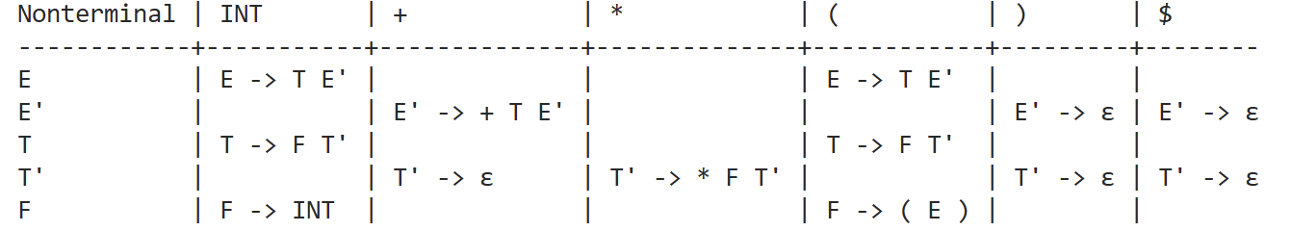

Invalid Table
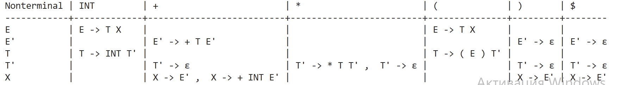

This table is invalid because some cells contain more than 1 production. For example, X in terminal + has both X->E’ and X-> + INT E’ which makes it unclear which of those two production rules we should use when we encounter +.

