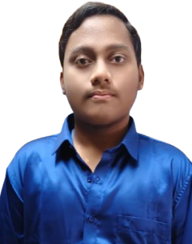
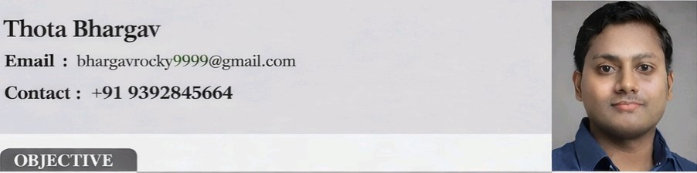
To secure a high-paying Position in the software industry where I can use my computer science Knowledge and Problem-solving skills to work on Practical Solutions support the company's Work, and improve my technical, Skills through contintious learning.
Course | College/School | University/Board | Pass Out Year | Percentage /  /CGPA
B.Tech.  (CSE) | Aditya Institute Of  Technology and  Management, Tekkali | JNTUGV, Vizianagaram | 2027 | 7.49
Intermediate (MPC) | SriVenkataRadha  KrishnaJuniorCollege | BoardofIntermediate  Education, Andhra Pradesh | 2023 | 80%
SSC | AdarshaSchool, Tekkali | Board of Secondary  Education, Andhra Pradesh | 2021 | 10.0
Programming: Python, C
Development: HTML, CSS
Database: MySQL
Operating Systems: Windows
Title: Helping Hands
Technology Used: HTML, CSS, JavaScript, MySQL
Problem Description:
There are significant safety challenges in public spaces, requiring immediate access to emergency assistance. Traditional safety solutions and databases such as MySQL and NoSQL often operate in isolation, lacking real-time integration and effective communication. Most existing safety systems do not provide instant emergency alerts or real-time location tracking for family members, friends, or guardians.
1.Completed certification in technical workshop on Arduino Explorers Mastery Workshop-Arduino, IoT, Robotics
2.Completed certifications at a hands-on workshop on Generative Al, focusing on building basic Al models and understanding real-world Al applications.
- Participated in technical workshops on Arduino, IOT, and generative Al conducted at AITAM COLLEGE.
- Attended seminars and technical talks related to Al, ML, and emerging technology
- Participated in sports and recreational activities at the college level.
- Volunteered in college programs, workshops, and student activities, supporting event coordination.
Father's NameThota Venkata Ramana
Date of Birth10th october 2005
Address: 6-94AB Srinivasa nagar, Tekkali , Tekkali Mandal,
Srikakulam Dist, Pin:532201
Hobbies/lnterestsListening Music, Reading books, learning new Technology.
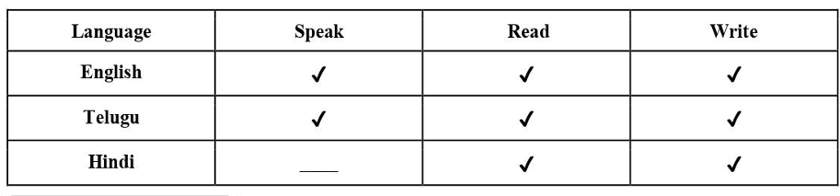
I hereby declare that the details furnished above are true and correct.
Date: 27-01-2026
Place: Tekkali Insert signature photo here

