import java.io.BufferedReader;
import java.io.InputStreamReader;
import java.net.HttpURLConnection;
import java.net.MalformedURLException;
import java.net.URL;
import java.net.SocketTimeoutException;

public class HttpSimulation {
public static void main(String[] args) {
String urlString = "https://www.bbc.com"; // You can change this to any news site URL
HttpURLConnection connection = null;
BufferedReader reader = null;

try {
URL url = new URL(urlString);

// Open connection
connection = (HttpURLConnection) url.openConnection();

// Set request method to GET
connection.setRequestMethod("GET");

// Set connection timeout and read timeout (in milliseconds)
connection.setConnectTimeout(5000); // 5 seconds to connect
connection.setReadTimeout(5000); // 5 seconds to read data

// Connect to the URL
connection.connect();

// Check the response code
int responseCode = connection.getResponseCode();
if (responseCode != HttpURLConnection.HTTP_OK) {
System.out.println("Failed to fetch content. HTTP response code: " + responseCode);
return;
}

// Read the input stream from the connection
reader = new BufferedReader(new InputStreamReader(connection.getInputStream()));
StringBuilder content = new StringBuilder();
String line;

while ((line = reader.readLine()) != null) {
content.append(line).append("\n");
if (content.length() >= 500) {
break; // Stop reading after 500 characters
}
}

// Display the first 500 characters
String result = content.toString();
if (result.length() > 500) {
result = result.substring(0, 500);
}

System.out.println("First 500 characters of the page content:\n");
System.out.println(result);

} catch (MalformedURLException e) {
System.out.println("Invalid URL format: " + e.getMessage());
} catch (SocketTimeoutException e) {
System.out.println("Connection timed out: " + e.getMessage());
} catch (Exception e) {
System.out.println("Error occurred: " + e.getMessage());
} finally {
try {
if (reader != null)
reader.close();
if (connection != null)
connection.disconnect();
} catch (Exception e) {
System.out.println("Error closing resources: " + e.getMessage());
}
}
}
}
OUTPUT : 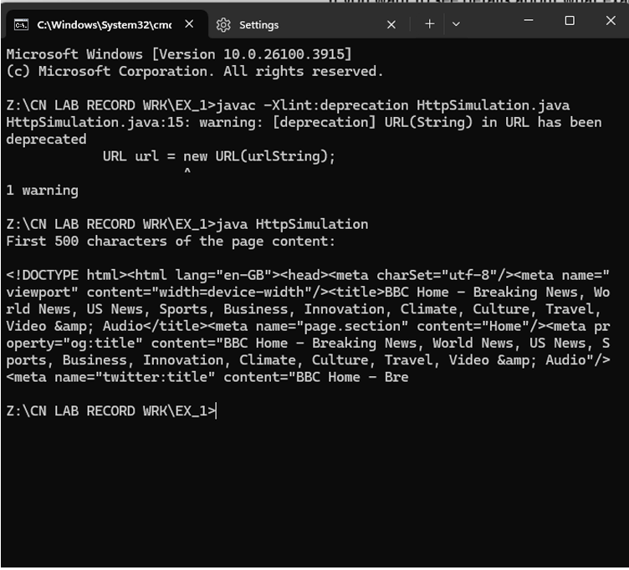

Server Code (TCPServer.java)
import java.io.*;
import java.net.*;

public class TCPServer {
public static void main(String[] args) {
ServerSocket serverSocket = null;
Socket clientSocket = null;
try {
serverSocket = new ServerSocket(6789); // Server listening on port 6789
System.out.println("Server started. Waiting for client...");

clientSocket = serverSocket.accept();
System.out.println("Client connected.");

BufferedReader in = new BufferedReader(
new InputStreamReader(clientSocket.getInputStream()));
PrintWriter out = new PrintWriter(clientSocket.getOutputStream(), true);

String message;
while ((message = in.readLine()) != null) {
System.out.println("Received from client: " + message);
// Echo the message back to client
out.println(message);
}
System.out.println("Client disconnected.");
} catch (IOException e) {
System.out.println("Server exception: " + e.getMessage());
} finally {
try {
if (clientSocket != null)
clientSocket.close();
if (serverSocket != null)
serverSocket.close();
} catch (IOException e) {
System.out.println("Error closing sockets: " + e.getMessage());
}
}
}
}

Client Code (TCPClient.java)
import java.io.*;
import java.net.*;
import java.util.Scanner;

public class TCPClient {
public static void main(String[] args) {
Socket socket = null;
try {
socket = new Socket("localhost", 6789); // Connect to server at localhost:6789
System.out.println("Connected to server.");

BufferedReader in = new BufferedReader(
new InputStreamReader(socket.getInputStream()));
PrintWriter out = new PrintWriter(socket.getOutputStream(), true);

Scanner scanner = new Scanner(System.in);
String message;
System.out.println("Enter messages to send to server (type 'exit' to quit):");

while (true) {
System.out.print("Client: ");
message = scanner.nextLine();
if (message.equalsIgnoreCase("exit")) {
break;
}
// Send message to server
out.println(message);
// Receive echoed message from server
String response = in.readLine();
System.out.println("Server: " + response);
}
scanner.close();
} catch (IOException e) {
System.out.println("Client exception: " + e.getMessage());
} finally {
try {
if (socket != null)
socket.close();
} catch (IOException e) {
System.out.println("Error closing socket: " + e.getMessage());
}
}
}
}

OUTPUT :
SERVER SIDE :
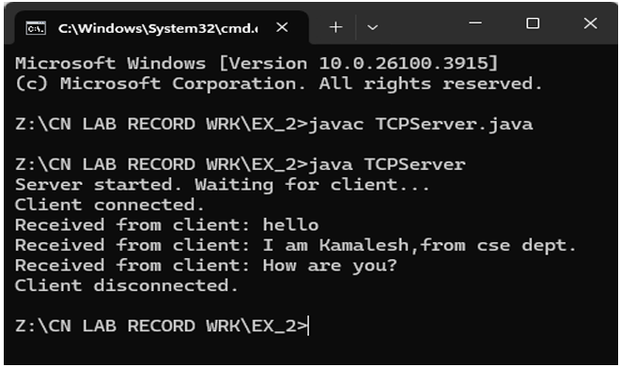
CLIENT SIDE :
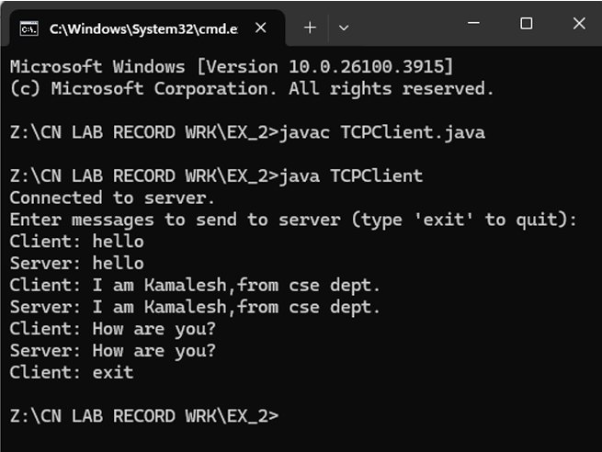
SERVER CODE — FileServer.java
import java.io.*;
import java.net.*;
import java.util.*;

public class FileServer {
public static final int PORT = 12345;
public static final String REPO_FOLDER = "repository";

public static void main(String[] args) {
new File(REPO_FOLDER).mkdirs(); // Create repository folder
try (ServerSocket serverSocket = new ServerSocket(PORT)) {
System.out.println("[+] Server is listening on port " + PORT);
while (true) {
Socket socket = serverSocket.accept();
System.out.println("[+] Connected: " + socket.getInetAddress());
new Thread(() -> handleClient(socket)).start();
}
} catch (IOException e) {
e.printStackTrace();
}
}

public static void handleClient(Socket socket) {
try (
DataInputStream dis = new DataInputStream(socket.getInputStream());
DataOutputStream dos = new DataOutputStream(socket.getOutputStream());
) {
String choice = dis.readUTF();

if (choice.equalsIgnoreCase("upload")) {
String filename = dis.readUTF();
FileOutputStream fos = new FileOutputStream(REPO_FOLDER + "/" + filename);

int bytes;
byte[] buffer = new byte[1024];
while ((bytes = dis.read(buffer)) != -1) {
String check = new String(buffer, 0, bytes);
if (check.equals("DONE")) break;
fos.write(buffer, 0, bytes);
if (bytes < 1024) break;
}
fos.close();
System.out.println("[+] File uploaded: " + filename);

} else if (choice.equalsIgnoreCase("download")) {
File folder = new File(REPO_FOLDER);
File[] files = folder.listFiles();

if (files != null && files.length > 0) {
dos.writeInt(files.length);
for (File f : files) {
dos.writeUTF(f.getName());
}

String requestedFile = dis.readUTF();
File fileToSend = new File(REPO_FOLDER + "/" + requestedFile);

if (fileToSend.exists()) {
FileInputStream fis = new FileInputStream(fileToSend);
byte[] buffer = new byte[1024];
int bytes;
while ((bytes = fis.read(buffer)) != -1) {
dos.write(buffer, 0, bytes);
}
fis.close();
dos.write("DONE".getBytes());
System.out.println("[+] File sent: " + requestedFile);
} else {
dos.write("ERROR".getBytes());
}
} else {
dos.writeInt(0);
}
}
} catch (IOException e) {
System.err.println("[-] Error: " + e.getMessage());
}
}
}

CLIENT CODE — FileClient.java
import java.io.*;
import java.net.*;
import java.util.*;

public class FileClient {
public static final String SERVER = "127.0.0.1";
public static final int PORT = 12345;

public static void main(String[] args) {
try (
Socket socket = new Socket(SERVER, PORT);
DataInputStream dis = new DataInputStream(socket.getInputStream());
DataOutputStream dos = new DataOutputStream(socket.getOutputStream());
Scanner scanner = new Scanner(System.in);
) {
System.out.print("Do you want to upload or download? (upload/download): ");
String choice = scanner.nextLine();
dos.writeUTF(choice);

if (choice.equalsIgnoreCase("upload")) {
System.out.print("Enter path of file to upload: ");
String filePath = scanner.nextLine();
File file = new File(filePath);

if (!file.exists()) {
System.out.println("File does not exist.");
return;
}

dos.writeUTF(file.getName());
FileInputStream fis = new FileInputStream(file);
byte[] buffer = new byte[1024];
int bytes;

while ((bytes = fis.read(buffer)) != -1) {
dos.write(buffer, 0, bytes);
}
fis.close();
dos.write("DONE".getBytes());
System.out.println("[+] Upload complete.");

} else if (choice.equalsIgnoreCase("download")) {
int fileCount = dis.readInt();

if (fileCount == 0) {
System.out.println("No files available on the server.");
return;
}

System.out.println("Available files:");
List<String> fileList = new ArrayList<>();

for (int i = 0; i < fileCount; i++) {
String fname = dis.readUTF();
fileList.add(fname);
System.out.println((i + 1) + ". " + fname);
}

System.out.print("Enter filename to download: ");
String fileToDownload = scanner.nextLine();
dos.writeUTF(fileToDownload);

FileOutputStream fos = new FileOutputStream("downloaded_" + fileToDownload);
byte[] buffer = new byte[1024];
int bytes;

while ((bytes = dis.read(buffer)) != -1) {
String check = new String(buffer, 0, bytes);
if (check.equals("DONE") || check.equals("ERROR")) break;
fos.write(buffer, 0, bytes);
if (bytes < 1024) break;
}

fos.close();

if (new String(buffer, 0, bytes).equals("ERROR")) {
System.out.println("[-] File not found on server.");
} else {
System.out.println("[+] Download complete. Saved as downloaded_" + fileToDownload);
}
} else {
System.out.println("Invalid choice.");
}

} catch (IOException e) {
System.err.println("[-] Client error: " + e.getMessage());
}
}
}
OUTPUT:
SERVER SIDE :
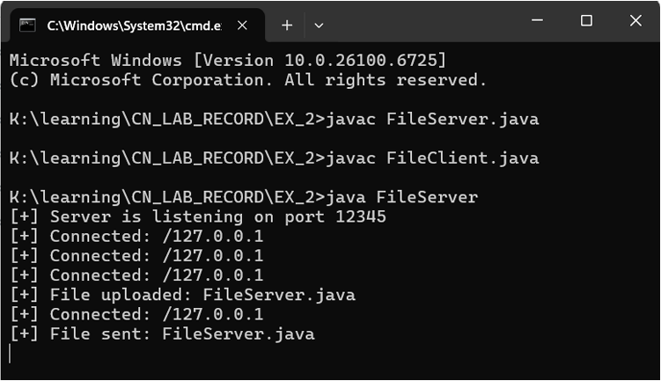

CLIENT SIDE :
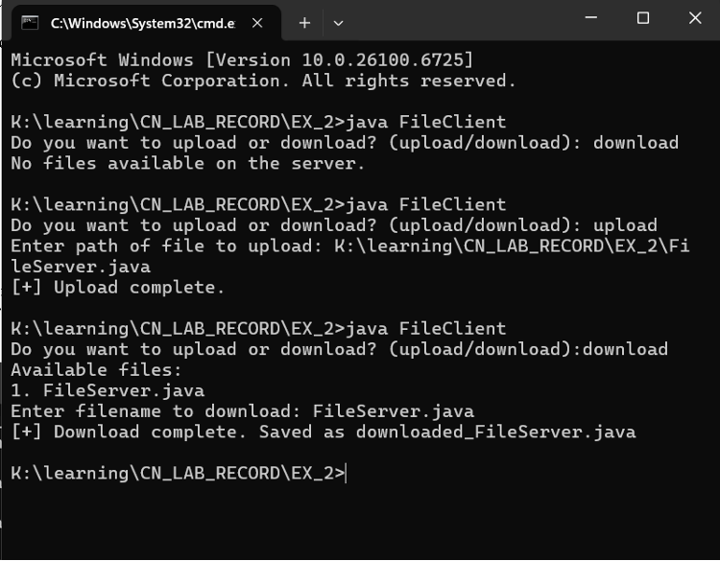

SERVER CODE — UDPFileServer.java
import java.io.*;
import java.net.*;
import java.util.*;

public class UDPFileServer {
public static final int PORT = 9876;
public static final String REPO_FOLDER = "repository";

public static void main(String[] args) throws IOException {
DatagramSocket serverSocket = new DatagramSocket(PORT);
byte[] receiveData = new byte[1024];
byte[] sendData;

File repo = new File(REPO_FOLDER);
if (!repo.exists()) repo.mkdirs();

System.out.println("[+] Server started on port " + PORT);

while (true) {
DatagramPacket receivePacket = new DatagramPacket(receiveData, receiveData.length);
serverSocket.receive(receivePacket);

InetAddress clientAddress = receivePacket.getAddress();
int clientPort = receivePacket.getPort();

String choice = new String(receivePacket.getData(), 0, receivePacket.getLength());

if (choice.equalsIgnoreCase("upload")) {
// Receive filename
receivePacket = new DatagramPacket(receiveData, receiveData.length);
serverSocket.receive(receivePacket);
String filename = new String(receivePacket.getData(), 0, receivePacket.getLength());

// Receive file data
FileOutputStream fos = new FileOutputStream(REPO_FOLDER + "/" + filename);
while (true) {
receivePacket = new DatagramPacket(receiveData, receiveData.length);
serverSocket.receive(receivePacket);

String doneCheck = new String(receivePacket.getData(), 0, receivePacket.getLength());
if (doneCheck.equals("DONE")) break;

fos.write(receivePacket.getData(), 0, receivePacket.getLength());
}
fos.close();
System.out.println("[+] File received: " + filename);

} else if (choice.equalsIgnoreCase("download")) {
// Send file list
File[] files = repo.listFiles();
StringBuilder fileList = new StringBuilder();
for (File f : files) {
fileList.append(f.getName()).append(",");
}

sendData = fileList.toString().getBytes();
DatagramPacket sendPacket = new DatagramPacket(sendData, sendData.length, clientAddress, clientPort);
serverSocket.send(sendPacket);

// Receive requested file name
receivePacket = new DatagramPacket(receiveData, receiveData.length);
serverSocket.receive(receivePacket);
String requestedFile = new String(receivePacket.getData(), 0, receivePacket.getLength());

File file = new File(REPO_FOLDER + "/" + requestedFile);
if (!file.exists()) {
sendData = "ERROR".getBytes();
sendPacket = new DatagramPacket(sendData, sendData.length, clientAddress, clientPort);
serverSocket.send(sendPacket);
continue;
}

FileInputStream fis = new FileInputStream(file);
byte[] buffer = new byte[1024];
int bytesRead;

while ((bytesRead = fis.read(buffer)) != -1) {
sendPacket = new DatagramPacket(buffer, bytesRead, clientAddress, clientPort);
serverSocket.send(sendPacket);
}

fis.close();
sendData = "DONE".getBytes();
sendPacket = new DatagramPacket(sendData, sendData.length, clientAddress, clientPort);
serverSocket.send(sendPacket);

System.out.println("[+] File sent: " + requestedFile);
}
}
}
}
CLIENT CODE — UDPFileClient.java
import java.io.*;
import java.net.*;
import java.util.*;

public class UDPFileClient {
public static final int SERVER_PORT = 9876;
public static final String SERVER_IP = "127.0.0.1";

public static void main(String[] args) throws IOException {
DatagramSocket clientSocket = new DatagramSocket();
InetAddress IPAddress = InetAddress.getByName(SERVER_IP);
Scanner scanner = new Scanner(System.in);

byte[] sendData;
byte[] receiveData = new byte[1024];

System.out.print("Do you want to upload or download? ");
String choice = scanner.nextLine();

sendData = choice.getBytes();
DatagramPacket sendPacket = new DatagramPacket(sendData, sendData.length, IPAddress, SERVER_PORT);
clientSocket.send(sendPacket);

if (choice.equalsIgnoreCase("upload")) {
System.out.print("Enter path of file to upload: ");
String filePath = scanner.nextLine();
File file = new File(filePath);

if (!file.exists()) {
System.out.println("File does not exist.");
clientSocket.close();
return;
}

// Send filename
sendData = file.getName().getBytes();
sendPacket = new DatagramPacket(sendData, sendData.length, IPAddress, SERVER_PORT);
clientSocket.send(sendPacket);

// Send file data
FileInputStream fis = new FileInputStream(file);
byte[] buffer = new byte[1024];
int bytesRead;

while ((bytesRead = fis.read(buffer)) != -1) {
sendPacket = new DatagramPacket(buffer, bytesRead, IPAddress, SERVER_PORT);
clientSocket.send(sendPacket);
}

fis.close();

// Send DONE
sendData = "DONE".getBytes();
sendPacket = new DatagramPacket(sendData, sendData.length, IPAddress, SERVER_PORT);
clientSocket.send(sendPacket);

System.out.println("[+] File uploaded.");

} else if (choice.equalsIgnoreCase("download")) {
// Receive file list
DatagramPacket receivePacket = new DatagramPacket(receiveData, receiveData.length);
clientSocket.receive(receivePacket);

String fileList = new String(receivePacket.getData(), 0, receivePacket.getLength());
if (fileList.trim().isEmpty()) {
System.out.println("No files available.");
clientSocket.close();
return;
}

System.out.println("Available files: " + fileList);
System.out.print("Enter filename to download: ");
String filename = scanner.nextLine();

// Send filename to server
sendData = filename.getBytes();
sendPacket = new DatagramPacket(sendData, sendData.length, IPAddress, SERVER_PORT);
clientSocket.send(sendPacket);

// Receive file data
FileOutputStream fos = new FileOutputStream("downloaded_" + filename);
while (true) {
receivePacket = new DatagramPacket(receiveData, receiveData.length);
clientSocket.receive(receivePacket);

String check = new String(receivePacket.getData(), 0, receivePacket.getLength());
if (check.equals("DONE")) break;
if (check.equals("ERROR")) {
System.out.println("[-] File not found on server.");
fos.close();
clientSocket.close();
return;
}

fos.write(receivePacket.getData(), 0, receivePacket.getLength());
}

fos.close();
System.out.println("[+] File downloaded as: downloaded_" + filename);
}

clientSocket.close();
}
}

OUTPUT :
SERVER SIDE :
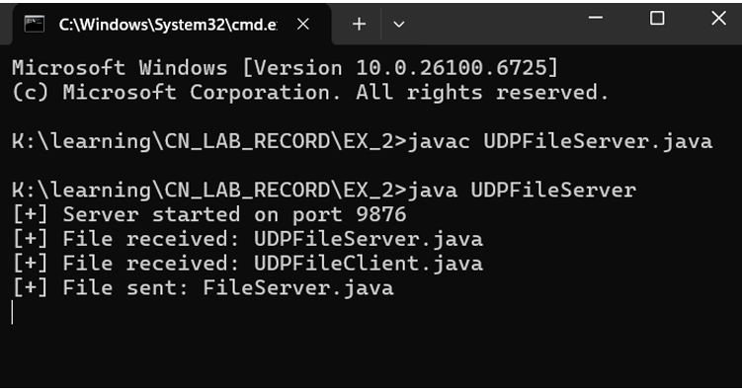
CLIENT SIDE :
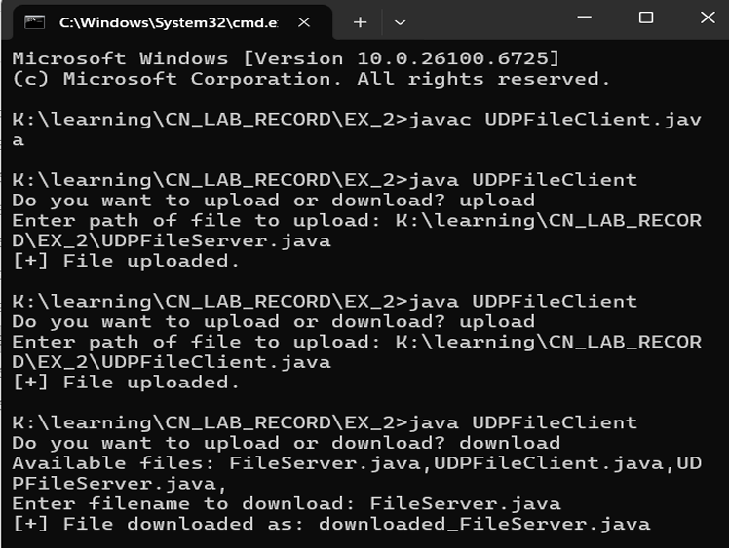
UDP Server (UDPServer.java)
import java.net.DatagramPacket;
import java.net.DatagramSocket;

public class UDPServer {
public static void main(String[] args) {
int port = 12345;

try {
DatagramSocket socket = new DatagramSocket(port);
System.out.println("UDP server started on port " + port + ". Waiting for messages...");

byte[] buffer = new byte[1024];

while (true) {
DatagramPacket packet = new DatagramPacket(buffer, buffer.length);
socket.receive(packet); // Receive packet from client

String receivedMsg = new String(packet.getData(), 0, packet.getLength());
String clientIP = packet.getAddress().getHostAddress();
int clientPort = packet.getPort();

System.out.println("Received message from " + clientIP + ":" + clientPort + " - " + receivedMsg);
}

} catch (Exception e) {
System.out.println("Error: " + e.getMessage());
e.printStackTrace();
}
}
}
UDP Client (UDPClient.java)
import java.net.DatagramPacket;
import java.net.DatagramSocket;
import java.net.InetAddress;
import java.util.Scanner;

public class UDPClient {
public static void main(String[] args) {
Scanner scanner = new Scanner(System.in);
System.out.print("Enter server IP address: ");
String serverIP = scanner.nextLine();
int serverPort = 12345;

try {
DatagramSocket socket = new DatagramSocket();
System.out.println("Type your messages below. Type 'exit' to quit.");

while (true) {
System.out.print("You: ");
String message = scanner.nextLine();

if (message.equalsIgnoreCase("exit")) {
break;
}

byte[] buffer = message.getBytes();
InetAddress serverAddress = InetAddress.getByName(serverIP);
DatagramPacket packet = new DatagramPacket(buffer, buffer.length, serverAddress, serverPort);

socket.send(packet);
}

socket.close();
System.out.println("Client exited.");

} catch (Exception e) {
System.out.println("Error: " + e.getMessage());
e.printStackTrace();
}

scanner.close();
}
}
OUTPUT :
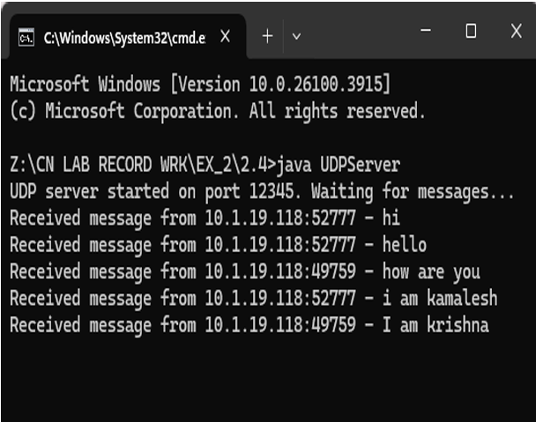

CLIENT 1 :
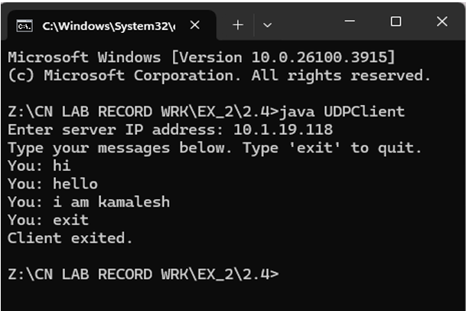
CLIENT 2 :
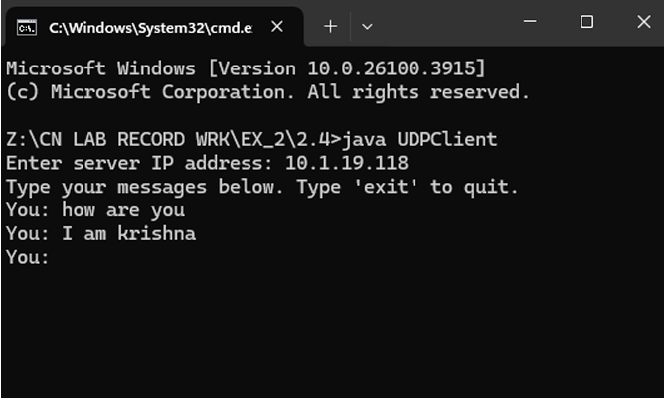
CODE :
1. Remote Interface - ServiceInterface.java
import java.rmi.Remote;
import java.rmi.RemoteException;

public interface ServiceInterface extends Remote {
// CGPA calculation: takes an array of grades and returns CGPA
double calculateCGPA(double[] grades) throws RemoteException;

// Temperature conversion: Celsius to Fahrenheit
double celsiusToFahrenheit(double celsius) throws RemoteException;

// Simple calculator: operation could be "add", "sub", "mul", "div"
double calculate(String operation, double a, double b) throws RemoteException;
}

2. Server Implementation - ServiceImplementation.java
import java.rmi.RemoteException;
import java.rmi.server.UnicastRemoteObject;

public class ServiceImplementation extends UnicastRemoteObject implements ServiceInterface {

protected ServiceImplementation() throws RemoteException {
super();
}

@Override
public double calculateCGPA(double[] grades) throws RemoteException {
double total = 0;
for (double g : grades) {
total += g;
}
return total / grades.length;
}

@Override
public double celsiusToFahrenheit(double celsius) throws RemoteException {
return (celsius * 9 / 5) + 32;
}
@Override
public double calculate(String operation, double a, double b) throws RemoteException {
switch (operation.toLowerCase()) {
case "add":
return a + b;
case "sub":
return a - b;
case "mul":
return a * b;
case "div":
if (b == 0) throw new ArithmeticException("Division by zero");
return a / b;
default:
throw new UnsupportedOperationException("Invalid operation");
}
}
}

3. Server — Server.java
import java.rmi.registry.LocateRegistry;
import java.rmi.registry.Registry;

public class Server {
public static void main(String[] args) {
try {
// Create and export remote object
ServiceImplementation service = new ServiceImplementation();

// Start RMI registry on port 1099
Registry registry = LocateRegistry.createRegistry(1099);

// Bind the remote object's stub in the registry
registry.rebind("Service", service);

System.out.println("✅ Server is ready...");
} catch (Exception e) {
System.out.println("Server exception: " + e.toString());
e.printStackTrace();
}
}
}
4. Client — Client.java
import java.rmi.registry.LocateRegistry;
import java.rmi.registry.Registry;
import java.util.Scanner;

public class Client {
public static void main(String[] args) {
try {
Registry registry = LocateRegistry.getRegistry("localhost");
ServiceInterface stub = (ServiceInterface) registry.lookup("Service");

Scanner sc = new Scanner(System.in);

while (true) {
System.out.println("\n=== Remote Services Menu ===");
System.out.println("1. CGPA Calculation");
System.out.println("2. Celsius to Fahrenheit");
System.out.println("3. Simple Calculator");
System.out.println("4. Exit");
System.out.print("Enter choice: ");
int choice = sc.nextInt();

if (choice == 4) {
System.out.println("Exiting...");
break;
}

switch (choice) {
case 1:
System.out.print("Enter number of subjects: ");
int n = sc.nextInt();
double[] grades = new double[n];
for (int i = 0; i < n; i++) {
System.out.print("Enter grade for subject " + (i + 1) + ": ");
grades[i] = sc.nextDouble();
}
double cgpa = stub.calculateCGPA(grades);
System.out.println("Calculated CGPA: " + cgpa);
break;

case 2:
System.out.print("Enter temperature in Celsius: ");
double celsius = sc.nextDouble();
double fahrenheit = stub.celsiusToFahrenheit(celsius);
System.out.println("Temperature in Fahrenheit: " + fahrenheit);
break;

case 3:
System.out.print("Enter operation (add, sub, mul, div): ");
String op = sc.next();
System.out.print("Enter first number: ");
double a = sc.nextDouble();
System.out.print("Enter second number: ");
double b = sc.nextDouble();
try {
double result = stub.calculate(op, a, b);
System.out.println("Result: " + result);
} catch (Exception e) {
System.out.println("Error: " + e.getMessage());
}
break;

default:
System.out.println("Invalid choice.");
}
}

sc.close();
} catch (Exception e) {
System.out.println("Client exception: " + e.toString());
e.printStackTrace();
}
}
}
OUTPUT :
SERVER SIDE :
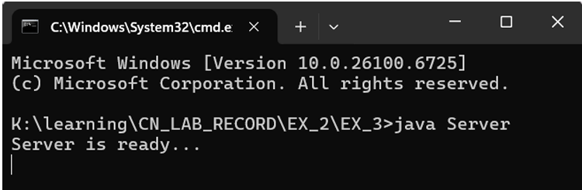
CLIENT SIDE :
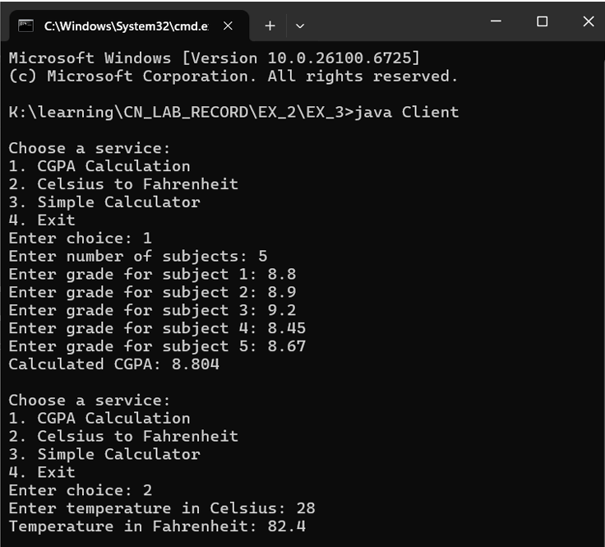

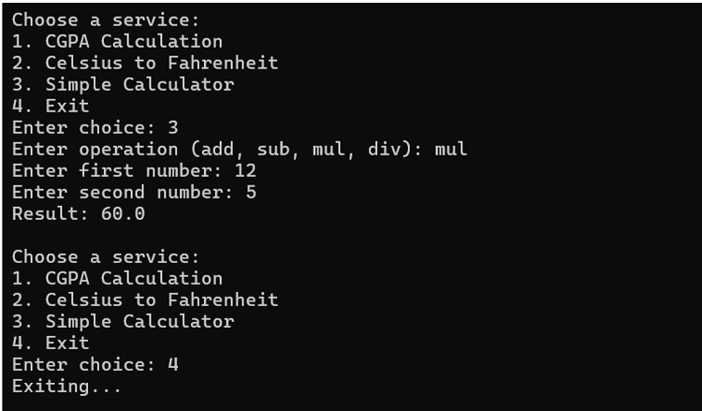

OUTPUT:
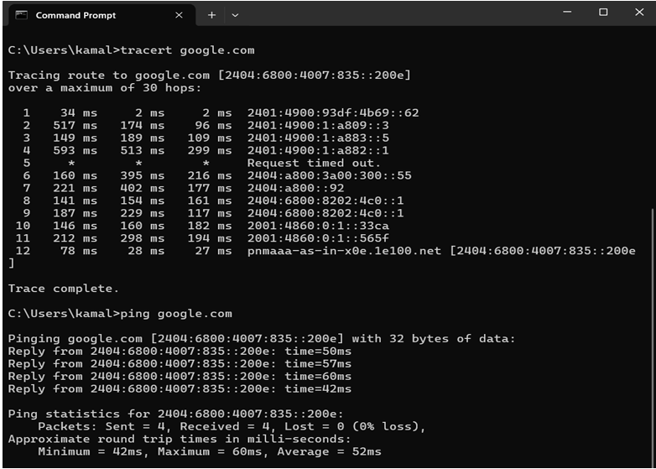

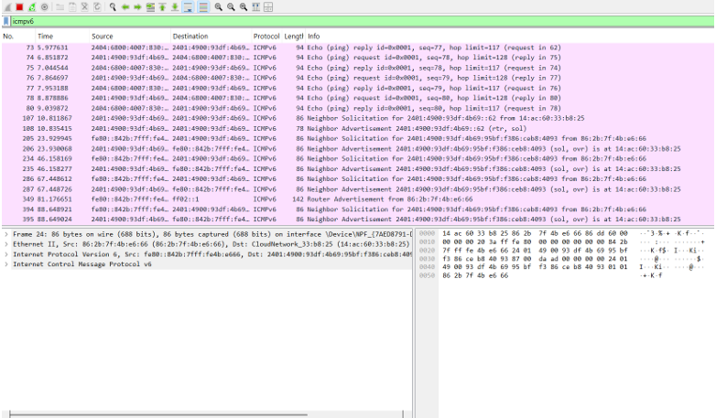
OUTPUT:
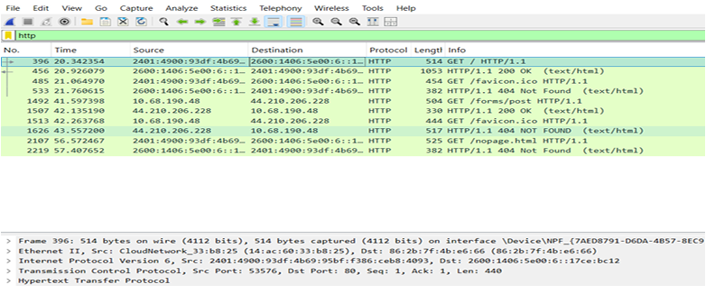

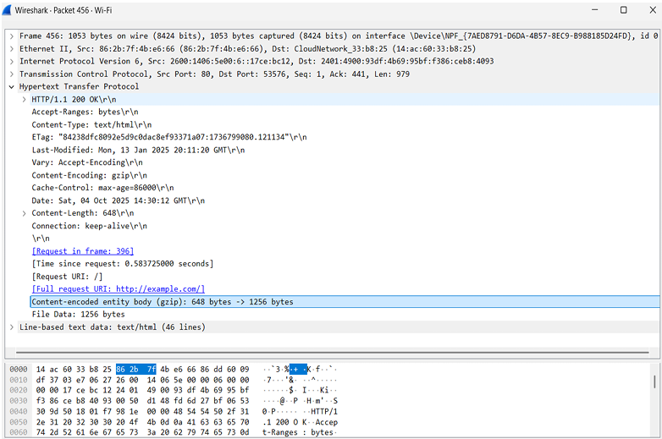

Output:
HTTP Traffic Packet Capture with Tshark
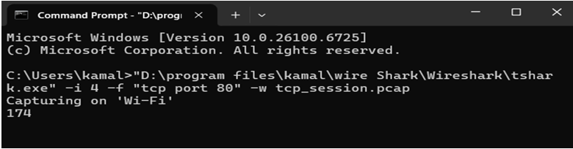
Three-Way Handshake && Data Transfer Sequence:
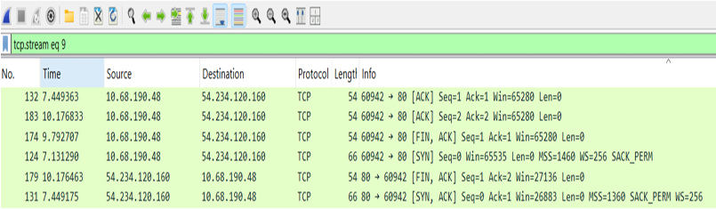
TCP Stream connection:
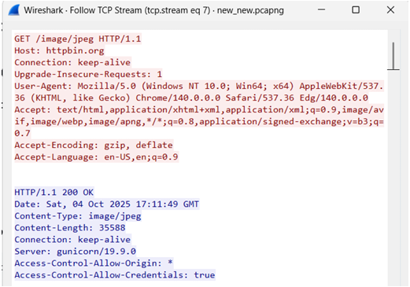
Connection Termination:
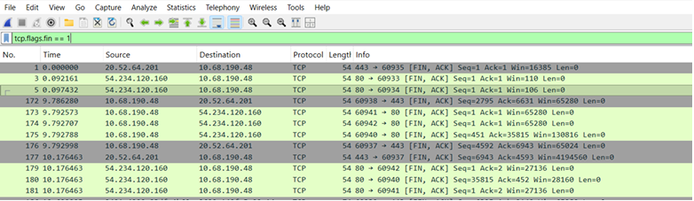

Output :
HTTP Traffic Analysis:
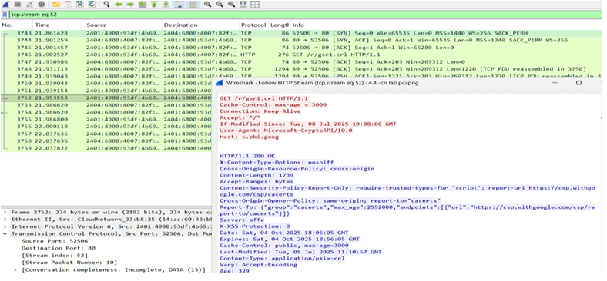
HTTPS Traffic Analysis:
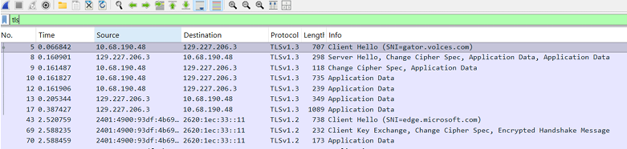
Tshark IO Statistics Summary (Total Traffic Overview):
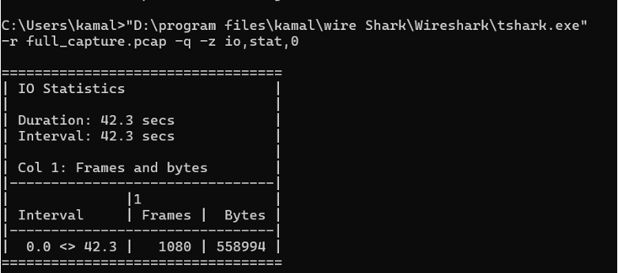
Protocol Statistics from Tshark Capture ( HTTP & HTTPS ):
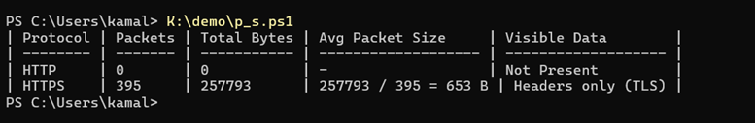

Component setup :
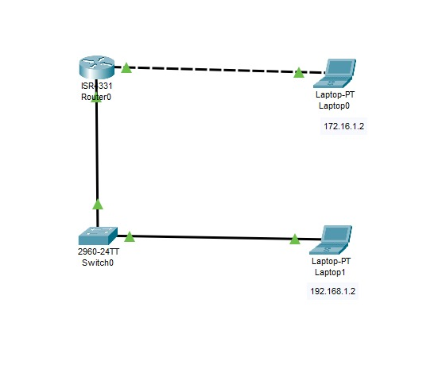
CLI Commands :
# Enter privileged EXEC mode
Router> enable
# Enter global configuration mode
Router# configure terminal
# Configure interface connected to Laptop0 (Remote Laptop)
Router(config)# interface gigabitEthernet0/0
Router(config-if)# ip address 172.16.1.1 255.255.255.0
Router(config-if)# no shutdown
Router(config-if)# exit
# Configure interface connected to Switch (Local Network)
Router(config)# interface gigabitEthernet0/1
Router(config-if)# ip address 192.168.1.1 255.255.255.0
Router(config-if)# no shutdown
Router(config-if)# exit
# Exit configuration mode and save
Router(config)# exit
Router# copy running-config startup-config
Destination filename [startup-config]?
Building configuration...
[OK]
OUTPUT :
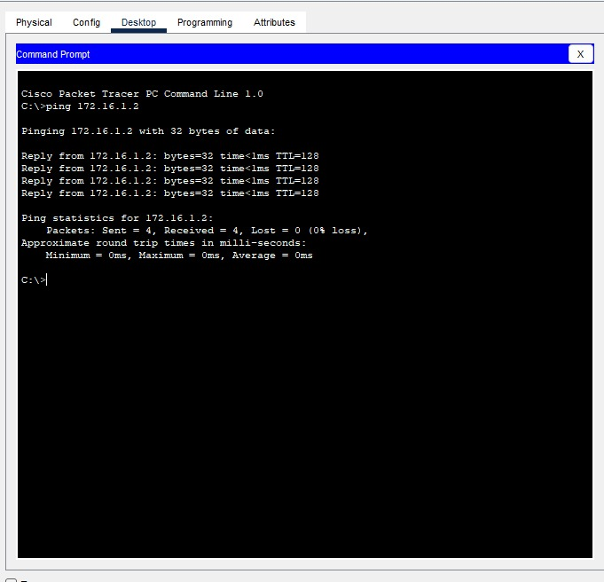

Component Setup :
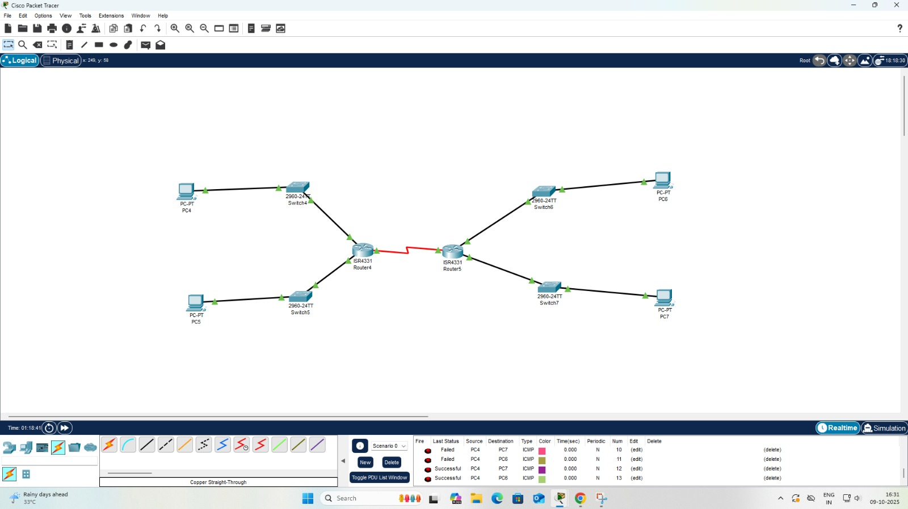
CLI COMMENTS :
Router4 Configuration
# Enter privileged EXEC mode
Router4> enable
# Enter global configuration mode
Router4# configure terminal
# Configure LAN interfaces
Router4(config)# interface gigabitEthernet0/0
Router4(config-if)# ip address 10.1.1.1 255.255.255.0
Router4(config-if)# no shutdown
Router4(config-if)# exit
Router4(config)# interface gigabitEthernet0/1
Router4(config-if)# ip address 10.1.2.1 255.255.255.0
Router4(config-if)# no shutdown
Router4(config-if)# exit
# Configure router-to-router interface
Router4(config)# interface serial0/0/0
Router4(config-if)# ip address 172.16.1.1 255.255.255.252
Router4(config-if)# no shutdown
Router4(config-if)# exit
# Configure static routes
Router4(config)# ip route 192.168.10.0 255.255.255.0 172.16.1.2
Router4(config)# ip route 192.168.20.0 255.255.255.0 172.16.1.2
Router4(config)# exit
Router4# copy running-config startup-config
Router5 Configuration
# Enter privileged EXEC mode
Router5> enable
# Enter global configuration mode
Router5# configure terminal
# Configure LAN interfaces
Router5(config)# interface gigabitEthernet0/0
Router5(config-if)# ip address 192.168.10.1 255.255.255.0
Router5(config-if)# no shutdown
Router5(config-if)# exit
Router5(config)# interface gigabitEthernet0/1
Router5(config-if)# ip address 192.168.20.1 255.255.255.0
Router5(config-if)# no shutdown
Router5(config-if)# exit
# Configure router-to-router interface
Router5(config)# interface serial0/0/0
Router5(config-if)# ip address 172.16.1.2 255.255.255.252
Router5(config-if)# no shutdown
Router5(config-if)# exit
# Configure static routes
Router5(config)# ip route 10.1.1.0 255.255.255.0 172.16.1.1
Router5(config)# ip route 10.1.2.0 255.255.255.0 172.16.1.1
Router5(config)# exit
Router5# copy running-config startup-config

OUTPUT :

