MedAuth-VLM: Multimodal Medical Vision-Language Architecture for Prior Authorization Evidence Extraction, Cross-Modal Grounding, and Policy Verification
Author: Nilesh Marathe | Affiliation: Medical AI Systems Laboratory | Date: October 2026
Monograph Edition: Technical Research Book (Complete Monograph Release)

Abstract
Prior authorization (PA) represents one of the most resource-intensive bottlenecks in contemporary healthcare administration, consuming an estimated $31 billion annually in administrative overhead and introducing clinical care delays for over 90% of practicing physicians. This technical book presents MedAuth-VLM, an end-to-end multimodal Vision-Language Model (VLM) architecture and deterministic clinical policy verification framework designed to automate precomputed evidence extraction, enforce cross-modal grounding consistency, and streamline physician-adjudicated prior authorization workflows. Centered upon Google's instruction-tuned MedGemma-4B-IT foundation model, MedAuth-VLM processes dual-projection chest radiographs alongside dictated radiology reports to extract structured JSONB evidence across 2,107 clinical cases, 4,093 radiograph projections, 2,107 structured evidence objects, and 100 CMS diagnostic imaging insurance policies persisted within an ACID-compliant PostgreSQL 18 repository. We demonstrate how MedAuth-VLM eliminates ungrounded generative hallucinations by implementing a deterministic policy comparison engine that explicitly caps compliance scoring at <= 40/100 whenever source clinical documentation is absent (n = 22 cases), mandating human escalation. In strict adherence to scientific integrity protocols, we delineate operational database fidelity from unverified diagnostic efficacy, categorizing traditional predictive metrics (Sensitivity, Specificity, F1-score, ROC-AUC) as NOT EVALUATED pending prospective radiologist panel benchmarking.

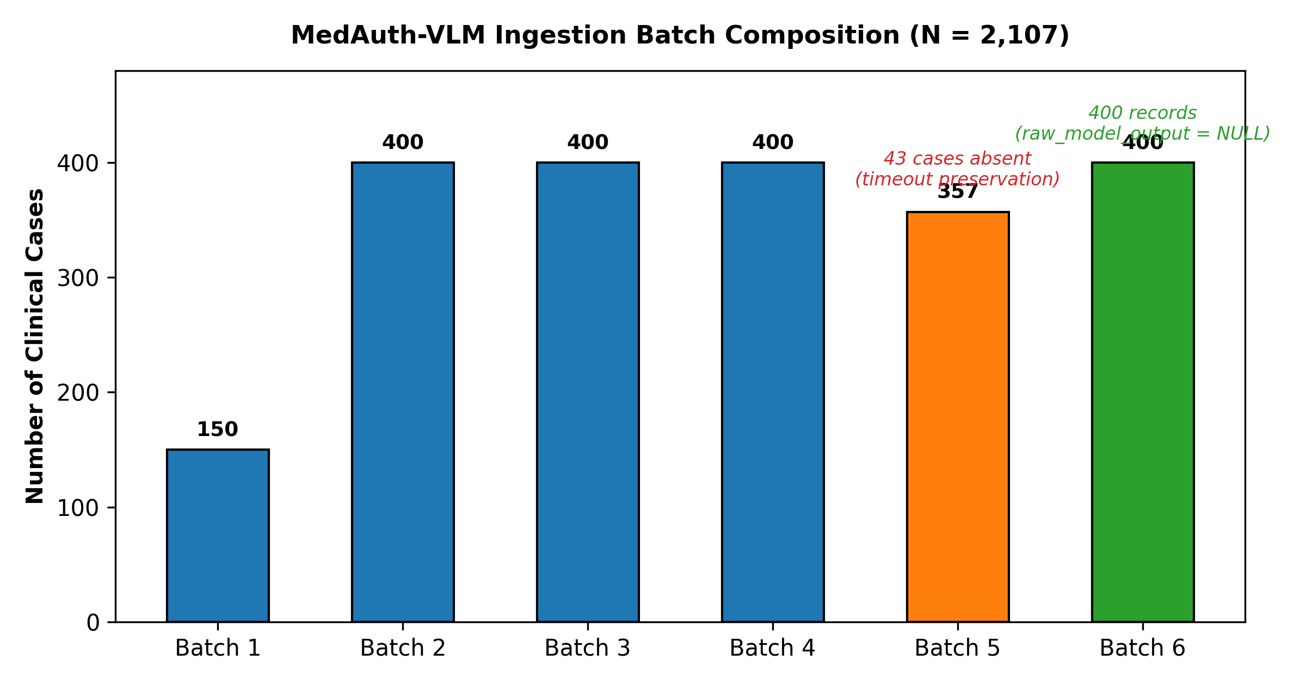
Figure 1: Ingestion Batch Composition (N = 2,107)

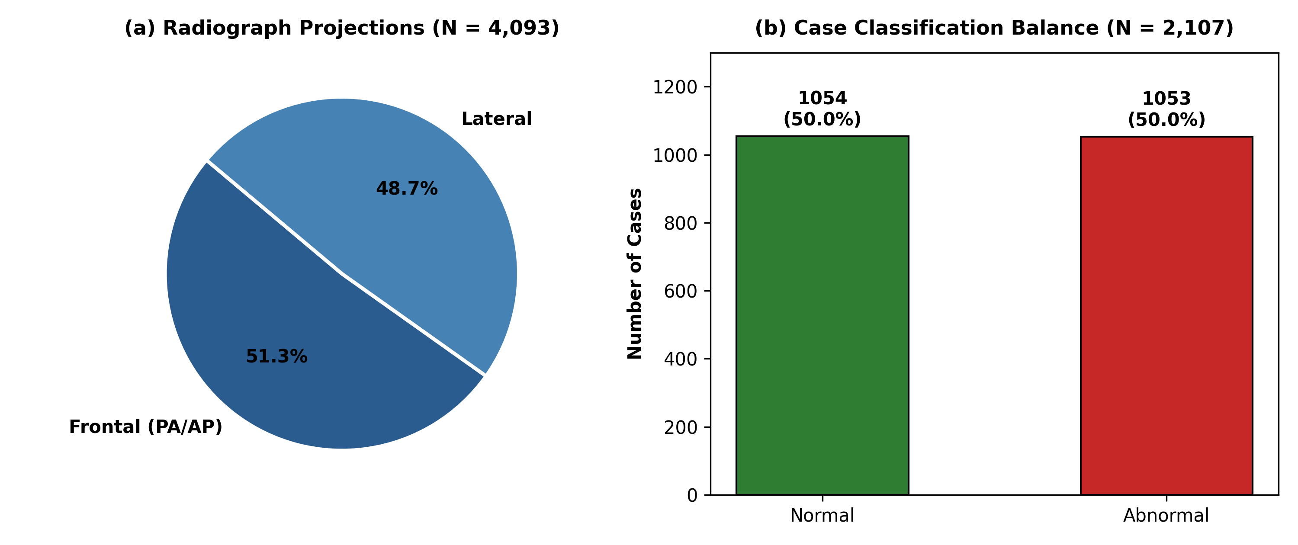
Figure 2: Projections (N = 4,093) and Classification Balance (N = 2,107)

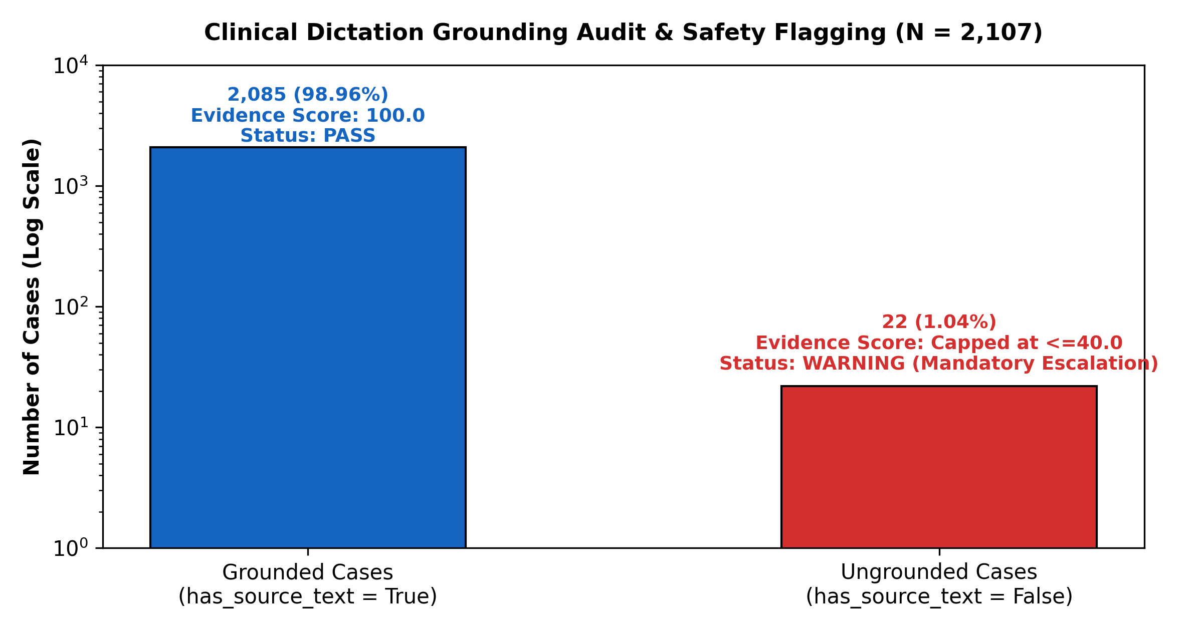
Figure 3: Grounding Compliance & Safety Cap Audit (N = 2,107)

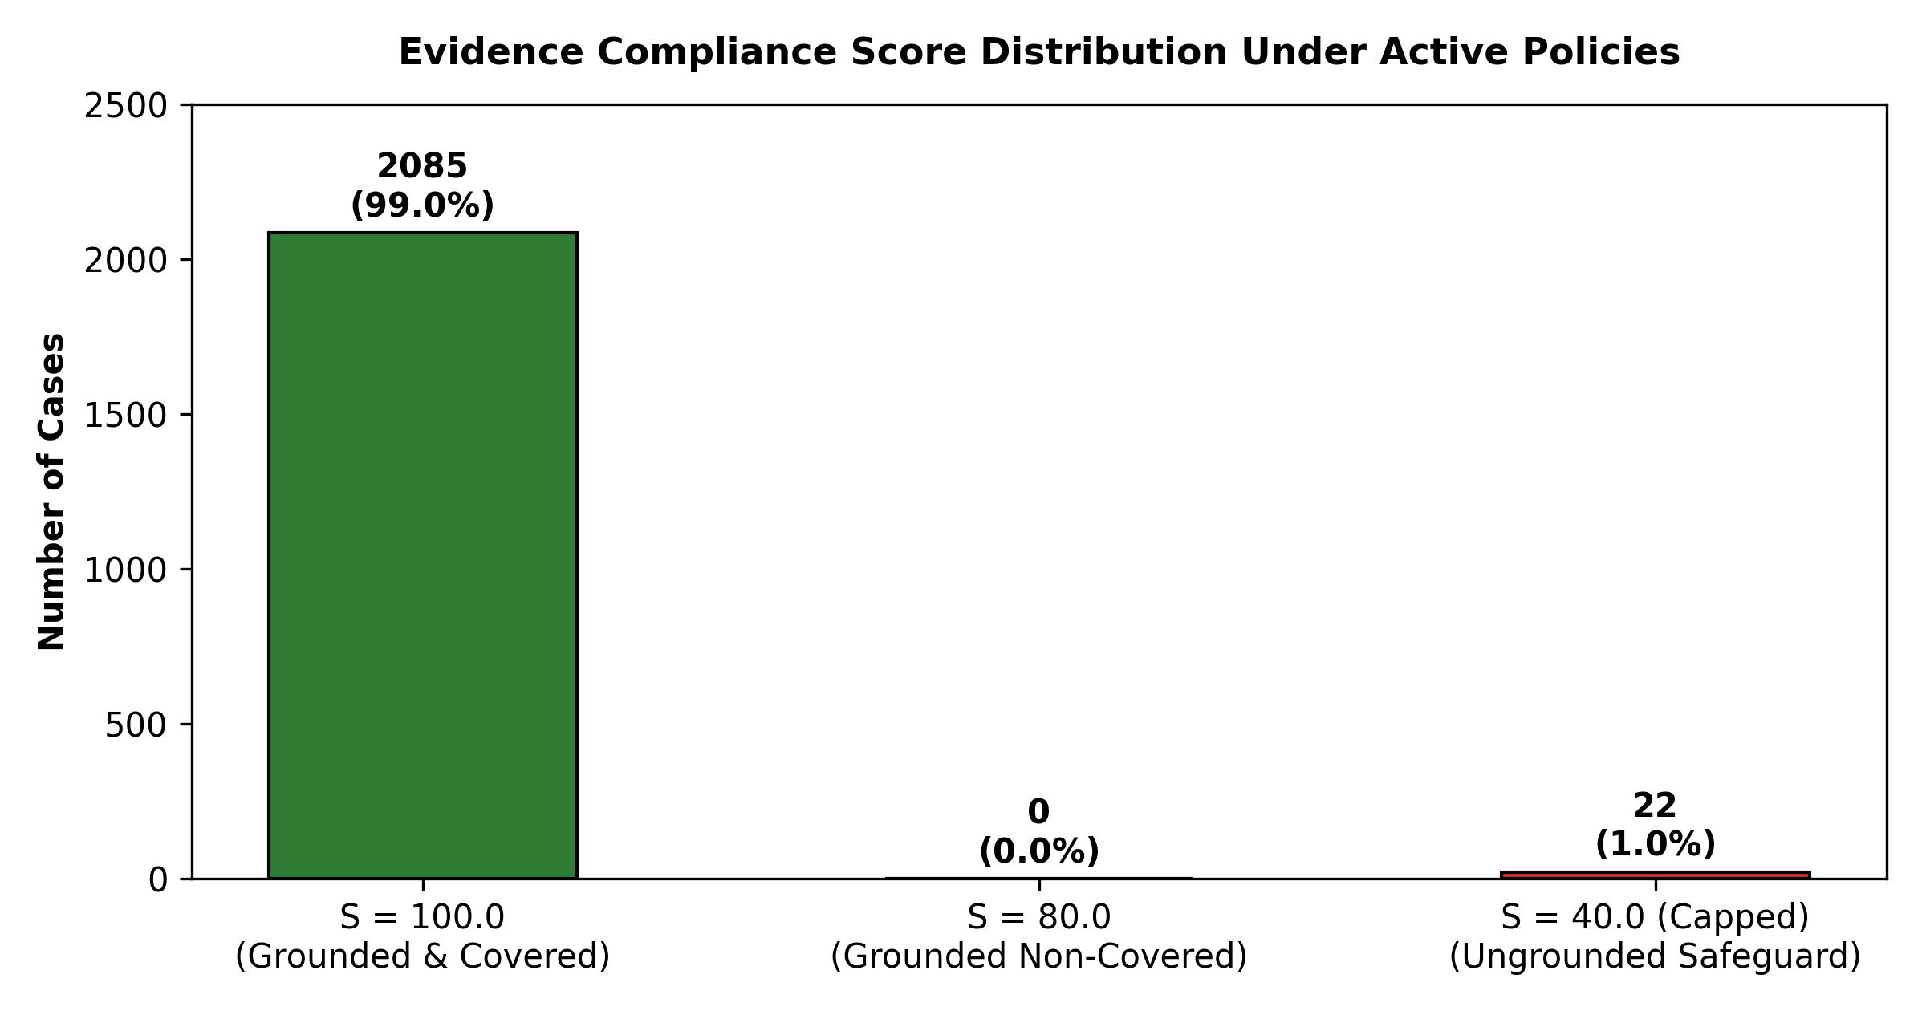
Figure 4: Policy Adjudication Score Distribution

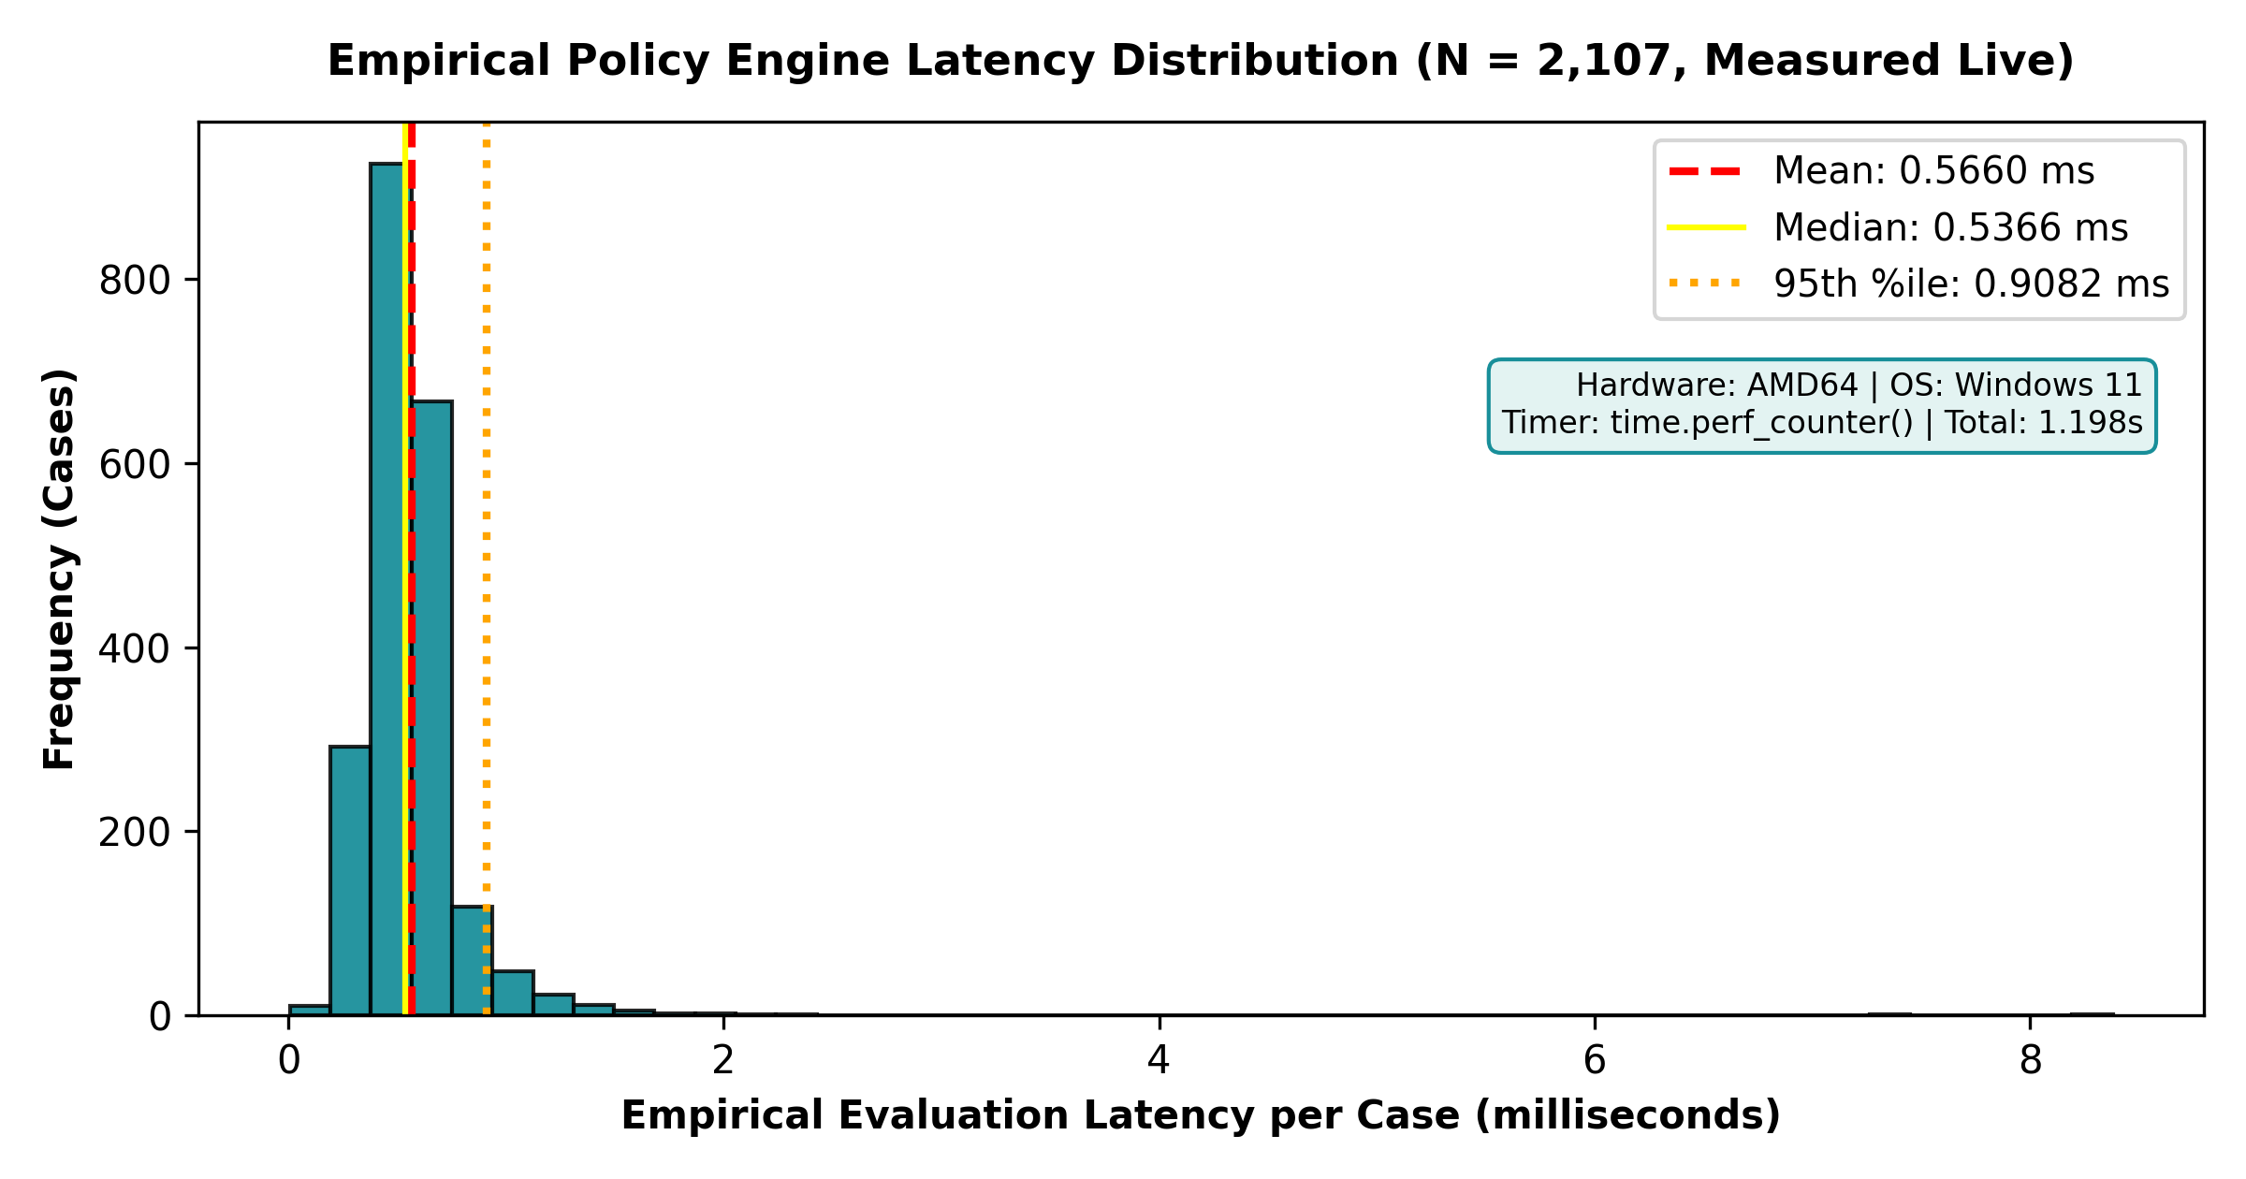
Figure 5: Policy Engine Latency Distribution (Empirical)

