**1.Data input/collection**

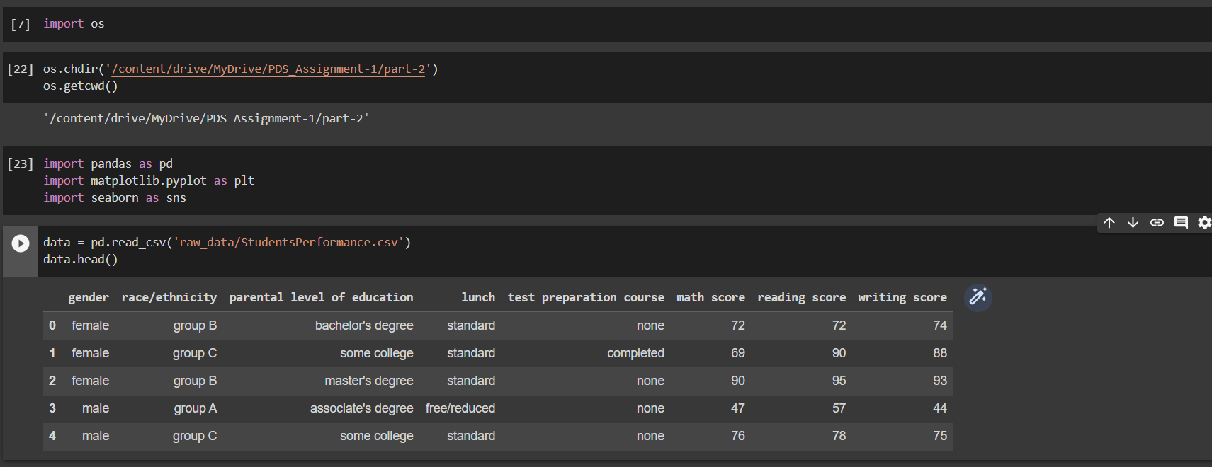

loaded the StudentsPerformance.csv file in a python environment using ***pandas*** library.

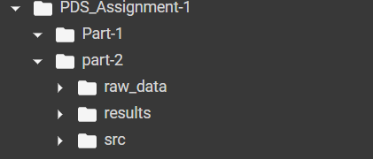

**2. Data processing**

Since the data doesn’t have any null values and data types are correct didn’t make any refinements to the data.

**3. Data analysis**

**a)**

With this visualization, we can see that there is a positive correlation between math score and reading score. This means that students who perform well in math are likely to perform well in reading, and vice versa.

b)

With this visualization, we can see that most of the students in the dataset belong to the group 'group C', followed by 'group D'. There are very few students in the 'group A' category.

c)

With this visualization, we can see that the distribution of writing score scores is roughly normal, with a mean around 68.

d)

With this visualization, we can see that the median math_score for males is slightly higher than females, but the distributions are largely similar.

e)

This visualization shows box plots of different Reading scores in the data set to give more insight on their distribution.

the folder structure looks like this after ***data analysis*** stage.