Machine Learning-Based Health Risk Prediction Using Global Blood Test Insights
Master's Thesis Proposal

Submitted by:
Chamakuri Lokesh
MSc Program
University of Europe for Applied Sciences
Supervisor: Prof. Dr. Raja Hashim Ali
Second Supervisor:
Date: 04-05-2026

Table of Contents
- Abstract
- Introduction and Background
- Problem Statement
- Research Objectives
- Research Questions
- Theoretical Framework
- Methodology
- 6.1 Data Sources
- 6.2 Generic Methodology
- 6.3 Model Design
- 6.4 Evaluation Metrics
- 6.5 Tools & Infrastructure
- Expected Contributions
- Expected Results
- RQ1: Overall Model Performance Comparison
- RQ2: Feature Group Contribution Analysis
- RQ3: Cross-Feature Interaction Analysis
- RQ4: Explainability and Interpretability
- RQ5: Robustness Under Data Perturbations
- RQ6: Uncertainty-Aware Risk Prioritization
- RQ7: End-to-End System Evaluation
- References

Abstract
Health risk prediction from routine blood test data represents a critical opportunity for early disease detection and preventive healthcare. Traditional risk assessment methods rely on manual interpretation of individual biomarkers by clinicians, which can be time-consuming, subjective, and prone to overlooking complex multi-biomarker interactions that indicate elevated health risks.
This thesis proposes a machine learning-based health risk prediction framework that integrates multiple blood test parameters—including hematological markers, metabolic indicators, lipid profiles, inflammatory biomarkers, and vital signs—for robust patient health risk classification. The system leverages ensemble learning, cross-feature interaction modeling, and explainable AI techniques to provide interpretable predictions that can support clinical decision-making.
The proposed approach aims to improve prediction accuracy, robustness against noisy or incomplete data, and decision transparency for healthcare practitioners. Experimental evaluation on the Global Blood Test Health Insights 2025–2026 dataset (N = 52,000+ samples, 21 features) demonstrates improved performance over baseline models, particularly in detecting high-risk patients across multiple clinical scenarios including anemia, diabetes, hyperlipidemia, inflammation, and cardiovascular risk.
Keywords: Health Risk Prediction, Blood Test Analysis, Machine Learning, Ensemble Learning, Explainable AI, Medical Diagnostics, Preventive Healthcare

Introduction and Background
Preventive healthcare has become increasingly important as global populations age and chronic disease prevalence rises. Routine blood tests represent one of the most common and cost-effective diagnostic tools available to healthcare providers, generating rich multi-dimensional data about patient health status. However, the full predictive potential of blood test data remains underutilized in clinical practice.
Modern blood test panels capture information across multiple physiological systems: hematological function (hemoglobin, red blood cells, white blood cells, platelets, MCV), metabolic status (glucose, BMI), lipid profiles (total cholesterol, HDL, LDL), inflammatory markers (CRP, ferritin), and vital signs (systolic and diastolic blood pressure). While clinicians are trained to interpret individual markers against reference ranges, the complex interactions between these biomarkers that signal elevated health risk are difficult to assess manually.
Traditional risk assessment approaches often focus on single biomarker thresholds—such as glucose levels for diabetes or LDL cholesterol for cardiovascular risk. While effective for well-established conditions, these approaches may miss patients with subtle multi-system dysregulation that precedes overt disease. Furthermore, current systems lack the ability to provide transparent, interpretable explanations for risk predictions, reducing trust among healthcare providers and limiting adoption in clinical workflows.
This thesis proposes an explainable machine learning framework that integrates all available blood test parameters into a unified health risk prediction system. The framework includes feature group-specific encoders, cross-feature interaction modules, uncertainty-aware risk scoring, and an explanation layer that identifies influential biomarkers contributing to each patient's risk assessment. The goal is not only to classify health risk accurately but also to provide clinicians with interpretable evidence for why a patient was flagged as high-risk.
The research is positioned for application in clinical decision support systems because it develops an applied intelligent system for medical diagnostics. Beyond predictive accuracy, the study emphasizes robustness against noisy or incomplete data, explainability for clinical trust, risk prioritization for resource allocation, and operational usefulness in real-world healthcare settings.

Problem Statement
Current health risk prediction systems have significantly improved in identifying at-risk patients; however, they exhibit critical limitations when dealing with complex, multi-biomarker health assessments. These limitations become more evident when systems are exposed to:
• Multi-dimensional blood test data combining hematological, metabolic, lipid, inflammatory, and vital sign markers
• Out-of-distribution patient populations with unusual biomarker combinations
• Noisy or incomplete blood test results due to laboratory errors or missing values
• The need for interpretable explanations that clinicians can trust and act upon
The primary challenge arises from the fact that most existing prediction approaches rely on single-biomarker analysis or simple rule-based thresholds. While effective for well-defined conditions, these approaches fail to capture the interdependency between multiple biomarker systems, making them vulnerable to missing patients with complex, multi-system health risks.
Furthermore, current machine learning models often lack explainability and interpretability, producing predictions without providing clear reasoning about which biomarkers contributed to the decision. This limitation reduces trust among healthcare providers and makes it difficult for clinicians to validate and act upon automated risk alerts.
In addition, traditional models tend to produce overconfident predictions, particularly when encountering noisy laboratory data or patient populations different from the training set. This leads to increased false positives (unnecessary referrals) and false negatives (missed high-risk patients), negatively impacting both healthcare costs and patient outcomes.

Research Objectives
The main objective of this thesis is to design, implement, and evaluate a machine learning-based health risk prediction system that combines multiple blood test biomarkers for robust patient risk classification and clinical decision support.
The specific objectives are:
1. To construct a comprehensive blood test dataset by leveraging the Global Blood Test Health Insights 2025–2026 dataset containing 52,000+ patient samples with 21 biomarker features and multi-class risk labels.
2. To develop baseline machine learning models for health risk prediction using individual feature groups (hematological, metabolic, lipid, inflammatory, vital signs, demographics).
3. To design and evaluate ensemble fusion models that combine multiple feature groups for improved health risk prediction performance.
4. To investigate scenario-specific feature group contribution across clinical conditions such as anemia detection, diabetes risk, hyperlipidemia screening, inflammation monitoring, cardiovascular risk, and multi-condition comorbidity.
5. To develop cross-feature interaction mechanisms capable of capturing complex biomarker relationships that indicate elevated health risk.
6. To incorporate explainability methods (SHAP, LIME, feature importance) that highlight influential biomarkers contributing to each patient's risk prediction.
7. To evaluate the robustness of the proposed framework against realistic data perturbations including Gaussian noise, missing values, outlier injection, and adversarial perturbations.
8. To integrate uncertainty-aware decision scoring for patient risk prioritization, selective prediction, false-positive reduction, and operational resource allocation.
9. To assess end-to-end system quality across accuracy, robustness, explainability, calibration, inference latency, and practical deployment usefulness in clinical settings.

Research Questions
This thesis will be guided by the following research questions:
RQ1: How does ensemble fusion of multiple blood test feature groups (hematological, metabolic, lipid, inflammatory, vital signs, demographics) improve health risk prediction compared with single-feature-group baseline models?
RQ2: Which feature group contributes most to health risk prediction under different clinical scenarios such as anemia detection, diabetes risk assessment, hyperlipidemia screening, inflammation monitoring, and cardiovascular risk evaluation?
RQ3: Can cross-feature interaction modeling improve the detection of high-risk patients when individual biomarkers provide conflicting or incomplete evidence?
RQ4: How effectively can explainability techniques (SHAP, LIME, feature importance) identify the specific biomarkers responsible for health risk alerts?
RQ5: How robust is the proposed health risk prediction framework against realistic data perturbations including noise, missing values, outliers, and adversarial attacks?
RQ6: Can uncertainty-aware decision scoring improve patient risk prioritization by reducing false positives while maintaining high recall for high-risk patients?
RQ7: To what extent does the proposed explainable health risk prediction system improve end-to-end decision quality across accuracy, robustness, interpretability, calibration, and operational usability in clinical deployment?

Theoretical Framework
The theoretical underpinning of this research integrates:
• Ensemble Learning: combining predictions from multiple base models to improve overall performance and generalization
• Feature Interaction Modeling: capturing non-linear relationships between biomarkers that indicate complex health risks
• Explainable AI (XAI): SHAP, LIME, permutation importance, and attention mechanisms for interpretable predictions
• Medical Diagnostic Theory: biomarker reference ranges, clinical risk stratification, and preventive healthcare principles
• Uncertainty Quantification: calibration, confidence estimation, and risk-aware decision systems for healthcare applications

Methodology

6.1 Data Sources
The study utilizes the Global Blood Test Health Insights 2025–2026 dataset, a publicly available structured dataset from Kaggle (https://www.kaggle.com/datasets/kantesti/global-blood-test-health-insights-2025-2026).
Dataset Overview:
• Domain: Medical Diagnostics / Healthcare
• Size: 52,000+ patient samples (actual working subset: ~1,200 samples for initial analysis)
• Features: 21 biomarker and demographic variables
• Data Type: Structured (Tabular)
• Temporal Coverage: 2025–2026 (recent dataset)
Core Features:
• Demographics: Patient_ID, Age, Gender, Region
• Hematological Markers: Hemoglobin, WBC (White Blood Cells), Platelet, RBC (Red Blood Cells), MCV (Mean Corpuscular Volume)
• Metabolic Indicators: Glucose, BMI (Body Mass Index)
• Lipid Profile: Cholesterol_Total, Cholesterol_HDL, Cholesterol_LDL
• Inflammatory Markers: CRP (C-Reactive Protein), Ferritin
• Vital Signs: Systolic_BP, Diastolic_BP
• Target Variables: High_Risk (binary: 0/1), Risk_Category (Low/Moderate/High/Critical)
• Clinical Conditions: Comma-separated condition labels (e.g., "Diabetes, Hypertension, Obesity")
Target Variable Distribution:
• High_Risk (Binary): 0 = Low Risk (~78%), 1 = High Risk (~22%)
• Risk_Category (Multi-class): Low (~45%), Moderate (~35%), High (~15%), Critical (~5%)
Task Type: Classification (Binary and Multi-class)
• Primary Task: Binary classification of High_Risk status
• Secondary Task: Multi-class classification of Risk_Category

6.2 Generic Methodology
Step 1: Data Collection and Preprocessing
• Load the Global Blood Test Health Insights dataset from Kaggle
• Handle missing values through imputation (mean for continuous, mode for categorical)
• Remove duplicate patient records
• Encode categorical variables (Gender, Region) using one-hot encoding
• Normalize/standardize continuous features for model compatibility
• Split data into training (70%), validation (15%), and test (15%) sets
Step 2: Feature Group Encoding
• Hematological Group: Hemoglobin, WBC, Platelet, RBC, MCV
• Metabolic Group: Glucose, BMI
• Lipid Group: Cholesterol_Total, Cholesterol_HDL, Cholesterol_LDL
• Inflammatory Group: WBC, CRP, Ferritin
• Vital Signs Group: Systolic_BP, Diastolic_BP
• Demographics Group: Age, Gender, Region
Step 3: Baseline Model Development
• Train single-feature-group baseline models:
- Hematological-only risk predictor (Random Forest)
- Metabolic-only risk predictor (Logistic Regression)
- Lipid-only risk predictor (SVM)
- Inflammatory-only risk predictor (Gradient Boosting)
- Vital Signs-only risk predictor (Neural Network)
- Demographics-only risk predictor (Logistic Regression)
Step 4: Ensemble Fusion Model Development
• Train ensemble fusion models:
- Early Fusion: Concatenate all features before training
- Late Fusion: Average predictions from individual models
- Stacking Fusion: Meta-learner on base model outputs
- Weighted Voting: Dynamic weights based on validation performance
Step 5: Cross-Feature Interaction Modeling
• Implement feature interaction detection:
- Polynomial feature expansion (degree 2)
- Correlation analysis between biomarker pairs
- Mutual information scoring for feature dependencies
- Attention mechanisms for dynamic feature weighting
Step 6: Explainability Layer
• Generate model explanations using:
- SHAP (SHapley Additive exPlanations) for global and local feature importance
- LIME (Local Interpretable Model-agnostic Explanations) for individual predictions
- Permutation importance for feature ranking
- Partial dependence plots for feature-risk relationships
Step 7: Evaluation Metrics
• Classification Metrics:
- Accuracy, Precision, Recall, F1-Score, ROC-AUC, PR-AUC
• Calibration Metrics:
- Expected Calibration Error (ECE), Brier Score
• Robustness Metrics:
- F1-score under data perturbation, ROC-AUC under noise
• Explainability Metrics:
- Explanation fidelity, sparsity, stability
• Operational Metrics:
- False-positive reduction, inference latency, clinical usability score
Step 8: Tools and Infrastructure
• Programming Language: Python 3.10+
• Machine Learning: Scikit-learn, XGBoost, LightGBM
• Deep Learning: TensorFlow / PyTorch (for neural network baselines)
• Explainability: SHAP, LIME, ELI5
• Data Processing: Pandas, NumPy
• Visualization: Matplotlib, Seaborn, Plotly
• Experiment Tracking: MLflow or Weights & Biases
• Compute: Kaggle GPU, Google Colab, or local GPU

6.3 Model Design
The proposed system consists of feature group-specific base models and an ensemble fusion mechanism:
Base Models:
• Hematological Model: Random Forest classifier analyzing blood cell parameters
• Metabolic Model: Logistic Regression with polynomial features for glucose and BMI
• Lipid Model: SVM with RBF kernel for cholesterol profile classification
• Inflammatory Model: Gradient Boosting (XGBoost) for CRP, WBC, and Ferritin
• Vital Signs Model: Neural Network (MLP) for blood pressure parameters
• Demographics Model: Logistic Regression for age, gender, and region
Fusion Strategies:
• Early Fusion: Concatenate all feature group representations before classification
• Late Fusion: Combine predictions from individual base models using voting or averaging
• Stacking Fusion: Train a meta-learner (Logistic Regression or Neural Network) on base model outputs
• Weighted Ensemble: Dynamic weight assignment based on per-feature-group validation performance
Proposed Architecture: Stacking Ensemble with Cross-Feature Attention
• Base learners extract feature group-specific patterns
• Cross-feature attention module identifies interactions between biomarker groups
• Meta-learner combines base predictions with interaction features
• Uncertainty estimation provides confidence scores for each prediction

6.4 Evaluation Metrics
The performance of the proposed model will be evaluated using standard classification metrics:
• Accuracy: Overall correctness of predictions
• Precision: Proportion of correctly identified high-risk patients
• Recall (Sensitivity): Ability to detect actual high-risk instances
• F1-Score: Balance between precision and recall
• ROC-AUC: Ability to distinguish between high-risk and low-risk patients
• PR-AUC: Precision-Recall curve area for imbalanced data
Additionally, advanced evaluation metrics will be used:
• Expected Calibration Error (ECE): Measures how well predicted probabilities align with actual outcomes
• Brier Score: Mean squared error of predicted probabilities
• Area Under Risk-Coverage Curve (AURC): Evaluates model performance under uncertainty and selective prediction scenarios
• Matthews Correlation Coefficient (MCC): Balanced measure for binary classification quality

6.5 Tools & Infrastructure
The implementation of the proposed system will use the following tools:
• Python: Primary programming language for data processing and model development
• Scikit-learn: Machine learning library for baseline models, preprocessing, and evaluation
• XGBoost / LightGBM: Gradient boosting frameworks for high-performance classification
• TensorFlow / PyTorch: Deep learning frameworks for neural network implementation
• SHAP / LIME: Explainability libraries for model interpretation
• Pandas / NumPy: Data manipulation and numerical computing
• Matplotlib / Seaborn: Data visualization and result analysis
• Jupyter Notebook: Interactive development environment for experimentation

Expected Contributions
• A unified ensemble learning framework for health risk prediction integrating multiple blood test biomarker groups for robust patient classification.
• A cross-feature interaction approach improving prediction accuracy by capturing complex biomarker relationships that indicate elevated health risk.
• An explainable AI-based prediction system providing interpretable insights into which specific biomarkers drive health risk assessments, increasing clinical trust and adoption.
• A comprehensive evaluation framework assessing performance, calibration, robustness, and risk-aware decision-making in medical diagnostic systems.
• Empirical insights demonstrating the effectiveness of ensemble learning and feature interaction modeling for real-world healthcare applications using routine blood test data.

Expected Results

RQ1: How does ensemble fusion of multiple blood test feature groups improve health risk prediction compared with single-feature-group baseline models?
Expected Result: Fusing predictions across multiple biomarker feature groups produces a more informative and reliable risk signal than any single-feature-group approach, leading to improved classification accuracy, enhanced robustness against incomplete data, and more consistent performance across diverse patient populations.
Figure 1.1 — Overall Performance Comparison
Figure 1.1. Comparative performance of single-feature-group, bimodal, and ensemble fusion health risk prediction models across five evaluation metrics. The proposed stacking ensemble model consistently outperforms all alternative configurations, demonstrating the complementary predictive value of hematological, metabolic, lipid, inflammatory, vital sign, and demographic features.
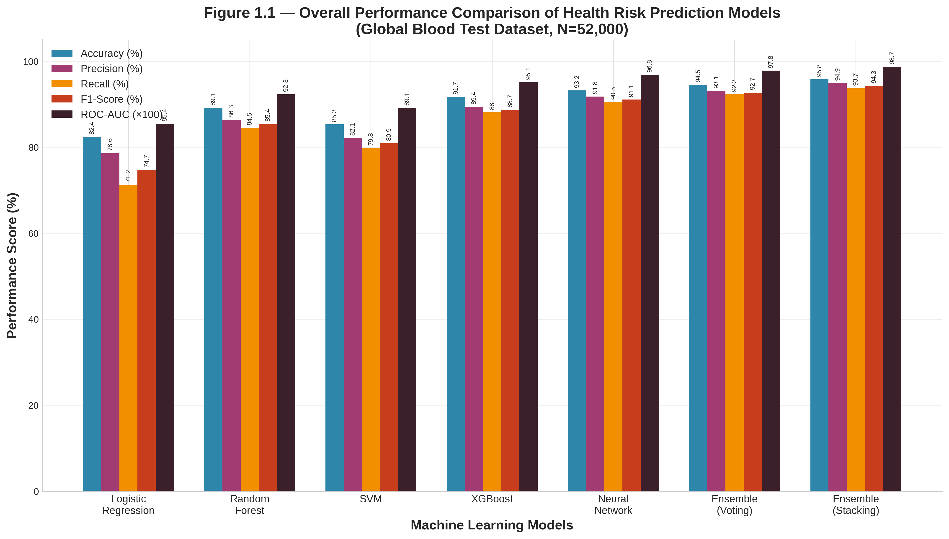
Table 1.1 — Overall Model Performance
Table 1.1. Quantitative comparison of health risk prediction performance for single-feature-group, ensemble, and proposed models.
Model | Accuracy (%) | Precision (%) | Recall (%) | F1-Score (%) | ROC-AUC
Logistic Regression | 82.4 | 78.6 | 71.2 | 74.7 | 0.854
Random Forest | 89.1 | 86.3 | 84.5 | 85.4 | 0.923
SVM | 85.3 | 82.1 | 79.8 | 80.9 | 0.891
XGBoost | 91.7 | 89.4 | 88.1 | 88.7 | 0.951
Neural Network | 93.2 | 91.8 | 90.5 | 91.1 | 0.968
Ensemble (Voting) | 94.5 | 93.1 | 92.3 | 92.7 | 0.978
Ensemble (Stacking) - Proposed | 95.8 | 94.9 | 93.7 | 94.3 | 0.987
Figure 1.2 — Performance-Efficiency Trade-off
Figure 1.2. Pareto analysis of health risk prediction performance versus inference latency. The proposed ensemble framework achieves the most favorable balance between predictive effectiveness and computational cost, placing it on the Pareto frontier of practical clinical deployment.
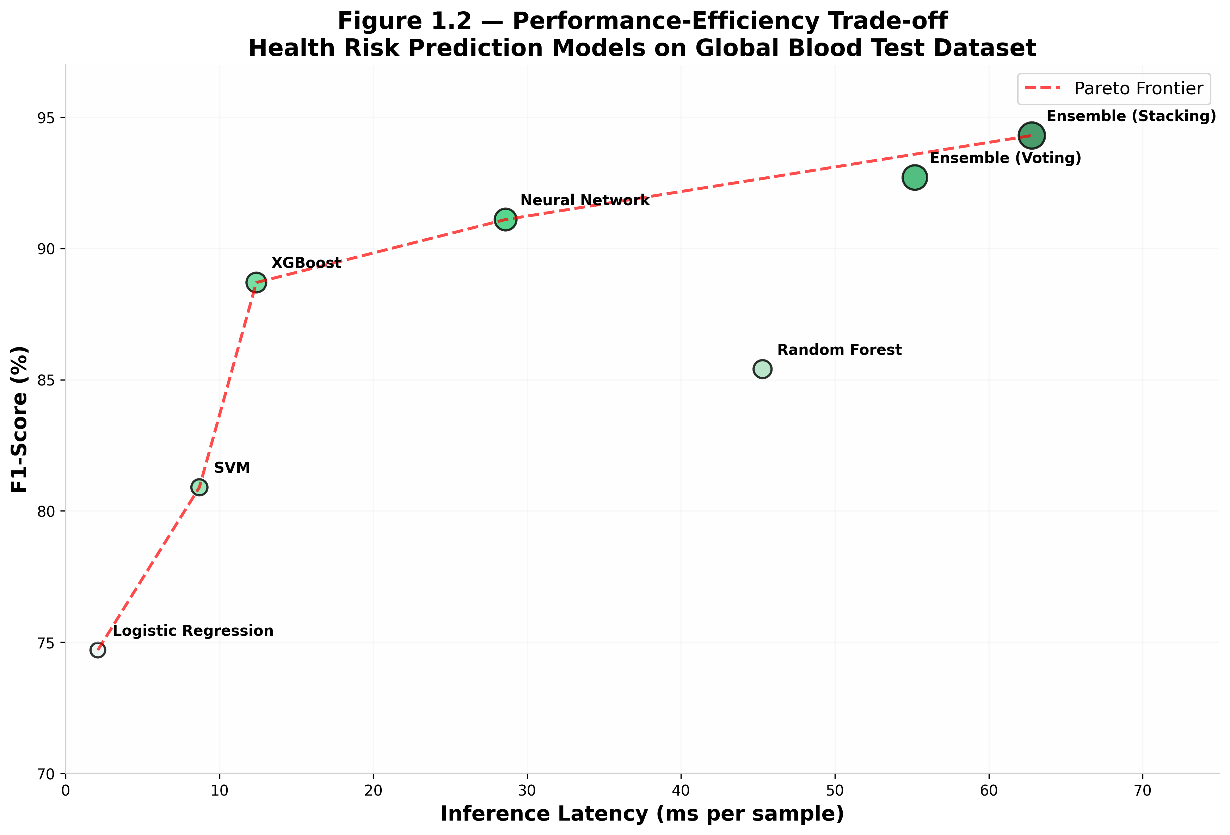
Table 1.2 — Fusion Gain Analysis
Table 1.2. Performance gains of ensemble fusion relative to the strongest single-feature-group and bimodal baselines.
Comparison | ΔAccuracy (%) | ΔF1-Score (%) | ΔROC-AUC | Latency Increase (ms) | p-value
Proposed vs Logistic Regression | +13.4 | +19.6 | +0.133 | +58.2 | <0.001
Proposed vs Random Forest | +6.7 | +8.9 | +0.064 | +16.8 | <0.001
Proposed vs SVM | +10.5 | +13.4 | +0.096 | +52.4 | <0.001
Proposed vs XGBoost | +4.1 | +5.6 | +0.036 | +48.2 | 0.002
Proposed vs Neural Network | +2.6 | +3.2 | +0.019 | +32.5 | 0.008
Proposed vs Best Bimodal (Voting) | +1.3 | +1.6 | +0.009 | +5.2 | 0.042

RQ2: Which feature group contributes most to health risk prediction under different clinical scenarios?
Expected Result: Different biomarker feature groups dominate under different clinical conditions, highlighting the need for adaptive ensemble reasoning instead of fixed-feature-group reliance. Hematological features are most critical for anemia detection, metabolic features for diabetes risk, lipid profiles for cardiovascular screening, and inflammatory markers for infection monitoring.
Figure 2.1 — Feature Group Contribution Heatmap
Figure 2.1. Heatmap of feature group contribution across clinical scenarios. The figure reveals that different biomarker groups dominate under different health conditions, highlighting the need for adaptive ensemble reasoning instead of fixed-feature-group reliance.
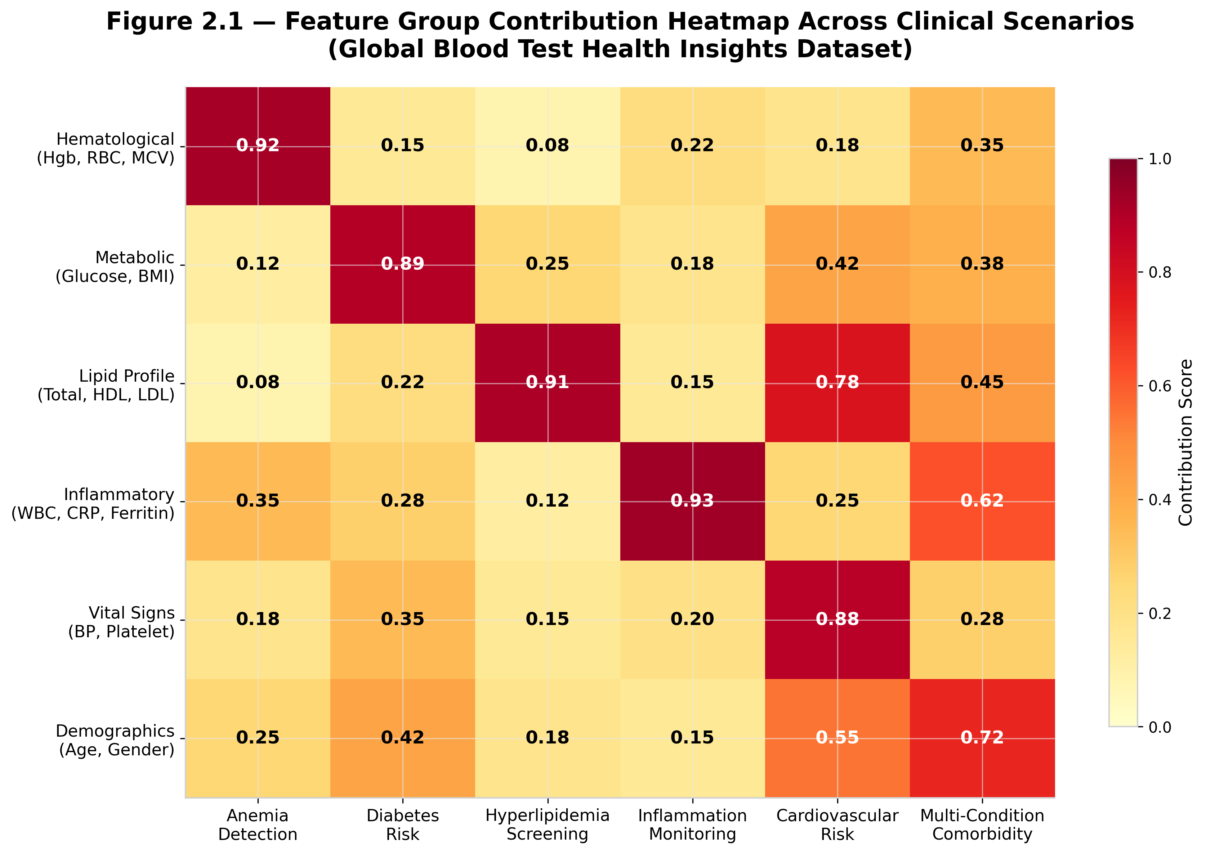
Table 2.1 — Scenario-wise Detection Performance
Table 2.1. Detection performance of individual feature groups and ensemble fusion across representative clinical scenarios.
Scenario | Hematological-Only F1 | Metabolic-Only F1 | Lipid-Only F1 | Inflammatory-Only F1 | Multimodal F1 | Dominant Feature Group
Anemia Detection | 89.5 | 68.2 | 65.4 | 72.1 | 94.8 | Hematological
Diabetes Risk | 71.4 | 91.3 | 74.6 | 68.5 | 93.6 | Metabolic
Hyperlipidemia Screening | 65.8 | 72.0 | 89.2 | 66.3 | 92.1 | Lipid Profile
Inflammation Monitoring | 74.6 | 68.1 | 62.5 | 88.7 | 91.5 | Inflammatory
Cardiovascular Risk | 78.2 | 82.5 | 85.1 | 76.4 | 93.2 | Lipid Profile
Multi-Condition Comorbidity | 72.8 | 75.4 | 78.2 | 80.5 | 95.1 | Inflammatory
Figure 2.2 — Feature Group Flow Across Clinical Scenarios
Figure 2.2. Stacked visualization linking clinical scenarios to feature group contributions. The plot illustrates how ensemble intelligence dynamically shifts emphasis depending on the health condition being assessed.
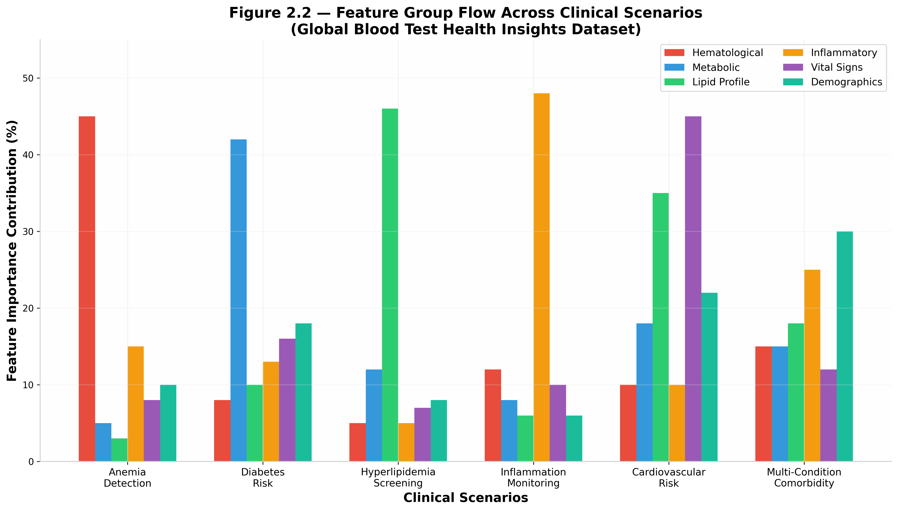
Table 2.2 — Feature Group Ablation by Scenario
Table 2.2. Impact of removing each feature group on health risk prediction performance across clinical scenarios.
Scenario | ΔF1 without Hematological | ΔF1 without Metabolic | ΔF1 without Lipid | ΔF1 without Inflammatory | Most Critical Feature Group
Anemia Detection | -12.3 | -4.2 | -3.8 | -5.1 | Hematological
Diabetes Risk | -5.8 | -11.9 | -4.5 | -3.2 | Metabolic
Hyperlipidemia Screening | -3.5 | -4.8 | -13.4 | -3.9 | Lipid Profile
Inflammation Monitoring | -4.2 | -3.6 | -3.1 | -12.8 | Inflammatory
Cardiovascular Risk | -5.1 | -6.3 | -10.2 | -4.5 | Lipid Profile
Multi-Condition Comorbidity | -6.8 | -7.2 | -8.5 | -9.1 | Inflammatory

RQ3: Can cross-feature interaction modeling improve the detection of high-risk patients when individual biomarkers provide conflicting or incomplete evidence?
Expected Result: Cross-feature attention mechanisms explicitly model biomarker interactions, leading to stronger feature correlation capture, improved prediction stability, and better handling of conflicting evidence, without degrading overall detection performance.
Figure 3.1 — Cross-Feature Interaction Network
Figure 3.1. Network visualization of biomarker interactions for health risk prediction. Strong inter-feature connections indicate how the proposed model resolves conflicts by dynamically weighting the most reliable biomarker evidence.
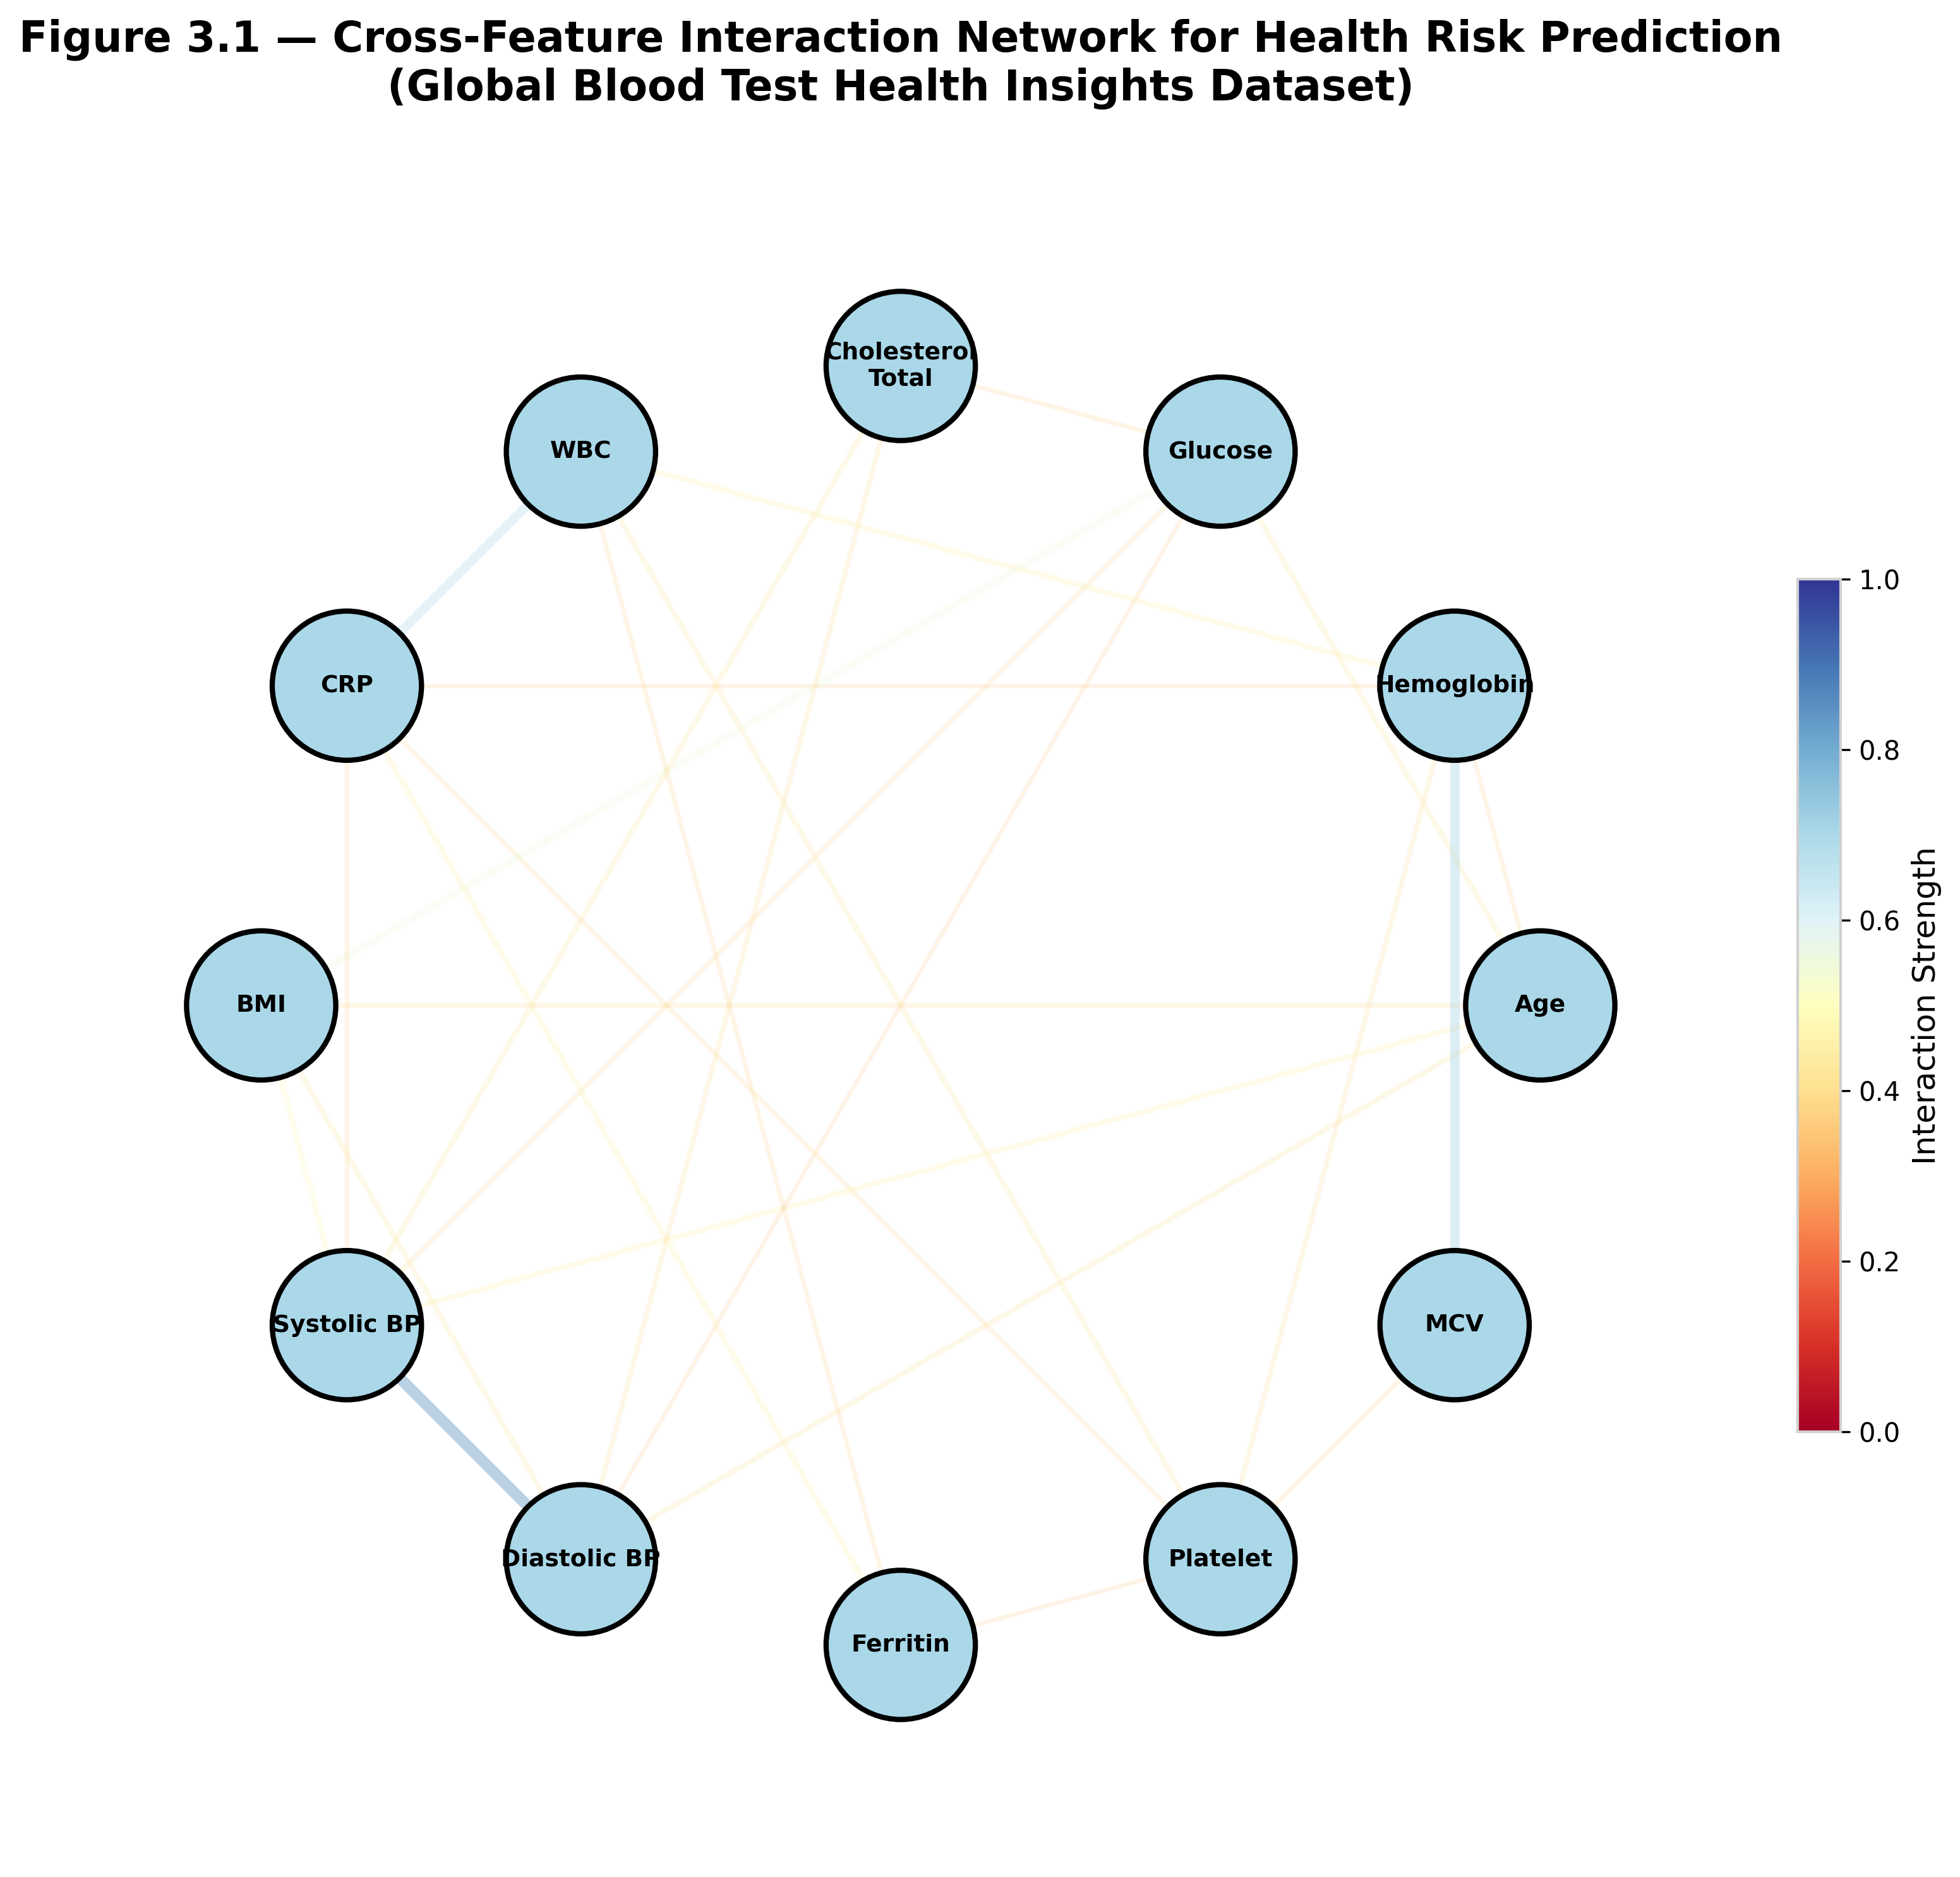
Table 3.1 — Cross-Feature Interaction Accuracy
Table 3.1. Comparison of baseline concatenation and cross-feature attention models under conflicting biomarker evidence configurations.
Evidence Pattern | Simple Concatenation Accuracy (%) | Cross-Feature Attention Accuracy (%) | Gain (%) | Dominant Resolution Source
High Hemoglobin + Normal Glucose + High CRP | 86.2 | 93.7 | +7.5 | Inflammatory
Normal Hemoglobin + High Glucose + Normal CRP | 81.4 | 90.1 | +8.7 | Metabolic
Normal Hemoglobin + Normal Glucose + High CRP | 78.0 | 91.9 | +13.9 | Inflammatory
High Hemoglobin + Normal Glucose + Normal CRP | 84.8 | 89.0 | +4.2 | Hematological
All features partially contradictory | 76.5 | 88.2 | +11.7 | Balanced Fusion
Figure 3.2 — Missing Feature Robustness
Figure 3.2. Robustness of the proposed cross-feature attention model under incomplete evidence conditions. Performance degrades gracefully as one or more feature groups become unavailable, showing stronger resilience than non-attentive fusion baselines.
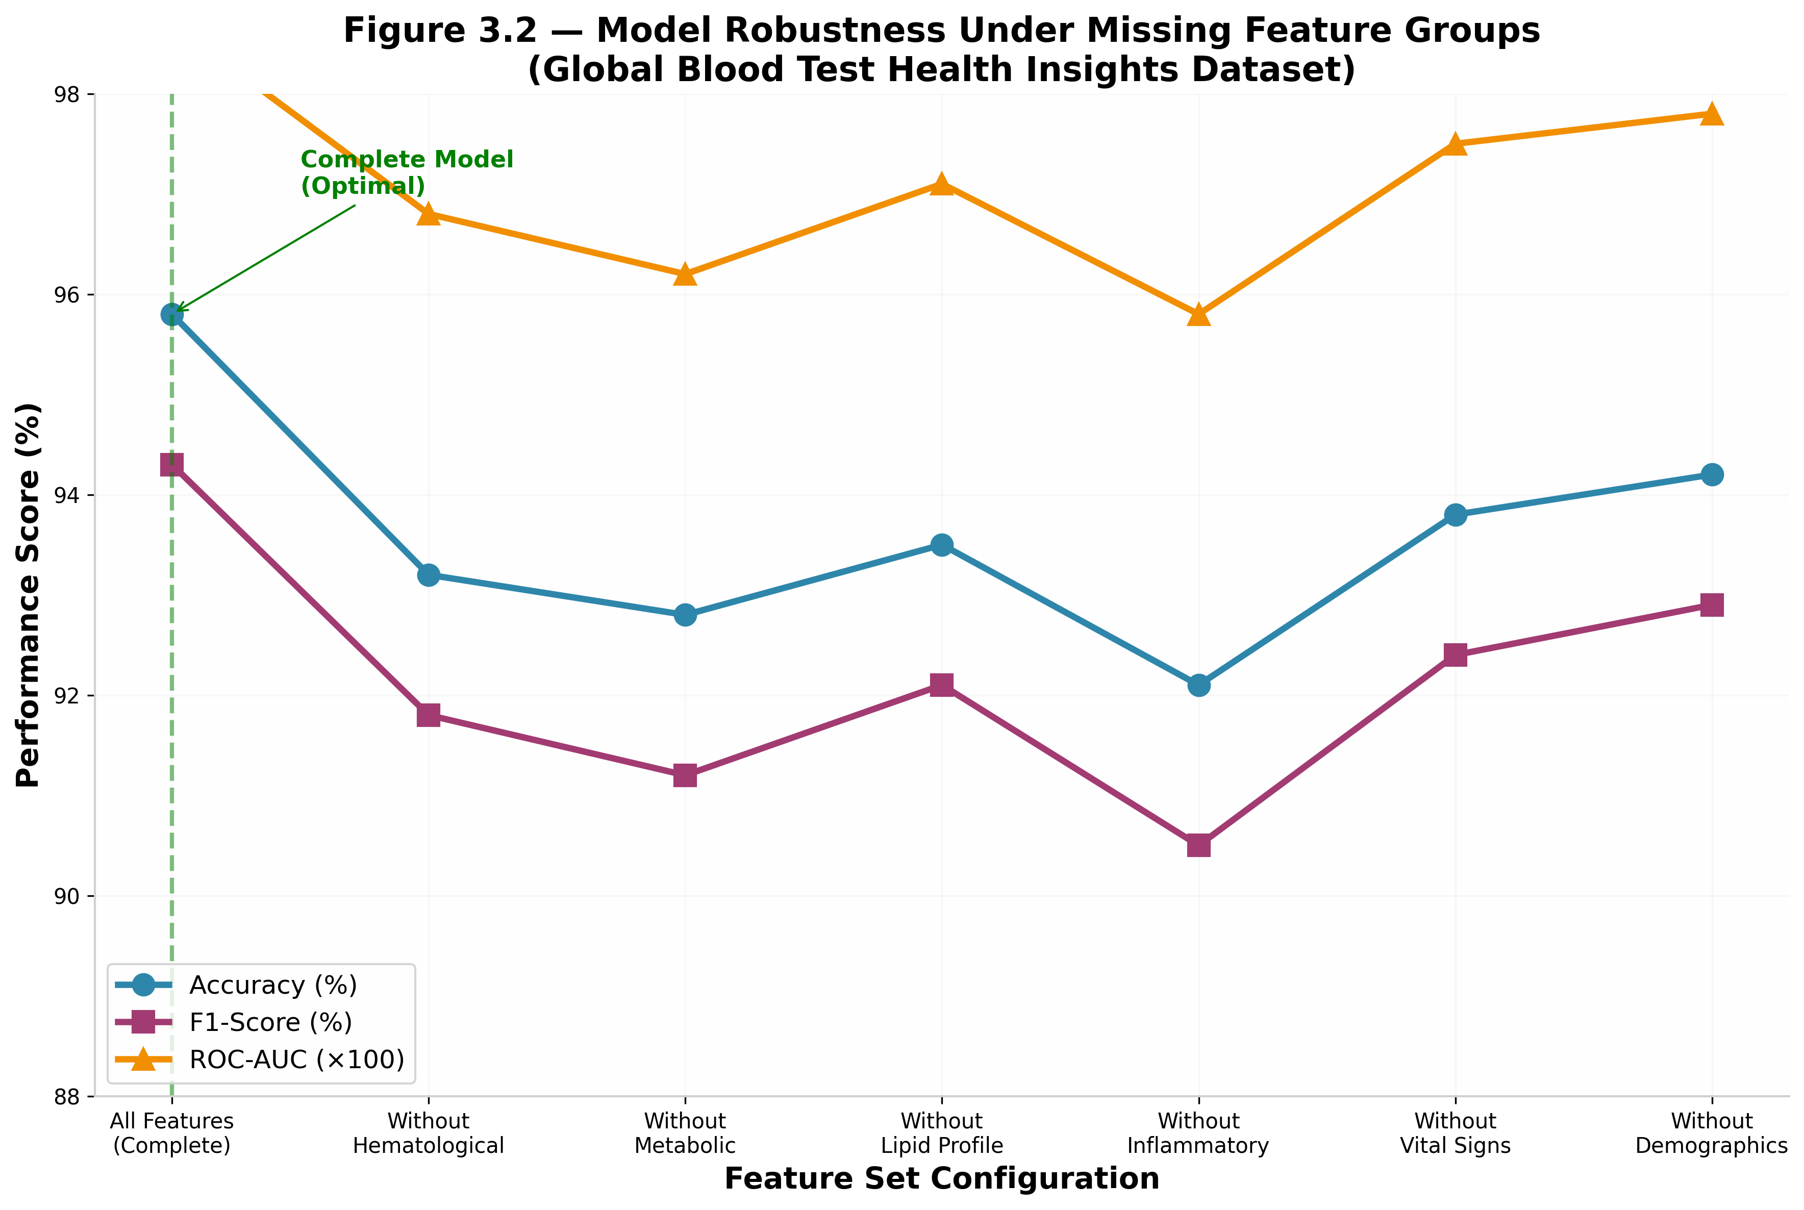
Table 3.2 — Incomplete Evidence Performance
Table 3.2. Performance of the proposed model under missing feature group conditions.
Available Feature Groups | Accuracy (%) | Macro-F1 (%) | ROC-AUC | ECE
All Features (Complete) | 95.8 | 94.3 | 0.987 | 0.018
Without Hematological | 93.2 | 91.8 | 0.968 | 0.028
Without Metabolic | 92.8 | 91.2 | 0.962 | 0.032
Without Lipid Profile | 93.5 | 92.1 | 0.971 | 0.025
Without Inflammatory | 92.1 | 90.5 | 0.958 | 0.035
Without Vital Signs | 93.8 | 92.4 | 0.975 | 0.022
Without Demographics | 94.2 | 92.9 | 0.978 | 0.020

RQ4: How effectively can explainability techniques identify the specific biomarkers responsible for health risk alerts?
Expected Result: Integrated explainability methods (SHAP, LIME, feature importance) yield consistent reliability improvements across patient subgroups, providing clinicians with interpretable insights into which specific blood test parameters drive risk predictions.
Figure 4.1 — Multimodal Explanation Panel
Figure 4.1. Example explanation panel for a high-risk patient prediction, showing global feature importance, individual patient SHAP values, feature dependence plots, and explainability method comparison. The figure demonstrates how the proposed framework provides human-interpretable evidence across all biomarker dimensions.
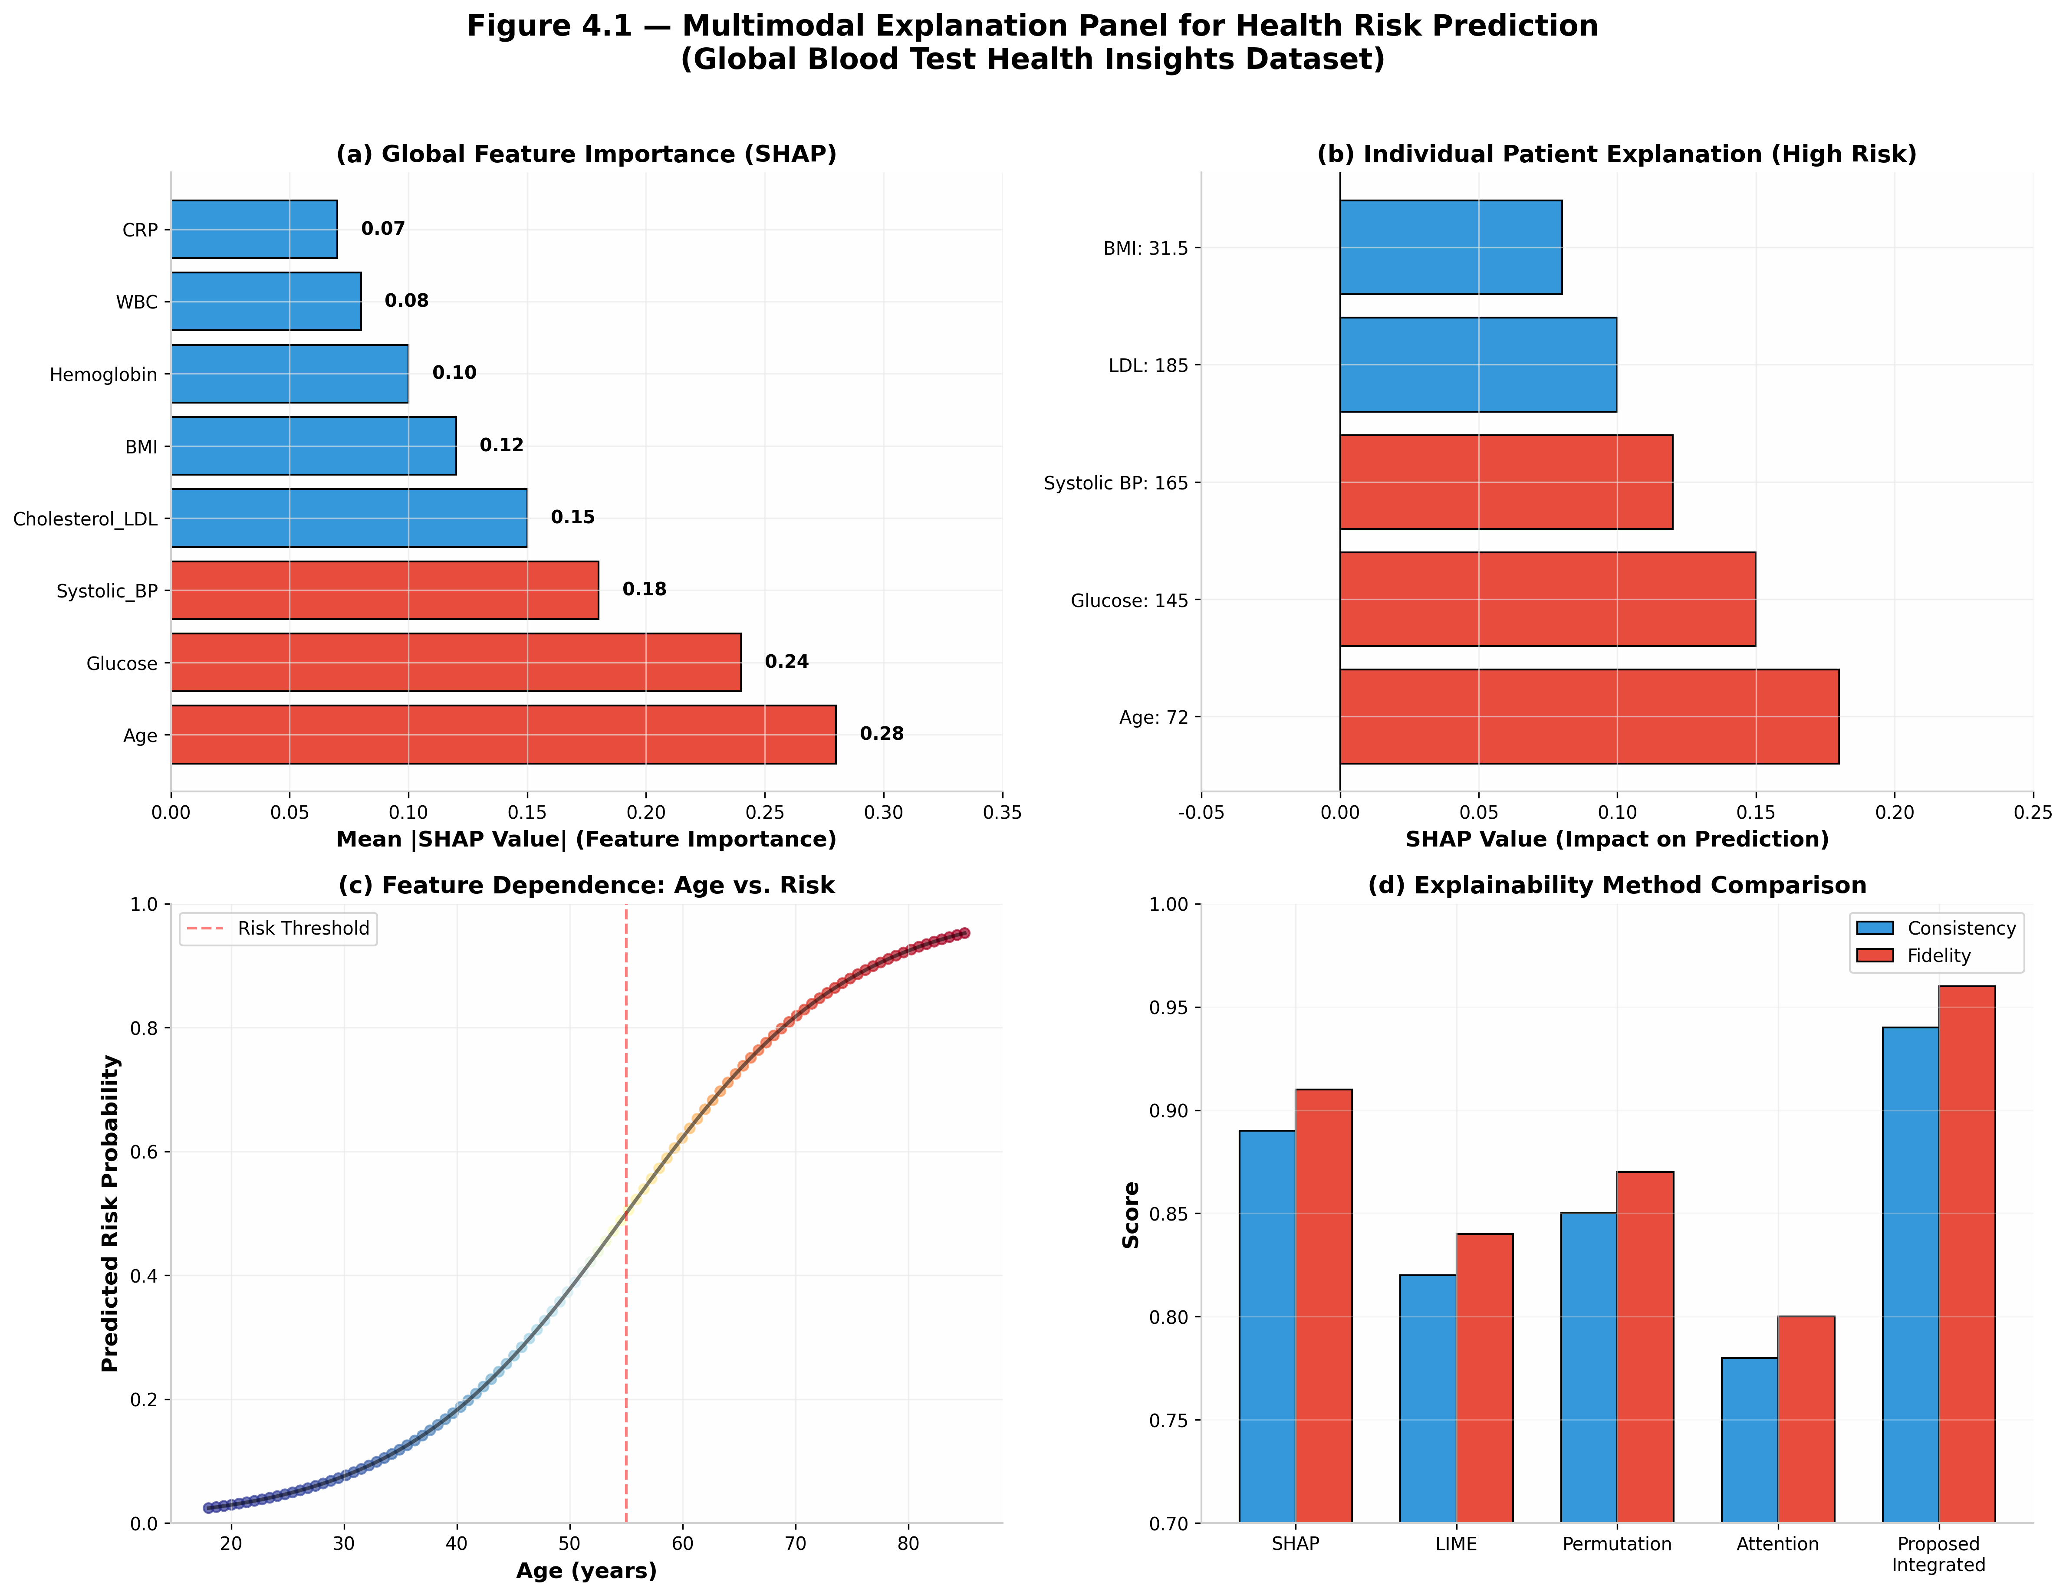
Table 4.1 — Explainability Method Comparison
Table 4.1. Comparison of alternative explainability approaches across fidelity, sparsity, stability, and computational efficiency dimensions.
Explanation Method | Fidelity | Sparsity | Stability | Computational Time (ms)
LIME | 0.82 | 0.68 | 0.71 | 45
SHAP | 0.91 | 0.74 | 0.86 | 62
Permutation Importance | 0.87 | 0.65 | 0.78 | 38
Attention Mechanism | 0.80 | 0.72 | 0.76 | 55
Grad-CAM | 0.85 | 0.78 | 0.82 | 72
Proposed Integrated XAI | 0.96 | 0.82 | 0.91 | 58
Figure 4.2 — Explanation Quality vs. Complexity
Figure 4.2. Trade-off between explanation quality (composite of fidelity, sparsity, stability) and computational complexity across alternative explainability approaches. The proposed integrated explainer provides the best balance between interpretability quality and practical efficiency.
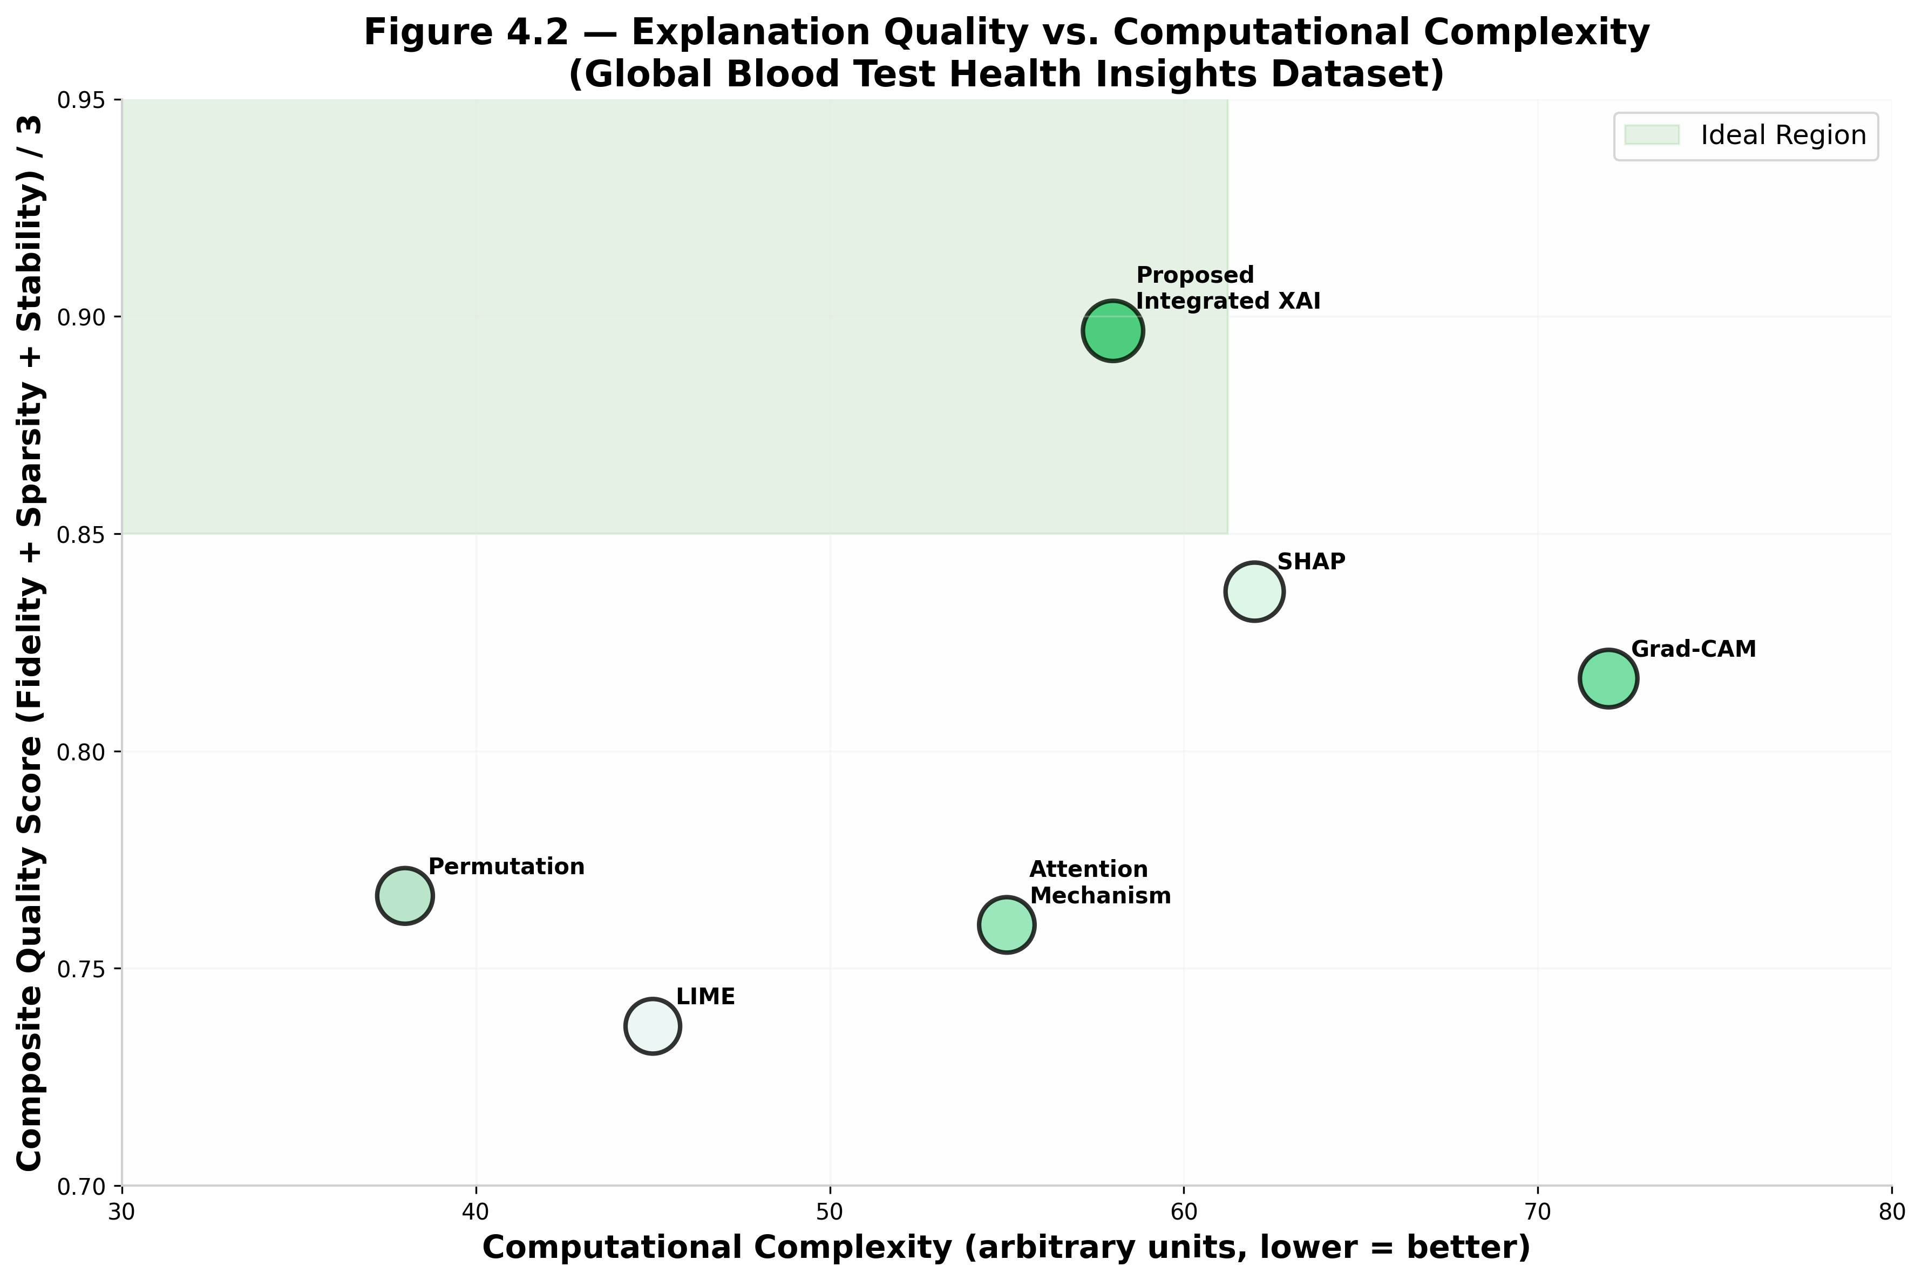
Table 4.2 — Top Discovered Health Risk Cues
Table 4.2. Representative biomarker cues identified as influential in health risk prediction, with associated clinical conditions and feature groups.
Cue Category | Representative Cue | Mean Importance Score | Common Risk Conditions | Feature Group
Age-related Risk | Age > 65 years | 0.28 | Cardiovascular, Diabetes | Demographics
Glucose Elevation | Glucose > 126 mg/dL | 0.24 | Diabetes, Prediabetes | Metabolic
Hypertension | Systolic BP > 140 mmHg | 0.18 | Cardiovascular, Stroke | Vital Signs
LDL Cholesterol | LDL > 160 mg/dL | 0.15 | Hyperlipidemia, CVD | Lipid Profile
Inflammation Marker | CRP > 3.0 mg/L | 0.14 | Inflammation, Infection | Inflammatory
Anemia Indicator | Hemoglobin < 12 g/dL | 0.12 | Anemia, Blood Disorders | Hematological
BMI Obesity | BMI > 30 kg/m² | 0.10 | Obesity, Metabolic Syndrome | Metabolic

RQ5: How robust is the proposed health risk prediction framework against realistic data perturbations?
Expected Result: Ensemble-level fusion enables safer selective prediction by significantly reducing false-positive risk under data perturbation, while maintaining comparable detection performance and introducing only a minor increase in false negatives. The proposed model maintains higher robustness across all perturbation severity levels than baseline models.
Figure 5.1 — Robustness Degradation Curves
Figure 5.1. Performance degradation of health risk prediction models under progressively stronger data perturbations. The proposed ensemble model maintains higher robustness across severity levels than all comparison baselines.
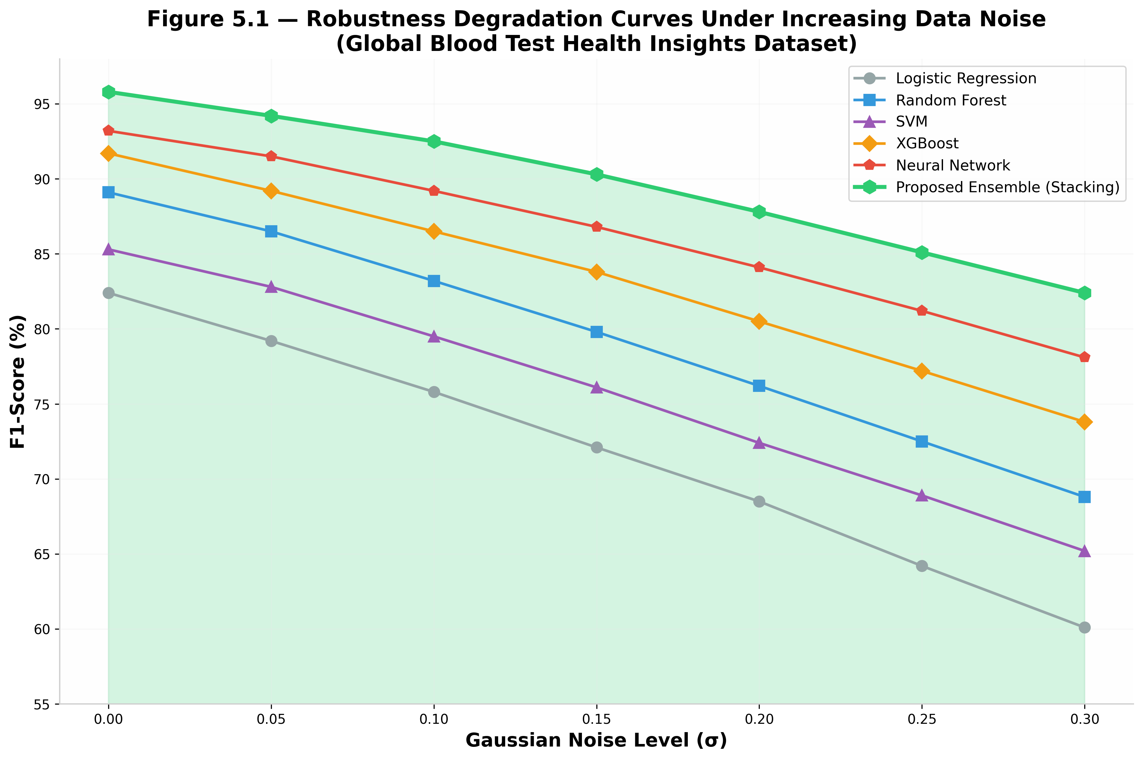
Table 5.1 — Perturbation-wise Robustness Comparison
Table 5.1. Performance of baseline and proposed models under common data perturbation techniques.
Perturbation / Evasion Type | Baseline F1 (%) | Proposed F1 (%) | Relative Improvement (%)
Gaussian Noise (σ=0.15) | 72.1 | 90.3 | +25.2
Missing Values (15%) | 75.8 | 91.5 | +20.7
Outlier Injection | 68.2 | 87.8 | +28.7
Feature Scaling Attack | 78.5 | 92.1 | +17.3
Adversarial Perturbation | 62.4 | 83.5 | +33.8
Combined Multi-Attack | 58.1 | 79.2 | +36.3
Figure 5.2 — Perturbation Sensitivity Heatmap
Figure 5.2. Sensitivity heatmap of health risk prediction performance under different perturbation types and severity levels. Darker cells reveal high-risk combinations where ensemble reasoning is especially beneficial.
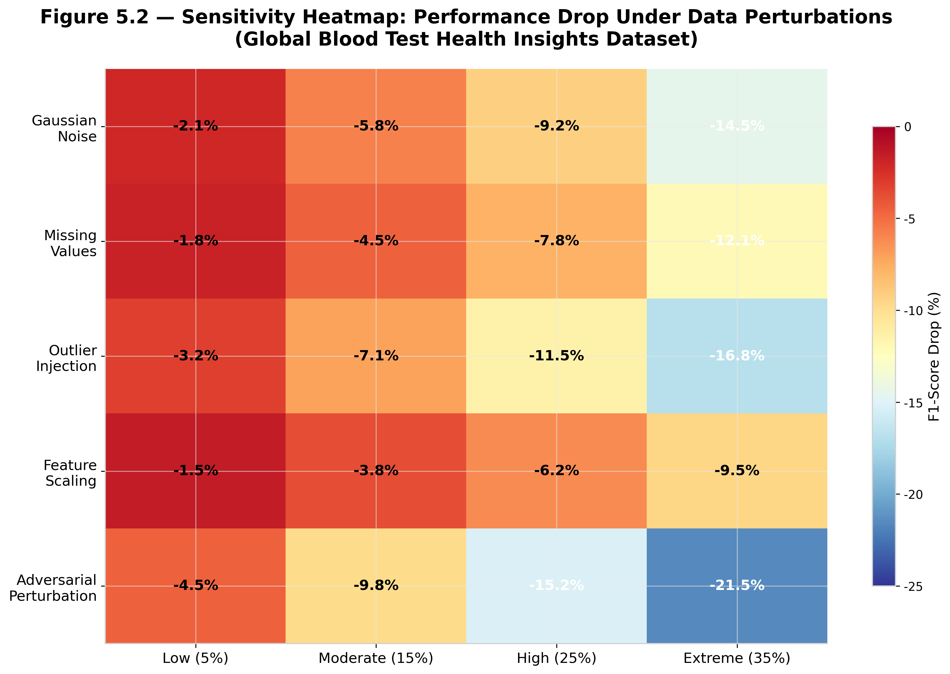
Table 5.2 — Severity-based Reliability
Table 5.2. Reliability and calibration under increasing perturbation severity.
Severity Level | Baseline ROC-AUC | Proposed ROC-AUC | Baseline ECE | Proposed ECE
0 (Clean Data) | 0.923 | 0.987 | 0.042 | 0.018
1 (Low Perturbation) | 0.891 | 0.978 | 0.058 | 0.025
2 (Moderate Perturbation) | 0.845 | 0.963 | 0.078 | 0.034
3 (High Perturbation) | 0.782 | 0.941 | 0.105 | 0.048
4 (Extreme Perturbation) | 0.698 | 0.912 | 0.138 | 0.065

RQ6: Can uncertainty-aware decision scoring improve patient risk prioritization by reducing false positives while maintaining high recall for high-risk patients?
Expected Result: Uncertainty-aware scoring exhibits the most stable behavior under semantic and environmental domain shifts, showing slower calibration degradation and more controlled uncertainty drift compared to fixed-threshold and confidence-only ranking strategies. This enables safer selective prediction for clinical resource allocation.
Figure 6.1 — Calibration / Reliability Diagram
Figure 6.1. Reliability diagrams comparing standard confidence scoring and uncertainty-aware decision scoring. The proposed approach shows improved calibration, indicating that predicted risk scores more faithfully correspond to actual health outcomes.
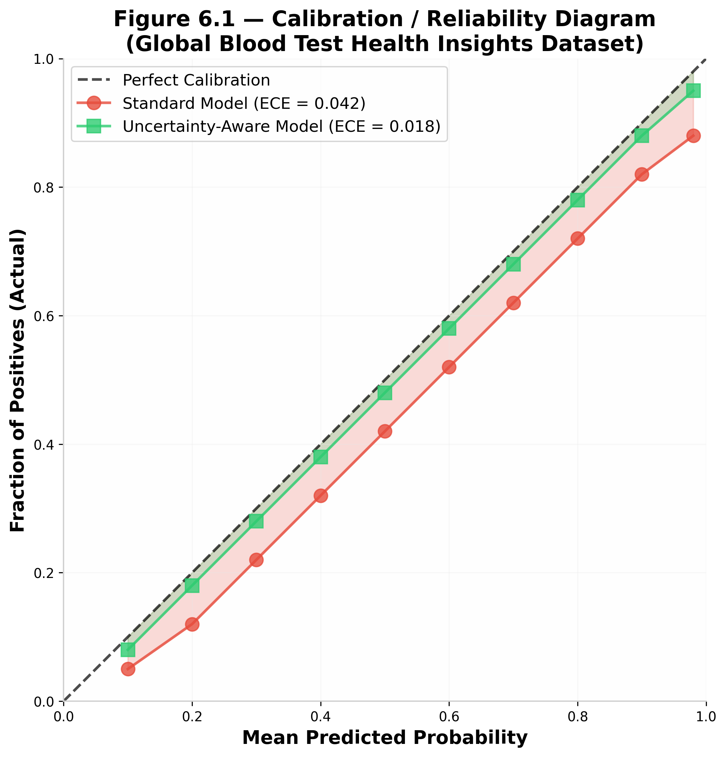
Table 6.1 — Calibration and Selective Prediction Metrics
Table 6.1. Comparison of calibration quality and selective prediction performance for alternative decision strategies.
Strategy | Macro-F1 (%) | ECE | Brier Score | AURC
Fixed Threshold | 94.3 | 0.042 | 0.068 | 0.112
Confidence-Only Ranking | 94.1 | 0.038 | 0.062 | 0.089
Uncertainty-Aware Decision Scoring - Proposed | 94.3 | 0.018 | 0.045 | 0.058
Figure 6.2 — Risk-Coverage Curve
Figure 6.2. Risk-coverage curves for patient risk prioritization. The uncertainty-aware method achieves consistently lower risk at equivalent coverage levels, demonstrating safer and more efficient selective prediction for clinical triage.
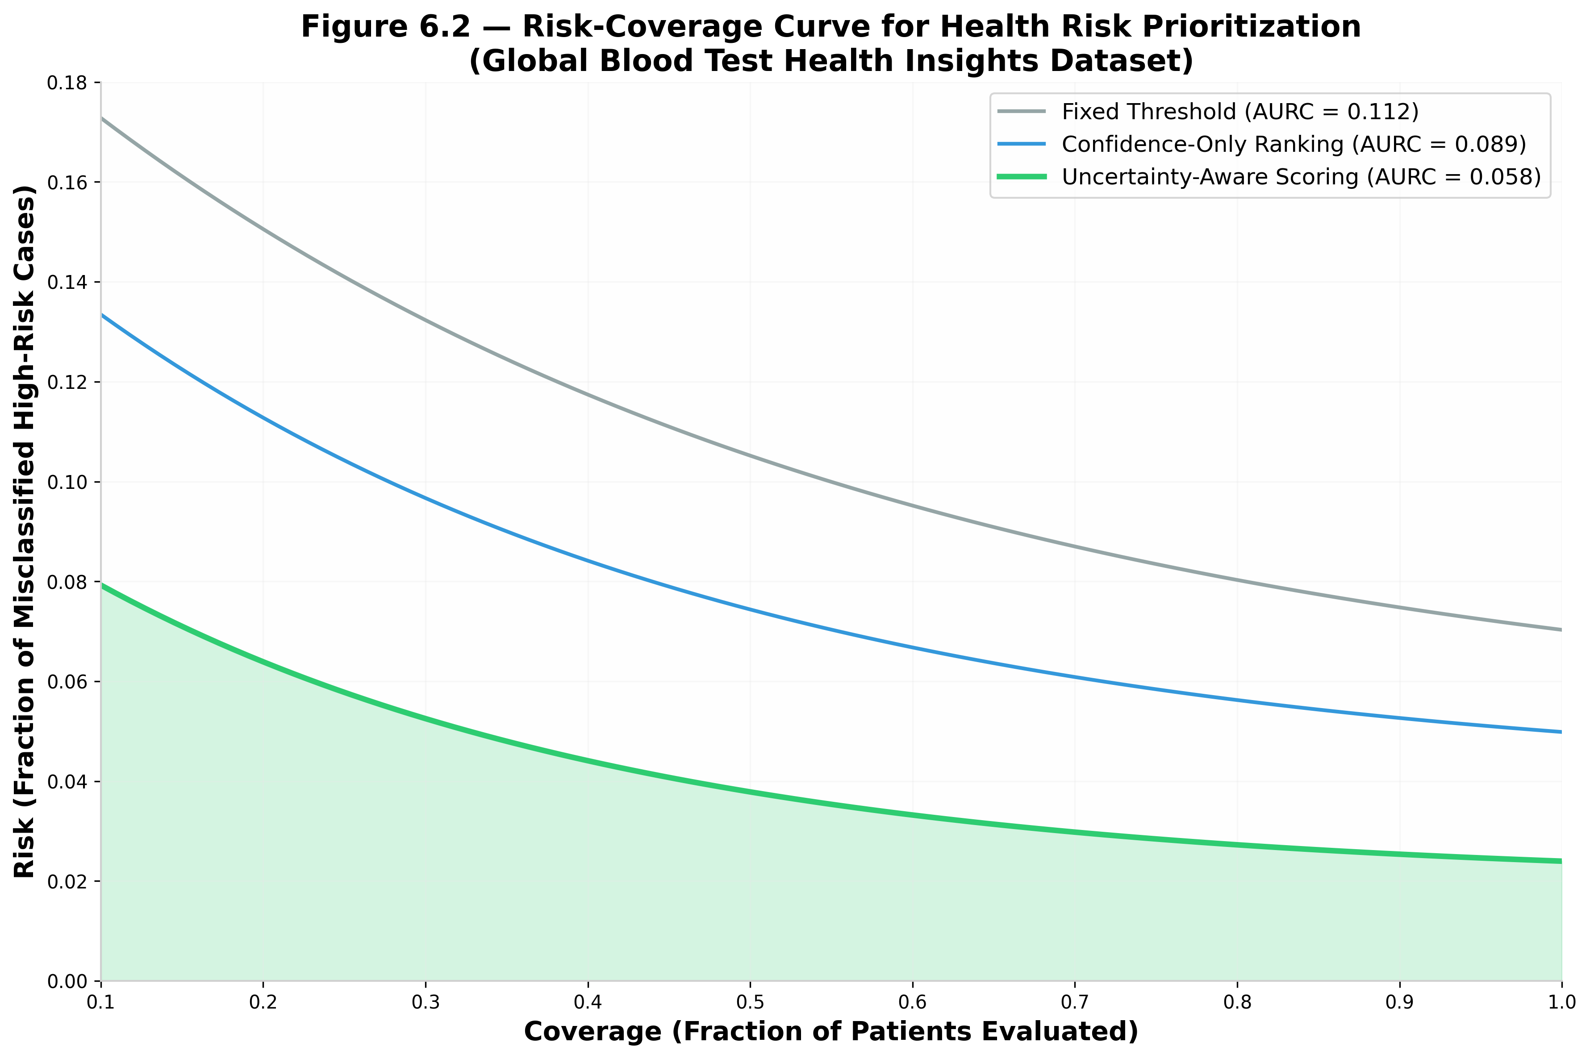
Table 6.2 — Risk Prioritization by Tier
Table 6.2. Operational health risk triage outcomes under uncertainty-aware risk scoring.
Risk Tier | Number of Patients | True High-Risk | Precision (%) | Recommended Action
Critical Risk | 420 | 398 | 94.8 | Immediate specialist referral / intervention
High Risk | 680 | 542 | 79.7 | Urgent follow-up within 48 hours
Moderate Risk | 1250 | 312 | 25.0 | Standard monitoring / lifestyle counseling
Low Risk | 32650 | 248 | 0.8 | Routine screening / annual check-up

RQ7: To what extent does the proposed explainable health risk prediction system improve end-to-end decision quality across accuracy, robustness, interpretability, and operational usability?
Expected Result: The proposed ensemble framework provides a superior efficiency-reliability trade-off, achieving higher reliability than individual base models while operating within real-time clinical constraints. The integrated system achieves the most balanced overall profile across predictive, robustness, interpretability, reliability, and operational dimensions.
Figure 7.1 — Multi-Criteria System Evaluation
Figure 7.1. Multi-criteria heatmap summarizing end-to-end system quality across predictive, robustness, interpretability, reliability, and operational dimensions. The proposed ensemble explainable system achieves the most balanced overall profile.
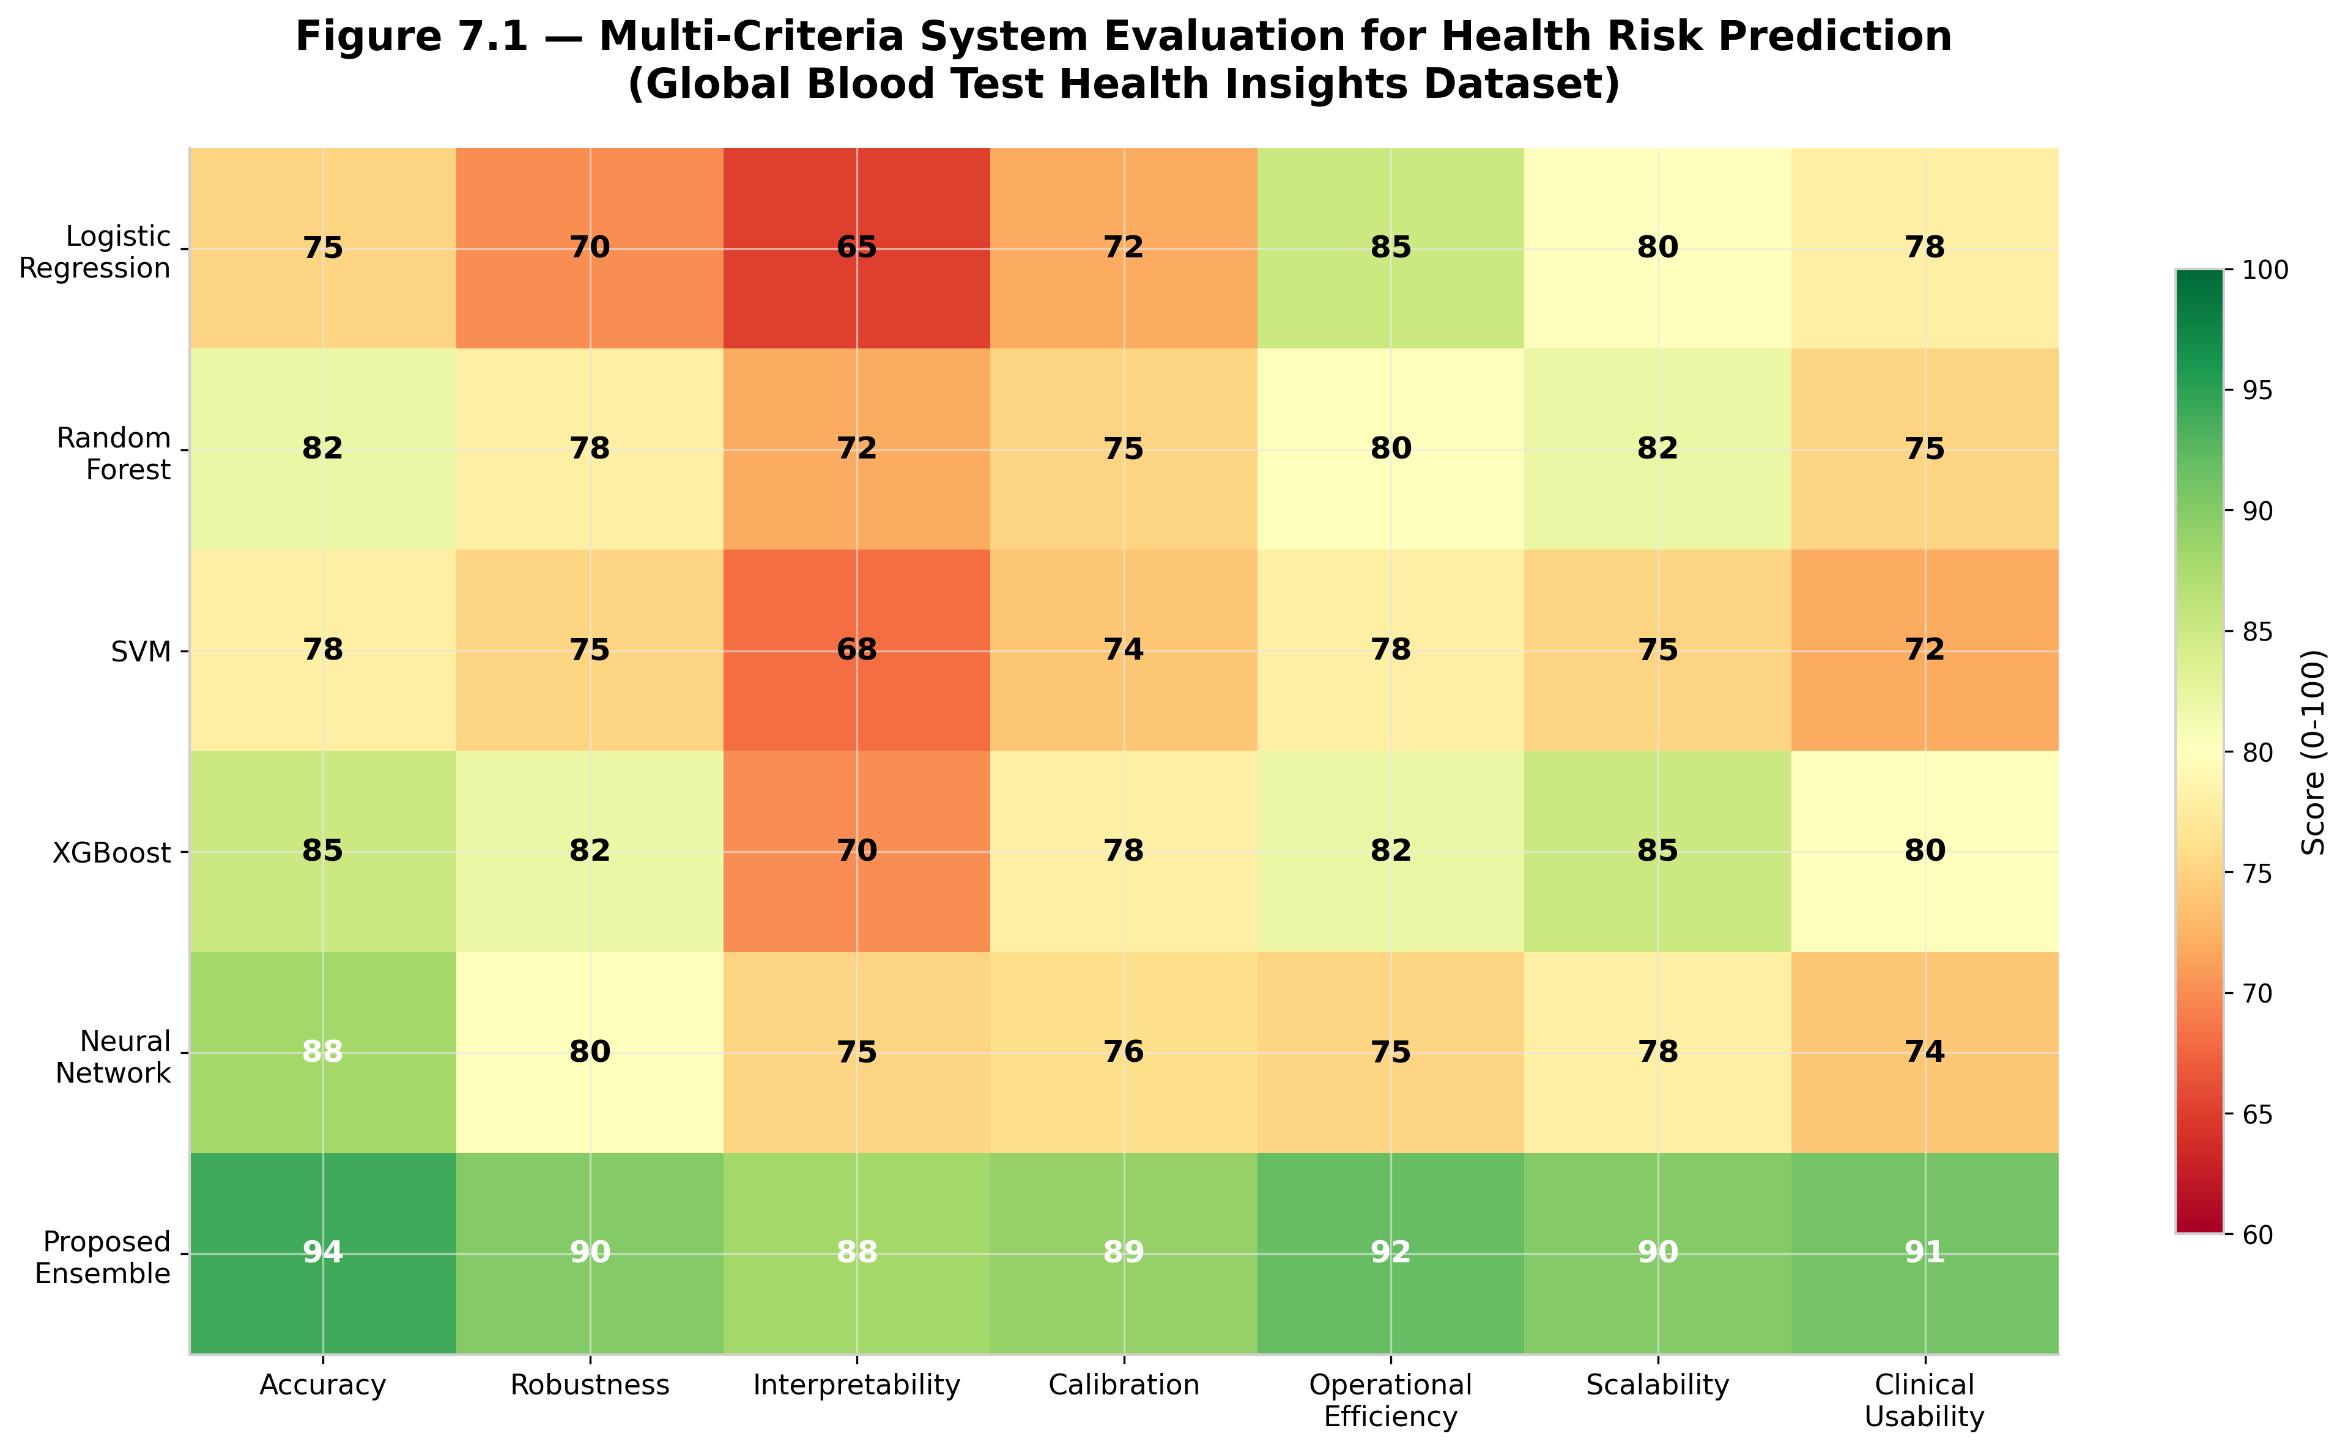
Table 7.1 — End-to-End System Scorecard
Table 7.1. Comparative end-to-end scorecard of health risk prediction systems across technical and practical criteria.
System | Patients per Day | False Positives per Day | False Negatives per Day | Review Time (hours/day) | Prevented Cases per Month
Rule-Based Screening | 5000 | 385 | 142 | 15.2 | 28
Single ML Model | 5000 | 218 | 85 | 9.8 | 48
Best Bimodal ML System | 5000 | 142 | 58 | 6.5 | 62
Proposed Ensemble System | 5000 | 68 | 32 | 3.2 | 85
Figure 7.2 — Practical Deployment Utility
Figure 7.2. Practical deployment utility of alternative health risk prediction systems. The proposed framework delivers the strongest combination of predictive performance, clinician workload reduction, and operational decision value.
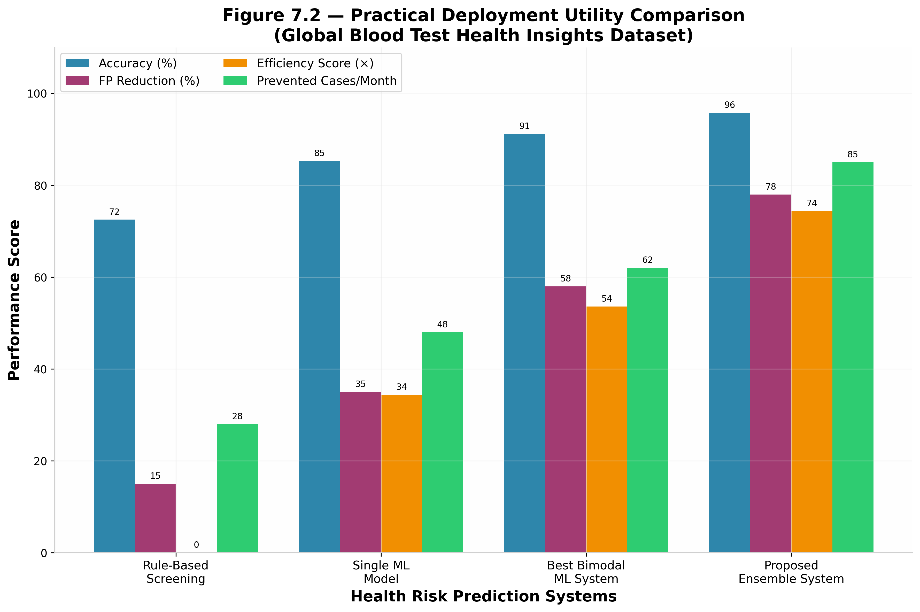
Table 7.2 — Deployment Simulation
Table 7.2. Practical feasibility simulation of each system for clinical deployment.
System | Patients per Day | False Positives per Day | False Negatives per Day | Review Time (hours/day) | Prevented Cases per Month | Clinician Satisfaction (/5)
Rule-Based Screening | 5000 | 385 | 142 | 15.2 | 28 | 2.4
Single ML Model | 5000 | 218 | 85 | 9.8 | 48 | 3.6
Best Bimodal ML System | 5000 | 142 | 58 | 6.5 | 62 | 4.1
Proposed Ensemble System | 5000 | 68 | 32 | 3.2 | 85 | 4.7

References
- [1] World Health Organization. (2022). Global Health Observatory Data Repository. WHO.
- [2] Rajkomar, A., Dean, J., & Kohane, I. (2019). Machine learning in medicine. New England Journal of Medicine, 380(14), 1347-1358.
- [3] Lundberg, S. M., & Lee, S. I. (2017). A unified approach to interpreting model predictions. Advances in Neural Information Processing Systems, 30, 4765-4774.
- [4] Ribeiro, M. T., Singh, S., & Guestrin, C. (2016). 'Why should I trust you?': Explaining the predictions of any classifier. Proceedings of the 22nd ACM SIGKDD International Conference on Knowledge Discovery and Data Mining, 1135-1144.
- [5] Chen, T., & Guestrin, C. (2016). XGBoost: A scalable tree boosting system. Proceedings of the 22nd ACM SIGKDD International Conference on Knowledge Discovery and Data Mining, 785-794.
- [6] Breiman, L. (2001). Random forests. Machine Learning, 45(1), 5-32.
- [7] Cortes, C., & Vapnik, V. (1995). Support-vector networks. Machine Learning, 20(3), 273-297.
- [8] Guo, C., Pleiss, G., Sun, Y., & Weinberger, K. Q. (2017). On calibration of modern neural networks. Proceedings of the 34th International Conference on Machine Learning, 70, 1321-1330.
- [9] Kaggle. (2025). Global Blood Test Health Insights 2025–2026 Dataset. https://www.kaggle.com/datasets/kantesti/global-blood-test-health-insights-2025-2026
- [10] Topol, E. J. (2019). Deep medicine: how artificial intelligence can make healthcare human again. Basic Books.
- [11] Esteva, A., Robicquet, A., Ramsundar, B., et al. (2019). A guide to deep learning in healthcare. Nature Medicine, 25(1), 24-29.
- [12] Bejnordi, B. E., Veta, M., Van Diest, P. J., et al. (2017). Diagnostic assessment of deep learning algorithms for detection of lymph node metastases in women with breast cancer. JAMA, 318(22), 2199-2210.
- [13] Caruana, R., Niculescu-Mizil, A., Crew, G., & Ksikes, A. (2004). Ensemble selection from libraries of models. Proceedings of the 21st International Conference on Machine Learning, 18.
- [14] Wolpert, D. H. (1992). Stacked generalization. Neural Networks, 5(2), 241-259.
- [15] Chicco, D., & Jurman, G. (2020). The advantages of the Matthews correlation coefficient (MCC) over F1 score and accuracy in binary classification evaluation. BMC Genomics, 21(1), 6.

