REPORT

**By**

|  |  |  |  |
| --- | --- | --- | --- |
| Sr. No. | Registration No | Name of Students | Roll No |
| 1 | **11706946** | **Gayathri Kilaru** | 30 |
| 2 | **11706854** | **Lokesh Veeravalli** | 37 |
| 3 | **11706725** | **Ruchitha Sevakula** | 16 |

**SECTION:K17RE**



**Department of Intelligent Systems**

**School of Computer Science Engineering**

**Lovely Professional University, Jalandhar**

OBJECTIVES

* To design a calculator with the help of tkinter in order to get the Graphical User Interface.
* To design a window consisting of buttons and the answer window.
* To use classes and methods in the program.

CODE

import tkinter

from tkinter import *

class Application(Frame):

""" Main class for calculator"""

def __init__(self, master):

""" Initialise the Frame. """

super(Application, self).__init__(master)

self.task = ""

self.UserIn = StringVar()

self.grid()

self.create_widgets()

def create_widgets(self):

""" Create all the buttons for calculator. """

# User input stored as an Entry widget.

self.user_input = Entry(self, bg = "#5BC8AC", bd = 29,

insertwidth = 4, width = 24,

font = ("Verdana", 20, "bold"), textvariable = self.UserIn, justify = RIGHT)

self.user_input.grid(columnspan = 4)

self.user_input.insert(0, "0")

# Button for value 7

self.button1 = Button(self, bg = "#98DBC6", bd = 12,

text = "7", padx = 33, pady = 25, font = ("Helvetica", 20, "bold"),

command = lambda : self.buttonClick(7))

self.button1.grid(row = 2, column = 0, sticky = W)

# Button for value 8

self.button2 = Button(self, bg = "#98DBC6", bd = 12,

text = "8", padx = 35, pady = 25,

command = lambda : self.buttonClick(8), font = ("Helvetica", 20, "bold"))

self.button2.grid(row = 2, column = 1, sticky = W)

# Button for value 9

self.button3 = Button(self, bg = "#98DBC6", bd = 12,

text = "9", padx = 33, pady = 25,

command = lambda : self.buttonClick(9), font = ("Helvetica", 20, "bold"))

self.button3.grid(row = 2, column = 2, sticky = W)

# Button for value 4

self.button4 = Button(self, bg = "#98DBC6", bd = 12,

text = "4", padx = 33, pady = 25,

command = lambda : self.buttonClick(4), font = ("Helvetica", 20, "bold"))

self.button4.grid(row = 3, column = 0, sticky = W)

# Button for value 5

self.button5 = Button(self, bg = "#98DBC6", bd = 12,

text = "5", padx = 35, pady = 25,

command = lambda : self.buttonClick(5), font = ("Helvetica", 20, "bold"))

self.button5.grid(row = 3, column = 1, sticky = W)

# Button for value 6

self.button6 = Button(self, bg = "#98DBC6", bd = 12,

text = "6", padx = 33, pady = 25,

command = lambda : self.buttonClick(6), font = ("Helvetica", 20, "bold"))

self.button6.grid(row = 3, column = 2, sticky = W)

# Button for value 1

self.button7 = Button(self, bg = "#98DBC6", bd = 12,

text = "1", padx = 33, pady = 25,

command = lambda : self.buttonClick(1), font = ("Helvetica", 20, "bold"))

self.button7.grid(row = 4, column = 0, sticky = W)

# Button for value 2

self.button8 = Button(self, bg = "#98DBC6", bd = 12,

text = "2", padx = 35, pady = 25,

command = lambda : self.buttonClick(2), font = ("Helvetica", 20, "bold"))

self.button8.grid(row = 4, column = 1, sticky = W)

# Button for value 3

self.button9 = Button(self, bg = "#98DBC6", bd = 12,

text = "3", padx = 33, pady = 25,

command = lambda : self.buttonClick(3), font = ("Helvetica", 20, "bold"))

self.button9.grid(row = 4, column = 2, sticky = W)

# Button for value 0

self.button9 = Button(self, bg = "#98DBC6", bd = 12,

text = "0", padx = 33, pady = 25,

command = lambda : self.buttonClick(0), font = ("Helvetica", 20, "bold"))

self.button9.grid(row = 5, column = 0, sticky = W)

# Operator buttons

# Addition button

self.Addbutton = Button(self, bg = "#98DBC6", bd = 12,

text = "+", padx = 36, pady = 25,

command = lambda : self.buttonClick("+"), font = ("Helvetica", 20, "bold"))

self.Addbutton.grid(row = 2, column = 3, sticky = W)

# Subtraction button

self.Subbutton = Button(self, bg = "#98DBC6", bd = 12,

text = "-", padx = 39, pady = 25,

command = lambda : self.buttonClick("-"), font = ("Helvetica", 20, "bold"))

self.Subbutton.grid(row = 3, column = 3, sticky = W)

# Multiplication button

self.Multbutton = Button(self, bg = "#98DBC6", bd = 12,

text = "*", padx = 38, pady = 25,

command = lambda : self.buttonClick("*"), font = ("Helvetica", 20, "bold"))

self.Multbutton.grid(row = 4, column = 3, sticky = W)

# Division button

self.Divbutton = Button(self, bg = "#98DBC6", bd = 12,

text = "/", padx = 39, pady = 25,

command = lambda : self.buttonClick("/"), font = ("Helvetica", 20, "bold"))

self.Divbutton.grid(row = 5, column = 3, sticky = W)

# Equal button

self.Equalbutton = Button(self, bg = "#E6D72A", bd = 12,

text = "=", padx = 100, pady = 25,

command = self.CalculateTask, font = ("Helvetica", 20, "bold"))

self.Equalbutton.grid(row = 5, column = 1, sticky = W, columnspan = 2)

# Clear Button

self.Clearbutton = Button(self, bg = "#E6D72A", bd = 12,

text = "AC", font = ("Helvetica", 20, "bold"), width = 28, padx = 7, command = self.ClearDisplay)

self.Clearbutton.grid(row = 1, columnspan = 4, sticky = W)

def buttonClick(self, number):

self.task = str(self.task) + str(number)

self.UserIn.set(self.task)

def CalculateTask(self):

self.data = self.user_input.get()

try:

self.answer = eval(self.data)

self.displayText(self.answer)

self.task = self.answer

except SyntaxError as e:

self.displayText("Invalid Syntax!")

self.task = ""

def displayText(self, value):

self.user_input.delete(0, END)

self.user_input.insert(0, value)

def ClearDisplay(self):

self.task = ""

self.user_input.delete(0, END)

self.user_input.insert(0, "0")

calculator = Tk()

calculator.title("Calculator")

app = Application(calculator)

# Make window fixed (cannot be resized)

calculator.resizable(width = False, height = False)

calculator.mainloop()

GRAPHICAL USER INTERFACE

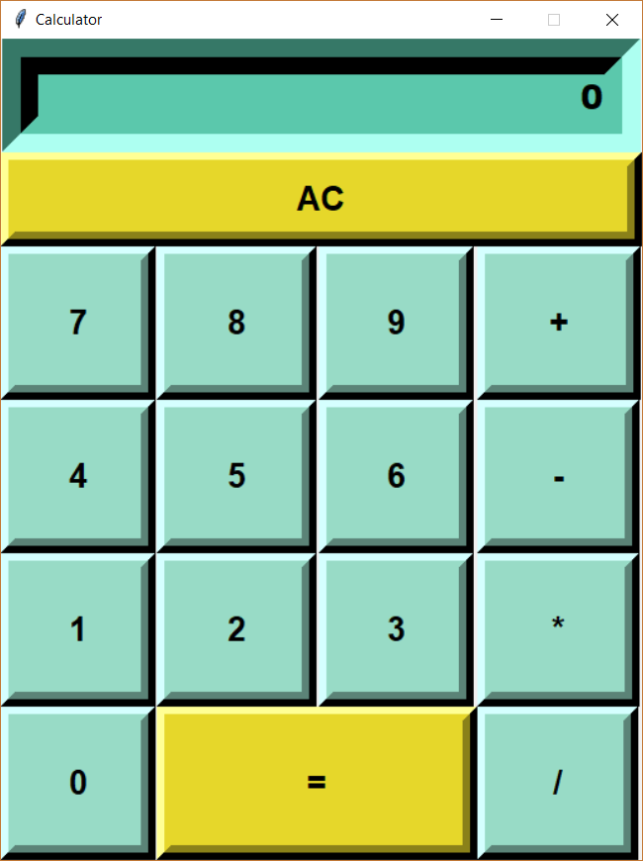

EXPLANATION

This program is a simple calculator that is designed using tkinter in Python 3.6.5 version. This program contains :

1. Buttons
2. Methods
3. Classes

Every button is designed with padding, added background colour to it and also contains a command for which the action to be performed. Whenever a button is clicked to the display widget window where the pressed button number is displayed and whenever ‘=’ is clicked then the operation is performed on given information it may be addition, subtraction, multiplication. There are 9 different modules with comments attached to each and every module for clear explanation.

RESULT

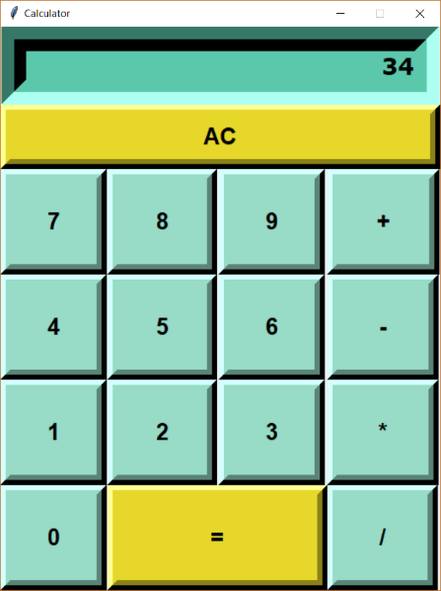 12+22 =34 is the result.

