Ex. No.: 1 | Write a simple HTML code to display data / content on a web page.
Date:

Aim
To create a simple HTML Code to display data / Content on a web page
Introduction
HTML is an acronym which stands for Hyper Text Markup Language which is used for creating web pages and web applications. Let's see what is meant by Hypertext Markup Language, and Web page.
Hyper Text: HyperText simply means "Text within Text." A text has a link within it, is a hypertext. Whenever you click on a link which brings you to a new webpage, you have clicked on a hypertext. HyperText is a way to link two or more web pages (HTML documents) with each other.
Markup language: A markup language is a computer language that is used to apply layout and formatting conventions to a text document. Markup language makes text more interactive and dynamic. It can turn text into images, tables, links, etc.
Web Page: A web page is a document which is commonly written in HTML and translated by a web browser. A web page can be identified by entering an URL. A Web page can be of the static or dynamic type. With the help of HTML only, we can create static web pages.
HTML Tags
HTML tags contain three main parts: opening tag, content and closing tag. But some HTML tags are unclosed tags.
- All HTML tags must enclosed within < > these brackets.
- Every tag in HTML perform different tasks.
- If you have used an open tag <tag>, then you must use a close tag </tag> (except some tags)
Syntax
<tag> content </tag>
Examples
<p> Paragraph Tag </p>

<h2> Heading Tag </h2>
<b> Bold Tag </b>
<i> Italic Tag </i>
<u> Underline Tag</u>
Unclosed HTML Tags
Some HTML tags are not closed, for example br and hr.
<br> Tag: br stands for break line, it breaks the line of the code.
<hr> Tag: hr stands for Horizontal Rule. This tag is used to put a line across the webpage.
HTML Meta Tags
DOCTYPE, title, link, meta and style
HTML Text Tags
<p>, <h1>, <h2>, <h3>, <h4>, <h5>, <h6>, <strong>, <em>, <abbr>, <acronym>, <address>, <bdo>, <blockquote>, <cite>, <q>, <code>, <ins>, <del>, <dfn>, <kbd>, <pre>, <samp>, <var> and <br>
HTML Link Tags
<a> and <base>
HTML Image and Object Tags
<img>, <area>, <map>, <param> and <object>
HTML List Tags
<ul>, <ol>, <li>, <dl>, <dt> and <dd>
HTML Table Tags
table, tr, td, th, tbody, thead, tfoot, col, colgroup and caption
HTML Form Tags
form, input, textarea, select, option, optgroup, button, label, fieldset and legend
HTML Scripting Tags
script and noscript
Source Code:
<Html> <!-- This tag is compulsory for any HTML document. -->
<Head> <!-- The Head tag is used to create a title of web page, CSS syntax for a web page, and helps in written a JavaScript code. -->
<title>
Example of Title tag
</title>
</Head>
<Body>
<!-- The Body tag is used to display the content on a web page. In this example we do not specify any content or any tag, so in output nothing will display on the web page. -->
<b> [This text is Bold......] </b>
<I> [This text is Italic......] </I>
<U> [This text is Underline......] </U>
<p> <!-- It is a Paragraph tag for creating the paragraph -->
<b> HTML </b> stands for <i> <u> Hyper Text Markup Language. </u> </i> It is used to create a web pages and applications. This language
is easily understandable by the user and also be modifiable. It is actually a Markup language, hence it provides a flexible way for designing the
web pages along with the text.
</p>
HTML file is made up of different elements. <b> An element </b> is a collection of <i> start tag, end tag, attributes and the text between them</i>.
</p>
<h6> H6 Heading Text </h6>
<h5> H5 Heading Text </h5>
<h4> H4 Heading Text </h4>
<h3> H3 Heading Text </h3>
<h2> H2 Heading Text </h2>
<h1> H1 Heading Text </h1>
<!-- In this example we use the center tag which specify the content at centre of the webpage.-->
<center>
Text in Center alignment <br> <!-- The BR tag is used to break a line. -->
HTML Tutorial for Simple Web Page <br>
</center>
JavaScript tutorial in for next line statement <!-- Here BR tag is not used, so the next statement is in continuous with one space after this statement. -->
Jquery tutorial in JavaTpoint <br>
<!-- In this example we use the anchor tag for linking one page to another by using the href attribute which specify the url of the second page which you want to link.-->
<center> Click on <a href="https://www.w3schools.com/html/html_headings.asp"> this link </a> for reading about HTML favicon in w3schools.
</center>
</Body>
</Html>

Output:
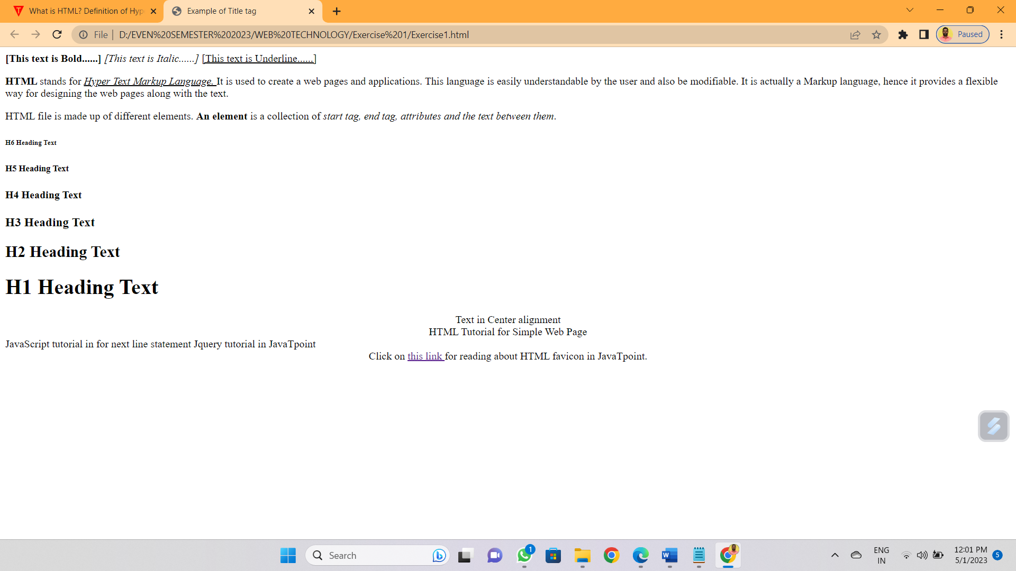

Result:
Thus, a simple HTML Code to display data / Content on a web page is created and output was verified.

