**Assignment:**

1.       Difference between ‘this’ and ‘let’ and when to use what, explain with examples.

2.       Write a function which accepts an array of strings and returns a map of character to

count of the character(including spaces and special characters).

Eg: input: [‘hello world’, ‘hello world’]  output: {h: 2, e: 2, l: 6, ‘ ‘: 1, o: 4 …… }

3.       Write a function to return all the keys present in an object at any level.

Eg: input: {  a: 5, b: { c: { d: 10 } }}   output: [a, b, c, d]

4.       Write a function to reverse every word of a string.

* Using split and reverse
* Without using split and reverse and in O(1) space (since strings are immutable, assume that the input is a character array).

5.       Write a function to remove duplicate strings from an array of strings.

Angular Version : Angular 6

Typescript : 2.9

**Let and Var Keywords:** Below is the snapshot of let and var key words

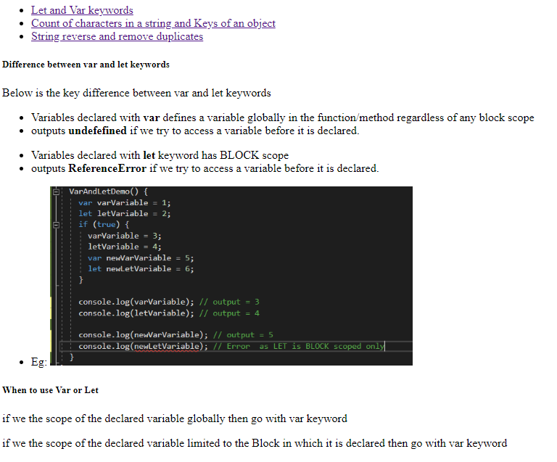

**Count of Characters in a string:**

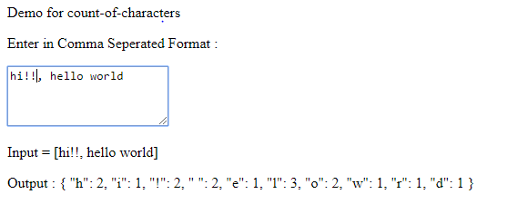

**Keys of Object:**

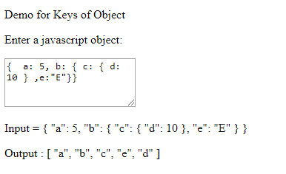

**String Reverse:**

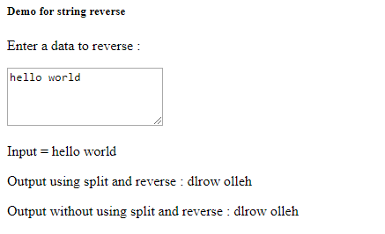

**Remove duplicates from Array:**

