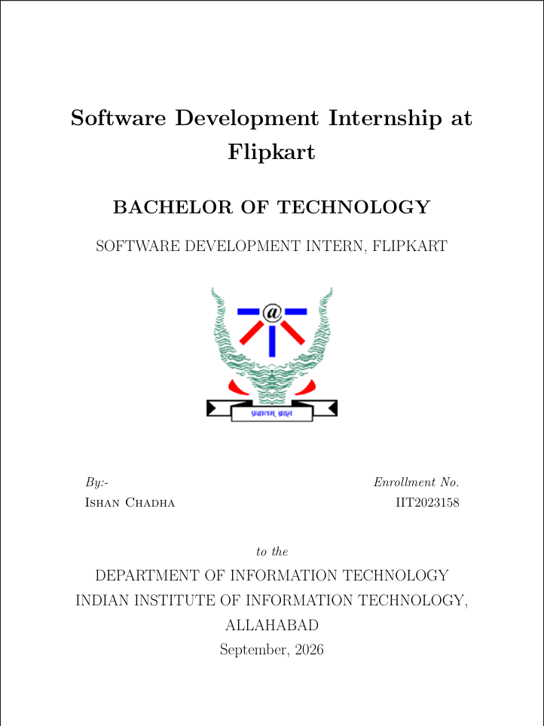

Table of Contents
1. Introduction
2. About the Organization
3. Problem Statement
4. Project Overview - Taru Platform
5. Technology Stack
6. System Architecture & Design
7. Features Implemented
8. My Contributions & Work Done
9. Challenges Faced & Solutions
10. Key Learnings & Skills Acquired
11. Conclusion & Future Scope

1. Introduction
This report presents the work carried out during my Software Development Internship at Cogniease Techno Labs Pvt. Ltd. during the period of August 2026 to September 2026. The internship was undertaken as part of the curriculum requirement for the Bachelor of Technology program at the Indian Institute of Information Technology, Allahabad.
During this internship, I worked as a Full-Stack Developer on "Taru" - an Emotional Wellbeing Platform designed specifically for college students. The platform aims to address the growing mental health crisis among college students by providing a comprehensive, accessible, and confidential digital space for emotional support.
The internship provided me with hands-on experience in modern web development technologies including React.js, Node.js, Express.js, MongoDB, Socket.IO, and WebRTC. I was responsible for designing, developing, and deploying multiple full-stack features across the platform, contributing over 33 commits to the project repository over the internship duration.

1.1 Objectives of the Internship
- To gain practical experience in full-stack web application development in a professional setting.
- To understand the software development lifecycle (SDLC) in a startup environment.
- To develop proficiency in modern frontend and backend technologies.
- To learn real-time communication systems including WebSockets and WebRTC.
- To contribute meaningfully to a production-grade application serving real users.
- To develop skills in database design, API development, and authentication systems.

2. About the Organization
Cogniease Techno Labs Pvt. Ltd. is a technology company focused on building digital solutions for mental health and emotional wellbeing. The company is committed to leveraging technology to make mental health support more accessible, affordable, and stigma-free, particularly for young adults and college students.
The company's flagship product, Taru, is an emotional wellbeing platform that combines evidence-based mental health assessments, peer support systems, professional counseling access, and stress-relief tools into a single unified platform. The vision of Cogniease is to create technology that genuinely helps people take care of their mental health without the barriers of traditional mental health services.

2.1 Work Environment
The internship was conducted in a remote/hybrid work setting, typical of modern technology startups. The team followed Agile development practices with regular code reviews, feature branches, and pull request-based workflows using GitHub. The collaborative environment encouraged learning, experimentation, and ownership of features from conception to deployment.

3. Problem Statement
Mental health issues among college students have reached alarming levels globally. Research indicates that approximately 1 in 3 college students experience significant anxiety or depression during their academic career. Despite this prevalence, the majority of affected students never seek professional help due to several barriers:
- Stigma: Fear of being judged by peers, faculty, or family members.
- Accessibility: Long waiting lists at campus counseling centers, limited availability of professionals.
- Awareness: Many students do not recognize the signs of declining mental health.
- Cost: Professional mental health services can be prohibitively expensive for students.
- Fragmentation: Existing solutions address only one aspect (e.g., only meditation, only therapy booking) without providing a holistic platform.

3.1 Proposed Solution
Taru was conceived as a unified emotional wellbeing platform that addresses all these barriers simultaneously. The platform brings together daily mental health check-ins, anonymous peer support chat, direct psychiatrist booking and video consultations, mood tracking and visualization, AI chatbot support, stress-relief games, and institutional analytics - all within a single, confidential, and student-friendly application. The platform is designed to be free for students, lowering the barrier to seeking help.

4. Project Overview - Taru Platform
Taru is a full-stack web application built as a comprehensive emotional wellbeing platform for college students. The platform serves three distinct user roles, each with dedicated portals and functionality:

4.1 Student Portal
- Daily Check-ins: Science-backed assessments tracking mood, energy, stress, sleep, concentration, social support, and motivation with a computed total wellbeing score.
- Mood Tracking & History: Visual weekly mood charts and calendar-based history for identifying emotional patterns over time.
- Anonymous Peer Chat: Random matchmaking-based anonymous chat connecting students for peer-to-peer support without identity disclosure.
- AI Chatbot (Taru AI): An integrated AI chatbot providing 24/7 mental health guidance, conversation support, and coping strategies.
- Psychiatrist Booking: Browse certified psychiatrists, view their availability slots, and book confidential online video appointments.
- Video Meetings: WebRTC-based peer-to-peer video conferencing with an integrated text chat panel for psychiatrist consultation sessions.
- Stress Relief Activities: Breathing Bubble component and interactive mindfulness activities for grounding and stress management.
- Profile Management: Comprehensive profile with college, year, degree, batch, age, gender details, and check-in streak tracking.

4.2 Psychiatrist Portal
- Dedicated registration and authentication for mental health professionals.
- Dashboard with upcoming appointment overview and patient management.
- Weekly availability slot management (day and time configuration).
- WebRTC video meetings with students including in-session text chat.
- Ability to view student mood history during consultation sessions.
- Profile management with specialization and professional details.

4.3 Institution Portal
- Secure institution-level registration and authentication system.
- Overview dashboard with aggregate student analytics and wellbeing trends.
- Enrolled student list with search, filtering, and individual insight views.
- Mood trend visualization across the student body for data-driven decisions.
- Check-in participation rate monitoring and institutional mental health KPIs.

5. Technology Stack
The Taru platform is built using a modern JavaScript/TypeScript technology stack, following industry best practices for scalability, maintainability, and developer experience. The technology choices were driven by the need for real-time communication, responsive UI, and rapid development iteration.

5.1 Frontend Technologies
Technology | Version | Purpose
React | 19.0.0 | UI library with hooks & functional components
TypeScript | 5.7+ | Type-safe development for reliability
Vite | 6.0+ | Build tool and development server
Tailwind CSS | 4.0 | Utility-first CSS framework
React Router | v7.18 | Client-side routing and navigation
TanStack React Query | 5.x | Server state management & data caching
Lucide React | 1.x | Icon library for consistent UI

5.2 Backend Technologies
Technology | Version | Purpose
Node.js | >=18.0 | JavaScript runtime for server-side logic
Express.js | 4.21 | Minimal and flexible web framework for REST APIs
MongoDB + Mongoose | 8.14 | NoSQL database with Object Data Modeling
Socket.IO | 4.8 | Real-time bidirectional event-based communication
JSON Web Tokens | 9.0 | Stateless authentication tokens
bcryptjs | 2.4 | Secure password hashing
WebRTC | - | Peer-to-peer video/audio communication

6. System Architecture & Design
The Taru platform follows a three-tier client-server architecture with clear separation of concerns between the presentation layer, business logic layer, and data access layer. The architecture is designed to support both RESTful HTTP communication and real-time bidirectional communication via WebSockets.

6.1 Architecture Layers
Client Layer (Frontend):
Built with React 19 and TypeScript, compiled via Vite, and styled with Tailwind CSS 4. The frontend consists of three separate portal interfaces (Student, Psychiatrist, Institution), each with dedicated authentication contexts, protected routes, and dashboard layouts. React Router v7 handles client-side navigation, while TanStack React Query manages server state and API data caching.
Application Layer (Backend):
The backend is a Node.js server built with Express.js, organized using an MVC-like pattern with separate directories for controllers (9 modules), models (7 schemas), routes, middleware, and a dedicated realtime module. The server handles REST API endpoints, JWT-based authentication middleware, input validation via express-validator, and Socket.IO event handling. The realtime module includes matchmaking queues, room management, game logic engines, meeting signaling, and chat functionality.
Data Layer (Database):
MongoDB serves as the primary database, accessed through Mongoose ODM. The database contains 7 collections: User, DailyCheckIn, Appointment, Availability, Psychiatrist, Institution, and Meeting. Schemas include pre-validation hooks (e.g., auto-computing totalScore in DailyCheckIn), pre-save middleware (password hashing), and compound indexes for query optimization.

6.2 Real-Time Communication Architecture
The platform's real-time features are powered by Socket.IO for WebSocket communication and WebRTC for peer-to-peer video conferencing. The real-time module includes:
- Event-driven architecture: Server-side event handlers for matchmaking, game state synchronization, chat messaging, and meeting signaling.
- Room management: In-memory room store for managing active game sessions and chat rooms with FIFO queue-based matchmaking.
- Game module system: A generalized game module lookup pattern allowing new games to be plugged in by exporting an attach(io) function.
- WebRTC signaling: ICE candidate exchange and SDP offer/answer relay for establishing peer-to-peer video connections.
- Five multiplayer games: Memory, Connect Four, Beach Balls (with physics engine), Color Wars (with powerups), and Sea Battle.

7. Features Implemented
Over the course of the internship, I implemented numerous features spanning the full stack of the application. Below is a detailed account of the major features developed:

7.1 Authentication & Authorization System
Implemented a multi-role authentication system supporting three distinct user types: Students, Psychiatrists, and Institutions. Each role has its own registration/login flow, JWT token generation, cookie-based session management, and protected route middleware. Passwords are securely hashed using bcryptjs with a salt factor of 12. The frontend uses three separate React Context providers (AuthContext, PsychiatristAuthContext, InstitutionAuthContext) for managing authentication state.

7.2 Daily Check-in System
Developed a comprehensive daily mental health check-in system that tracks seven dimensions of emotional wellbeing: mood (with label and numerical score), energy level, stress level, sleep quality, concentration ability, social support feeling, and motivation level. A pre-validation Mongoose hook automatically computes a totalScore aggregating all dimensions. The system also tracks user check-in streaks to encourage consistent self-monitoring.

7.3 WebRTC Video Conferencing
Built a complete WebRTC-based video conferencing system for psychiatrist-student sessions. The implementation includes a custom useWebRTC React hook managing RTCPeerConnection lifecycle, ICE candidate gathering and exchange, SDP offer/answer negotiation via Socket.IO signaling, local and remote media stream management, and integration with the appointment system for meeting access control. An in-meeting text chat panel was also developed for sharing resources and notes during sessions.

7.4 Real-Time Multiplayer Games
Designed and developed five real-time multiplayer stress-relief games with Socket.IO-based matchmaking and game state synchronization:
- Memory Game: Card matching game with turn-based validation, flip mechanics, scoring system, and game-over detection.
- Connect Four: Classic 4-in-a-row game with a generalized backend game module lookup, animated drop mechanics, and win detection.
- Beach Balls: Physics-based game with custom collision detection engine, real-time ball position synchronization, and bounce mechanics.
- Color Wars: Territory control game with powerup system, virtual joystick for mobile controls, and viewport management for large game areas.
- Sea Battle: Battleship-style naval combat with fleet placement phase, turn-based shot mechanics, and animated hit/miss visual feedback.

7.5 Anonymous Peer Chat & AI Chatbot
Implemented an anonymous peer-to-peer random chat system using Socket.IO matchmaking queues. Students are paired anonymously with auto-generated usernames (taru_XXXXXXXX format) for peer support conversations. Additionally, integrated the Taru AI Chatbot for 24/7 mental health guidance, providing students with immediate conversational support and coping strategies.

8. My Contributions & Work Done
During the internship period (August 9, 2026 - September 19, 2026), I made 33 commits to the project repository across multiple feature branches and the main branch. My key contributions are summarized below:
Area | Work Done
Backend Setup | Initialized the Express.js backend server with MongoDB connection, environment configuration, and API client setup
Psychiatrist Portal | Full-stack implementation: authentication, dashboard, availability management, appointment system, and profile management
Institution Portal | Complete implementation: registration, auth, student analytics dashboard, mood trends, and enrolled student management
Video Conferencing | WebRTC-based P2P video calls with Socket.IO signaling, appointment integration, and in-meeting text chat
Multiplayer Games | 5 complete games (Memory, Connect Four, Beach Balls, Color Wars, Sea Battle) with backend logic and animated frontends
Anonymous Chat | Random peer-to-peer chat system with Socket.IO matchmaking
AI Integration | Taru AI chatbot integration for 24/7 student mental health support
Check-in System | Daily wellbeing assessments, mood history, streak tracking, and calendar view
UI/UX | Responsive design with Tailwind CSS, landing page, breathing bubble component, and stress relief activities

9. Challenges Faced & Solutions
WebRTC Connectivity Issues: Establishing reliable peer-to-peer video connections required careful handling of ICE candidate exchange timing and SDP offer/answer negotiation. Solution: Implemented proper signaling flow with Socket.IO relay and added STUN server configuration for NAT traversal.
Real-Time Game State Synchronization: Keeping game state consistent across two players with network latency was challenging. Solution: Adopted a server-authoritative game state model where all game logic validation runs on the server, and clients receive authoritative state updates.
Multi-Role Authentication: Managing three separate user types with different schemas and auth flows required careful architectural planning. Solution: Designed three independent auth contexts on the frontend and separate middleware chains on the backend, each with its own JWT secret and cookie name.
CORS & Deployment Configuration: Cross-origin issues arose when deploying frontend and backend to different domains. Solution: Simplified the CORS configuration to accept an array of allowed origins from environment variables, enabling seamless production deployment.
Physics Engine for Beach Balls: Implementing realistic ball physics with collision detection in a real-time multiplayer context was complex. Solution: Built a custom physics module with velocity, acceleration, boundary bouncing, and inter-ball collision calculations, running at server-tick rate.

10. Key Learnings & Skills Acquired
This internship was an invaluable learning experience that significantly enhanced my technical skills and professional capabilities. The key learnings are:
- Full-Stack Web Development: Gained end-to-end proficiency in building production-grade applications with React, Node.js, Express.js, and MongoDB. Learned the complete SDLC from requirement analysis to deployment.
- Real-Time Systems: Developed deep understanding of Socket.IO architecture, event-driven programming, room management, matchmaking queue design, and state synchronization patterns.
- WebRTC Video Communication: Learned the intricacies of peer-to-peer communication including ICE framework, SDP negotiation, STUN/TURN server configuration, and media stream API.
- Authentication & Security: Implemented multi-role JWT-based authentication with bcrypt password hashing, HTTP-only cookies, protected route middleware, and input validation.
- Game Development: Built five complete multiplayer games, learning physics simulation, turn-based logic, server-authoritative state management, and frontend animation techniques.
- Database Design: Designed MongoDB schemas with Mongoose including pre-validation hooks, compound indexes, virtual fields, and relationship modeling with population.
- Deployment & DevOps: Gained experience with Vercel deployment, environment variable management, CORS configuration, and production debugging.
- Professional Skills: Improved skills in Git workflow (branching, PRs, code reviews), Agile development, problem decomposition, and technical documentation.

11. Conclusion & Future Scope

11.1 Conclusion
The internship at Cogniease Techno Labs Pvt. Ltd. was a transformative experience that provided me with substantial exposure to real-world software development. Working on Taru allowed me to apply theoretical knowledge from my coursework to solve a meaningful problem - improving mental health support accessibility for college students.
Over the course of the internship, I successfully developed and deployed multiple major features including the Psychiatrist Portal, Institution Portal, WebRTC video conferencing system, five real-time multiplayer games, anonymous peer chat, and AI chatbot integration. The experience strengthened my understanding of full-stack development, real-time systems, and modern web technologies, preparing me well for a career in software engineering.

11.2 Future Scope
- AI-Powered Mood Prediction: Implement machine learning models to predict mood trends and trigger early intervention alerts for at-risk students.
- Horizontal Scaling: Replace the in-memory room store with a Redis-backed implementation and add the Socket.IO Redis adapter for horizontal scaling.
- Mobile Application: Develop a React Native mobile app for on-the-go access to check-ins, chat, and mood tracking.
- Group Therapy Sessions: Extend WebRTC implementation to support multi-party video calls for group therapy sessions.
- Notification System: Implement push notifications for appointment reminders, check-in nudges, and streak maintenance alerts.
- Analytics Dashboard Enhancement: Add advanced data visualization with predictive analytics for institutions to make data-driven wellbeing decisions.

--- End of Report ---

