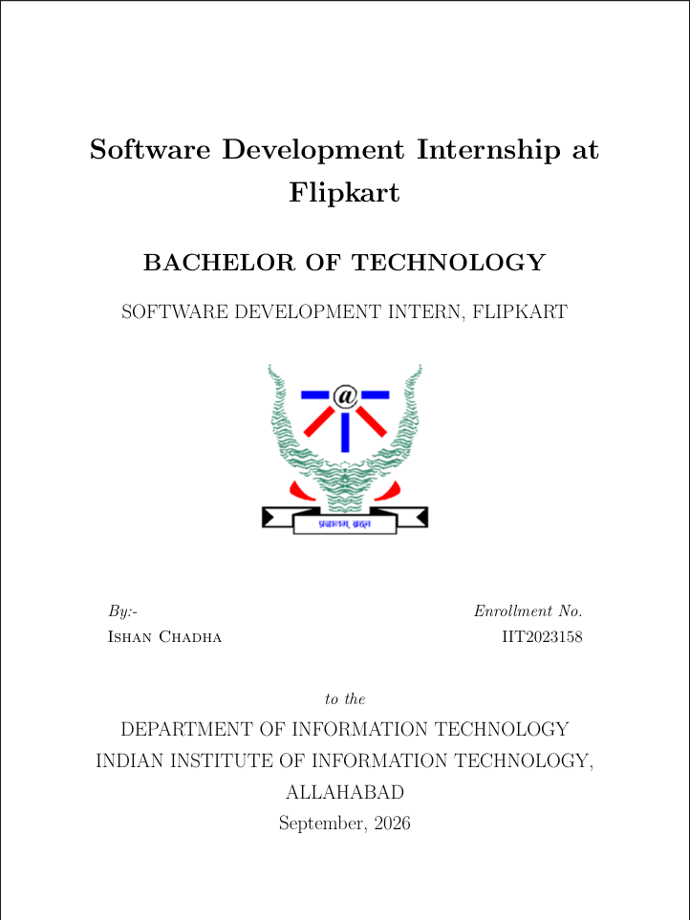

Table of Contents
1. Introduction
2. About the Organization
3. Problem Statement & Proposed Solution
4. Project Overview
5. Technology Stack
6. System Architecture
7. Features Implemented
8. My Contributions
9. Challenges & Solutions
10. Key Learnings
11. Conclusion & Future Scope

1. Introduction
This report presents the work done during my Software Development Internship at Cogniease Techno Labs Pvt. Ltd. (August-September 2026), as part of the B.Tech curriculum at IIIT Allahabad.
I worked as a Full-Stack Developer on "Taru" — an Emotional Wellbeing Platform for college students. Over 33 commits, I built features spanning React, Node.js, MongoDB, Socket.IO, and WebRTC.

Internship Objectives
- Gain hands-on experience in full-stack web development.
- Learn real-time communication systems (WebSockets, WebRTC).
- Contribute to a production-grade application serving real users.
- Develop skills in database design, API development, and authentication.

2. About the Organization
Cogniease Techno Labs Pvt. Ltd. is a technology company building digital solutions for mental health and emotional wellbeing. Their flagship product, Taru, combines evidence-based assessments, peer support, professional counseling, and stress-relief tools into one platform.
The team follows Agile development practices with GitHub-based code reviews, feature branches, and pull request workflows in a remote/hybrid setting.

3. Problem Statement & Proposed Solution
1 in 3 college students experience significant anxiety or depression, yet most never seek help due to stigma, cost, long wait times, and fragmented solutions.
Taru addresses this by providing:
- Daily mental health check-ins with science-backed assessments
- Anonymous peer-to-peer chat for community support
- Direct psychiatrist booking with video consultations
- AI chatbot for 24/7 guidance
- Stress-relief interactive games
- Institution dashboard for aggregate student analytics

4. Project Overview
Taru is a full-stack web application serving three distinct user roles:

Student Portal
- Daily check-ins tracking 7 wellbeing dimensions (mood, energy, stress, sleep, concentration, support, motivation)
- Mood tracking with weekly charts and calendar history
- Anonymous peer chat and AI chatbot support
- Psychiatrist booking with WebRTC video meetings
- Stress-relief activities and breathing exercises

Psychiatrist Portal
- Dashboard with appointment management
- Weekly availability slot configuration
- Video consultations with in-session chat and mood history viewing

Institution Portal
- Aggregate student analytics and mood trend visualization
- Enrolled student list with search and individual insights
- Check-in participation monitoring

5. Technology Stack

Frontend
Technology | Purpose
React 19 + TypeScript | UI library with type-safe development
Vite 6 | Fast build tool and dev server
Tailwind CSS 4 | Utility-first CSS framework
React Router v7 | Client-side routing
TanStack React Query | Server state management & caching
Socket.IO Client | Real-time communication

Backend
Technology | Purpose
Node.js + Express.js | Server-side runtime and REST API framework
MongoDB + Mongoose | NoSQL database with ODM
Socket.IO | Real-time bidirectional WebSocket communication
JWT + bcryptjs | Authentication tokens and password hashing
WebRTC | Peer-to-peer video conferencing
Express Validator | Input validation middleware

6. System Architecture
The platform follows a three-tier architecture with REST APIs and real-time WebSocket communication:
Client Layer:
React 19 + TypeScript frontend with three portal interfaces, each having dedicated auth contexts and protected routes. Vite handles builds; Tailwind CSS handles styling.
Application Layer:
Node.js + Express server with 9 controller modules, JWT auth middleware, and a dedicated realtime module handling Socket.IO events, matchmaking, game logic, and WebRTC signaling.
Data Layer:
MongoDB with 7 Mongoose schemas: User, DailyCheckIn, Appointment, Availability, Psychiatrist, Institution, and Meeting. Includes pre-validation hooks and compound indexes.

Real-Time Module
- Socket.IO server with event-driven room management
- FIFO queue-based matchmaking per game type
- Generalized game module lookup (plug-in pattern)
- WebRTC signaling relay for ICE/SDP exchange
- 5 multiplayer games: Memory, Connect Four, Beach Balls, Color Wars, Sea Battle

7. Features Implemented
Authentication System: Multi-role JWT auth for Students, Psychiatrists, and Institutions with bcrypt hashing, cookie sessions, and 3 separate React auth contexts.
Daily Check-in System: Tracks 7 wellbeing dimensions with auto-computed total score, streak tracking, and calendar-based mood history visualization.
WebRTC Video Conferencing: Custom useWebRTC hook managing peer connections, ICE/SDP exchange via Socket.IO, with in-meeting text chat panel.
Real-Time Multiplayer Games: 5 games with server-authoritative logic: Memory (card matching), Connect Four, Beach Balls (physics engine), Color Wars (powerups + joystick), Sea Battle (fleet combat).
Anonymous Peer Chat: Random matchmaking with auto-generated usernames (taru_XXXXXXXX) for anonymous support.
AI Chatbot: Taru AI integration for 24/7 mental health guidance and conversational support.
Stress Relief: Breathing Bubble component and interactive mindfulness activities.

8. My Contributions
33 commits from August 9 to September 19, 2026. Key areas:
Area | Work Done
Backend Setup | Express server, MongoDB schemas, API client, env config
Psychiatrist Portal | Auth, dashboard, availability, appointments, profile
Institution Portal | Auth, student analytics, mood trends, student management
Video Conferencing | WebRTC P2P calls, signaling, meeting chat
Multiplayer Games | 5 games — backend logic + animated React frontends
Peer Chat | Anonymous random chat with Socket.IO matchmaking
AI Chatbot | Taru AI integration for 24/7 support
Check-in System | 7-dimension assessments, streaks, mood history
UI/UX | Landing page, breathing bubble, responsive design

9. Challenges & Solutions

WebRTC Connectivity
Challenge: Reliable P2P video required careful ICE/SDP timing.
Solution: Implemented proper signaling flow with STUN server config for NAT traversal.

Game State Synchronization
Challenge: Keeping state consistent across players with network latency.
Solution: Server-authoritative model — all validation on server, clients get authoritative updates.

Multi-Role Authentication
Challenge: 3 user types with different schemas and auth flows.
Solution: Independent auth contexts on frontend + separate JWT secrets and middleware per role.

CORS & Deployment
Challenge: Cross-origin issues with separate frontend/backend domains.
Solution: Simplified CORS to accept origins array from environment variables.

Physics Engine
Challenge: Realistic ball physics with collision detection in multiplayer.
Solution: Custom physics module with velocity, boundary bouncing, and inter-ball collisions.

10. Key Learnings
- Full-Stack Development — End-to-end proficiency with React, Node.js, Express, and MongoDB.
- Real-Time Systems — Socket.IO architecture, event-driven design, room management, matchmaking.
- WebRTC — P2P video with ICE framework, SDP negotiation, and STUN/TURN servers.
- Authentication — Multi-role JWT auth, bcrypt hashing, cookie sessions, protected routes.
- Game Development — Physics simulation, turn-based logic, server-authoritative state.
- Database Design — Mongoose schemas with hooks, indexes, and relationship modeling.
- Deployment — Vercel deployment, environment management, CORS configuration.
- Professional Skills — Git workflows (branching, PRs), Agile practices, documentation.

11. Conclusion & Future Scope

Conclusion
This internship at Cogniease Techno Labs was a transformative experience. Working on Taru allowed me to apply academic knowledge to a real-world problem — making mental health support accessible for college students.
I successfully built multiple major features including the Psychiatrist and Institution portals, WebRTC video conferencing, 5 multiplayer games, anonymous chat, and AI chatbot integration. The experience strengthened my full-stack development skills and prepared me well for a career in software engineering.

Future Scope
- AI-powered mood prediction and early intervention alerts
- Redis-backed horizontal scaling for real-time modules
- React Native mobile app for on-the-go access
- Multi-party WebRTC for group therapy sessions
- Push notifications for reminders and streak alerts
- Advanced analytics with predictive insights for institutions

— End of Report —

