Linux Programming
Online Lab
Name:C Lokesh
Reg no:17MIS1088
1. Sl command:(print a running train)
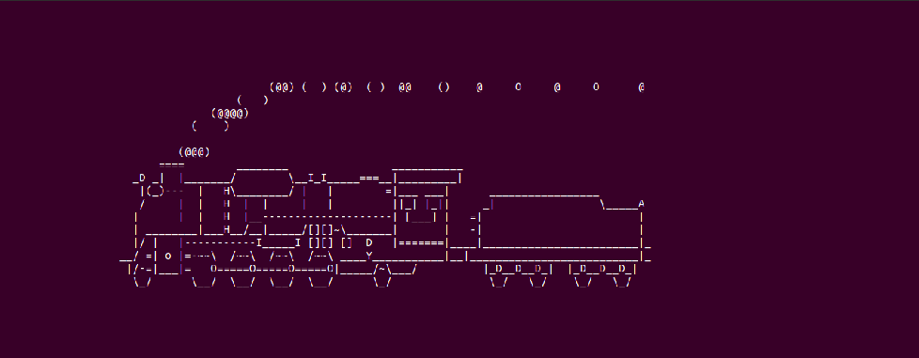
2.
rev(It will reverse all the sentences or a word in the given text)

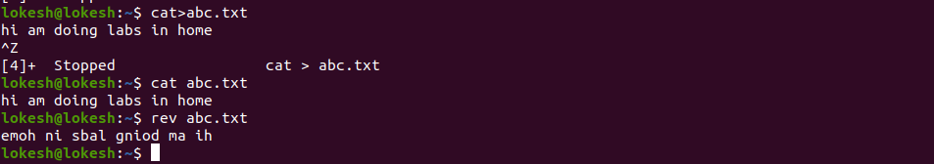
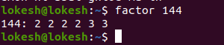
factor(It will give all the factors of the given number)

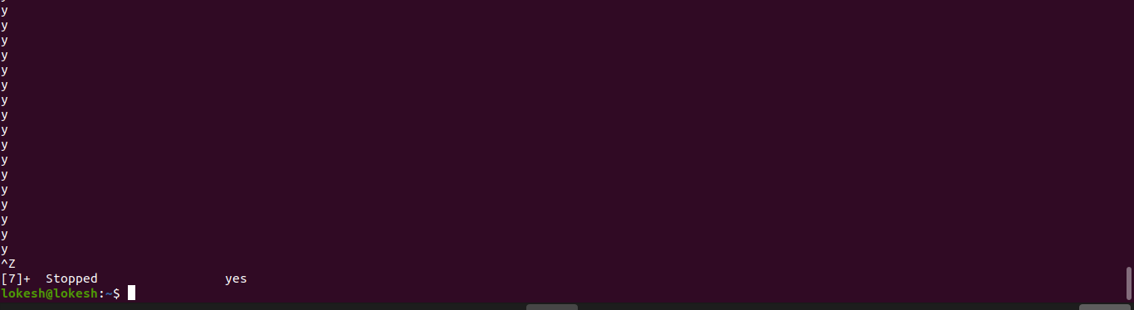
yes(it keep on printing y until it is stopped)

Write a program to implement Simple reader – writer algorithm using shared memory segment with semaphore

reader.cpp
#include <iostream>
#include <sys/ipc.h>
#include <sys/shm.h>
#include <stdio.h>
using namespace std;

int main()
{
// ftok to generate unique key
key_t key = ftok("shmfile",65);

// shmget returns an identifier in shmid
int shmid = shmget(key,1024,0666|IPC_CREAT);

// shmat to attach to shared memory
char *str = (char*) shmat(shmid,(void*)0,0);

printf("Data read from memory: %s\n",str);

//detach from shared memory
shmdt(str);

// destroy the shared memory
shmctl(shmid,IPC_RMID,NULL);

return 0;
}

writer.cpp
#include <iostream>
#include <sys/ipc.h>
#include <sys/shm.h>
#include <stdio.h>
using namespace std;

int main()
{
// ftok to generate unique key
key_t key = ftok("shmfile",65);

// shmget returns an identifier in shmid
int shmid = shmget(key,1024,0666|IPC_CREAT);

// shmat to attach to shared memory
char *str = (char*) shmat(shmid,(void*)0,0);

cout<<"Write Data : ";
cin>>str;

printf("Data written in memory: %s\n",str);

//detach from shared memory
shmdt(str);

return 0;
}

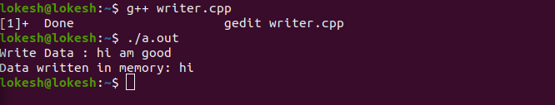
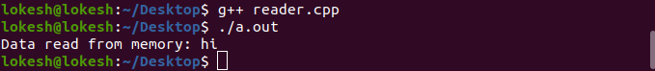
Hot Question
Write a bash shell script to monitor the health of your system. Let the details be stored and archived in any folder of your choice.
hot.sh
top -b -d 1 -n 5 >> hot.txt
echo " "
echo "Memory Stats"
free -m >> hot.txt
echo " "
echo "Netw. Stats"
netstat >> hot.txt
echo " "
echo "CPU Load and Vmstat"
vmstat -s >> hot.txt

