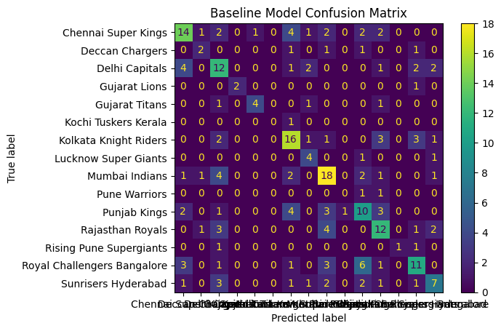
Baseline model with features = ["team1", "team2", "venue", "toss_winner", "toss_decision"]
Train & Test: Baseline Model Results
----------------------
Accuracy : 0.49130434782608695
Precision: 0.5017055175938107
Recall : 0.49130434782608695
F1 Score : 0.48919905909863437

Model 2: with last 7 matches form:
----------------------------------------
Accuracy : 0.5043478260869565
Precision: 0.5099655858345337
Recall : 0.5043478260869565
F1 Score : 0.5020423167344495

