**Scout museum**

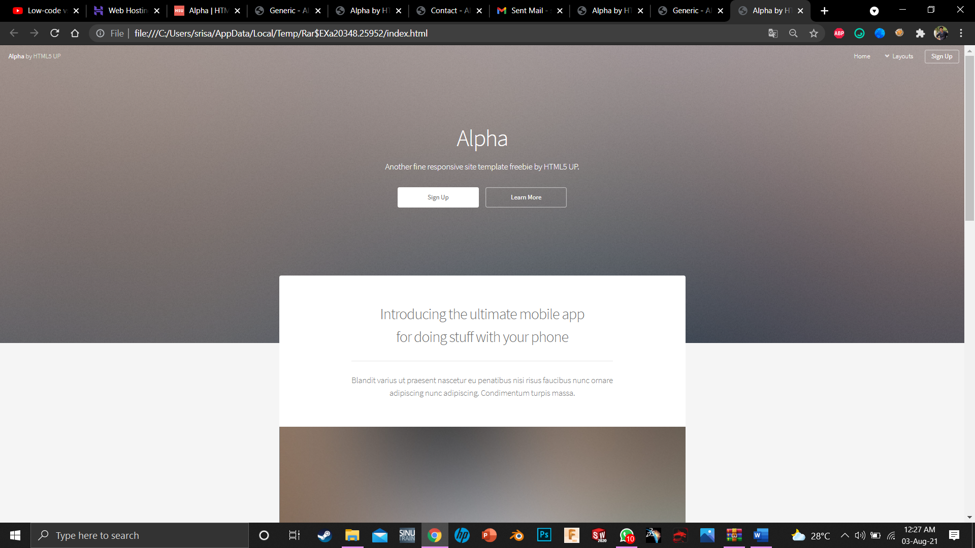

8

7

6

5

4

3

2

1

1. enter the name “ First Scout Museum – India”.

2. “ BP & VB Museum”

3. “ Here you can see and learn about the souvenirs and Books in scouting and in general life. All the content at one place.”

4. as it is. In learn more redirect to last bottom right learn more sq.

5. Image 1

6. “The Ultimate learning site of scouting which has the India’s first Scout Museum and the India’s largest scout library at your ease.”

7. Consist of nearly ----- books and ---- museum products to learn about.

8. Image 2

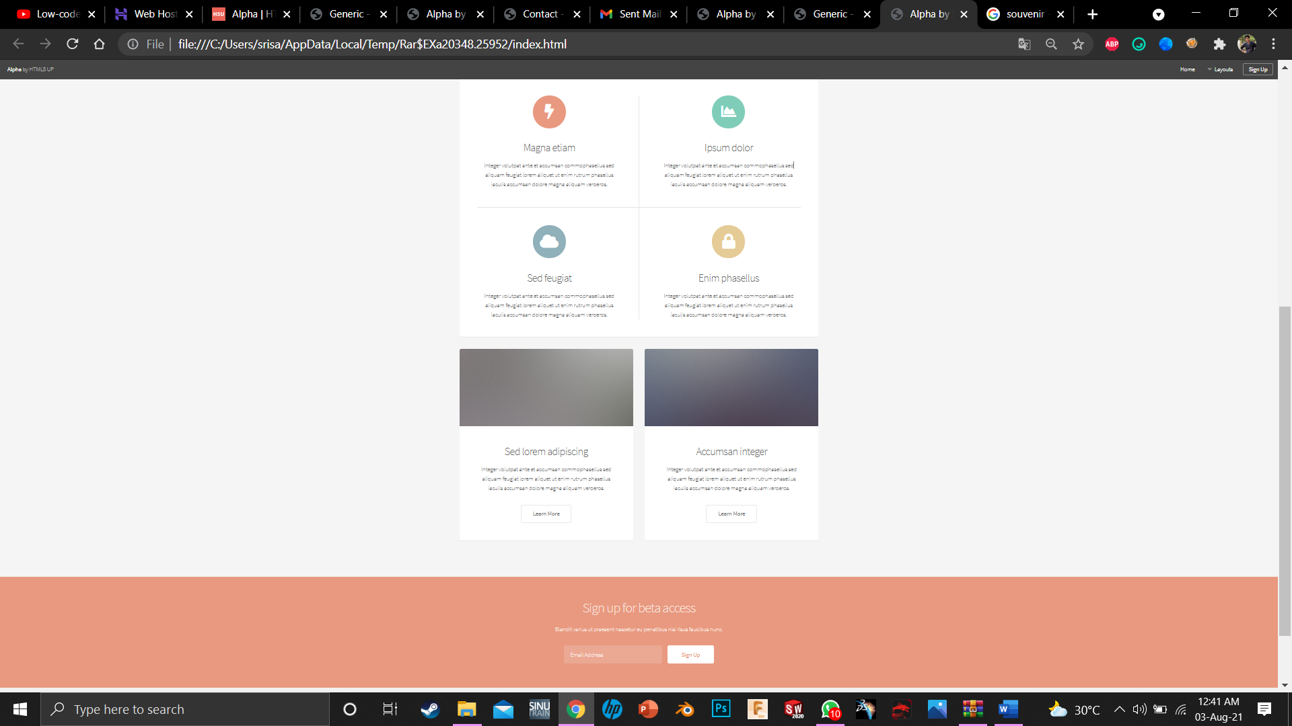

7

6

5

4

3

2

1

1. View all the books. Redirect pop up of book titles display

2. View all the Museum products. Redirect pop up of images of Museum products.

3. Open-Source knowledge ,Contact us for further info and Development. Redirect to Contact us

4. Rare collections and books. Redirect to pop up of rare book data.

5. Wosm page, wagggs page redirect [www.scout.org](http://www.scout.org) , [www.wagggs.org](http://www.wagggs.org)

6. History of the India’s First Library and Museum. Redirect popup of history with images and info

7. sinup and enjoy! . site visitors number.

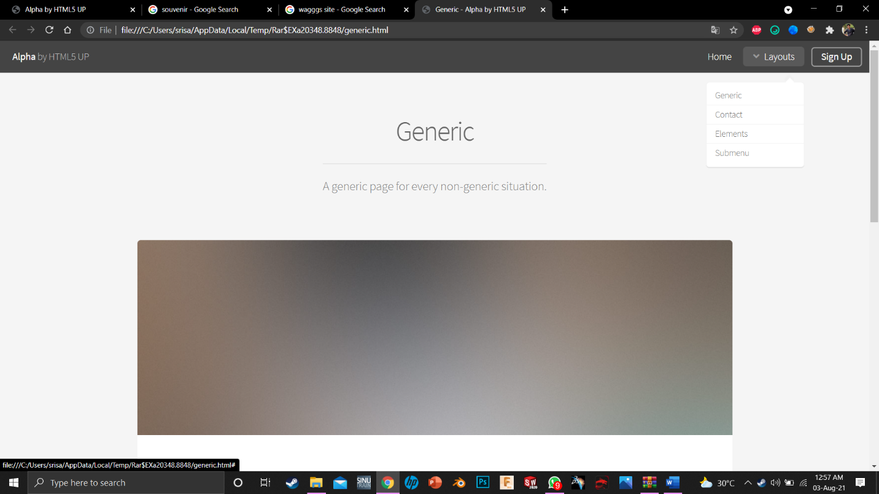

1. Generic – About us

2. BP & VB Museum.

3. India’s First Scout Library and Museum.

4. image 3

4

3

2

1

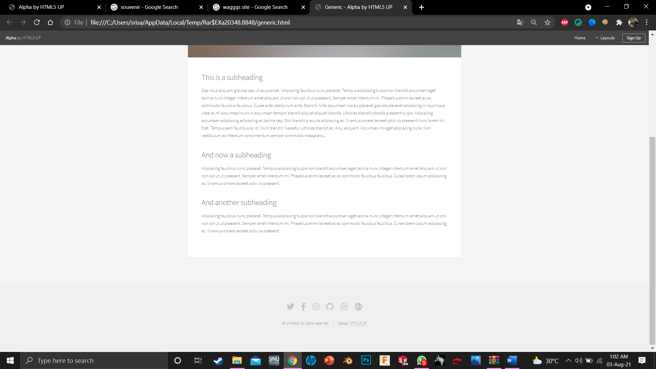

**Logic:**

1. Content will be given tomorrow.

1

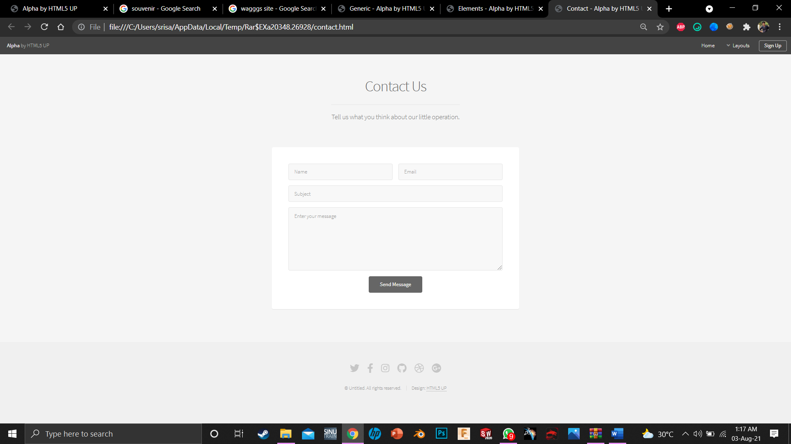

1. Instead of social media pages - > you can also contact us at :

Anbarasan.R.S.

+91- 98402 13002

No.53, Railway Quarters,

Perambur,Chennai-600011.

1