Task 1: Database Design and Implementation

Task 1: ER Diagram - Electronic Voting System
The primary objective of this task is to design a conceptual database model for an Electronic Voting System intended to modernize the manual voting process in Nepal. The system is designed to manage voter registration, election cycles, candidate information, and the casting of votes while maintaining data integrity and transparency.

1.1 Design Assumptions and Requirements
- Voter Registration: Each voter is identified by a unique citizenship number and associated with a constituency.
- Election Management: The system supports multiple election types (e.g., Local, Federal) with specific dates.
- Infrastructure: Voters are assigned to specific polling stations within their constituencies.
- Candidates and Parties: Candidates belong to political parties and participate in specific elections.
- Voting Process: The system ensures a one-voter-one-vote rule by linking votes to registrations.

1.2 Entity Relationship Diagram (ERD)
The ER Diagram below illustrates the conceptual entities and their relationships. Key features include the ISA relationship between Voters and their registration status, and the linkage between candidates and political parties.
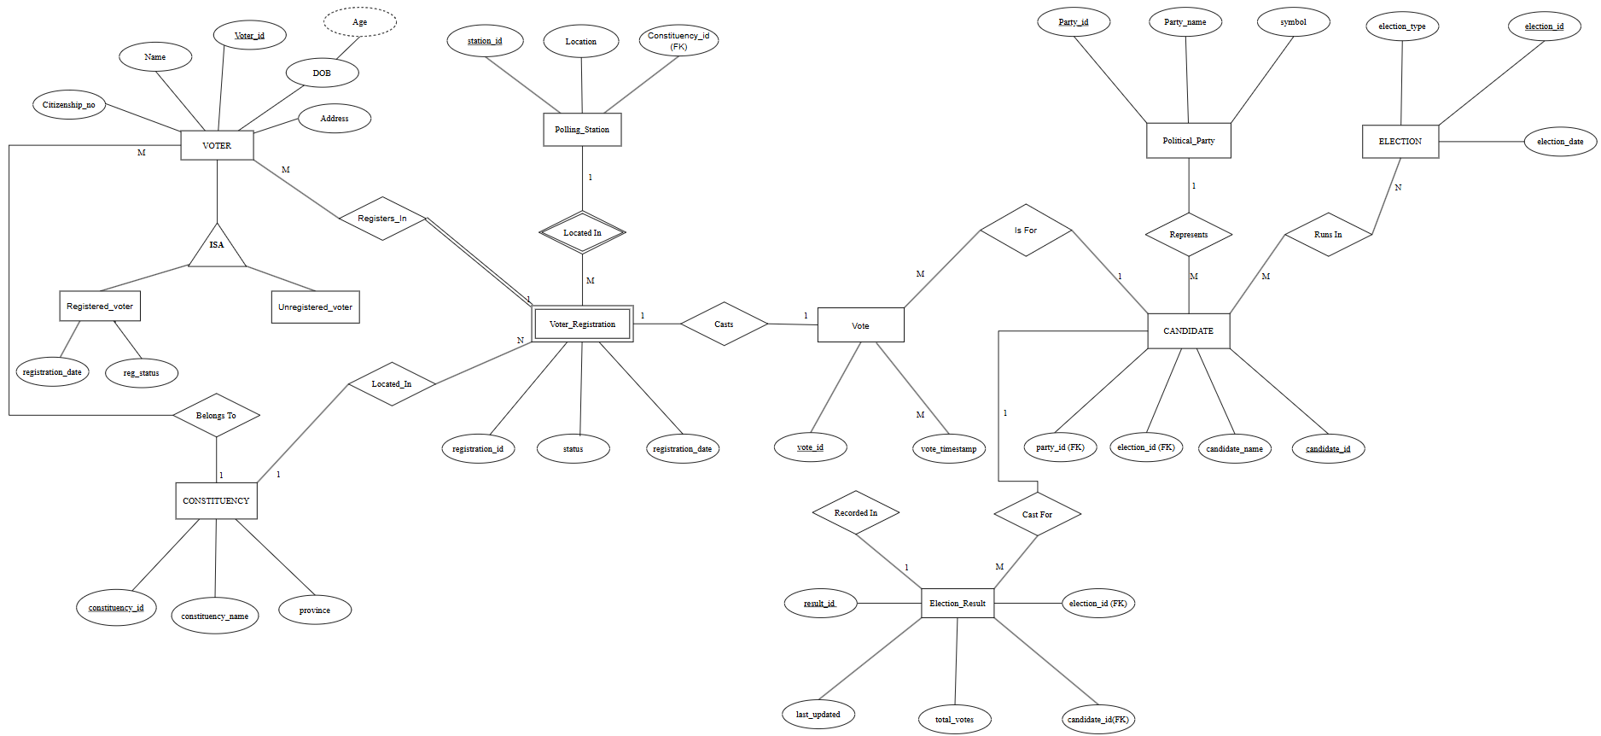
Figure 1: ER Diagram for Electronic Voting System

1.3 Relational Schema
Converting the conceptual ERD into a logical relational schema results in the following tables. Primary keys are underlined and foreign keys are indicated to maintain referential integrity.
• constituency (constituency_id, constituency_name, province)
• polling_station (station_id, location, constituency_id*)
• voter (voter_id, name, citizenship_no, address, dob, constituency_id*)
• registered_voter (voter_id*, registration_date, reg_status)
• unregistered_voter (voter_id*)
• voter_registration (registration_id, voter_id*, station_id*, constituency_id*)
• political_party (party_id, party_name, symbol)
• election (election_id, election_type, election_date)
• candidate (candidate_id, candidate_name, party_id*, election_id*)
• vote (vote_id, registration_id*, candidate_id*, election_id*, vote_timestamp)
• election_result (result_id, election_id*, candidate_id*, total_votes, result_status)

1.4 Relational Schema Diagram
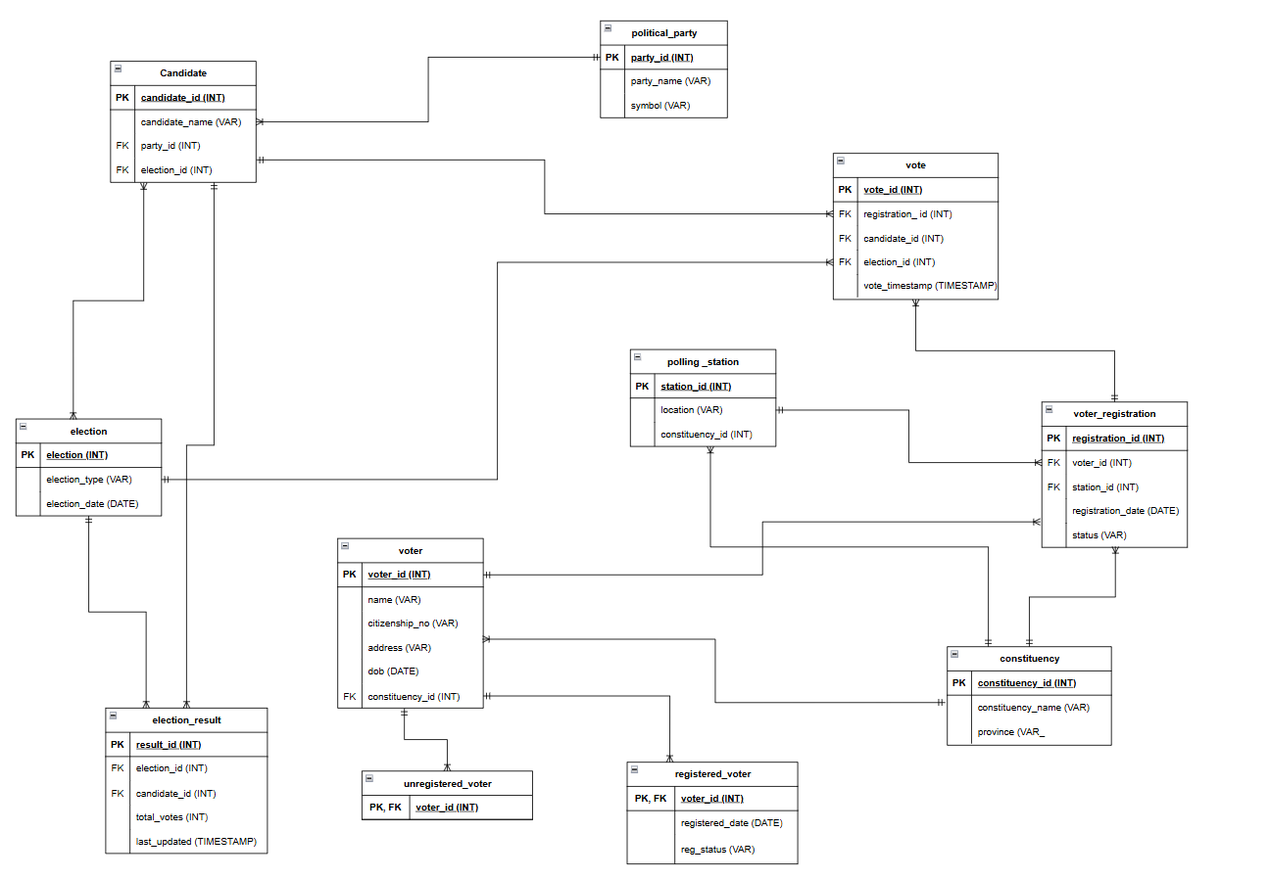
Figure 2: Logical Relational Schema Diagram

1.5 Data Definition Language (DDL) Implementation
The following SQL script outlines the physical implementation of the database, including table structures and foreign key constraints.
CREATE TABLE voter (
voter_id INT PRIMARY KEY,
name VARCHAR(150),
citizenship_no VARCHAR(30) UNIQUE,
address VARCHAR(255),
dob DATE,
constituency_id INT,
FOREIGN KEY (constituency_id) REFERENCES constituency(constituency_id)
);
CREATE TABLE candidate (
candidate_id INT PRIMARY KEY,
candidate_name VARCHAR(150),
party_id INT,
election_id INT,
FOREIGN KEY (party_id) REFERENCES political_party(party_id),
FOREIGN KEY (election_id) REFERENCES election(election_id)
);

