Task 1
ER Diagram - Electronic Voting System

Submitted By : Lokesh Bhatta
Email : blokesh24@tbc.edu.np
UWE ID : 24071110
Section : A
Submitted To : Mr Rabin Gautam
The British College Kathmandu
Date : April 26, 2026

Introduction
This report presents the conceptual design of an Electronic Voting System along with its Entity-Relationship Diagram(ERD), relational schema diagram and lastly its entire SQL schema. The ERD is modeled using Chen notation to clearly represent entities,attributes, relationships, cardinalities, and constraints. The system aims to ensure secure, transparent, and accurate handling of voters, registrations, elections, candidates, votes, and results.
The entire project is also uploaded in my Github. The link to the github repo is here: https://github.com/LokeshBhatta2428/Electronic-Voting-System.git

Entity-Relationship Diagram (ERD)
The ER Diagram below illustrates the conceptual entities and their relationships. Key features include the ISA relationship between Voters and their registration status, and the linkage between candidates and political parties.

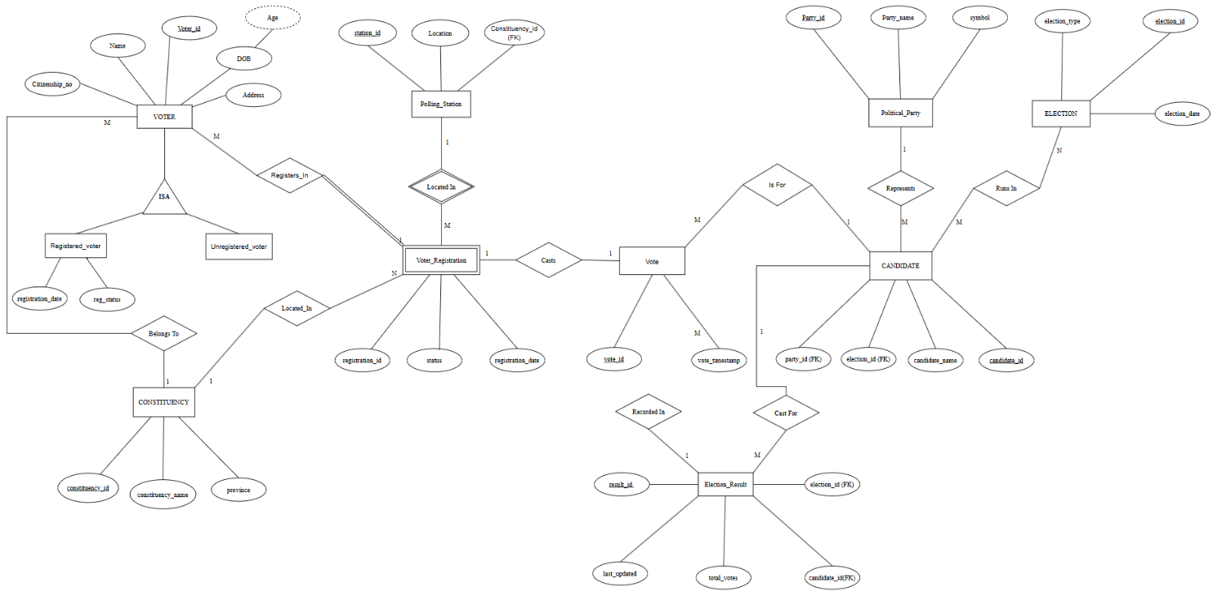

fig-1: Entity-Relationship Diagram

This ERD was made using https://app.diagrams.net/
The Google drive link to this diagram is here : https://drive.google.com/file/d/1_dDmUrHv_KdAoLHo0_RPjbf_S1fFtZlC/view?usp=sharing make sure to open with draw.io for efficiency.

Relational Schema

Converting the conceptual ERD into a logical relational schema results in the following tables. Primary keys are indicated as (PK) and foreign keys are indicated as (FK), to maintain referential integrity.

• constituency (constituency_id (PK), constituency_name, province)
• polling_station (station_id (PK), location, constituency_id (FK))
• voter (voter_id (PK), name, citizenship_no, address, dob, constituency_id (FK))
• registered_voter (voter_id(PK, FK), registration_date, reg_status)
• unregistered_voter (voter_id (PK, FK))
• voter_registration (registration_id (PK), voter_id(FK), station_id (FK), constituency_id(FK))
• political_party (party_id(PK), party_name, symbol)
• election (election_id(PK), election_type, election_date)
• candidate (candidate_id (PK), candidate_name, party_id (FK), election_id (FK))
• vote (vote_id (PK), registration_id(FK), candidate_id (FK), election_id(FK), vote_timestamp)
• election_result (result_id(PK), election_id(FK), candidate_id(FK), total_votes, result_status)
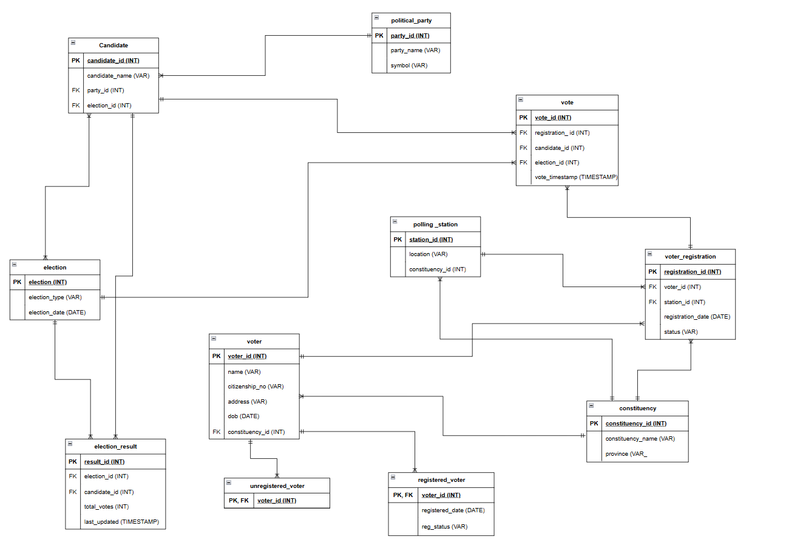
fig-2: Relational Schema Diagram

This relational schema diagram was made using https://app.diagrams.net/.
The Google drive link to this diagram is here : https://drive.google.com/file/d/17vGvafwiwY58TIEsUCbBfPB_7obnrgSh/view?usp=sharing make sure to open with draw.io for efficiency.

SQL Script
The following SQL script outlines the physical implementation of the database, including table structures and foreign key constraints.

Create Database Election;
use election;

CREATE TABLE constituency (
constituency_id INT PRIMARY KEY,
constituency_name VARCHAR(150),
province VARCHAR(100)
);

CREATE TABLE polling_station (
station_id INT PRIMARY KEY,
location VARCHAR(255),
constituency_id INT,
FOREIGN KEY (constituency_id) REFERENCES constituency(constituency_id)
);

CREATE TABLE voter (
voter_id INT PRIMARY KEY,
name VARCHAR(150),
citizenship_no VARCHAR(30),
address VARCHAR(255),
dob DATE,
constituency_id INT,
FOREIGN KEY (constituency_id) REFERENCES constituency(constituency_id)
);

CREATE TABLE registered_voter (
voter_id INT PRIMARY KEY,
registration_date DATE,
reg_status VARCHAR(20),
FOREIGN KEY (voter_id) REFERENCES voter(voter_id)
);

CREATE TABLE unregistered_voter (
voter_id INT PRIMARY KEY,
FOREIGN KEY (voter_id) REFERENCES voter(voter_id)
);

CREATE TABLE voter_registration (
registration_id INT PRIMARY KEY,
voter_id INT,
station_id INT,
constituency_id INT,
registration_date DATE,
status VARCHAR(20),
FOREIGN KEY (voter_id) REFERENCES voter(voter_id),
FOREIGN KEY (station_id) REFERENCES polling_station(station_id),
FOREIGN KEY (constituency_id) REFERENCES constituency(constituency_id)
);

CREATE TABLE political_party (
party_id INT PRIMARY KEY,
party_name VARCHAR(150),
symbol VARCHAR(100)
);

CREATE TABLE election (
election_id INT PRIMARY KEY,
election_type VARCHAR(50),
election_date DATE
);

CREATE TABLE candidate (
candidate_id INT PRIMARY KEY,
candidate_name VARCHAR(150),
party_id INT,
election_id INT,
FOREIGN KEY (party_id) REFERENCES political_party(party_id),
FOREIGN KEY (election_id) REFERENCES election(election_id)
);

CREATE TABLE vote (
vote_id INT PRIMARY KEY,
registration_id INT,
candidate_id INT,
election_id INT,
vote_timestamp TIMESTAMP,
FOREIGN KEY (registration_id) REFERENCES voter_registration(registration_id),
FOREIGN KEY (candidate_id) REFERENCES candidate(candidate_id),
FOREIGN KEY (election_id) REFERENCES election(election_id)
);

CREATE TABLE election_result (
result_id INT PRIMARY KEY,
election_id INT,
candidate_id INT,
total_votes INT,
last_updated TIMESTAMP,
FOREIGN KEY (election_id) REFERENCES election(election_id),
FOREIGN KEY (candidate_id) REFERENCES candidate(candidate_id)
);

