Devops Project:

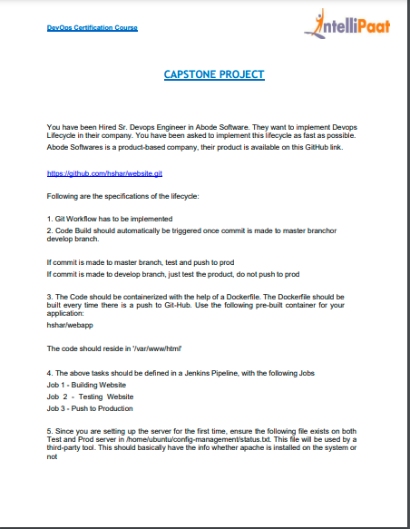

Step1 : Creating 3 servers using t2.micro instance and ubuntu 20.04 os on AWS.

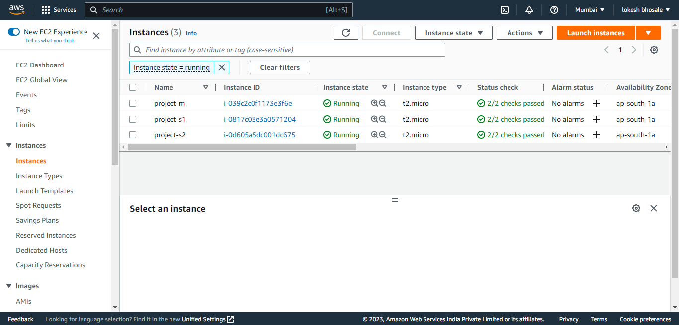

Step 2: By using Ansible, install Java, Jenkins, Docker on Master server and Java, Docker on Slaves servers respectively.

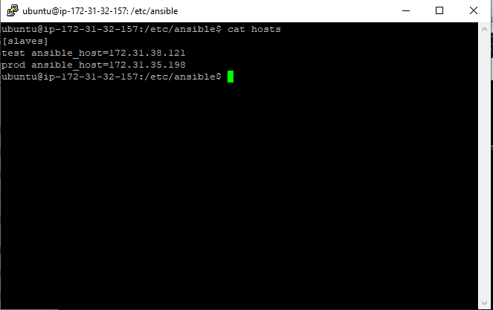

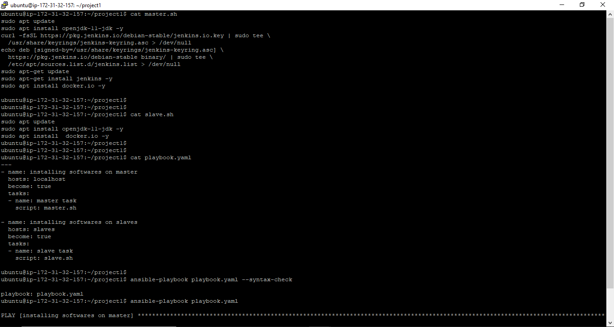

Step 3: configuring Jenkins (at Master server).

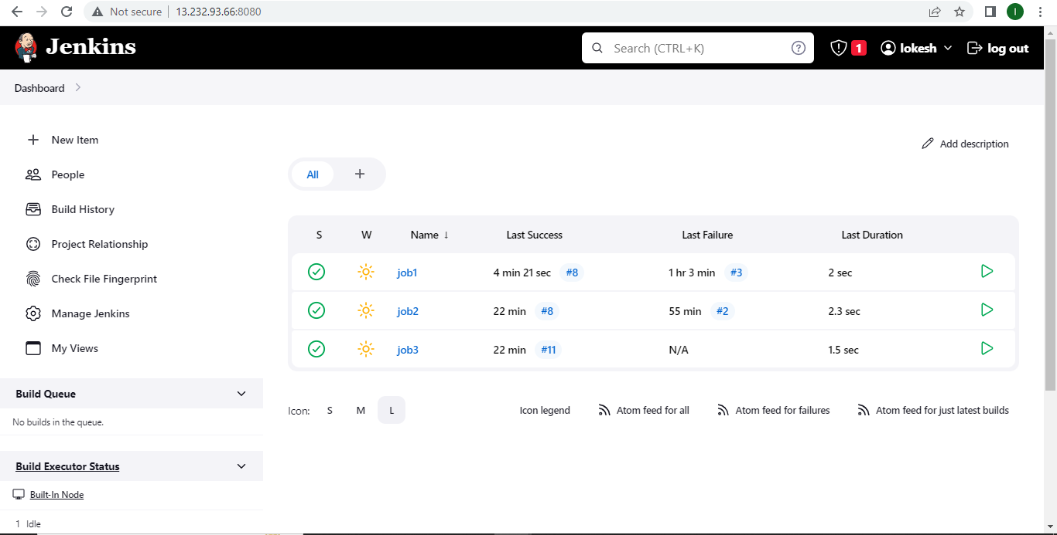

Step 4: Creating the Dockerfile on Master server

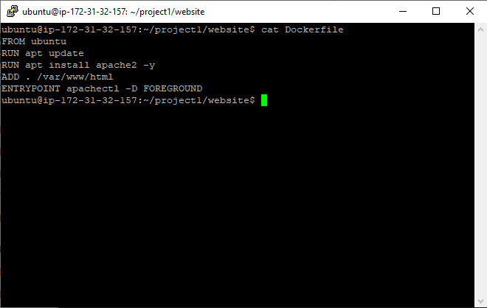

Step 5: configuration of job1 on Jenkins.

This job will use the Label ‘test’ and work on ‘develop’ branch. We are using this job to perform testing operation after pushing the files from ‘develop’ branch.

After pushing the files on GIT, the job1 will delete existing Docker containers and create a new image named ‘testapp’. This container will run on port 82.

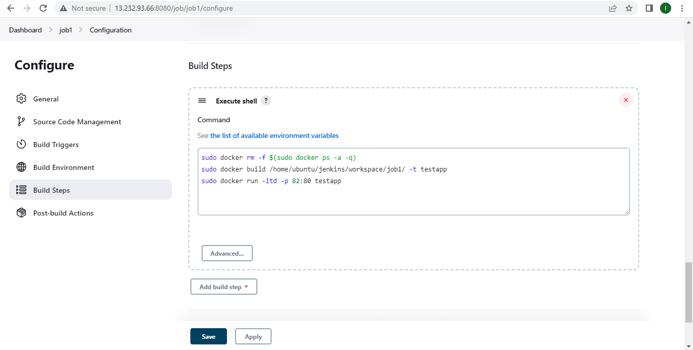

Step 6: Pushing files from develop branch on GIT repository.

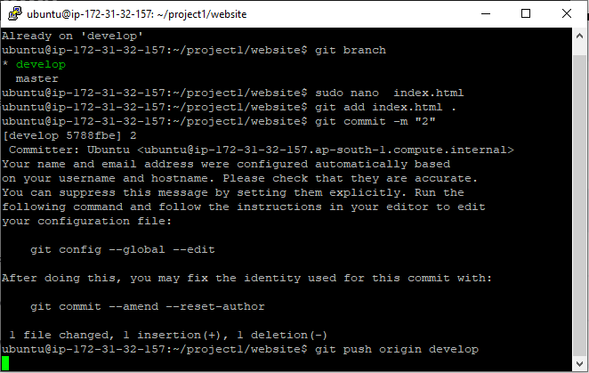

Output :

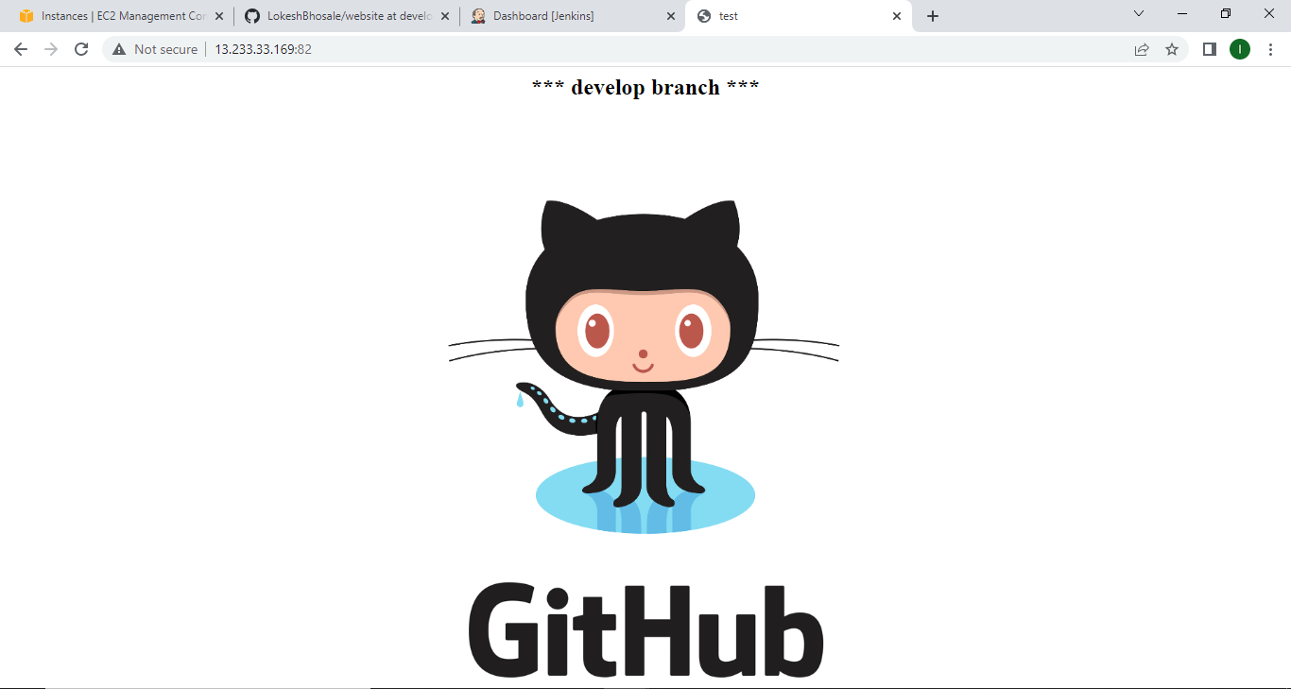

Step 7: Configuring job2 and job3 on Jenkins.

Here, job2 will perform testing operation and after the successful execution the job3 will be triggered.

These jobs will create the docker images and run the containers using them on mentioned port.

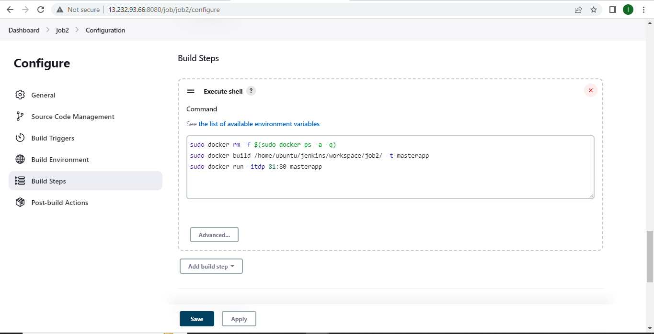

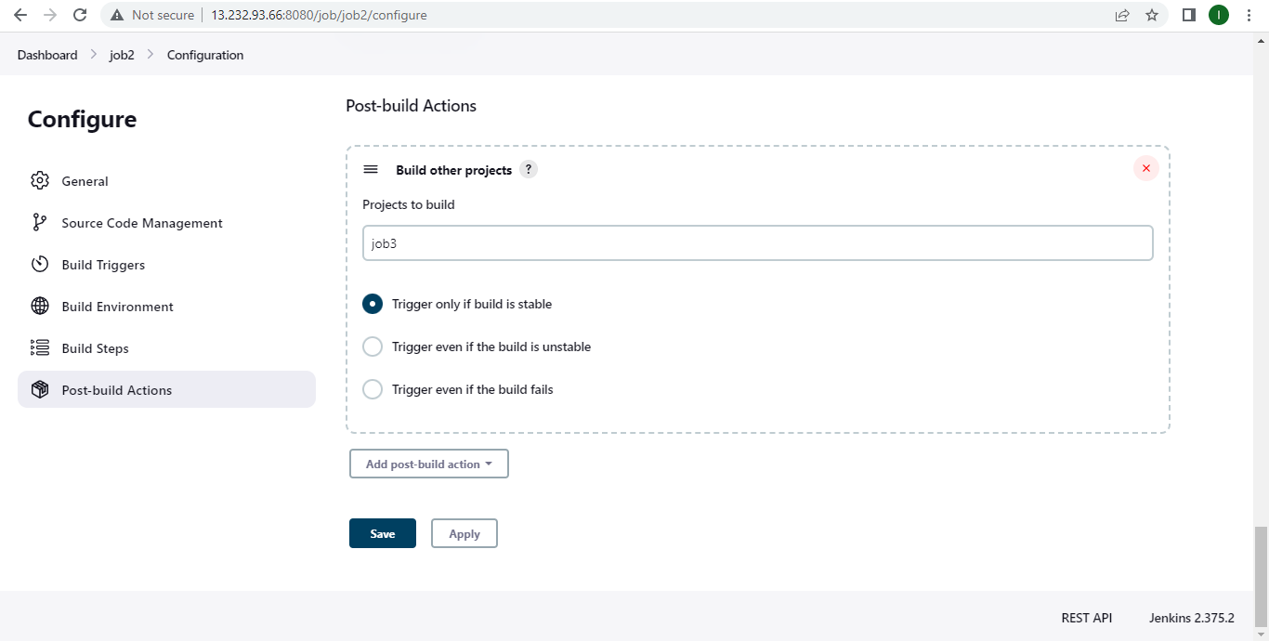

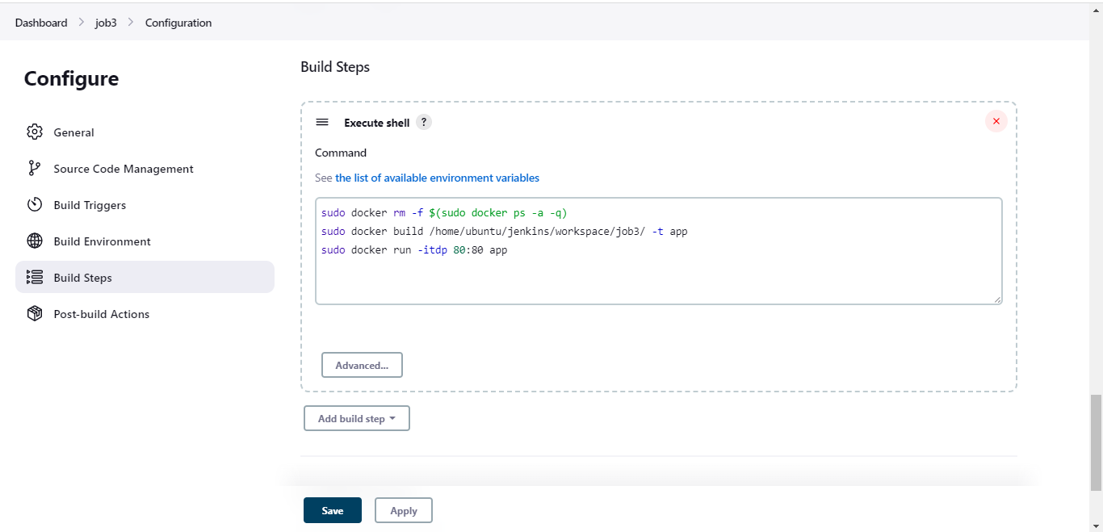

Step 8: Pushing files from master branch on GIT repository.

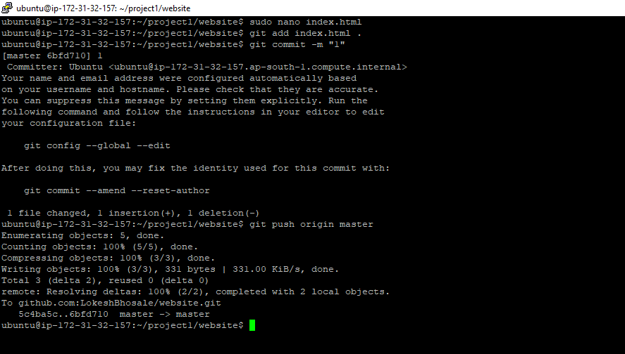

Output :

In this snap we can see the output on test server.

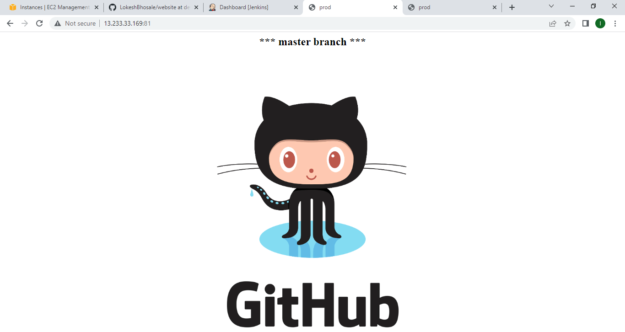

In this snap we can see output on prod server