**Health Monitoring System**

**INTRODUCTION**

The **Health Monitoring System** (HMS) is a evolutionary medicine regulative process in which actuarial assessment of [fitness](https://en.wikipedia.org/wiki/Biological_fitness) and economic type [cost–benefit analysis](https://en.wikipedia.org/wiki/Cost%E2%80%93benefit_analysis) determines the body’s regulation of its [physiology](https://en.wikipedia.org/wiki/Physiology) and [health](https://en.wikipedia.org/wiki/Health).

In these recent times of pandemic fitness and health has become an inevitable component for survival. It is of utmost importance for people to maintain good physical health and immunity for fighting off the deadly pathogens.

When it comes to fitness and health there are only few basic fundamental parameters to look for like height, weight, diet, etc. However, there are indices based on these factors which shows the fitness quality of a person. These indices are Body mass index (BMI), Basal metabolic rate (BMR), fat percentage and so on.

This project aims to calculate the above-mentioned indices of a person and give out the fitness check of the person. The person has to input the basic details of height, weight which will be processed to give output.

## **RESEARCH**

Health Monitoring System is easily used for maintaining the data of the human health, and keep the data in single software for maintaining the records.

* Help in Keeping the data for the future purpose of the management and help the owner to easily managed the data.
* Save money: With medical treatment getting expensive and unaffordable for a common man, staying healthy not only saves your hard-earned money but also leads to happier life and wellness.

#### 

#### **Objectives**

* Store and retrieve the data.
* Easy to handle the data of particular person.
* Saves money and keeps you healthy with proper diet.

**FEATURES**

* The person will be giving certain details such as name, age, height, weight, etc required for the calculation for the fitness indices.
* The person will be then giving an input as to which index the person wishes to see for himself.
* As per the input corresponding function will be called by the code and the functions will be processing all the input data and all the output will be printed accordingly.
* Thus, this project is a handy tool where person simply gives input and output will be given within no time.

## **STRENGTH**

* Easy to use and handle.
* Calculate the BMI, BMR, Fat percentage indices taking barely few inputs.
* Efficient functions used for calculating the indices with accuracy.
* Accessible.

#### **WEAKNESS**

* Will calculate only mentioned BMI, BMR and fat % indices
* Gap in knowledge and implementation.

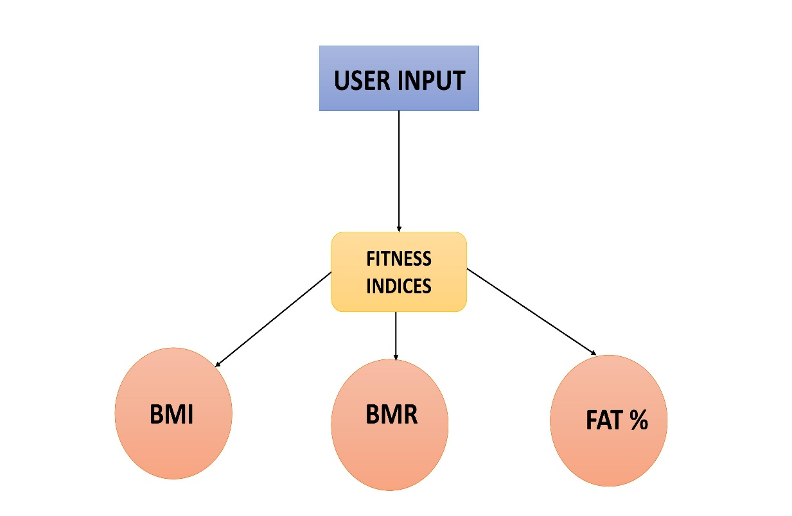**User Interface: -**

**Flow chart**

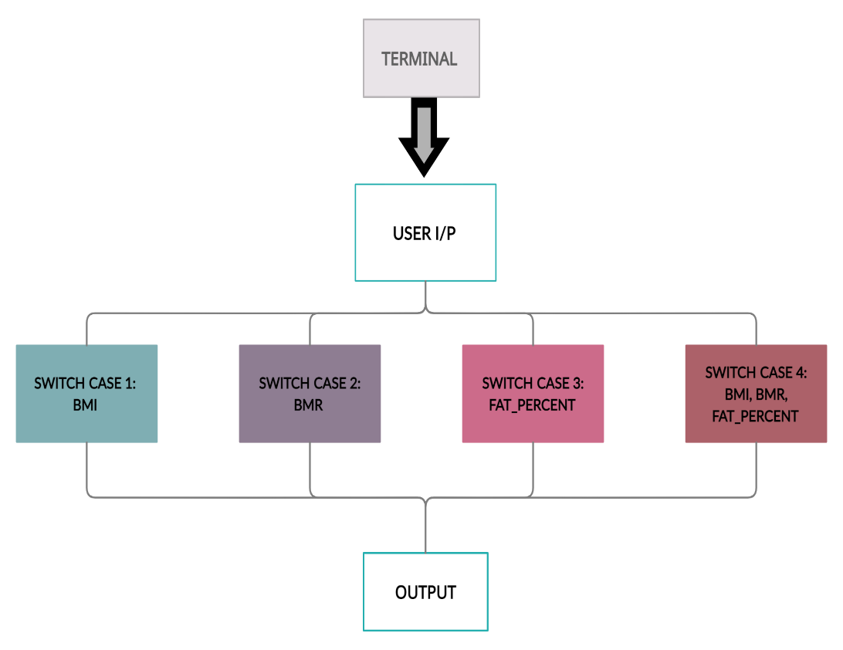

**Conclusion:** We have successfully implemented the gym management system using the C and execute the code.