

Master in Computer Application

**Book-Shop Automation**

**Submitted By:-**

LokeshDebta 2306151004

SK Samsuddhin 2306151006

**Problem Statement**

Develop a book store automation system that efficiently handles inventory, sales, and customer data. The system should allow the host to add, update, and delete books, track sales transactions, manage customer information, generate sales reports, and provide an intuitive user interface for seamless navigation. The goal is to enhance the overall book store operations, improve inventory management, and streamline customer interactions.

**Major Functions**

1. User Authentication:
2. Inventory Management
3. Based on genres or authors
4. User Roles
5. Search and Filter
6. Reporting
7. Supplier Management:
8. Customer Management:
9. Notifications

10. Security Measures

**Sub Functions**

1. **User Authentication**

* Log in/Registration
* Logout
* Recovery
* Delete

1. **Inventory Management**

* Add new books to the inventory
* Removes books from the inventory
* Update books details
* Check stock availability

1. **Users roles**

* Manages user accounts
* Assign permissions

1. **Search and filter**

* Implements a search box for quick lookups.
* Provide filters for refining search results.

1. **Reporting**

* Generates daily, weekly and monthly sales.
* Track popular books and customers preference

1. **Supplier Management**

* Records details of books suppliers
* Place order of new books

1. Customer management

* Store customer information securely.
* Track purchase history of personalized recommendation.

1. Billing and payment management

* Generate invoice
* Record Payments
* View Payment History

1. Notifications

* Notify staff about low stocks
* Send promotional and order transaction

1. Security measures

* Encrypt sensitive user data
* Regular backup of database

|  |  |  |  |
| --- | --- | --- | --- |
| User Authentication | Yes | Yes | Yes |
| Inventory Management | Yes | Yes | Yes |
| based on genres or authors | Yes | Yes | Yes |
| User Roles | Yes | Yes | Yes |
| Search and Filter | Yes | Yes | Yes |
| Reporting | Yes | Yes | Yes |
| Supplier Management | Yes | Yes | Yes |
| Customer Management | Yes | Yes | Yes |
| Notifications | Yes | Yes | Yes |
| Security Measures: | Yes | Yes | Yes |
|  |  |  |  |

**Feasibility Study:**

**Types of users:**

**- Administrator:**

**- System administration**

**- User account management**

**- System configuration**

**- Report generation**

**- Staff:**

**- Inventory management**

**- Sales processing**

**- Customer assistance**

**- Store maintenance**

**- Customer:**

**- Book browsing**

**- Order placement**

**- Payment processing**

**- Account management**

**SDLC Model Selection and Justification**

For the Hostel Management System, Agile Model of SDLC is chosen for the following reasons:

Agile project management refers to using the Agile method for software creation. Agile characteristics are attributes focused on providing value to customers. These apply Agile software development, which is a method that involves finding requirements and discovering solutions through collaboration. It prioritizes the customer and applies changes based on the feedback they give. Agile characteristics help businesses save time and money and produce better-quality products.

Advantages of using Agile Model for Project Management :

Using Agile processes in project management has several benefits. Some advantages of taking an Agile approach include:

• Faster deployment of solutions

• Increased focus on customer needs

• Improved frequency of collaboration

• Quicker detection of issues

• Enhanced flexibility and adaptability to change

Characteristics of the Software :

Managing hostels can become a tedious task. Especially if you don't have an appropriate management system. With so many software and applications available, it might get overwhelming about the number of management systems prevalent in the market. Hence, it is important to select a Hostel Management Software that has the features that cover all hostel management needs.

Some of the features that should be present in a hostel management system are

• Simple to use and ease of navigation

• Transparency of features

• Quick access to information

• Smart system

• Seamless transfer between pages

• Manage student records

• Monitor the hostel status

• Visitor and student management

• Reminders and alerts

**Software Requirement Specification**

**Introduction**

a. Purpose: The Bookshop Automation System aims to provide an efficient platform for managing bookshop operations including inventory management, sales processing, customer management, and administrative tasks.

b. Overview: The system will consist of a robust software solution designed to streamline bookshop operations, improve inventory tracking, enhance sales efficiency, and facilitate administrative functions.

c. Environmental Characteristics:

i. Hardware: The system will be deployed on standard computing hardware including servers, workstations, and networking equipment.

ii. Peripherals: Peripheral devices such as barcode scanners, receipt printers, and cash registers may be utilized for efficient sales processing.

Goal of Implementation

a. Reduction in processing times for bookshop transactions.

b. Accurate and error-free transactions to maintain data integrity.

c. Implementation of robust security measures to prevent fraud and safeguard customer information.

d. Provision of systematic display of information, customer management, and report generation.

Functional Requirements

a. User Class-I: Administrator

R1: Authorization

Description: Administrators will be authenticated using credentials to access administrative functionalities.

Input: Administrator credentials.

Output: Administrator dashboard.

b. User Class-II: Customer

R1: Account Creation

Description: Customers can register their details and obtain an account for purchasing books.

Input: Customer information including name, contact details, and address.

Output: Customer account credentials.

R2: Browse and Purchase Books

Description: Customers can browse the available books, add them to their cart, and proceed with the purchase.

Input: Book selection, payment details.

Output: Confirmation of purchase.

c. User Class-III: Staff

R1: Manage Inventory

Description: Staff can update the inventory, add new books, and remove outdated ones.

Input: Inventory changes.

Output: Updated inventory records.

R2: Process Sales

Description: Staff can process sales transactions, generate receipts, and update customer accounts.

Input: Book details, payment information.

Output: Sales receipt.

Non-functional Requirements

a. User Interface: The user interface should be intuitive and easy to navigate, with clear forms for input and standardized reports.

b. Software Interface: The system should include authentication mechanisms, transaction logging, and integration with external payment gateways if applicable.

c. Communication Interface: Communication interfaces should facilitate data exchange with suppliers, payment processors, and other relevant parties.

Behavioural Description

a. System States

i. Inventory Management State: Staff can view, update, and modify inventory details.

ii. Sales Processing State: Staff can process customer orders, generate invoices, and update sales records.

iii. Administrative State: Administrators have access to privileged functionalities such as user management, system configuration, and generating reports.

b. Events and Actions

i. Event: Incorrect login credentials entered.

- Action: Display error message and prompt for correct credentials.

ii. Event: Out-of-stock item selected for purchase.

- Action: Notify customer of unavailability and suggest alternatives.

iii. Event: Payment authorization failure.

- Action: Notify customer of transaction failure and suggest alternative payment methods.

**Dataflow Diagram (Level 0)**

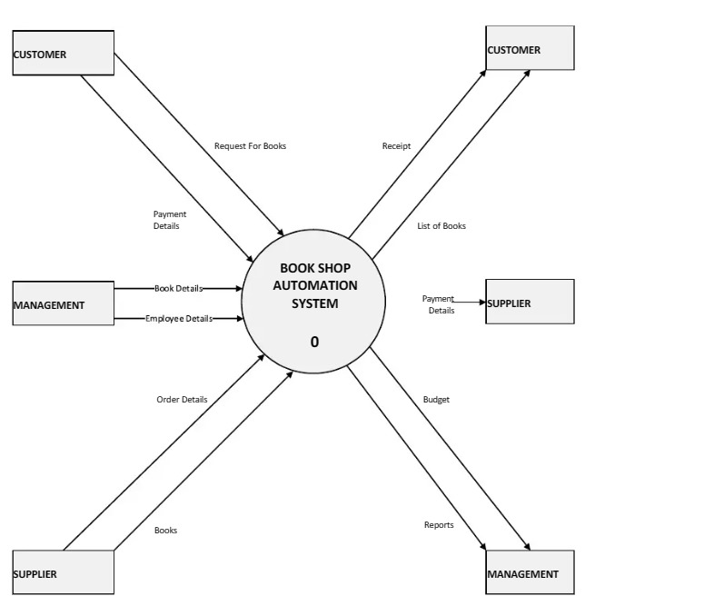

**Dataflow Diagram ( Level 1 )**

