Network configuration to enable internet on BBB (BeagleBone Black):
S1. Boot BBB in eMMC (Directly connect BBB to Usb port)
Setting to be done on windows:
S1: goto “All Settings->Network and Internet ->
- Goto “change adaptor settings”
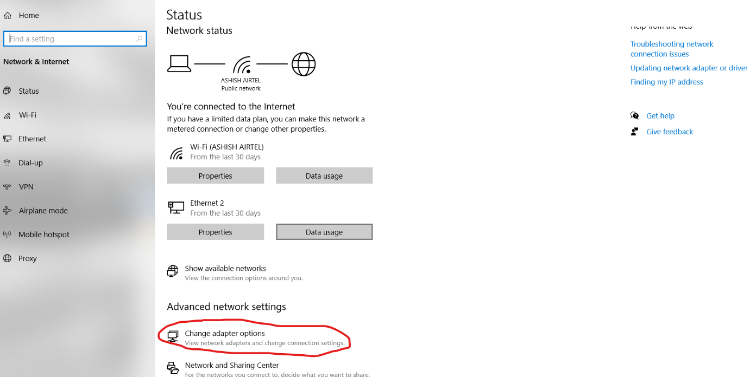
- Check for main internet source (Wifi in my case) and BBB network adaptor:
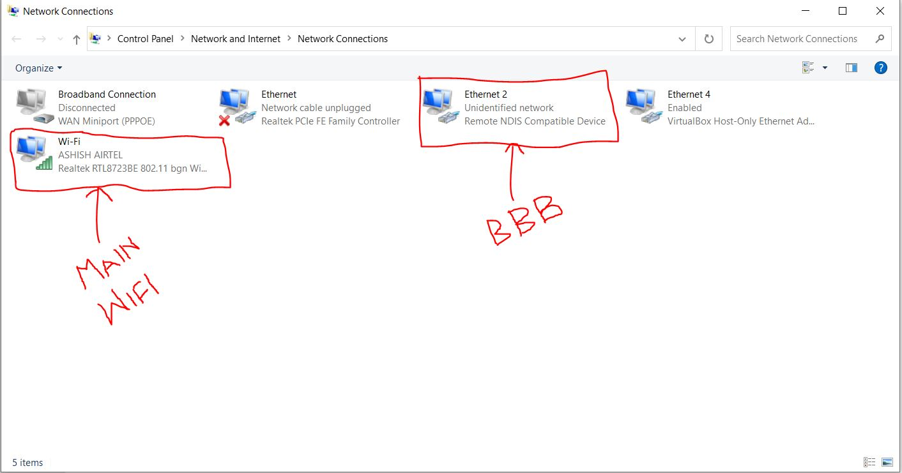
- check BBB adaptor, it will be mentioned similar as “Remote NDIS Compatible device”
S2: For Main WIFI: To share internet (from main wifi), right click and goto properties, go to sharing tab and mark check on “Allow other network users to connect through the computer internet connection” and put BBB adapter (in my case it’s Ethernet 2) name in “Home networking connection”.
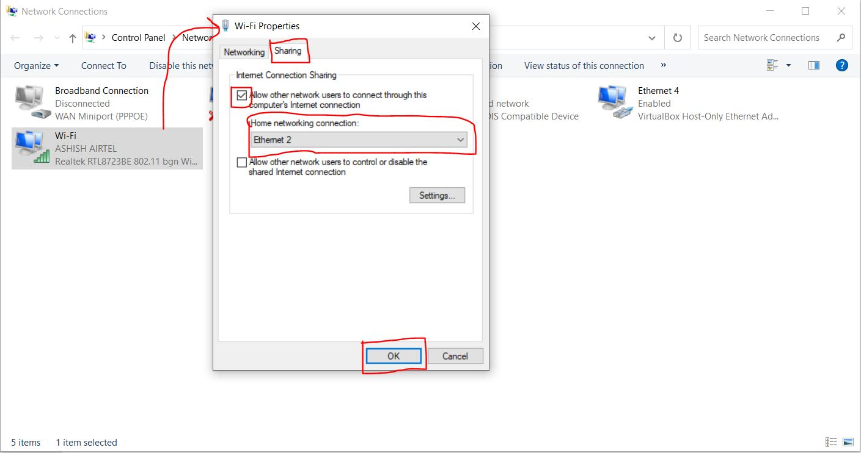
S3: For BBB adaptor, right click on it, goto properties, then double click on “Internet Protocol version 4 (TCP/IPv4), then put “obtain IP address” and “DNS server” automatically and click “ok”.
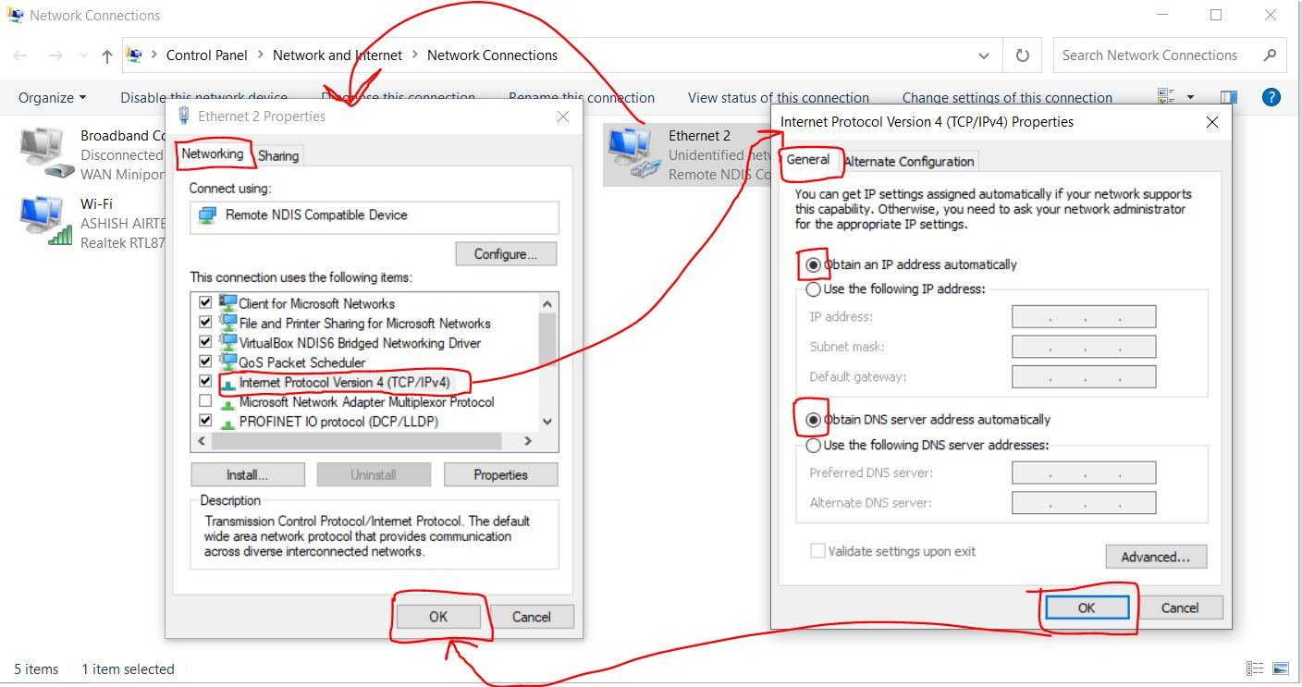

Setting to be done on BBB (Debian):
S1. Access BBB terminal through ssh: > ssh debian@192.168.7.2
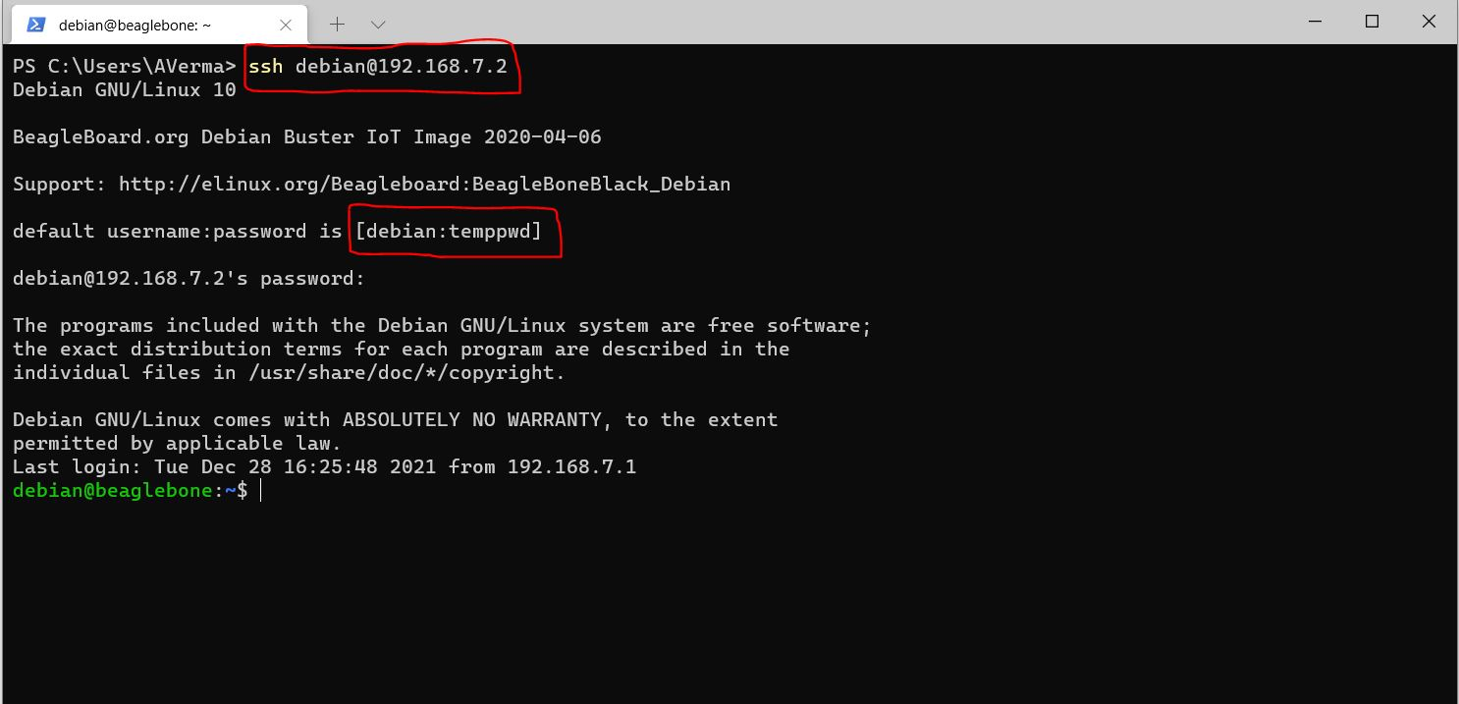
S2: add default gateway: > sudo /sbin/route add default gw 192.168.7.1
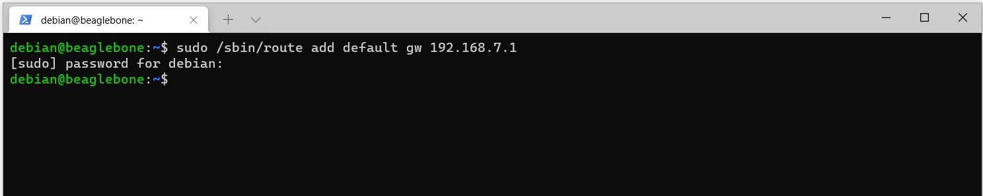
- After adding default gateway, verify: > sudo ping 192.168.7.1
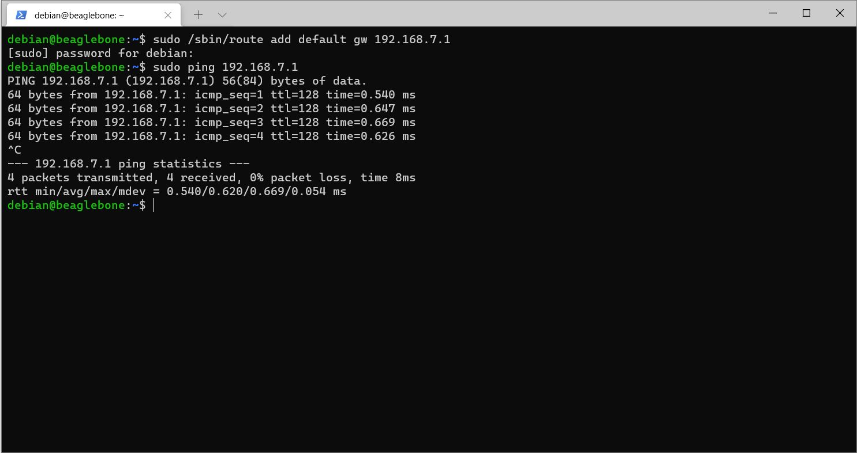

S3: Add static IP address on BBB: > sudo nano /etc/network/interfaces
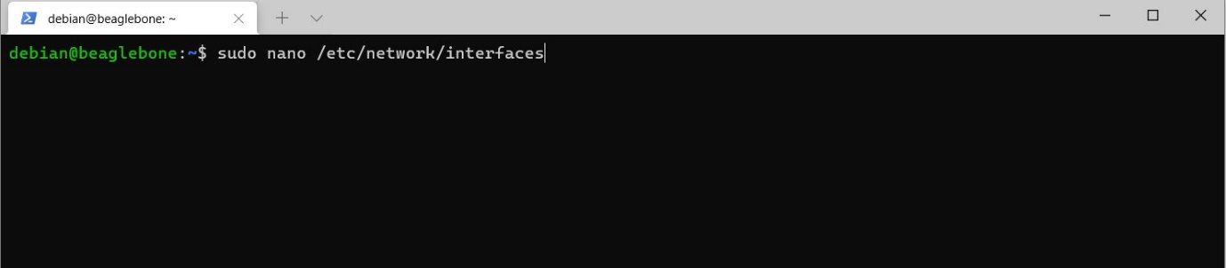
- Add following entries at the end of file:
iface usb0 inet static
address 192.168.7.2
netmask 255.255.255.0
network 192.168.7.0
gateway 192.168.7.1
dns-nameservers 8.8.8.8
dns-nameservers 8.8.4.4
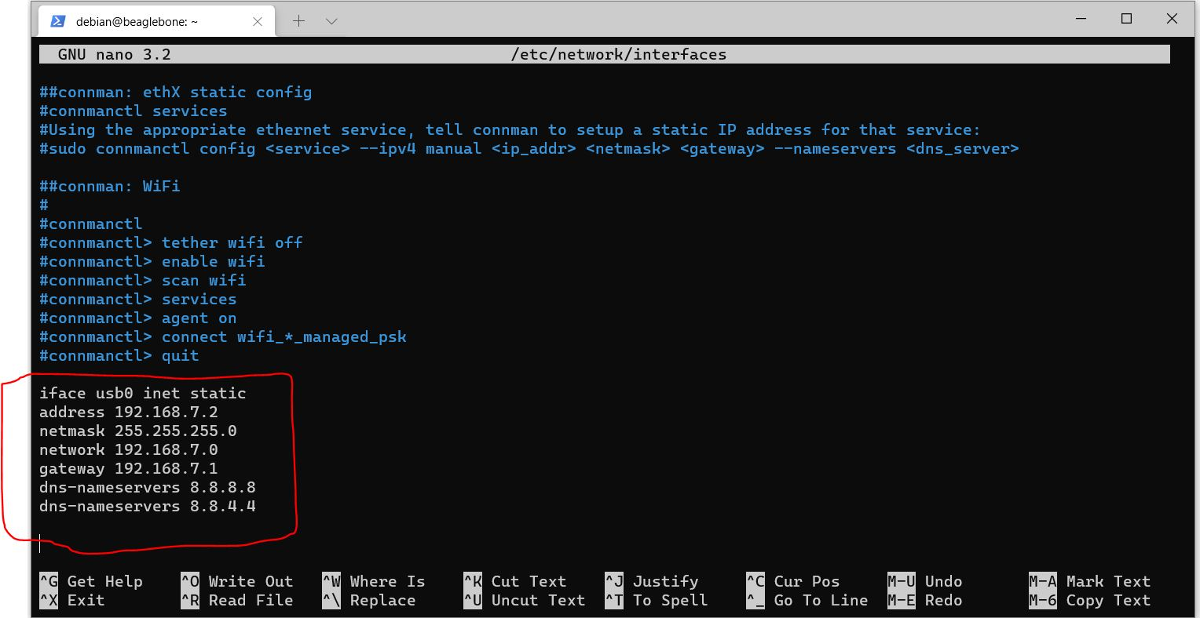
- Save and Exit.

Verify : > sudo ping 8.8.8.8
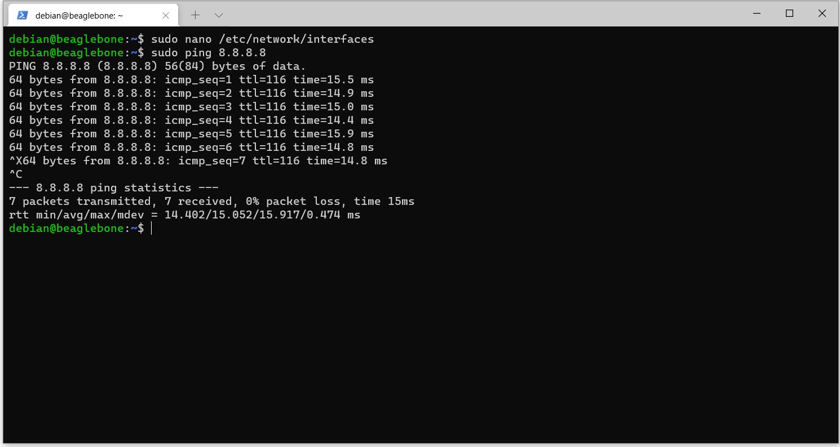

S4: Add google DNS server IP address to the config file.
cmd: > sudo nano /etc/resolv.conf
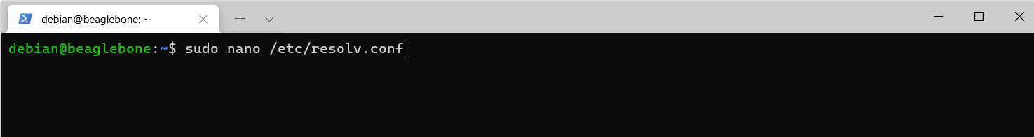
- Add following entries there:
nameserver 8.8.8.8
nameserver 8.8.4.4
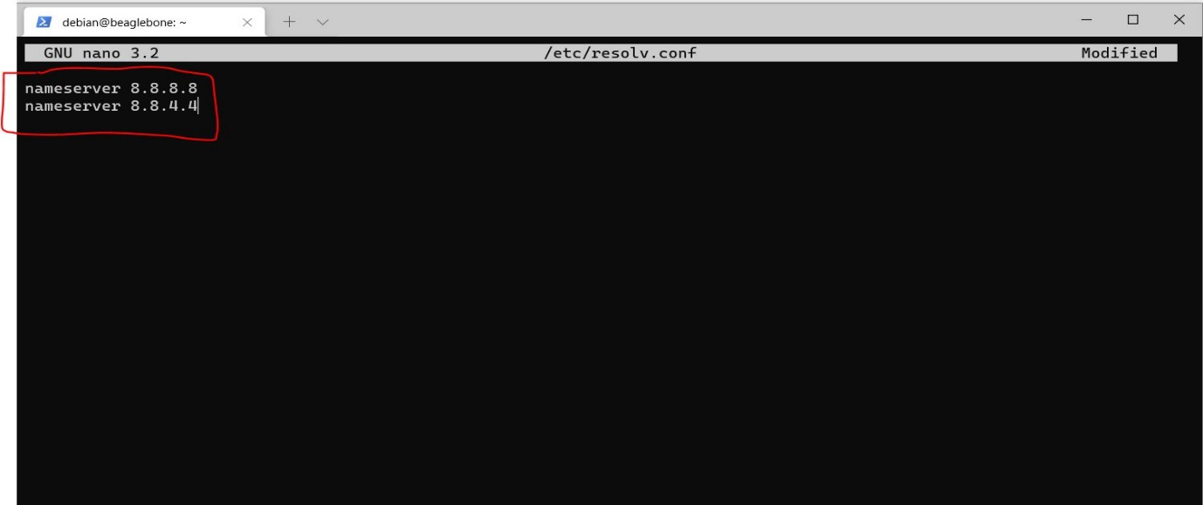
- Save and exit.
- Verify: > sudo ping google.com
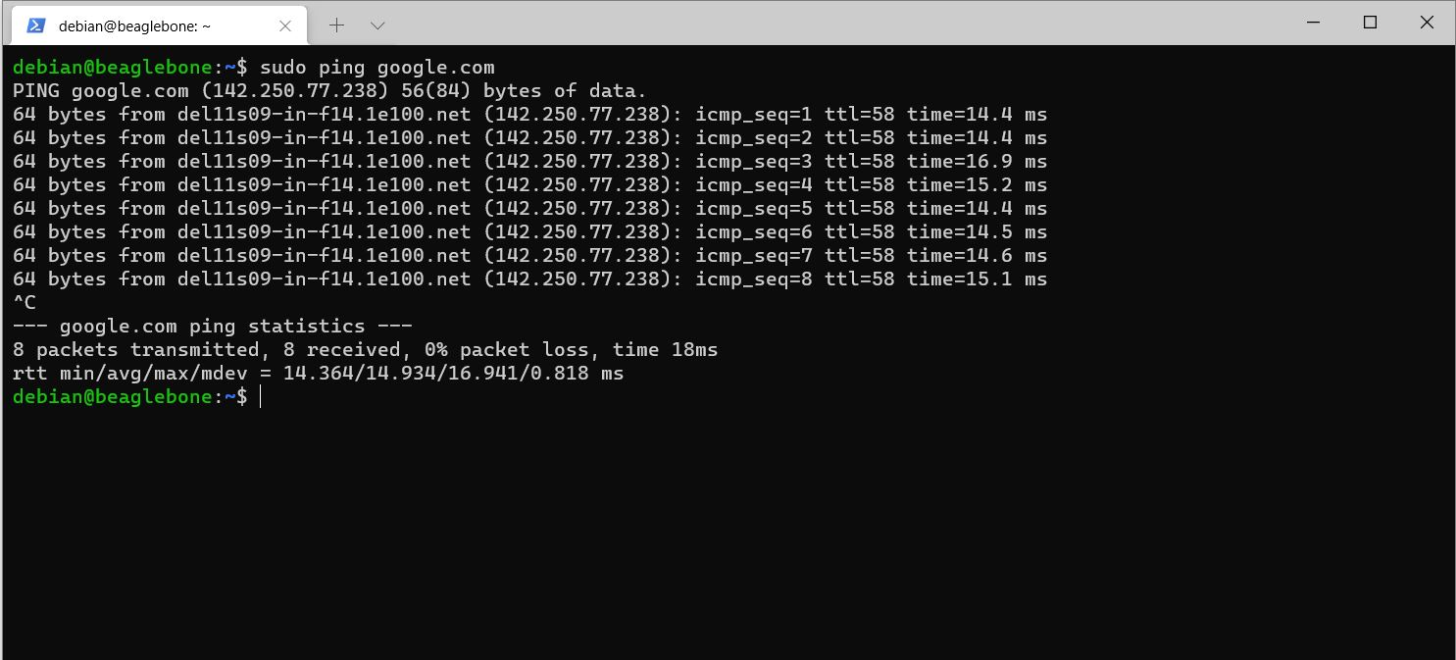

** Internet is working on your BBB, run following command:
cmd: > sudo apt-get update

** In case your internet is not working, try “Network Reset” from “windows start menu”
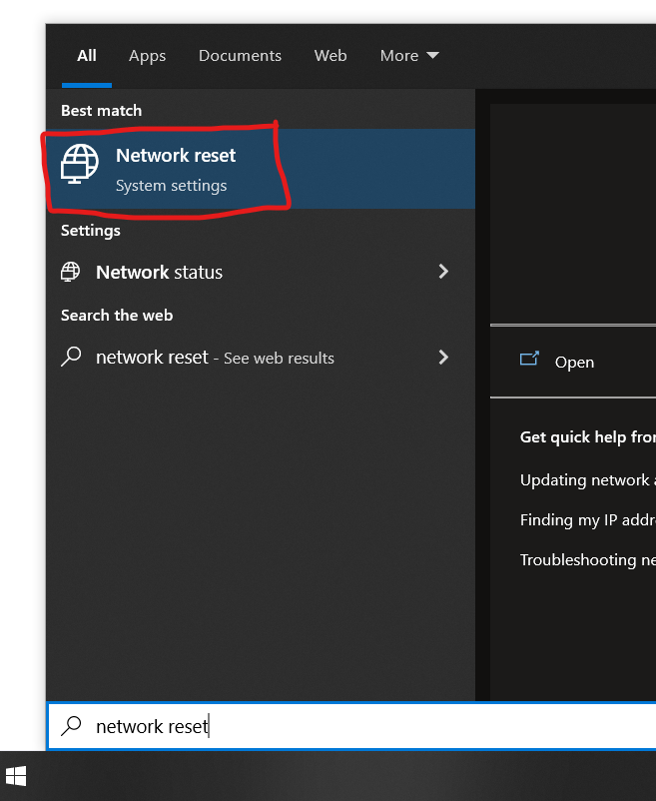
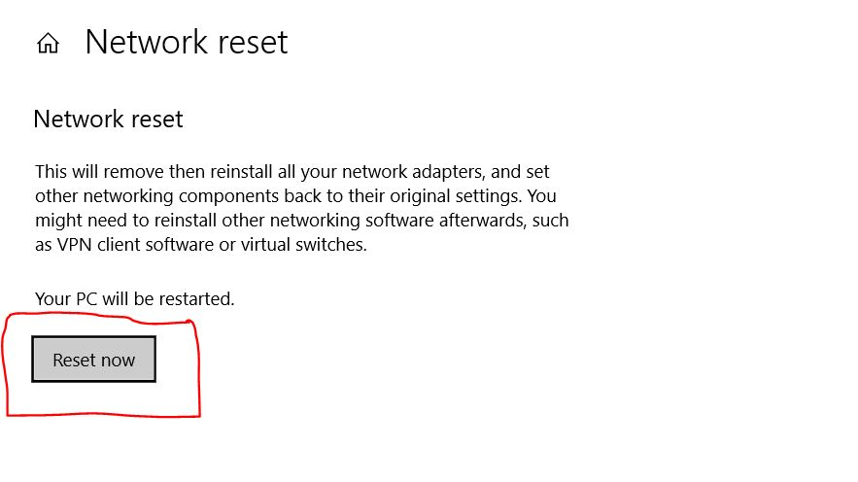
- It will give prompt that system will reboot in 5 min, then you can manually restart your system and follow same steps from starting.

