AI REVOLUTION
The Artificial Intelligence (AI) Revolution refers to the rapid advancement and adoption of intelligent systems capable of performing tasks that traditionally required human intelligence. These tasks include learning, reasoning, perception, decision-making, and language understanding. AI has moved from theoretical research into real-world deployment across industries.
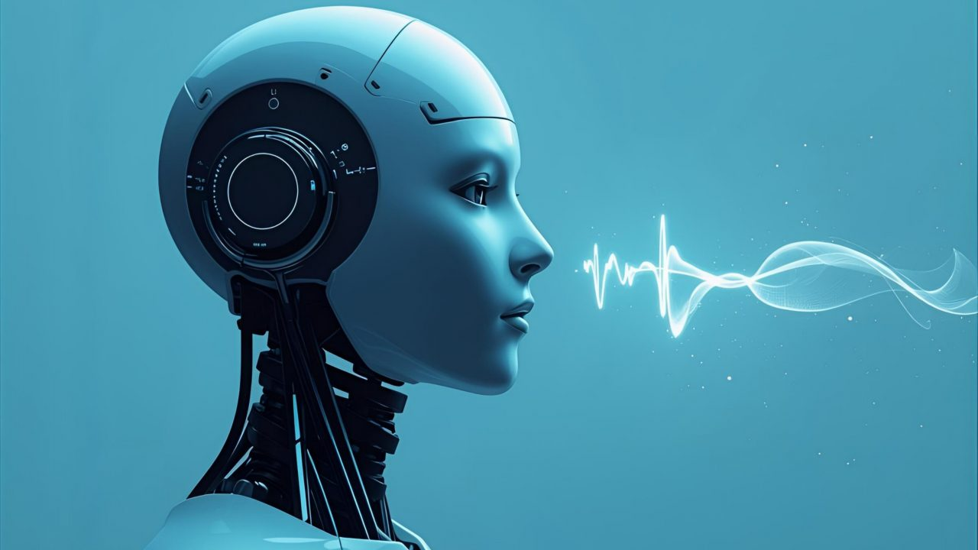
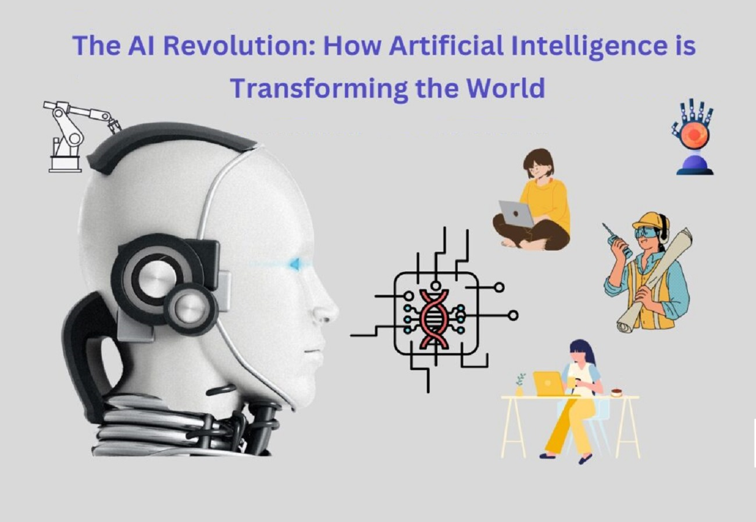Historical Evolution of AI
AI development began in the 1950s with rule-based systems and symbolic reasoning. The evolution continued through expert systems, machine learning, and finally deep learning. Modern AI systems are data-driven and benefit from increased computational power and large datasets.

Era | Key Technology | Example
1950s–1980s | Rule-Based AI | Expert Systems
1990s–2000s | Machine Learning | Spam Filters
2010s–Present | Deep Learning | Self-driving Cars

Applications of AI
AI is transforming industries such as healthcare, finance, education, manufacturing, and entertainment. In healthcare, AI assists in diagnosis and medical imaging. In finance, it enables fraud detection and algorithmic trading.

Industry | AI Use Case
Healthcare | Disease Prediction
Finance | Fraud Detection
Education | Personalized Learning
Manufacturing | Predictive Maintenance
- Impact on Society and Jobs
AI has a significant impact on employment and society. While automation may replace repetitive tasks, it also creates new job roles requiring advanced technical and analytical skills. Ethical concerns such as bias, transparency, and privacy are central to AI governance.
Future of the AI Revolution
The future of AI includes the development of general-purpose intelligence, improved human-AI collaboration, and stronger regulatory frameworks. Responsible AI development will determine how beneficial this revolution is for humanity.

