AIRTEL CLONE

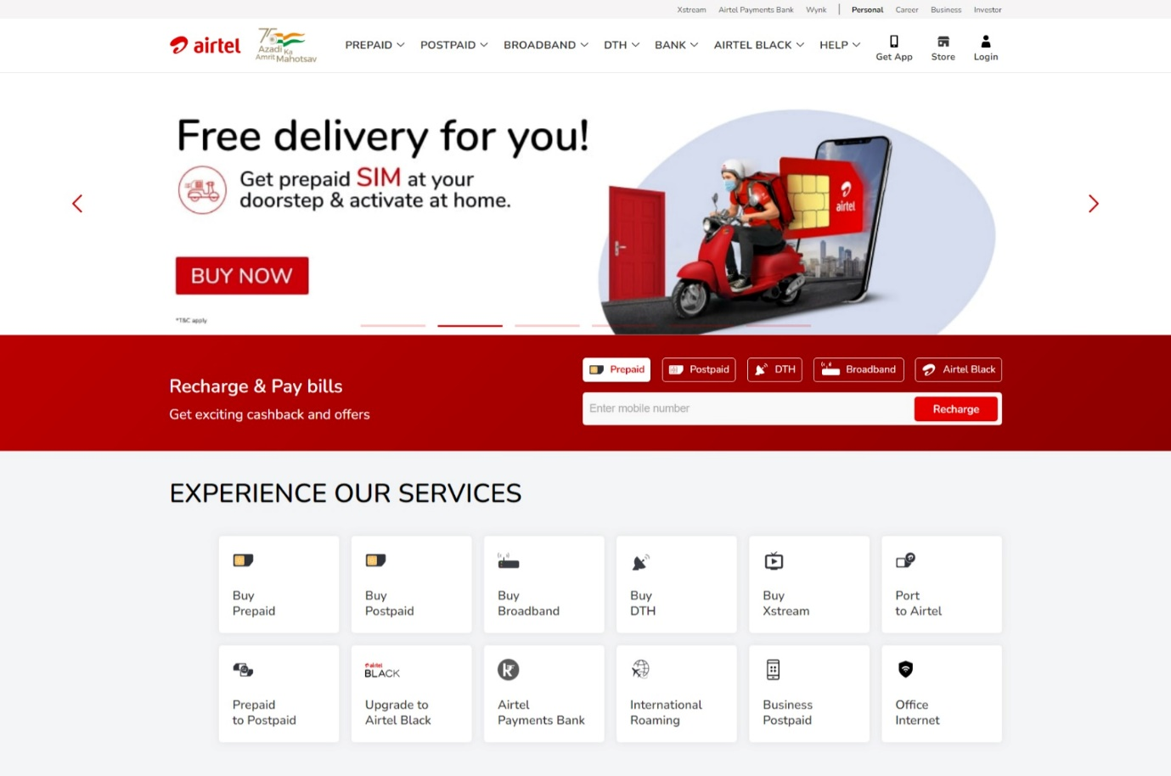

LOGESHWAR

Edureka Presents

Overview

**Bharti Airtel** Limited, also known as Airtel, is**an Indian multinational telecommunications services company based in New Delhi.** It operates in 18 countries across South Asia and Africa, as well as the Channel Islands

Goals

* **Login page**
* **Payment**
* **Buy airtel Xtream product**
* **Offer and plans page**

Technologies used in this project

**FRONT-END**

* HTML
* CSS
* BOOTSTRAP
* GOOGLE FONTS

**DYNAMIC**

* JAVASCRIPT

**DATABASE**

* MONGODB

**CODE COMPILER**

* VISUAL STUDIO CODE