Used Ruby + Cucumber

Load TestING : JMeter

Q1: Create a class to perform simple arithmetic and write unit tests for it.

**Ans1:** simple_calculator.feature

<https://github.com/vishalm/dubizzle/blob/master/features/simple_calculator.feature>

Q2: Why is test code coverage a good metric and whats are it's shortcoming?

To elaborate use the class and tests created in Q1.

Ans2: Code coverage is used in software testing, as it measures the quality of your test procedures, by describing the degree to which the source code of a program has been tested.

* Thoroughly test the method.
  + **Advantage:** the method is now well tested.
  + **Disadvantage:** it may lead future developers astray by making something coincidental seem intentional.
* Do the minimal amount of testing to cover the method.
* **Advantage:** the method has some basic tests for it.
* **Disadvantage:** you're focused on the wrong goal. You should strive for well tested code, not 100% code coverage. There's a big difference.
* Don't test it until you can verify the requirements. Then thoroughly test it.
  + **Advantage**: avoiding the disadvantages of options 1 and 2.
  + **Disadvantage**: verifying the requirements can be time consuming, and until you do, you have untested code.

CodeCoveage Tool:” **simplecov”**

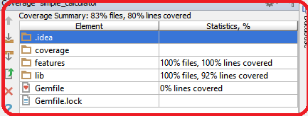

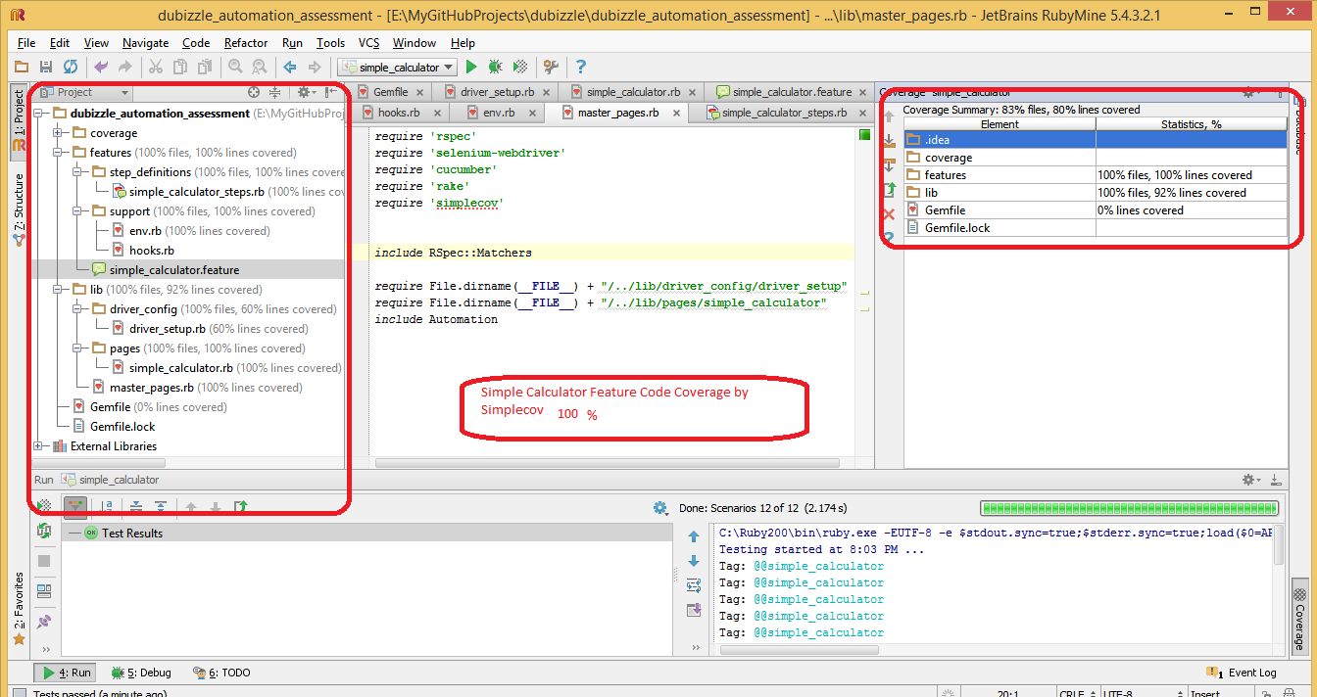

Q3: How do you think testing in agile context is different then testing in traditional software development processes?

Ans3 : It’s a wide open question and in many ways testing in agile is different from the traditional ways.

Agile testing generally means the practice of testing software for bugs or performance issues within the context of an agile workflow.

Agile development integrates testing into the development process, verses having it as a separate phase. Testing therefore is an integral part of the core software development and actively participates though out the software coding process. Agile Testing involves a cross-functional Agile team actively relying on the special expertise contributed by Testers.

**Agile Testing Practices**

* Includes Testers as full members of the Agile development team.
* Leverage Testers as active contributors in planning and requirements analysis.
* Promote the importance of Testers and encourage continuous feedback sharing with the programmers and the customer.
* Testers actively participate in meetings to define the main business flows.
* Testers complete short iteration activities alongside developers.
* Encourage maintenance of traceability between the requirements, test cases and bugs.
* Testers contribute to user story improvements.
* Leverage the specialized skills of test-driven development, including unit testing, continuous integration and unit level.
* Leverage Automation testing as a key way to do regression testing.

Any repetitive task should be automated

**Automated Test**

* Allows re-use of tests
* Enables faster execution for the most important test cases.
* Facilitates greater test coverage
* Delivers higher test accuracy and identifies defects sooner
* Facilitates regression testing

**SBTM(Session based manual testing)**

It’s a new way to organise and execute manual testing in agile world.

Q4: Write a load test to upload images to imugr using your account by consuming it's API https://api.imgur.com/

Note: If you are having trouble in using your account, you can consume the API anonymously.

Ans: I Used Jmeter and created JMX file added test plan added request currently its working with below mention configruations

<stringProp name="LoopController.loops">20</stringProp>

<stringProp name="ThreadGroup.num_threads">10</stringProp>

<stringProp name="ThreadGroup.ramp_time">1</stringProp>

Location: <https://github.com/vishalm/dubizzle/tree/master/ImgurLoadTest>

Q5: Open dubai.dubizzle.com in your browser and take a look around Now open egypt.dubizzle.com and do the same.

Now consider the following scenario and automate it using Selenium or similar tool.

"As a user I want the list of least expensive apartment to rent in marina which have at least two bathrooms"

-- Additionally open the last item in the result set and verify it has two bathrooms

-- Bonus points: Refactor the above script to be data driven?

***Ans:***

<https://github.com/vishalm/dubizzle/blob/master/features/search.feature>

Additional Question for candidates with experience of mobile test automation:

Q6: Which is your favorite open source Android/iOS apps? Automate two of its functional tests.

Ans : As I didn’t get much time to work on this Please consider : [***https://github.com/vishalm/demo_mobile_project***](https://github.com/vishalm/demo_mobile_project) one of my old project, if require I can create new project using APPIUM or Calabash.