Project Report
LOKESH REDDY SONTIREDDY
CS 773: DATA MINING AND SECURITY
UIN: 01236994

TABLE OF CONTENTS

EXECUTIVE SUMMARY SOLUTIONS
REFERENCES
APPENDIX

EXECUTIVE SUMMARY

Considering the significant amount of pressure that various stakeholders are putting on international airport terminals to improve the overall quality of the travel experience, it is highly important to make investments in technology that will increase the percentage of satisfied passengers.

In addition, gathering and evaluating the accumulated data in batches is a complicated and time-consuming process that may be made a great deal simpler by employing sequential analysis. The analysis of passenger data provides a method for airlines to discover which factors lead to higher levels of passenger satisfaction and higher quality of service by determining which qualities contribute to a higher quality of service. It is vital for airlines to build passenger data analytics since it is a dependable and complete forecasting model that needs to be utilized on a constant basis to evaluate the impact of operations in order to increase customer happiness and improve the overall quality of service that is offered.

An inquiry into the level of satisfaction experienced by airline passengers uncovered the fact that passengers rarely experience long delays upon arrival or departure and that a disproportionately high number of people in the middle years of their lives go on vacations of moderate to extended length. The passengers on the long-haul flights were satisfied with the in-flight service, the passengers on the medium-haul flights were more satisfied with the in-flight entertainment, and the passengers on the short-haul flights preferred the cleanliness over in-flight entertainment that the airline offered. First-time passengers have lower overall satisfaction than those who are repeat customers. An explanation of the more precise insights gathered from the results has been offered by the subsequent steps in this process.

SOLUTIONS

Before answering the questions, I preprocessed the data. There are 393 null values in Arrival Delay. So, I used forward fill method to fill those null values.

Step 1: Statistics on departure delay (A8) and arrival delay (A9).

1a. For features A8 and A9

- Central tendency measures: mean, mode, and median

Departure Delay Central Tendency Values

Mean : 14.713712657838004
Mode : 0
Median. : 0.0

Arrival Delay Central Tendency Values

Mean : 15.101455189405605
Mode : 0
Median : 0.0

- The spread: standard deviation (for each)

Departure Delay Spread

Standard Deviation : 38.07112621501333

Arrival Delay Spread

Standard Deviation : 38.47227554800929

- Percentiles: the 10th, 50th, 75th and 90th percentiles (for each)

Departure Delay

10th Percentile : 0.0
50th Percentile : 0.0
75th Percentile : 12.0
90th Percentile : 44.0

Arrival Delay

10th Percentile : 0.0
50th Percentile : 0.0
75th Percentile : 13.0
90th Percentile : 44.0

- 1st quartile, 3rd quartile, and the median

Departure Delay

1st quartile : 0.0
Median: 0.0
3rd quartile : 12.0

Departure Delay

1st quartile : 0.0
Median: 0.0
3rd quartile : 13.0

- The skewness (for each)

Departure Delay

Skewness : 6.821980

Arrival Delay

Skewness : 6.660696

- The covariance and correlation between A8 and A9

Covariance between A8 and A9 : 1404.284791

Correlation between A8 and A9 : 0.958764

- Plot the two delays on a chart to display their distributions

As the Delays are in minutes which is a continuous type we use histograms.

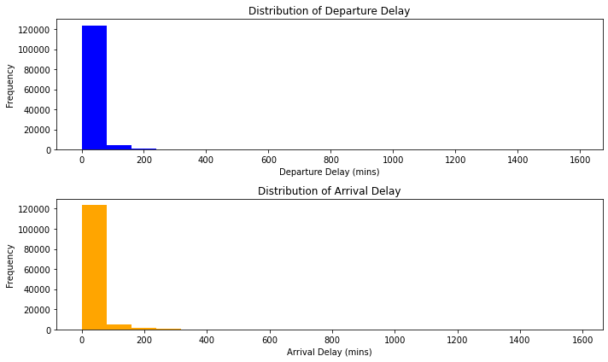

1b. Based on the above results in 1a, make useful conclusions. This is an important part of data analysis. It should be an English description that non-mathematically oriented airline executives can understand.

A notable correlation can be observed between the Arrival delay and the Departure delay, as there is a significant similarity in the distribution of data across various central tendency measures. Specifically, an increase in arrival delay is accompanied by a corresponding increase in departure delay, and conversely. The data exhibits a right-skewed distribution, indicating that the majority of delays fall within the range of 0 to 50 minutes (approximately).

STEP 2: Convert numerical values to categorical values

  - Discretize age (A3) to nominal values using the following criteria: 0-15: Child; 16-35: Youth; 36-55 Middle age; 56-70: Old; >70- Senior.
  - Discretize flight distance (A7) to nominal values using the following criteria: 0-500miles:
Short haul; 501-3000 miles: medium haul; >3000 Long haul
  - Discretize delays (A8 and A9) to nominal values: Small: 0-15; Medium: 16-45; Long:
>45

Code for conversion of A3, A7, A8 and A9 in excel is as follows:

function main(workbook: ExcelScript.Workbook) {
// Get the active worksheet
let worksheet = workbook.getActiveWorksheet();

// Discretize Age column
let ageRange = worksheet.getRange("A2:A129881");
ageRange.getValues().forEach((value, index) => {
let age = value[0];
let discretizedValue = "";

if (age <= 15) {
discretizedValue = "Child";
} else if (age <= 35) {
discretizedValue = "Youth";
} else if (age <= 55) {
discretizedValue = "Middle age";
} else if (age <= 70) {
discretizedValue = "Old";
} else {
discretizedValue = "Senior";
}

let cell = ageRange.getCell(index, 0);
cell.setValue(discretizedValue);
});

// Discretize Flight Distance column
let distanceRange = worksheet.getRange("B2:B129881");
distanceRange.getValues().forEach((value, index) => {
let distance = value[0];
let discretizedValue = "";
if (distance <= 500) {
discretizedValue = "Short haul";
} else if (distance <= 3000) {
discretizedValue = "Medium haul";
} else {
discretizedValue = "Long haul";
}

let cell = distanceRange.getCell(index, 0);
cell.setValue(discretizedValue);
});

// Discretize Departure Delay column
let departureDelayRange = worksheet.getRange("C2:C129881");
departureDelayRange.getValues().forEach((value, index) => {
let departureDelay = value[0];
let discretizedValue = "";

if (departureDelay <= 15) {
discretizedValue = "Small";
} else if (departureDelay <= 45) {
discretizedValue = "Medium";
} else {
discretizedValue = "Long";
}

let cell = departureDelayRange.getCell(index, 0);
cell.setValue(discretizedValue);
});

// Discretize Arrival Delay column
let arrivalDelayRange = worksheet.getRange("D2:D129881");
arrivalDelayRange.getValues().forEach((value, index) => {
let arrivalDelay = value[0];
let discretizedValue = "";

if (arrivalDelay <= 15) {
discretizedValue = "Small";
} else if (arrivalDelay <= 45) {
discretizedValue = "Medium";
} else {
discretizedValue = "Long";
}
let cell = arrivalDelayRange.getCell(index, 0);
cell.setValue(discretizedValue);
});
}

  - Plot the distributions for each of the above using the discretized values.

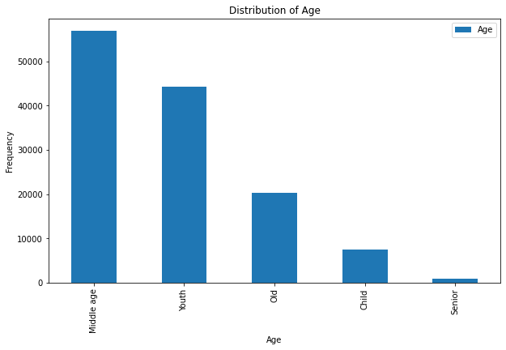

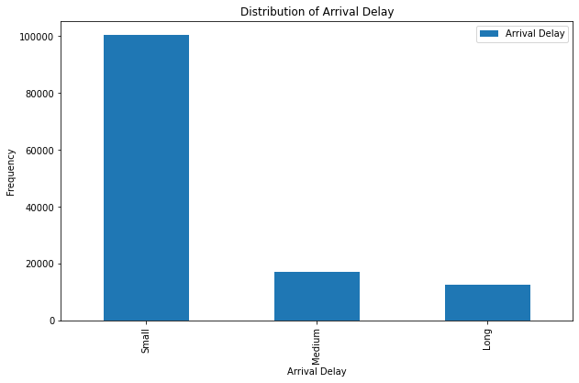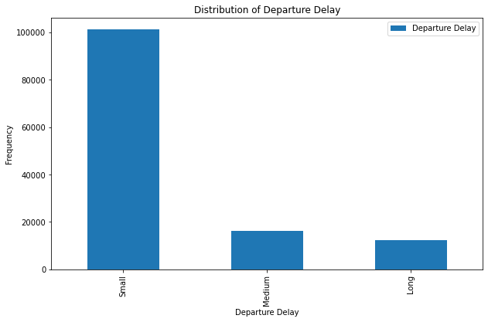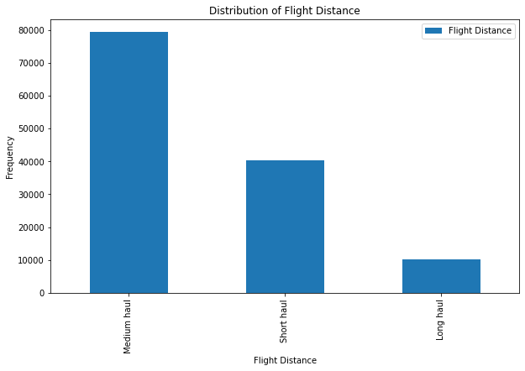2b. Based on the distributions in 2d, make some useful observations and write them.

According to the Flight Distance distribution, a greater number of passengers are observed to be traveling within the range of 501 to 3000 miles. Additionally, it is noted that individuals within the age group of 56-70 years exhibit a greater desire for air travel, as indicated by the age distribution. The observed arrival and departure delays exhibit minimal magnitudes, ranging from 0 to 15 minutes.

Step 3. Test the following two hypotheses. Show evidence to show whether they are true or false.

3H1: Long haul passengers’ overall satisfaction is influenced more by the in-flight service quality than by the departure delays.

OLS Regression Results
================================================================================
Dep. Variable: Overall_Satisfaction R-squared: 0.272
Model: OLS Adj. R-squared: 0.272
Method: Least Squares F-statistic: 1929.
Date: Wed, 26 Jul 2023 Prob (F-statistic): 0.00
Time: 15:49:15 Log-Likelihood: -4012.8
No. Observations: 10313 AIC: 8032.
Df Residuals: 10310 BIC: 8053.
Df Model: 2
Covariance Type: nonrobust
====================================================================================
coef std err t P>|t| [0.025 0.975]
------------------------------------------------------------------------------------
Intercept 0.0702 0.012 5.713 0.000 0.046 0.094
Inflight_Service 0.1875 0.003 61.342 0.000 0.182 0.193
Departure_Delay -0.0005 9.2e-05 -5.429 0.000 -0.001 -0.000
==============================================================================
Omnibus: 702.399 Durbin-Watson: 1.842
Prob(Omnibus): 0.000 Jarque-Bera (JB): 852.577
Skew: -0.698 Prob(JB): 7.33e-186
Kurtosis: 3.189 Cond. No. 148.
==============================================================================

Notes:
[1] Standard Errors assume that the covariance matrix of the errors is correctly specified.
In [48]:

Based on the results obtained from the Ordinary Least Squares (OLS) regression analysis, the following interpretations can be made:

The R-squared value, which is 0.272, suggests that the model accounts for approximately 27.2% of the variability observed in overall satisfaction. This finding suggests that approximately 27.2% of the variability in overall satisfaction can be ascribed to the joint influence of in-flight service quality and departure delays.

The coefficient associated with the variable "Inflight_Service" is 0.1875, and it has a standard error of 0.003. This finding suggests that there is a positive relationship between in-flight service quality and overall satisfaction. Specifically, for each one-unit increase in in-flight service quality, there is an expected increase of 0.1875 units in overall satisfaction, while regulating for other variables.
The coefficient associated with the variable "Departure_Delay" is -0.0005, and it has a standard error of 9.2e-05. This finding implies that there is a negative relationship between departure delays and overall satisfaction, with a decrease of 0.0005 units in overall satisfaction for each one-unit increase in departure delays, while regulating for other variables.

The p-values for both coefficients are observed to be extremely small, suggesting a high level of statistical significance. In essence, substantial evidence exists indicating that the quality of in-flight service and the occurrence of departure delays exert a noteworthy influence on the overall satisfaction levels of long-haul passengers.

The coefficients' confidence intervals, with a confidence level of 95%, do not encompass the value of zero. This finding provides additional evidence for the statistical significance of the coefficients.

In conclusion, the findings indicate that in the context of long-haul passengers, the quality of in-flight service exerts a more significant impact on overall satisfaction when compared to the influence of departure delays. The presence of a positive coefficient pertaining to in-flight service quality suggests that enhancing the quality of in-flight services is likely to result in increased levels of overall satisfaction among passengers on long-haul flights. Conversely, the presence of a negative coefficient in relation to departure delays suggests that reducing such delays could potentially enhance overall satisfaction levels.

Therefore, we can support the alternative hypothesis (3H1) that long haul passengers' overall satisfaction is influenced more by in-flight service quality than by departure delays.

3H2. Medium haul passengers’ overall satisfaction is influenced more by the arrival delays than by the in-flight entertainment.

OLS Regression Results
================================================================================
Dep. Variable: Overall_Satisfaction R-squared: 0.162
Model: OLS Adj. R-squared: 0.162
Method: Least Squares F-statistic: 7689.
Date: Wed, 26 Jul 2023 Prob (F-statistic): 0.00
Time: 15:49:16 Log-Likelihood: -49957.
No. Observations: 79291 AIC: 9.992e+04
Df Residuals: 79288 BIC: 9.995e+04
Df Model: 2
Covariance Type: nonrobust
==========================================================================================
coef std err t P>|t| [0.025 0.975]
------------------------------------------------------------------------------------------
Intercept -0.0517 0.004 -11.645 0.000 -0.060 -0.043
Inflight_Entertainment 0.1490 0.001 122.965 0.000 0.147 0.151
Arrival_Delay -0.0005 4.09e-05 -12.817 0.000 -0.001 -0.000
==============================================================================
Omnibus: 486255.478 Durbin-Watson: 1.515
Prob(Omnibus): 0.000 Jarque-Bera (JB): 5860.828
Skew: 0.111 Prob(JB): 0.00
Kurtosis: 1.687 Cond. No. 120.
==============================================================================

Notes:
[1] Standard Errors assume that the covariance matrix of the errors is correctly specified.
In [61]:

Based on the results obtained from the Ordinary Least Squares (OLS) regression analysis, the following interpretations can be made:

The R-squared value, which is 0.162, suggests that the model accounts for approximately 16.2% of the variability observed in the measure of overall satisfaction. This finding suggests that approximately 16.2% of the variability in overall satisfaction can be attributed to the joint influence of in-flight entertainment and arrival delays.

The coefficient associated with the variable "Inflight_Entertainment" is estimated to be 0.1490, with a standard error of 0.004. This finding suggests that there is a positive relationship between in-flight entertainment and overall satisfaction. Specifically, for each additional unit of in-flight entertainment, there is an expected increase of 0.1490 units in overall satisfaction, while controlling for other variables.
The regression coefficient for the variable "Arrival_Delay" is estimated to be -0.0005, with a standard error of 4.09e-05. This finding implies that a one-unit increase in arrival delays is associated with a predicted decrease in overall satisfaction by 0.0005 units, while controlling for other variables.

The p-values for both coefficients are observed to be extremely small, suggesting a high level of statistical significance. In essence, substantial evidence exists to indicate that the satisfaction of medium haul passengers is significantly influenced by both in-flight entertainment and arrival delays.

The 95% confidence intervals for both coefficients exhibit exclusion of zero, thereby providing additional evidence in favor of the statistical significance of the coefficients.

In conclusion, the findings of this study indicate that in-flight entertainment exerts a more significant impact on the overall satisfaction of medium haul passengers, as opposed to arrival delays. The presence of a positive coefficient associated with in-flight entertainment suggests that enhancing the quality of in-flight entertainment is expected to result in increased levels of overall satisfaction among passengers traveling medium distances. Conversely, the presence of a negative coefficient pertaining to arrival delays suggests that mitigating such delays could potentially enhance overall satisfaction levels.
Therefore, we can support the alternative hypothesis (3H2) that medium haul passengers' overall satisfaction is influenced more by arrival delays than by in-flight entertainment.

3H3. Make your own hypothesis, state it, and test it.

Hypothesis: Short haul passengers’ overall satisfaction is influenced more by the cleanliness than by the in-flight entertainment.

OLS Regression Results
================================================================================
Dep. Variable: Overall_Satisfaction R-squared: 0.102
Model: OLS Adj. R-squared: 0.102
Method: Least Squares F-statistic: 2294.
Date: Wed, 26 Jul 2023 Prob (F-statistic): 0.00
Time: 15:49:16 Log-Likelihood: -24756.
No. Observations: 40276 AIC: 4.952e+04
Df Residuals: 40273 BIC: 4.954e+04
Df Model: 2
Covariance Type: nonrobust
==========================================================================================
coef std err t P>|t| [0.025 0.975]
------------------------------------------------------------------------------------------
Intercept -0.0140 0.006 -2.288 0.022 -0.026 -0.002
Inflight_Entertainment 0.1208 0.002 49.273 0.000 0.116 0.126
Cleanliness -0.0135 0.002 -5.439 0.000 -0.018 -0.009
==============================================================================
Omnibus: 45103.776 Durbin-Watson: 1.618
Prob(Omnibus): 0.000 Jarque-Bera (JB): 4687.550
Skew: 0.571 Prob(JB): 0.00
Kurtosis: 1.780 Cond. No. 13.9
==============================================================================

Notes:
[1] Standard Errors assume that the covariance matrix of the errors is correctly specified.
In [67]:

Based on the Ordinary Least Squares (OLS) Regression Results, the following interpretations can be made:

The R-squared value, which is 0.102, suggests that the model accounts for roughly 10.2% of the variability observed in overall satisfaction. This finding suggests that approximately 10.2% of the variance in overall satisfaction can be attributed to the joint influence of in-flight entertainment and cleanliness.

The coefficient associated with the variable "Inflight_Entertainment" is 0.1208, and it has a standard error of 0.002. This finding suggests that there is a positive relationship between in-flight entertainment and overall satisfaction. Specifically, for each one-unit increase in in-flight entertainment, there is an expected increase of 0.1208 units in overall satisfaction, while controlling for other variables.
The coefficient associated with the variable "Cleanliness" is -0.0135, and it has a standard error of 0.002. This finding implies that there is a negative relationship between cleanliness and overall satisfaction, with a decrease of 0.0135 units in overall satisfaction for each one-unit increase in cleanliness, while controlling for other variables.

The p-values for both coefficients are observed to be extremely small, suggesting a high level of statistical significance. In essence, there exists compelling evidence indicating that the satisfaction levels of short haul passengers are notably influenced by both in-flight entertainment and cleanliness.

The 95% confidence intervals for both coefficients exhibit exclusion of zero, thereby providing additional evidence in favor of the statistical significance of the coefficients.

Conclusion: The findings indicate that cleanliness exerts a more substantial impact on overall satisfaction among short haul passengers in comparison to in-flight entertainment. The presence of a negative coefficient in the context of cleanliness suggests that upholding stringent cleanliness standards is likely to play a pivotal role in promoting greater levels of overall satisfaction among passengers traveling on short-haul flights. Conversely, the presence of a positive coefficient pertaining to in-flight entertainment suggests that augmenting the in-flight entertainment experience can likewise contribute to increased levels of overall satisfaction.

Therefore, we can support the null hypothesis (3H3) that short haul passengers' overall satisfaction is influenced more by the cleanliness than by the in-flight entertainment.

Step 4. Find associations between some of the important attributes.

4a. With Gender, Age, Type of travel, Flight distance, Class, Arrival delays, and Overall satisfaction as attributes, determine association rules with a minimum support of 100 and a minimum confidence of 60%.

I first converted all variables to nominal type.

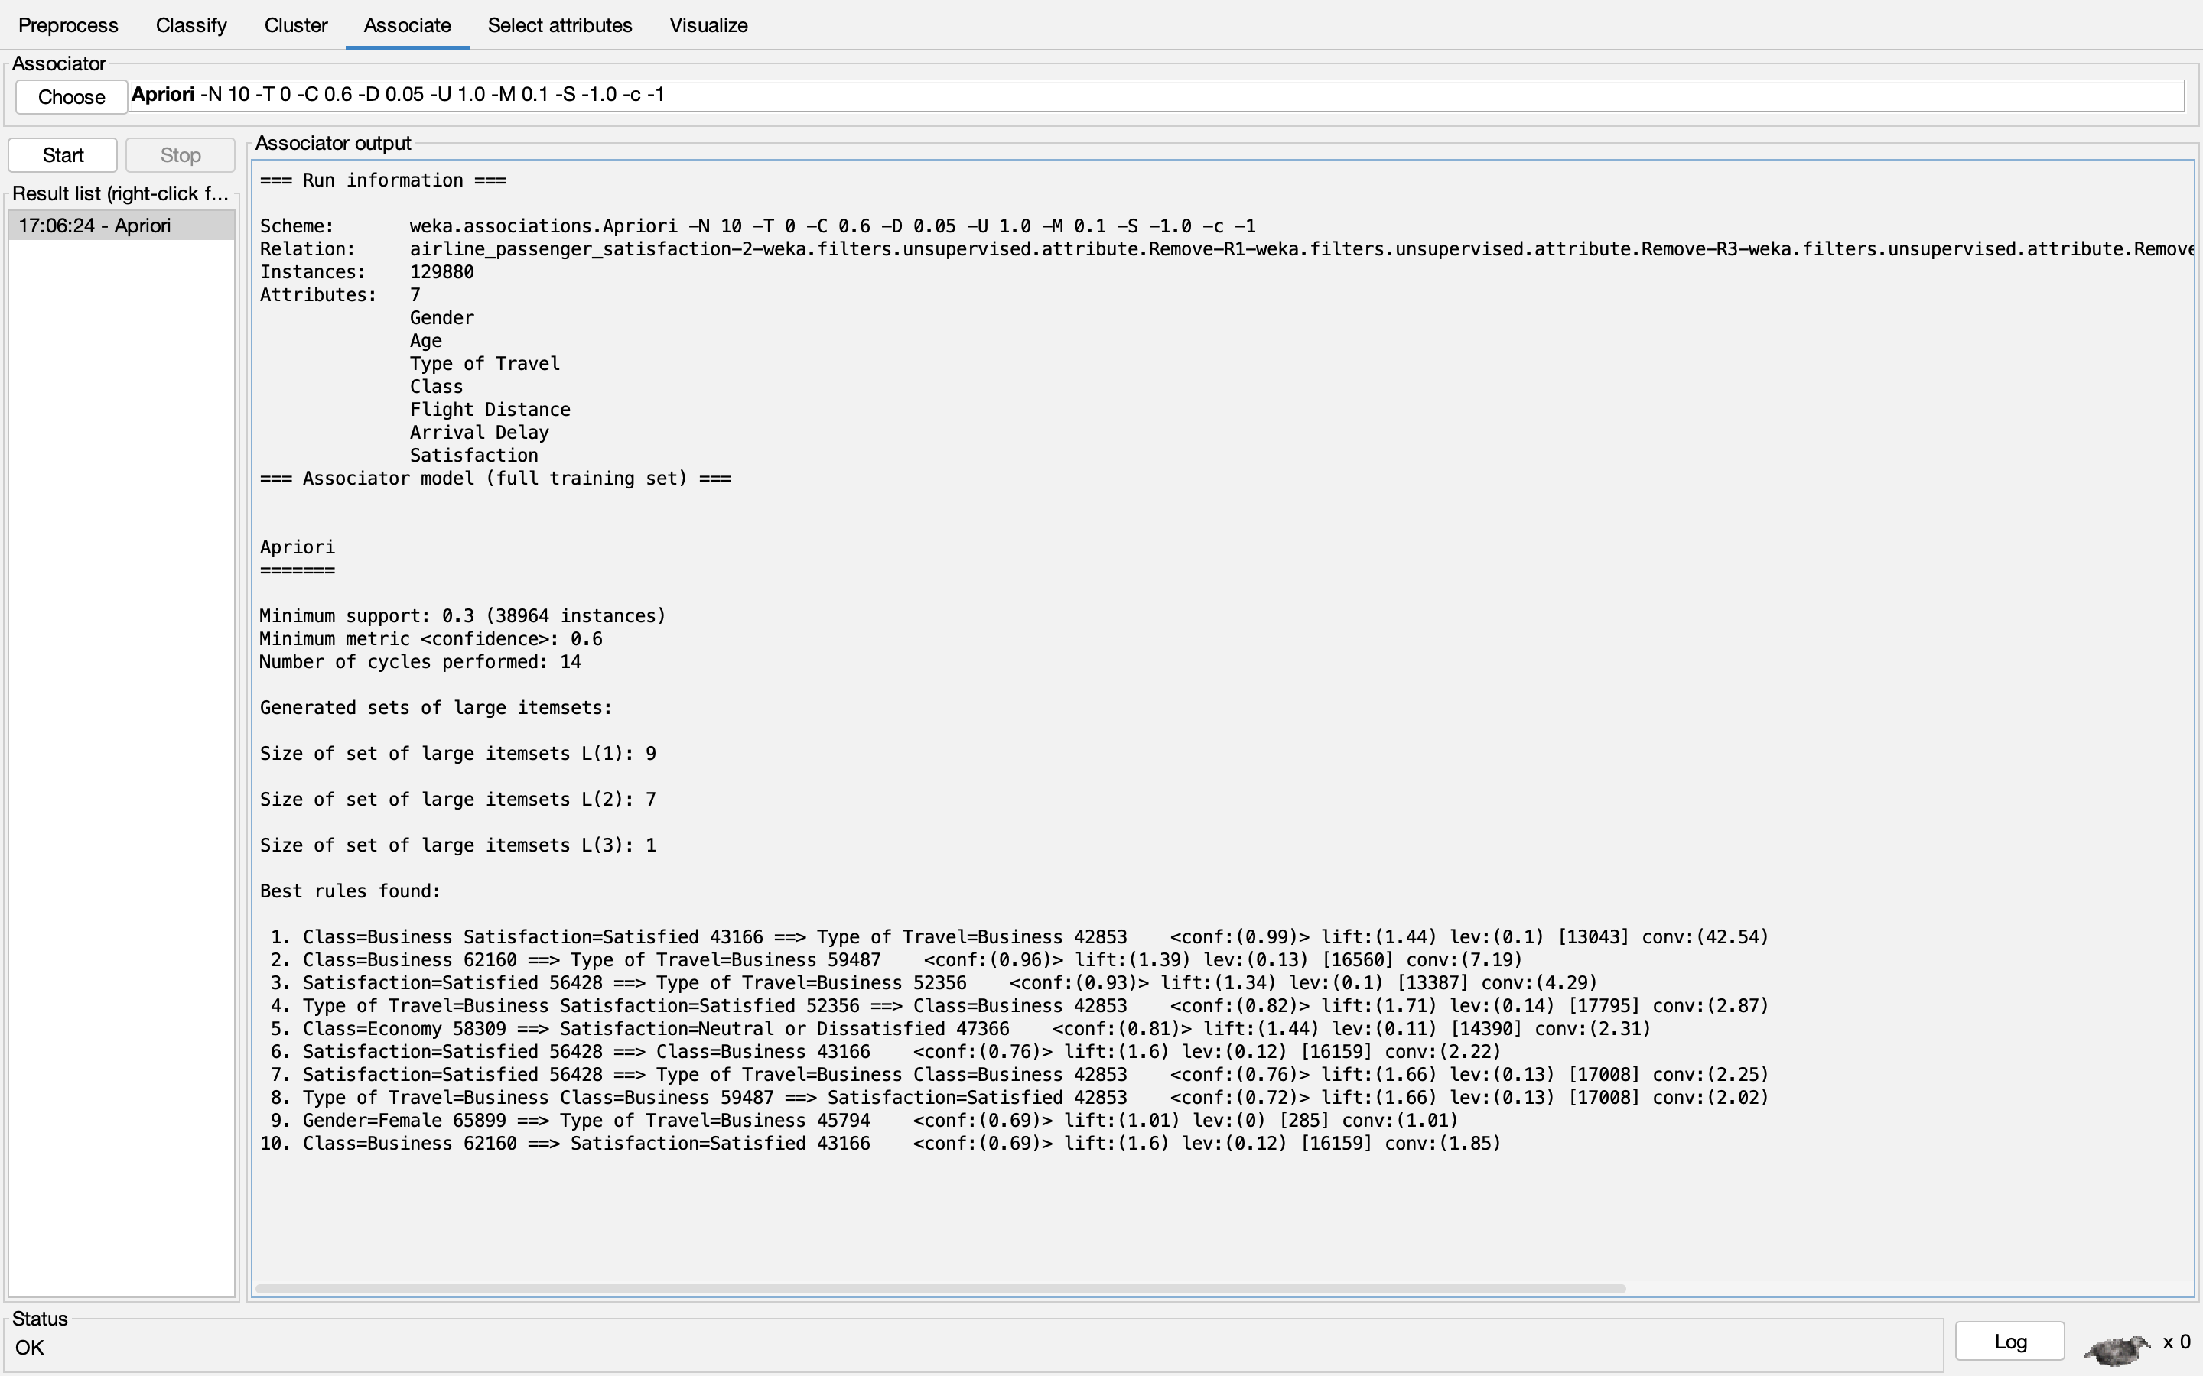

=== Run information ===

Scheme: weka.associations.Apriori -N 10 -T 0 -C 0.6 -D 0.05 -U 1.0 -M 0.1 -S -1.0 -c -1
Relation: airline_passenger_satisfaction-2-weka.filters.unsupervised.attribute.Remove-R1-weka.filters.unsupervised.attribute.Remove-R3-weka.filters.unsupervised.attribute.Remove-R6,8-21-weka.filters.unsupervised.attribute.NumericToNominal-Rfirst-last
Instances: 129880
Attributes: 7
Gender
Age
Type of Travel
Class
Flight Distance
Arrival Delay
Satisfaction
=== Associator model (full training set) ===

Apriori
=======

Minimum support: 0.3 (38964 instances)
Minimum metric <confidence>: 0.6
Number of cycles performed: 14

Generated sets of large itemsets:

Size of set of large itemsets L(1): 9

Size of set of large itemsets L(2): 7

Size of set of large itemsets L(3): 1

Best rules found:

1. Class=Business Satisfaction=Satisfied 43166 ==> Type of Travel=Business 42853 <conf:(0.99)> lift:(1.44) lev:(0.1) [13043] conv:(42.54)
2. Class=Business 62160 ==> Type of Travel=Business 59487 <conf:(0.96)> lift:(1.39) lev:(0.13) [16560] conv:(7.19)
3. Satisfaction=Satisfied 56428 ==> Type of Travel=Business 52356 <conf:(0.93)> lift:(1.34) lev:(0.1) [13387] conv:(4.29)
4. Type of Travel=Business Satisfaction=Satisfied 52356 ==> Class=Business 42853 <conf:(0.82)> lift:(1.71) lev:(0.14) [17795] conv:(2.87)
5. Class=Economy 58309 ==> Satisfaction=Neutral or Dissatisfied 47366 <conf:(0.81)> lift:(1.44) lev:(0.11) [14390] conv:(2.31)
6. Satisfaction=Satisfied 56428 ==> Class=Business 43166 <conf:(0.76)> lift:(1.6) lev:(0.12) [16159] conv:(2.22)
7. Satisfaction=Satisfied 56428 ==> Type of Travel=Business Class=Business 42853 <conf:(0.76)> lift:(1.66) lev:(0.13) [17008] conv:(2.25)
8. Type of Travel=Business Class=Business 59487 ==> Satisfaction=Satisfied 42853 <conf:(0.72)> lift:(1.66) lev:(0.13) [17008] conv:(2.02)
9. Gender=Female 65899 ==> Type of Travel=Business 45794 <conf:(0.69)> lift:(1.01) lev:(0) [285] conv:(1.01)
10. Class=Business 62160 ==> Satisfaction=Satisfied 43166 <conf:(0.69)> lift:(1.6) lev:(0.12) [16159] conv:(1.85)

4b. Provide a plausible English explanation for the associations identified in step 4a.

Association rule mining is a data mining technique utilized to discover and analyze the inherent relationships that exist between various items. There exist numerous techniques for conducting association rule mining. The Apriori algorithm was employed in Weka to obtain the aforementioned outcome. Upon the completion of the Apriori algorithm, a set of rules is obtained, wherein the support of each rule is equal to or greater than the specified minimum support threshold.

Based on the initial rule, it can be inferred that if the class is categorized as business and satisfaction is satisfied, the type of travel is likely to be business, with a confidence level of 99%. Additionally, another rule states that if the class is business then the type of travel is business with a confidence level of 96%.
In the Weka software, a set of ten rules will be generated that best represent the data, with a minimum confidence threshold of 60%.

Step 5. Reduce the satisfaction features using PCA.
5a. Using PCA (Principal Component Analysis), combine features A10-A23 into a single feature. Let us call it PCAS. Now find average, minimum, and maximum of A10-A23 (computed for each passenger record). Let us call them AVES, MINS, and MAXS, respectively. Convert A24 (overall satisfaction) into a numeric value by converting neutral or unsatisfied to 1.0 and satisfied to 4. Let us call it DA24.

Principal Component Analysis (PCA) is being employed to condense the A10-A23 features into a singular feature.

In order to conduct Principal Component Analysis (PCA), the data was imported and organized into a data frame using the pandas library. Principal Component Analysis (PCA) is influenced by the scale of the features in the dataset. Therefore, it is necessary to standardize or normalize the features prior to performing PCA. The Standard Scaler was employed to standardize the features of the dataset, resulting in a unit scale with a mean of 0 and a variance of 1. The PCA algorithm from the sci-kit learn library was utilized to generate a singular component, which was subsequently referred to as PCAS. Subsequently, the data was transformed into a dataframe, which was assigned the variable name "feat."

The average, minimum, and maximum values were computed for each passenger's A10-A23 features. Subsequently, new columns were created to represent these values, labeled as AVES, MINS, and MAXS. The values "Satisfied" and "Neutral or dissatisfied" were converted to numerical representations of 0 and 1, respectively, and subsequently stored in the DA24 column.

5b. Which among PCAS, AVES, MINS, and MAXS could be used as proxy (or proxies) for DA24? You need to make some runs to answer this question.

Upon analyzing a newly acquired dataset containing variables such as PCAS, AVES, MINS, MAXS, and DA24, I conducted a correlation analysis to ascertain which column best represents the DA24 variable. The Pearson correlation coefficient between the PCAS and DA24 is 0.527628, indicating a strong positive correlation. The PCAS has the potential to serve as a proxy for DA24.

Additionally, regression models were constructed and mean squared error (MSE) was computed for each model. These calculations revealed that Principal Component Analysis Score (PCAS) emerged as the most suitable proxy for DA24, with a value of 0.1766776212995587.

5c. What benefit, if any, is derived by using PCAS from A10-A23? Is there any additional benefit if we had derived three components from PCA instead of just one? Show some evidence to justify your answer.
(Hint: Repeat PCA in 5a with 3 components and then answer the question.)

The concept of explained variance pertains to the quantification of the proportion of total variance in a dataset that can be accounted for by individual principal components. Here

Single Component:
The first principal component explains 3.79720954 units of variance.

Three Components:
The first principal component explains 3.79720954 units of variance.
The second principal component explains 2.3713795 units of variance.
The third principal component explains 2.16901558 units of variance.

It is imperative to acknowledge that the cumulative explained variance in the context of employing multiple components is equivalent to the summation of the variances accounted for by each individual component. In this particular instance, the cumulative explained variance is determined to be 8.33760462, which is the sum of the variances explained by three components: 3.79720954, 2.3713795, and 2.16901558.

The concept of explained variance is useful for assessing the extent to which each principal component retains information. A greater degree of explained variance signifies that the principal component is able to capture a larger proportion of the variability present in the original dataset. When employing multiple components, it is advisable to evaluate the cumulative explained variance as a means of gauging the extent to which the overall variance is retained across all components.

In this particular instance, the initial component elucidates an equivalent degree of variance in both scenarios, namely, when utilizing a single component and when employing three components. Utilizing a combination of three components enables the capture of a greater overall variance (8.33760462) in comparison to the utilization of a single component (3.79720954). This implies that the utilization of three components yields a more all-encompassing depiction of the data and potentially presents a greater understanding of the fundamental patterns and connections among variables.

Step 6. Using linear regression,
model the relationship between (i) flight distance (in miles) and arrival delay (in minutes), and (ii) flight distance (in miles) and departure delay (in minutes). Explain the derived models and their accuracy. State whether such a relationship makes sense based on the derived models.

- flight distance (in miles) and arrival delay (in minutes)

I used statsmodels.api package and in that used OLS (Ordinary Least Squares) method.
The R square value for this case is 0.0000 which indicates a poor linear regression fit.
And also, the p-value is 0.499 (greater than the significance level of 0.05). Thus, we can say that there is no relationship between flight distance and arrival delay.

The equation is Arrival Delay= 15.18748427-0.048697926206*Flight Distance

OLS Regression Results
==============================================================================
Dep. Variable: Arrival_Delay R-squared: 0.000
Model: OLS Adj. R-squared: -0.000
Method: Least Squares F-statistic: 0.4560
Date: Tue, 25 Jul 2023 Prob (F-statistic): 0.499
Time: 17:35:53 Log-Likelihood: -6.5834e+05
No. Observations: 129880 AIC: 1.317e+06
Df Residuals: 129878 BIC: 1.317e+06
Df Model: 1
Covariance Type: nonrobust
===================================================================================
coef std err t P>|t| [0.025 0.975]
-----------------------------------------------------------------------------------
Intercept 15.1875 0.166 91.376 0.000 14.862 15.513
Flight_Distance -7.227e-05 0.000 -0.675 0.499 -0.000 0.000
==============================================================================
Omnibus: 162845.563 Durbin-Watson: 1.942
Prob(Omnibus): 0.000 Jarque-Bera (JB): 49644611.661
Skew: 6.661 Prob(JB): 0.00
Kurtosis: 97.848 Cond. No. 2.42e+03
==============================================================================

Notes:
[1] Standard Errors assume that the covariance matrix of the errors is correctly specified.
[2] The condition number is large, 2.42e+03. This might indicate that there are
strong multicollinearity or other numerical problems.

The regression plot using seaborn lmplot is as follows:

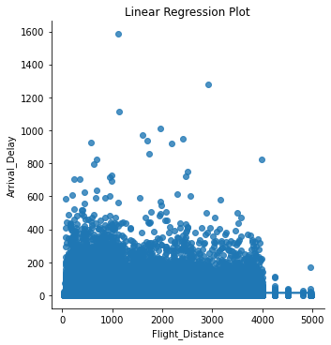

- flight distance (in miles) and departure delay (in minutes)

The R square value for this case is 0.0000 which indicates a poor linear regression fit.
And also, the p-value is 0.387 (greater than the significance level of 0.05). Thus, we can say that there is no relationship between flight distance and departure delay.

The equation is Arrival Delay= 14.6046-0.0617734980876*Flight Distance

OLS Regression Results
==============================================================================
Dep. Variable: Departure_Delay R-squared: 0.000
Model: OLS Adj. R-squared: -0.000
Method: Least Squares F-statistic: 0.7494
Date: Tue, 25 Jul 2023 Prob (F-statistic): 0.387
Time: 17:36:05 Log-Likelihood: -6.5698e+05
No. Observations: 129880 AIC: 1.314e+06
Df Residuals: 129878 BIC: 1.314e+06
Df Model: 1
Covariance Type: nonrobust
===================================================================================
coef std err t P>|t| [0.025 0.975]
-----------------------------------------------------------------------------------
Intercept 14.6046 0.164 88.795 0.000 14.282 14.927
Flight_Distance 9.168e-05 0.000 0.866 0.387 -0.000 0.000
==============================================================================
Omnibus: 165372.886 Durbin-Watson: 1.950
Prob(Omnibus): 0.000 Jarque-Bera (JB): 55806049.416
Skew: 6.821 Prob(JB): 0.00
Kurtosis: 103.628 Cond. No. 2.42e+03
==============================================================================

Notes:
[1] Standard Errors assume that the covariance matrix of the errors is correctly specified.
[2] The condition number is large, 2.42e+03. This might indicate that there are
strong multicollinearity or other numerical problems.

The regression plot using seaborn lmplot is as follows:

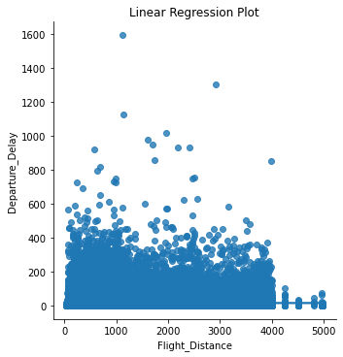

The derived models exhibit a notably low level of accuracy, as evidenced by their R-squared value of zero, which is indicative of poor performance. Based on the derived models, it is not possible to establish a meaningful relationship between variables.

Step 7. Using any of the data mining techniques you are familiar with, answer the following questions. Show your work to justify your conclusions.
7a. Is satisfaction with seat comfort related (or depends on) to passenger Gender?

Based on the obtained t-statistic of -11.089373612558425 and the significantly small p-value of 1.455122380044486e-28, it can be concluded that there exists a statistically significant association between gender and satisfaction with seat comfort within the provided dataset.
The t-statistic demonstrates a statistically significant disparity in satisfaction levels between genders; however, it does not yield explicit insights regarding which gender exhibits greater satisfaction.
In summary, the findings present compelling evidence for rejecting the null hypothesis, suggesting a relationship between gender and satisfaction with seat comfort. Moreover, a notable disparity in satisfaction levels is observed between males and females..

7b. Is satisfaction with gate location related to passenger age?

Correlation coefficient for satisfaction with gate location and Age: -0.00039807576080006115
P-value for satisfaction with gate location and Age: 0.8859264082579607

Based on the findings presented, it is possible to derive the following interpretations:

The correlation coefficient indicates a negligible value, implying a lack of significant linear association between passenger age and satisfaction with gate location. Put simply, there is no discernible pattern that suggests a notable shift in satisfaction with gate location in relation to changes in passenger age.

The obtained p-value of 0.886 exceeds the conventional significance threshold of 0.05. These findings suggest that there is no statistically significant correlation between passenger age and satisfaction with gate location. Put differently, it is plausible that any observed correlation may be attributed to random variation rather than a genuine association.

In conclusion, our correlation analysis does not yield any empirical support for the notion that passenger age has a significant relationship with satisfaction regarding gate location. The observed correlation exhibits a low magnitude and lacks statistical significance. Hence, it is not possible to draw a definitive inference regarding the impact of age on satisfaction with gate location from the findings of this analysis.
7c. Do first time passengers have more or less expectations than returning customers measured in terms of overall satisfaction?

T-statistic for overall satisfaction and Customer Type: -68.2288056293342
P-value for overall satisfaction and Customer Type: 0.0
First-time passengers have significantly lower overall satisfaction than returning customers.

7d. Is there a distinct (statistically significant) difference between business and personal travelers (A5) in terms of their reaction to their flights? (Hint: Use any attribute(s) that you think appropriate to measure their reaction.)

The t-statistic of 181.52943164162733 and a p-value of 0.0 suggest that there is a statistically significant difference in satisfaction levels between different types of travel. In this context, "Type of Travel" likely refers to categories such as "Business" and "Personal" travel.
With a p-value of 0.0 (which is practically 0), it indicates that the observed difference in satisfaction between the different types of travel is not due to chance and is highly significant.
7e. Is there a distinct (statistically significant) difference between business class passengers and economy passengers (A6) in terms of their reaction to satisfaction with food-and-drink?

The t-statistic of 31.94600905821368 and a p-value of 5.287862406504557e-223 indicate that there is a statistically significant difference in satisfaction with food-and-drink between business and economy class passengers.
The extremely small p-value (close to zero) suggests that the observed difference in satisfaction levels with food-and-drink across business and economy class passengers is highly significant and not due to chance. The large t-statistic value further emphasizes the magnitude of this difference.
In summary, based on the provided t-statistic and p-value, we can conclude that there is a statistically significant difference in satisfaction with food-and-drink between business and economy class passengers.

Step 8.

8a. Determine if any relationship exists between check-in service (A12) and baggage handling (A23) using any data mining technique. Based on this, provide a guidance to airline executives.

The association between two variables or features can be characterized by determining the correlation or regression between them. One effective approach for establishing relationships is to employ the regression technique on the available data.
Scatter plots are considered the most effective method for examining the relationship between variables. The Check-in Service will be represented on the Y-axis, while Baggage Handling will be represented on the X-axis. Each pair of values will be used to position a marker on the graph.

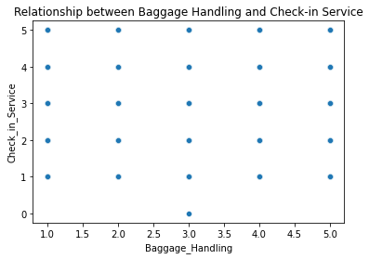

The plot does not provide a clear depiction of the correlation between the variables. However, the corr() method can be utilized to compute and present the correlations among numerical variables within a given data frame.

The obtained correlation coefficient is 0.23450312820140468. The presence of positivity suggests a relatively weak positive correlation. This implies that there exists a modest inclination for the two variables to exhibit parallel growth, albeit the association is not robust.

The linear regression model equation will be:

Check-In Service = 2.3923 + 0.2516 * Baggage Handling

The R square value is 0.055 which indicates a poor relation fit between them.

My recommendation to airline executives is that ensuring proper handling of passengers' baggage will have no impact on the ratings for check-in service, as these two aspects are independent of each other.

8b. Between A10 and A16, which one do you think passengers value the most? Assume that the overall satisfaction (A24) is a good proxy for the value.
The t-statistic is a statistical measure employed in hypothesis testing to evaluate the significance of the coefficients of independent variables within a statistical model, such as linear regression. The t-statistic is employed in linear regression to assess the statistical significance of the estimated coefficient associated with a specific independent variable, determining whether it deviates significantly from zero.

Within the framework of a linear regression model, the computation of the t-statistic entails dividing the estimated coefficient of the independent variable by its corresponding standard error. The mathematical expression representing the t-statistic for an independent variable, denoted as X, can be defined as follows:

The variable t can be calculated as the ratio of the coefficient of X to the standard error of the coefficient of X.

The t-statistic conforms to a t-distribution, where the degrees of freedom are determined by subtracting the number of independent variables in the model from the sample size. The t-distribution is a probability distribution that exhibits symmetry and bears resemblance to the standard normal distribution, albeit with heavier tails.

The t-statistic is utilized to assess the presence of a statistically significant association between the independent variable and the dependent variable. When the magnitude of the t-statistic is large and the corresponding p-value is small (usually below a predetermined significance level, such as 0.05), it suggests that the coefficient is likely to be significantly different from zero. This provides evidence of a statistically significant relationship between the independent variable and the dependent variable.

In essence, the t-statistic serves as a metric for assessing the dependability of coefficient estimates and aids in ascertaining the statistical significance of the impact of independent variables on the dependent variable within a regression model.

OLS Regression Results
================================================================================
Dep. Variable: Overall_Satisfaction R-squared: 0.003
Model: OLS Adj. R-squared: 0.003
Method: Least Squares F-statistic: 383.6
Date: Tue, 25 Jul 2023 Prob (F-statistic): 2.66e-85
Time: 15:57:58 Log-Likelihood: -92949.
No. Observations: 129880 AIC: 1.859e+05
Df Residuals: 129878 BIC: 1.859e+05
Df Model: 1
Covariance Type: nonrobust
==========================================================================================================
coef std err t P>|t| [0.025 0.975]
----------------------------------------------------------------------------------------------------------
Intercept 0.4883 0.003 158.842 0.000 0.482 0.494
Departure_and_Arrival_Time_Convenience -0.0176 0.001 -19.587 0.000 -0.019 -0.016
==============================================================================
Omnibus: 466220.152 Durbin-Watson: 1.459
Prob(Omnibus): 0.000 Jarque-Bera (JB): 21422.154
Skew: 0.264 Prob(JB): 0.00
Kurtosis: 1.081 Cond. No. 8.18
==============================================================================

Notes:
[1] Standard Errors assume that the covariance matrix of the errors is correctly specified.

OLS Regression Results
================================================================================
Dep. Variable: Overall_Satisfaction R-squared: 0.122
Model: OLS Adj. R-squared: 0.122
Method: Least Squares F-statistic: 1.799e+04
Date: Tue, 25 Jul 2023 Prob (F-statistic): 0.00
Time: 15:58:45 Log-Likelihood: -84715.
No. Observations: 129880 AIC: 1.694e+05
Df Residuals: 129878 BIC: 1.695e+05
Df Model: 1
Covariance Type: nonrobust
================================================================================
coef std err t P>|t| [0.025 0.975]
--------------------------------------------------------------------------------
Intercept -0.0166 0.004 -4.603 0.000 -0.024 -0.010
Seat_Comfort 0.1311 0.001 134.139 0.000 0.129 0.133
==============================================================================
Omnibus: 915265.299 Durbin-Watson: 1.511
Prob(Omnibus): 0.000 Jarque-Bera (JB): 12200.545
Skew: 0.193 Prob(JB): 0.00
Kurtosis: 1.549 Cond. No. 11.0
==============================================================================

Notes:
[1] Standard Errors assume that the covariance matrix of the errors is correctly specified.

The t-statistic for the variable "Departure_and_Arrival_Time_Convenience" is -19.587, and the associated P-value is less than 0.000. This finding suggests that the coefficient associated with the variable "Departure_and_Arrival_Time_Convenience" exhibits a high level of statistical significance, indicating that it is improbable for its value to be zero. A t-statistic with a negative value indicates that there is a negative relationship between the variable "Departure_and_Arrival_Time_Convenience" and the variable "Overall_Satisfaction".

The t-statistic for the variable "Seat_Comfort" is calculated to be 134.139, with a corresponding P-value that is less than 0.000. This finding suggests that the coefficient associated with the variable "Seat_Comfort" exhibits a high level of statistical significance. A positive t-statistic indicates a positive relationship between the variable "Seat_Comfort" and the variable "Overall_Satisfaction," suggesting that an increase in "Seat_Comfort" is associated with an increase in "Overall_Satisfaction."

The magnitudes of the t-statistics offer a quantification of the significance of the influence of each variable on the dependent variable "Overall_Satisfaction." In this instance, the magnitude of the t-statistic for "Seat_Comfort" (134.139) is considerably greater than that of the t-statistic for "Departure_and_Arrival_Time_Convenience" (19.587), indicating a significant difference between the two variables. This suggests that the variable "Seat_Comfort" exerts a more significant impact on the dependent variable "Overall_Satisfaction" in comparison to the variable "Departure_and_Arrival_Time_Convenience."

Hence, according to the t-statistics, the variable "Seat_Comfort" exhibits a greater significance in the determination of "Overall_Satisfaction" when compared to the variable "Departure_and_Arrival_Time_Convenience" within the framework of this regression model.

APPENDIX

In [1]:
import numpy as np
import pandas as pd
from scipy.stats import skew
import seaborn as sns
import matplotlib.pyplot as plt import statsmodels.formula.api as smf import statsmodels.api as sm
from sklearn.preprocessing import LabelEncoder from sklearn.preprocessing import StandardScaler from sklearn.decomposition import PCA
from sklearn.model_selection import train_test_split from sklearn.linear_model import LinearRegression from sklearn.metrics import mean_squared_error import scipy.stats as stats

In [2]:
df=pd.read_csv("/Users/lokeshreddy/Desktop/DATA MINING/Final Project/airl df

Out[2]:
 | ID | Gender | Age | Customer  Type | Type of  Travel | Class | Flight  Distance | Departure  Delay | Arrival  Delay
0 | 1 | Male | 48 | First-time | Business | Business | 821 | 2 | 5.0
1 | 2 | Female | 35 | Returning | Business | Business | 821 | 26 | 39.0
2 | 3 | Male | 41 | Returning | Business | Business | 853 | 0 | 0.0
3 | 4 | Male | 50 | Returning | Business | Business | 1905 | 0 | 0.0
4 | 5 | Female | 49 | Returning | Business | Business | 3470 | 0 | 1.0
... | ... | ... | ... | ... | ... | ... | ... | ... | ...
129875 | 129876 | Male | 28 | Returning | Personal | Economy  Plus | 447 | 2 | 3.0

129876 129877
Male 41 Returning Personal
Economy
Plus
308
0
0.0

129877 129878 Male 42 Returning Personal Economy
Plus
337 6 14.0

129878 129879
Male 50 Returning Personal
Economy
Plus
337
31
22.0

129879 129880 Female 20 Returning Personal Economy
Plus
337 0 0.0

129880 rows × 24 columns

In [3]:

Out[3]:
df.isnull().sum()
ID 0
Gender 0
Age 0
Customer Type 0
Type of Travel 0
Class 0
Flight Distance 0
Departure Delay 0
Arrival Delay 393
Departure and Arrival Time Convenience 0
Ease of Online Booking 0

 | Check-in Service |  |  | 0
 | Online Boarding |  |  | 0
 | Gate Location |  |  | 0
 | On-board Service |  |  | 0
 | Seat Comfort |  |  | 0
 | Leg Room Service |  |  | 0
 | Cleanliness |  |  | 0
 | Food and Drink |  |  | 0
 | In-flight Service |  |  | 0
 | In-flight Wifi Service |  |  | 0
 | In-flight Entertainment |  |  | 0
 | Baggage Handling |  |  | 0
 | Satisfaction |  |  | 0
 | dtype: int64
In [4]: | df['Arrival Delay'].fillna(method='ffill', |  |  | inplace=True)
In [5]: | df.isnull().sum()
Out[5]: | ID  Gender |  |  | 0  0
 | Age |  |  | 0
 | Customer | Type |  | 0
 | Type of Travel |  | 0
 | Class |  | 0
 | Flight Distance |  | 0
 | Departure Delay |  | 0
 | Arrival Delay |  | 0
 | Departure and Arrival Time Convenience |  | 0
 | Ease of Online Booking |  | 0
 | Check-in Service |  | 0
 | Online Boarding |  | 0
 | Gate Location |  | 0
 | On-board Service |  | 0
 | Seat Comfort |  | 0
 | Leg Room Service |  | 0
 | Cleanliness |  | 0
 | Food and Drink |  | 0
 | In-flight Service |  | 0
 | In-flight Wifi Service |  | 0
 | In-flight Entertainment |  | 0
 | Baggage Handling |  | 0
 | Satisfaction |  | 0
 | dtype: int64
In [6]: | feature=df[["Departure Delay","Arrival feature |  | Delay"]]

Out[6]: |  | Departure Delay | Arrival Delay
 | 0 | 2 | 5.0
 | 1 | 26 | 39.0
 | 2 | 0 | 0.0
 | 3 | 0 | 0.0
 | 4 | 0 | 1.0
 | ... | ... | ...
 | 129875 | 2 | 3.0
 | 129876 | 0 | 0.0
 | 129877 | 6 | 14.0

129878 | 31 | 22.0
129879 | 0 | 0.0

129880 rows × 2 columns

Step 1: Statistics on departure delay (A8) and arrival delay (A9).
Here is a link that talks about useful statistics that a data scientist would like to know about an entity. https://towardsdatascience.com/5-useful-statistics-data- scientists-need-to-know- 5b4ac29a7da9

1a. For features A8 and A9, determine

- Central tendency measures: mean, mode, and median (for each)

- The spread: standard deviation (for each)

- Percentiles: the 10th, 50th, 75th and 90th percentiles (for each)

- 1st quartile, 3rd quartile, and the median

- The skewness (for each)

- The covariance and correlation between A8 and A9

- Plot the two delays on a chart to display their distributions https://www.webdatarocks.com/blog/best-charts-for-data-distribution/

1b. Based on the above results in 1a, make useful conclusions. This is an important part of data analysis. It should be an English description that non-mathematically oriented airline executives can understand.

In [7]:
mean_dep=feature["Departure Delay"].mean() median_dep=feature["Departure Delay"].median() mode_dep=feature["Departure Delay"].mode()
print("The mean, median, and mode of Departure Delay are:", mean_dep, med

The mean, median, and mode of Departure Delay are: 14.713712657838004 0.0
0 0
Name: Departure Delay, dtype: int64

In [8]:
mean_arr=feature["Arrival Delay"].mean() median_arr=feature["Arrival Delay"].median() mode_arr=feature["Arrival Delay"].mode()
print("The mean, median, and mode of Arrival Delay are:", mean_arr, media

The mean, median, and mode of Arrival Delay are: 15.101455189405605 0.0 0 0.0
Name: Arrival Delay, dtype: float64

In [9]:
std_dep=feature["Departure Delay"].std() std_arr=feature["Arrival Delay"].std()
print("The standard deviation of Departure Delay are:", std_dep) print("The standard deviation of Arrival Delay are:", std_arr)

The standard deviation of Departure Delay are: 38.07112621501333 The standard deviation of Arrival Delay are: 38.47227554800929

In [10]:
feature.describe()

Out[10]: |  | Departure Delay | Arrival Delay
 | count | 129880.000000 | 129880.000000
 | mean | 14.713713 | 15.101455
 | std | 38.071126 | 38.472276
 | min | 0.000000 | 0.000000
 | 25% | 0.000000 | 0.000000
 | 50% | 0.000000 | 0.000000
 | 75% | 12.000000 | 13.000000
 | max | 1592.000000 | 1584.000000

In [11]:
skew_dep = skew(feature["Departure Delay"]) skew_arr = skew(feature["Arrival Delay"])
print("The skewness of Departure Delay is:", skew_dep) print("The skewness of Arrival Delay is:", skew_arr)

 |  | The skewness of Departure Delay is: 6.821901522036001 The skewness of Arrival Delay is: 6.6606186496913775
In | [12]: | percentiles = [10, 50, 75, 90]
 |  | departure_delay_percentiles = feature["Departure Delay"].quantile(np.divi
arrival_delay_percentiles = feature["Arrival Delay"].quantile(np.divide(p

print("Departure Delay:")
print("10th percentile:", departure_delay_percentiles.iloc[0]) print("50th percentile:", departure_delay_percentiles.iloc[1]) print("75th percentile:", departure_delay_percentiles.iloc[2]) print("90th percentile:", departure_delay_percentiles.iloc[3])

print("\nArrival Delay:")
print("10th percentile:", arrival_delay_percentiles.iloc[0]) print("50th percentile:", arrival_delay_percentiles.iloc[1]) print("75th percentile:", arrival_delay_percentiles.iloc[2]) print("90th percentile:", arrival_delay_percentiles.iloc[3])
Departure Delay: 10th percentile: |  |  |  | 0.0
50th |  |  | percentile: | 0.0
75th |  |  | percentile: | 12.0
90th |  |  | percentile: | 44.0
Arrival Delay: 10th percentile: |  |  |  | 0.0
50th |  |  | percentile: | 0.0
75th |  |  | percentile: | 13.0
90th |  |  | percentile: | 44.0

In [13]:
quartiles = [25, 50, 75]

departure_delay_quartiles = feature["Departure Delay"].quantile(np.divide arrival_delay_quartiles = feature["Arrival Delay"].quantile(np.divide(qua

print("Departure Delay:")

print("1st quartile:", departure_delay_quartiles.iloc[0]) print("Median:", departure_delay_quartiles.iloc[1]) print("3rd quartile:", departure_delay_quartiles.iloc[2])

print("\nArrival Delay:")
print("1st quartile:", arrival_delay_quartiles.iloc[0]) print("Median:", arrival_delay_quartiles.iloc[1]) print("3rd quartile:", arrival_delay_quartiles.iloc[2])
Departure Delay:
1st quartile: 0.0
Median: 0.0
3rd quartile: 12.0

Arrival Delay:
1st quartile: 0.0
Median: 0.0
3rd quartile: 13.0

In [14]:

Out[14]:
feature.skew()
Departure Delay 6.821980
Arrival Delay 6.660696 dtype: float64

In [15]: | feature.cov()
Out[15]: | Departure Delay | Arrival Delay
 | Departure Delay 1449.410651 | 1404.284791
 | Arrival Delay 1404.284791 | 1480.115986
In [16]: | feature.corr()
Out[16]: | Departure Delay | Arrival Delay
 | Departure Delay 1.000000 | 0.958764
 | Arrival Delay 0.958764 | 1.000000

In [17]:
plt.figure(figsize=(10, 6))
sns.histplot(feature["Departure Delay"], bins=10, kde=True, label="Arriva plt.xlabel("Delay (minutes)")
plt.ylabel("Frequency") plt.title("Distribution of Departure Delays") plt.legend()
plt.show()

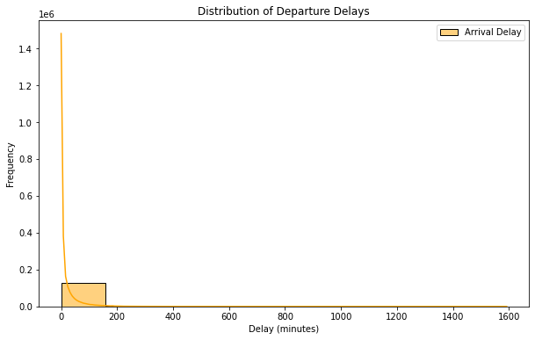

In [18]:
plt.figure(figsize=(10, 6))
plt.subplot(2, 1, 1)
plt.hist(feature['Departure Delay'], bins=20, color='blue') plt.xlabel("Departure Delay (mins)") plt.ylabel("Frequency")
plt.title("Distribution of Departure Delay")

plt.subplot(2, 1, 2)
plt.hist(feature['Arrival Delay'], bins=20, color='orange') plt.xlabel("Arrival Delay (mins)")
plt.ylabel("Frequency") plt.title("Distribution of Arrival Delay")

plt.tight_layout() plt.show()

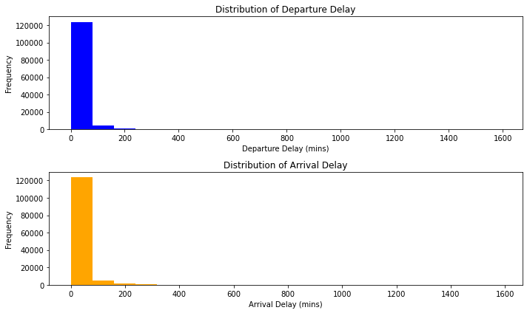

In [19]:
plt.figure(figsize=(10, 6))
sns.histplot(feature["Arrival Delay"], bins=10, kde=True, label="Arrival plt.xlabel("Delay (minutes)")
plt.ylabel("Frequency") plt.title("Distribution of Arrival Delays") plt.legend()
plt.show()

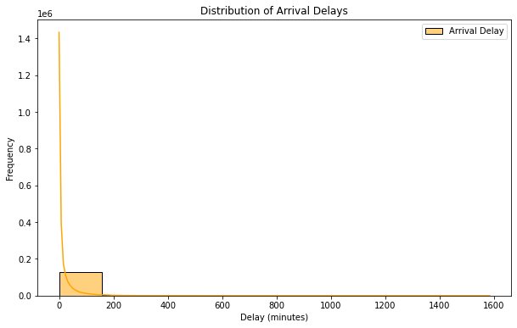

Step 2: Convert numerical values to categorical values
  - Discretize age (A3) to nominal values using the following criteria: 0-15: Child; 16-35: Youth; 36-55 Middle age; 56-70: Old; >70- Senior;

  - Discretize flight distance (A7) to nominal values using the following criteria: 0-500 miles: Short haul; 501-3000 miles: Medium haul; >3000 Long haul

  - Discretize delays (A8 and A9) to nominal values: Small: 0-15; Medium: 16-45; Long:
>45

  - Plot the distributions for each of the above using the discretized values.

2b. Based on the distributions in 2d, make some useful observations and write them.

In [20]:
disc=pd.read_csv("/Users/lokeshreddy/Desktop/DATA MINING/Final Project/ai disc

Out[20]:

Age Flight Distance Departure Delay Arrival Delay

0 Middle age Medium haul Small Small

1 Youth Medium haul Medium Medium
2 Middle age Medium haul Small Small
3 Middle age Medium haul Small Small

4 | Middle age | Long haul | Small | Small
... | ... | ... | ... | ...
129875 | Youth | Short haul | Small | Small
129876 | Middle age | Short haul | Small | Small
129877 | Middle age | Short haul | Small | Small
129878 | Middle age | Short haul | Medium | Medium
129879 | Youth | Short haul | Small | Small

129880 rows × 4 columns

In [21]:
age_counts = disc['Age'].value_counts() plt.figure(figsize=(10, 6)) age_counts.plot(kind='bar') plt.xlabel("Age") plt.ylabel("Frequency") plt.title("Distribution of Age") plt.legend()
plt.show()

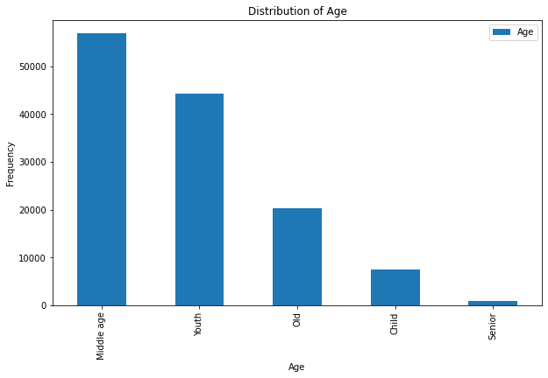

In [22]:
dist_counts = disc['Flight Distance'].value_counts() plt.figure(figsize=(10, 6)) dist_counts.plot(kind='bar')
plt.xlabel("Flight Distance") plt.ylabel("Frequency") plt.title("Distribution of Flight Distance") plt.legend()
plt.show()

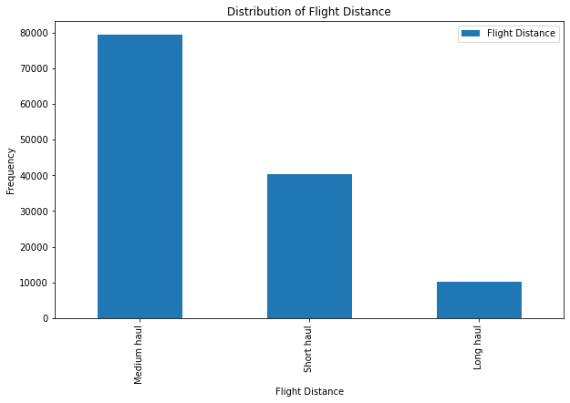

In [23]:
dep_counts = disc['Departure Delay'].value_counts() plt.figure(figsize=(10, 6)) dep_counts.plot(kind='bar')
plt.xlabel("Departure Delay") plt.ylabel("Frequency") plt.title("Distribution of Departure Delay") plt.legend()
plt.show()

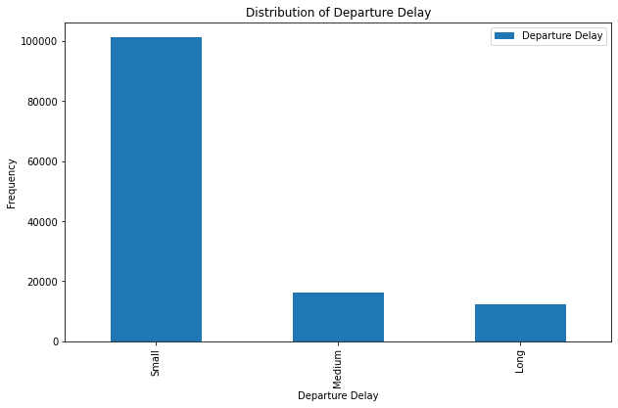

In [24]:
arr_counts = disc['Arrival Delay'].value_counts() plt.figure(figsize=(10, 6)) arr_counts.plot(kind='bar')

plt.xlabel("Arrival Delay") plt.ylabel("Frequency") plt.title("Distribution of Arrival Delay") plt.legend()
plt.show()

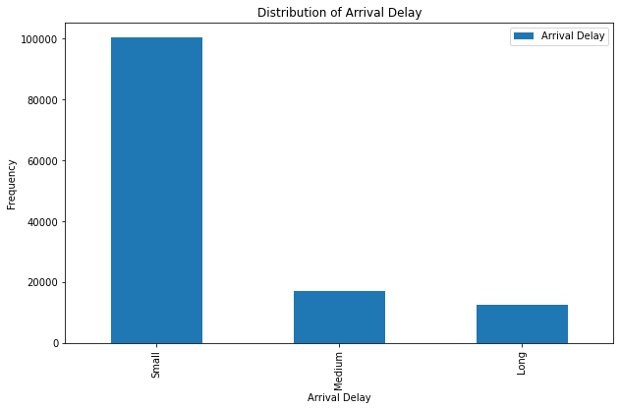

Step 3. Test the following two hypotheses. Show evidence to show whether they are true or false.
You may refer to the following URLs for hypothesis testing procedure. https://vitalflux.com/linear-regression-hypothesis-testing-examples/ https://vitalflux.com/data-science-how-to-formulate-hypothesis-for-hypothesis- testing/

3H1: Long haul passengers’ overall satisfaction is influenced more by the in-flight service quality than by the departure delays.

3H2. Medium haul passengers’ overall satisfaction is influenced more by the arrival delays than by the in-flight entertainment.

3H3. Make your own hypothesis, state it, and test it.

In [25]:
disc.drop(['Departure Delay', 'Arrival Delay'], axis=1, inplace=True)

In [26]:
hyp = disc.merge(df[['In-flight Service', 'Cleanliness','In-flight Entert hyp

Out[26]:

Age

Flight Distance

In- flight Service

Cleanliness

In-flight Entertainment

Departure
Delay

Arrival Satisfacti Delay

0 Middle age

Medium
haul

5 5 5 2 5.0 Neutral Dissatisfi

1 Youth
Medium
haul
5
5
5
26
39.0
Satisfi

2 Middle age
Medium
haul
3 5 3 0 0.0 Satisfi

3 Middle age
Medium
haul
5
4
5
0
0.0
Satisfi

4 Middle age
Long haul
3 5 3 0 1.0 Satisfi

... ... ... ... ... ... ... ...

129875 Youth Short haul
5 4 4 2 3.0 Neutral Dissatisfi

129876 Middle
age
Short haul
4
2
2
0
0.0 Neutral Dissatisfi

129877 Middle
age
Short haul
4 3 3 6 14.0 Neutral Dissatisfi

129878 Middle
age
Short haul
4
3
3
31
22.0
Satisfi

129879 Youth Short haul
- 2 2 0 0.0 Neutral Dissatisfi

129880 rows × 8 columns

In [27]:
hyp1 = hyp[hyp['Flight Distance'] == 'Long haul'] hyp1

Out[27]:

Age

Flight Distance

In- flight Service

Cleanliness

In-flight Entertainment

Departure
Delay

Arrival Satisfacti Delay

4 Middle age

Long haul

- 5 3 0 1.0 Satisfi

5 Middle age
Long haul
4
3
4
0
0.0
Satisfi

24 Middle age
Long haul
5 4 5 0 2.0 Satisfi

28 Middle age
Long haul
5
3
5
0
52.0
Satisfi

29 Middle age
Long haul
- 3 4 0 12.0 Satisfi

... ... ... ... ... ... ... ...

129728 Youth Long haul
1 3 1 160 173.0 Neutral Dissatisfi

129729 Middle
age
Long haul
4
2
4
100
94.0 Neutral Dissatisfi

129746 Youth Long haul
3 1 1 0 6.0 Neutral Dissatisfi

129756 Middle
age
Long haul
5
1
5
0
0.0
Satisfi

129855 Middle
age
Long haul
- 5 2 0 0.0 Satisfi

10313 rows × 8 columns

In [28]:
hyp1.rename(columns={'In-flight Entertainment': 'Inflight_Entertainment',
/var/folders/mf/k95w0sl124dd8fzv9hjs54kw0000gn/T/ipykernel_44300/16905471 0.py:1: SettingWithCopyWarning:
A value is trying to be set on a copy of a slice from a DataFrame

See the caveats in the documentation: https://pandas.pydata.org/pandas-do cs/stable/user_guide/indexing.html#returning-a-view-versus-a-copy
hyp1.rename(columns={'In-flight Entertainment': 'Inflight_Entertainmen t', 'Departure Delay': 'Departure_Delay', 'In-flight Service': 'Inflight_ Service', 'Arrival Delay': 'Arrival_Delay'}, inplace=True)

In [29]:
hyp1

Out[29]:

Age Flight Distance

Inflight_Service Cleanliness Inflight_Entertainment Departure_Del

4 Middle age
Long haul

3 5 3

5 Middle age
Long haul
4
3
4

24 Middle age
Long haul
5 4 5

28 Middle age
Long haul
5
3
5

29 Middle age
Long haul
4 3 4

... ... ... ... ... ...

129728 Youth Long haul
1 3 1 1

129729 Middle
age
Long haul
4
2
4
1

129746 Youth Long haul
3 1 1

129756 Middle
age
Long haul
5
1
5

129855 Middle
age
Long haul
2 5 2

10313 rows × 8 columns

In [30]:
label_encoder = LabelEncoder()
hyp1['Overall_Satisfaction'] = label_encoder.fit_transform(hyp1['Satisfac hyp1

/var/folders/mf/k95w0sl124dd8fzv9hjs54kw0000gn/T/ipykernel_44300/15729270
44.py:2: SettingWithCopyWarning:
A value is trying to be set on a copy of a slice from a DataFrame. Try using .loc[row_indexer,col_indexer] = value instead

See the caveats in the documentation: https://pandas.pydata.org/pandas-do cs/stable/user_guide/indexing.html#returning-a-view-versus-a-copy
hyp1['Overall_Satisfaction'] = label_encoder.fit_transform(hyp1['Satisf action'])

Out[30]:
Age Flight Distance
Inflight_Service Cleanliness Inflight_Entertainment Departure_Del

4 Middle age
Long haul
3 5 3

5 Middle age
Long haul
4
3
4

24 Middle age
Long haul
5 4 5

28 Middle age
Long haul
5
3
5

29 Middle age
Long haul
4 3 4

... ... ... ... ... ...

129728 Youth Long haul
1 3 1 1

129729 Middle
age
Long haul
4
2
4
1

129746 Youth Long haul
3 1 1

129756 Middle
age
Long haul
5
1
5

129855 Middle
age
Long haul
2 5 2

10313 rows × 9 columns

In [31]:
X1 = hyp1[['Inflight_Service', 'Departure_Delay']] y1 = hyp1['Overall_Satisfaction']

In [32]:
X1 = sm.add_constant(X1)

In [33]:
model1 = sm.OLS(y1, X1).fit()

In [34]:
print("Hypothesis 1 Results:") print(model1.summary())

Hypothesis 1 Results:
OLS Regression Results
=========================================================================
=======
Dep. Variable: | Overall_Satisfaction | R-squared:
0.272
Model: | OLS | Adj. R-squared:
0.272
Method: | Least Squares | F-statistic:
1929.
Date: | Wed, 26 Jul 2023 | Prob (F-statistic):
0.00
Time: | 16:41:49 | Log-Likelihood:
-4012.8
No. Observations: | 10313 | AIC:
8032.
Df Residuals: | 10310 | BIC:
8053.
Df Model: | 2
Covariance Type: | nonrobust
=========================================================================
===========

0.975] | coef | std err | t | P>|t| | [0.025
const | 0.0702 | 0.012 | 5.713 | 0.000 | 0.046
0.094
Inflight_Service | 0.1875 | 0.003 | 61.342 | 0.000 | 0.182
0.193
Departure_Delay | -0.0005 | 9.2e-05 | -5.429 | 0.000 | -0.001
-0.000
=========================================================================
=====
Omnibus: | 702.399 |  | Durbin-Watson:
1.842
Prob(Omnibus): | 0.000 |  | Jarque-Bera (JB): |  | 85
2.577
Skew: | -0.698 |  | Prob(JB): |  | 7.33
e-186
Kurtosis: | 3.189 |  | Cond. No.
148.
=========================================================================
=====

Notes:
[1] Standard Errors assume that the covariance matrix of the errors is co rrectly specified.

In [35]:
model=smf.ols(formula='Overall_Satisfaction~Inflight_Service',data=hyp1)

In [36]:
results=model.fit() print(results.summary())

OLS Regression Results
=========================================================================
=======
Dep. Variable: | Overall_Satisfaction | R-squared:
0.270
Model: | OLS | Adj. R-squared:
0.270
Method: | Least Squares | F-statistic:
3818.
Date: | Wed, 26 Jul 2023 | Prob (F-statistic):
0.00
Time: | 16:41:49 | Log-Likelihood:
-4027.6
No. Observations: | 10313 | AIC:
8059.
Df Residuals: | 10311 | BIC:
8074.
Df Model: | 1
Covariance Type: | nonrobust
=========================================================================
===========
0.975] | coef | std err | t | P>|t| | [0.025
Intercept | 0.0583 | 0.012 | 4.814 | 0.000 | 0.035
0.082  Inflight_Service | 0.1887 | 0.003 | 61.788 | 0.000 | 0.183
0.195
=========================================================================
=====

Omnibus: | 705.847 | Durbin-Watson:
1.840
Prob(Omnibus): | 0.000 | Jarque-Bera (JB): | 85
7.668
Skew: | -0.700 | Prob(JB): | 5.75
e-187
Kurtosis: | 3.185 | Cond. No.
14.4
=========================================================================
=====

Notes:
[1] Standard Errors assume that the covariance matrix of the errors is co rrectly specified.

In [37]:
model1=smf.ols(formula='Overall_Satisfaction~Departure_Delay',data=hyp1)

In [38]:
results=model1.fit() print(results.summary())

OLS Regression Results
=========================================================================
=======
Dep. Variable: | Overall_Satisfaction |  | R-squared:
0.007
Model: | OLS |  | Adj. R-squared:
0.007
Method: | Least Squares |  | F-statistic:
69.60
Date: | Wed, 26 Jul 2023 |  | Prob (F-statistic):
8.18e-17
Time: | 16:41:49 |  | Log-Likelihood:
-5617.2
No. Observations: | 10313 |  | AIC: |  | 1.
124e+04
Df Residuals: | 10311 |  | BIC: |  | 1.
125e+04
Df Model: | 1
Covariance Type: | nonrobust
=========================================================================
==========
 | coef | std err | t | P>|t| | [0.025
0.975]
Intercept | 0.7869 | 0.004 | 178.324 | 0.000 | 0.778
0.796
Departure_Delay | -0.0009 | 0.000 | -8.343 | 0.000 | -0.001
-0.001
=========================================================================
=====
Omnibus: | 1816.564 |  | Durbin-Watson:
1.751
Prob(Omnibus): | 0.000 |  | Jarque-Bera (JB): |  | 292
0.279
Skew: | -1.296 |  | Prob(JB):
0.00
Kurtosis: | 2.723 |  | Cond. No.
44.2
=========================================================================
=====

Notes:

[1] Standard Errors assume that the covariance matrix of the errors is co rrectly specified.

In [39]:
model2=smf.ols(formula='Overall_Satisfaction~Inflight_Service+Departure_D

In [40]:
results=model2.fit() print(results.summary())

OLS Regression Results
=========================================================================
=======
Dep. Variable: | Overall_Satisfaction | R-squared:
0.272
Model: | OLS | Adj. R-squared:
0.272
Method: | Least Squares | F-statistic:
1929.
Date: | Wed, 26 Jul 2023 | Prob (F-statistic):
0.00
Time: | 16:41:49 | Log-Likelihood:
-4012.8
No. Observations: | 10313 | AIC:
8032.
Df Residuals: | 10310 | BIC:
8053.
Df Model: | 2
Covariance Type: | nonrobust
=========================================================================
===========
0.975] | coef | std err | t | P>|t| | [0.025
Intercept | 0.0702 | 0.012 | 5.713 | 0.000 | 0.046
0.094
Inflight_Service | 0.1875 | 0.003 | 61.342 | 0.000 | 0.182
0.193
Departure_Delay | -0.0005 | 9.2e-05 | -5.429 | 0.000 | -0.001
-0.000
=========================================================================
=====
Omnibus: | 702.399 |  | Durbin-Watson:
1.842
Prob(Omnibus): | 0.000 |  | Jarque-Bera (JB): |  | 85
2.577
Skew: | -0.698 |  | Prob(JB): |  | 7.33
e-186
Kurtosis: | 3.189 |  | Cond. No.
148.
=========================================================================
=====

Notes:
[1] Standard Errors assume that the covariance matrix of the errors is co rrectly specified.

In [41]:
coefficients = results.params p_values = results.pvalues

print("Coefficient Estimates:") print(coefficients)

print("P-values:") print(p_values)
Coefficient Estimates:
Intercept | 0.070159
Inflight_Service | 0.187504
Departure_Delay | -0.000499
dtype: float64
P-values:
Intercept | 1.139647e-08
Inflight_Service | 0.000000e+00
Departure_Delay | 5.807986e-08
dtype: float64

In [42]:
hyp2 = hyp[hyp['Flight Distance'] == 'Medium haul'] hyp2

Out[42]:

Age

Flight Distance

In- flight Service

Cleanliness

In-flight Entertainment

Departure
Delay

Arrival Satisfacti Delay

0 Middle age

Medium
haul

- 5 5 2 5.0 Neutral Dissatisfi

1 Youth
Medium
haul
5
5
5
26
39.0
Satisfi

2 Middle age
Medium
haul
- 5 3 0 0.0 Satisfi

3 Middle age
Medium
haul
5
4
5
0
0.0
Satisfi

- Middle age
Medium
haul
5 4 5 0 0.0 Satisfi

... ... ... ... ... ... ... ...

129763 Middle
age
Medium
haul
- 1 4 0 0.0 Satisfi

129854
Old
Medium
haul
3
5
3
0
0.0
Satisfi

129861 Middle
age
Medium
haul
3 3 3 1 0.0 Satisfi

129863 Middle
age
Medium
haul
5
3
5
0
0.0
Satisfi

129864 Middle
age
Medium
haul
- 5 5 0 0.0 Satisfi

79291 rows × 8 columns

In [43]:
hyp2.rename(columns={'In-flight Entertainment': 'Inflight_Entertainment',
/var/folders/mf/k95w0sl124dd8fzv9hjs54kw0000gn/T/ipykernel_44300/34395252 70.py:1: SettingWithCopyWarning:
A value is trying to be set on a copy of a slice from a DataFrame

See the caveats in the documentation: https://pandas.pydata.org/pandas-do cs/stable/user_guide/indexing.html#returning-a-view-versus-a-copy
hyp2.rename(columns={'In-flight Entertainment': 'Inflight_Entertainmen t', 'Departure Delay': 'Departure_Delay', 'In-flight Service': 'Inflight_ Service', 'Arrival Delay': 'Arrival_Delay'}, inplace=True)

In [44]:
label_encoder = LabelEncoder()

hyp2['Overall_Satisfaction'] = label_encoder.fit_transform(hyp2['Satisfac hyp2

/var/folders/mf/k95w0sl124dd8fzv9hjs54kw0000gn/T/ipykernel_44300/20577355
73.py:2: SettingWithCopyWarning:
A value is trying to be set on a copy of a slice from a DataFrame. Try using .loc[row_indexer,col_indexer] = value instead

See the caveats in the documentation: https://pandas.pydata.org/pandas-do cs/stable/user_guide/indexing.html#returning-a-view-versus-a-copy
hyp2['Overall_Satisfaction'] = label_encoder.fit_transform(hyp2['Satisf action'])

Out[44]:
Age Flight Distance
Inflight_Service Cleanliness Inflight_Entertainment Departure_Del

0 Middle age
Medium
haul

5 5 5

1 Youth
Medium
haul
5
5
5

2 Middle age
Medium
haul
3 5 3

3 Middle age
Medium
haul
5
4
5

- Middle age
Medium
haul
5 4 5

... ... ... ... ... ...

129763 Middle
age
Medium
haul
4 1 4

129854
Old
Medium
haul
3
5
3

129861 Middle
age
Medium
haul
3 3 3

129863 Middle
age
Medium
haul
5
3
5

129864 Middle
age
Medium
haul
5 5 5

79291 rows × 9 columns

In [45]:
model=smf.ols(formula='Overall_Satisfaction~Inflight_Entertainment+Arriva

In [46]:
results=model.fit() print(results.summary())

OLS Regression Results
=========================================================================
=======
Dep. Variable: | Overall_Satisfaction | R-squared:
0.162
Model: | OLS | Adj. R-squared:
0.162
Method: | Least Squares | F-statistic:
7689.
Date: | Wed, 26 Jul 2023 | Prob (F-statistic):
0.00
Time: | 16:41:50 | Log-Likelihood:
-49957.

No. Observations: | 79291 | AIC: | 9.
992e+04
Df Residuals: | 79288 | BIC: | 9.
995e+04
Df Model: | 2
Covariance Type: | nonrobust
=========================================================================
=================
coef std err t P>|t|
[0.025 0.975]

Intercept -0.0517 0.004 -11.645 0.000 -
0.060 -0.043
Inflight_Entertainment | 0.1490 | 0.001 |  | 122.965 | 0.000
0.147 0.151
Arrival_Delay | -0.0005 | 4.09e-05 |  | -12.817 | 0.000 | -
0.001 -0.000
=========================================================================
=====
Omnibus: | 486255.478 |  | Durbin-Watson:
1.515
Prob(Omnibus): | 0.000 |  | Jarque-Bera (JB): |  | 586
0.828
Skew: | 0.111 |  | Prob(JB):
0.00
Kurtosis: | 1.687 |  | Cond. No.
120.
=========================================================================
=====

Notes:
[1] Standard Errors assume that the covariance matrix of the errors is co rrectly specified.

In [47]:
coefficients = results.params p_values = results.pvalues

print("Coefficient Estimates:") print(coefficients)

print("P-values:") print(p_values)

Coefficient Estimates:
Intercept | -0.051654
Inflight_Entertainment | 0.148993
Arrival_Delay | -0.000524
dtype: float64
P-values:
Intercept | 2.582786e-31
Inflight_Entertainment | 0.000000e+00
Arrival_Delay | 1.429505e-37
dtype: float64

In [48]:
hyp3 = hyp[hyp['Flight Distance'] == 'Short haul'] hyp3

Out[48]:

Age

Flight Distance

In- flight Service

Cleanliness

In-flight Entertainment

Departure
Delay

Arrival Satisfacti Delay

11 Youth Short haul

3 1 1 20 21.0 Neutral Dissatisfi

12 Youth
Short haul
4
5
5
16
30.0 Neutral Dissatisfi

30 Youth Short haul
4 2 2 0 0.0 Neutral Dissatisfi

31 Youth
Short haul
4
3
3
0
0.0
Satisfi

32 Youth Short haul
5 2 2 22 28.0 Neutral Dissatisfi

... ... ... ... ... ... ... ...

129875 Youth Short haul
5 4 4 2 3.0 Neutral Dissatisfi

129876 Middle
age
Short haul
4
2
2
0
0.0 Neutral Dissatisfi

129877 Middle
age
Short haul
4 3 3 6 14.0 Neutral Dissatisfi

129878 Middle
age
Short haul
4
3
3
31
22.0
Satisfi

129879 Youth Short haul
2 2 2 0 0.0 Neutral Dissatisfi

40276 rows × 8 columns

In [49]:
hyp3.rename(columns={'In-flight Entertainment': 'Inflight_Entertainment',
/var/folders/mf/k95w0sl124dd8fzv9hjs54kw0000gn/T/ipykernel_44300/95286862
6.py:1: SettingWithCopyWarning:
A value is trying to be set on a copy of a slice from a DataFrame

See the caveats in the documentation: https://pandas.pydata.org/pandas-do cs/stable/user_guide/indexing.html#returning-a-view-versus-a-copy
hyp3.rename(columns={'In-flight Entertainment': 'Inflight_Entertainmen t', 'Departure Delay': 'Departure_Delay', 'In-flight Service': 'Inflight_ Service', 'Arrival Delay': 'Arrival_Delay'}, inplace=True)

In [50]:
label_encoder = LabelEncoder()
hyp3['Overall_Satisfaction'] = label_encoder.fit_transform(hyp3['Satisfac hyp3

/var/folders/mf/k95w0sl124dd8fzv9hjs54kw0000gn/T/ipykernel_44300/21572196
2.py:2: SettingWithCopyWarning:
A value is trying to be set on a copy of a slice from a DataFrame. Try using .loc[row_indexer,col_indexer] = value instead

See the caveats in the documentation: https://pandas.pydata.org/pandas-do cs/stable/user_guide/indexing.html#returning-a-view-versus-a-copy
hyp3['Overall_Satisfaction'] = label_encoder.fit_transform(hyp3['Satisf action'])

Out[50]:
Age Flight Distance
Inflight_Service Cleanliness Inflight_Entertainment Departure_Del

haul haul
11 Youth Short 3 | 1 | 1
12 Youth Short 4 | 5 | 5
30 Youth Short 4 | 2 | 2

haul

31 Youth
Short haul
4
3
3

32 Youth Short haul
5 2 2

... ... ... ... ... ...

129875 Youth Short haul
5 4 4

129876 Middle
age
Short haul
4
2
2

129877 Middle
age
Short haul
4 3 3

129878 Middle
age
Short haul
4
3
3

129879 Youth Short haul
2 2 2

40276 rows × 9 columns

In [51]:
model=smf.ols(formula='Overall_Satisfaction~Inflight_Entertainment+Cleanl

In [52]:
results=model.fit() print(results.summary())

OLS Regression Results
=========================================================================
=======
Dep. Variable: Overall_Satisfaction R-squared: 0.102
Model: OLS Adj. R-squared:
0.102
Method: Least Squares F-statistic: 2294.
Date: Wed, 26 Jul 2023 Prob (F-statistic): 0.00
Time: 16:41:50 Log-Likelihood:
-24756.
No. Observations: 40276 AIC: 4.
952e+04
Df Residuals: 40273 BIC: 4.
954e+04
Df Model: 2
Covariance Type: nonrobust
=========================================================================
=================
coef std err t P>|t|
[0.025 0.975]
Intercept -0.0140 0.006 -2.288 0.022 -
0.026 -0.002
Inflight_Entertainment | 0.1208 | 0.002 | 49.273 | 0.000
0.116 0.126
Cleanliness | -0.0135 | 0.002 | -5.439 | 0.000 | -
0.018 -0.009
=========================================================================
=====
Omnibus: | 45103.776 | Durbin-Watson:
1.618
Prob(Omnibus): | 0.000 | Jarque-Bera (JB): |  | 468

7.550
Skew: | 0.571 | Prob(JB):
0.00
Kurtosis: | 1.780 | Cond. No.
13.9
=========================================================================
=====

Notes:
[1] Standard Errors assume that the covariance matrix of the errors is co rrectly specified.

In [53]:
coefficients = results.params p_values = results.pvalues

print("Coefficient Estimates:") print(coefficients)

print("P-values:") print(p_values)

Coefficient Estimates:
Intercept | -0.014007
Inflight_Entertainment | 0.120788
Cleanliness | -0.013500
dtype: float64
P-values:
Intercept | 2.214190e-02
Inflight_Entertainment | 0.000000e+00
Cleanliness | 5.380089e-08
dtype: float64

Step 5. Reduce the satisfaction features using PCA.
(https://www.youtube.com/watch?v=zuoMjUAPihA https://www.youtube.com/watch? v=THA8zBR64Kk )

5a. Using PCA (Principal Component Analysis), combine features A10-A23 into a single feature. Let us call it PCAS. Now find average, minimum, and maximum of A10-A23 (computed for each passenger record). Let us call them AVES, MINS, and MAXS, respectively. Convert A24 (overall satisfaction) into a numeric value by converting neutral or unsatisfied to 1.0 and satisfied to 4. Let us call it DA24.

5b. Which among PCAS, AVES, MINS, and MAXS could be used as proxy (or proxies) for DA24? You need to make some runs to answer this question.

5c. What benefit, if any, is derived by using PCAS from A10-A23? Is there any additional benefit if we had derived three components from PCA instead of just one? Show some evidence to justify your answer. (Hint: Repeat PCA in 5a with 3 components and then answer the question.)

In [54]:
pc=df[['Departure and Arrival Time Convenience', 'Ease of Online Booking' 'Check-in Service', 'Online Boarding', 'Gate Location',
'On-board Service', 'Seat Comfort', 'Leg Room Service', 'Cleanline 'Food and Drink', 'In-flight Service', 'In-flight Wifi Service',

'In-flight Entertainment', 'Baggage Handling']]
pc
Out[54]:
 | Departure and Arrival  Time Convenience | Ease of Online Booking | Check-  in Service | Online Boarding | Gate Location | On- board Service | Seat Comfort | Leg  Room Cle Service
0 | 3 | 3 | 4 | 3 | 3 | 3 | 5 | 2
1 | 2 | 2 | 3 | 5 | 2 | 5 | 4 | 5
2 | 4 | 4 | 4 | 5 | 4 | 3 | 5 | 3
3 | 2 | 2 | 3 | 4 | 2 | 5 | 5 | 5
4 | 3 | 3 | 3 | 5 | 3 | 3 | 4 | 4
... | ... | ... | ... | ... | ... | ... | ... | ...
129875 | 4 | 4 | 4 | 4 | 2 | 5 | 1 | 4
129876 | 5 | 3 | 5 | 3 | 4 | 5 | 2 | 5
129877 | 5 | 2 | 4 | 2 | 1 | 3 | 3 | 4
129878 | 4 | 4 | 3 | 4 | 1 | 4 | 4 | 5
129879 | 1 | 3 | 4 | 3 | 2 | 4 | 2 | 4

129880 rows × 14 columns

In | [55]: | scaler=StandardScaler() scaler.fit(pc)  standardized_data=scaler.transform(pc)
In | [56]: | pca=PCA(n_components=1)
In | [57]: | pca.fit(standardized_data)

Out[57]:

In [58]:

Out[58]:

In [59]:

Out[59]:

In [60]:
PCAS=pca.fit_transform(standardized_data)
PCA(n_components=1)
pca.explained_variance_
array([3.79720954])
pca.components_
array([[-0.10052275, -0.16356808, -0.18185138, -0.2810387 , -0.06573268,
-0.27761463, | -0.34519421, | -0.2229702 , | -0.35652701, -0.30731637,
-0.26633397, | -0.23552875, | -0.42839602, | -0.26331914]])

In [61]:
feat=pd.DataFrame(PCAS)

In [62]:
feat=feat.rename(columns={0:"PCAS"})

In [63]:
feat['AVES'] = df[['Departure and Arrival Time Convenience', 'Ease of Onl 'Check-in Service', 'Online Boarding', 'Gate Location',
'On-board Service', 'Seat Comfort', 'Leg Room Service', 'Cleanline 'Food and Drink', 'In-flight Service', 'In-flight Wifi Service', 'In-flight Entertainment', 'Baggage Handling']].mean(axis=1)
feat['MINS'] = df[['Departure and Arrival Time Convenience', 'Ease of Onl

'Check-in Service', 'Online Boarding', 'Gate Location',
'On-board Service', 'Seat Comfort', 'Leg Room Service', 'Cleanline 'Food and Drink', 'In-flight Service', 'In-flight Wifi Service', 'In-flight Entertainment', 'Baggage Handling']].min(axis=1)
feat['MAXS'] = df[['Departure and Arrival Time Convenience', 'Ease of Onl 'Check-in Service', 'Online Boarding', 'Gate Location',
'On-board Service', 'Seat Comfort', 'Leg Room Service', 'Cleanline 'Food and Drink', 'In-flight Service', 'In-flight Wifi Service', 'In-flight Entertainment', 'Baggage Handling']].max(axis=1)

In [64]:
feat

Out[64]: | PCAS | AVES | MINS | MAXS
 | 0 -2.237036 | 3.857143 | 2 | 5
 | 1 -2.314195 | 3.785714 | 2 | 5
 | 2 -1.692450 | 3.928571 | 3 | 5
 | 3 -2.327462 | 3.785714 | 2 | 5
 | 4 -0.814373 | 3.500000 | 3 | 5
 | ... ... | ... | ... | ...
 | 129875 -1.430219 | 3.785714 | 1 | 5
 | 129876 -0.021228 | 3.571429 | 2 | 5
 | 129877 0.294096 | 3.142857 | 1 | 5
 | 129878 -1.324229 | 3.714286 | 1 | 5
 | 129879 2.218961 | 2.500000 | 1 | 4

129880 rows × 4 columns

In [65]:
feat['DA24'] = df['Satisfaction'].replace({'Neutral or Dissatisfied': 1,

In [66]:
feat

Out[66]: | PCAS | AVES | MINS | MAXS | DA24
 | 0 -2.237036 | 3.857143 | 2 | 5 | 1
 | 1 -2.314195 | 3.785714 | 2 | 5 | 4
 | 2 -1.692450 | 3.928571 | 3 | 5 | 4
 | 3 -2.327462 | 3.785714 | 2 | 5 | 4
 | 4 -0.814373 | 3.500000 | 3 | 5 | 4
 | ... ... | ... | ... | ... | ...
 | 129875 -1.430219 | 3.785714 | 1 | 5 | 1
 | 129876 -0.021228 | 3.571429 | 2 | 5 | 1
 | 129877 0.294096 | 3.142857 | 1 | 5 | 1
 | 129878 -1.324229 | 3.714286 | 1 | 5 | 4
 | 129879 2.218961 | 2.500000 | 1 | 4 | 1

129880 rows × 5 columns

In [67]:
feat.corr()

Out[67]: | PCAS | AVES | MINS | MAXS | DA24
 | PCAS 1.000000 | -0.960973 | -0.533692 | -0.491267 | -0.527628
 | AVES -0.960973 | 1.000000 | 0.615213 | 0.505341 | 0.495315
 | MINS -0.533692 | 0.615213 | 1.000000 | 0.172739 | 0.253225
 | MAXS -0.491267 | 0.505341 | 0.172739 | 1.000000 | 0.324412
 | DA24 -0.527628 | 0.495315 | 0.253225 | 0.324412 | 1.000000

In [68]:
X_train, X_test, y_train, y_test = train_test_split(feat[['PCAS', 'AVES',

# Build regression models for each variable
models = {}
for column in ['PCAS', 'AVES', 'MINS', 'MAXS']:
model = LinearRegression() model.fit(X_train[[column]], y_train) models[column] = model

# Evaluate model performance
results = {}
for column, model in models.items():
y_pred = model.predict(X_test[[column]]) mse = mean_squared_error(y_test, y_pred) results[column] = mse

# Compare the results
best_proxy = min(results, key=results.get) print("Best proxy for DA24: ", best_proxy)

Best proxy for DA24: PCAS

In [69]:
results

Out[69]:
{'PCAS': | 1.5900985935748189,
'AVES': | 1.6626484194629385,
'MINS': | 2.0648022255439846,
'MAXS': | 1.982606349499693}

In [70]:
pca=PCA(n_components=3)

In [71]:

Out[71]:

In [72]:

Out[72]:
pca.fit(standardized_data)
PCA(n_components=3)
pca.explained_variance_
array([3.79720954, 2.3713795 , 2.16901559])

Step 6.
Using linear regression, model the relationship between (i) flight distance (in miles) and arrival delay (in minutes), and (ii) flight distance (in miles) and departure delay (in minutes). Explain the derived models and their accuracy. State whether such a relationship makes sense based on the derived models.

In [73]:
reg=df[["Flight Distance","Departure Delay","Arrival Delay"]] reg

Out[73]: | Flight Distance | Departure Delay | Arrival Delay
 | 0 821 | 2 | 5.0
 | 1 821 | 26 | 39.0
 | 2 853 | 0 | 0.0
 | 3 1905 | 0 | 0.0
 | 4 3470 | 0 | 1.0
 | ... ... | ... | ...
 | 129875 447 | 2 | 3.0
 | 129876 308 | 0 | 0.0
 | 129877 337 | 6 | 14.0
 | 129878 337 | 31 | 22.0
 | 129879 337 | 0 | 0.0

129880 rows × 3 columns

In [74]:
reg.rename(columns={'Flight Distance': 'Flight_Distance', 'Departure Dela
/var/folders/mf/k95w0sl124dd8fzv9hjs54kw0000gn/T/ipykernel_44300/18833212 06.py:1: SettingWithCopyWarning:
A value is trying to be set on a copy of a slice from a DataFrame

See the caveats in the documentation: https://pandas.pydata.org/pandas-do cs/stable/user_guide/indexing.html#returning-a-view-versus-a-copy
reg.rename(columns={'Flight Distance': 'Flight_Distance', 'Departure De lay': 'Departure_Delay', 'Arrival Delay': 'Arrival_Delay'}, inplace=True)

In [75]:
model=smf.ols(formula='Arrival_Delay ~ Flight_Distance',data=reg)

In [76]:
results=model.fit() print(results.summary())

OLS Regression Results
=========================================================================
=====
Dep. Variable: Arrival_Delay R-squared:
0.000
Model: OLS Adj. R-squared: - 0.000
Method: Least Squares F-statistic: 0.4560
Date: Wed, 26 Jul 2023 Prob (F-statistic): 0.499
Time: 16:41:53 Log-Likelihood: -6.583 4e+05
No. Observations: 129880 AIC: 1.31
7e+06
Df Residuals: 129878 BIC: 1.31
7e+06
Df Model: 1
Covariance Type: nonrobust
=========================================================================
==========

0.975] | coef | std err | t | P>|t| | [0.025
Intercept | 15.1875 | 0.166 | 91.376 | 0.000 | 14.862
15.513
Flight_Distance | -7.227e-05 | 0.000 | -0.675 | 0.499 | -0.000
0.000
=========================================================================
=====
Omnibus: | 162845.563 |  | Durbin-Watson:
1.942
Prob(Omnibus): | 0.000 |  | Jarque-Bera (JB): |  | 4964461
1.661
Skew: | 6.661 |  | Prob(JB):
0.00
Kurtosis: | 97.848 |  | Cond. No. |  | 2.4
2e+03
=========================================================================
=====

Notes:
- Standard Errors assume that the covariance matrix of the errors is co rrectly specified.
- The condition number is large, 2.42e+03. This might indicate that the re are
strong multicollinearity or other numerical problems.

In [77]:
x=reg["Flight_Distance"] y=reg["Arrival_Delay"] Xt=x[:,np.newaxis] Yt=y[:,np.newaxis]

/var/folders/mf/k95w0sl124dd8fzv9hjs54kw0000gn/T/ipykernel_44300/28145995
12.py:3: FutureWarning: Support for multi-dimensional indexing (e.g. `obj [:, None]`) is deprecated and will be removed in a future version. Conve rt to a numpy array before indexing instead.
Xt=x[:,np.newaxis]
/var/folders/mf/k95w0sl124dd8fzv9hjs54kw0000gn/T/ipykernel_44300/28145995
12.py:4: FutureWarning: Support for multi-dimensional indexing (e.g. `obj [:, None]`) is deprecated and will be removed in a future version. Conve rt to a numpy array before indexing instead.
Yt=y[:,np.newaxis]

In [78]:
regr=LinearRegression() regr.fit(Xt,Yt)

Out[78]:

In [79]:
LinearRegression()
print("Intercept=", regr.intercept_, "Slope=",regr.coef_[0])
Intercept= [15.18748427] Slope= [-7.22741307e-05]

In [80]:
yhat=regr.predict(Xt) yhat.T

Out[80]:

In [81]:
array([[15.12814721, 15.12814721, 15.12583444, ..., 15.16312789,
15.16312789, 15.16312789]])
beta0=regr.predict(np.array([[0]])) beta1=regr.predict(np.array([[1]]))-regr.predict(np.array([[0]]))

In [82]:
b0=beta0[0]

b1=beta1[0] b0,b1

Out[82]:

In [83]:
sns.lmplot(x='Flight_Distance', y='Arrival_Delay', data=reg, markers=['o'

# Set title and axis labels plt.title('Linear Regression Plot') plt.xlabel('Flight_Distance') plt.ylabel('Arrival_Delay')

# Show the plot
plt.show()
(array([15.18748427]), array([-7.22741307e-05]))

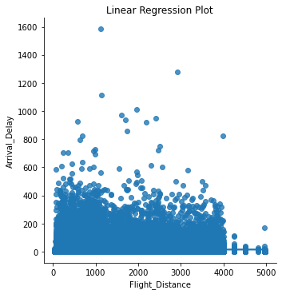

In [84]:
model1=smf.ols(formula='Departure_Delay ~ Flight_Distance',data=reg)

In [85]:
results=model1.fit() print(results.summary())

OLS Regression Results
=========================================================================
=====
Dep. Variable: | Departure_Delay | R-squared:
0.000
Model: | OLS | Adj. R-squared: | -
0.000
Method: | Least Squares | F-statistic:
0.7494
Date: | Wed, 26 Jul 2023 | Prob (F-statistic):
0.387
Time: | 16:42:00 | Log-Likelihood: | -6.569
8e+05
No. Observations: | 129880 | AIC: | 1.31
4e+06
Df Residuals: | 129878 | BIC: | 1.31
4e+06
Df Model: | 1
Covariance Type: | nonrobust

=========================================================================
==========
 | coef | std err | t | P>|t| | [0.025
0.975]
Intercept | 14.6046 | 0.164 | 88.795 | 0.000 | 14.282
14.927
Flight_Distance | 9.168e-05 | 0.000 | 0.866 | 0.387 | -0.000
0.000
=========================================================================
=====
Omnibus: | 165372.886 |  | Durbin-Watson:
1.950
Prob(Omnibus): | 0.000 |  | Jarque-Bera (JB): |  | 5580604
9.416
Skew: | 6.821 |  | Prob(JB):
0.00
Kurtosis: | 103.628 |  | Cond. No. |  | 2.4
2e+03
=========================================================================
=====

Notes:
- Standard Errors assume that the covariance matrix of the errors is co rrectly specified.
- The condition number is large, 2.42e+03. This might indicate that the re are
strong multicollinearity or other numerical problems.

In [86]:
sns.lmplot(x='Flight_Distance', y='Departure_Delay', data=reg, markers=['

# Set title and axis labels plt.title('Linear Regression Plot') plt.xlabel('Flight_Distance') plt.ylabel('Departure_Delay')

# Show the plot
plt.show()

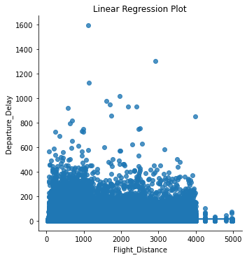

Step 7. Using any of the data mining techniques you are familiar with, answer the following questions. Show your work to justify your conclusions.
7a. Is satisfaction with seat comfort related (or depends on) to passenger Gender? 7b. Is satisfaction with gate location related to passenger age?
7c. Do first time passengers have more or less expectations than returning customers measured in terms of overall satisfaction?

7d. Is there a distinct (statistically significant) difference between business and personal travelers (A5) in terms of their reaction to their flights? (Hint: Use any attribute(s) that you think appropriate to measure their reaction.)

7e. Is there a distinct (statistically significant) difference between business class passengers and economy passengers (A6) in terms of their reaction to satisfaction with food-and-drink?

In [87]:
satisfaction_mapping = { 'Satisfied': 1,
'Neutral or Dissatisfied': 0,
# Add more labels and their corresponding numeric values as needed
}

# Apply the mapping to the 'Satisfaction' column
df['Overall_Satisfaction'] = df['Satisfaction'].map(satisfaction_mapping)

In [88]:
t_statistic_seat_gender, p_value_seat_gender = stats.ttest_ind(df[df['Gen print("T-statistic for satisfaction with seat comfort and Gender:", t_sta print("P-value for satisfaction with seat comfort and Gender:", p_value_s

T-statistic for satisfaction with seat comfort and Gender: -11.0893736125 58425
P-value for satisfaction with seat comfort and Gender: 1.455122380044486e
-28

In [89]:
correlation_coefficient, p_value_gate_age = stats.pearsonr(df['Gate Locat print(f"Correlation coefficient for satisfaction with gate location and A print(f"P-value for satisfaction with gate location and Age: {p_value_gat

Correlation coefficient for satisfaction with gate location and Age: -0.0 0039807576080006115
P-value for satisfaction with gate location and Age: 0.8859264082579607

In [90]:
first_time_passengers = df[df['Customer Type'] == 'First-time'] returning_customers = df[df['Customer Type'] == 'Returning']

# Extract the overall satisfaction scores for each group first_time_satisfaction = first_time_passengers['Overall_Satisfaction'] returning_satisfaction = returning_customers['Overall_Satisfaction']

# Perform the t-test
t_statistic, p_value = stats.ttest_ind(first_time_satisfaction, returning print(f"T-statistic for overall satisfaction and Customer Type: {t_statis print(f"P-value for overall satisfaction and Customer Type: {p_value}")

# Interpret the results
if p_value < 0.05:
if t_statistic < 0:
print("First-time passengers have significantly lower overall sat
else:
print("First-time passengers have significantly higher overall sa
else:
print("There is no statistically significant difference in overall sa
T-statistic for overall satisfaction and Customer Type: -68.2288056293342 P-value for overall satisfaction and Customer Type: 0.0
First-time passengers have significantly lower overall satisfaction than returning customers.

In [91]:
t_statistic, p_value = stats.ttest_ind(df[df['Type of Travel'] == 'Busine
df[df['Type of Travel'] == 'Person print(f"T-statistic for satisfaction and Type of Travel: {t_statistic}") print(f"P-value for satisfaction and Type of Travel: {p_value}")

T-statistic for satisfaction and Type of Travel: 181.52943164162733 P-value for satisfaction and Type of Travel: 0.0

In [92]:
t_statistic, p_value = stats.ttest_ind(df[df['Class'] == 'Business']['Foo
df[df['Class'] == 'Economy']['Food print(f"T-statistic for satisfaction with food-and-drink and Class: {t_st print(f"P-value for satisfaction with food-and-drink and Class: {p_value}

T-statistic for satisfaction with food-and-drink and Class: 31.9460090582 1368
P-value for satisfaction with food-and-drink and Class: 5.287862406504557 e-223

Step 8.
8a. Determine if any relationship exists between check-in service (A12) and baggage handling (A23) using any data mining technique. Based on this, provide a guidance to airline executives.

8b. Between A10 and A16, which one do you think passengers value the most? Assume that the overall satisfaction (A24) is a good proxy for the v

In [93]:
rel=df[["Baggage Handling","Check-in Service","Departure and Arrival Time rel

Out[93]:

Baggage Handling

Check-in Service

Departure and Arrival Time
Convenience

Seat Comfort

Satisfaction

0 5 4 3 5 Neutral or Dissatisfied
1 5 3 2 4 Satisfied
2 3 4 4 5 Satisfied
3 5 3 2 5 Satisfied
4 3 3 3 4 Satisfied
... ... ... ... ... ...
129875 4 4 4 1 Neutral or Dissatisfied
129876
5
5
5
2
Neutral or Dissatisfied

Dissatisfied
129877 | 5 | 4 | 5 | 3 Neutral or Dissatisfied
129878 | 5 | 3 | 4 | 4 Satisfied
129879 | 1 | 4 | 1 | 2 Neutral or

129880 rows × 5 columns

In [94]:
rel.rename(columns={"Baggage Handling": "Baggage_Handling", "Check-in Ser
/var/folders/mf/k95w0sl124dd8fzv9hjs54kw0000gn/T/ipykernel_44300/35262224
34.py:1: SettingWithCopyWarning:
A value is trying to be set on a copy of a slice from a DataFrame

See the caveats in the documentation: https://pandas.pydata.org/pandas-do cs/stable/user_guide/indexing.html#returning-a-view-versus-a-copy
rel.rename(columns={"Baggage Handling": "Baggage_Handling", "Check-in S ervice": "Check_in_Service", "Departure and Arrival Time Convenience": 'D eparture_and_Arrival_Time_Convenience',"Seat Comfort":"Seat_Comfort"}, in place=True)

In [95]: | rel
Out[95]: |  | Baggage_Handling | Check_in_Service | Departure_and_Arrival_Time_Convenience | Sea
 | 0 | 5 | 4 | 3
 | 1 | 5 | 3 | 2
 | 2 | 3 | 4 | 4
 | 3 | 5 | 3 | 2
 | 4 | 3 | 3 | 3
 | ... | ... | ... | ...
 | 129875 | 4 | 4 | 4
 | 129876 | 5 | 5 | 5
 | 129877 | 5 | 4 | 5
 | 129878 | 5 | 3 | 4
 | 129879 | 1 | 4 | 1

129880 rows × 5 columns

In [96]:
sns.scatterplot(x='Baggage_Handling', y='Check_in_Service', data=rel)

# Set plot labels plt.xlabel('Baggage_Handling') plt.ylabel('Check_in_Service')
plt.title('Relationship between Baggage Handling and Check-in Service')

# Show the plot
plt.show()

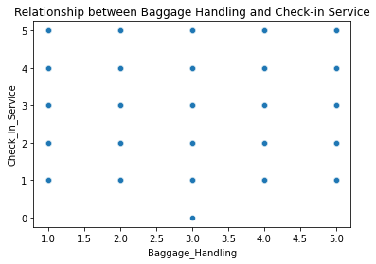

In [97]:

Out[97]:

In [98]:
model=smf.ols(formula='Check_in_Service ~ Baggage_Handling',data=rel)
rel['Check_in_Service'].corr(rel['Baggage_Handling'])
0.23450312820140468

In [99]:
results=model.fit() print(results.summary())

OLS Regression Results
=========================================================================
=====
Dep. Variable: | Check_in_Service |  | R-squared:
0.055
Model: | OLS |  | Adj. R-squared:
0.055
Method: | Least Squares |  | F-statistic:
7558.
Date: | Wed, 26 Jul 2023 |  | Prob (F-statistic):
0.00
Time: | 16:42:11 |  | Log-Likelihood: |  | -2.112
7e+05
No. Observations: | 129880 |  | AIC: |  | 4.22
5e+05
Df Residuals: | 129878 |  | BIC: |  | 4.22
6e+05
Df Model: | 1
Covariance Type: | nonrobust
=========================================================================
===========
 | coef | std err | t | P>|t| | [0.025
0.975]
Intercept | 2.3923 | 0.011 | 216.430 | 0.000 | 2.371
2.414
Baggage_Handling | 0.2516 | 0.003 | 86.936 | 0.000 | 0.246
0.257
=========================================================================
=====
Omnibus: | 10469.634 |  | Durbin-Watson:
1.890
Prob(Omnibus): | 0.000 |  | Jarque-Bera (JB): |  | 516
0.098

Skew: | -0.317 | Prob(JB):
0.00
Kurtosis: | 2.258 | Cond. No.
13.1
=========================================================================
=====

Notes:
[1] Standard Errors assume that the covariance matrix of the errors is co rrectly specified.

In [100…
lm=smf.ols('Check_in_Service ~ Baggage_Handling',data=rel).fit() table=sm.stats.anova_lm(lm)
print(table)

(>F) | df | sum_sq | mean_sq | F PR
Baggage_Handling | 1.0 | 11450.666710 | 11450.666710 | 7557.832421
0.0
Residual | 129878.0 | 196774.631688 | 1.515073 | NaN
NaN

In [101…
label_encoder = LabelEncoder()
rel['Overall_Satisfaction'] = label_encoder.fit_transform(rel['Satisfacti rel

/var/folders/mf/k95w0sl124dd8fzv9hjs54kw0000gn/T/ipykernel_44300/30573083
97.py:2: SettingWithCopyWarning:
A value is trying to be set on a copy of a slice from a DataFrame. Try using .loc[row_indexer,col_indexer] = value instead

See the caveats in the documentation: https://pandas.pydata.org/pandas-do cs/stable/user_guide/indexing.html#returning-a-view-versus-a-copy
rel['Overall_Satisfaction'] = label_encoder.fit_transform(rel['Satisfac tion'])

Out[101]: | Baggage_Handling | Check_in_Service | Departure_and_Arrival_Time_Convenience | Se
 | 0 5 | 4 | 3
 | 1 5 | 3 | 2
 | 2 3 | 4 | 4
 | 3 5 | 3 | 2
 | 4 3 | 3 | 3
 | ... ... | ... | ...
 | 129875 4 | 4 | 4
 | 129876 5 | 5 | 5
 | 129877 5 | 4 | 5
 | 129878 5 | 3 | 4
 | 129879 1 | 4 | 1

129880 rows × 6 columns

In [102…
model1=smf.ols(formula='Overall_Satisfaction ~ Departure_and_Arrival_Time

In [103…
results=model1.fit() print(results.summary())

OLS Regression Results
=========================================================================
=======
Dep. Variable: Overall_Satisfaction R-squared: 0.003
Model: OLS Adj. R-squared:
0.003
Method: Least Squares F-statistic: 383.6
Date: Wed, 26 Jul 2023 Prob (F-statistic): 2.66e-85
Time: 16:42:11 Log-Likelihood:
-92949.
No. Observations: 129880 AIC: 1.
859e+05
Df Residuals: 129878 BIC: 1.
859e+05
Df Model: 1
Covariance Type: nonrobust
=========================================================================
=================================
coef std err t
P>|t| [0.025 0.975]
Intercept 0.4883 0.003 158.842
0.000 0.482 0.494
Departure_and_Arrival_Time_Convenience -0.0176 0.001 -19.587
0.000 -0.019 -0.016
=========================================================================
=====
Omnibus: 466220.152 Durbin-Watson:
1.459
Prob(Omnibus): 0.000 Jarque-Bera (JB): 2142
2.154
Skew: 0.264 Prob(JB):
0.00
Kurtosis: 1.081 Cond. No. 8.18
=========================================================================
=====

Notes:
[1] Standard Errors assume that the covariance matrix of the errors is co rrectly specified.

In [104…
model2=smf.ols(formula='Overall_Satisfaction ~ Seat_Comfort',data=rel)

In [105…
results=model2.fit() print(results.summary())

OLS Regression Results
=========================================================================
=======
Dep. Variable: | Overall_Satisfaction | R-squared:
0.122
Model: | OLS | Adj. R-squared:
0.122
Method: | Least Squares | F-statistic: | 1.
799e+04

Date: | Wed, | 26 | Jul 2023 | Prob (F-statistic):
0.00
Time: |  |  | 16:42:11 | Log-Likelihood:
-84715.
No. Observations: |  |  | 129880 | AIC: | 1.
694e+05
Df Residuals: |  |  | 129878 | BIC: | 1.
695e+05
Df Model: 1
Covariance Type: nonrobust
=========================================================================
=======
0.975] | coef | std err | t | P>|t| | [0.025
Intercept | -0.0166 | 0.004 | -4.603 | 0.000 | -0.024
-0.010
Seat_Comfort | 0.1311 | 0.001 | 134.139 | 0.000 | 0.129
0.133
=========================================================================
=====
Omnibus: | 915265.299 |  | Durbin-Watson:
1.511
Prob(Omnibus): | 0.000 |  | Jarque-Bera (JB): |  | 1220
0.545
Skew: | 0.193 |  | Prob(JB):
0.00
Kurtosis: | 1.549 |  | Cond. No.
11.0
=========================================================================
=====

Notes:
[1] Standard Errors assume that the covariance matrix of the errors is co rrectly specified.

In [ ]:

