1. What is a Computer Network?
A computer network is a group of computers connected together so they can communicate and share data and resources.
Example:
When your laptop connects to Wi-Fi and accesses Google, your laptop communicates with Google's servers through a network.

2. What are LAN, MAN, and WAN?
These are types of networks based on their geographical area.
Type | Full Form | Area | Example
LAN | Local Area Network | Small area | Home, office, college
MAN | Metropolitan Area Network | City | Network connecting offices across a city
WAN | Wide Area Network | Large geographical area | Internet
1. PAN (Personal Area Network)
- PAN is a network used for personal devices within range of 10m.
Technologies Used
- Bluetooth
7. GAN (Global Area Network)
- GAN connects networks across the entire world using satellites.
Examples
- Satellite communication systems

What is the OSI model? Explain all 7 layers.
The OSI model is a seven-layer model that explains how data is transmitted between two different sources
Layer | Name | Main Function
7 | Application | Provides network services to applications
6 | Presentation | Data formatting, encryption, compression
5 | Session | Establishes and manages sessions
4 | Transport | Reliable data delivery
3 | Network | Routing and IP addressing
2 | Data Link | MAC addressing and frames
1 | Physical | Sends bits through physical medium

4. What is the TCP/IP Model?
TCP/IP = Transmission Control Protocol / Internet Protocol
TCP/IP is the protocol used to transmit data from one source to another using internet
It commonly has 4 layers:
TCP/IP Layer | Main Function
Application | Application-level communication
Transport | End-to-end communication
Internet | IP addressing and routing
Network Access | Physical + Data Link communication

6. What is a Protocol?
A protocol is a set of rules that defines how devices communicate with each other.
7. What is an IP Address?
An IP address is a logical address assigned to a device on a network.

8. IPv4 vs IPv6
IPv4
IPv4 uses 32-bit addresses.
IPv6
IPv6 uses 128-bit addresses.

9. What is a MAC Address?
MAC = Media Access Control
A MAC address is address of the hardware devices in the network

10. MAC Address vs IP Address
This is a very common interview question.
MAC Address | IP Address
Hardware/interface address | Logical address

1. What is a Subnet Mask?
A subnet mask is used with an IP address to determine:
- Which part represents the network
- Which part represents the host/device

A subnet mask separates the network portion and host portion of an IP address and helps determine whether devices belong to the same network.

VPN (Virtual Private Network)
A VPN is a private network built over the public internet that allows users to securely connect to network.

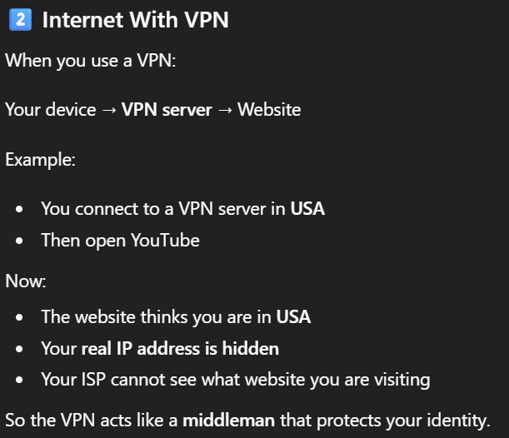
What is DNS?
Domain Name System(DNS)
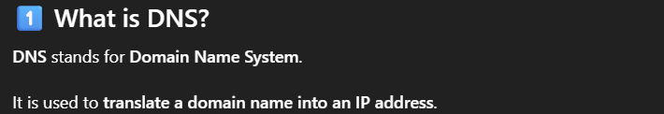
4. What is DHCP?
DHCP = Dynamic Host Configuration Protocol
DHCP automatically provides network configuration(IP address) to devices when connected over internet.

5. What is ARP?
ARP = Address Resolution Protocol
ARP is used to find the MAC address using the IPv4 address on the local network.

6. What is a Router?
A router is a networking device that connects different networks and forwards packets between them.
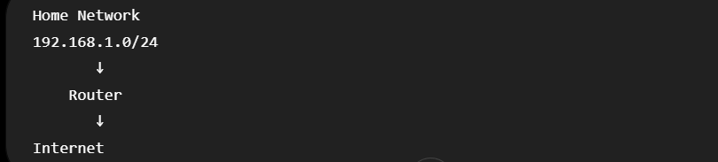

7. Router vs Switch vs Hub
Router connects different networks whereas Switch connects devices within a local network.
Switch is a hardware device that connects multiple devices in the LAN.It’s doesn’t send the data to all devices.It specially uses MAC address of the device and communicates with it
Hub
A hub is a device used to connect multiple devices in LAN by receives a signal/frame and broadcasts it out to all ports.
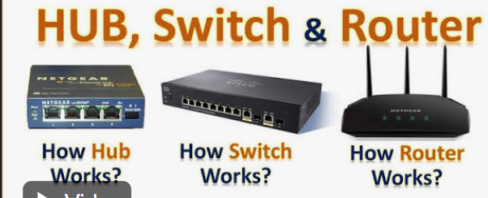
Whereas connects different devices in LAN

9. TCP vs UDP
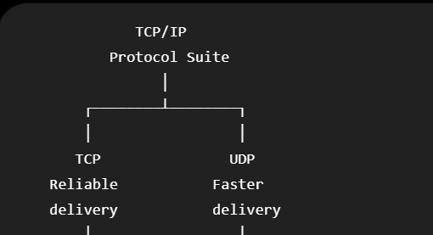
TCP (Transmission Control Protocol) or IP and UDP (User Datagram Protocol) are transport layer protocols
TCP = Transmission Control Protocol
TCP is connection-oriented protocol which guarantee reliable and ordered data delivery
Example: Websites, file downloads
UDP=User Datagram Protocol
UDP is a connectionless protocol which doesn’t guarantee delivery and ordered data

Example: Online gaming, video calls

10. What is the TCP Three-Way Handshake?
Three-Way Handshake is used to establish a connection between client and server
Establishes a TCP connection using three messages: SYN, SYN-ACK, and ACK.

Step 1 — SYN
Client sends:
SYN
Meaning:
"I want to establish a TCP connection."

Step 2 — SYN + ACK
Server responds:
SYN + ACK
Meaning:
"I received your request, and I also want to establish the connection."

Step 3 — ACK
Client sends:
ACK
Meaning:
"I received your response."
Now the TCP connection is established and data can be exchanged.

1. What is a Port Number?
A port number is a logical number used to identify a specific application service on a device.
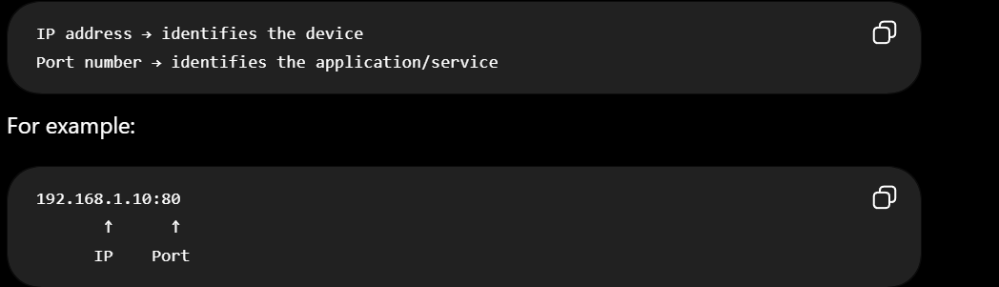

2. What are HTTP and HTTPS?
HTTP
HTTP = HyperText Transfer Protocol
It is a protocol used for communication between web clients and web servers.
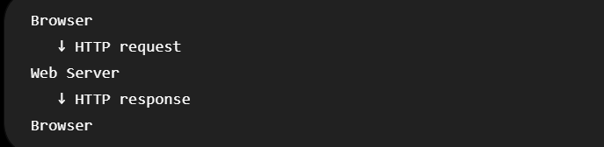

HTTPS
HTTPS = HTTP Secure
HTTPS (HyperText Transfer Protocol Secure) is the secure version of HTTP where request and response are encrypted.

4. What are HTTP Status Codes?
HTTP status codes are three-digit codes sent by a server to indicate the result of an HTTP request.
2xx → Success
4xx → Client Error
5xx → Server Error

5. What is a Firewall?
A firewall is a security system that monitors and controls network traffic based on predefined rules.
It can allow or block traffic based on things such as:
- Source IP
- Destination IP

6. What is NAT?
NAT = Network Address Translation
NAT (Network Address Translation) is a method used by routers to let multiple devices on a private local network share a single public IP address when connecting to the internet.

7. What is Packet Switching?
Packet switching is a method of transmitting data by breaking it into smaller units called packets.
The destination then processes the packets and reconstructs the original data at the appropriate higher layer.

8. What is Congestion Control?
Congestion control is a mechanism to manage traffic to server so that its doesn’t go down using congestion-control mechanisms

9. Unicast vs Multicast vs Broadcast
main ways to send data on a network
Unicast
Unicast is the way to send data from one sender to one receiver
Example:
You request a webpage from a web server.

Multicast
Muilticast is the way to send data from one sender to many specific receivers
Example:Video Confering

Broadcast
Broadcast is the way to send data to all the devices in the local domain
Example:TV Broadcasting

