1. What is DBMS?
Answer:
A Database Management System (DBMS) is software that allows users to create, store, retrieve, update, and manage data efficiently in a database
Examples:
- MySQL
- Oracle
- PostgreSQL

2. What are the advantages of using a DBMS over a file system?
Answer:
A DBMS provides several advantages compared to the traditional file system.
DBMS | File System
Controls data redundancy | Duplicate data is common
Maintains data consistency | Data inconsistency can occur
Backup and recovery of data No automatic backup and recovery of data
Access and manipulate the Manual access of data
Data through queries

3. What are the different types of DBMS?
Answer:
There are four major types of DBMS.
1. Hierarchical DBMS
- Data is organized like a tree like structure.
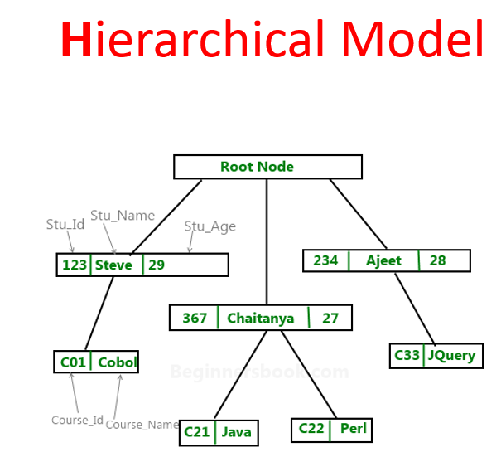
2. Network DBMS
- Data is organized like a graph like structure.
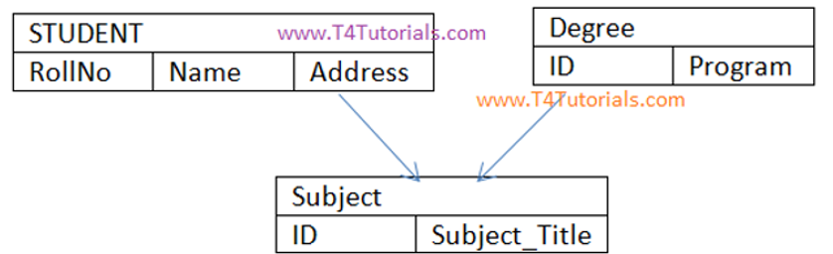
3. Relational DBMS (RDBMS)
- Data is stored in tables.

4. Object-Oriented DBMS (OODBMS)
Stores data as objects.
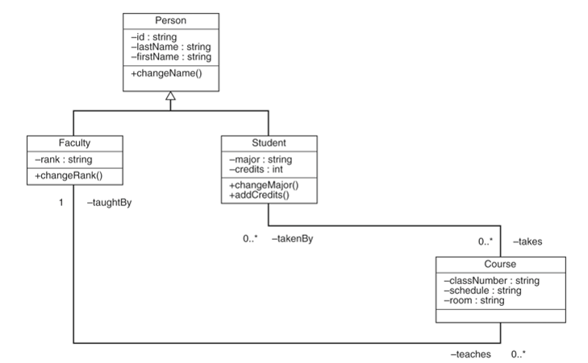
ER model(Entity-Relation Model) is a model that represents relation between different entities in the database
ER model is a part of Object Oriented DBMS
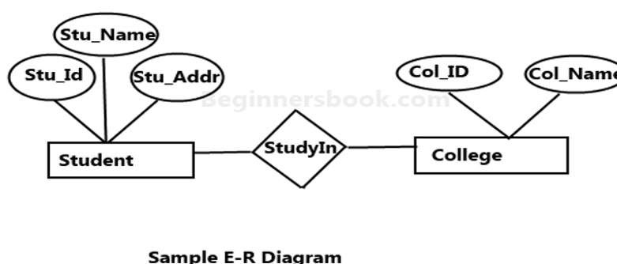

4. What is RDBMS?
Answer:
RDBMS (Relational Database Management System) is a type of DBMS in which data is stored in tables (relations) consisting of rows and columns.
Tables are connected using Primary Keys and Foreign Keys.
Examples:
- MySQL
- Oracle
- SQL Server
- PostgreSQL

6. What is a database schema?
Answer:
A schema is the logical structure or blueprint of a database. It defines:
- Tables
- Columns
- Data types
- Relationships
- Constraints
- Keys

7. What is a database instance?
Answer:
A database instance is the actual data stored in the database at a specific point in time.
8. What is metadata?
Answer:
Metadata means data about data. Metadata tells about database schema,constraints and relationships in the database

9. What is data abstraction in DBMS?
Answer:
Data abstraction is the process of hiding unnecessary implementation details and showing only the required information to users.
Purpose
- Hides complexity
- Improves security
There are three levels of data abstraction:
- Physical Level
- Logical (Conceptual) Level
- View (External) Level
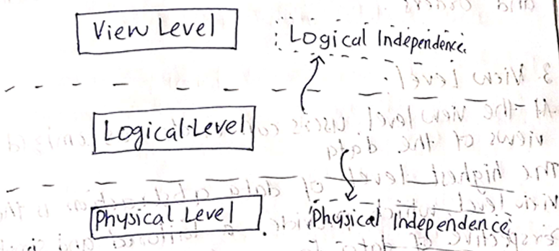
10. What are the different levels of data abstraction?
Answer:
There are three levels of data abstraction:
  - Physical Level (Lowest Level)
- Describes how the data is stored on disk.
- It includes what type of complex data structures are used,what file organization methods are used in the disk
2. Logical (Intermediate) Level
- Logical level consists of metadata of the database
- Used by database designers and administrators.
3. View Level (Highest Level)
- Shows only the data required by a particular user or application.
- Different users can have different views of the same database.
Ex:A Manager can see all the user accounts whereas user can only see his own account
Example
Suppose there is an Employee table with the following columns:
EmpID | Name | Salary | Department
- Physical Level: Specifies how this table is stored on disk.
- Logical Level: Defines that the table has columns EmpID, Name, Salary, and Department.
- View Level: An HR employee may see all columns, while a regular employee may see only EmpID, Name, and Department.

11. What is data independence?
Answer:
Data independence is the ability to modify the database schema without affecting the application programs
Example
Suppose an Employee table is stored on a hard disk.
If the database administrator changes the storage method (for example, adds indexes), the application still works without any changes.

12. What is the difference between logical and physical data independence?

Logical Data Independence means ability to change the logical schema of database so that it doesn’t affect application programs
Logical Data Independence Example
Adding a new column:

Physical data independence means ability to change the physical schema of database like moving file from one place to another so that it doesn’t affect the application programs
Physical Data Independence Example
- Adding an index
- Moving data to another disk

13. What are the components of a DBMS?
Answer
The major components of a DBMS are:

Core Components of a DBMS
- Hardware
  - Physical computers, servers, storage devices
- Software
  - The application programs used to manage the data
- Data
  - The actual information stored in DBMS
- Query Processor
  - Translates user queries into low-level instructions.
- Database Access Language
  - Languages like SQL used to command the database.
- Users
  - Database administrators, application programmers, and end users.

Internal Software Modules
- Query Processor
  - Translates user queries into low-level instructions.
- Storage Manager
  - Controls data storage allocation and memory caching.
- Transaction Manager
  - Ensures database consistency despite system crashes

14. What is the difference between DBMS and RDBMS?
Answer
DBMS | RDBMS
Stores data in files or simple structures | Stores data in tables
Relationships may not exist | Supports relationships between tables

15. Who is a Database Administrator (DBA)?
Answer
A Database Administrator (DBA) is a person responsible for managing, maintaining, the database.
The DBA creates the databases,manages permissions and involves in backup and recovery

16. What are the responsibilities of a DBA?
Answer
Responsibilities
- Creating databases
- Managing users and Granting permissions
- Backup and recovery

17. What is a database language?
Answer
A database language is the language used to interact with database
In RDBMS,we use SQL(Structured Query Language)

18. What are DDL, DML, DCL, and TCL?
Answer
1. DDL (Data Definition Language)
These are the commands used to create and remove tables from data
Commands:
- CREATE
- ALTER
- DROP
- TRUNCATE
- RENAME
2. DML (Data Manipulation Language)
Used to manipulate data.
Commands:
- INSERT
- UPDATE
- DELETE
3. DCL (Data Control Language)
Used to control user permissions.
Commands:
- GRANT
- REVOKE
4. TCL (Transaction Control Language)
Used to manage transactions.
Commands:
- COMMIT
- ROLLBACK
- SAVEPOINT

19. What is SQL?
Answer
SQL (Structured Query Language) is the standard language used to communicate with relational databases.

20. What are the different categories of SQL commands?

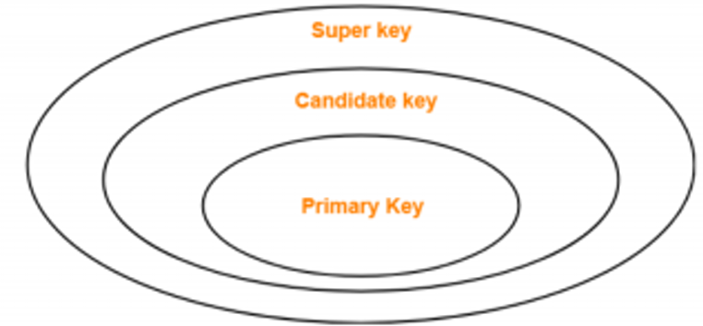

21. What is a Primary Key?
Answer
A Primary Key is a column that uniquely identifies each row in a table.
A Primary Key:
- Cannot contain NULL values.
- Must contain unique values.
- There can be only one Primary Key in a table.
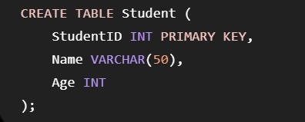
22. What is a Foreign Key?
Answer
A Foreign Key is a column in one table that refers to the another Key of another table.
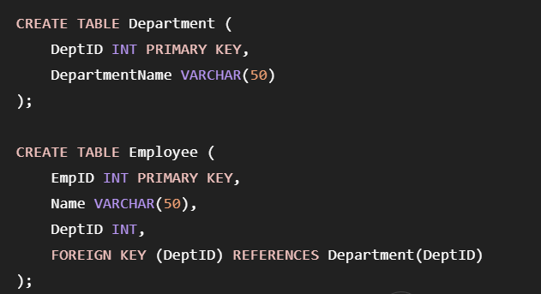
23. What is a Candidate Key?
Answer
A Candidate Key is column that can uniquely identify each row in a table.
NOT NULL,UNIQUE
One of the candidate keys is chosen as the Primary Key.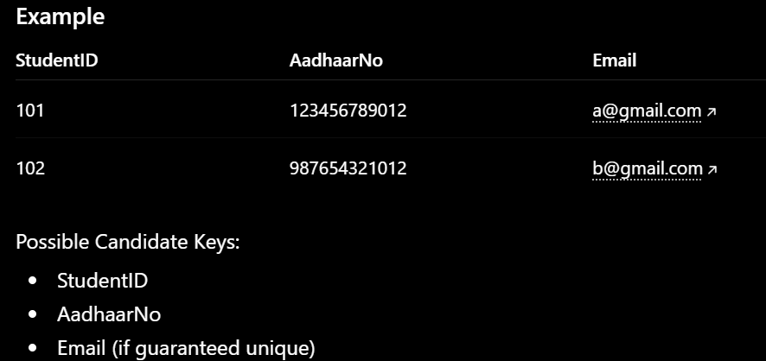
24. What is a Super Key?
Answer
A Super Key is a column or set of columns that can uniquely identify a rows in the table.
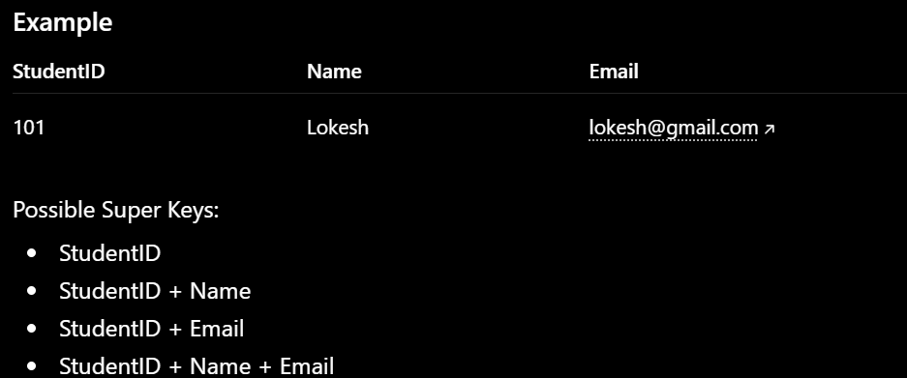
25. What is an Alternate Key?
Answer
An Alternate Key is a Candidate Key that is not selected as the Primary Key.

26. What is a Composite Key?
A Composite Key is a Primary Key made up of two or more columns.

A Surrogate key is auto-generated key usually for ordering

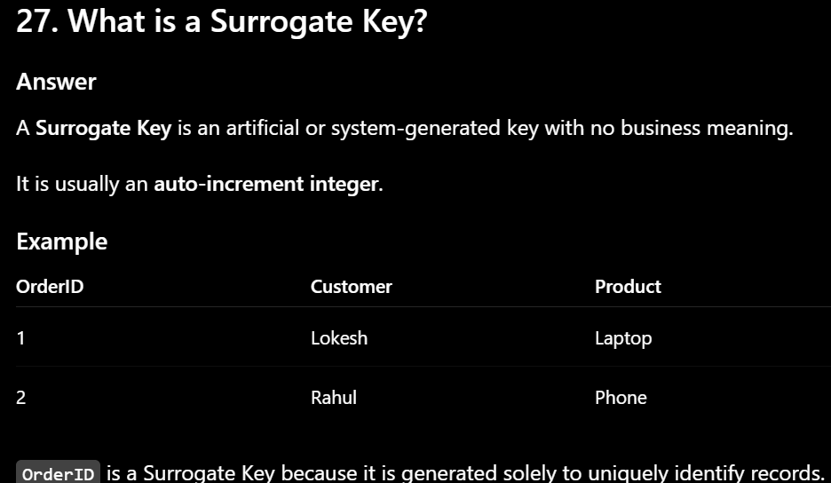

30. What are Integrity Constraints?
Answer
Integrity Constraints are rules in dbms that ensure consistency,validness and integrity.
1. Domain Constraint
Definition
1. Domain Constraint enforces only specific range of values based on constraints defined in the schema
2. Key Constraint
Definition
A Key Constraint tells about primary key especially uniqueness property
3. Entity Integrity Constraint
Definition
Entity Integrity tells about primary key especially its nullness property

29. What is Referential Integrity?
Answer
Referential Integrity ensures tells about foreign key
Foreign key is a column in one table that references to another key in another table

31. What is the NOT NULL Constraint?
Answer
The NOT NULL constraint ensures that a column cannot store NULL (empty) values.
Name VARCHAR(50) NOT NULL,

32. What is the CHECK Constraint?
Answer
The CHECK constraint is used to check the condition and allow the values into table if the conditions are met.
Age INT CHECK (Age >= 18)

33. What is the DEFAULT Constraint?
Answer
The DEFAULT constraint automatically assigns a default value to a column when no value is provided during insertion.
Example
Salary INT DEFAULT 30000;
34. What is the UNIQUE Constraint?
Answer
The UNIQUE constraint ensures that all values in a column are unique.
Email VARCHAR(100) UNIQUE;

35. What is the difference between a Primary Key and a Foreign Key?
Answer
Primary Key | Foreign Key
Uniquely identifies a record | References the Primary Key of another table
Cannot contain NULL values | Can contain NULL values (if allowed)

36. What is an ER Model?
Answer
ER Model (Entity-Relationship Model) is a conceptual model used to design the structure of a database.
It represents:
- Entities
- Attributes
- Relationships
It is usually drawn as an ER Diagram (ERD) before creating database tables.
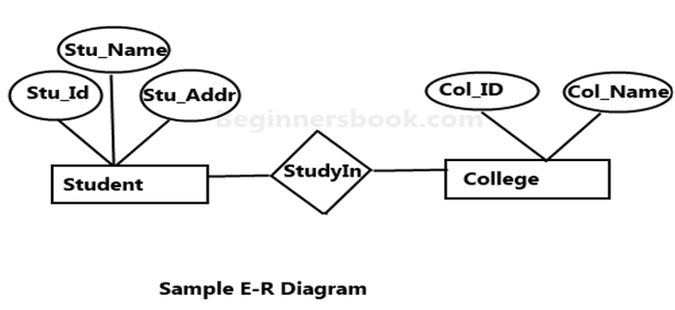]
37. What is an Entity?
Answer
An Entity is a real-world object or concept about which data is stored.
Examples:
- Student
- Employee
- Product
- Department

38. What is an Entity Set?
Answer
An Entity Set is a collection of similar entities.
Example
Student Entity Set
StudentID | Name
101 | Lokesh
102 | Rahul
103 | Priya

39. What is an Attribute?
Answer
An Attribute is a property or characteristic of an entity.
Example
Entity: Student
Attributes:
- StudentID
- Name
- Age

40. What are the different types of Attributes?
Answer
There are several types of attributes in the ER Model.

1. Simple Attribute
Cannot be divided further.
Example:
- Age
- Gender
2. Composite Attribute
Can be divided into smaller parts.
Example:
Name
├── First Name
├── Middle Name
└── Last Name
Address can also be divided into:
- Street
- City
- State

3. Single-Valued Attribute
Contains only one value.
Example:
- Date of Birth
- Aadhaar Number
4. Multi-Valued Attribute
Can have multiple values.
Example:
- Phone Numbers
- Skills
5. Derived Attribute
Calculated from another attribute.
Example:
- Age is derived from Date of Birth.

41. What is a Relationship in an ER Diagram?
Answer
A Relationship in an ER Diagram represents the association between two or more entities.
Example
- A Student enrolls in a Course.

42. What are the types of Relationships?
Answer
1. One-to-One (1:1)
One record in one table is related to only one record in another table.
- One to One: One teacher has one office.
- One to Many: One teacher teaches many courses.
- Many to One: Many students belong to one class.
- Many to Many: Many students enroll in many courses.

Q: What is the difference between Cardinality and Degree?
Cardinality refers to number of rows/records
Degree refers to number of columns/attributes
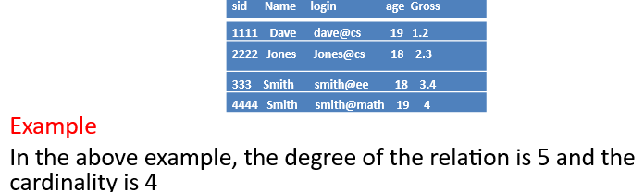

44. What is Participation Constraint?
Answer
Participation Constraint specifies whether the participation of an entity in a relationship is mandatory or optional.
There are two types.

1. Total Participation
Every entity must participate in the relationship.
Example:
Every Employee must belong to a Department.
2. Partial Participation
Participation is optional.
Example:
A Customer may or may not place an Order.

45. What is the difference between Strong Entity and Weak Entity?
Answer
Strong Entity
A Strong Entity has its own Primary Key.
Strong Entity (Employee): An Employee is independent. It has a unique primary key called Employee_ID
Weak Entity
A Weak Entity does not have its own Primary Key.
It depends on another (strong) entity for identification.
Weak Entity (Dependent): A Dependent (such as a child or spouse of an employee) cannot exist in the system without that employee. It does not have a standalone primary key.
46. What is Normalization?
Answer
Normalization is the process of dividing larger tables into smaller related tables to improve data consistency and reduce data redundancy

1. What is Functional Dependency
A Functional Dependency (FD) means:
One attribute depends on another attribute.
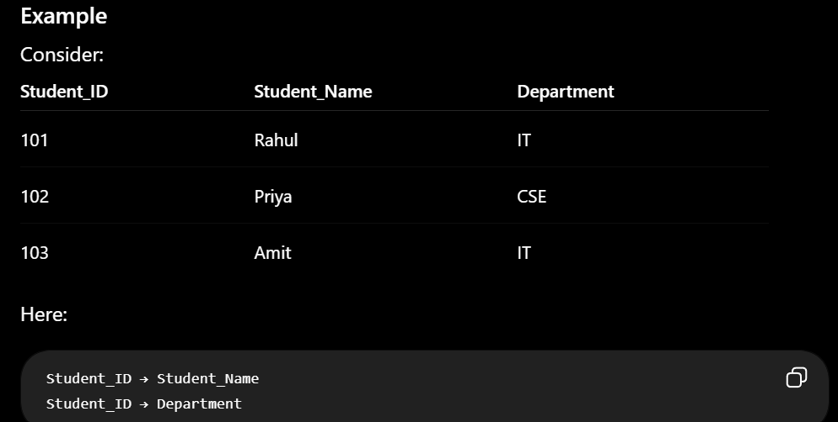
2. What is Partial Dependency?
Partial dependency occurs when:
A non-primary key attribute depends on only part of a composite primary key, instead of the complete primary key.
This is important for second-normal form
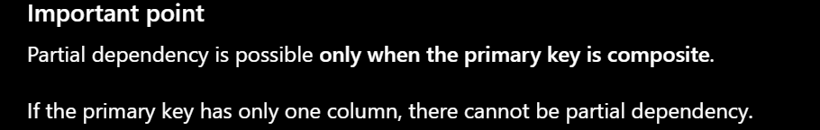
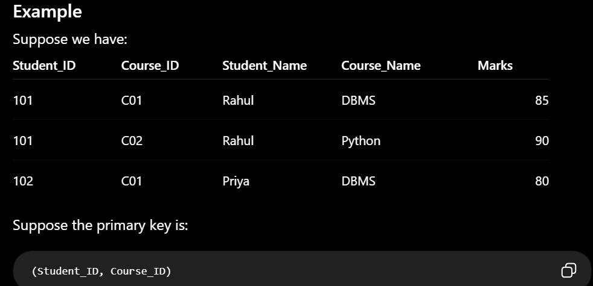

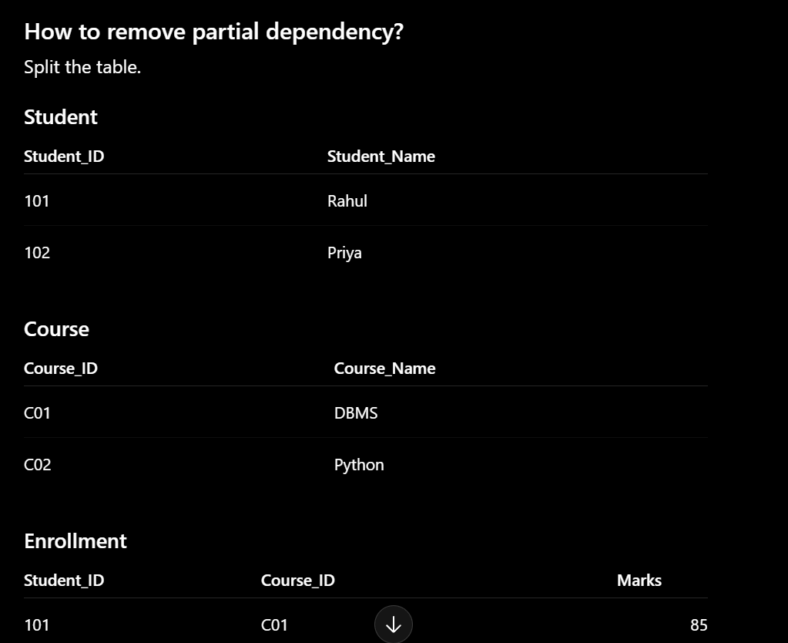

3. What is Transitive Dependency?
Simple definition
Transitive dependency occurs when:
A non-key attribute depends on another non-key attribute, without directly depending on the primary key
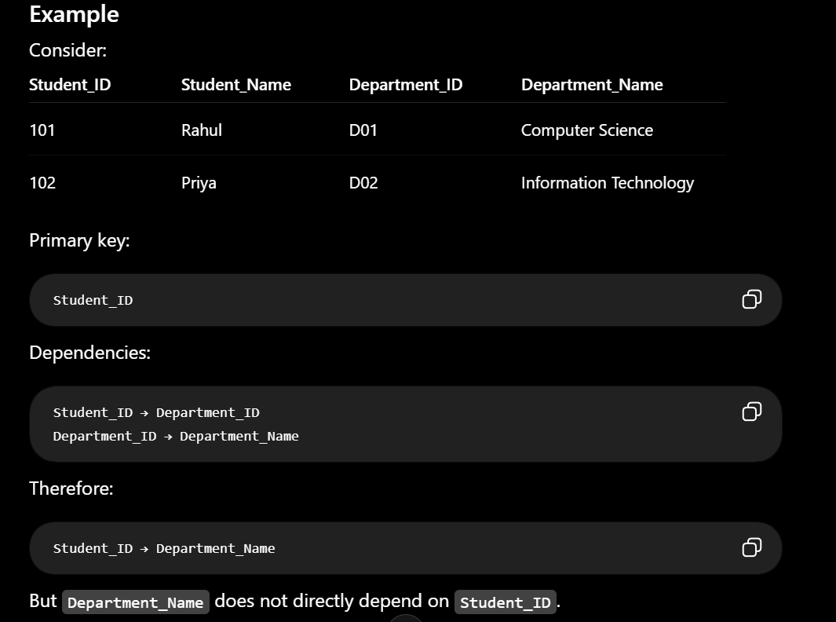
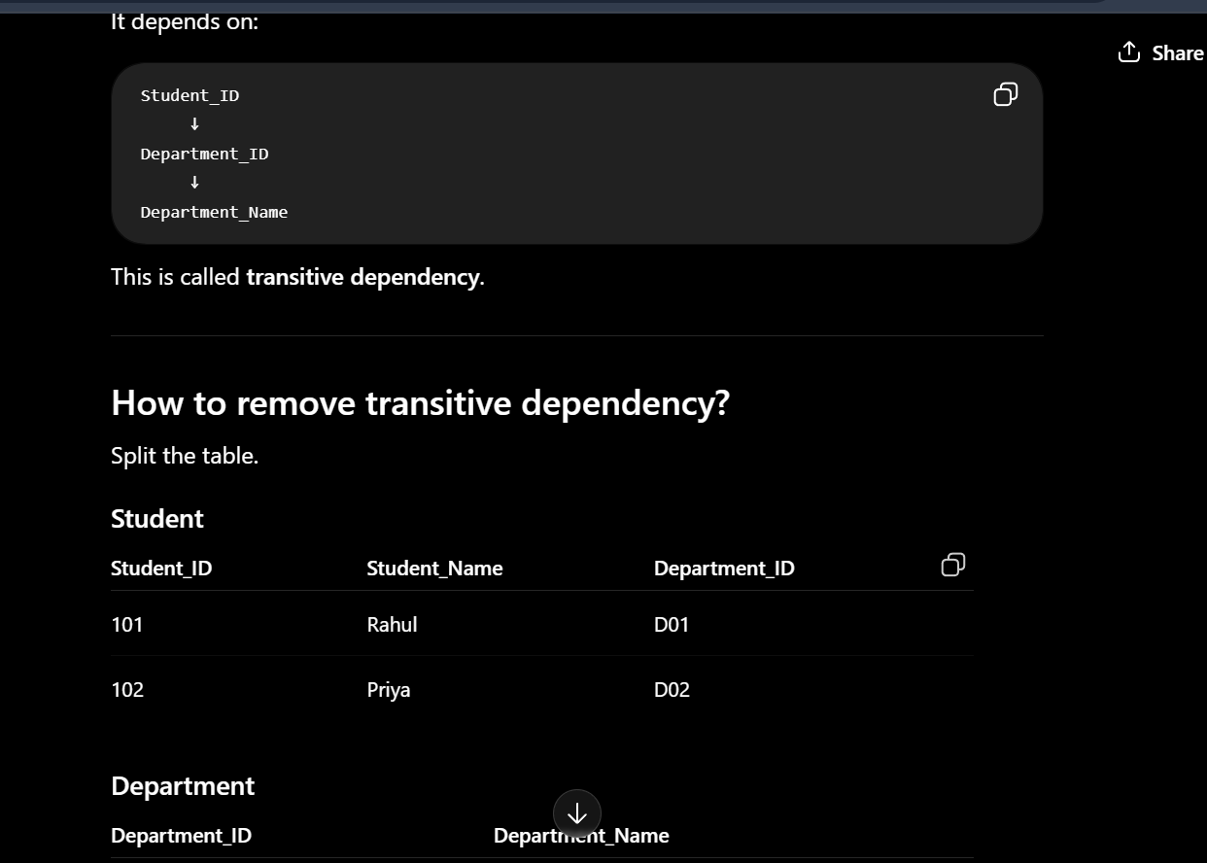
48. What is First Normal Form (1NF)?
Answer
A table is in First Normal Form (1NF) if:
- Each column contains only atomic (single) values.
- No multiple values are stored in a single column.

2NF — Second Normal Form
2NF means:
First satisfy 1NF + no partial dependency.
Non-primary key should depend on the whole primary key, not just part of it

50. What is Third Normal Form (3NF)?
2NF+No Transitive Dependency:
Non-primary key should depend only on the primary key.”

51. What is Boyce-Codd Normal Form (BCNF)?
Answer
BCNF (Boyce-Codd Normal Form) is an advanced version of Third Normal Form (3NF).
3NF+ For every functional dependency A → B, A must be a super key.
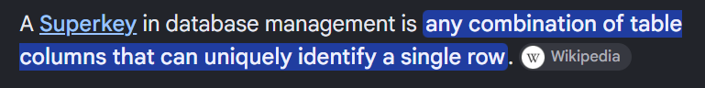
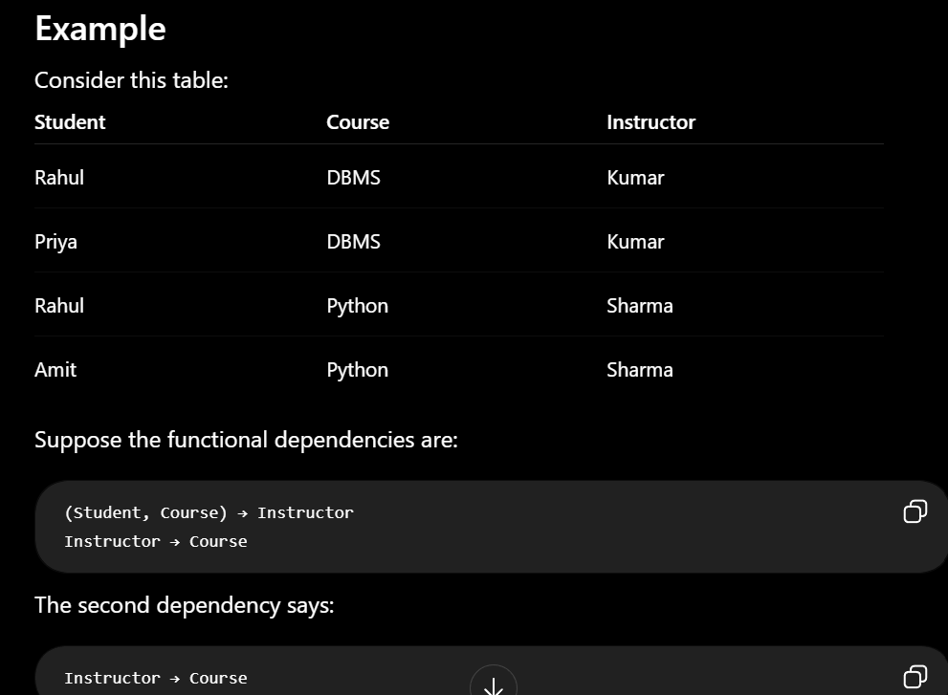
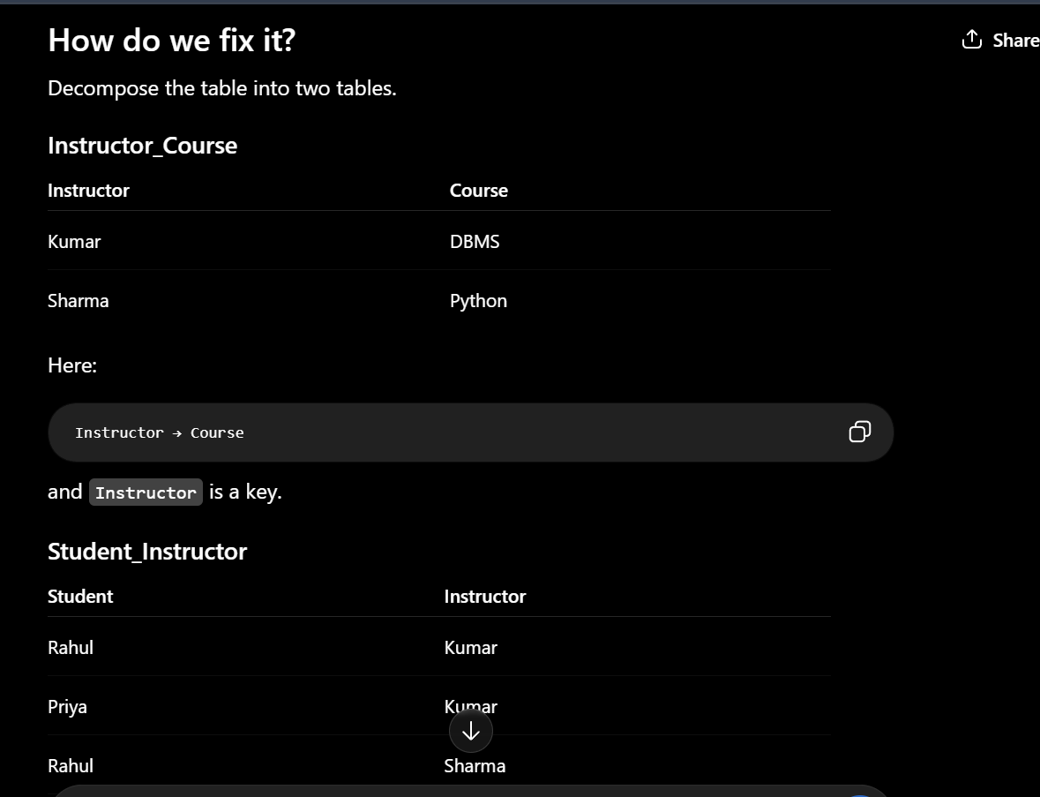
54. What is Denormalization?
Answer
Denormalization is the process of combining normalized tables to improve query performance.

56. What is the difference between DELETE, DROP, and TRUNCATE?
Answer
DELETE | TRUNCATE | DROP
Removes selected rows | Removes all rows | Removes the entire table

57. What is the difference between WHERE and HAVING?
Answer
WHERE | HAVING
Filters rows | Filters groups
Used before GROUP BY | Used after GROUP BY

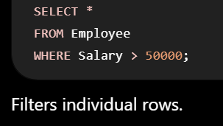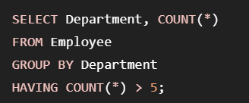
58. What is the ORDER BY clause?
Answer
The ORDER BY clause is used to sort query results in ascending or descending order.
Syntax
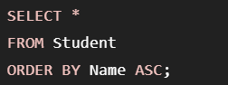
59. What is the GROUP BY clause?
Answer
The GROUP BY clause groups similar data items
It is commonly used with aggregate functions such as:
- COUNT()
- SUM()
- AVG()
- MAX()
- MIN()
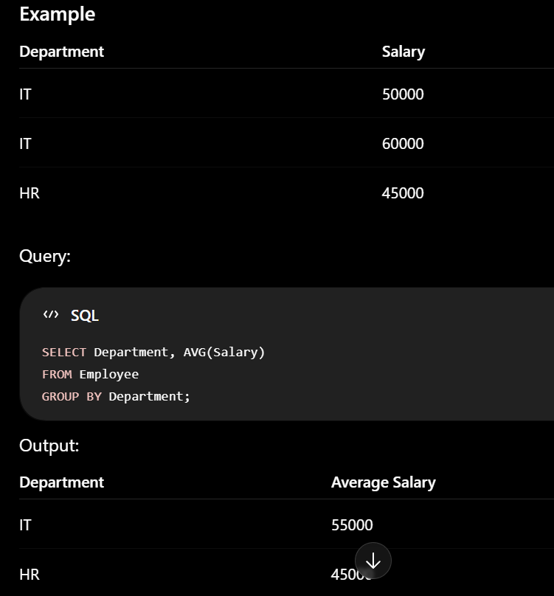
60. What are Aggregate Functions in SQL?
Answer
Aggregate functions perform calculations on multiple rows and return a single result.
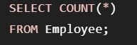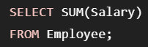

61. What is the DISTINCT Keyword?
Answer
The DISTINCT keyword is used to remove duplicate values from the result set and return only unique records.

62. What is the LIMIT (or TOP) Clause?
Answer
The LIMIT clause is used to restrict the number of rows returned by a query.
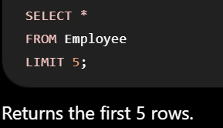
71. What is a Transaction?
Answer
A transaction is a sequence of operations performed on Database which are considered as single unit of work
72. What are the ACID Properties?
"ACID properties guarantee reliable transaction
ACID Properties stand for Atomicity, Consistency, Isolation, and Durability."
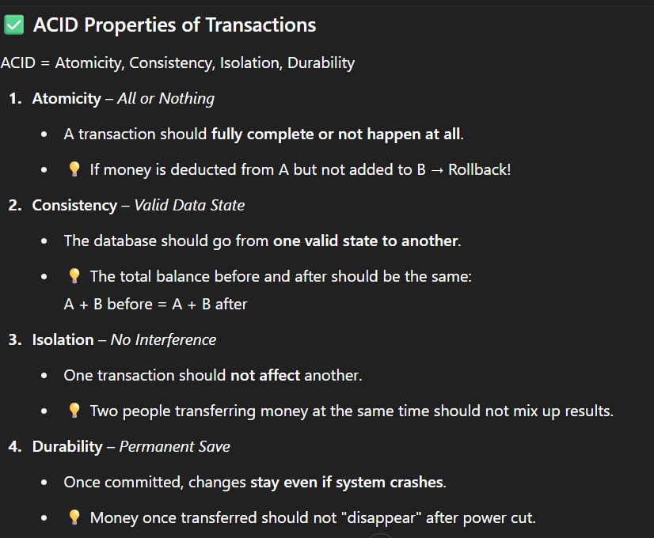
77. What are the States of a Transaction?
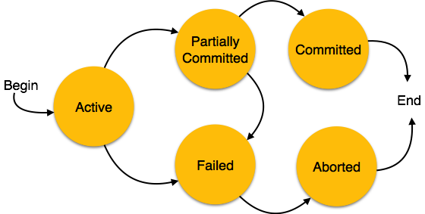
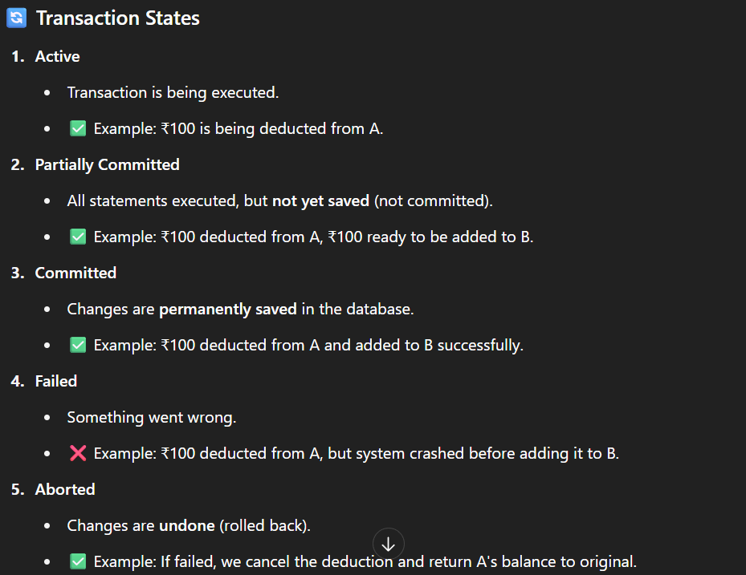
78. What is Concurrency Control?
Answer
Concurrency Control is the process of managing multiple transactions simultaneously without causing data inconsistency.
Example
Suppose an account balance is ₹10,000.
Two users simultaneously withdraw ₹2,000.
Without concurrency control, both transactions might read the same balance, causing incorrect results.
Concurrency control ensures that transactions execute safely.

79. What is a Deadlock?
Answer
A deadlock is a situation where two or more processes are waiting for each other to release resources, so none of them can continue.
As a result, none of the transactions can continue.

80. How Can Deadlocks Be Prevented?
Answer
Several techniques can prevent or handle deadlocks.
1. Resource Ordering
Always acquire resources in the same order.
2. Timeout
Abort a transaction if it waits too long.

81. What is an Index?
An index in SQL is a data structure that stores location of the all the records for faster retrieval
81. What is Indexing?
Answer
"Indexing is a technique that use index to locate records quickly."

82. What are Clustered and Non-Clustered Indexes?
There are two important concepts:
- Clustered index
- Non-clustered index

A clustered index sorts and stores the data in the order based on the index key
A clustered index stores all the data in the index itself
Non-Clustered Index
A non-clustered index is a separate index structure that stores indexed values and data references
a non-clustered index does not store all the data of a table.

86. What is an Indexed View?
An indexed view is a view for which an clustered index is created

84. What is the Difference Between Clustered and Non-Clustered Index?
Difference
Clustered | Non-Clustered
Sorts actual data | Stores pointers
Faster range search | Faster exact search
Changes data order | Doesn't change data

86. What is Query Optimization?
Answer
SQL query optimization is the process of writing efficient queries so they run faster and use less computing power, memory, and I/O resource

87. What is a Query Execution Plan?
Answer
A Query Execution Plan is a detailed plan generated by the database optimizer showing how a SQL query will be executed.
It includes information such as:
- Table scans
- Index scans
- Join operations
- Sorting
- Filtering

88. What is Hashing in DBMS?
Hashing is a technique to find data quickly using a hash function.
The hash function converts a key into an address (bucket).

89. What is B-Tree Indexing?
Answer
A B-Tree (Balanced Tree) is a self-balancing tree data structure widely used for database indexes.
It keeps data sorted and supports:
- Fast searching
- Fast insertion
- Fast deletion
The search complexity is approximately O(log n).
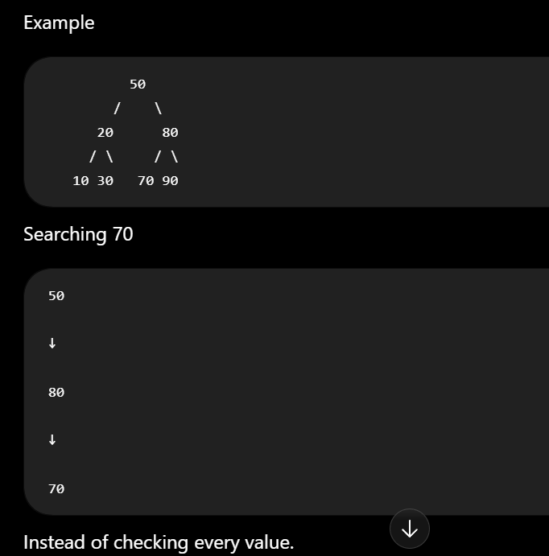
What is B+ Tree?
B+ Tree is an improved version of the B-Tree.
The biggest difference is:
Only the leaf nodes store the actual data.
The internal nodes store only keys (used for navigation).

91. What is a View in DBMS?
Definition
A View is a virtual table created from one or more existing tables.
It does not store data itself. It displays data from the original table whenever you query it.
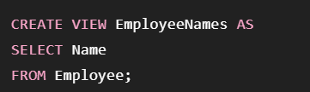
92. What is the Difference Between a View and a Table?
Answer
Table | View
Stores actual data | Usually stores only the SQL query
Occupies physical storage | Usually requires little additional storage
Can exist independently | Depends on underlying table(s)

93. What is a Stored Procedure?
Answer
A Stored Procedure is a collection of SQL statements stored in the database that can be executed whenever needed.
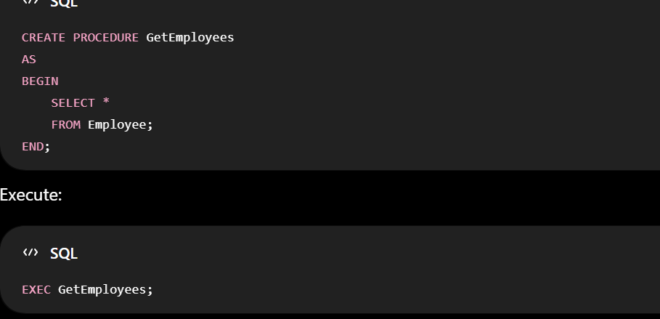
94. What is a Trigger?
Answer
A Trigger is a special type of stored program that automatically executes when a specific database event occurs.
Events include:
- INSERT
- UPDATE
- DELETE

95. What is a Cursor?
Answer
A Cursor is a database object used to process query results one row at a time.
It is useful for row-level operations but is generally slower than set-based SQL."
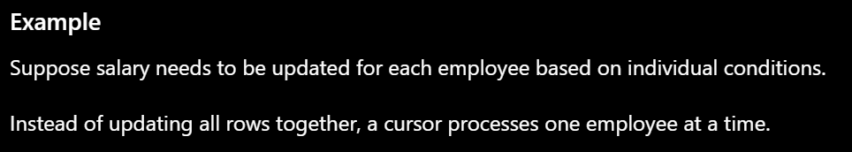

96. Difference Between Procedure and Function
Procedure | Function
May return zero, one, or many values | Must return one value
Called using EXEC | Used inside SQL expressions
Can perform INSERT/UPDATE/DELETE | Mainly computes and returns a value
Used for business logic | Used for calculations

97. What is a Sequence?
"A Sequence is a database object that automatically generates unique numeric values, commonly used for primary keys."

98. What is Database Partitioning?
Answer
Partitioning divides a large table into smaller, manageable parts called partitions.
The table appears as a single table to users, but internally the data is stored in separate partitions.
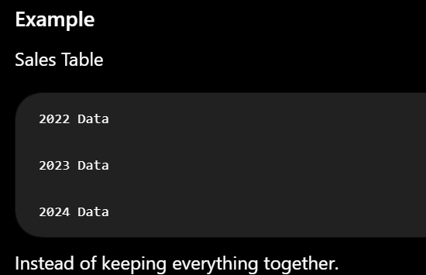
99. What is Database Replication?
Replication means copying the same database to multiple servers.w
Advantages
- High availability
- Backup

100. What are Database Sharding and Database Clustering?
Database Sharding
Sharding means splitting data across multiple servers.
Each server stores only a part of the data.
Purpose: Distribute data to handle very large databases and high traffic.

Database Clustering
Clustering means multiple servers work together as a single database system.
Each server can help process requests, and if one fails, another continues the work.
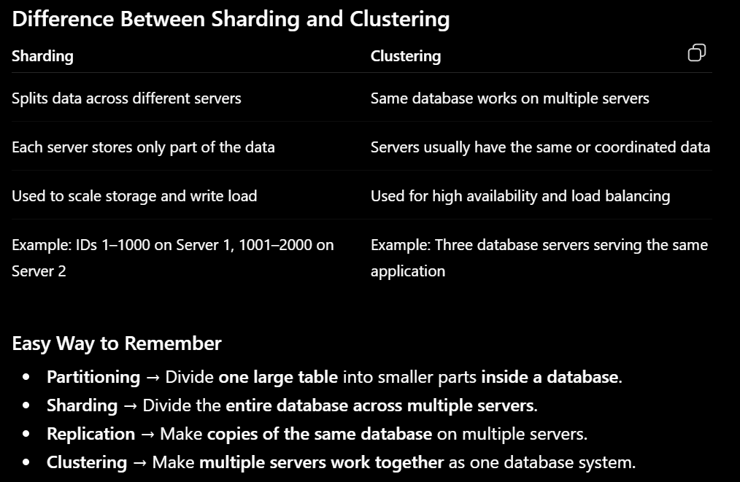

1. What is Denormalization, and when would you use it?
Denormalization is the process of combining the data to improve query performance

3. What is Concurrency Control, and why is it needed?
Concurrency control manages multiple transactions executing at the same time

4. What is a Schedule in DBMS?
A schedule is the order in which the operations of multiple transactions are executed.
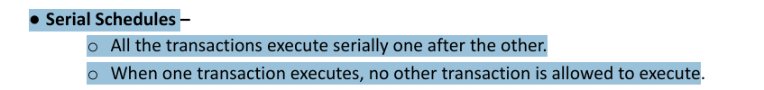\ 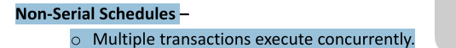
7. What is the difference between 2-Tier and 3-Tier Database Architecture?
2-Tier Architecture
There are generally two layers: Client and Application
The client communicates directly with the database.
Example
A desktop application directly connecting to MySQL or SQL Server.
3-Tier Architecture
Frontend ↓ Backend/API ↓ Database

8. What is the CAP Theorem?
CAP theorem applies primarily to distributed databases/systems.
CAP stands for:
- C — Consistency
- A — Availability
- P — Partition Tolerance(The applications will be still available even there is a small fault)

9. Explain Database Replication and its Types
What is Database Replication?
Database replication is the process of maintaining multiple copies of data in different servers

2. What is a Self-Join, and when would you use one?
A self-join is when a table is joined with itself.
It is useful when rows in the same table have a relationship with other rows in that same table.

3. What is a Subquery? Correlated vs Non-correlated Subquery
What is a Subquery?
A subquery is a query written inside another SQL query.
Non-Correlated Subquery
A non-correlated subquery is independent of the outer query.
It can execute independently.
Correlated Subquery
A correlated subquery depends on a value from the outer query.

5. What is the use of the PARTITION BY clause?
PARTITION BY divides the result into logical groups called partitions.
So that window function can be applied to each partition separately and perform calculations

6. How would you optimize a slow-running SQL query?
3. Improve Indexing Strategy
I will improve my indexing strategy by adding indexes to the columns
"I'll create an index."
Step 3: Retrieve only required columns

7. Explain OLTP vs OLAP
These are very important database concepts.
OLTP
OLTP = Online Transaction Processing
OLTP systems are designed to handle day-to-day transactions.
Examples:
- Banking transactions
- Online shopping

OLAP
OLAP = Online Analytical Processing
OLAP systems are designed for analysis and reporting.
Examples:
- Sales analysis
- Customer behavior analysis
- Trend analysis

- SQL Query Execution Order ⭐⭐⭐
FROM->WHERE->GROUP BY->HAVING->SELECT->ORDER BY->LIMIT

Explain ISNULL(), COALESCE(), and NULLIF()
These functions deal with NULL, but they work differently.

ISNULL()
ISNULL() is used to replace NULL with another value.
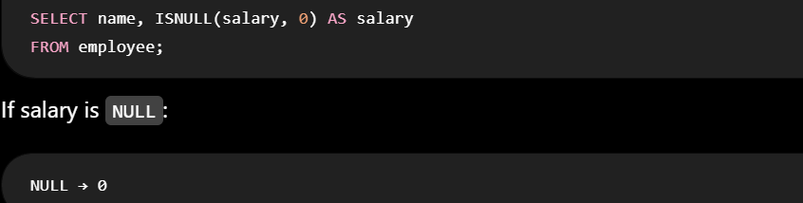
3. COALESCE()
COALESCE() returns the first non-NULL value from multiple values.
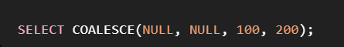
4. NULLIF()
NULLIF() does almost the opposite of ISNULL().
It returns NULL when two values are equal.


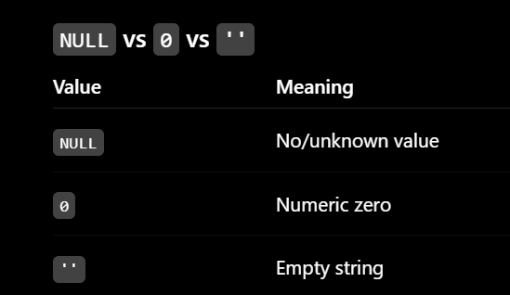
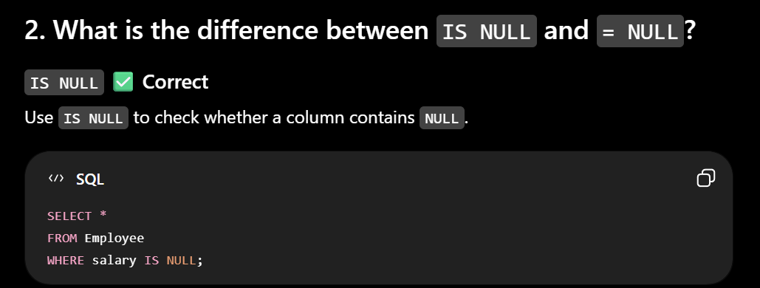
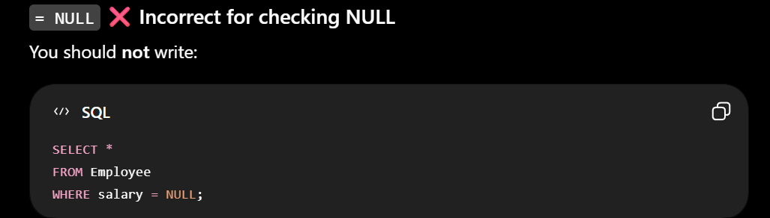
5. Difference between IN and BETWEEN
IN
IN checks whether a value exist in the sequence
BETWEEN
BETWEEN checks whether a value falls within a range.

6. Difference between LIKE and =
=
= is used for exact matching.

LIKE
LIKE is used for pattern matching.
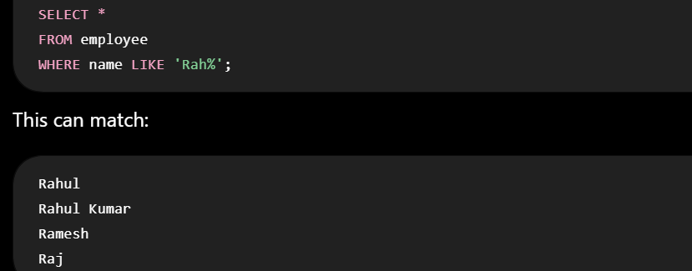

7. What are % and _ in SQL?
These are wildcards used with LIKE.
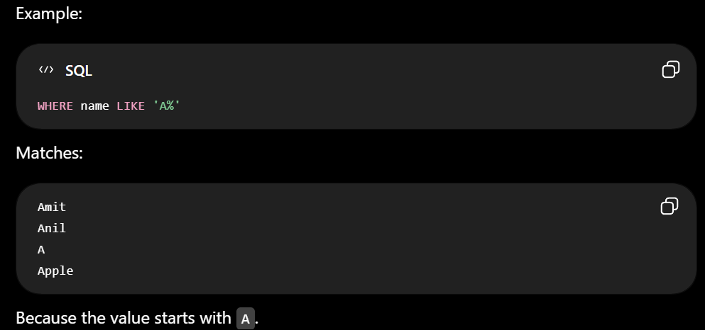
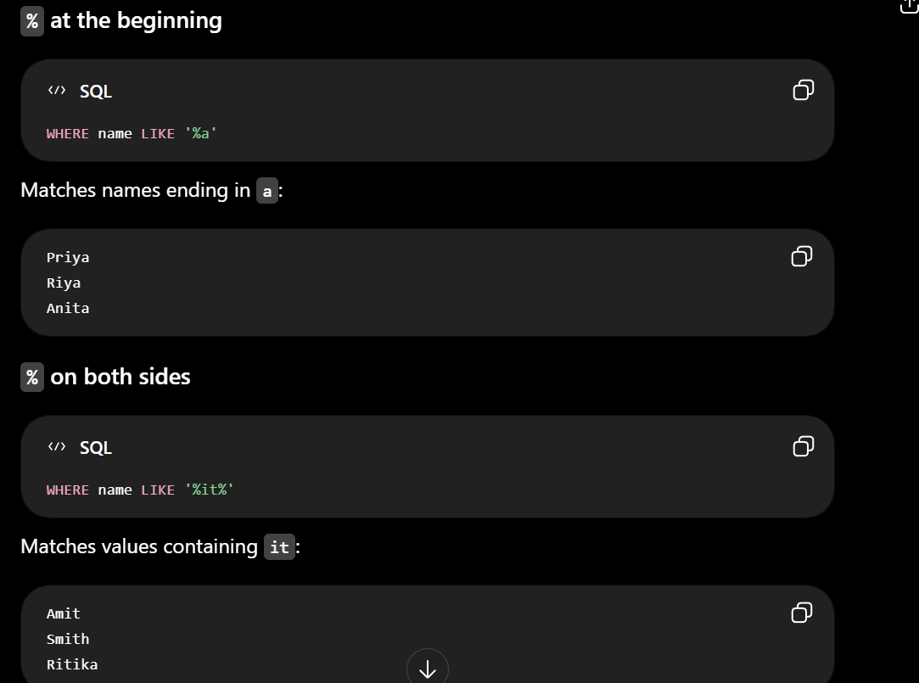
8. _ wildcard
_ means:
Exactly one character
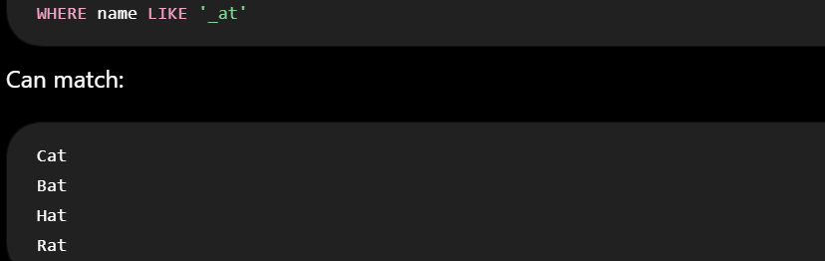
1. Can a foreign key contain NULL?
✅ Yes
A foreign key column can contain NULL if the column is not defined as NOT NULL
2. Can a foreign key reference a Primary key?
✅ Yes
A foreign key does not always have to reference a primary key.

1. What are Date and Time Functions in SQL?
Date and Time functions are built-in SQL functions used to work with dates and times
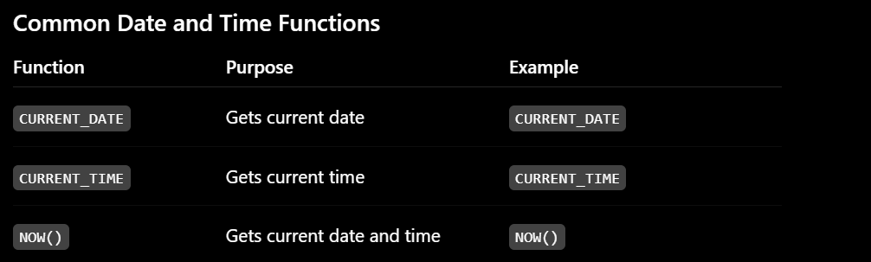
2. What are Common String Functions in SQL?
String functions are SQL functions used to manipulate and work with string values.
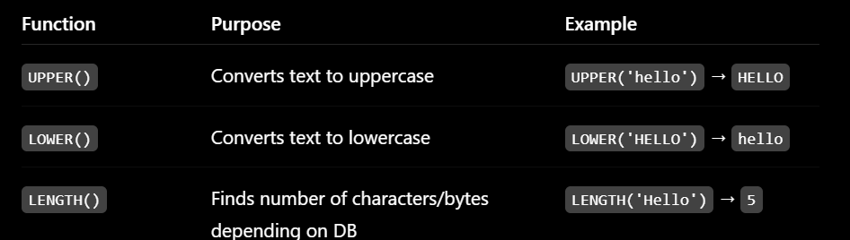
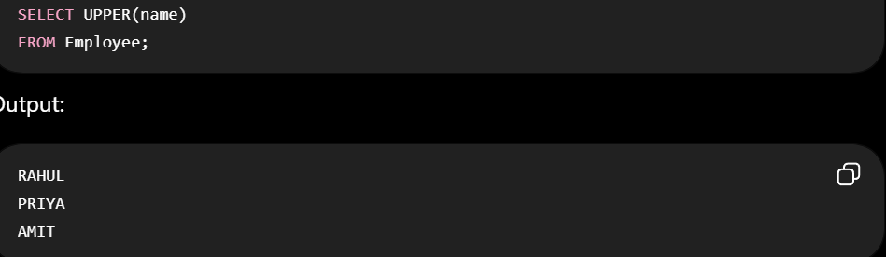
1. What are SQL Isolation Levels?
1. READ UNCOMMITTED
2. READ COMMITTED
3. REPEATABLE READ
4. SERIALIZABLE

1. READ UNCOMMITTED
This is the lowest isolation level.
A transaction can read data that another transaction has changed but not committed yet.
Therefore, Dirty Reads are possible.
Ex:A Transcation can be rolled back after updated since it was not commited
2. What is a Dirty Read?
A Dirty Read occurs when one transaction reads data that another transaction has modified but not yet committed.

2. READ COMMITTED
A transaction can read only committed data.
So dirty reads are prevented.

3. What is a Non-Repeatable Read? ⭐⭐⭐⭐⭐
A Non-Repeatable Read occurs when a transaction reads the same row twice(before commit and after commit) and gets different values

3. REPEATABLE READ
The transaction reads the same value twice because the database doesn’t allow to update the value till some time
4. What is a Phantom Read? ⭐⭐⭐⭐⭐
A Phantom Read occurs when a transaction executes the same query twice and the second execution returns a different set of rows because another transaction inserted, deleted,
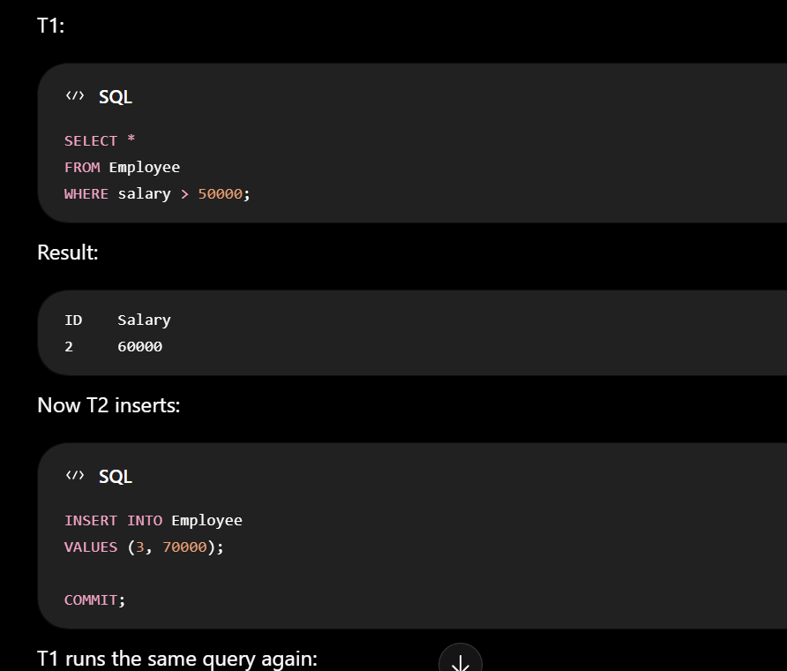
4. SERIALIZABLE
This is the highest standard isolation level.
Transactions behave as though they were executed one after another, rather than concurrently.

5. What is a Shared Lock and Exclusive Lock? ⭐⭐⭐⭐
Locks are mechanisms used by DBMSs to control concurrent access to data.
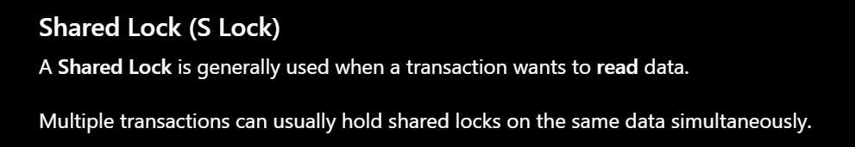
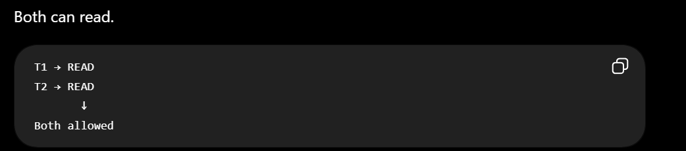
Exclusive Lock (X Lock)
An Exclusive Lock is generally used when a transaction wants to modify data.
UPDATE
DELETE
INSERT
An exclusive lock prevents conflicting access by other transactions.

6. Optimistic vs Pessimistic Concurrency Control ⭐⭐⭐⭐
Both are techniques for handling concurrent transactions.

Pessimistic Concurrency Control
Uses locks for each transcation(Read/Write)
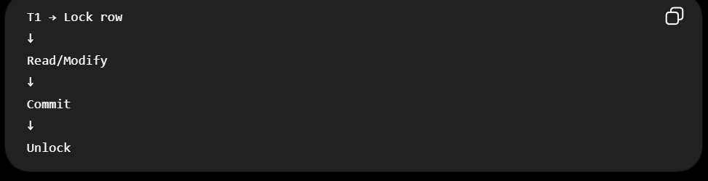
Optimistic Concurrency Control
Transactions can work without holding traditional locks for the entire operation but rollbacks when conflicts arises
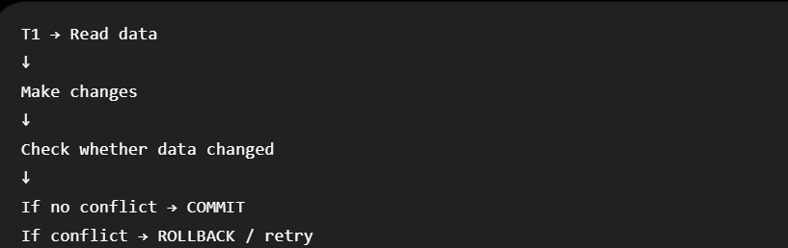

- What are LAG() and LEAD() window functions?
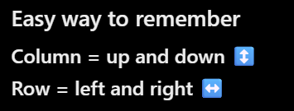
1. LAG() Function
- LAG() looks backward to access data from a previous row.
2. LEAD() Function
LEAD() looks forward and access the data next consecutive rows
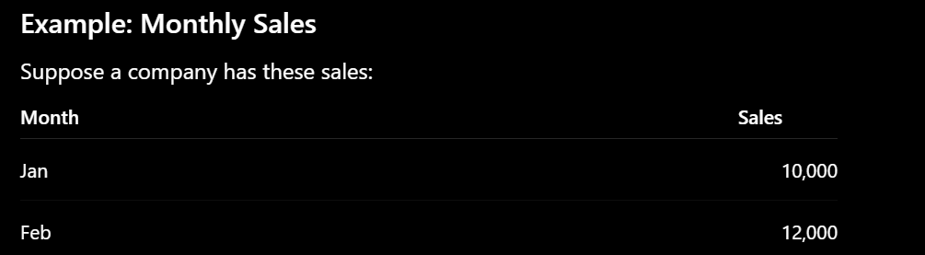
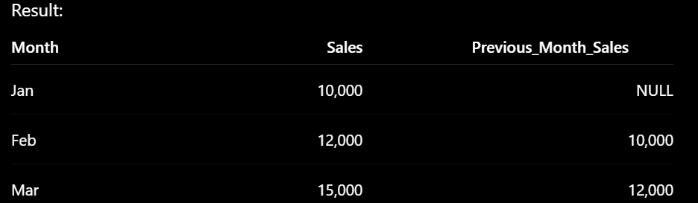
What is a CTE (Common Table Expression)?
A CTE(Common Table Expression) is the temporary result query that we create at the beginning of a query and then use in the main query.
We create Common Table Expression using with keyword

Need for Common Table Expression:
🔄 Reusability within the Same Query
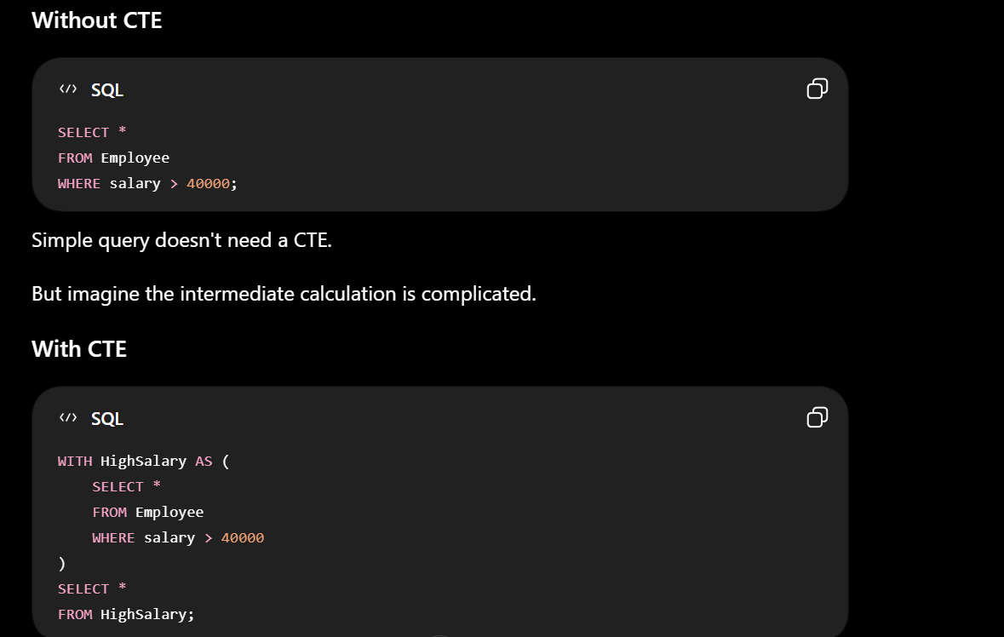
Common Table expression is useful in complex calculations.

What is the Two-Phase Locking (2PL) protocol and Strict 2PL?

