ARRAYS
1. What is an Array?
An array is a mutable data structure that stores the same type in a continuous memory location
Arrays supports indexing
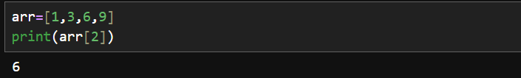

2. Array vs Linked List
Array | Linked List
Elements are stored contiguously in traditional arrays | Nodes can be stored at different memory locations
Fast random access | Sequential access
Access by index: O(1) | Access by position: O(n)

3. Static Array vs Dynamic Array
Static Array
A static array has a fixed size.
Once its size is determined, it cannot normally be changed.

Dynamic Array
A dynamic array can grow or shrink as needed.
Examples:
- Python list

4. What are the Advantages and Disadvantages of Arrays?
1. Fast access(This is O(1))
5. What is the Time Complexity of Common Array Operations?
HASHING
16. What is Hashing?
Hashing is a technique used to store and retrieve data quickly using a hash function.
How Hashing works:
• The key is given to a hash function.
• The hash function generates a hash value.
• The hash value is mapped to an index in the table.
• The data is stored at that index.
• During searching, the same process is used to find the data quickly.

Average time complexity for insertion, search, and deletion is O(1).

7. What is a Hash Table?
A hash table is a data structure that stores data in key-value pairs using a hash function.

19. What is a Hash Function?
A hash function is a function that converts a key into a hash value, which is used to determine the storage location in a hash table.

20. What is a Collision in Hashing?
A collision occurs when two different keys produce the same hash table index.

21. How are Collisions Handled?
The two common techniques for handling collisions are:
1. Chaining
Multiple elements are stored at the same index using a linked list or another collection.
2. Open Addressing
If the desired position is occupied, another empty position is searched.

22. What is the Difference Between a Hash Map and a Hash Set?
Both are data structures
HashMap stores data as key-value pairs
HashSet stores only unique individual elements

4. Linked List ⭐⭐
- What is a linked list?
- Array vs Linked List?
- What are the types of linked lists?
- How do you traverse a linked list?

27. What is a Linked List?
A linked list is a linear data structure where elements are stored in nodes, and each node contains:
- Data – the actual value.
- Link/Pointer – the address/reference of the next node.

28. Array vs Linked List
Feature | Array | Linked List
Memory | Contiguous | Non-contiguous
Access | Fast — O(1) | Slow — O(n)

Contiguous memory allocation in an array means that all the elements of the array are stored in a single, unbroken block of physical memory

29. What are the types of Linked Lists?
There are mainly three types:
1. Singly Linked List
Each node points only to the next node.
2. Doubly Linked List
Each node has two references:
- Previous node
- Next node

3. Circular Linked List
The last node points back to the first node instead of pointing to None.

30. How do you traverse a Linked List?
Traversal means visiting each node one by one, starting from the head.
How it works
- Start with the head.
- Access the current node's data.
- Move to the next node using current.next.
- Continue until current becomes None.
Time complexity: O(n) because we may need to visit every node.

5. Stack & Queue ⭐⭐
- What is a stack?
- What is a queue?
- Stack vs Queue?
- What are the applications of a stack?
- What are the applications of a queue?
- What is LIFO and FIFO?

34. What is a Stack?
A stack is a linear data structure which follows LIFO — Last In, First Out rule
Insertion and deletion happen from the same end, called the top.
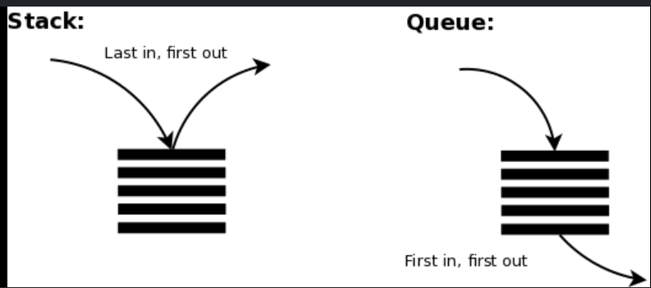
Common operations:
- Push → Add an element
- Pop → Remove the top element
- Peek/Top → View the top element without removing it

35. What is a Queue?
A queue is a linear data structure which follows FIFO — First In, First Out rule
Elements are inserted from the rear and removed from the front.
Common operations:
- Enqueue → Add an element to the rear
- Dequeue → Remove an element from the front
- Peek → View the rear element
- Front → View the front element

36. Stack vs Queue
Feature | Stack | Queue
Principle | LIFO | FIFO
Insertion | Top | Rear
Deletion | Top | Front
Main operation | Push / Pop | Enqueue / Dequeue
Example | Stack of plates | People waiting in a line

37. What are the applications of a Stack?
Undo/Redo operations
Browser history
- Back/forward navigation can be implemented using stacks.

38. What are the applications of a Queue?
CPU scheduling and Printer queue
7. Trees — Basic ⭐
- What is a tree?
- What is a binary tree?
- What is a Binary Search Tree (BST)?
- Binary Tree vs BST?
- What are inorder, preorder, and postorder traversals?
- What is the difference between BFS and DFS?

51. What is a Tree?
A tree is a non-linear hierarchical data structure consisting of nodes connected by edges
52. What is a Binary Tree?
A binary tree is a tree in which each node can have at most two children.
The two children are called:
- Left child
- Right child

53. What is a Binary Search Tree (BST)?
A Binary Search Tree, or BST, is a binary tree that follows a specific ordering rule.
For every node:
Left subtree < Node < Right subtree

55. What are Inorder, Preorder, and Postorder Traversals?
These are DFS-based tree traversal methods.
1. Inorder Traversal
Order:
Left → Root → Right
2. Preorder Traversal
Order:
Root → Left → Right
3. Postorder Traversal
Order:
Left → Right → Root

1. What is a Graph? What are its Types?
A graph is a non-linear data structure consisting of vertices and edges
Types of Graphs
1. Directed Graph
In a directed graph, edges have a specific direction.
2. Undirected Graph
In an undirected graph, edges have no direction.
3. Weighted Graph
Edges have a weight or cost.
4. Unweighted Graph
Edges don't have any weight.

3. What is BFS? How does it work?
BFS = Breadth-First Search(Traversal mechanism)
BFS visits nodes level by level.
It uses a queue.

4. What is DFS? How does it work?
DFS = Depth-First Search
DFS explores a path as deeply as possible before backtracking.
It uses a stack

5. BFS vs DFS — Difference and When to Use Each?
Feature | BFS | DFS
Full form | Breadth-First Search | Depth-First Search
Approach | Level by level | Depth first
Data structure | Queue | Stack / Recursion

Time & Space Complexity — Interview Answers
1. What is Time Complexity?
Time complexity describes how the execution time of an algorithm grows as the input size increases.
For example:
- Accessing an array element → O(1)
- Linear search → O(n)

2. What is Space Complexity?
Space complexity describes how much additional memory an algorithm requires as the input size increases.

3. What is Big O Notation?
Big O notation describes the upper-bound growth rate of an algorithm's time or space requirements as the input size becomes large.
Complexity | Name | Example
O(1) | Constant | Array access
O(log n) | Logarithmic | Binary search
O(n) | Linear | Single loop
O(n²) | Quadratic | Nested loops
O(2ⁿ) | Exponential | Some recursive algorithms

4. Difference Between Best, Average, and Worst-Case Complexity
These describe how an algorithm behaves for different types of inputs.
Best Case
The minimum amount of time/space the algorithm needs for a particular input.
Average Case
The expected amount of time/space for typical inputs.
Worst Case
The maximum amount of time/space the algorithm may need for an input.

5. What is the Time Complexity of Accessing an Array Element?
Accessing an element by index is:
O(1) — Constant time

1. What are Render and Vercel, and why did you use them in your project?
Render and Vercel are cloud platforms used to deploy applications.
I used Render to deploy my backend because it supports backend services such as FastAPI, and I used Vercel to deploy my frontend because it is well suited for frontend applications

3. How did you deploy your backend on Render?
My steps were:
- I pushed my backend code to GitHub.
- I created a new Web Service on Render.
- I connected my GitHub repository.
- I selected the appropriate Python environment.
- I configured the build/install command to install dependencies.
- I configured the start command to run my FastAPI application using Uvicorn.
- I added required environment variables/API keys in Render.
- Render built and deployed the application.
- I tested the deployed API using its public URL.

4. How did you deploy your frontend on Vercel?
My steps were:
- I pushed the frontend code to GitHub.
- I imported the GitHub repository into Vercel.
- Vercel detected the frontend framework and configured the build settings.
- I added the backend API URL as an environment variable.
- Vercel built the frontend.
- After successful deployment, Vercel provided a public URL.
- I tested the frontend and verified that it could communicate with the deployed backend.

5. What deployment problems did you face, and how did you solve them?
A few common problems I faced during deployment were environment variables, CORS error

