1. What is SDLC? Explain all phases of the Software Development Life Cycle.
SDLC (Software Development Life Cycle) is a systematic process used to develop, test, deploy, and maintain software.
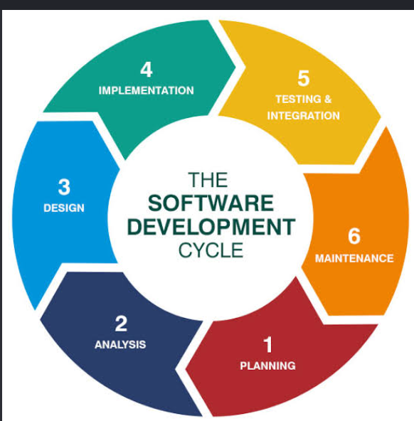
• Requirement Analysis
- The team collects and understands the customer's requirements.
- Example: For an online shopping application, requirements may include login, product search, cart, payment, and order tracking.
• Planning
- The team decides the resources, budget, timeline, technologies, and people required for the project.
• Design
- The architecture and design of the software are created.
- This includes database design, UI design, system architecture, APIs, etc.
• Development / Implementation
- Developers write the actual code based on the design and requirements.
• Testing
- Testers check the software for bugs and verify that it works according to the requirements.
- Examples include unit testing, integration testing, system testing, and acceptance testing.
• Deployment
- The completed software is released to users or deployed to the production environment.
• Maintenance
- After deployment, the team fixes bugs, improves performance, adds new features, and updates the software.

2. What is the difference between Waterfall and Agile methodologies?
"Waterfall is a sequential development methodology where each phase is completed before moving to the next phase. It works well when requirements are stable and clearly defined.
Agile is an iterative methodology where software is developed and delivered in small increments called sprints.

CLOUD COMPUTING
1. What is Cloud Computing? What are its advantages?
Answer
Cloud computing is the technology used to deliver resources such as computation power, storage, and software over the Internet
The cloud companies manages all the underlying infrastructure

2. What are IaaS, PaaS, and SaaS?
These are the three main cloud service models.
1. IaaS — Infrastructure as a Service
The cloud provider gives us infrastructure, such as virtual machines, storage, and networking.
Ex: AWS EC2
2. PaaS — Platform as a Service
The cloud provider manages the infrastructure and platform, and we mainly focus on deploying our application.
Ex: Azure App Service
3. SaaS — Software as a Service
A complete software application is provided through the Internet.
We simply use the software instead of managing the infrastructure.
Examples:
- Gmail
- Google Docs

4. What is a Virtual Machine and what is a Container?
Virtual Machine (VM)
A virtual machine is a virtual computer that runs its own operating system on a physical machine.
It provides computing power and storage virtually
5. What is Load Balancing? Why is it used in Cloud Computing?
Answer
A load balancer distributes incoming network requests across multiple servers so that no single server becomes overloaded.

FastAPI and MongoDB
1. What are Status Codes and How Do You Return Custom Status Codes in FastAPI?
What are HTTP Status Codes?
HTTP status codes are three-digit codes returned by a server to indicate the result of an HTTP request.

200 OK:The request is processed and the server is returning the response for the request
201 Created:The POST request is successfully executed and new resource is created
202 Accepted:The request is received but haven't processed yet!
400 Bad Request-400 means the server cannot process the request because the request is invalid or malformed.
401 Unauthorized--401 means the client is not authenticated.
403 means the user is authenticated but does not have permission to access the resource.(authorized)
404 Resource Not Found—Requested resource doesn’t exist or not found
500—Internal Server Error—Failed to process business logic

1. What is JWT?
JWT (JSON Web Token) is a compact token used to securely transfer information between a client and a server.
5. What is Rate Limiting?
Rate limiting controls how many requests a client can make to an API within a specific period.

1. How do you improve API performance?
2. Optimize database queries
5. Use asynchronous programming

