Top 100 Machine Learning Interview Questions
1. Machine Learning Basics (1–15)
- What is Machine Learning?
- What are the different types of Machine Learning?
- What is the difference between AI, Machine Learning, and Deep Learning?
- What are supervised, unsupervised, semi-supervised, and reinforcement learning?
- What is a machine learning model?
- What is training data and testing data?
- What is feature engineering?
- What is a feature and a label?
- What is overfitting?
- What is underfitting?
- What is bias and variance?
- What is the bias-variance tradeoff?
- What is cross-validation?
- What is the difference between parametric and non-parametric models?
- What are the steps in a Machine Learning pipeline?

2. Data Preprocessing (16–30)
- Why is data preprocessing important?
- How do you handle missing values?
- What are outliers, and how do you handle them?
- What is feature scaling?
- What is normalization?
- What is standardization?
- What is one-hot encoding?
- What is label encoding?
- What is ordinal encoding?
- What is data imbalance?
- How do you handle imbalanced datasets?
- What is train-test split?
- Why do we shuffle data before training?
- What is data leakage?
- What is data augmentation?

3. Regression Algorithms (31–40)
- What is Linear Regression?
- What assumptions does Linear Regression make?
- What is Multiple Linear Regression?
- What is Polynomial Regression?
- What is Ridge Regression?
- What is Lasso Regression?
- What is Elastic Net Regression?
- What is the difference between Ridge and Lasso Regression?
- What evaluation metrics are used for regression?
- What is R² Score?

4. Classification Algorithms (41–55)
- What is Logistic Regression?
- Why is Logistic Regression called regression despite being a classification algorithm?
- What is the sigmoid function?
- What is the decision boundary?
- What is K-Nearest Neighbors (KNN)?
- What are the advantages and disadvantages of KNN?
- What is Naive Bayes?
- What is Bayes' Theorem?
- What are the types of Naive Bayes?
- What is Support Vector Machine (SVM)?
- What is the kernel trick in SVM?
- What are different kernel functions?
- What is margin in SVM?
- What is multiclass classification?
- What evaluation metrics are used for classification?

5. Decision Trees & Ensemble Learning (56–65)
- What is a Decision Tree?
- How does a Decision Tree split data?
- What is entropy?
- What is Gini Index?
- What is Information Gain?
- What is Random Forest?
- How does Random Forest reduce overfitting?
- What is Bagging?
- What is Boosting?
- What is XGBoost?

6. Clustering & Unsupervised Learning (66–75)
- What is clustering?
- What is K-Means clustering?
- How do you choose the value of K?
- What is the Elbow Method?
- What is Silhouette Score?
- What is Hierarchical Clustering?
- What is DBSCAN?
- What is Principal Component Analysis (PCA)?
- Why is dimensionality reduction important?
- What is t-SNE?

7. Model Evaluation & Metrics (76–85)
- What is a Confusion Matrix?
- What is Accuracy?
- What is Precision?
- What is Recall?
- What is F1 Score?
- What is ROC Curve?
- What is AUC?
- When is accuracy not a good metric?
- What is Mean Absolute Error (MAE)?
- What is Root Mean Squared Error (RMSE)?

8. Advanced Machine Learning Concepts (86–95)
- What is Gradient Descent?
- What are the types of Gradient Descent?
- What is the learning rate?
- What are activation functions?
- What is regularization?
- What is dropout?
- What is hyperparameter tuning?
- What is Grid Search?
- What is Random Search?
- What is Bayesian Optimization?

9. Practical & Interview-Based Questions (96–100)
- How would you choose the right Machine Learning algorithm for a problem?
- How would you handle a dataset with millions of records?
- Describe a Machine Learning project you have worked on.
- How do you deploy a Machine Learning model into production?
- What challenges did you face in your Machine Learning projects, and how did you solve them?

1. Machine Learning Basics (1–15)
1. What is Machine Learning?
Definition:
Machine Learning (ML) is a branch of Artificial Intelligence (AI) where we train AI Model on massive data to learn patterns and make predictions without being explicitly programmed.

2. What are the different types of Machine Learning?
There are three main types:
Type | Description | Example
Supervised Learning | Learns using labeled data | Predicting house prices
Unsupervised Learning | Learns from unlabeled data | Customer segmentation
Reinforcement Learning | Learns through rewards and penalties | Robot learning to walk

3. Difference between AI, ML, and Deep Learning?
AI is field where we develop intelligent machines
ML is Subset of AI where models learn pattern from data and predict outcomes
DL is a subset of ML where model uses neutral networks to learn from data and predict
Example
- AI: Voice assistant like Siri
- ML: Predicts insurance cost
- DL: Recognizes faces in photos

4. What is Supervised Learning?
Definition:
Supervised learning is a type of ML where the model learns using labeled data (input and correct output are provided).
Applications
- House price prediction
Popular Algorithms
- Linear Regression
- Logistic Regression
- Decision Tree

5. What is Unsupervised Learning?
Definition:
Unsupervised learning is a type of ML where the model learnunlabeled data. The model finds hidden patterns or groups on its own.
Applications
- Customer segmentation
- Anomaly detection
Popular Algorithms
- K-Means
- Hierarchical Clustering

6. What is Reinforcement Learning?
Definition:
Reinforcement learning is a type of ML where an agent learns the patterns using trail and error method.

7. What is a Training Dataset?
Definition:
The training dataset is the data used to train the machine learning model.

8. What is a Testing Dataset?
Definition:
The testing dataset is used to evaluate the final performance of a trained model

9. What is a Validation Dataset?
Definition:
The validation dataset is used during training to tune the model's hyperparameters and choose the best model.
Hyperparameters are configuration settings that you choose before training a machine learning model(Learning rate)
Parameters: Learned by the algorithm from data; update automatically during training(Weights,Bias)
Example
Suppose you are trying different Decision Tree depths:
- Depth = 3
- Depth = 5
- Depth = 10
You train on the training data and use the validation data to see which depth performs best.
After selecting the best depth, you evaluate the final model on the test data.
Usually: 10–15% of the data is used for validation.

10. Why do we split data into train, validation, and test sets?
Splitting ensures the model learns well, is tuned properly, and is evaluated fairly.
Roles of Each Dataset
Dataset | Purpose
Training Set | Learns patterns from data
Validation Set | Tunes hyperparameters and selects the best model
Testing Set | Measures final performance on unseen data

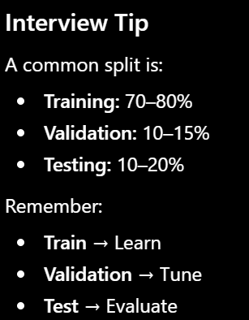
11. What is a Feature?
Definition
A feature is an input variable (column) used by a machine learning model to make predictions.
• Hours Studied → Feature
• Attendance → Feature
• Previous Marks → Feature
• Final Marks → Target (Output)

12. What is a Target (Label)?
Definition
The target (also called label or output variable) is the value the model tries to predict.

13. What is a Model?
Definition
A Model can be defined as system which learns the relationship between features and target.
14. What is Inference in ML?
Definition
Inference is the process of using a trained model to make predictions on new, unseen data.
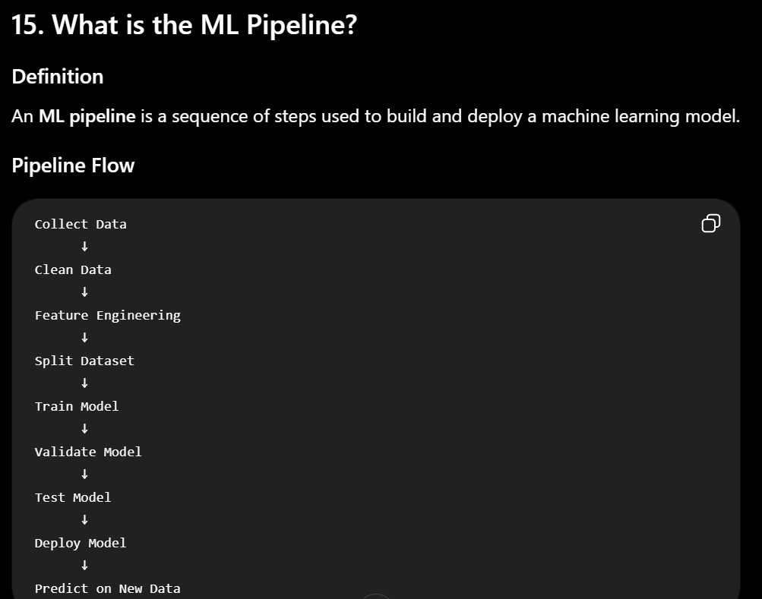

2. Data Preprocessing (16–30)
16. Why is Data Preprocessing Important?
Definition
Data preprocessing is the process of removing all the inconsistencies and preparing raw data to training dataset
Why is it Important?
- Improves model accuracy.

17. How do you Handle Missing Values?
Definition
Missing values are empty or unknown values in a dataset.
Example
Methods
1. Remove Rows
- Suitable if only a few records have missing values.
2. Remove Columns
- If a column has too many missing values.
3. Fill with Mean
- Best for numerical data without many outliers.
4. Fill with Median
- Best for skewed data or data with outliers.
5. Fill with Mode
- Best for categorical data.

18. How do you Handle Duplicate Data?
Definition
Duplicate data means the same record appears more than once.
Common Method
Use tools like Pandas drop_duplicates() (in Python) or SQL queries to remove duplicate rows.

19. How do you Detect Outliers?
Definition
An outlier is a data point that is very different from the rest of the data.
Outliers can be detected using Box Plots or Z-Score analysis.

Common Methods
1. Box Plot
- Values outside the whiskers are potential outliers.
3. Z-Score
- Measures how many standard deviations a value is from the mean.

20. How do you Handle Outliers?
Outliers can be handled by removing them, replacing them with suitable values like mean,mode, transforming the data, or using algorithms that are less affected by outliers.
• Decision Trees
• Random Forest

What is Multicollinearity?
Multicollinearity occurs when two or more independent (input) variables in a regression model are highly correlated with each other.
How Do You Detect Multicollinearity?
1. Correlation Matrix
How to Fix It
Drop Redundant Features
21. What is Feature Engineering?
Feature Engineering is the process of transforming raw data into numerical data so that models can understand.
21. What is Feature Scaling?
Definition
Feature Scaling is the process of bringing all numerical features to a similar scale or range.
It ensures that no feature dominates others because of its larger values.
Age | Salary
25 | 30,000
35 | 50,000
45 | 80,000
Here:
- Age ranges from 25–45
- Salary ranges from 30,000–80,000
Since salary values are much larger, some ML algorithms may give more importance to salary than age.
After Scaling
Age | Salary
0.0 | 0.0
0.5 | 0.4
1.0 | 1.0
Now both features have a similar scale.
Why is Feature Scaling Important?
- Improves model accuracy.

Algorithms that Need Scaling
- KNN
- K-Means
- Logistic Regression
- Linear Regression
Algorithms that Do NOT Usually Need Scaling
- Decision Tree
- Random Forest

What is Standardization in Machine Learning?
Standardization is a feature scaling technique that transforms data so that it has:
- Mean = 0
- Standard Deviation = 1
This ensures that all features are on a similar scale,
24. What is StandardScaler?
Definition
StandardScaler is a preprocessing tool in Python's Scikit-learn library used to standardize numeric features
It transforms data so that:
- Mean = 0
- Standard Deviation = 1

22. Difference Between Normalization and Standardization?
Normalization | Standardization
Scales values between 0 and 1 | Converts data to mean = 0 and standard deviation = 1
Uses Min-Max formula | Uses Z-score formula

23. What is Min-Max Scaling?
Definition
Min-Max Scaling is a normalization technique that converts data into the range 0 to 1.

25. What is Label Encoding?
Definition
Label Encoding converts categorical values into integers.
Color | Encoded
Red | 0
Blue | 1
Green | 2

26. What is One-Hot Encoding?
Definition
One-Hot Encoding converts each category into a separate binary (0/1) column.
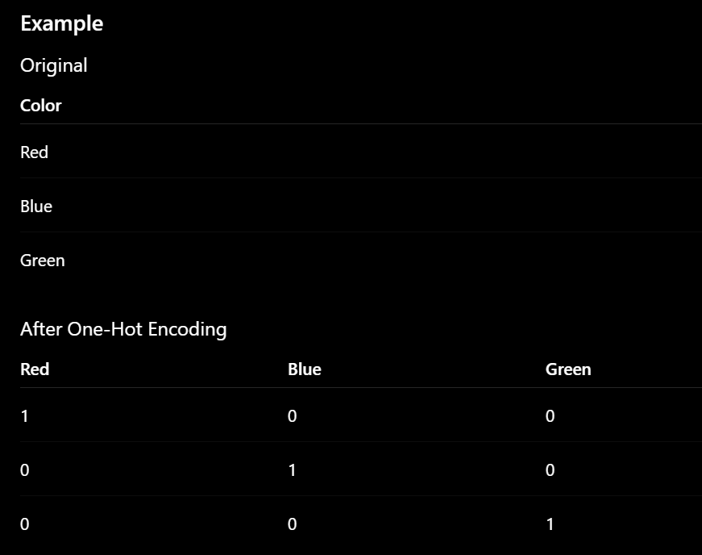

27. Difference Between Label Encoding and One-Hot Encoding?
Label Encoding | One-Hot Encoding
Converts categories into integers | Converts categories into binary columns
Creates one column | Creates multiple columns
Memory efficient | Uses more memory

1. What is the difference between Parametric and Non-Parametric Models?
Parametric Models
Definition
Parametric models have a fixed number of parameters(weights,bias) regardless of the size of the dataset.
Examples
- Linear Regression
- Logistic Regression
Non-Parametric Models
Definition
Non-parametric models do not assume a fixed number of parameters. Their complexity can grow as more training data is provided.
Examples
- Decision Tree
- Random Forest
Advantages
- Can learn complex patterns

3. What is Data Imbalance?
Definition
A dataset is imbalanced when one class has many more samples than another class.

Example
Disease Detection
Class | Samples
Healthy | 990
Disease | 10
The model may predict Healthy for everyone and still achieve high accuracy.

4. How do you handle Imbalanced Datasets?
Several techniques can be used.
1. Oversampling
Increase minority class samples.
2. Undersampling
Reduce majority class samples.
3. Class Weights
Assign higher importance to minority class during training.

5. What is Train-Test Split?
Definition
Train-Test Split divides the dataset into:
- Training Set → Used to train the model.
- Testing Set → Used to evaluate the model.
The train_test_split function from Scikit-Learn (sklearn) divides a dataset into separate subsets for training and testing a machine learning model.
By default, it splits the data into 75% training and 25% testing subsets

6. Why do we shuffle data before training?
Definition
Shuffling increases the randomness in the dataset so that model can learn accurate patterns.
Example
Without shuffling
Cat
Cat
Cat
Dog
Dog
Dog
The model may learn biased patterns.

7. What is Data Leakage?
Definition
Data Leakage is a situation where the model gets more information durning training than that would be available during inference
This leads to artificially high performance during training/testing, but poor performance in production.
How Do You Avoid Data Leakage?
1. Split the data first
Separate:
Training
Validation
Test
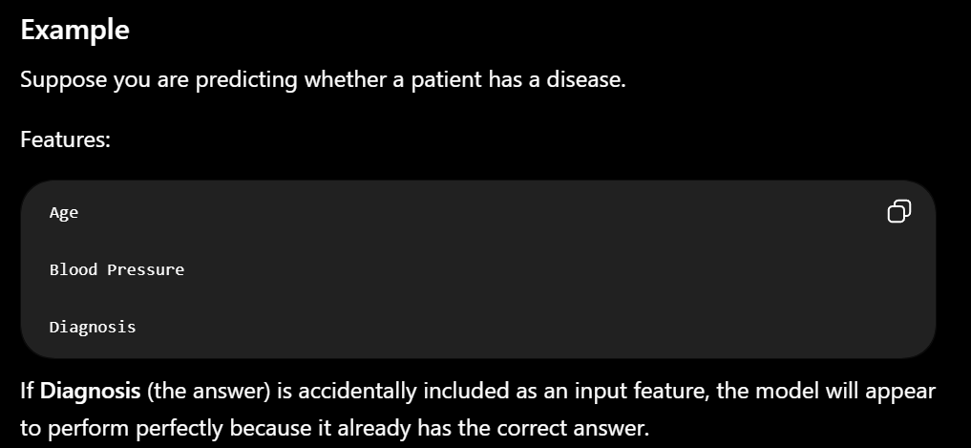
8. What is Data Augmentation?
Definition
Data Augmentation is a technique used to increase the size and diversity of a training dataset by creating modified versions of existing data.
It is commonly used in deep learning, especially for image data.

Image Examples
Original Image
↓
- Rotate
- Flip
- Zoom
- Crop

28. What is Data Cleaning?
Definition
Data cleaning is the process of identifying and removing inconsistencies in a dataset.
Common Data Cleaning Tasks
- Remove missing values.
- Remove duplicate records.
- Handle outliers.

29. What is Data Transformation?
Definition
Data transformation is the process of converting raw data into a format that is more suitable for machine learning.
Common Transformations
- Feature scaling.
- Label Encoding.
- One-Hot Encoding.

30. What is Feature Selection?
Definition
Feature selection is the process of selecting only the most important features from a dataset for model training.

3. Supervised Learning (31–45)
31. What is Regression?
Definition
Regression is a supervised machine learning technique used to predict continuous numerical values.
Examples
- Predicting house price

Common Regression Algorithms
- Linear Regression
- Decision Tree Regression
- Random Forest Regression
- Support Vector Regression (SVR)

32. What is Classification?
Definition
Classification is a supervised machine learning technique used to predict categories
The output is discrete, not continuous.
Examples
- Spam or Not Spam
- Pass or Fail

Common Classification Algorithms
- Logistic Regression
- Decision Tree
- Random Forest
- SVM
- KNN
- Naive Bayes
33. Difference Between Regression and Classification?
Regression | Classification
Predicts continuous values | Predicts categories or classes
Output is a number | Output is a label
Example: House price | Example: Spam/Not Spam
Evaluation: RMSE, MAE, R² | Evaluation: Accuracy, Precision, Recall, F1-score

- RMSE, MAE, R² → Used for Regression
- Accuracy, Precision, Recall, F1-score → Used for Classification

1. MAE (Mean Absolute Error)
Definition
MAE is the average of the absolute differences between actual and predicted values.
MAE measures average absolute errors
Formula
$$MAE=\frac{1}{n}∑∣Actual-Predicted∣$$
2. RMSE (Root Mean Squared Error)
Definition
RMSE is the square root of the average squared errors.
RMSE heavily penalizes larger errors and outliers because it squares the errors before averaging them.
Formula
$$RMSE=\sqrt{\frac{1}{n}∑(Actual-Predicted)^{2}}$$
3. R² Score (Coefficient of Determination)
R² tells how perfect the model is..
Interpretation
- 1 → Perfect prediction
- 0 → Model performs like predicting the mean
- Negative → Model is worse than predicting the mean

1. Accuracy
Definition
Accuracy is the percentage of correct predictions.
Formula
$$Accuracy=\frac{TP+TN}{TP+TN+FP+FN}$$
Example
Using the confusion matrix:
$$=\frac{40+45}{40+45+5+10}=\frac{85}{100}=85\%$$
Interpretation
Model correctly predicts 85% of the samples.

2. Precision
Definition
Precision tells how many predicted positives are actually positive.
"Out of all the emails the model flagged as spam, how many were actually spam?"
Formula
$$Precision=\frac{TP}{TP+FP}$$
Example
$$=\frac{40}{40+5}=\frac{40}{45}=88.89\%$$
Interpretation
Out of all predicted positive cases, 88.89% are truly positive.

3. Recall (Sensitivity)
Definition
Recall tells how many actual positives were correctly found.
"Out of all the actual spam emails in my inbox, how many did the model catch?"
Formula
$$Recall=\frac{TP}{TP+FN}$$
Example
$$=\frac{40}{40+10}=\frac{40}{50}=80\%$$
Interpretation
The model detected 80% of all actual positive cases.
4. F1-Score
Definition
F1-score is the harmonic mean of Precision and Recall.

34. What is Linear Regression?
Definition
Linear Regression is a supervised learning algorithm used to predict continuous values by finding the best-fit straight line between input and output.
Equation
Y = mX + c
Where:
- Y = Predicted value 28
- X = Input feature
- m = Slope of the line
- c = Intercept
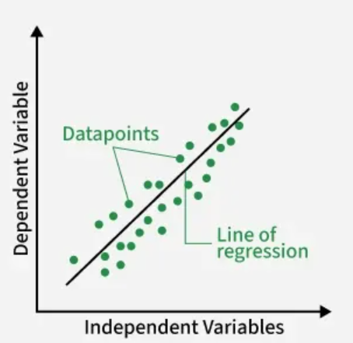
The line represents the best-fit line that minimizes prediction errors.
Applications
- House price prediction
The cost function measures the error which is the difference between actual values and predited values
$$MSE=\frac{∑(Actual-Predicted)^{2}}{n}$$
The most commonly used cost function for Linear Regression is Mean Squared Error (MSE).
• Calculates the cost.
• Calculates the gradient, which tells us the direction in which the cost increases.
• Moves the coefficients in the opposite direction.
• Repeats this process until the cost reaches or approaches its minimum.

9. What is Multiple Linear Regression?
Definition
Multiple Linear Regression predicts a continuous target variable using two or more independent variables (features).

Formula
$$Y=b_{0}+b_{1}X_{1}+b_{2}X_{2}+...+b_{n}X_{n}$$
Where:
- Y = Target variable.
- X₁, X₂, ... = Features.
- b₀ = Intercept.
- b₁, b₂, ... = Coefficients.

10. What is Polynomial Regression?
Definition
Polynomial Regression is a type of regression where the models form a non-linear relationship by adding polynomial terms.
Although the relationship is curved, the model is still linear in its coefficients.

Formula
$$Y=b_{0}+b_{1}X+b_{2}X^{2}+b_{3}X^{3}+...$$

Example
Suppose house prices increase non-linearly with area.
A straight line does not fit well, but a curve does.

11. What is Ridge Regression?
Already covered earlier.
Summary
- Uses L2 Regularization.
- Shrinks coefficient values.
- Keeps all features.

12. What is Lasso Regression?
Already covered earlier.
Summary
- Uses L1 Regularization.
- Can make some coefficients exactly 0.

13. What is Elastic Net Regression?
Already covered earlier.
Summary
- Combines L1 and L2 Regularization.

14. What is the Decision Boundary?
Definition
A Decision Boundary is the line, curve that separates different classes in a classification problem.
It defines where the model changes its prediction from one class to another.

Example
Imagine classifying emails as Spam or Not Spam.

35. What are the Assumptions of Linear Regression?
Linear Regression performs well when the following assumptions are satisfied.
1. Linear Relationship
The relationship between input and output should be approximately a straight line.
2. Independence of Observations
Each data point should be independent of the others.
Example:
- One student's marks should not directly determine another student's marks.

5. Normally Distributed Residuals
The prediction errors should be approximately normally distributed, especially for reliable statistical inference.

36. What is Logistic Regression?
Definition
Logistic Regression is a classification algorithm which produces binary values as output
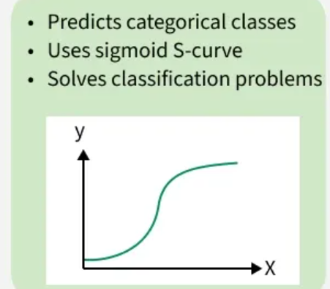
Applications
- Spam detection
- Disease prediction
2. Explain Logistic Regression. Why is it called "Regression" despite being used for Classification?
Logistic Regression estimates a continuous probability, rather than directly producing the class label.So,we apply sigmoid to produce binary values

37. Why is Logistic Regression Used for Classification?
Linear Regression can predict any real number, including values below 0 or above 1, which are not valid probabilities.
Logistic Regression solves this problem by applying the sigmoid function, which converts any real value into a number between 0 and 1.
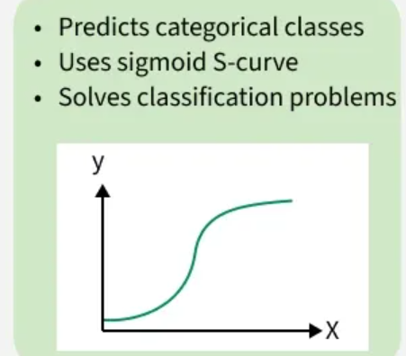
Applications
- Spam detection
- Disease prediction

38. What is the Sigmoid Function?
Definition
The sigmoid function converts any real-valued number into a probability between 0 and 1.
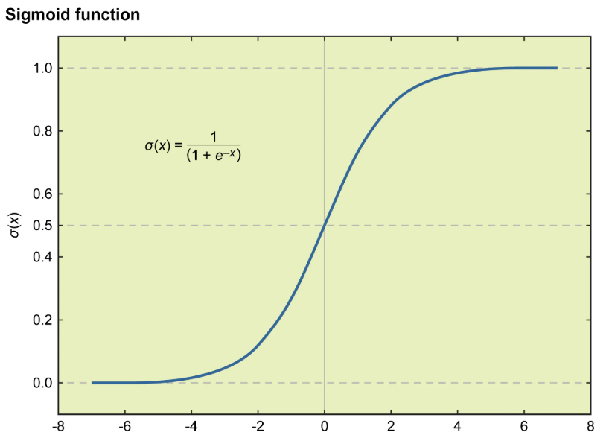

What is an Activation Function?
An activation function is a mathematical function applied to the neuron
An activation function is a function used in a neural network to decide whether a neuron should be activated or not.
Without an activation function, a neural network would basically perform only linear operations, so it couldn't learn complex patterns.

2. Tanh
Formula
$$f(x)=tanh(x)$$The Tanh (hyperbolic tangent) activation function is a mathematical function that maps input values to a continuous output range between -1 and 1
Mostly in hidden layers (especially in older neural network)

3. ReLU (Rectified Linear Unit)
Formula
$$f(x)=max(0,x)$$it passes positive inputs through unchanged while turning all negative values to zero.
Almost every modern deep-learning model uses ReLU in the hidden layers.
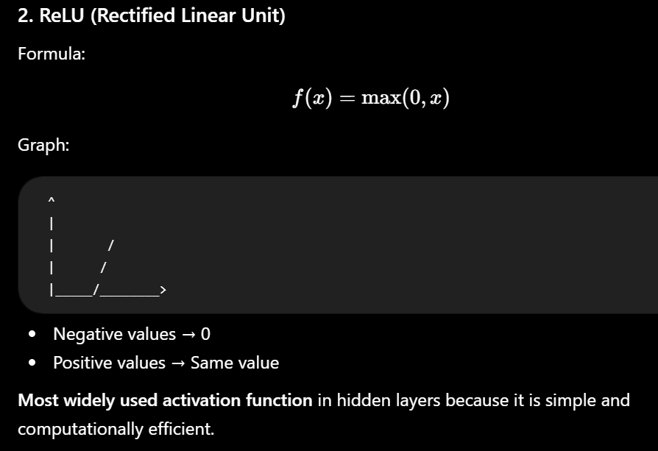
4.Softmax Function
The softmax function is a activation function which takes input and generate into a probability distribution, where each value ranges from 0 to 1 and all values sum to exactly 1
Purpose
Converts outputs into probabilities.
All probabilities:
- Sum to 1
- Are between 0 and 1

The softmax function is for multi-class classification.

39. What is a Decision Tree?
Definition
A Decision Tree is a supervised learning algorithm used for both classification and regression.
It makes predictions by asking a series of questions and splitting the data into smaller groups.
Applications
- Loan approval

1. How does a Decision Tree split data?
Definition
A Decision Tree splits data by asking a series of yes/no questions about the features.
At each step, it chooses the feature that creates the purest groups (i.e., groups where most data points belong to the same class).
How Does the Algorithm Decide Where to Split?
It chooses the feature that:
- Maximizes Information Gain, or
- Minimizes Gini Impurity
The goal is to make child nodes as pure as possible.

40. What is Entropy?
Definition
Entropy is a measure of impurity or uncertainty in a dataset.
It tells us how mixed the data is.
- Low Entropy → Data is pure (mostly one class).
- High Entropy → Data is mixed (contains multiple classes equally).
Decision Trees use entropy to decide the best feature to split the data.
3. What is Gini Index?
Definition
Gini Index (also called Gini Impurity) is a score that measures the "purity" of a dataset
Like entropy, lower Gini means purer nodes.

41. What is Information Gain?
Definition
Information Gain (IG) measures how much uncertainty (entropy) is reduced after splitting the data.
A Decision Tree chooses the feature with the highest Information Gain because it creates the purest child nodes.

Q.What is Pruning?
Pruning is the process of removing unnecessary branches or nodes from a Decision Tree to reduce its complexity and prevent overfitting.

42. What is Random Forest?
Definition
A Random Forest is an ensemble learning algorithm that combines many Decision Trees to make a final prediction.
Instead of relying on one tree, it uses the majority vote (classification) or average prediction (regression).

How Does It Work?
- Create multiple Decision Trees using different random samples of the training data.
- Each tree makes its own prediction.
- Combine the predictions.
- Classification: Majority voting.
- Regression: Average of predictions.
Why is Random Forest Better than a Single Decision Tree?
A single Decision Tree may overfit the training data.
Random Forest reduces overfitting by combining many trees.

43. What is Support Vector Machine (SVM)?
Definition
Support Vector Machine (SVM) is a supervised learning algorithm used for classification and sometimes regression.
Its goal is to find the best boundary (hyperplane) that separates different classes.
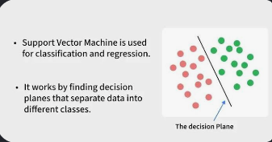
What is a Hyperplane?
A hyperplane is the decision boundary that separates different classes.
In 2D: Straight Line
In 3D:Plane
In higher dimensions:Hyperplane

What are Support Vectors?
Support vectors are the data points closest to the hyperplane.
They determine the position of the boundary.

Applications
- Face recognition
- Text classification
What is Kernal Trick?
It’s a mathematical function used to find the relationships in higher-dimensional space without actually transforming data there

4. What is Multiclass Classification?
Definition
Multiclass Classification is a classification problem where the model predicts one class out of three or more classes.
Unlike binary classification, there are multiple possible outcomes.

44. What is Naive Bayes?
Definition
Naive Bayes is a supervised machine learning classification algorithm based on Bayes' theorem.
It takes input and calculate the probability with each class and chooses the class with the highest probability.
Examples:
- Spam Detection
- Sentiment Analysis
- Disease Prediction
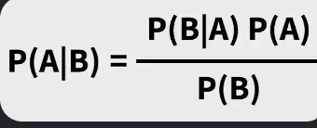
Why is it called "Naive"?
This is the most important part of the question.
Naive Bayes makes a strong assumption that the features are conditionally independent of each other given the class.

45. What is K-Nearest Neighbors (KNN)?
Definition
K-Nearest Neighbors (KNN) is a supervised learning algorithm used for classification and regression.
It predicts the output based on the K nearest data points in the training dataset.

How Does It Work?
- Choose a value of K (number of neighbors).
- Select the K nearest neighbors.
- Calculate the distance from the new data point to all k-neighbours points (commonly using Euclidean distance).
- Make a prediction:
  - Classification: Majority vote.
  - Regression: Average of neighbors' values.
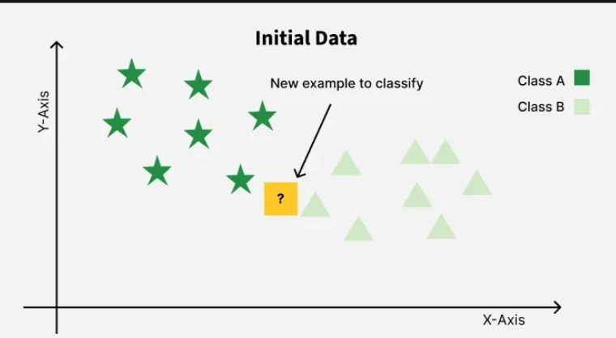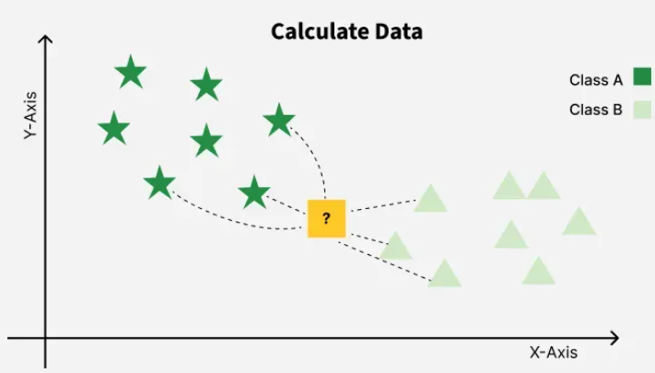
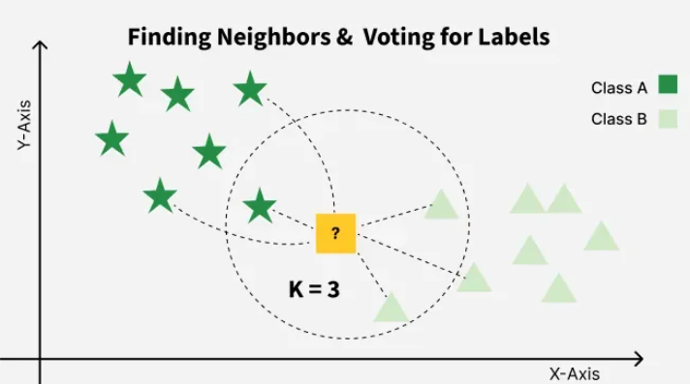

4. Unsupervised Learning (46–55)
46. What is Clustering?
Definition
Clustering is an unsupervised learning technique that groups similar data points together without using labeled data.
Clustering automatically groups datapoints based on similarity.
Real-Life Applications
- Customer segmentation
Popular Clustering Algorithms
- K-Means
- Hierarchical Clustering
- DBSCAN

1. How do you handle high-dimensional data in clustering? What is the "Curse of Dimensionality"?
What is the Curse of Dimensionality?
The curse of dimensionality is a situation where number of features in the dataset are too large,so forming clusters can be difficult

How do you handle high-dimensional data in clustering?
1. Feature Selection and Feature Scaling
2. Dimensionality Reduction

47. What is K-Means Clustering?
K-Means Clustering is an Unsupervised Machine Learning algorithm used to group similar data points into K clusters.
It divides the dataset into K clusters, where K is chosen before training.
Each cluster has a center called a centroid.
Examples:
- Customer segmentation
- Product grouping

Why is it called K-Means?
- K → Number of clusters.
- Means → Each cluster is represented by its mean (centroid).
What is a Cluster?
A cluster is a group of similar data points.

48. How Does K-Means Work?
K-Means works in five simple steps.

Step 1: Choose K
Decide how many clusters you want.
K=2

Step 2: Select Initial Centroids
The algorithm randomly selects K points as initial centroids.

Step 3: Assign Points to the Nearest Centroid
Each data point is assigned to the closest centroid.
Step 4: Update Centroids
Calculate the new center (average position) of each cluster.
The centroid moves to the middle of its assigned points.

Step 5: Repeat Until Stable
Repeat:
- Assign points
- Update centroids
until the centroids no longer move significantly or cluster assignments stop changing.
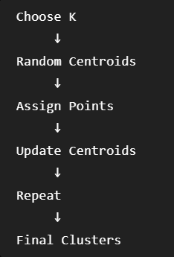
49. What is the Elbow Method?
Definition
The Elbow Method helps determine the optimal value of K in K-Means clustering.

Why is it Needed?
If:
- K is too small, different groups may be merged.
- K is too large, the model creates unnecessary clusters.
We need to choose the best value of K.
How it works:
Step 1: Try different values of K and apply clustering algorithms and try to find the best K value

50. What is Hierarchical Clustering?
Hierarchical Clustering is an Unsupervised Machine Learning algorithm which forms clusters in a tree-like structure called Dendrogram

Why is it called Hierarchical?
Because it creates a hierarchy (tree structure) of clusters.
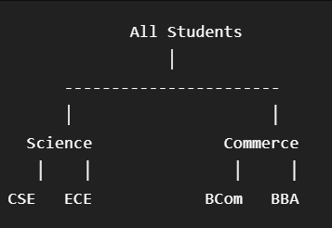
Types of Hierarchical Clustering
There are two types.
1. Agglomerative Hierarchical Clustering (Bottom-Up)
Every datapoint is formed as initial clusters at the bottom and they keep on merging to form single cluster or desired number of clusters reach at top
Starts with every data point as its own cluster.
Then it keeps merging the closest clusters until only one cluster remains.

2. Divisive Hierarchical Clustering (Top-Down)
Starts with all data points in one cluster.
Then repeatedly splits the cluster into smaller clusters.

Dendrogram:
A dendrogram is a tree-like diagram used to visualize clusters in hierarichial clustering

Applications
- Gene analysis
- Customer segmentation
51. Difference Between K-Means and Hierarchical Clustering?
K-Means | Hierarchical Clustering
Must choose K before training | Does not require K initially
Faster on large datasets | Slower on large datasets
Produces flat clusters | Produces a hierarchy (tree) of clusters

52. What is DBSCAN?
Definition
DBSCAN is a density-based clustering algorithm that groups closely packed points together as clusters and identifies isolated points as noise without requiring the number of clusters in advance.

53. What is Dimensionality Reduction?
Definition
Dimensionality Reduction is the process of reducing the number of input features (dimensions) while preserving as much useful information as possible.
Too many features can:
- Increase training time.
- Increase memory usage.

Example
Before10 features
After3 features

54. What is PCA (Principal Component Analysis)?
Definition
PCA (Principal Component Analysis) is a dimensionality reduction technique that transforms the original features into a new set of uncorrelated features, called Principal Components.
These components capture the maximum possible variance (information) in the data.

• Marks and CGPA are closely related.
• Height and Weight may also be correlated.
So,creating only one-feature by combining the two

How PCA Works:
1. Standardize the Data
2. Generate the Covariance Matrix
Create Principal Components.
Keep only the most important components.

55. Difference Between PCA and Feature Selection?
Although both reduce the number of features, they do it differently.
PCA | Feature Selection
Creates new features (principal components) | Selects existing features
Original features are transformed | Original features remain unchanged
Focuses on preserving maximum variance | Focuses on keeping the most relevant features
5. Model Evaluation (56–70)
56. What is Accuracy?
Definition
Accuracy is the percentage of correct predictions made by the model out of all predictions.
It is one of the simplest evaluation metrics for classification problems.
Formula
$$\text{Accuracy}=\frac{TP+TN}{TP+TN+FP+FN}$$
57. What is Precision?
Definition
Out of all the samples predicted as positive, how many are actually positive?
Formula
$$Precision=\frac{TP}{TP+FP}$$
58. What is Recall?
Definition
Recall answers:
Out of all actual positive cases, how many did the model correctly identify?
Recall is also called Sensitivity or True Positive Rate (TPR).
Formula
$$Recall=\frac{TP}{TP+FN}$$
59. What is F1-Score?
Definition
The F1-Score is the harmonic mean of Precision and Recall.
It balances both metrics.
Formula
$$F1=\frac{2×Precision×Recall}{Precision+Recall}$$60. What is a Confusion Matrix?
Definition
A Confusion Matrix is a table used to evaluate the performance of a classification model.
It compares Actual values with Predicted values.
Actual \ Predicted | Positive | Negative
Positive | TP | FN
Negative | FP | TN

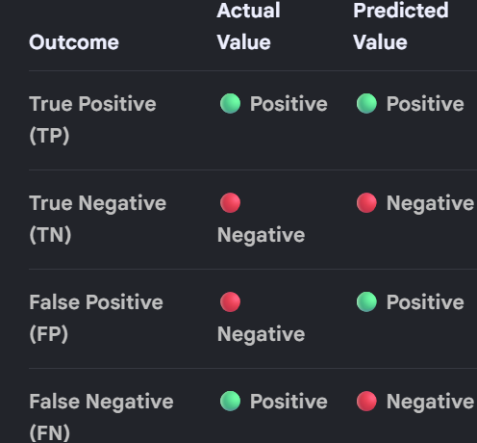
61. What is Specificity?
Definition
Specificity measures:
Out of all actual negative cases, how many were correctly predicted as negative?
It is also called the True Negative Rate (TNR).
Formula
$$Specificity=\frac{TN}{TN+FP}$$
Recall vs Specificity
Recall | Specificity
Measures positives | Measures negatives
Uses TP | Uses TN

62. What is ROC Curve?
Definition
ROC (Receiver Operating Characteristic) Curve is a graph used to evaluate the performance of a binary classification model.
It shows how well the model can distinguish between positive and negative classes at different classification thresholds.
The ROC Curve shows the model's performance at all possible thresholds.
It plots:
- True Positive Rate (TPR) on the Y-axis
- False Positive Rate (FPR) on the X-axis

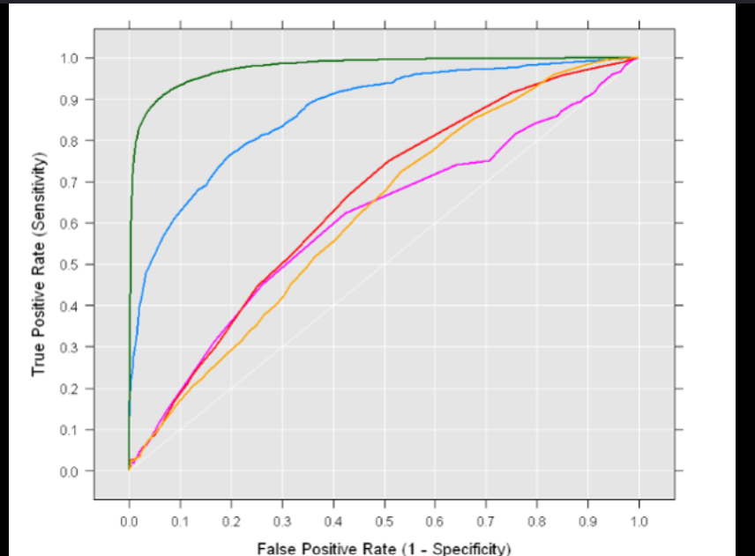
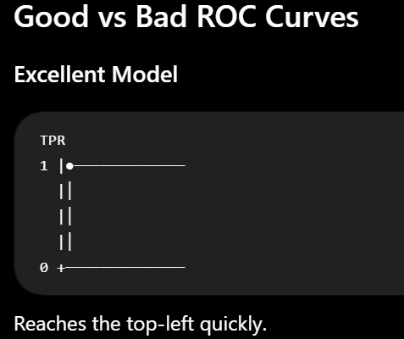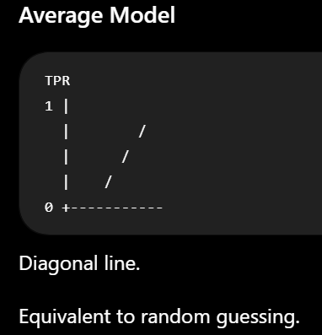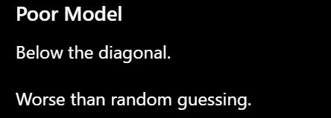
63. What is AUC?
AUC stands for Area Under the ROC Curve.
It gives us a single number representing how well the model can distinguish between the two classes across thresholds.
AUC ranges from:
0 → 1
AUC | Meaning
1.0 | Perfect Model
0.9 | Excellent
0.8 | Good
0.7 | Fair
0.5 | Random Guess

3. What are Type I and Type II Errors?
Type I Error — False Positive
Type I error occurs when we predict positive when the actual result is negative.

Type II Error — False Negative
Type II error occurs when we predict negative when the actual result is positive.

65. What is Mean Squared Error (MSE)?
Definition
MSE measures the average squared difference between actual values and predicted values.
It is commonly used for regression models.
Formula
$$MSE=\frac{∑(Actual-Predicted)^{2}}{n}$$

66. What is Root Mean Squared Error (RMSE)?
Definition
RMSE is simply the square root of MSE.
Formula
$$RMSE=\sqrt{MSE}$$
67. What is Mean Absolute Error (MAE)?
Definition
MAE measures the average absolute difference between actual and predicted values.
Formula
$$MAE=\frac{∑∣Actual-Predicted∣}{n}$$
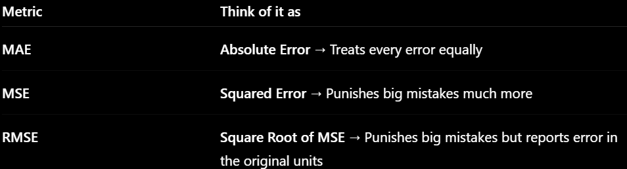
68. What is R² Score?
Definition
3. R² Score (Coefficient of Determination)
R² tells how perfect the model is..
Interpretation
- 1 → Perfect prediction
- 0 → Model performs like predicting the mean
- Negative → Model is worse than predicting the mean

69. What is Cross-Validation?
Definition
Cross-validation is a model evaluation technique where the dataset is divided into multiple parts, and the model is trained and validated multiple times using different parts of dataset
Why is cross-validation used?
- Better model evaluation

70. What is K-Fold Cross-Validation?
Definition
K-Fold Cross-Validation is the most commonly used cross-validation technique.
The dataset is divided into K equal parts (folds).
K-Fold Cross-Validation divides the dataset into K folds, trains the model K and validate the model K times using the model and averages the results to estimate model performance.
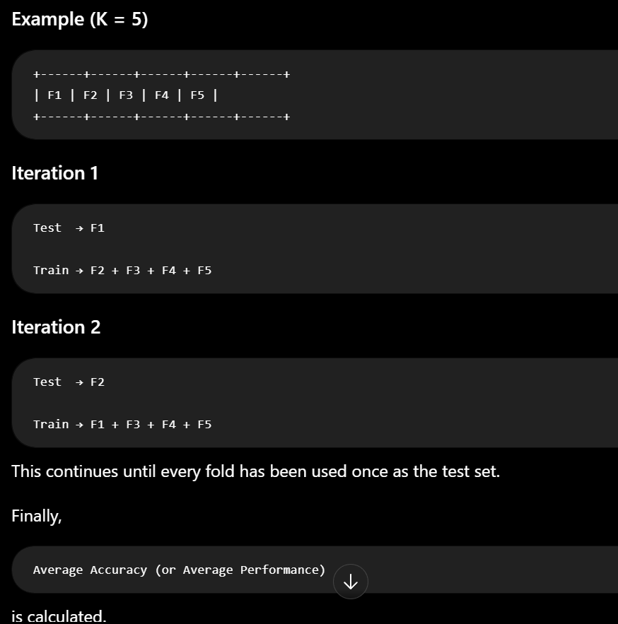
2. K-Fold vs Stratified K-Fold Cross-Validation
In K-Fold, the dataset is divided into K approximately equal-sized folds.

Stratified K-Fold is mainly used for classification problems.
It divides the data into K folds while trying to maintain the same proportion of each class in every fold.

6. Overfitting, Underfitting & Regularization (71–80)
71. What is Overfitting?
Definition
Overfitting is a scenario where the model learns and memorizes the training data too well including noise.
Here,the model was failed to learn the patterns from the data.
Characteristics
- Very low training error.
- High testing error.

72. What is Underfitting?
Definition
Underfitting is a scenario where the model is too simple and fail to capture the relation between input and output
As a result:
- Low training accuracy.
- Low testing accuracy.

How to prevent underfitting?
• Use a more complex model.
• Reduce excessive regularization.
->Reduce overly aggressive feature selection.

73. How Do You Prevent Overfitting?
There are several techniques to reduce overfitting.

1. Collect More Data
More training examples help the model learn general patterns instead of memorizing specific examples.
aggressive feature selection
3. Cross-Validation
Use techniques like K-Fold Cross-Validation to ensure the model performs well on different subsets of the data.
4. Regularization
Add a penalty to discourage overly complex models.
Examples:
- L1 Regularization (Lasso)
- L2 Regularization (Ridge)

5. Pruning (Decision Trees)

What is Generalization?
Generalization refers to a model's ability to apply the knowledge and patterns it learned during training to new, unseen data
How Developers Improve Generalization
Using Regularization and Cross-Validation Techniques

What is Pruning?
Pruning is a technique used to reduce the size and complexity of models by removing unnecessary components, such as redundant branches in decision trees or insignificant weights in neural networks

74. What is Regularization?
Definition
Regularization is a technique used to reduce overfitting by adding a penalty term to the model's loss function.
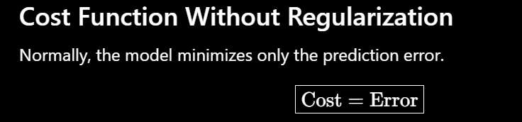
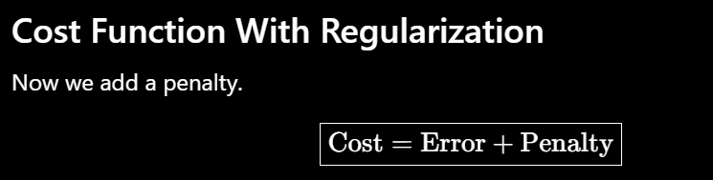
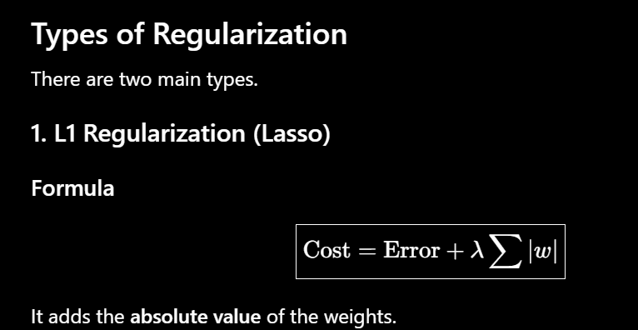
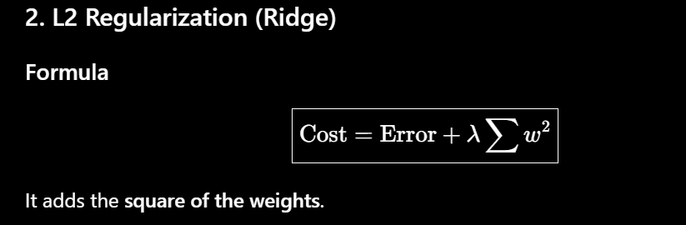
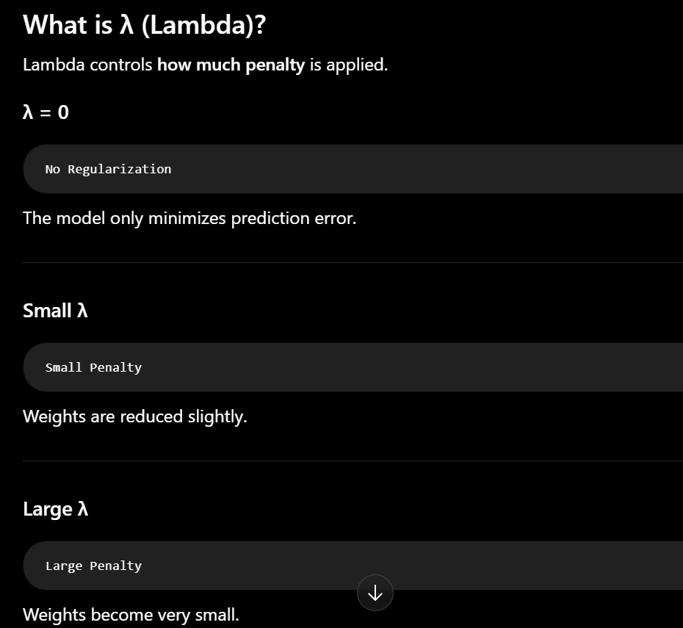
4. What happens if λ is too large?
Answer:
The penalty becomes very strong, forcing the weights to become very small. The model may become too simple and underfit, leading to poor performance on both training and test data.

3. What is the difference between L1 and L2 Regularization?
L1 removes some features by making coefficients zero; L2 shrinks coefficients but keeps all features.
L1 | L2
Uses absolute values of weights | Uses squared weights

76. What is Ridge Regression?
Definition
Ridge Regression is a type of Linear Regression that uses L2 Regularization to reduce overfitting.
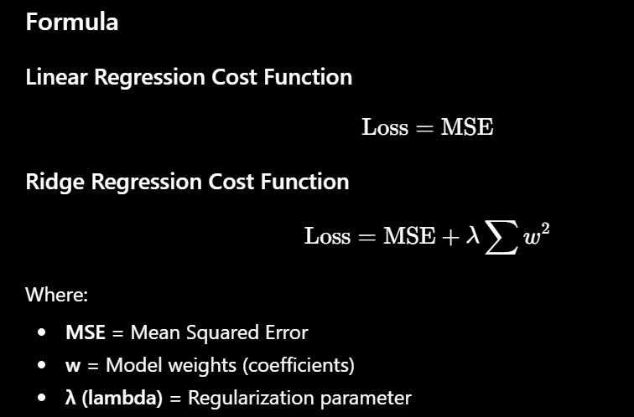
77. What is Lasso Regression?
Definition
Lasso Regression is a type of Linear Regression that uses L1 Regularization.
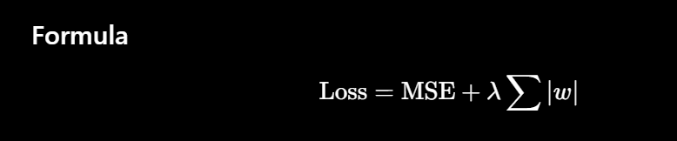
Why is This Useful?
Lasso automatically performs feature selection.
Only important features remain.

78. What is Elastic Net?
Definition
Elastic Net is a regularization technique that combines both L1 (Lasso) and L2 (Ridge) regularization.
It provides the benefits of both methods.
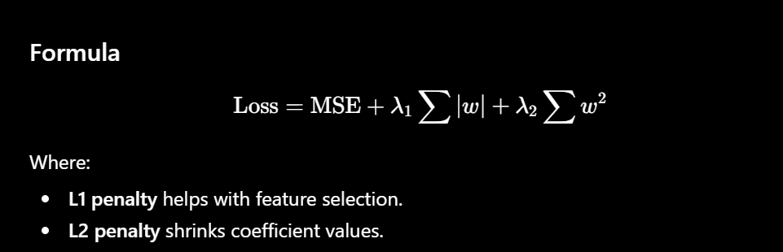

79. What is Bias?
Bias is the error caused because the model is too simple to learn the real pattern in the data.
High bias leads to underfitting.

80. What is Variance?
Variance is the error caused because the model memorized training data include noise instead of finding underlying patterns.
Bias vs Variance
Bias | Variance
Model too simple | Model too complex
Underfitting | Overfitting
Misses patterns | Learns noise
High training error | Low training error
High testing error | High testing error

What is bias-variance tradeoff?
The bias-variance tradeoff is a machine learning concept where the model balances bias and variance effectively.

What are Weights?
A weight is a number that tells the model how important a feature is when making predictions.
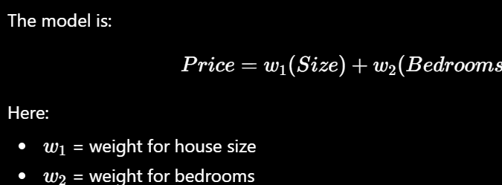

7. Ensemble Learning (81–88)
Ensemble learning is a popular machine learning technique where multiple models are combined to produce a better and more accurate prediction than a single model.
81. What is Ensemble Learning?
Definition
Ensemble Learning is a technique that combines the predictions of multiple machine learning models to improve overall performance.
The idea is:
Many weak or average models together can produce a strong model.

Types of Ensemble Learning
- Bagging
- Boosting
- Voting

82. What is Bagging?
Definition
Bagging (Bootstrap Aggregating) is an ensemble technique where multiple models are trained independently on different random subsets of the training data, and their predictions are combined.
How Bagging Works
Step 1
Create multiple random datasets using Bootstrap Sampling.
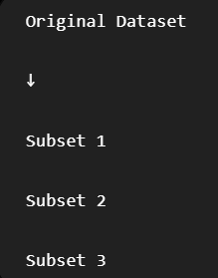
Step 2
Train one model on each subset.
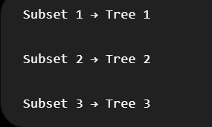
Step 3
Classification
Combine predictions.

Regression
Take the average prediction.

What is Random Forest?
Random Forest is an ensemble learning algorithm that uses multiple Decision Trees trained on different subsets of data and combines their predictions Why is it called "Random Forest"?
- Random → Each tree is trained on a random subset of the data and often a random subset of features.
- Forest → A collection (forest) of many Decision Trees.

83. What is Boosting?
Definition
Boosting is an ensemble technique where models are trained sequentially, and each new model focuses on correcting the mistakes made by the previous model.
How Boosting Works
Model 1
Makes predictions.
Calculate error(Actual-Predicted)
Model2
Train the decision tree on same data along with error
Basically we are updating hyperparameters(weights) to reduce error
Model 3
Corrects the remaining mistakes.
Final Prediction
Combines all models.

Popular Boosting Algorithms
- AdaBoost
- Gradient Boosting
- XGBoost

84. Difference Between Bagging and Boosting?
Bagging | Boosting
Models are trained independently | Models are trained sequentially
Uses random subsets of the data | Focuses on correcting previous mistakes
Example: Random Forest Example: XGBoost

85. What is AdaBoost?
Definition
AdaBoost (Adaptive Boosting) is one of the earliest and simplest boosting algorithms.
It works by giving more importance (higher weight) to incorrectly classified training examples.
How AdaBoost Works
Step 1
Train the first model.
Step 2
Identify the incorrect predictions.
Step 3
Increase the weights of those incorrectly classified examples.
Step 4
Train the next model using the updated weights.
Step 5
Repeat the process.

86. What is Gradient Boosting?
Definition
Gradient Boosting is a boosting algorithm where each new model tries to reduce the errors (residuals) made by the previous model using gradient descent principles.
Instead of changing data weights like AdaBoost, it fits new models to the remaining prediction errors.
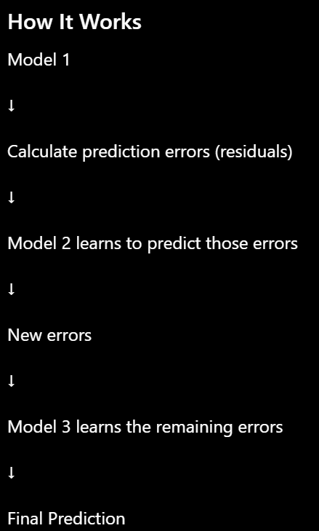
87. What is XGBoost?
Definition
XGBoost (Extreme Gradient Boosting) is an optimized implementation of Gradient Boosting that is faster, more accurate, and includes regularization to reduce overfitting.

88. What is a Voting Classifier?
Definition
A Voting Classifier is an ensemble method that combines predictions from multiple different classification algorithms.
Instead of using many models of the same type, it combines different types of classifiers.
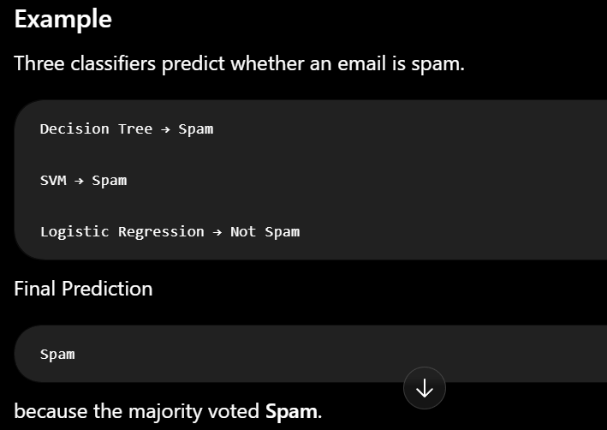

What is Gradient Descent Algorithm?
Gradient Descent is an optimization algorithm used to find the best values of model parameters (weights and bias) by minimizing the loss (cost) function.

The model measures its error using a Cost Function (Loss Function).
For Linear Regression, we usually use Mean Squared Error (MSE).

How Gradient Descent Works
Step 1: Initialize Parameters
Choose random values.
Weight = 5

Bias = 3

Step 2: Make Predictions
Use
$$y=wx+b$$
to predict outputs.

Step 3: Calculate Error
Compute the cost using MSE.
Example:
Cost = 100

Step 4: Compute Gradient
The gradient tells us:
- Which direction to move.
- How much to change the parameters.

Step 5: Update Parameters
Update weights and bias.
Step 6: Repeat
Repeat until the cost becomes very small.

8. Deep Learning Basics (89–94)

89. What is Deep Learning?
Definition
Deep Learning is a subset of Machine Learning that uses Artificial Neural Networks (ANNs) with multiple hidden layers to learn complex patterns from data.
It is widely used in Applications
- Image Recognition
- Face Recognition
- Self-driving Cars

90. Difference Between Machine Learning and Deep Learning
Machine Learning | Deep Learning
Subset of AI | Subset of Machine Learning
Works well with small to medium datasets | Performs best with very large datasets
Can run on CPUs | Often requires GPUs/TPUs
Learns patterns Learn complex patterns

91. What is an Artificial Neural Network (ANN)?
Definition
An Artificial Neural Network (ANN) is a computational model inspired by the human brain.
It consists of interconnected neurons organized into layers.
How ANN Works
- Receive input.
- Multiply inputs by weights.
- Add bias.
- Apply activation function.
- Pass output to the next layer.
- Generate prediction.

Role of Weights
Weights determine how important each input is to a neuron.

92. What are Activation Functions?
Definition
An activation function is a mathematical operation applied to the output of a neuron.
It introduces non-linearity into a neural network, allowing the model to learn and represent complex, real-world patterns that a simple linear equation cannot capture.
Without activation functions, a neural network behaves like a simple linear model, regardless of how many layers it has.

93. What is Backpropagation?
Definition
Backpropagation is the algorithm used to train neural networks.
Backpropagation uses the gradient descent algorithm to calculate how weights should change to minimize the loss, and then updates those weights to improve the model's accuracy.

How It Works
Step 1
Forward Pass
Prediction
Step 2
Calculate Error
Step 3
Backward Pass
The error is propagated backward through the network.
Step 4
Update Weights
Weights are adjusted using Gradient Descent so that future predictions become more accurate.

Why Is It Important?
Without backpropagation, the neural network would not know how to improve its weights, so learning would not occur.

94. What is Dropout?
Definition
Dropout is a regularization technique used in neural networks to reduce overfitting.
During training, it randomly disables (drops) some neurons.

Why Use Dropout?
If every neuron always participates in training, the network may memorize the training data.
Dropout forces the network to learn more robust and general features.

- CNN vs RNN — What is the Difference and Where are They Used?
A CNN is a deep learning algorithn designed to process images and videos.
An RNN is designed to process sequential data, where the order of information matters

9. Deployment & MLOps (95–97)
After training a Machine Learning model, the next step is to deploy it so real users or applications can use it. MLOps (Machine Learning Operations) focuses on deploying, monitoring, and maintaining ML models in production.
Deployment Steps
Step 1: Train the Model
Step 2: Create an API
Use frameworks like:
- FastAPI
Step 3: Test the API
Use:
- Swagger UI (FastAPI)
Step 4: Deploy to Cloud
Common platforms:
- Render

Step 5: Connect Frontend

96. What is Model Drift?
Definition
Model Drift occurs when the data trained durning training changes over time, causing the model's performance to decrease.
The model was trained on one type of data, but production data is now different.

Example
A house price model is trained using 2022 data.
In 2026, house prices have changed significantly.
The model still uses old patterns, so its predictions become inaccurate.

97. What is Model Monitoring?
Definition
Model Monitoring is the continuous process of tracking a deployed model's performance to ensure it continues making accurate predictions.
What Do We Monitor?
Accuracy
Is the model still making correct predictions?

Prediction Errors
Are errors increasing over time?

100. How do you choose the best machine learning algorithm for a problem?
There is no single best algorithm for every problem. The choice depends on the data, problem type, dataset size, interpretability requirements, and performance needs.

Step 1: Identify the Problem Type
Regression
Predict continuous values.

1. Why is Dimensionality Reduction Important?
Definition
Dimensionality Reduction is the process of reducing the number of input features (columns) in a dataset while preserving as much useful information as possible.
It helps make machine learning training much faster and more accurate.

2. What is the Learning Rate?
Definition
The Learning Rate (η or alpha) is a hyperparameter that controls how much the model's weights are updated during each step of training.
It determines the step size taken toward the minimum of the loss function.

3. What is Hyperparameter Tuning?
Definition
Hyperparameter Tuning is the process of finding the best values for hyperparameters to improve a model's performance.
Unlike model parameters (weights), hyperparameters are set before training.

Parameters vs Hyperparameters
Parameters | Hyperparameters
Learned during training | Set before training
Example: Weights, Biases | Example: Learning Rate, K, Tree Depth

4. How would you handle a dataset with millions of records?
Large datasets require efficient processing because they may not fit into memory and can take a long time to train.
1. Use Efficient Data Storage
Instead of loading the entire dataset into memory:
- Read data in chunks.

2. Use Distributed Processing
When one machine is not enough, use distributed frameworks.

How do you deploy a Machine Learning model into production?
Step 1: Train the Model
Step 2: Save the Trained Model
Step 3: Create an API
Applications cannot directly call a Python model file. Instead, expose it through a REST API.
Popular frameworks:
- FastAPI (modern and fast)

Step 4: Test the API
Before deployment, verify that the API works correctly.
Common tools:
- Swagger UI (automatically available with FastAPI)
Step 5: Deploy to a Cloud Server
Host the API so it is accessible over the internet.
Popular platforms:
- Render

Step 6: Connect the Frontend
A web or mobile application sends user input to the API.

What are Model Parameters and Hyperparameters?
Model parameters are the values that the model learns automatically from the training data during training.
The training algorithm updates these values to minimize the error (loss).
Example 1: Linear Regression
Equation:
$$y=mx+b$$
Here:
- m = slope (weight)
- b = intercept (bias)
These values are not set by us.
The training process finds the best values for m and b.

Hyperparameters
Definition
Hyperparameters are settings that you choose before training begins.
They control how the model learns, not what it learns.
Hyperparameters are chosen by the user or tuned automatically.

Examples
Learning Rate
Suppose Gradient Descent updates the weights.
Learning rate decides:
How big should each update be?

1. What is Exploratory Data Analysis (EDA)?
EDA is the process of analysing a dataset before building a machine learning model.
We use EDA to find:
- Missing values
- Duplicate values
- Relationships between features

2. How do you identify categorical and numerical features?
We identify them based on the type of values stored in the column.
Numerical features(Stores int values)
Categorical features(Stores string values)

3. What is a Pipeline in Scikit-learn?
A Pipeline in Scikit-learn allows us to combine multiple machine learning steps which can be data-preprocessing,model building and evaluation into a single workflow.

4. What is the difference between Generative and Discriminative models?
Generative models focus on capturing the joint probability distribution of the input features and labels
Ex:Naïve Bayes
Discriminative models focus on capturing the conditional probability distribution of the input features and labels
Ex:Logistic Regression
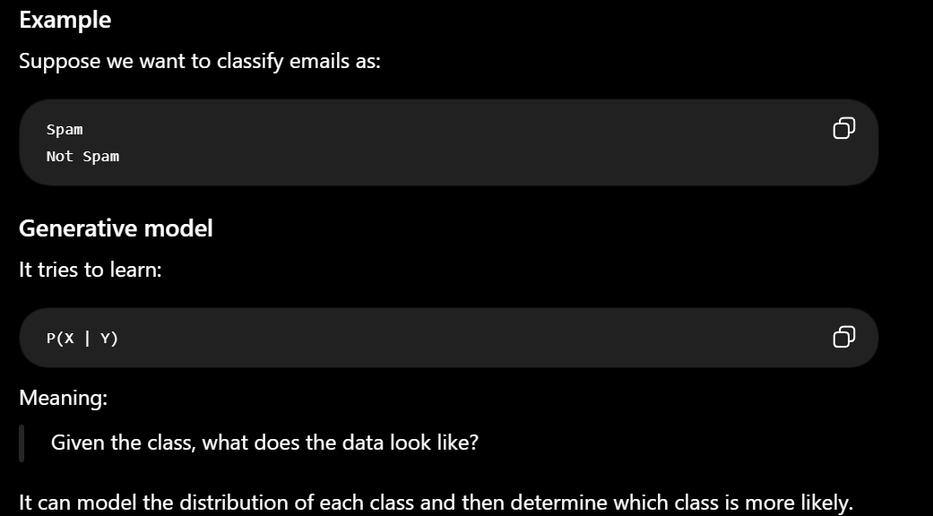
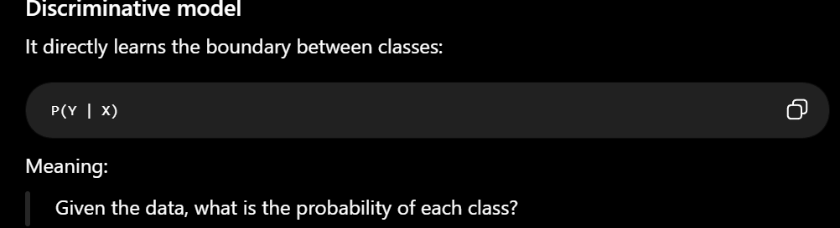

Q.What is Cost function and how is it measured in different algorithms.
Cost function represents the error in the Model.
For linear regression, a common cost function is Mean Squared Error (MSE).

1. What is Gradient Descent?
Gradient Descent is an optimization algorithm used to minimize the cost/loss function by repeatedly adjusting the model's parameters in the direction that reduces the error.

How it works:
Step 2: Calculate the error
Step 3: Calculate the gradient
The gradient tells us:
"Which direction should I move the weight to reduce the loss?"
Step 4: Update the weight
Step 5: Repeat
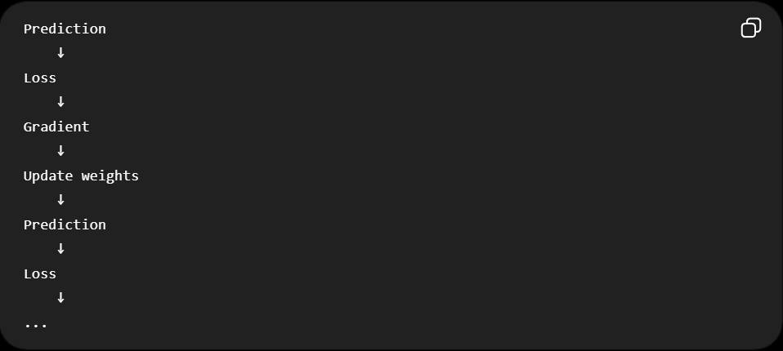

2. Batch vs Stochastic vs Mini-Batch Gradient Descent
The difference is basically:
How much training data do we use to calculate one gradient update?
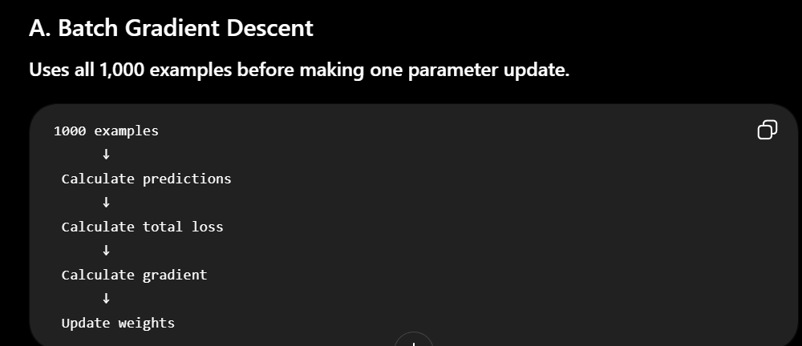
Batch Gradient Descent uses all the data to calculate the gradient and update the weights
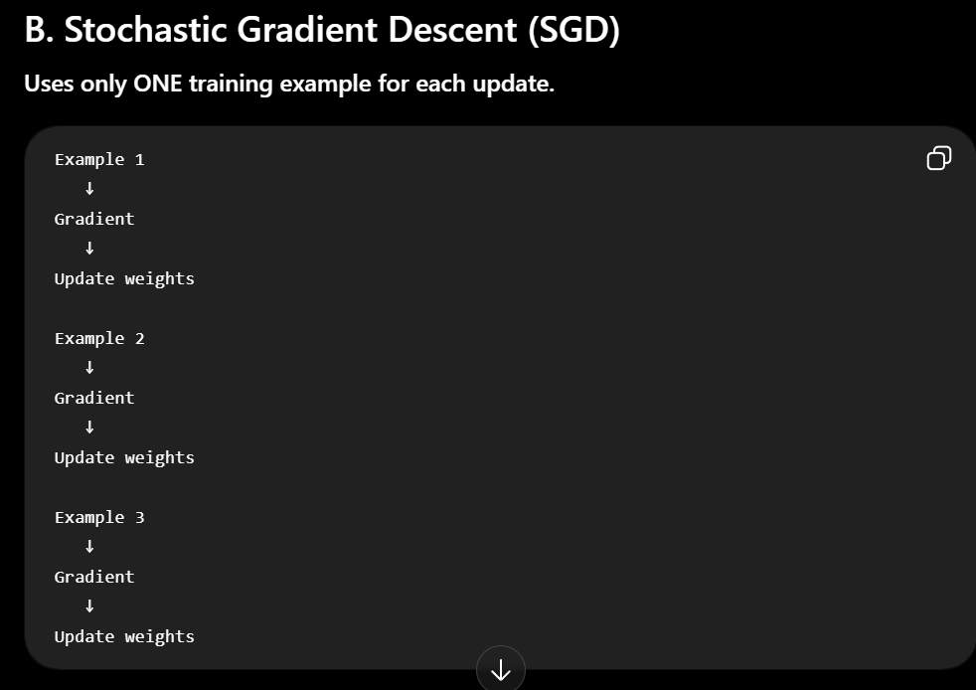
Stochastic Gradient Descent uses only one training example and calculate the gradient and update the weight

C. Mini-Batch Gradient Descent
This is the most commonly used approach in modern neural-network training.
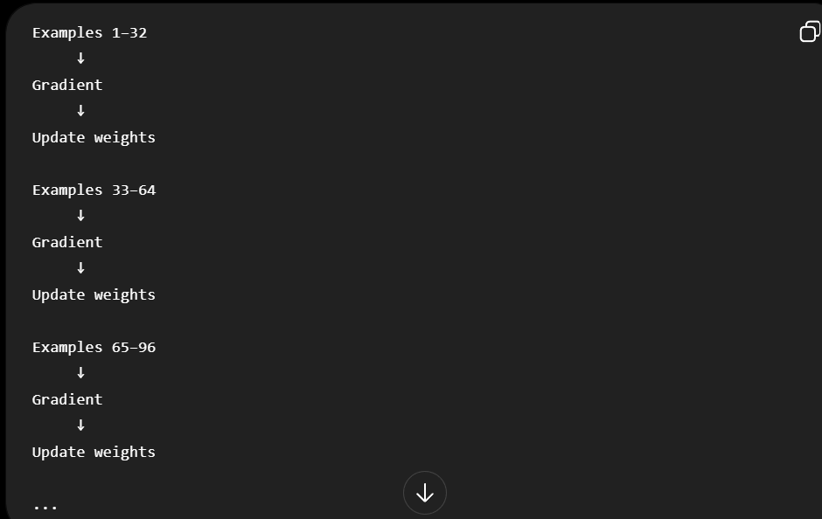
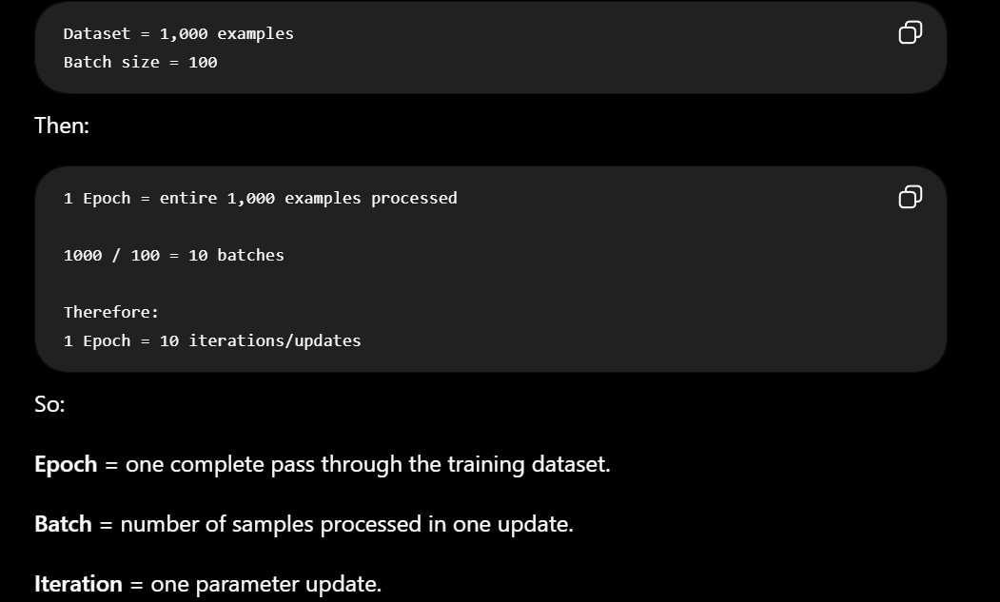
1. What is Multicollinearity?
Multicollinearity occurs when two or more input features are highly correlated with each other.
We detect Multicollinearity using
Method 1: Correlation Matrix

4. Why don't Tree-Based Models require Feature Scaling?
Tree-based algorithms performs prediction based on split the features and using different subset of data rather than scaling the features

1. What is Transfer Learning?
Transfer Learning means taking a pretrained-model foundation model and fine-tuning it and use for another task.

2. How do you handle categorical and numerical features together?
We use standardization for numerical features and use One-hot encoding for categorical values

4. How do you save and load a trained ML model?
We save the trained model to a file.
Joblib is a Python library used for saving the trained ml model files
5. What is Pickle?
Pickle is a Python module used to serialize and deserialize Python objects.
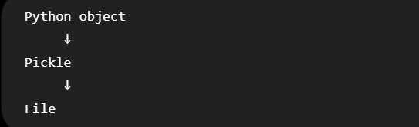
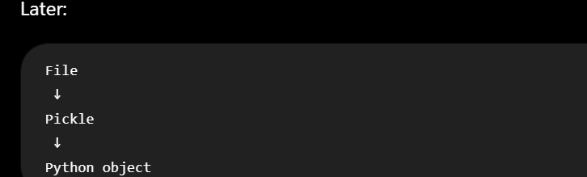
12. How do you monitor a deployed ML model?
Data Drift

13. What is Data Drift?
Data Drift means properties of input data changes over time
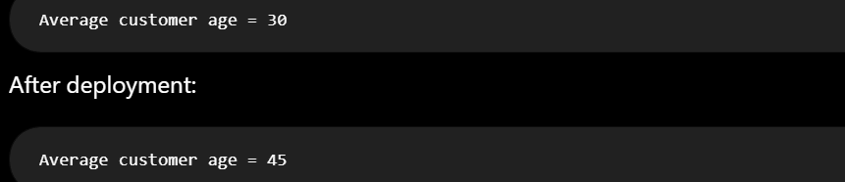

14. What is Feature Drift?
Feature Drift is a type of Model-Drift means specific features properties changed over-time

15.What is Concept Drift?
Concept drift means the relationship between the input features and the target changes over time.

1. What is A/B Testing, and how do you use it to evaluate a new ML model in production?
A/B testing means comparing two versions with real users.
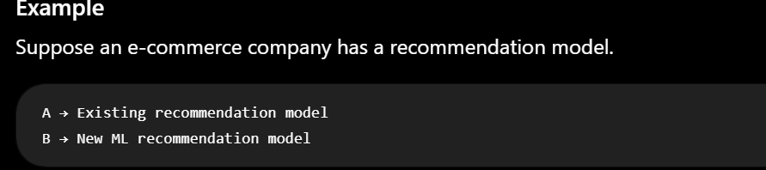
Q. Your model has 95% accuracy but performs poorly in production. Why?
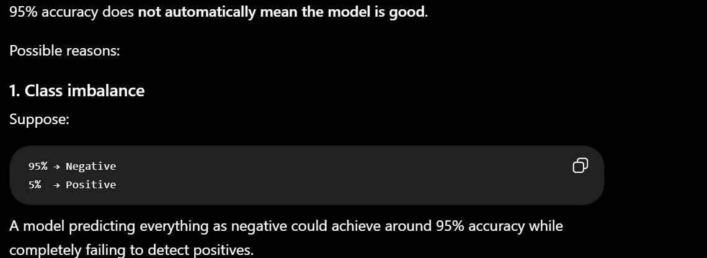
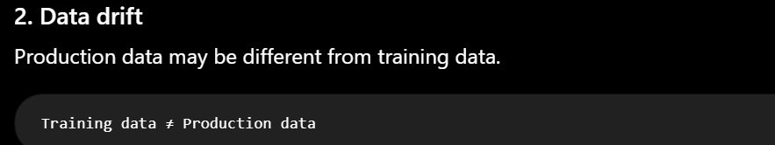
Q. Training accuracy is 99% but test accuracy is 70%. What would you do?
This is a classic sign of overfitting.
What can you do?
1. Reduce model complexity
2. Regularization

Q.Dataset contains 95% negative and 5% positive samples. How would you handle it?
Step 3 — Consider class weights

8. What would you do if your model takes too long to train?
1. Reduce unnecessary features

What is the Precision-Recall Curve, and when is it preferred over ROC-AUC?
- Grid Search vs. Random Search vs. Bayesian Optimization: What are the differences between these hyperparameter tuning techniques and when would you use each?
- What is the Vanishing/Exploding Gradient problem? (standard DL follow-up after backpropagation)

