1. What is MongoDB?
Answer:
MongoDB is a NoSQL, document-oriented database that stores data in JSON format instead of rows and columns.
Example
{
"name": "Nani",
"age": 22,
"skills": ["Python", "MongoDB"]
}
Advantages
- Flexible schema
- Highly scalable

7. What is BSON?
Answer:
BSON stands for Binary JSON.
MongoDB stores data internally as BSON because it:
- Is faster

2. What is NoSQL?
Answer:
NoSQL stands for Not Only SQL.
Unlike relational databases, NoSQL databases store data in different formats such as:
- Document
- Key-Value
- Column
- Graph
MongoDB is a Document Database.

3. MongoDB vs SQL — What is the difference?
MongoDB | SQL Database
NoSQL database | Relational database
Data stored as documents | Data stored in tables
Documents contain fields | Rows contain columns
Collection | Table
Document | Row
Field | Column

4. What is a Document and Collection?
Document
A document is the basic unit of data in MongoDB.
It is similar to a JSON object.
Example:
{
name: "Rahul",
age: 22,
course: "Computer Science"
}
Collection
A collection is a group of MongoDB documents.

6. What is _id and ObjectId?
Every MongoDB document normally has a unique _id field.

Example:
{
_id: ObjectId("64abc123..."),
name: "Rahul",
age: 22
}
What is ObjectId?
ObjectId is the default data type in MongoDB commonly uses for automatically generated _id values.

7. How do you perform CRUD operations in MongoDB?
CRUD means:
C → Create
R → Read
U → Update
D → Delete

Create
Use:
insertOne()
insertMany()

Read
Use:
find()
findOne()

Update
Use:
updateOne()
updateMany()

Delete
Use:
deleteOne()
deleteMany()

8. find() vs findOne()
Both are used to retrieve documents, but they behave differently.
find()
Returns multiple matching documents.
findOne()
Returns one matching document.

9. insertOne() vs insertMany()
Both are used to insert documents.
insertOne()
Inserts one document.
insertMany()
Inserts multiple documents.

10. updateOne() vs updateMany()
Both are used to modify existing documents.
updateOne()
Updates only one matching document.
updateMany()
Updates all matching documents.

1. What are MongoDB operators?
MongoDB operators are special keywords that perform operations on data, such as filtering,searching, updating, comparing, and checking conditions.
Main types of operators
A. Comparison operators
Used to compare values.
Operator | Meaning
$eq | Equal
$ne | Not equal
$gt | Greater than
$gte | Greater than or equal

B. Logical operators
Used to combine conditions.
Operator | Meaning
$and | All conditions must be true
$or | At least one condition must be true

2. What is an index and why is it used?
An index is a data structure that helps MongoDB find documents faster.
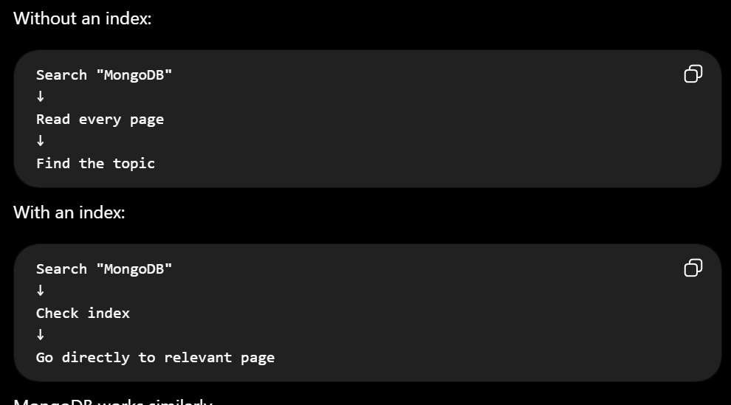
3. What is aggregation in MongoDB?
Aggregation is the process of processing multiple documents and producing calculated result.
It is commonly used for:
- Calculations
- Grouping
- Filtering
- Sorting

4. What is an aggregation pipeline?
An aggregation pipeline is a sequence of processing stages where the output of one stage becomes the input to the next stage.
Ex::First search all IT Employees and sort them according to salary

4. Explain $set, $push, and $pull
$set
Purpose:
Set is used to create or update a field with the value
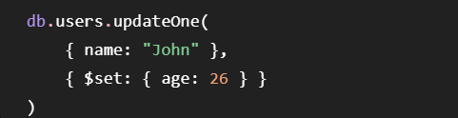
$push
Purpose:
Adds an element to an array.
$pull
Purpose:
Removes elements from an array.

5. What is $lookup in MongoDB?
$lookup is used to combine documents from two MongoDB collections.
It is similar to a JOIN in SQL.

7. What is Mongoose?
Mongoose is an library for MongoDB and Node.js.
It makes it easier for a Node.js application to work with MongoDB.

8. What is Mongoose Schema and Model?
A Mongoose Schema defines the structure, types, and validation rules for documents, while a Model is created from that schema and is used to perform database operations.
34. What is Replication?
Answer:
Replication keeps multiple copies of data on different servers.

36. What is Sharding?
Answer:
Sharding distributes data across multiple servers.
Benefits:
- Handles huge datasets

1. What is Embedding in MongoDB?
Embedding in MongoDB means storing related data as nested documents inside the original document
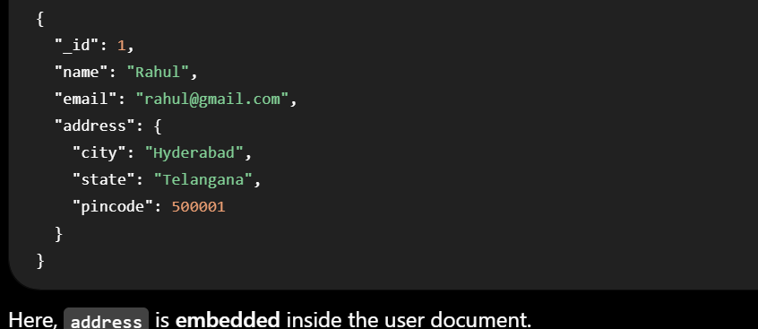
2. What is Referencing?
Referencing means storing related data in separate documents instead of storing as nested document in original document
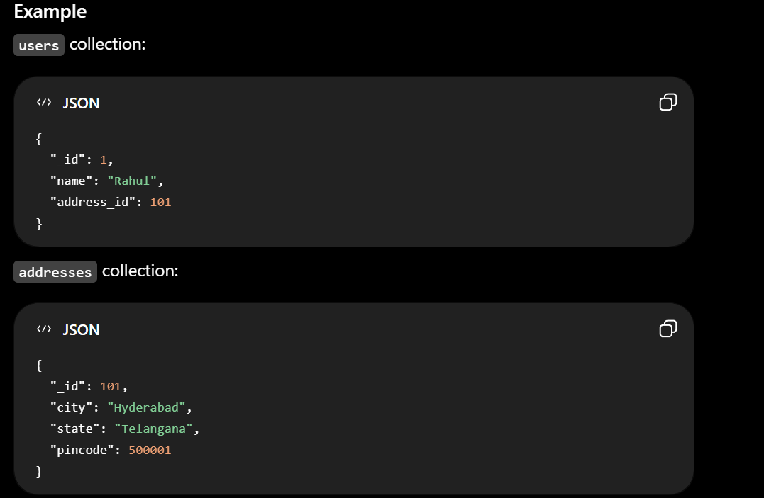
3. How does MongoDB handle large datasets?
2. Sharding ⭐
3. Replication

4. What is MongoDB Atlas?
MongoDB Atlas is cloud-based MongoDB's database

5. How did you connect FastAPI and Node.js to MongoDB?
In FastAPI, I used a MongoDB driver such as PyMongo or Motor, and in Node.js I used the MongoDB Node.js driver or Mongoose.

2. What are Indexes in MongoDB and Why Are They Important?
What is an Index?
An index in MongoDB is a data structure that allows MongoDB to find documents without scanning the entire collection.

