Operating Systems — Most Important Interview Questions
- What is an Operating System?
- What are the main functions of an OS?
- What is a process?
- Process vs Thread?
- What is a Process Control Block (PCB)?
- What is a context switch?
- What is multitasking and multiprocessing?
- What are the different process states?
- What is CPU scheduling?
- FCFS vs SJF vs Round Robin vs Priority Scheduling?
- What is a thread?
- User-level threads vs kernel-level threads?
- What is deadlock?
- What are the four necessary conditions for deadlock?
- Deadlock prevention vs avoidance vs detection?
- What is the Banker’s Algorithm?
- What is synchronization?
- What is a critical section?
- Mutex vs Semaphore?
- What is a race condition?
- What is virtual memory?
- What is paging?
- Paging vs segmentation?
- What is a page fault?
- What is demand paging?
- What is page replacement?
- FIFO vs LRU vs Optimal page replacement?
- What is thrashing?
- What is a system call?
- Kernel mode vs user mode?

1. What is an Operating System?
An Operating System (OS) is system software that acts as a middle layer between the user/applications and computer hardware.
It manages resources such as:
- CPU
- Memory
- Files
- Input/output devices
- Processes

2. What are the main functions of an OS?
The major functions are:
- Process Management
2. Memory Management
3. File Management

3. What is a Process?
A process is a program that is currently executing.
A program stored on disk is passive. When it starts running, it becomes a process.

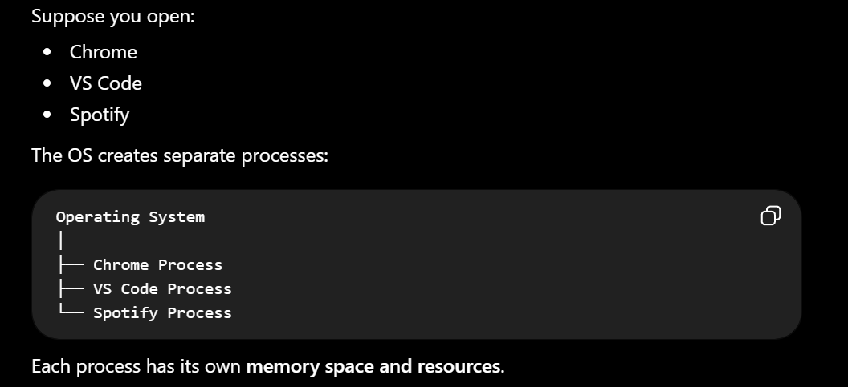
4. Process vs Thread
This is a very important interview question.
a thread is the smallest unit of execution inside a process.
A web browser, where one thread downloads a webpage, another plays a video

5. What is a Process Control Block (PCB)?
PCB is an OS data structure that stores all important information required to manage and resume a process.
A program counter (PC) is a special register that stores the memory address of the next instruction to be executed
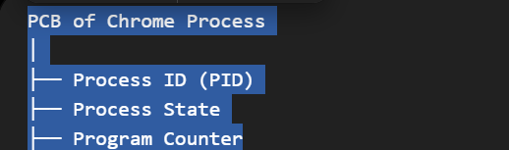
6. What is a Context Switch?
A context switch occurs when the CPU switches from one process or thread to another.
The OS must save the current process's state and load the next process's state.
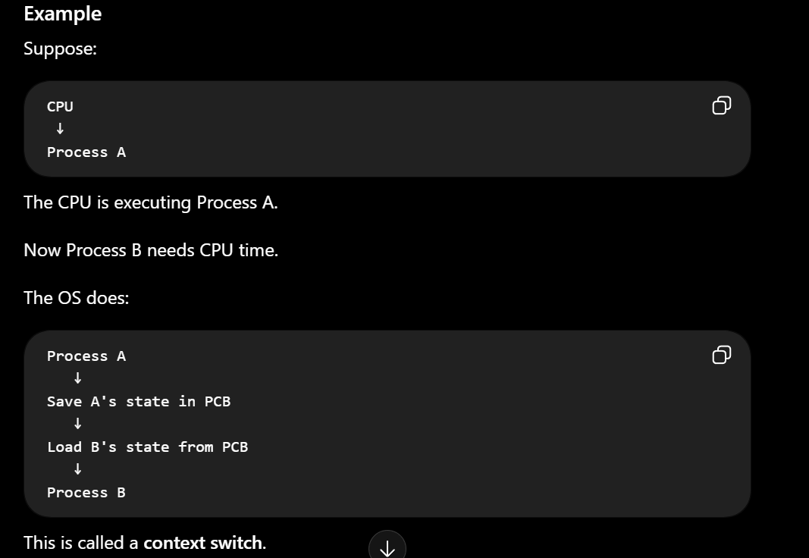

173. What is Multithreading?
Multithreading means running multiple threads within the same process.
A web browser, where one thread downloads a webpage, another plays a video

174. What is Multiprocessing?
Multiprocessing means running multiple processes.
When is multiprocessing useful?
Especially for CPU-bound tasks:
- Heavy calculations
- Image processing

8. What are the different Process States?
A process doesn't remain running all the time. It moves through different states.
1. New
The process is being created.
Example:
User opens an application
2. Ready
The process is ready to run but is waiting for CPU.
Ready → Waiting for CPU
3. Running
The process is currently executing on the CPU.
CPU → Process
4. Waiting / Blocked
The process is waiting for some event or I/O operation.
5. Terminated
The process has finished execution.

9. What is CPU Scheduling?
CPU scheduling is the process of selecting which process should be executed next.
Common CPU scheduling algorithms include:
- FCFS
- SJF
- Round Robin

Preemptive Scheduling
In preemptive scheduling, the OS can interrupt a running process and give the CPU to another process.
Examples
- Round Robin
- Preemptive Priority Scheduling

Non-Preemptive Scheduling
In non-preemptive scheduling, once a process gets the CPU, the OS doesn't forcibly take it away.
Examples
- FCFS

10. FCFS vs SJF vs Round Robin vs Priority Scheduling
These are important CPU scheduling algorithms.
A. FCFS — First Come First Serve
The process that arrives first gets executed first.
B. SJF — Shortest Job First
The process with the shortest CPU burst time is executed first.
C. Round Robin
Round Robin is commonly used in time-sharing systems.
Each process gets a fixed amount of CPU time called a time quantum.
D. Priority Scheduling
Each process is assigned a priority.
The CPU executes the process according to priority.

3. What is Deadlock?
Deadlock is a situation where two or more processes are permanently waiting for resources held by each other.

Starvation
Starvation means a process waits for a very long time because other processes keep getting the resources/CPU before it.

4. What are the Four Necessary Conditions for Deadlock?
There are four conditions that must exist simultaneously for deadlock to occur.
1. Mutual Exclusion
At least one resource cannot be shared by multiple processes at the same time.
2. Hold and Wait
A process is holding one resource while waiting for another.
3. No Preemption
A resource cannot be forcibly taken away from a process.
The process must release it voluntarily.
4. Circular Wait
Processes form a circular chain where each process waits for a resource held by another.

5. Deadlock Prevention vs Avoidance vs Detection
These three approaches are often confused.
Deadlock Prevention
Prevention means designing the system so that at least one of the four deadlock conditions can never occur.
For example, eliminate circular wait by requiring resources to be requested in a fixed order.

Deadlock Avoidance
Avoidance allows the conditions to exist but carefully checks resource allocation before granting requests.
The OS asks:
"If I give this resource to this process, will the system remain in a safe state?"
A famous algorithm used for this is the Banker's Algorithm.

Deadlock Detection
Here, the system allows deadlocks to occur, then periodically checks whether one has happened.
If detected, the OS can recover by:
- Terminating processes
- Taking resources back where possible
- Rolling back processes

6. What is the Banker's Algorithm?
The Banker's Algorithm is a deadlock avoidance algorithm.
Banker's Algorithm checks whether granting a resource request will keep the system in a safe state before allocating the resources.
It is called banker’s algorithm because a bank never gets all the deposited money to withdrawn.It maintain buffer stock

7. What is Synchronization?
Synchronization is a mechanism used to coordinate multiple processes or threads when accessing shared resources to avoid deadlock.

8. What is a Critical Section?
A critical section is a part of a program code where one process can run in this section at a time to stop data corruption
9. Mutex vs Semaphore
🔥 Very important interview question.
Both are synchronization mechanisms, but they are different.
(Mutual Exclusion) is a locking mechanism that allows only one thread at a time to access a critical section.
Semaphore
A semaphore is a synchronization mechanism where it allow control number of processes to access the shared resources
Suppose:
Semaphore = 3
Then up to 3 threads can access the resource simultaneously.

10. What is a Race Condition?
A race condition occurs when multiple threads/processes access shared data concurrently and the final result depends on the order in which they execute.
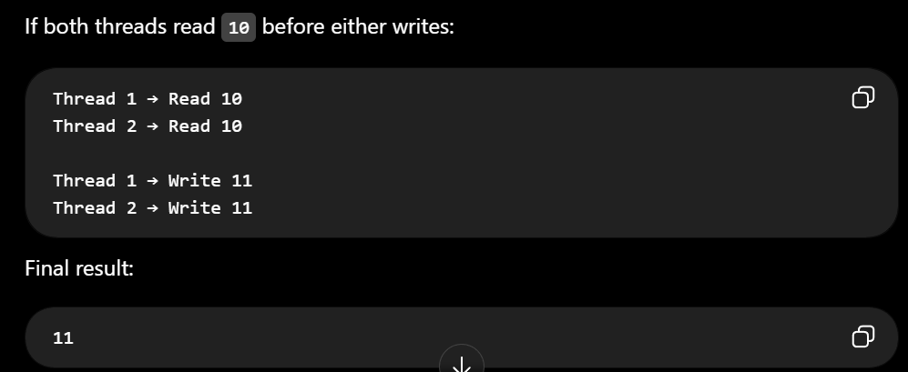

1. What is Virtual Memory?
Virtual memory is a memory management technique that allows a program to use more memory than the available physical RAM by using disk/SSD space as an extension of memory.
2. What is Paging?
Paging is a memory management technique that divides memory into fixed-size blocks.

3. Paging vs Segmentation
🔥 Very important interview question.
Both are memory-management techniques
Paging
Memory is divided into fixed-size blocks.
Segmentation
Memory is divided into variable-sized logical segments based on the program's logical structure.

4. What is a Page Fault?
A page fault occurs when a process tries to access a page that is not currently present in physical RAM.

5. What is Demand Paging?
Demand paging means loading a page into RAM only when it is actually needed.

9. What is a System Call?
A system call is a mechanism used by a user-level program to requests a service from operating system
Common Examples
- Files: Open, read, or write a file.

User Mode
Applications normally run in user mode.
Examples:
Chrome
VS Code

Kernel Mode
The OS kernel runs in kernel mode.
It has privileged access to:
- Hardware
- CPU control

3. What is IPC (Inter-Process Communication)?
IPC stands for Inter-Process Communication.
It refers to mechanisms that allow different processes to communicate and exchange data with each other.


