One of my projects is an Enterprise Document Retrieval System with Hybrid Search and RAG architecture.The main problem I wanted to solve was that,When a organization have a large number of documents such as reports,resumes,PDFs,finding an exact document using traditional keyword searching methods can be difficult.
To solve this,I have developed a hybrid search system that combines three techniques which are semantic search,keyword matching and fuzzy matching. Semantic search helps understand the meaning and context of the query, keyword matching identifies matching terms, and fuzzy search handles spelling variations. By combining these three techniques, the system can helps us to retrieve relevant documents.
In addition to document retrieval,I have implemented RAG(Retrieval-Augmented Generation) so that users can ask questions and get context-based answers based on the retrieved document content.

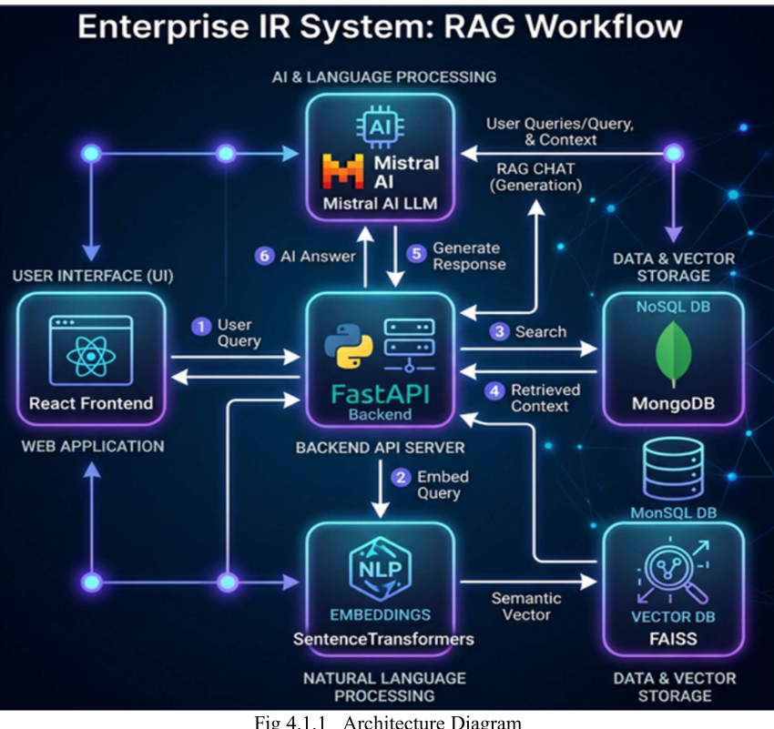
The user can upload PDF documents through the React frontend. The PDF is sent to my FastAPI backend through HTTP Methods.
The backend extracts the text from the PDF using PyPDF2.
After extraction, I divide the document into smaller chunks. I used a chunk size of 500 characters with 100 characters overlap.
“These chunks are converted into embeddings using the all-MiniLM-L6-v2 Sentence Transformer model. These embeddings represent the semantic meaning of the text.
Then I Implemented Hybrid Search System where I combined three approaches. I calculated the scores of all three techniques,normalized them and combined the scores using the weighted score formula to generate hybrid search score and fetch relevant document

For the RAG part, when the user asks a question, I convert the question into an embedding and use FAISS to retrieve the most relevant document chunks. These chunks are then passed as context to the Mistral LLM to generate context-based answer

CHALLENGES FACED IN YOUR PROJECT
1.Challenge — Connecting React frontend with FastAPI backend
“One challenge I faced was connecting my React frontend with the FastAPI backend.
Initially, when React tried to send requests to FastAPI using Axios, the browser blocked the request because the frontend and backend were running on different origins. I got a CORS error.
I learned that CORS, or Cross-Origin Resource Sharing, is a browser security mechanism that controls whether a frontend from one origin can communicate with a backend from another origin.
“I configured CORS in FastAPI using CORSMiddleware. I allowed cross-origin requests by configuring the allowed origins, methods, headers, and credentials. In my project, I used allow_origins=["*"] to allow requests from any origin.”
. After that, the React frontend was able to communicate with the FastAPI APIs successfully.”

2.Challenge — Handling hallucinations from the LLM
“Another challenge was handling hallucinations from the LLM.
Since an LLM can sometimes generate information that is not actually present in the documents, I wanted the answers to be based on the retrieved enterprise documents.
So I implemented RAG with strict prompt engineering.
I instruct the model to answer the user's question only using the provided context.
This helped reduce the chances of the model generating information that was not present in the retrieved documents.

4. Explain the complete architecture of your project.
Our project starts with frontend
The user can upload PDF documents through the React frontend. The PDF is sent to my FastAPI backend through REST APIs.
The backend extracts the text from the PDF using PyPDF2.
After extraction, I divide the document into smaller chunks. I used a chunk size of 500 characters with 100 characters overlap.
“These chunks are converted into embeddings using the all-MiniLM-L6-v2 Sentence Transformer model. These embeddings represent the semantic meaning of the text.
Then I Implemented Hybrid Search System where I combined three approaches. Semantic similarity which uses cosine similarity, keyword matching , and fuzzy matching which uses RapidFuzz library. Then,I combined all three scores and derived hybrid search score.

For the RAG part, when the user asks a question, I convert the question into an embedding and use FAISS to retrieve the most relevant document chunks. These chunks are then passed as context to the Mistral LLM to generate context-based answer
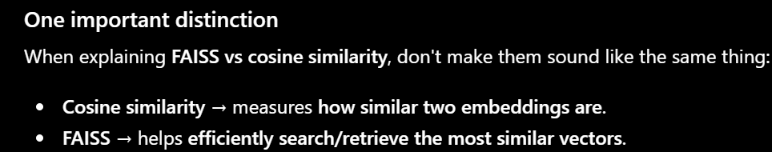
5. How do you implement authentication in FastAPI?
Authentication means:
Who are you?
Common authentication approaches include:
- JWT(Json Web Token) is a security mechanism in authenitication
- Step 1 — Login
- Step 2 — Server verifies credentials
- Step 3 — Server creates JWT
- Step 4 — Client receives token
- Step 5 — Client sends token
- Step 6 — Server verifies JWT

What haven’t you deployed?
I held off on deploying because the project uses sentence-transformers with PyTorch for embeddings, which needs more RAM than free-tier hosting typically offers,

32. Is MongoDB Your Vector Database?
In my project, embeddings are stored in MongoDB, and during retrieval I load them into FAISS which builds in-memory vector index(data structure) to perform fast similarity search. FAISS doesn’t store data permanently — it just temporarily indexes vectors in RAM to find the most relevant results.”
“FAISS is used for fast in-memory similarity search, while MongoDB stores the embeddings permanently.”

2. What Problem Does Your Project Solve?
Answer
The main problem I wanted to solve was that,When a organization have a large number of documents such as reports,resumes,PDFs,finding an exact document using traditional keyword searching methods can be difficult.
Traditional keyword-based search mainly looks for exact words, so it may fail when the user uses different words with the same meaning or makes a spelling mistake.

2. Why did you choose this project?
I have chosen this project because I want to solve the main commonly faced problem in informational retrieval.When a organization have a large number of documents such as reports,resumes,PDFs,finding an exact document using traditional keyword searching methods can be difficult.
So,I chose this project to build efficient search system for enterprises.

3. What are the main features of your project?
Semantic search
Keyword search
Fuzzy search
RAG-based question answering with AI chat

6. What technologies did you use and why did you choose them?
For the frontend, I have used React
For the backend,I have used Python and FastAPI to create REST APIs
For PDF processing, we used PyPDF2 to extract text from PDF files.
For embeddings, I used the Sentence Transformer all-MiniLM-L6-v2, which is a small, lightweight, and efficient embedding model.
For semantic search, I used cosine similarity to calculate the similarity between the query embedding and document embeddings.
For fuzzy matching, I used the RapidFuzz library to handle approximate and spelling-based matches.
For vector search, I used FAISS for fast similarity search over the embeddings.
For database storage, I used MongoDB to store the document chunks and embeddings.
Finally, I integrated RAG using the Mistral LLM to generate answers based on the retrieved document context

7. What was your role/contribution in this project?
“My main contribution was in backend development ,AI integration and database integration.
“My main contribution was in backend development, AI integration, and database integration.
I developed the backend using FastAPI and created the API endpoints required for the application.
I integrated the backend with MongoDB using pymongo.I have also integrated Mistral LLM to the Application by fetching its API Key

5. What improvements would you make if you had more time?
(say this for limitations also)
First, I would like to add vector database to store embeddings
Second, I would improve PDF processing. Currently, I use PyPDF2, which works well for text-based PDFs but doesn't handle scanned PDFs.So,I will use advance tools and libraries to process the data
Third, I would implement authentication and authorization.

8. How do you extract text from PDFs?
“I used the PyPDF2 library to extract text from the uploaded PDF documents
I process the PDF page by page to extract text

18. Which embedding model did you use?
“I used the all-MiniLM-L6-v2 model from Sentence Transformer because it is a small,lightweight and efficient Sentence Transformer model

2. What is Sentence Transformer?
Sentence Transformer is an embedding model that converts text into numerical vector representations called embeddings
7. Why Did You Choose Sentence Transformers?
Answer
“Because it provides high-quality sentence embeddings with low latency

1. What is Fuzzy search?
Fuzzy search is a technique used to find text that is similar to the search query, by handling spelling mistake and words difference by giving a score

1. What is RapidFuzz?
RapidFuzz is a Python library used for fuzzy matching
27. Explain Your Hybrid Scoring Formula
Answer
$$FinalScore=0.6(Semantic)+0.25(Keyword)+0.15(Fuzzy)$$

1. Why did you use MongoDB instead of a vector database?
I used MongoDB because it is already my permanent database linked to my project before generating embeddings.So,Instead of adding a separate vector database,I stored the embeddings in MongoDB to keep architecture simple
However,in my future improvement,I will implement VectorDB

12. Why Did You Use Mistral LLM?
Answer
“Mistral LLM provides accurate responses and provides free APIs

33. Why Did You Use Temperature = 0.2?
Answer
“Lower temperature produces more stable and less random answers, which is important for enterprise systems.”

37. Why Is Your Project Different From Normal Chatbots?
Answer
“Normal chatbots rely only on pretrained knowledge.
My system retrieves real enterprise documents dynamically before generating answers.”
38. What Happens if No Relevant Chunk is Found?
Answer
“The system returns the user that relevant information was not found.”

20. What APIs Did You Create?
Answer
“I created:
- /upload → upload and process PDFs
- /search → hybrid search
- /chat → RAG-based AI chat”
Your backend indeed contains these APIs.
36. What Improvements Can Be Added?
Answer
“Future improvements:
- authentication
- advanced vector databases like Pinecone or ChromaDB”

1. How does your frontend communicate with your backend?
Answer:
My React frontend communicates with my FastAPI backend using REST APIs over HTTP.

3. How do you handle errors in your API?
Answer:
I handle errors using exception handling and HTTPException Class
401 – Unauthorized
404 – Resource Not Found

6. How do you connect your backend to MongoDB?
Answer:
I connect my FastAPI backend to MongoDB using a MongoDB driver such as PyMongo

7. How do you handle database failures?
Answer:
I handle database failures using exception handling, using HTTPException class which provides proper error descriptions

7. What happens if MongoDB is unavailable?
“If MongoDB is unavailable,I will catch exception using HTTPExeption class which return an appropriate error response to the frontend. The frontend can then display an error message to the user instead of the application crashing.”

2. How does a request travel from React to FastAPI?
“When the user performs an action, React sends an HTTP request using Axios. The request reaches the corresponding FastAPI endpoint. FastAPI validates the request, performs the required business logic, interacts with MongoDB if needed, and then sends a JSON response back to React. React receives the response and updates the UI.”

What is Axios?
Axios is a JavaScript library used to make HTTP requests from your web browser to a backend server or external API.
While modern browsers come with a built-in fetch() API, many React developers prefer Axios because it simplifies repetitive tasks

1. How would you improve the ranking algorithm?
“Currently, I use a weighted combination of semantic, keyword, and fuzzy scores. To improve it, I could tune the weights using real search data and user feedback

2. What metrics would you use to evaluate retrieval?
Initially,I will use my application and generate sample set “I would use metrics such as Precision@K and Recall@K

3. How would you improve retrieval accuracy?
“I would improve the chunking strategy, tune my hybrid score mechanism

4. How would you handle thousands or millions of documents?
I’m currently using MongoDB which is not a vectorDB where it can’t efficiently handle millions of embeddings
Use VectorDB like ChromaDB
For student projects, ChromaDB is the most widely used and recommended vector database. It is popular because it can be installed locally with a single line of code (pip install chromadb) and easy maintained

5. What are the scalability limitations of your current approach?
I’m currently using MongoDB which is not a vectorDB where it can’t efficiently handle millions of embeddings

6. What happens when the FAISS index becomes very large?
“A very large index can consume a lot of memory and searching becomes slow

7. How would you update the FAISS index when a new document is uploaded?
“When a new document is uploaded, I would extract and chunk its text, generate embeddings for the new chunks, store them in MongoDB, and then add those new vectors to the FAISS index

3. How did you implement authentication in your project?
“Authentication is not implemented in my current version.In further improvements,I would like to implement JWT(Json Web Token) mechanism

