One of my key projects is SkillGap-AI which is an AI-Powered Resume Analysis System
The main problem I wanted to solve was that many students apply for jobs without tailoring their resume to that particular job role.
So, I built an AI-powered resume analysis system which takes a candidate's resume and a target job role and analyzes them to identify the candidate's missing skills, readiness score, learning resources, project recommendations, and a personalized learning roadmap.

Coming to the technology stack, I used React for the frontend, FastAPI for the backend, MongoDB for storing the analysis results, Mistral LLM for intelligent skill analysis, and PyPDF2 for extracting text from the resume PDF. I deployed the backend on Render and the frontend on Vercel.

Coming to the workflow, First, the user uploads their resume PDF and selects a target job role from the React frontend.
The frontend sends the resume and target role to my FastAPI backend through a POST request. I created an /analyze-skills API endpoint in FastAPI that receives the target role and the uploaded PDF.
Once the backend receives the resume, I use PyPDF2 to extract the text from the PDF page by page. This extracted text is then combined with the target role and passed to the Mistral LLM
I designed a structured prompt for the Mistral model that instructs it to analyze the candidate's skills, identify missing skills, calculate a readiness score, recommend courses and projects, and generate a learning roadmap.
After receiving the AI-generated analysis, I store the results in MongoDB.

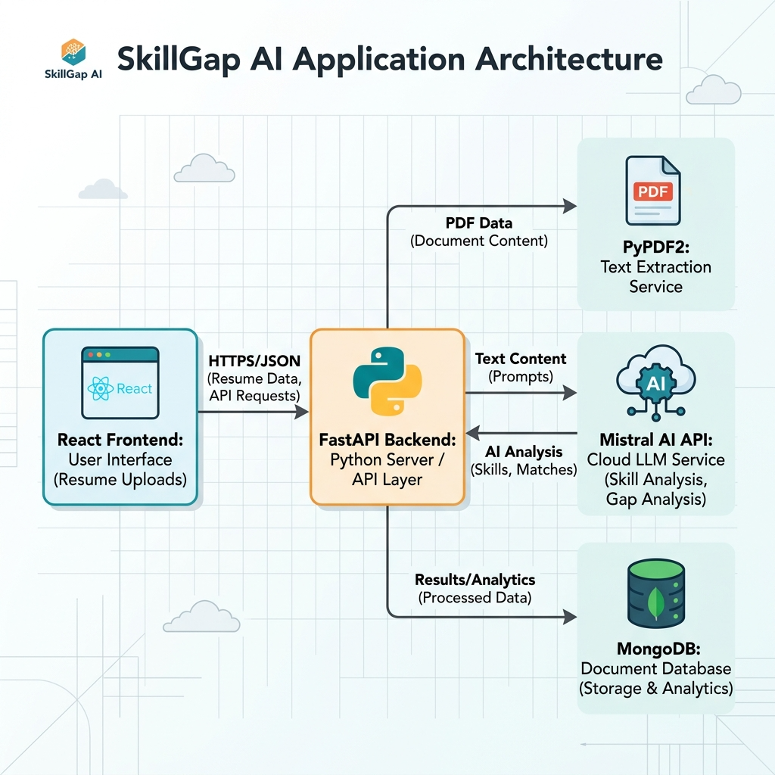
2. What problem does your project solve?
The main problem I wanted to solve was that many students apply for jobs without checking whether their skills actually match the requirements of the particular job role.
So, I built an AI-powered resume analysis system

3. Why did you choose this project?
I have chosen this project because I want to solve a problem in today’s job applicants.
The main problem I wanted to solve was that many students apply for jobs without checking whether their skills actually match the requirements of the particular job role.

7. What was your role/contribution in this project?
“My main contribution was in backend development, AI integration, and database integration.
I developed the backend using FastAPI and created the API endpoints required for the application.
I integrated the backend with MongoDB using pymongo.I have also integrated Mistral LLM to the Application by fetching its API Key

What are routes in your project?what does each do!
• GET / — Checks whether the backend server is running.
• POST /analyze-skills — Uploads a resume and target role, extracts resume text, sends it to Mistral AI for skill-gap analysis, and stores the result in MongoDB.

12. Explain your /analyze-skills endpoint.
Answer:
I created the /analyze-skills endpoint using a POST request.
It receives two inputs:
- target_role — the job role selected by the user
- resume_file — the uploaded resume PDF
The backend then:
- Reads the uploaded PDF.
- Extracts its text using PyPDF2.
- Combines the extracted text with the target role.
- Sends this information to the Mistral LLM.
- Receives the AI-generated analysis.
- Extracts the JSON response.
- Stores the result in MongoDB.
- Returns the analysis to the frontend.

14. What is UploadFile in FastAPI?
Answer:
UploadFile is a FastAPI class used to handle uploaded files.
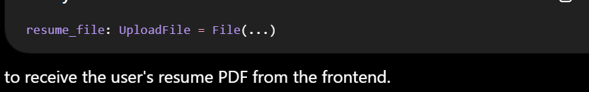
15. Why are you using Form() and File()?
Answer:
Because my request contains both normal form data and a file.
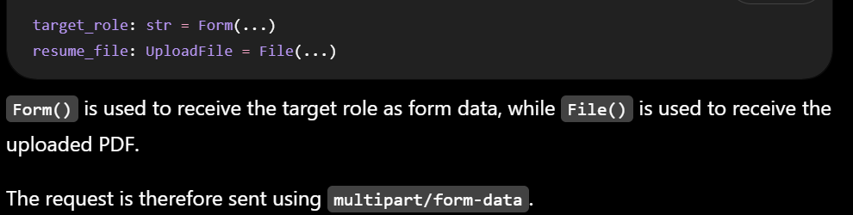
19. How did you solve the CORS problem?
Answer:
I used FastAPI's CORSMiddleware.
I configured the backend to allow the required origins, HTTP methods, and headers.
22. Explain how you extract text from the PDF.
Answer:
First, I read the uploaded PDF file using UploadFile.
Then I create a PdfReader using PyPDF2 and iterate through each page.

Challenges faced durning project development
Challenge — Connecting React frontend with FastAPI backend
“One challenge I faced was connecting my React frontend with the FastAPI backend.
Initially, when React tried to send requests to FastAPI using Axios, the browser blocked the request because the frontend and backend were running on different origins. I got a CORS error.
I learned that CORS, or Cross-Origin Resource Sharing, is a browser security mechanism that controls whether a frontend from one origin can communicate with a backend from another origin.
I solved this by configuring CORS middleware in FastAPI and allowing the required frontend origin, methods and headers. After that, the React frontend was able to communicate with the FastAPI APIs successfully.”
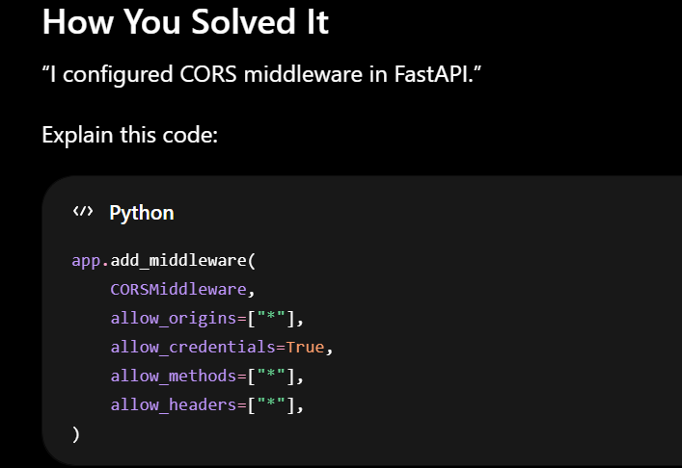
1. Challenge — Extracting text from different PDF/resume formats
“One challenge I faced was extracting clean text from different resume PDF formats.
I used PyPDF2 to extract text from the uploaded PDF files. It worked well for normal text-based PDFs, but some resumes contained tables, multiple columns, or scanned content, which made text extraction difficult.
To handle this, I implemented page-by-page text extraction and added validation before sending the extracted content to the AI model.

Why MongoDB?
“Because AI responses are semi-structured and MongoDB handles flexible JSON-like documents efficiently.”

How is readiness score calculated?"
The readiness score is generated by Mistral LLM by comparing the skills required with the skills mentioned in the resume.

Why Mistral Instead of Traditional ML?
"I chose an LLM because my task requires understanding the semantic context of resumes and generating output .Traditional machine learning models cannot understand the context of the resumes properly.Along with it requires large label resume dataset for training.

2.How Did You Handle Invalid AI Responses?
What happens if Mistral returns extra text?
Sometimes the AI returned responses with:
- extra explanations
- invalid JSON structure
So,I have implemented a custom JSON extraction function which handles this exception.

6. Why React?
Answer:
"I used React for the frontend because it is a component-based JavaScript library that makes it easier to build interactive user interfaces

8. How does React communicate with FastAPI?
Answer:
"The React frontend communicates with FastAPI through HTTP requests

10. Why POST for resume upload?
The client is submitting data to the server for processing so we use POST
14. Why Mistral?
Answer:
"I used Mistral because my project requires understanding the semantic context of a resume and comparing it with a target job role and generate the response.

17. How did you design your prompt?
This is another very important project-specific question.
Based on your document, you can say:
"I designed the prompt by providing the extracted resume text and the selected target role as inputs. Then I clearly instructed the Mistral model to analyze the candidate's skills, identify missing skills, provide a readiness score, recommend learning resources and projects, and generate a personalized roadmap

3. How would you improve the project if you had more time?
“If I had more time, I would improve the PDF processing by supporting scanned resumes,processing tables using advanced tools and libraries
Second, the readiness score is generated by LLM.So,I will try to develop a mechanism to calculate readiness score using python code

4. What are the limitations of your project?
You already identified the two important ones: scanned documents and AI hallucination.
“There are a few limitations. First, PyPDF2 works mainly with text-based PDFs, so scanned resumes may not be processed correctly. Second, because the analysis is generated by an LLM, the model can sometimes hallucinate or provide inaccurate recommendations.

5. What would you change if you built it again?
“If I had more time, I would improve the PDF processing by supporting scanned resumes,processing tables using advanced tools and libraries
Second, the readiness score is generated by LLM.So,I will try to develop a mechanism to calculate readiness score using python code

