Q66. What is a function in Python?
Answer:
A function is a block of code that performs a specific tasks.
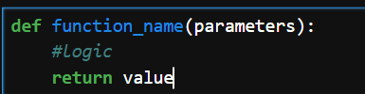
Python provides:
- Built-in functions (e.g., print(), len(), type()) ,count(),sort(),reverse()
- User-defined functions (created using the def keyword)

Q67. What are function arguments?
Answer:
Arguments are the values passed to a function when it is called
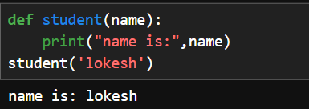
Here,name is the parameter and ‘lokesh’ is an argument.

Q68. What is the difference between parameters and arguments?
Answer:
Parameter | Argument
Variable defined in the function definition | Actual value passed to the function
Receives data | Sends data
Exists when the function is defined | Exists when the function is called
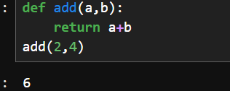
Types of Arguments:
1.Positional Arguments
2.Keyword Arguments
3.Default Arguments
4.Variable-Length Arguments(*args and **kwargs)

1.Positional Arguments:
In positional arguments,Values/Arguments are passed to parameters based on their position.
Therefore,the order of arguments are important
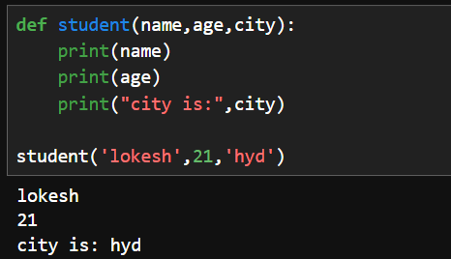
2.Keyword Arguments:
In Keyword Arguments,Keyword arguments are arguments passed using the parameter names.
Therefore,the order doesn’t matter
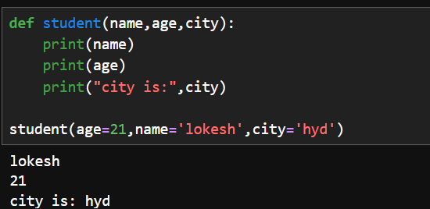
3.Default Arguments:
A default value is assigned to the parameter.If argument is not assigned to the parameter then Python uses this default argument.
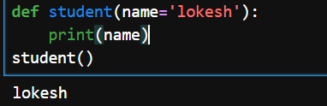
4.Variable-length Arguments:
Sometimes,we don’t know how many arguments will be passed.
So,for that Python provides:
*args-> Multiple positional arguments
*kwargs->Multiple keyword arguments

*args
*args collects multiple positional arguments into a tuple
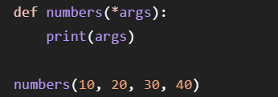
**kwargs
**kwargs collects multiple keyword arguments into a dictionary.
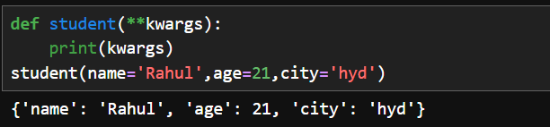

1. What is the difference between a function and a method?
Function
A function is a independent block of code that performs a specific task whereas method is a function that belongs to class or object.
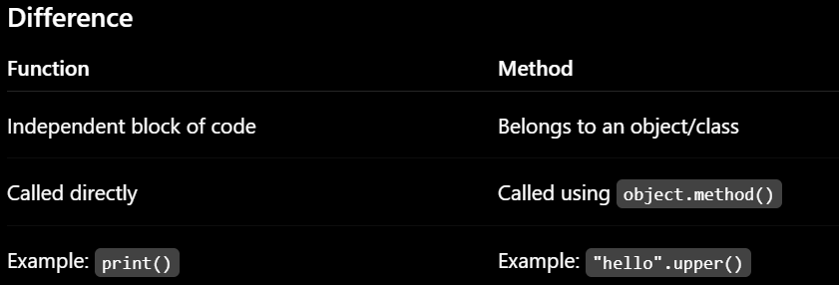
2. Can a function return multiple values?
Answer
Yes.
Python allows a function to return multiple values by separating them with commas.
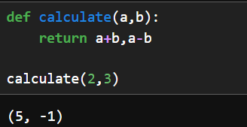
3. What happens if you don't write a return statement?
Answer
If a function has no return statement, Python automatically returns None.
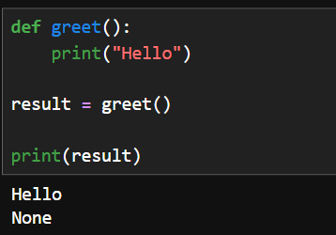
4. What is the difference between print() and return?
print()
- Displays output on the screen.
- Does not send a value back to the caller.
return
Sends a value back to the caller.
- The returned value can be stored, reused, or passed to another function.

6. Can you mix positional and keyword arguments?
Answer
Yes, but positional arguments must come before keyword arguments.
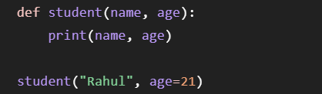

Q71. What are variable-length arguments (*args and **kwargs)?
Answer:
Variable-length arguments allow a function to accept a varying number of arguments,
There are two types:
*args:Accepts multiple positional arguments
**kwargs:Accepts multiple keyword arguments
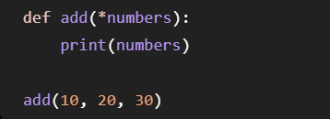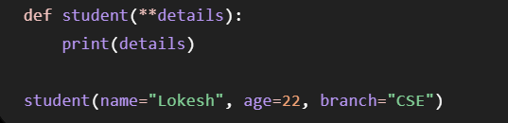
Q72. What is recursion?
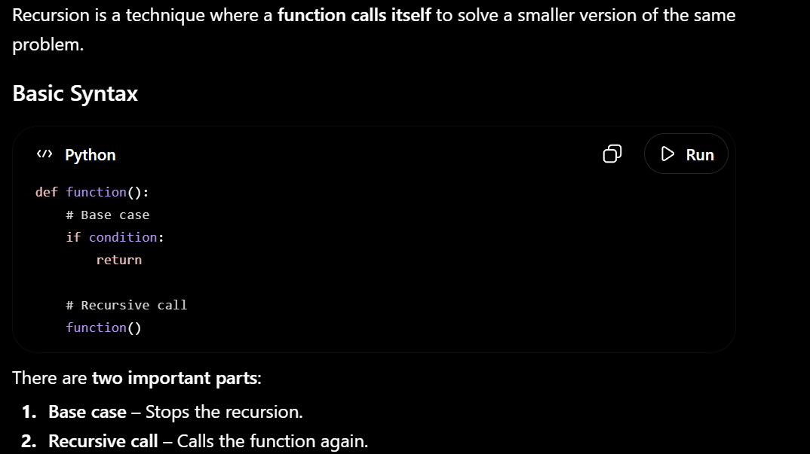
Q73. What is a lambda function?
Answer:
A lambda function is an small anonymous function written using lambda in a single line of code.
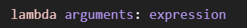
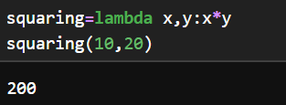
Q74. What are anonymous functions?
Answer:
An anonymous function is a function without a name.
In Python, anonymous functions are created using the lambda keyword.

Q75. What is the difference between a lambda function and a normal function?
Answer:
Lambda Function | Normal Function
Defined using lambda | Defined using def
Anonymous (no function name required) | Has a function name
Single expression only | Can contain multiple statements

1. Can a function have both *args and **kwargs?
Answer
Yes.
A function can have both *args and **kwargs.
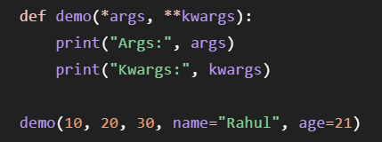

2. What happens if a recursive function has no base case?
Answer
A recursive function will keep calling itself indefinitely until Python reaches its recursion limit.
At that point, Python raises a:
RecursionError: maximum recursion depth exceeded

3. Why is recursion slower than iteration?
Answer
- Recursion is generally slower because: Every recursive call creates a new function call

4. Can a lambda function contain multiple statements?
Answer
No.

6. What is the maximum recursion depth in Python?
Answer
By default, Python allows about 1000 recursive calls.

OOPS
Q76. What is Object-Oriented Programming (OOP)?
Answer:
Object-Oriented Programming (OOP) is a programming paradigm that organizes programs using objects and classes.
The four main principles (pillars) of OOP are:
- Encapsulation
- Inheritance
- Polymorphism
- Abstraction

Q77. What is a class?
Answer:
A class is logical entity which acts as a blueprint or template used to create objects.”
It defines variables and methods of the objects
Basically, The class defines what an object should contain.
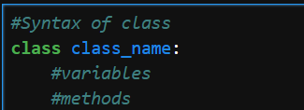
Q78. What is an object?
Answer:
An object is a physical entity which is a instance of class
Each object has its own variables and methods
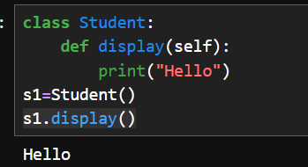
Q79. What is a constructor (__init__) in Python?
Answer:
A constructor is a special method that is automatically called when an object is created.
It is mainly used to initialize object attributes.
In Python, the constructor is written as __init__
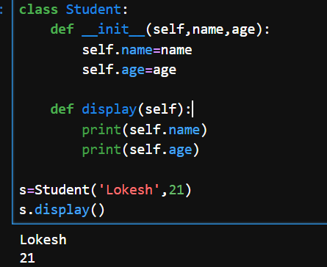
Q80. What is inheritance?
Answer:
Inheritance is an OOP feature where one class acquires the properties and methods of another class.
The existing class is called the Parent (Base) class, and the new class is called the Child (Derived) class.
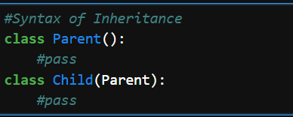
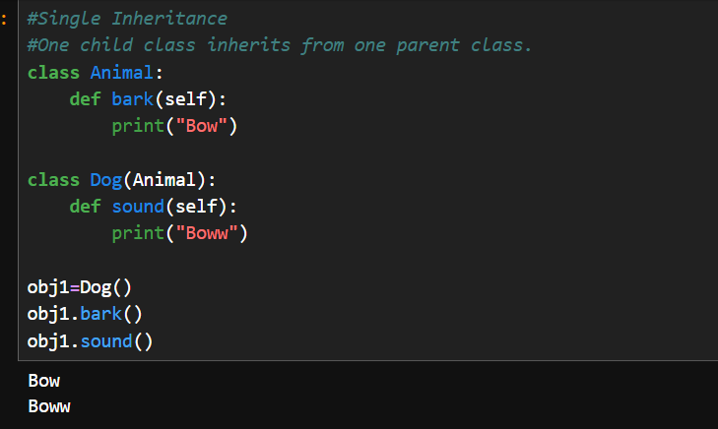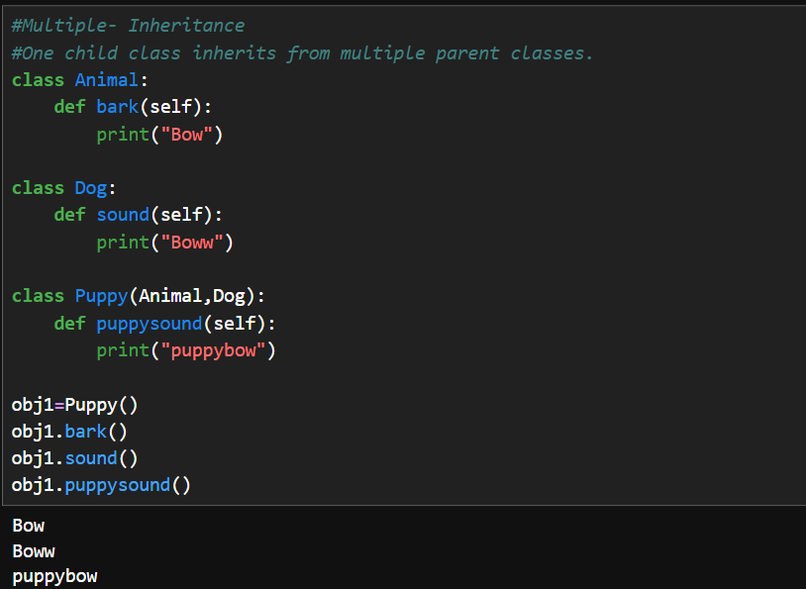
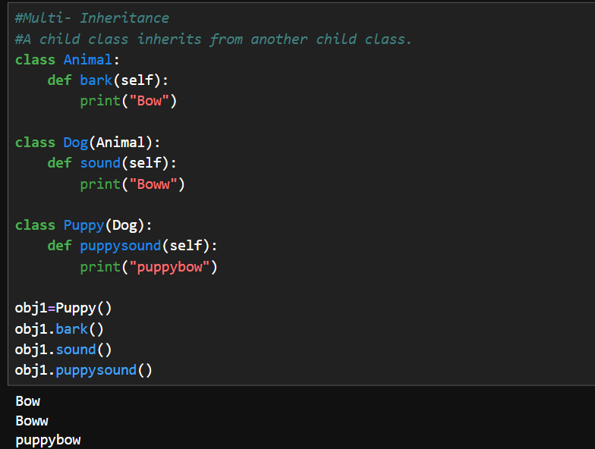
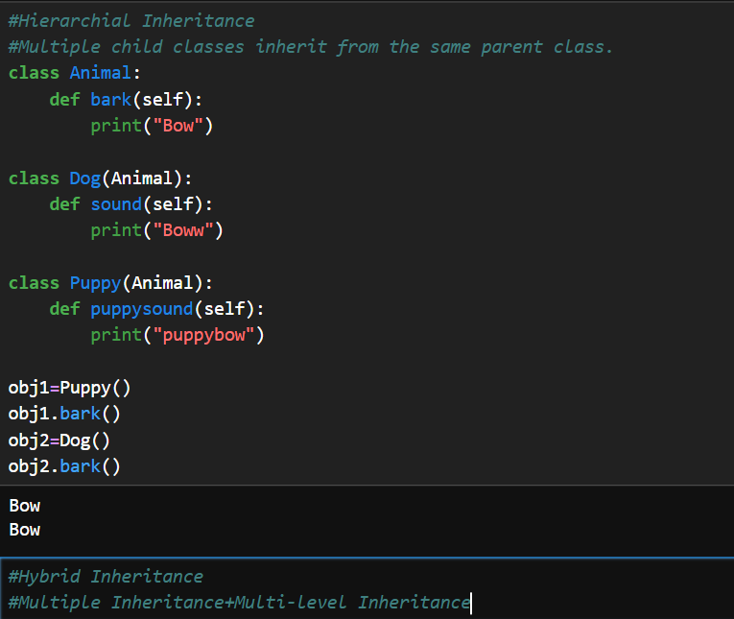
2. Can a class exist without an object?
Answer
Yes.
But vice-versa is false.

Q81. What is polymorphism?
Answer:
Polymorphism means "many forms." It allows the different/multiple methods with same name to perform different actions depending on the object that calls it.
In Python, polymorphism is mainly achieved through method overriding.
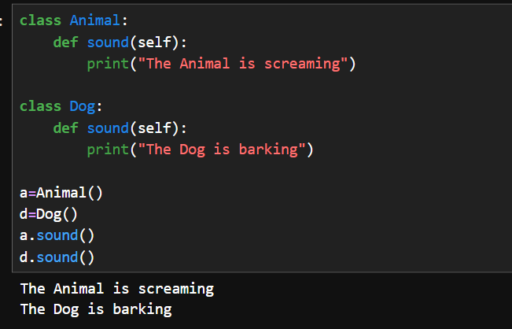
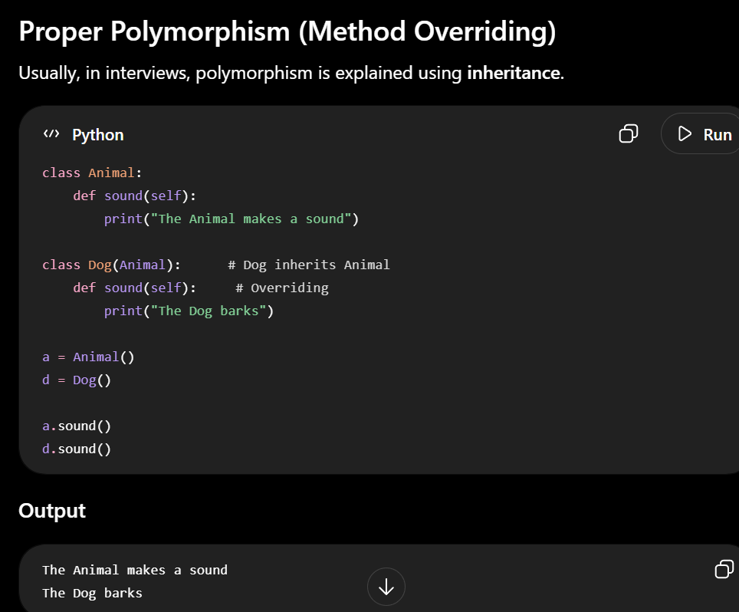
Q85. What is method overriding?
Answer:
Method overriding occurs when a child class provides its own implementation of a method that already exists in the parent class.

What is Method Overloading?
Method overloading means having multiple methods with the same name but different numbers or types of parameters performs different actions
In languages like Java and C++, method overloading is supported directly.
Python does not support method overloading in the traditional sense.
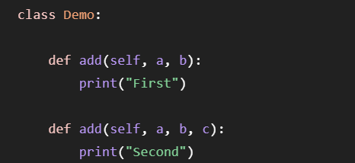
Difference Between Method Overloading and Method Overriding
Method Overloading | Method Overriding
Same method name with different parameters | Same method name and same parameters
Not directly supported in Python | Fully supported in Python

Q82. What is encapsulation?
Answer:
Encapsulation is the process of wrapping data (variables) and methods (functions) into a single unit (class) and restricting direct access to some of the object's data.
It helps protect data from accidental modification.
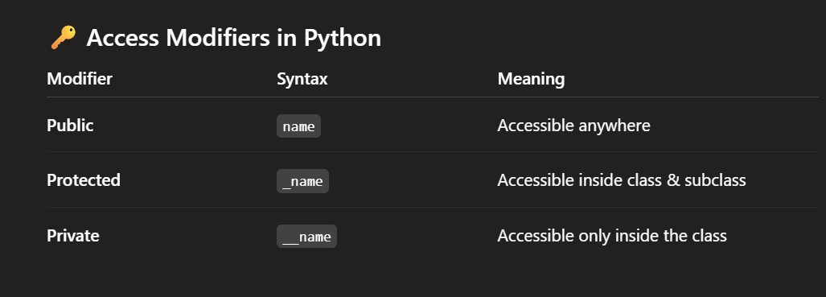
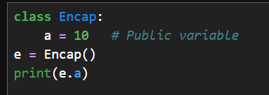
A member without an underscore is considered public.
A protected member starts with one underscore _.
A private member starts with two underscores __.
Anyone can change the value directly.
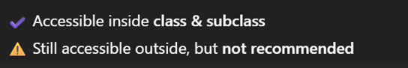
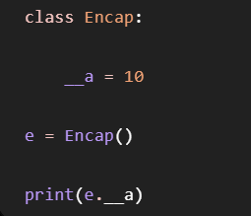

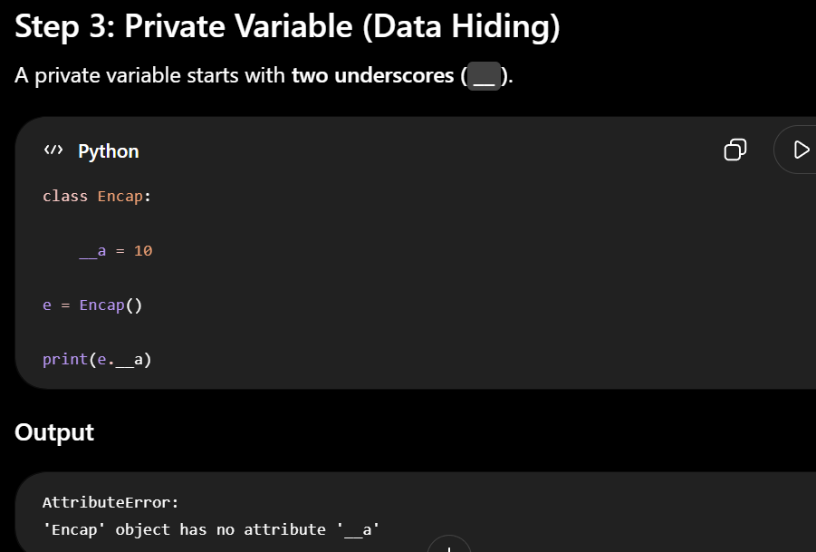`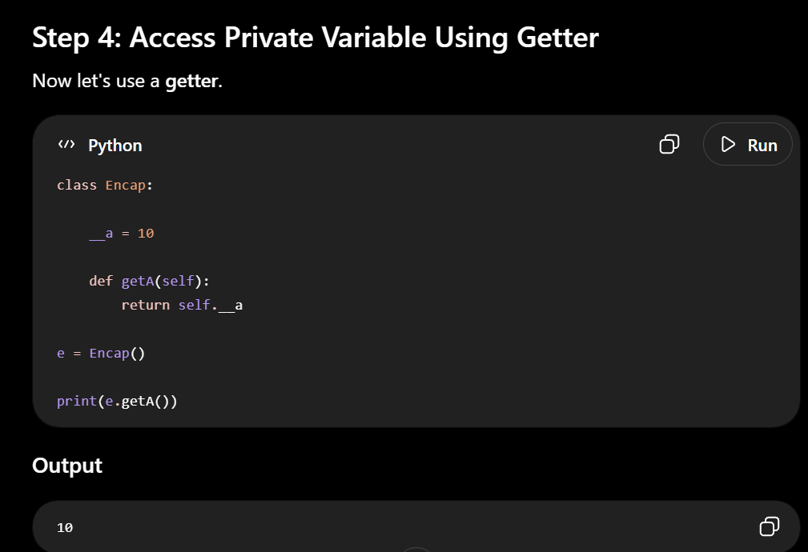
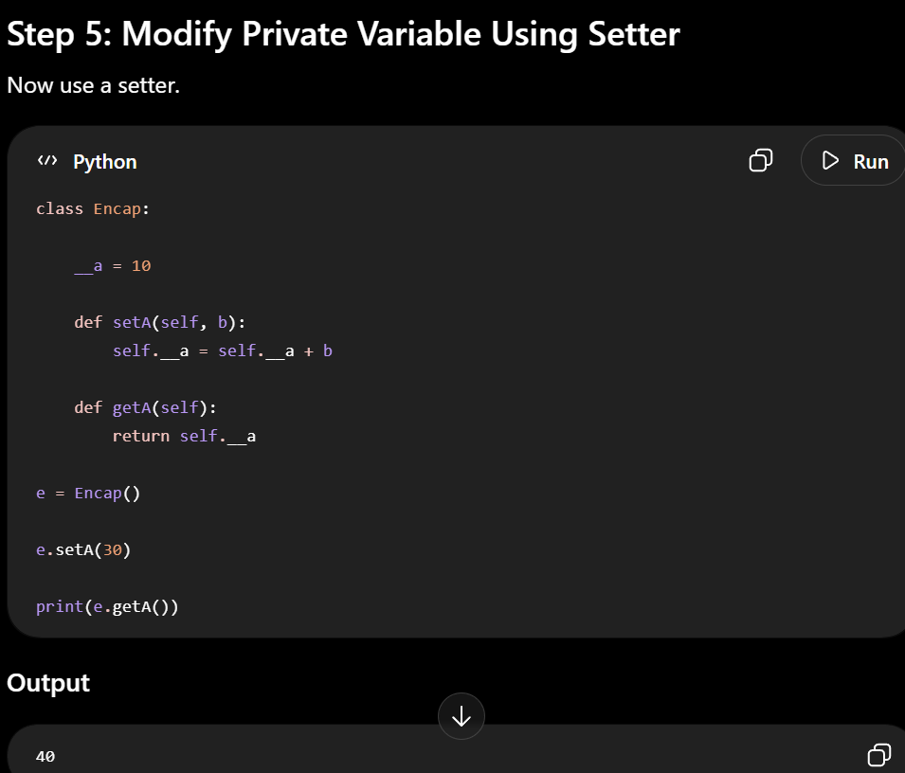

Difference Between Encapsulation and Abstraction
Encapsulation
Hide the data
Example:
__balance
Only getter/setter can access it.

Abstraction
Hide the implementation

Q83. What is abstraction?
Answer:
Abstraction means hiding implementation details and showing only the essential functionality to the user.
Python provides the abc (Abstract Base Class) module.
Abc module provides abstract class and abstract method.

So,basically abstract class should be inherited by sub-classes and abstract method should be strictly implemented in sub-classes inorder to hide implementation details
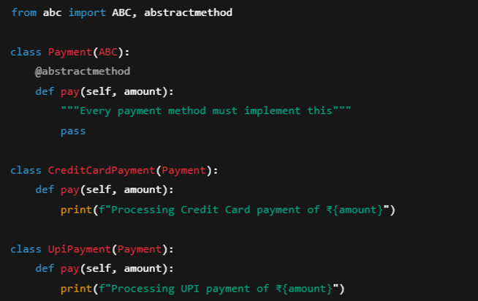
Can we create an object of an abstract class?
- Answer: No. An abstract class cannot be instantiated directly.

EXCEPTIONAL HANDLING
Q86. What is an exception in Python?
Answer:
An exception is an error that occurs during the execution of a program. When an exception occurs, the normal flow of the program is interrupted.
Examples of Exceptions:
- ZeroDivisionError
- ValueError #age = "25" + 5
- TypeError # number = int("banana")
- IndexError
- KeyError
- FileNotFoundError
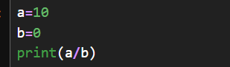
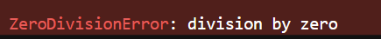

Q87. What is the difference between syntax errors and exceptions?
Answer:
Syntax Error | Exception
Occurs due to incorrect Python syntax. | Occurs during program execution due to error in logic
Detected before execution. | Detected while the program is running.

3. What is Exception Handling?
Answer
Exception handling is a mechanism to catch and handle runtime errors gracefully so that the program continues executing instead of terminating unexpectedly
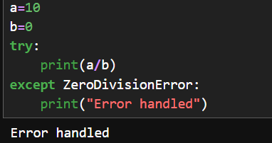
4. What is try?
Answer
The try block contains the code that may cause an exception.
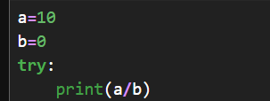
5. What is except?
Answer
The except block handles the exception that occurs in the try block.
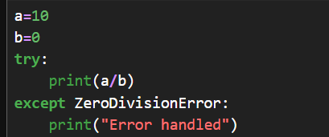
Q88. What is try-except?
Answer:
try-except is used to handle exceptions gracefully. Code that may raise an exception is placed inside the try block. If an exception occurs, the corresponding except block executes.
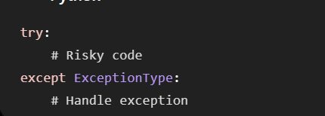
6. What is else in Exception Handling?
Answer
The else block executes only if no exception occurs.
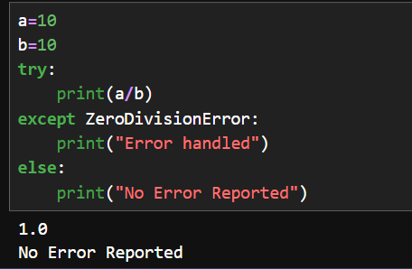
7. What is finally?
Answer
The finally block always executes, whether an exception occurs or not.
It is commonly used for cleanup tasks such as closing files or database connections.
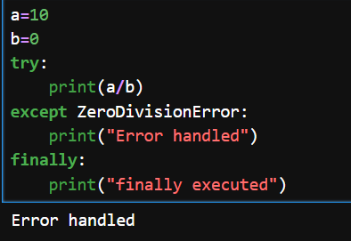
8. What is the raise Statement?
Answer
The raise statement is used to manually generate an exception.
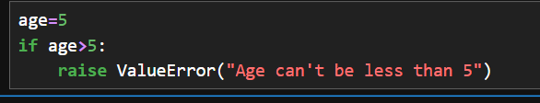
Q91. What is a custom exception?
Answer:
A custom exception is a user-defined exception created by inheriting from Python's built-in Exception class.
It is used when built-in exceptions do not clearly describe a specific application error.
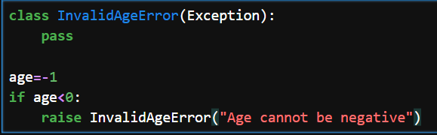
10. Difference Between Exception and BaseException
BaseException
- The top-most class for all exceptions in Python.
- Includes system-level exceptions like:
  - SystemExit
  - KeyboardInterrupt
Exception
- Derived from BaseException.
- Used for normal application errors.

Can we write try without except?
- Answer: Yes, if it has a finally block.

• Can a try block have multiple except blocks?
Yes, a try block can have multiple except blocks. This structure allows your program to capture and handle different types of errors

Q92. What are file modes (r, w, a, x) in Python?
Answer:
File modes are used to perform operations on the file
Mode | Description
r | Read mode. Opens an existing file for reading. Raises an error if the file does not exist.
w | Write mode. Creates a new file if it does not exist. If the file exists, its contents are overwritten.
a | Append mode. Adds data to the end of an existing file. Creates the file if it does not exist.
x | Exclusive creation mode. Creates a new file. Raises an error if the file already exists.
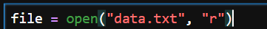

Q93. What is the difference between read(), readline(), and readlines()?
Answer:
These methods are used to read data from a file.
Method | Description
read() | Reads the entire file (or a specified number of characters).
readline() | Reads one line at a time.
readlines() | Reads all lines and returns them as a list.

Q94. What is the with statement?
Answer:
with statement is used for automatic resource management and exception handling
The with statement is used to open files safely. It automatically closes the file after the operations are completed, even if an exception occurs.
__enter__ and __exit__ methods are magic methods used with WITH Statement
__enter__ handles setup phase.(Opening an file)
__exit__handles leaving phase(Closing an file)
Q95. Why should we close a file?
Answer:
Closing a file releases the system resources associated with it and ensures that all buffered data is written to the file.

Q96. What is a module in Python?
Answer:
A module is a single Python file (.py) that contains variables, functions, and classes which can be reused in other Python programs.
Python provides:
- Built-in modules (e.g., math, random, os)
- User-defined modules

Q97. What is a package in Python?
Answer:
A package is a collection of related Python modules organized into directories.
It helps organize large projects by grouping related functionality together.
Example structure:
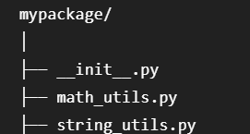

Q98. What is __name__ == "__main__"?
Answer:
"__main__" is the name of the environment where your code runs,
Every Python module has a special built-in variable called __name__.
- If the file is run directly, __name__ is set to "__main__".
- If the file is imported as a module, __name__ is set to the module's name.
"__main__" is the name of the environment where your top-level code runs,
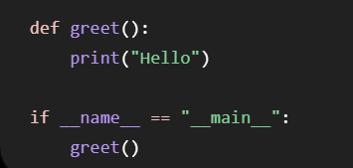
Why is it used?
- To ensure that certain code runs only when the file is executed directly.
- To prevent that code from running when the file is imported into another program.

Q99. What is a virtual environment in Python?
Answer:
A virtual environment is an isolated environment created for a Python project where you can install and manage that project's packages separately from other projects
Why use a virtual environment?
- Avoids dependency conflicts.
- Allows different projects to use different package versions.
- Keeps project dependencies isolated.
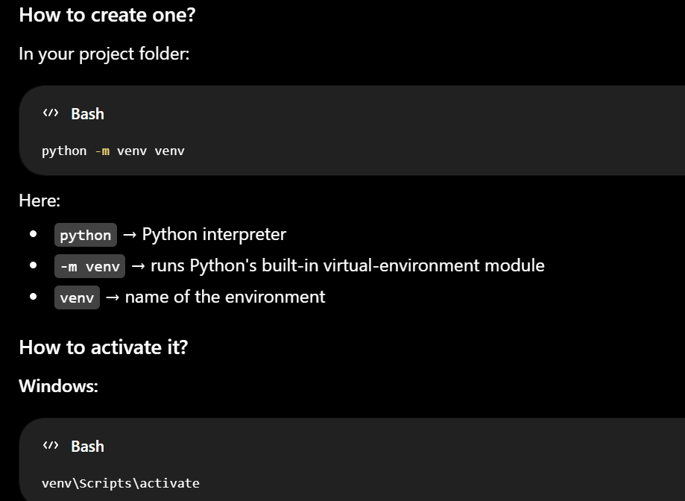

100. What is the difference between shallow copy and deep copy
Copying means creating another object from an existing object.
Python provides two types of copying:
- Shallow Copy
- Deep Copy

1. Shallow Copy
Definition
A shallow copy creates a new outer object, but the nested (inner) objects are shared between the original and the copy.
So, if you modify a nested object, both the original and copied objects are affected.
But Changing the Outer List Doesn't Affect the Original
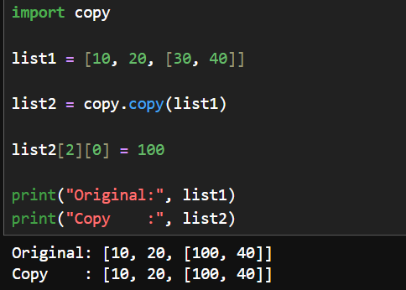
2. Deep Copy
Definition
A deep copy creates a completely independent copy, including all nested objects


