1. What is the self keyword in Python?
self refers to the current object (instance) of a class.
self is useful—when an object wanted to call a particular method

3. What is the cls keyword?
cls refers to the current class itself

4. What is the difference between self and cls?
self | cls
Refers to the current object | Refers to the current class

5. What is the super() function?
super() is used to access methods and attributes of a parent class from a child class.
It is commonly used in inheritance.
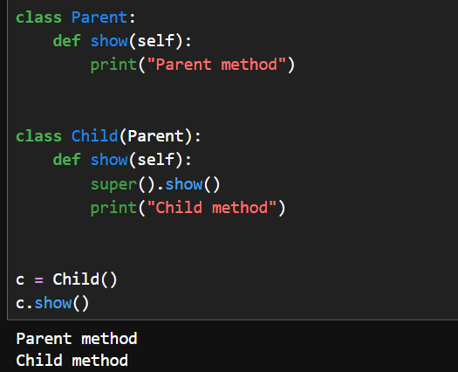
The main reason is to reuse the parent class's functionality instead of writing the same code again.

Difference Between @staticmethod, @classmethod, and Instance Methods
Instance Method: Takes self as first parameter, can access and modify instance attributes and class attributes.
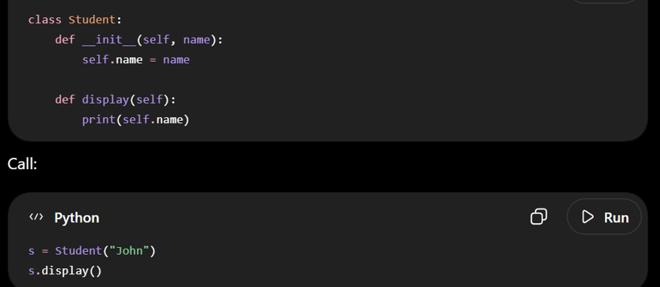
@classmethod: Takes cls as first parameter, can access/modify class-level attributes, cannot access instance attributes.
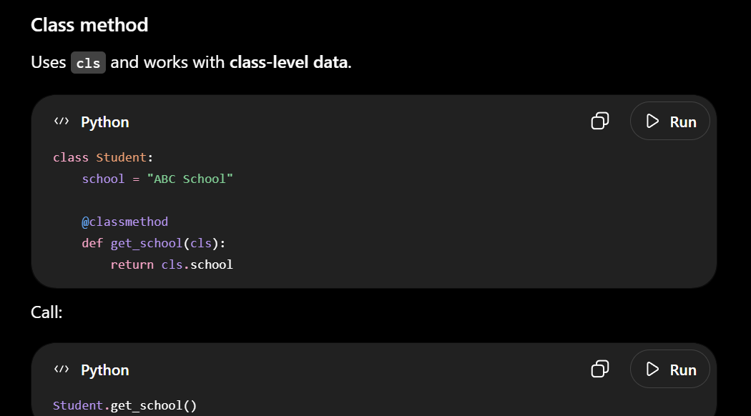
@staticmethod: Takes NO special first parameter, behaves like a regular function but belongs to class
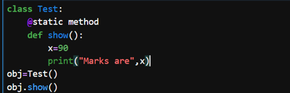
7. What are Instance Variables?
Instance variables are variables that work with specific object.
They are usually created using self.

Here self.name and self.marks are instance variables

8. What are Class Variables?
Class variables are variables that belong to the class itself.
They are shared by all objects of that class.
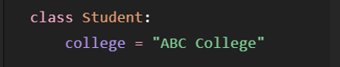



14. What is the @classmethod decorator?
@classmethod is a decorator used to create a class method.

15. What is the @staticmethod decorator?
@staticmethod is used to create a static method.

16. Can constructors be overloaded in Python?
No, Python does not support traditional constructor overloading.

1. Difference between __new__() and __init__()
Both are involved when creating an object, but they do different jobs.
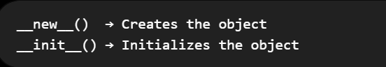

2. What is the purpose of __del__()?
__del__ is used to perform cleanup operations right before an object is destroyed

3. What are Magic (Dunder) Methods?
Magic methods, also called dunder methods, are special Python methods whose names start and end with double underscores.
Example: __new__(),__init__(),__del__()
5. What is Object Introspection?
Object introspection means examining an object to find information about it.
You can find things like:
- What type is the object?
- What methods does it have?
- What is its class?

Variables & Scope
- What is the difference between local and global variables?
- What is the global keyword?
- What is the nonlocal keyword?
- What is variable scope in Python?
- What is the LEGB rule?
- What is the difference between locals() and globals()?
- Can a local variable and a global variable have the same name?
- What is variable shadowing?

31. What is the difference between local and global variables?
Local variable
A variable created inside a function is a local variable. It can normally be accessed only inside that function.
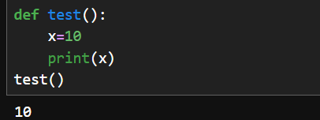
A variable created outside all functions and classes is a global variable
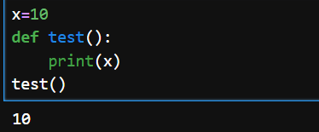
32. What is the global keyword?
The global keyword is used inside a function when you want to modify a global variable.
128. What is the `nonlocal` keyword?
Nonlocal keyword is used to modify the variable in outer function but not global variable

34. What is variable scope in Python?
Variable Scope means the upto which part of code a variable can be accessed.

35. What is the LEGB rule?
LEGB Rule is a rule used by python to search for a variable

36. Difference between locals() and globals()
locals() → returns the local variables.
globals() → returns the global variables.

37. Can a Local Variable and Global Variable Have the Same Name?
Yes.

38. What is Variable Shadowing?
Variable shadowing occurs when a variable has same name in outer function and inner(nested function)
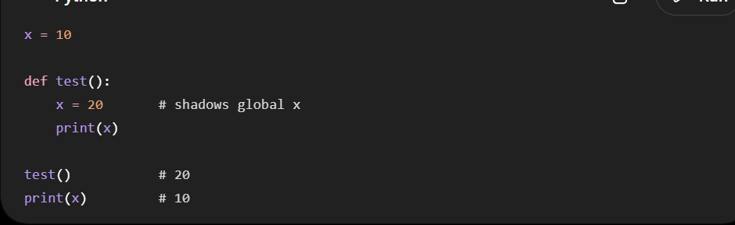

## Memory Management

101. What is Garbage Collection in Python?
102. How does Python manage memory?
103. What is reference counting?
104. What is the Global Interpreter Lock (GIL)?
105. Why does Python use the GIL?
106. What are memory leaks in Python?
107. How can you optimize memory usage?

101. What is Garbage Collection in Python?
Garbage Collection (GC) is the process removing objects that are no longer in use
Python has automatic garbage collection mechanism
Garbage collector is the specific tool
Example
x = [1, 2, 3]
Memory is allocated.
Later,
x = None
The list has no references anymore.
Python automatically removes it from memory.

Why Garbage Collection?
Without it,
- Unused objects stay in memory.
- RAM becomes full.

2. How does Python manage memory?
Python mainly uses:
- Reference counting
- Cyclic garbage collector

3. What is Reference Counting?
Reference Counting is Python's primary memory management technique.
When the references count of an object becomes zero,it automatically gets deleted
Every object stores the number of references pointing to it.
When the count becomes zero,
Python immediately removes the object.

Cyclic Garbage Collector :
Cyclic Garbage collector is a technique used to remove objects that are in cyclic references

4. What is Cyclic Reference?
A cyclic reference is a situation occurs when two or more objects reference each other in a closed loop
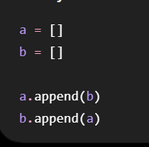
Even though a,b are None.. The two lists still reference each other.

Python solves this using Cyclic Garbage Collector
The cyclic garbage collector checks and removes the objects which are no longer useful.

104. What is the GIL?
GIL = Global Interpreter Lock.
The Global Interpreter Lock (GIL) is a lock in CPython that allows only one thread to execute Python bytecode at a time.

5. Why does Python use the GIL?
The GIL exists mainly to make memory management simpler and execution smoother,faster without interruption

6. What are memory leaks in Python?
Definition
A memory leak occurs when memory that is no longer needed is not released, causing the program's memory usage to keep growing.
Although Python has garbage collection, leaks can still happen.
This often happens because objects are still referenced or external resources are not released.

7. How can you optimize memory usage?
Some common techniques include:
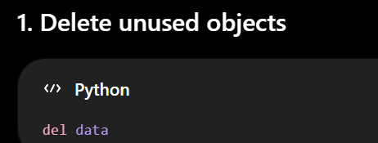
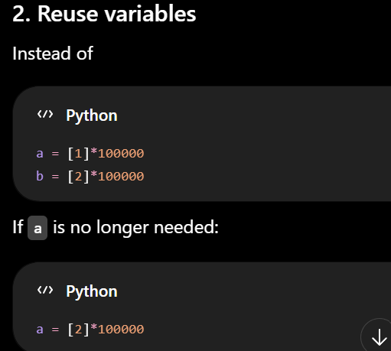
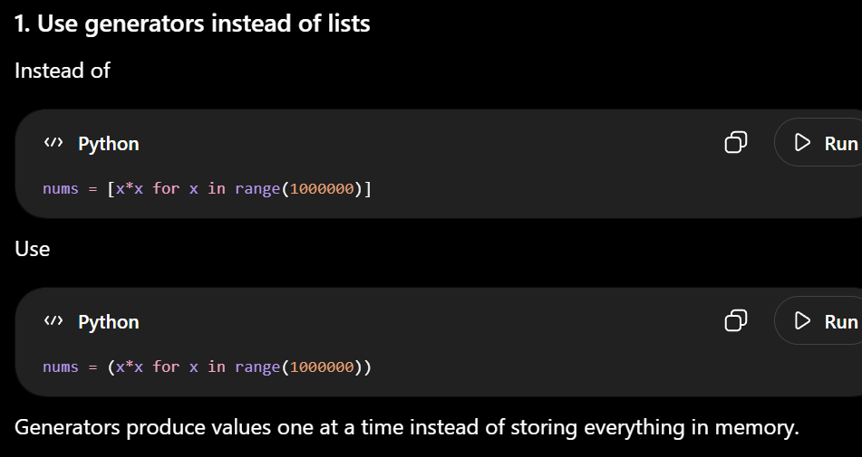

## Iterators & Generators
108. What is an iterator?
109. What is an iterable?
110. Difference between iterable and iterator.
111. What is `iter()`?
112. What is `next()`?
113. What is a generator?
114. Difference between generator and normal function.
115. What is the `yield` keyword?
116. Generator vs List Comprehension.

108. What is an Iterator?
An iterator is an object which iterates over iterable and gives values one by one using next().
An iterator implements two methods:
__iter__()
__next__()
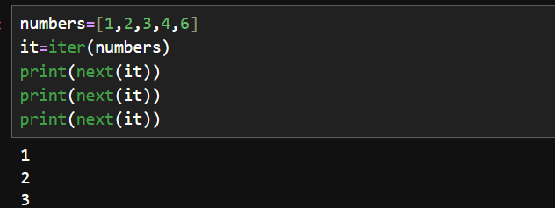
When there are no more elements, next() raises:
StopIteration

109. What is an Iterable?
An iterable is an object that we can loop over.
(List,Tuple,String)

110. Difference between Iterable and Iterator
An iterable is something you can loop over.
Whereas Iterator is used to access elements from iterable

111. What is iter()?
iter() is a built-in function used to create an iterator from an iterable.

112. What is next()?
next() is used to retrieve the next value from an iterator.

What is a generator?
A generator is a special function that produces values one at a time using yield.
Each time next() is called, execution resumes from where it previously paused.
This makes generators memory efficient because they don't need to store all generated values at once.
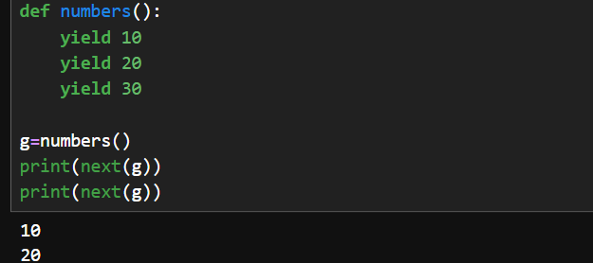
114. Difference between Generator and Normal Function
The main difference between normal function and Generator is that:
In Normal Function,entire sequence of values are returned.
In Generator,only one value is produced at a time and next value will be return if only it is called

115. What is the yield keyword?
yield is used inside a function to turn it into a generator.

116. Generator vs List Comprehension
In List Comprehension the entire list is created immediately in memory.
In Generator, Values are produced when needed.

## Decorators
117. What is a decorator?
118. Why are decorators used?
119. How do decorators work?
120. What are built-in decorators?
121. Difference between `@staticmethod` and `@classmethod`.
122. What is the `@property` decorator?

117. What is a Decorator?
A decorator is a function that adds additional functionality to the existing function without actually modifying the original source code

118. Why are decorators used?
Decorators are used when we want to add common functionality to multiple functions without actually modifying the original source code
Common uses include:
- Logging
- Authentication
- Authorization

119. How do decorators work?
A decorator works mainly using functions as first-class objects.
That means a function can be:
- passed as an argument
- can be returned from another function
- stored in a variable

120. What are built-in decorators?
Python provides several commonly used decorators.
1. @staticmethod
Creates a static method.
2. @classmethod
Creates a class method.

121. Difference between @staticmethod and @classmethod
@staticmethod doesn’t receive class or self as first-class arguments
@classmethod receives class as first-class argument

122. What is the @property decorator?
@property allows us to access a method like an attribute.

## Closures & Scope

123. What is a closure?
124. What is lexical scoping?
125. What is variable scope?
126. Difference between local and global variables.
127. What is the `global` keyword?
128. What is the `nonlocal` keyword?

123. What is a Closure?
A closure is a nested function that remembers and uses variables from its outer function, even after the outer function has completely finished executing
124. What is Lexical Scoping?
Lexical scoping means a function can access variables based on where the function is written/defined in the code, not where it is called.
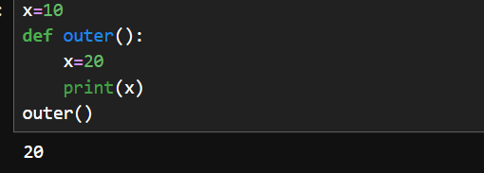
What are Python namespaces and scopes (LEGB rule)?
In Python,namespaces are the names of the variables

137. What is method resolution order?
MRO is the order in which Python searches for a method or attribute in a class

139. Difference between List and Array
Both store multiple values, but they are different.
List | Array
Built-in Python data structure | Usually provided by array module
Can store different data types | Usually stores same type

140. Difference between Tuple and Dictionary
Tuple | Dictionary
Stores ordered values | Stores key-value pairs
Immutable | Mutable

141. Why are tuples hashable?
A tuple is immutable, meaning its contents cannot be changed.
Because it cannot change, Python can calculate a stable hash value for it.

142. How is a set implemented?
A Python set is implemented using a hash table.
When you add an element, Python calculates its hash and uses that information to efficiently store and find the element.
This is why set operations like search, insertion, and deletion are generally O(1) on average.

143. Why are dictionary lookups fast?
Python dictionaries use a hash table.
When you search for a key, Python calculates the key's hash and uses it to quickly locate the corresponding value.
Therefore, dictionary lookup is O(1) on average.

144. How are lists implemented internally?
Python lists are implemented as dynamic arrays.
In Python, a dynamic array is a data structure that can grow or shrink in size according to operations

148. Functions are first-class objects — what does this mean?
It means a function can be treated like a normal value/object.
We can:
- store it in a variable
- pass it as an argument
- return it from another function

149. Can functions be passed as arguments?
Yes.
150. Can functions return other functions?
Yes.
151. What are higher-order functions?
A higher-order function is a function that:
- Takes another function as an argument, or
- Returns another function.

152. Difference between map(), filter(), and reduce()
Map, filter, and reduce are three data-processing functions
map() transforms each element, filter() selects elements based on a condition, and reduce() combines all elements into a single result.

map() → Transform every element
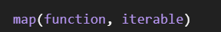
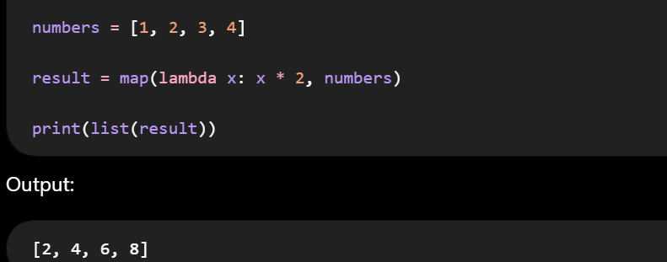
filter() → Select elements
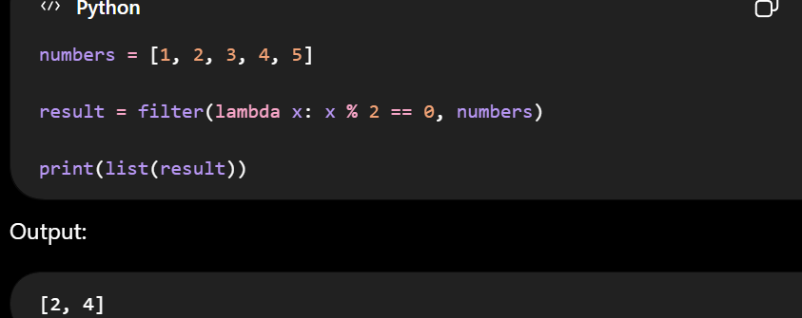
reduce() → Combine into one value
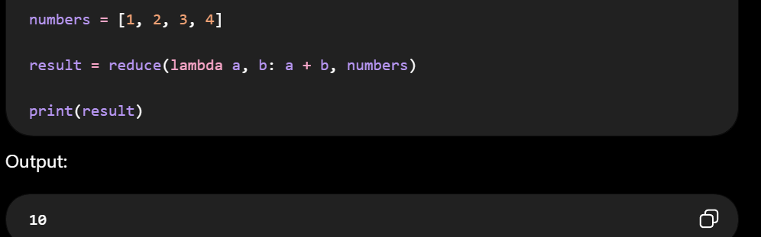
157. What is traceback?
A traceback is an error report generated by programming languages like Python when a program crashes.

158. Difference between import module and from module import
Difference
import module | from module import
Imports the module | Imports functions,class

159. What is __init__.py?
__init__.py is a special Python file to initialize a Python package
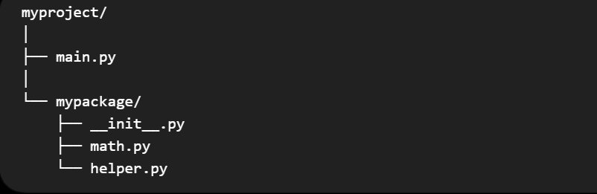
160. Difference between Built-in Modules and User-defined Modules
Built-in modules
Modules provided by Python itself or its standard library.
import math
User-defined modules
Modules created by the programmer.
Suppose you create:
calculator.py

164. What are Binary File Modes (rb, wb)?
rb — Read Binary
Used to read a binary file.
wb — Write Binary
Used to write bytes to a binary file.

165. What is File Buffering?
File buffering means temporarily keeping data in memory before performing operation

166. Difference between CSV, JSON, and Pickle
This is an important comparison.
1. CSV
CSV = Comma-Separated Values
Mainly used for tabular data.

2. JSON
JSON = JavaScript Object Notation

## Multithreading & Multiprocessing

173. What is multithreading?
174. What is multiprocessing?
175. Difference between thread and process.
176. When should you use multiprocessing instead of multithreading?
177. How does the GIL affect multithreading?

173. What is Multithreading?
Multithreading means running multiple threads within the same process.
A web browser, where one thread downloads a webpage, another plays a video

174. What is Multiprocessing?
Multiprocessing means running multiple processes.
When is multiprocessing useful?
Especially for CPU-bound tasks:
- Heavy calculations
- Image processing

175. Difference between Thread and Process
Process
A process is a program that is currently executing.
A program stored on disk is passive. When it starts running, it becomes a process.
Thread
A thread is a smaller unit of execution inside a process.

176. When should you use multiprocessing instead of multithreading?
Use multithreading mainly for I/O-bound tasks and multiprocessing mainly for CPU-bound tasks,

177. How does the GIL affect Multithreading?
GIL = Global Interpreter Lock.
In traditional CPython, the GIL allows only one thread at a time to execute Python bytecode within a process.

## Python Libraries
178. What is NumPy?
179. What is Pandas?
180. What is Matplotlib?
what is seaborn
what is skikit leatn
181. What is Requests?
182. What is Flask?
183. What is Django?
184. What is FastAPI?

178. What is NumPy?
NumPy is a Python library used for numerical and mathematical operations
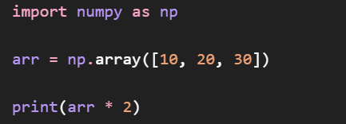
179. What is Pandas?
Pandas is a Python library used for data manipulation and data analysis.
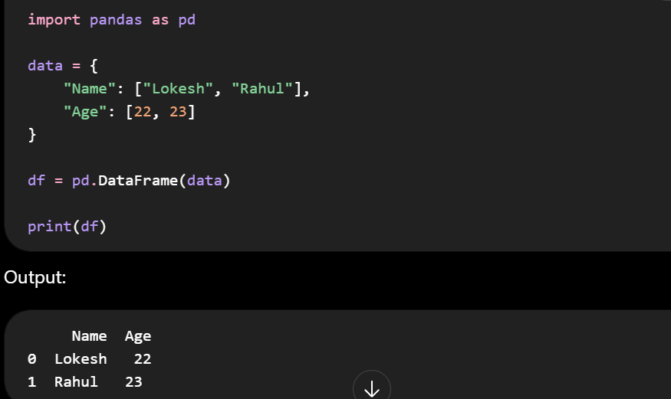
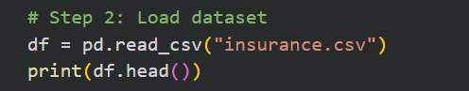
180. What is Matplotlib?
Matplotlib is a Python library used for data visualization.
• Bar charts
• Pie charts
• Scatter plots
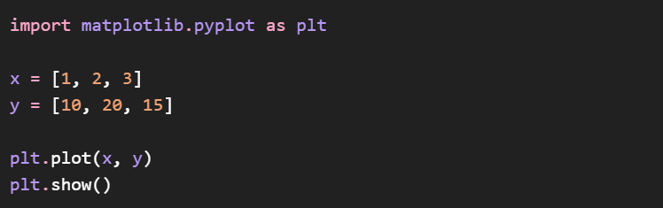
What is Seaborn?
It is built on top of Matplotlib and provides advanced visualization graphs
• Heatmaps
• Box plots
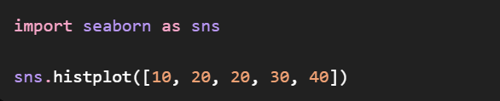
What is Scikit-learn?
Scikit-learn is a Python machine-learning library that provides algorithms and tools for data preprocessing, model training and evaluation

181. What is Requests?
Requests is a Python library used to send HTTP requests to web servers and APIs.

192. Why is Python slower than C++?
193. What is duck typing?
194. What is monkey patching?
195. What is serialization?
196. What is deserialization?
197. What is Pickle?
198. What is JSON?
199. What is PIP?
200. How do you install a Python package?

192. Why is Python slower than C++?
Python is generally slower because it is interpreted/dynamically typed

193. What is Duck Typing?
Duck typing means the type of an object is determined by what it can do, rather than its class/type.
"If it walks like a duck and quacks like a duck, it is treated as a duck."

Q.What are Compile-time and Run-time Errors?
Compile-time errors (Syntax Errors) are the errors which occur when Python parses your source code into bytecode
Ex: Syntax Error and Indentation Error
Run-time Errors are the errors which occur when the python executes ByteCode Ex:ZeroDivisionError 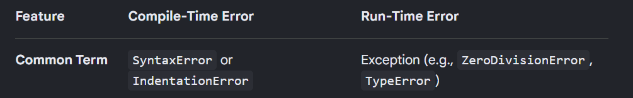
Money Patching means modifying the class or function durning run-time
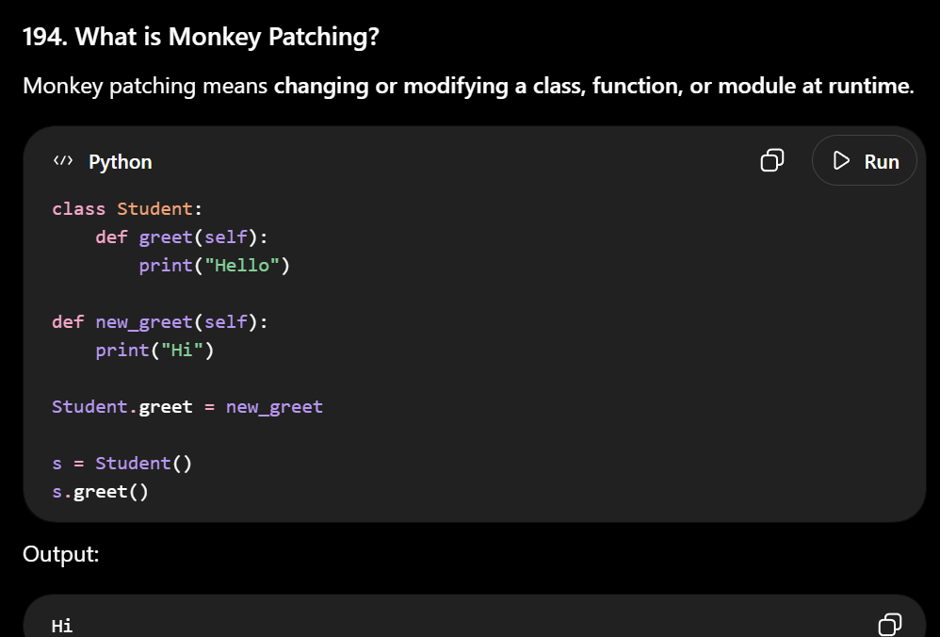
Serialization is the process of converting the data into one format so that it can easily stored or transmitted
Ex: Python Object->JSON/Bytes
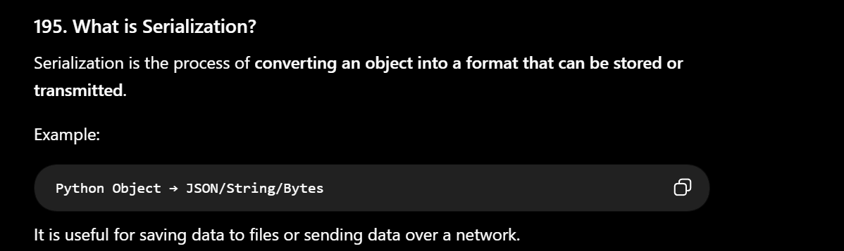
Deserialization is the process of coverting the data into its original format
Ex:JSON->Python Object
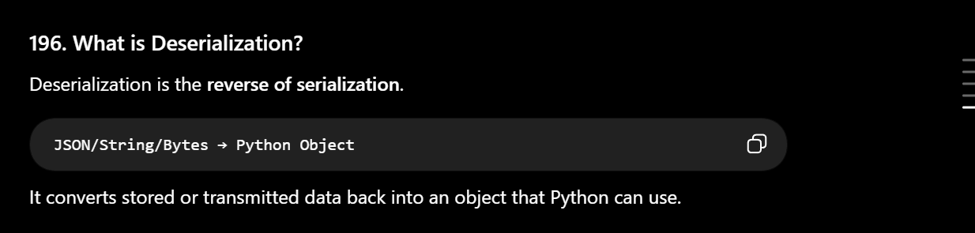
197. What is Pickle?
pickle is a Python module used to serialize and deserialize Python objects.

198. What is JSON?
JSON (JavaScript Object Notation) is a lightweight format used for storing data.
In MongoDB,the data will be stored in JSON format

199. What is PIP?
PIP is standard package installer in python. It is used to install, upgrade, and remove Python packages.
In Python, a package is a directory (folder) that organizes related modules (individual .py files)

200. How do you install a Python package?
Using PIP:
pip install pandas
pip install fastapi
pip install requests

1. Difference between sort() and sorted()
Both are used to sort elements, but they work differently.
sort()
- It modifies the original list.
It returns None. If you try to print it
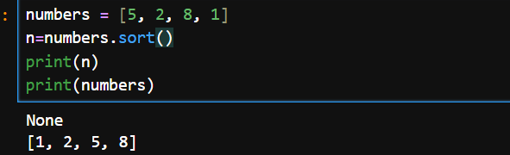
sorted()
- It does not modify the original object but builds new sorted list
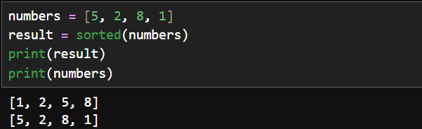
2. How do you iterate through a dictionary?
A dictionary contains key-value pairs.
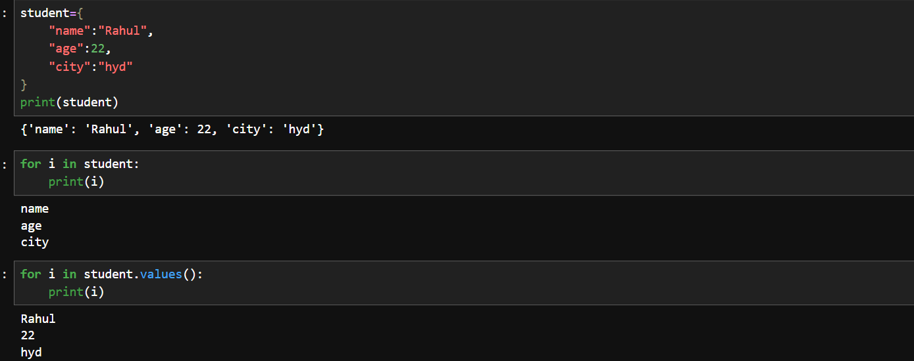
3. How do you remove duplicates using a set?
A set automatically stores only unique elements.
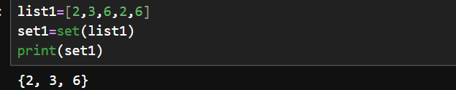
4. Why is a set unordered?
A set is implemented using a hash table.
When you add an element:
Python calculates a hash value for each element and uses that to determine where the element is stored internally.
Therefore, the elements are not stored according to insertion order as a set's defining behavior.

5. What is dictionary comprehension?
Dictionary comprehension is a short way of creating a dictionary using a single expression.

2. Difference between return and yield
Return keyword is used to return and send back the value to program
Yield is used to convert normal function into generator

1. What is None in Python?
None is a special value in Python that represents no value or absence of a value.

6. What is object identity?
Object identity tells us whether two variables refer to the exact same object in memory.
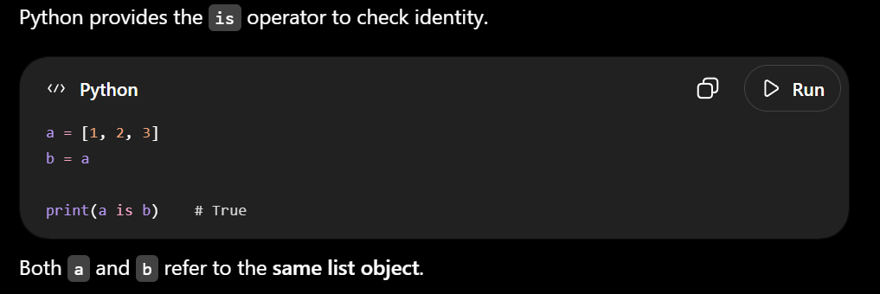

24. What is a docstring?
A docstring is a string enclosed in triple quotes in the program which explains the logic or class,functions

Explain dict.get()?
get()
get() returns the value if the key exists. If it doesn't exist, it returns None
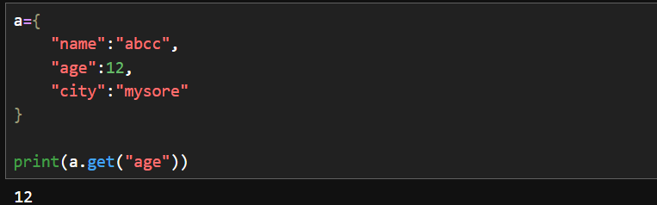
31. What happens when you access a missing dictionary key using dict[key]?
If the key doesn't exist, Python raises a KeyError.

33. What is Counter in Python?
Counter is a class from the collections module used to count how many times elements occur.
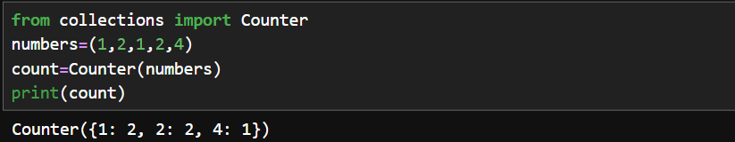
36. What is set comprehension?
Set comprehension is a short way to create a set using a single line code.
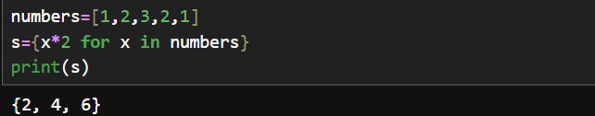

37. Can comprehensions contain conditions?
Yes. Comprehensions can contain conditions.
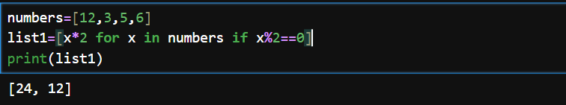
40. What is range()?
range() is a built-in Python function used to generate a sequence of numbers,
55. What is operator overloading?
Operator overloading means an operator +,-,*,/ behaves differently based on the objects
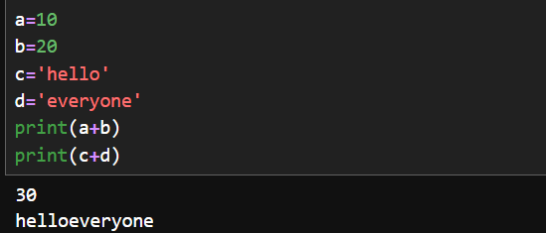
58. Difference between strip(), lstrip() and rstrip()
1. strip()
Removes characters from both sides of the string.
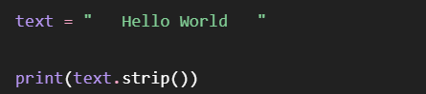
2. lstrip()
lstrip() removes characters from left to right.
3. rstrip()
rstrip() removes characters from the end/right side.

65. How does Python solve the Diamond Problem?
The Diamond Problem occurs in multiple inheritance when a class inherits from two classes that have the same parent.
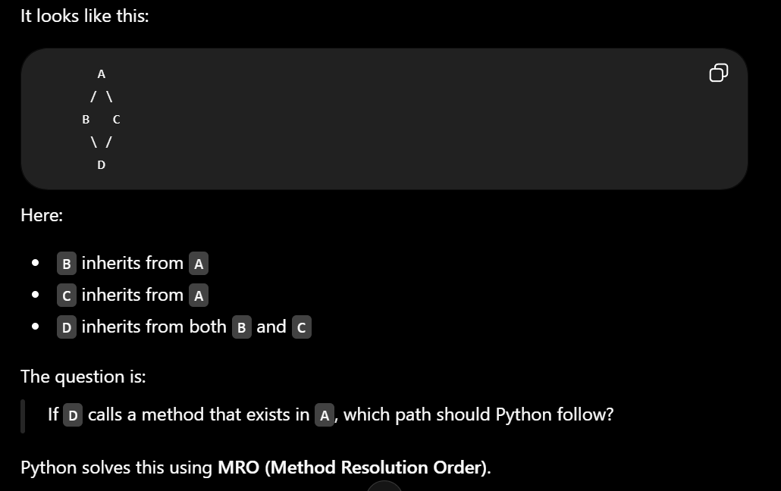

66. What is MRO?
MRO stands for Method Resolution Order.
It is the order in which Python searches classes when looking for a method or attribute.

76. What are magic methods such as __str__() and __repr__()?
__str__()
__str__() is used to print user-readable output which is simple
__repr__()
__repr__() is used to print print developer oriented output which is used for debugging

78. What is the Python Exception Hierarchy?
The exception hierarchy is the parent-child relationship between Python's built-in exception classes.
BaseException is the top most parent class

79. Difference between ValueError and TypeError
ValueError and TypeError occur when wrong datatype is passed.
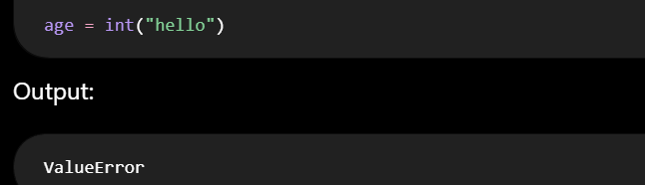
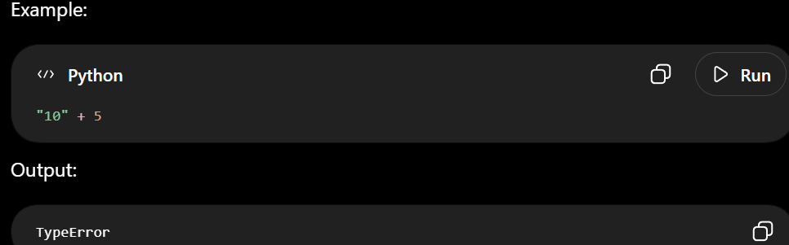
IndexError
Occurs when you use an invalid index for a sequence
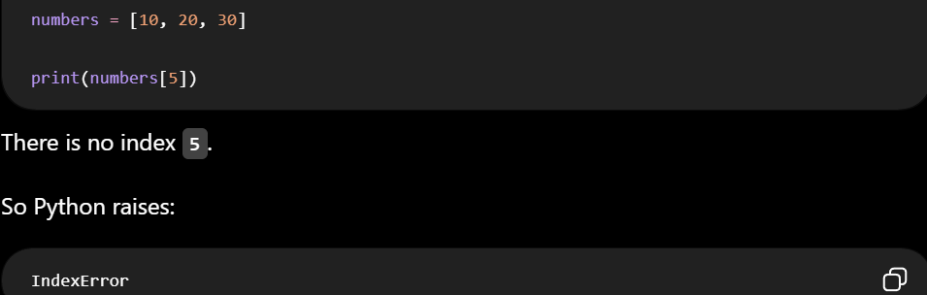
KeyError
Occurs when you try to access a dictionary key that doesn't exist.
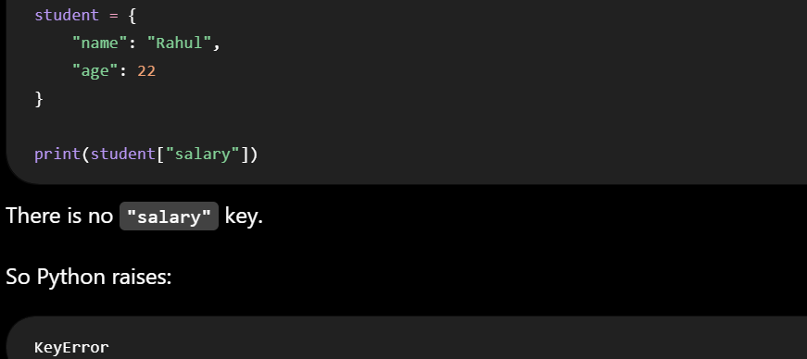
81. Difference between Exception and Error
Error is a general concept, while Exception is an actual Python class

82. What is Exception Chaining?
Exception chaining occurs when one exception is raised while handling another exception,

95. What is pip freeze?
pip freeze is a terminal command used in Python to list all the installed packages and their exact versions in your current environment
103. What is the gc module in Python?
gc stands for Garbage Collector.
It is a built-in Python module used in garbage collection mechanism.

106. What is the Iterator Protocol?
The iterator protocol is the set of methods that Python uses to make an object iterable and allow it to produce values one at a time.
__iter__()
Returns an iterator object.
__next__()
Returns the next value from the iterator.
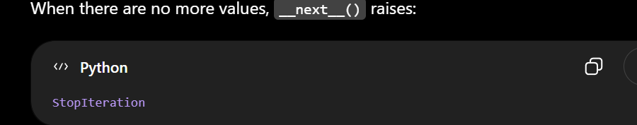

108. Can a generator be iterated over multiple times?
No, normally a generator is a one-time iterator.
Once its values have been consumed, you cannot restart the same generator.

110. What happens when a generator function is called?
Calling a generator function does not execute its body immediately. It returns a generator object. The function starts executing when next() is called
125. What is REST API?
Representation State Transfer API is a architectural style used to create HTTP Requests

What is CPython?
CPython is the popular default implementation of python
What is the asyncio module used for?
The asyncio module is a built-in Python library used to import and write code using async and await syntax.

1. What are Type Hints in Python?
Type hints allow us to explicitly specific the expected data type of output.

3. What is enumerate() used for?
enumerate() is used when you want to print both the index and the value while iterating over a sequence.
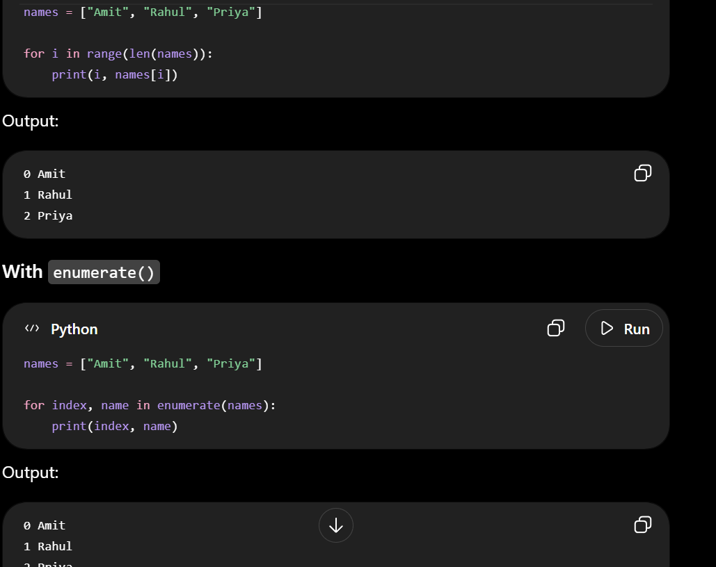
4. What is zip() used for?
zip() is used to combine elements from two or more iterables and iterate them


