What is Library?
library to perform a specific task.
framework provides a structural template for project development

Q1. What is Python and explain its features?
Python is a high-level,dynamic typed and general-purpose programming language.
  - Python is used for:
  - Web Development (Django, Flask)
  - Data Science / AI / ML (Pandas, TensorFlow, Scikit-learn)

3. Is Python compiled or interpreted?
Answer:
Python is both compiled and interpreted.
While traditionally classified as an interpreted language its standard implementation (CPython) operates using a two-step hybrid approach.
Python is called an interpreted language because its source code is translated and executed line by line in real-time by the Python Virtual Machine (PVM) during execution, rather than being fully translated into machine code before running
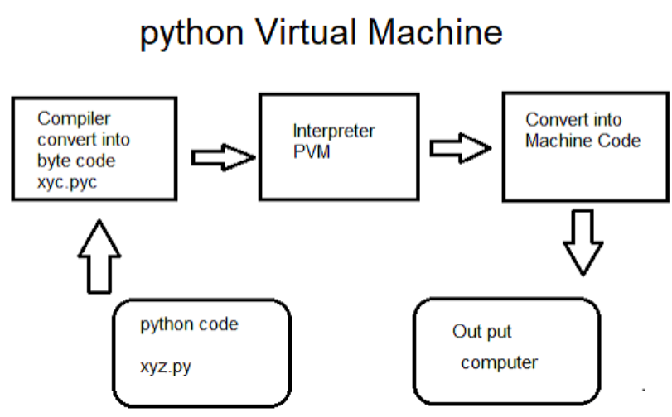
However, Python operates on a hybrid execution model: [1]
- Compilation: When you run a Python program, the code is first automatically compiled bytecode (saved as .pyc files). [1]
- Interpretation: This bytecode is then sent to the Python Virtual Machine (the interpreter), which converts into machine-level code. [1, 2]
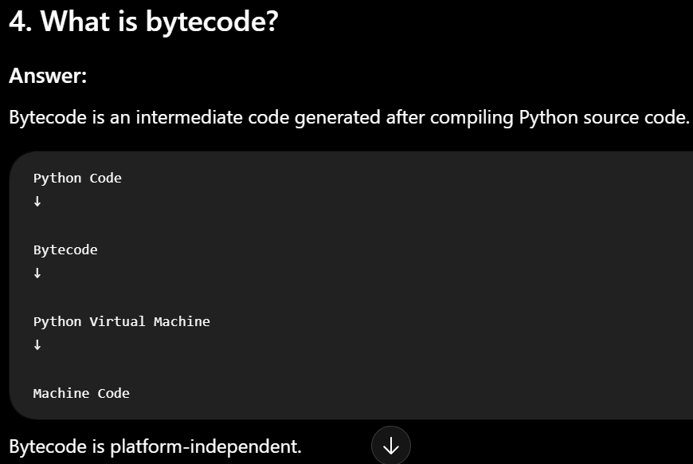
Current version of python
The current stable version of Python is 3.14.7.

6. Why is Python slower than C or C++?
Answer:
Python is slower because:
- It is interpreted at runtime. (executed line-by-line via a virtual machine)
- It is dynamically typed.

7. Is Python case-sensitive?
Answer:
Yes.
Python treats uppercase and lowercase letters differently.
Q8. What is indentation in Python?
In python,indentation refers to 4 spaces that defines the block of code

Q9. What are comments in Python?
Comments are the lines of text that python interpreter ignores
Single-line comment #
Multi-line comments-triple quotes(“”” “””)

Q10. What are keywords in Python?
Keywords are special reserved words that have pre-defined functionalities and those cannot be used as variable name,function name,class name
Ex: if,else,for,while,def,try
8. Why is Python called a high-level language?
Answer:
Because Python is close to human language and hides hardware-level details.

Q11. What is a variable---used to store values
Q12. What are Python data types?—
Data type specifies type of value stored in variables
Int-2,float-3.5,bool-true,false

Q13. What is dynamic typing?
Answer:
Python is a dynamically typed language, meaning you do not need to specify the data type of a variable. Python automatically determines the type when a value is assigned.
x = 10
print(type(x))

Q14. What is type casting?
Answer:
Type casting is the process of converting one data type into another.
Python provides built-in functions for type conversion.
Common Type Casting Functions:
Function | Purpose
int() | Converts to integer
float() | Converts to float
str() | Converts to string
list() | Converts to list
tuple() | Converts to tuple
set() | Converts to set

a = "100"
b = int(a)
print(b)
print(type(b))

Q15. What is the difference between mutable and immutable objects?
Mutuable objects are the one where we can modify the data after creation and immutable objects are the one whose values cannot be modified after creation
List,Set and Dictionary are mutable
Int,string,bool,tuple,frozenset are immutable

2. What happens if you try to modify a tuple?
TypeError: 'tuple' object does not support item assignment

Q16. What is the difference between == and is?
Answer:
== | is
Compares values | Compares object identity (memory location)
Checks whether values are equal | Checks whether both variables refer to the same object
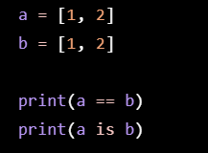

Q17. What are identifiers?
Identifiers are the names given to variables
age = 22
student_name = "Lokesh"
• Must begin with a letter or underscore (_)
• Cannot start with a digit
• Cannot contain spaces
Cannot be a Python keyword

Q18. What are literals?
Answer:
Literals are fixed values in the program.
age = 22 #Here 22 is a literals

Q20. What is type()?
Answer:
The type() function returns the data type of the variable.
type(object)
print(type(a))

Q21. What are arithmetic operators in Python?
Answer:
Arithmetic operators are the one used to perform mathematical operations
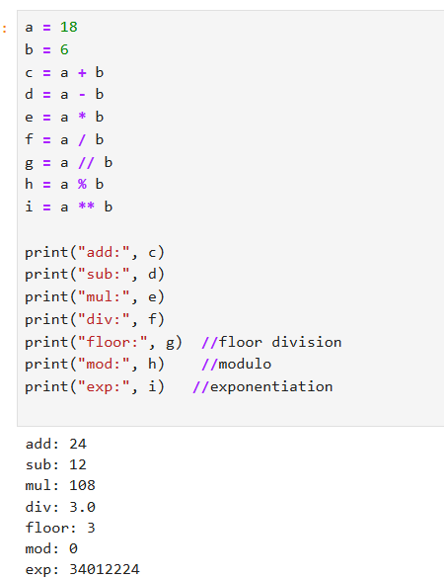
Q22. What are comparison operators in Python?
Answer:
Comparison operators compare two values and return either True or False.
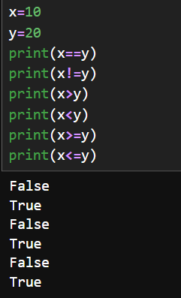
Q23. What are logical operators in Python?
Answer:
Logical operators used to combine multiple conditions.
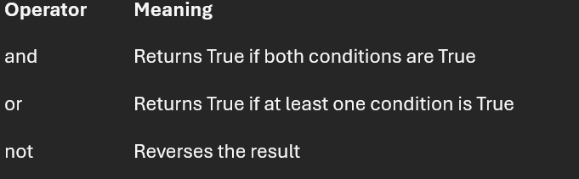
Q24. What are assignment operators in Python?
Answer:
Assignment operators are used to assign values to variables and can also perform operations while assigning.
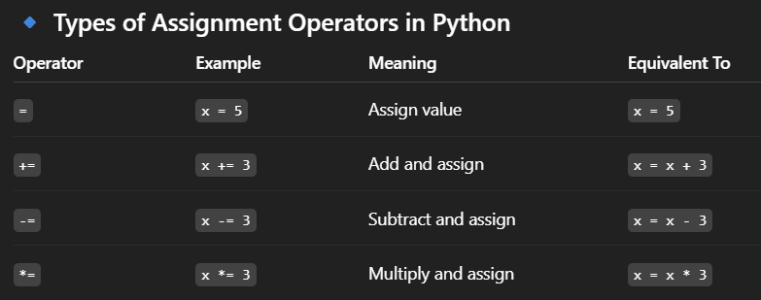
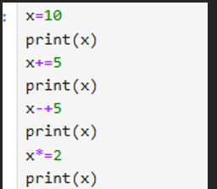
Q25. What are bitwise operators in Python?
Answer:
Bitwise operators are used to perform binary operations on numbers
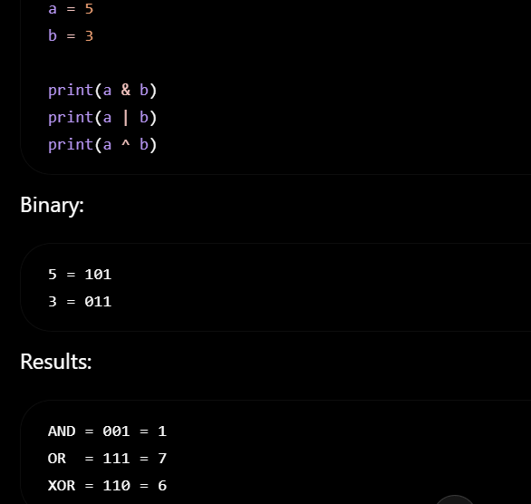
Q26. What are identity operators?
Answer:
Identity operators is used to compare and check whether the memory location of two variables.
Operator | Meaning
is | Same object
is not | Different objects

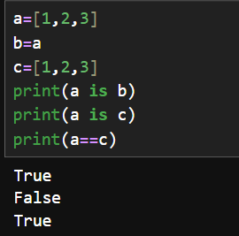
Q27. What are membership operators?
Answer:
Membership operators check whether a value exists in a sequence.
Operator | Meaning
in | Value exists
not in | Value does not exist
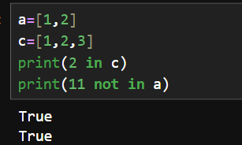
Q28. What is operator precedence?
Answer:
Operator precedence tells us the order in which operators are evaluated__- (),**

Q29. What is short-circuit evaluation?
Answer:
Short-circuit evaluation means Python stops evaluating an expression as soon as the final result is known.
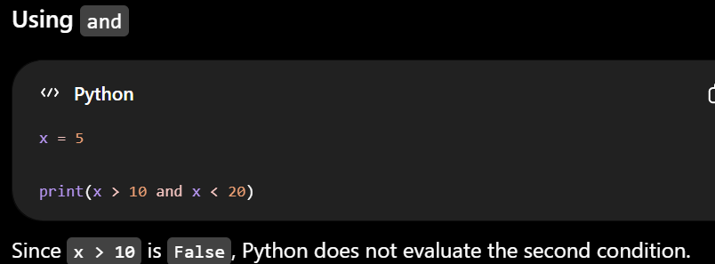
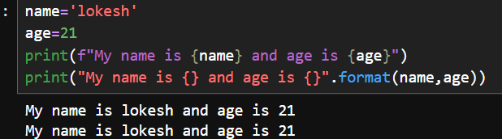
Q31. What is the if statement?
Answer:
The if statement is used to execute a block of code only when a specified condition is True.
if condition:
# code

Q32. What is if-elif-else?
Answer:
if-elif-else is used when there are multiple conditions to check.
elif lets you check multiple conditions sequentially.
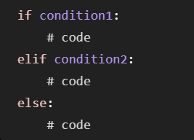

Q33. What is a nested if statement?
Answer:
A nested if-statement means placing one if statement inside the other inorder to check second condition if first-condition is true.

Q34. What is the for loop?
Answer:
A for-loop is used to iterate a block of code when you know no.of.iterations
For-loop is used to iterate over list,range,tuple ect..
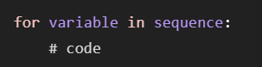
Q35. What is the while loop?
Answer:
A while loop executes a block of code as long as a specified condition is True.
We use while loop when we don’t know the number of iterations.
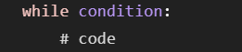

4. What happens if you forget to update the loop variable in a while loop?
Answer
The loop condition may never become False, causing an infinite loop.
An infinite loop can be created using while True:
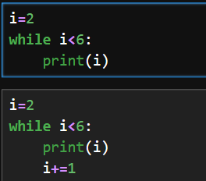
Q36. What is the difference between for and while loops?
Answer:
for Loop | while Loop
Used when the number of iterations is known. | Used when the number of iterations is unknown.
Iterates over a sequence. | Executes while a condition is True.

37.What is a break statement?
Answer:
The break statement is used to end the loop even the condition is still true
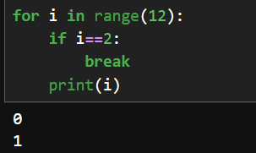

Q38. What is the continue statement?
Answer:
Continue statement is used to skip the current iteration of the loop and continues with the next iterations.
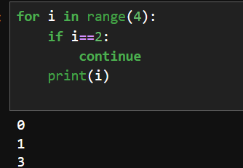
Q39. What is the pass statement?
Answer:
Pass Statement don’t have any functionality.It is only used for syntax purpose

Q40. What is the else block in loops?
Answer:
In Python, an else block can be used with both for and while loops.
Else statement executes the block of when the loop completes normally. It does not execute if the loop is terminated using break.
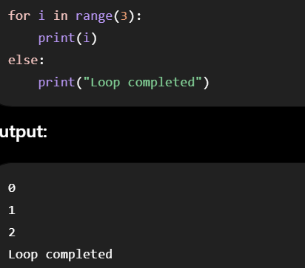
Explain NESTED loops?
Nested loops is the situation where one loop is placed inside another loop.

STRINGS
Q41. What is a string in Python?
Answer:
A String is a Immutable DataTypes which stores data in quotes
• Strings are ordered.
• Strings are immutable.
• Strings support indexing and slicing.

Slicing:
[0:3]==0,1,2
[:4]==0,1,2,3
[2:]==2,3,4,…
[::-1]--reverse

Q43. What are common string methods?
Answer:
Some commonly used string methods are:
Method | Description
upper() | Converts to uppercase
lower() | Converts to lowercase
title() | Converts first letter of each word to uppercase
capitalize() | Capitalizes the first character
strip() | Removes leading and trailing spaces
replace() | Replaces a substring
split() | Splits a string into a list
join() | Joins list elements into a string
find() | Finds the first occurrence
count() | Counts occurrences of a substring
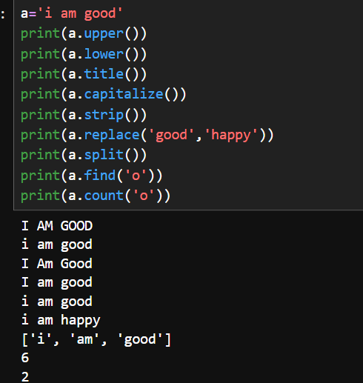
fruits = ["Apple", "Banana", "Mango"]
result = " ".join(fruits)

Q44. What is string slicing?
Answer:
String slicing is used to extract a portion of a string.
Syntax:
string[start : stop : step]
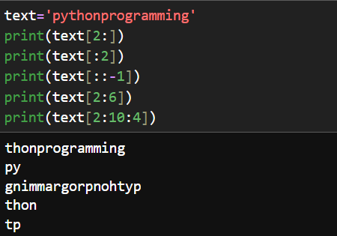
Q45. What is string formatting?
Answer:
String formatting is the process of inserting values into a string.
• format() method
• f-strings (recommended)

Q46. What is an f-string?
Answer:
An f-string (formatted string literal) is a modern way to format strings where Variables or expressions are placed inside curly braces {}.

Q47. What is the difference between split() and join()?
Answer:
split() | join()
Converts a string into a list | Converts a list into a string
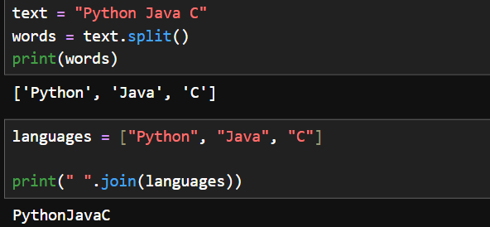
Q48. What is the difference between find() and index()?
Answer:
find() | index()
Returns the index if found | Returns the index if found
Returns -1 if not found | Raises ValueError if not found
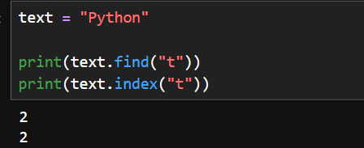
Explain String Slicing with Negative Indexing
Answer
Negative indexing means counting characters from the end of the string instead of the beginning.
- Positive indexing starts from 0.
- Negative indexing starts from -1.
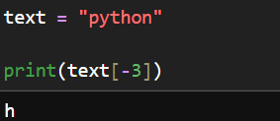

LIST,TUPLE,SET,DICTIONARY
Q51. What is a list in Python?
Answer:
A list is an ordered, mutable and heterogenous collection of elements enclosed in [].
An array is a ordered,mutuable and homogenous collection of data
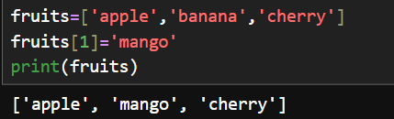
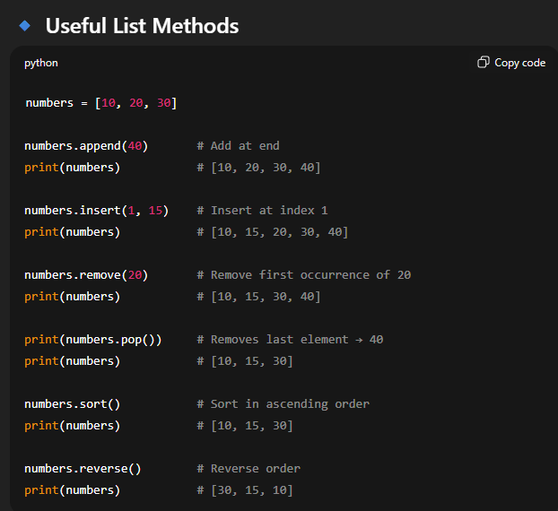
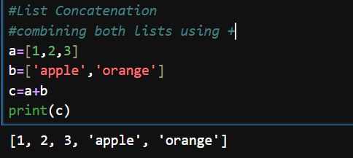

Q52. What is a tuple in Python?
Answer:
A tuple is a ordered,immutable and heterogenous collection of elements enclosed in () parathesis

Q53. What is a set in Python?
Answer:
A set is a unordered,mutable and heterogenous collection of elements enclosed in {}.
A set is an mutable, unordered collection of unique elements in Python
Common Set Methods:
- add()
- remove()
- discard()
- union()
- intersection()
- difference()
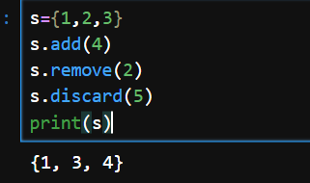
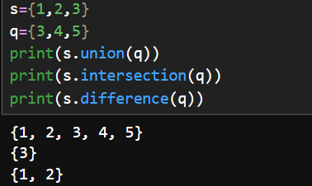

A frozenset is an immutable, unordered collection of unique elements in Python
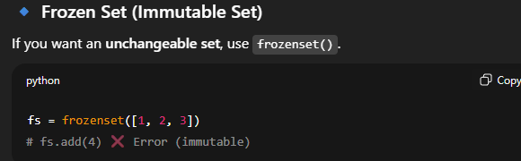
Q54. What is a dictionary in Python?
Answer:
A dictionary is a collection of key-value pairs.
It is mutuable data structure
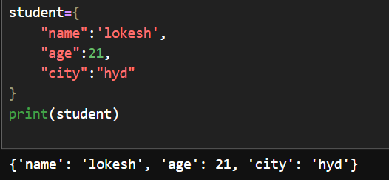
Common Dictionary Methods:
- keys()
- values()
- items()
- get()
- update()
- pop()
- clear()
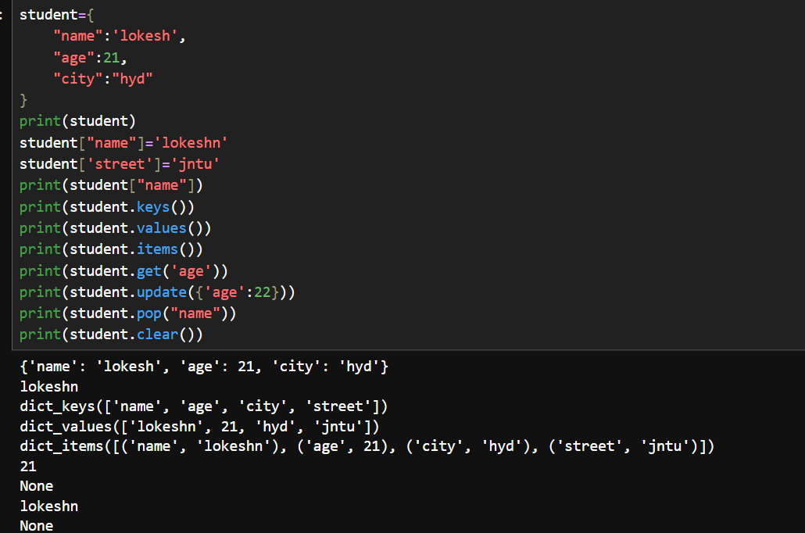
Q.Merge two dictionaries
dictionary.update() method modifies a dictionary in-place by inserting or updating key-value pairs
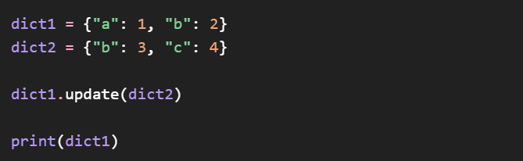
Q55. Difference between List and Tuple
Answer:
List | Tuple
Mutable | Immutable
Uses [] | Uses ()

Q56. Difference between List and Set
Answer:
List | Set
Ordered | Unordered
Allows duplicates | Does not allow duplicates

Q57. Difference between Tuple and Set
Answer:
Tuple | Set
Ordered | Unordered
Immutable | Mutable
Allows duplicates | No duplicates

Q58. Difference between Dictionary and List
Answer:
Dictionary | List
Stores key-value pairs | Stores values only
Access using keys | Access using indexes

Q59. What are list comprehensions?
Answer:
List comprehension is a concise way to create lists using a single line of code.
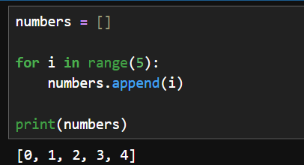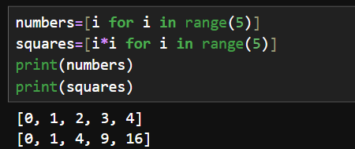

Q60. What is tuple packing and unpacking?
Answer:
Tuple Packing
Packing means storing multiple values into a single tuple.
Example:
student = ("Lokesh", 22, "CSE")
Tuple Unpacking
Unpacking means storing multiple values to individual variables.
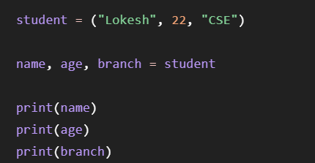

1. Can a tuple contain a list?
Answer
Yes. A tuple can contain a list as one of its elements.
But if an element is a list, the contents of that list can be modified because lists are mutable.
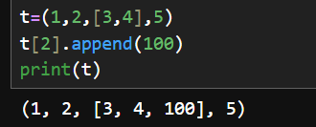
2. Can a dictionary key be a list? Why or why not?
Answer
No.
Dictionary keys must be immutable (hashable).
Lists are mutable, so they cannot be used as dictionary keys.

3. What is the difference between append() and extend()?
append() | extend()
Adds one element | Adds multiple elements
Entire list is added as one element | Elements are added individually
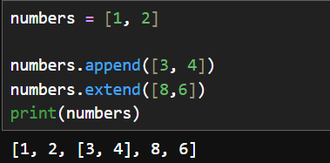

4. What is the difference between remove(), pop(), and del?
Method | Removes
remove(value) | By value
pop(index) | By index
del | By index/slice or entire object
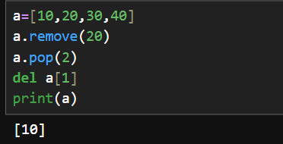

5. What is the difference between discard() and remove() in a set?
remove() | discard()
Raises an error if element doesn't exist | Does not raise an error

6. What is the difference between get() and [] in a dictionary?
get() | []
Returns None (or a default value) if the key is missing | Raises KeyError if the key is missing

Q62. Can dictionary keys be mutable?
Answer:
No. Dictionary keys cannot be mutable.
Keys must be immutable because Python uses a hash value to store and retrieve dictionary entries.

Q63. How is a dictionary implemented internally?
Answer:
Python dictionaries are implemented using a hash table.
A hash table stores data as key-value pairs and allows very fast lookup, insertion, and deletion.
Because of hashing, the average time complexity for lookup, insertion, and deletion is O(1).
Time Complexity
Operation | Average Time
Search | O(1)
Insert | O(1)
Delete | O(1)

Q65. What is the difference between keys(), values(), and items()?
Answer:
These dictionary methods are used to access different parts of a dictionary.
Method | Returns
keys() | All keys
values() | All values
items() | All key-value pairs as tuples

1. What is the difference between pop() and popitem()?
Answer
Both methods remove items from a dictionary, but they work differently.
pop() | popitem()
Removes an item by key | Removes the last inserted key-value pair (Python 3.7+)

2. Can two dictionary keys have the same hash value?
Answer
Yes. Two different dictionary keys can have the same hash value. This is called a hash collision.
Python's dictionary implementation is designed to handle these collisions internally, so both keys can still exist in the dictionary as long as they are not equal (key1 != key2).

