Below are 100 of the most frequently asked SQL + DBMS interview questions for freshers and experienced candidates. These are commonly asked in companies like Deloitte, Accenture, Infosys, TCS, Capgemini, Cognizant, HCL, Wipro, IBM, Oracle, and product-based companies.

SQL + DBMS Interview Questions (Top 100)
DBMS Fundamentals
- What is DBMS?
- What are the advantages of DBMS over the file system?
- What are the different types of DBMS?
- What is the difference between DBMS and RDBMS?
- What are the characteristics of a database?
- What is data independence?
- What are the types of data independence?
- What is metadata?
- What is a database schema?
- What is a database instance?

Keys
- What is a primary key?
- What is a foreign key?
- What is a candidate key?
- What is a super key?
- What is an alternate key?
- What is a composite key?
- What is a unique key?
- What is the difference between primary key and unique key?
- Can a table have multiple foreign keys?
- Can a primary key contain NULL values?

SQL Basics
- What is SQL?
- What are the different types of SQL commands?
- What is the difference between DDL and DML?
- What is the difference between DML and DCL?
- What is the difference between DCL and TCL?
- What is the difference between DELETE, DROP, and TRUNCATE?
- What is the difference between WHERE and HAVING?
- What is the difference between GROUP BY and ORDER BY?
- What is the purpose of the DISTINCT keyword?
- What is the difference between CHAR and VARCHAR?

Constraints
- What are SQL constraints?
- What is the NOT NULL constraint?
- What is the CHECK constraint?
- What is the DEFAULT constraint?
- What is the UNIQUE constraint?
- What is the FOREIGN KEY constraint?
- What is referential integrity?
- What is the CASCADE option?
- What is ON DELETE CASCADE?
- What is ON UPDATE CASCADE?

Joins
- What is a JOIN?
- What are the different types of joins?
- What is an INNER JOIN?
- What is a LEFT JOIN?
- What is a RIGHT JOIN?
- What is a FULL OUTER JOIN?
- What is a CROSS JOIN?
- What is a SELF JOIN?
- What is the difference between INNER JOIN and OUTER JOIN?
- When would you use a SELF JOIN?

SQL Functions
- What is the difference between aggregate functions and scalar functions?
- What are aggregate functions in SQL?
- What is the COUNT() function?
- What is the SUM() function?
- What is the AVG() function?
- What is the MAX() function?
- What is the MIN() function?
- What is the COALESCE() function?
- What is the difference between ISNULL(), IFNULL(), and COALESCE()?
- What is the ROUND() function?

Normalization
- What is normalization?
- Why is normalization required?
- What is denormalization?
- What is the First Normal Form (1NF)?
- What is the Second Normal Form (2NF)?
- What is the Third Normal Form (3NF)?
- What is BCNF?
- What are the advantages of normalization?
- What are the disadvantages of normalization?
- What is a functional dependency?

Transactions & Concurrency
- What is a transaction?
- What are ACID properties?
- What is Atomicity?
- What is Consistency?
- What is Isolation?
- What is Durability?
- What is COMMIT?
- What is ROLLBACK?
- What is SAVEPOINT?
- What is the difference between COMMIT and ROLLBACK?

Indexing & Views
- What is an index?
- What are clustered and non-clustered indexes?
- What is the difference between clustered and non-clustered indexes?
- What are the advantages and disadvantages of indexes?
- What is a view?
- Why are views used?
- What is a materialized view?
- What is the difference between a view and a table?
- Can we update a view?
- What is an indexed view?

Advanced SQL & DBMS
- What is a subquery?
- What is the difference between a subquery and a correlated subquery?
- What are Common Table Expressions (CTEs)?
- What are stored procedures?
- What are triggers?
- What are cursors?
- What is the difference between UNION and UNION ALL?
- What is the difference between EXISTS and IN?
- What are window functions in SQL?
- What are the differences between RANK(), DENSE_RANK(), and ROW_NUMBER()?

This list covers the most commonly asked SQL and DBMS theory questions in technical interviews. When you're ready, we can start preparing detailed interview answers in batches of 10, beginning with Questions 1–10.
1. What are the characteristics of a database?
1. Organized Data
2. Data Sharing
6. Backup and Recovery

2. Can a table have multiple foreign keys?
Yes.
A table can have one, two, or many foreign keys.
Student Table
Course Table
Enrollment Table

3. What is SQL?
SQL (Structured Query Language) is the standard language used to communicate with relational databases.
4. What are the different types of SQL commands?
SQL commands are divided into 5 types.
Type | Full Form | Purpose
DDL | Data Definition Language | Defines database structure
DML | Data Manipulation Language | Manipulates data
DQL | Data Query Language | Retrieves data
DCL | Data Control Language | Controls permissions
TCL | Transaction Control Language | Manages transactions

5. What is the difference between DDL and DML?
DDL | DML
Data Definition Language | Data Manipulation Language
Changes database structure | Changes data inside tables
Works on schema | Works on records

6. What is the difference between DML and DCL?
DML | DCL
Data Manipulation Language | Data Control Language
Manipulates data | Controls user permissions
Works on table records | Works on user privileges
Examples: INSERT, UPDATE, DELETE | Examples: GRANT, REVOKE

7. What is the difference between DCL and TCL?
DCL | TCL
Data Control Language | Transaction Control Language
Controls permissions | Controls transactions
Used for security | Used to save or undo changes
Examples: GRANT, REVOKE | Examples: COMMIT, ROLLBACK, SAVEPOINT

1. What is the difference between DELETE, DROP, and TRUNCATE?
DELETE | TRUNCATE | DROP
Removes selected rows | Removes all rows | Removes the entire table
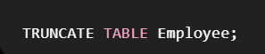

2. What is the difference between WHERE and HAVING?
WHERE | HAVING
Filters rows | Filters groups
Used before GROUP BY | Used after GROUP BY
Cannot use aggregate functions (SUM, COUNT, AVG, etc.) directly | Can use aggregate functions
Works on individual records | Works on grouped results
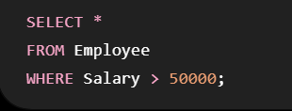

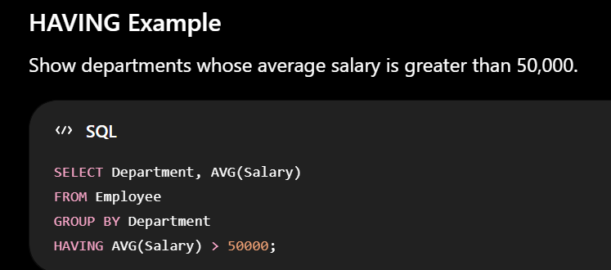

3. What is the difference between GROUP BY and ORDER BY?
GROUPBY is used to create groups of rows using aggregate functions.
ORDERBY is used to sort rows using asc,desc
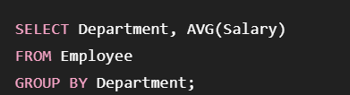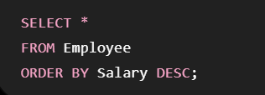

4. What is the purpose of the DISTINCT keyword?
DISTINCT is used to remove duplicate values and return only unique values.
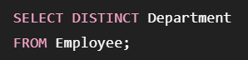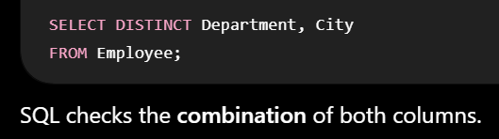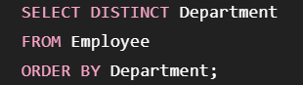

5. What is the difference between CHAR and VARCHAR?
CHAR takes up fixed-length irrespectively of the text stored
VARCHAR takes up only space based on the data stored
CHAR | VARCHAR
Fixed-length string | Variable-length string

1. What are SQL Constraints?
Definition
Constraints are rules applied to table columns to ensure that only valid and accurate data is stored.
They help maintain data integrity.
Common SQL Constraints
Constraint | Purpose
NOT NULL | Prevents NULL values
UNIQUE | Prevents duplicate values
PRIMARY KEY | Uniquely identifies each row
FOREIGN KEY | Maintains relationship between tables
CHECK | Restricts values based on a condition
DEFAULT | Assigns a default value if none is provided
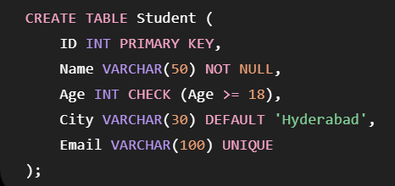
The NOT NULL constraint ensures that a column cannot have an empty (NULL) value.
The CHECK constraint checks the condition and allows only specific values2
The DEFAULT constraint automatically assigns a value when no value is provided.
The UNIQUE constraint ensures that all values in a column are different.

7. What is Referential Integrity?
Definition
Referential Integrity ensures that relationships between tables remain valid.
A foreign key value must either:
- Match a primary key in the parent table, or
- Be NULL (if allowed).

8. What is the CASCADE Option?
Definition
CASCADE is a feature that automatically updates or deletes related rows in the child table when changes occur in the parent table.
There are two common options:
- ON DELETE CASCADE
- ON UPDATE CASCADE

Without CASCADE
❌ Error because child_table is using it.

9. What is ON DELETE CASCADE constraint?
Definition
When a row is deleted from the parent table, all matching rows in the child table are automatically deleted.
10. What is ON UPDATE CASCADE constraint?
Definition
When the primary key value in the parent table changes, the matching foreign key values in the child table are automatically updated.

1. What is a JOIN?
Definition
A JOIN is used to combine data from two or more tables based on a related column.
Usually, the related column is a Primary Key in one table and a Foreign Key in another table.
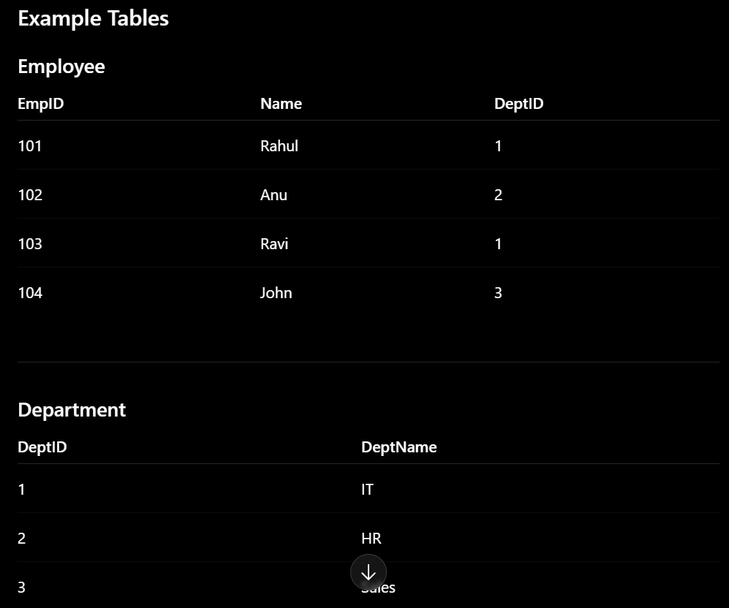
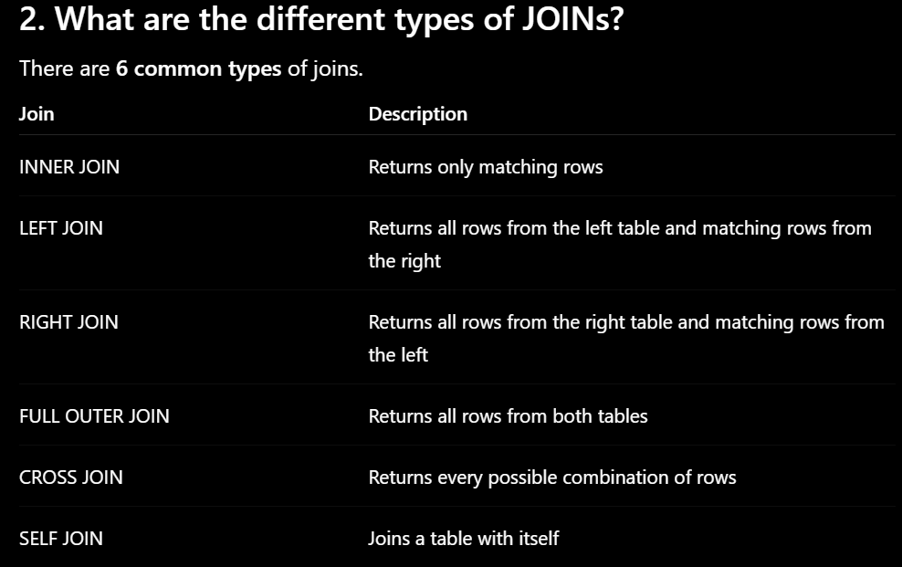
3. What is an INNER JOIN?
Definition
Returns only the rows that have matching values in both tables.
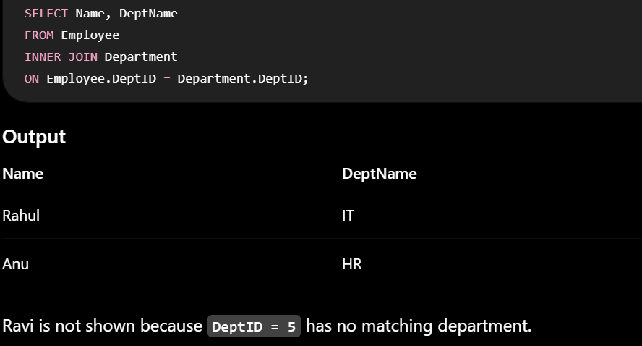
4. What is a LEFT JOIN?
Definition
Returns:
- All rows from the left table
- Matching rows from the right table
- If no match exists, NULL is returned for the right table columns.
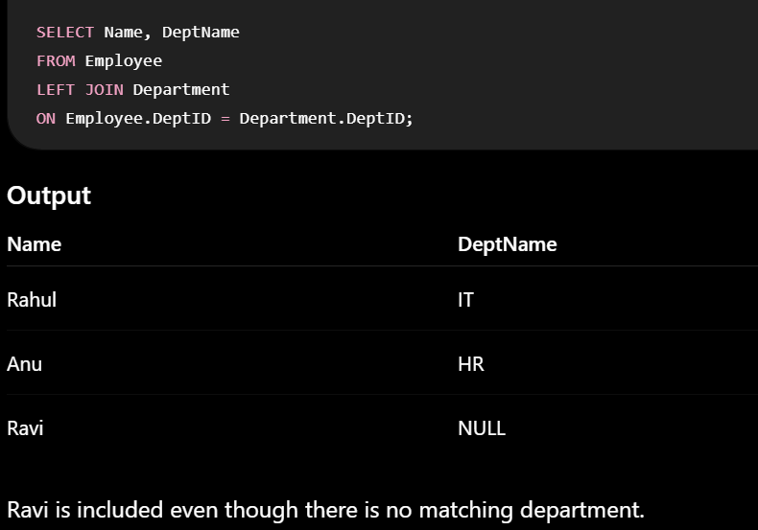
5. What is a RIGHT JOIN?
Definition
Returns:
- All rows from the right table
- Matching rows from the left table
- If no match exists, NULL is returned for the left table columns.
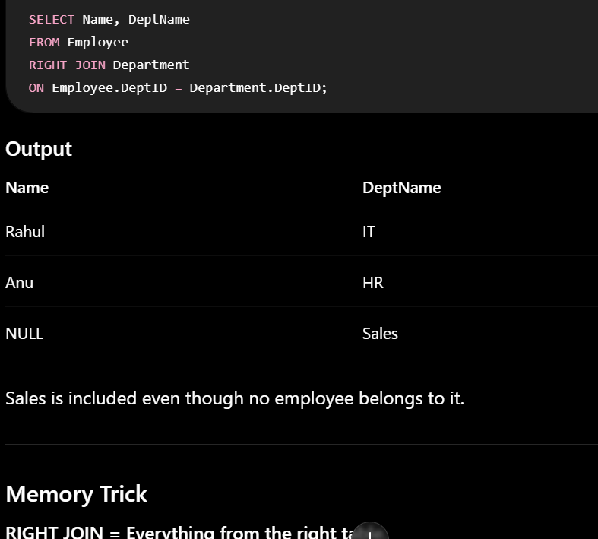
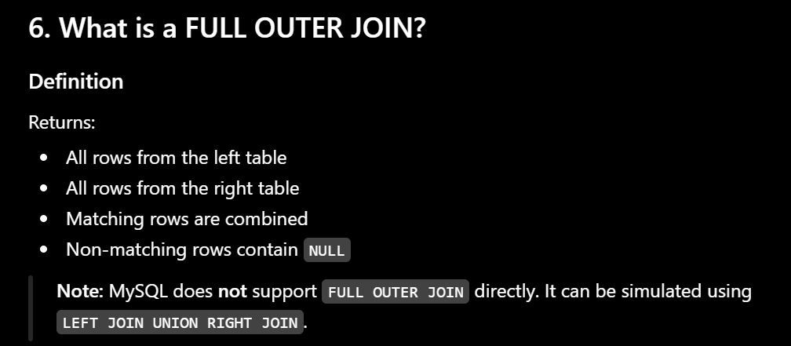
Full Join returns all the rows from left table and right table
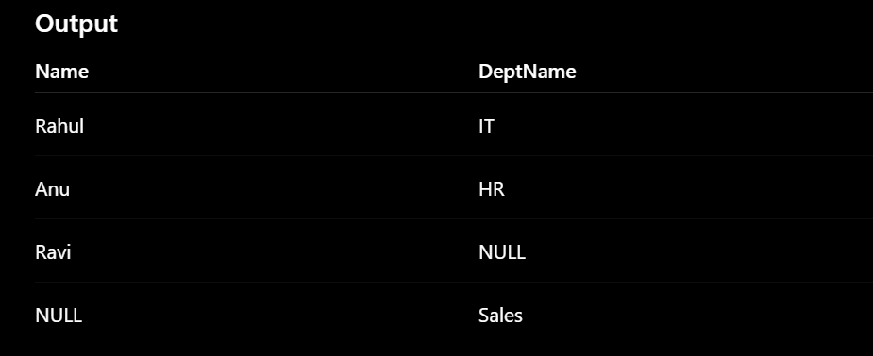
7. What is a CROSS JOIN?
Definition
Returns every possible combination of rows from both tables (Cartesian Product).
Table A
Color
Red
Blue

Table B
Size
S
M
L
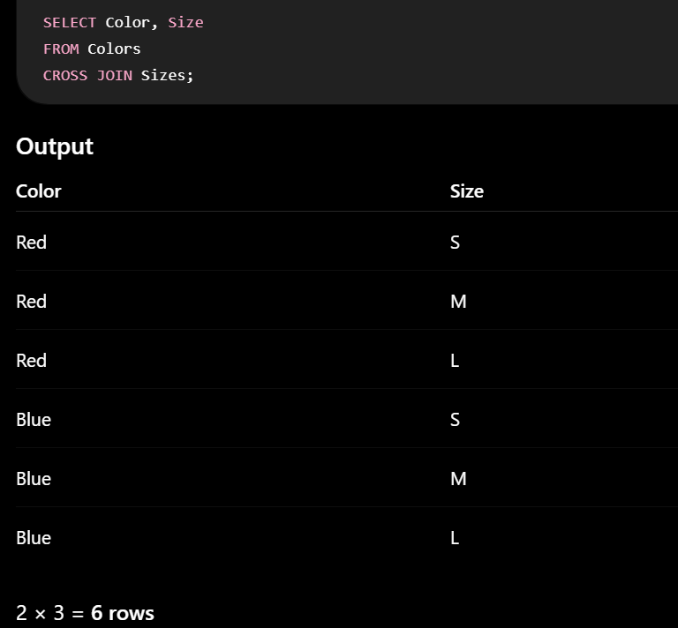
8. What is a SELF JOIN?
Definition
A SELF JOIN performs joins with the table itself.
It is useful when rows in the same table are related.

Employee Table
EmpID | Name | ManagerID
1 | Alice | NULL
2 | Bob | 1
3 | Charlie | 1
4 | David | 2
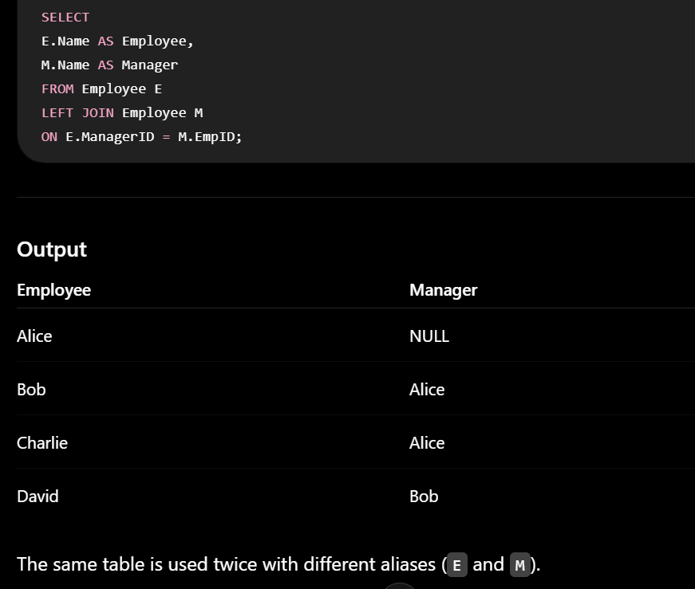
9. Difference Between INNER JOIN and OUTER JOIN
INNER JOIN | OUTER JOIN
Returns only matching rows | Returns matching and non-matching rows
Non-matching rows are excluded | Non-matching rows appear with NULL values

10. When would you use a SELF JOIN?
self-join is used when their is relation between the columns in the table
Common Examples
- Employee → Manager
- Family Tree (Parent → Child)

SQL Functions
- What is the difference between aggregate functions and scalar functions?
- What are aggregate functions in SQL?
- What is the COUNT() function?
- What is the SUM() function?
- What is the AVG() function?
- What is the MAX() function?
- What is the MIN() function?
- What is the COALESCE() function?
- What is the difference between ISNULL(), IFNULL(), and COALESCE()?
- What is the ROUND() function?

51. What is the difference between aggregate functions and scalar functions?
Answer:
Aggregate functions perform calculations on multiple rows and return one result.
SUM(), AVG(), MAX(), MIN()

Scalar functions operate on only one value/row at a time and return one result for each row.
ROUND()

53. What is the COUNT() function?
Answer:
COUNT() is an aggregate function used to calculate total number of rows


54. What is the SUM() function?
Answer:
SUM() is an aggregate function used to calculate the total sum of values in the rows

55. What is the AVG() function?
Answer:
AVG() is an aggregate function used to calculate the average of numeric values.

56. What is the MAX() function?
Answer:
MAX() is an aggregate function that returns the highest value

57. What is the MIN() function?
Answer:
MIN() is an aggregate function that returns the lowest value

58. What is the COALESCE() function?
Answer:
COALESCE() function is the scalar function that prints first not-null value from the expressions

60. What is the ROUND() function?
Answer:
ROUND() is a scalar function which prints round off number


71. What is COMMIT?
Answer:
COMMIT is used to permanently save the changes made during a transaction in the database.
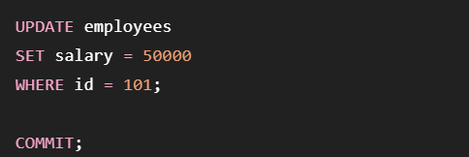
72. What is ROLLBACK?
Answer:
ROLLBACK is used to undo changes that have not yet been committed.
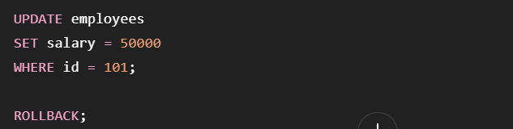
73. What is SAVEPOINT?
Answer:
SAVEPOINT creates a temporary checkpoint inside a transaction to which we can later roll back

74. What is the difference between COMMIT and ROLLBACK?
COMMIT | ROLLBACK
Saves changes permanently | Undoes uncommitted changes

👁️ Views
81. What is a View?
Answer:
A view is a virtual table created from original table.
It usually does not store the actual data .Instead, it simply displays data from tables through SQL.
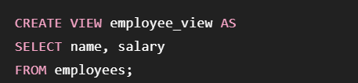

82. Why are Views used?
Views are mainly used for:
- Security – hide sensitive columns or rows.
- Simplicity – Showing only useful data

83. What is a Materialized View?
Answer:
A materialized view is a view whose query results(view table) is physically stored in the database.
Unlike a normal view, which runs the query every time you access it, a materialized view stores the query result(view table) so that it can be retrieved faster.

85. Can we update a View?
Answer:
Yes
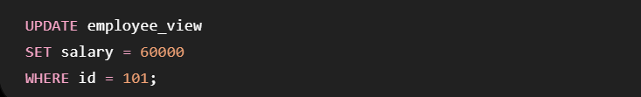
- What is a subquery?
- What is the difference between a subquery and a correlated subquery?
- What are Common Table Expressions (CTEs)?
- What are stored procedures?
- What are triggers?
- What are cursors?
- What is the difference between UNION and UNION ALL?
- What is the difference between EXISTS and IN?
- What are window functions in SQL?
- Explain RANK(), DENSE_RANK(), and ROW_NUMBER()?

91. What is a Subquery?
Answer:
A subquery is a query written inside another SQL query. The inner query provides a result that is used by the outer query.

92. What is the difference between a Subquery and a Correlated Subquery?
Normal Subquery
The inner query is independent of the outer query.
Correlated Subquery
The inner query depends on a value from the outer query.

94. What are Stored Procedures?
Answer:
A stored procedure is a pre-defined set of SQL code stored in the database that can be executed whenever required.
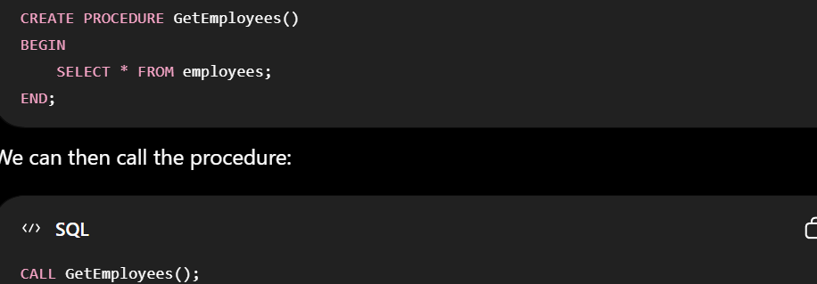
Stored Procedure | Function
Used mainly to perform an operation | Used mainly to calculate/return a value

95. What are Triggers?
Answer:
A trigger is lines of SQL code that automatically executes when a specified event occurs on a table or other database object.
BEFORE INSERT,AFTER INSERT,BEFORE UPDATE,AFTER UPDATE,BEFORE DELETE,AFTER DELETE

96. What are Cursors?
Answer:
A cursor is a database object used to process the query row by row.
Normally, SQL works with sets of rows at once. A cursor applies the query row by row
Drawbacks of Cursors
1. Slower performance

🔗 UNION & EXISTS
97. What is the difference between UNION and UNION ALL?
Both combine the results of two or more SELECT queries.
UNION
Removes duplicate rows.
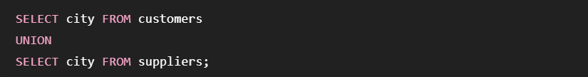 UNION ALL
Keeps duplicate rows.


98. What is the difference between EXISTS and IN?
IN
Checks whether a value exists in a list or subquery result.
EXISTS
Checks whether the value exists or not based on condition
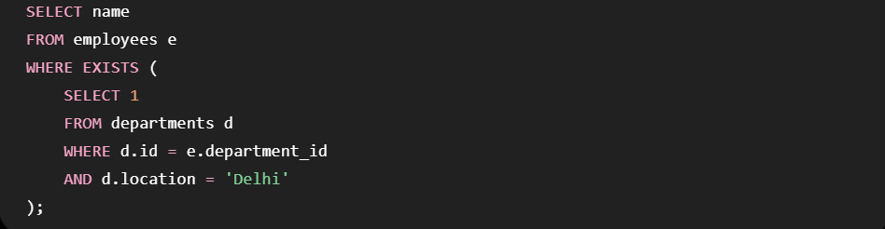
1. What is a Window Function?
A window function is a SQL function that performs a calculation on rows and returns the separate value for each rows
100. Explain RANK(), DENSE_RANK(), and ROW_NUMBER()
6. ROW_NUMBER()
ROW_NUMBER() assigns a unique sequential number to every row.
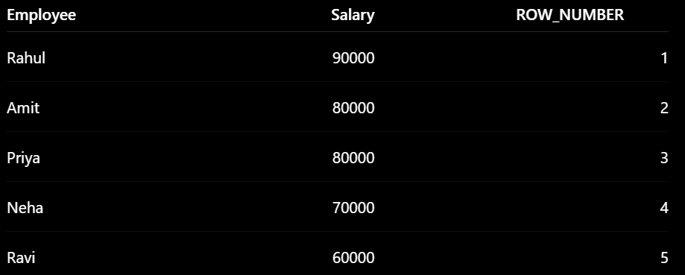
7. RANK()
RANK() gives the ranks to the rows in the table
It gives same rank to rows having the same value.
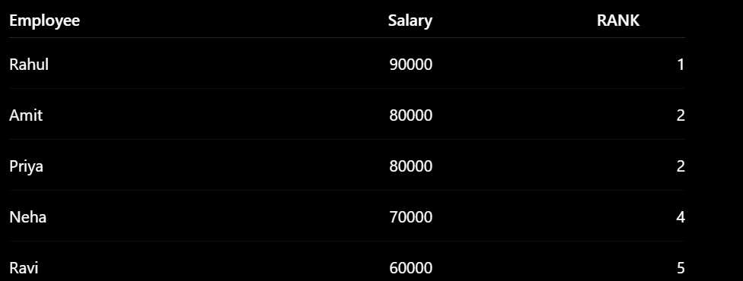
8. DENSE_RANK()
DENSE_RANK() gives ranks to the rows in the table
It gives the same rank to rows having the same value, but it doesn't leave gaps.


