1. What is Authentication?
Authentication is the security mechanism where the user gets verified before giving access
Methods:
- Password
- OTP
- Fingerprint

2. What is Authorization?
Authorization is the security mechanism where the user level of access is verified
This mechanism verifies whether the user is admin,developer or end-user

4. What is Multi-Factor Authentication (MFA)?
MFA is the authentication mechanism where the user gets verified using more than one-authentication factors

5. What is Encryption?
Encryption converts readable data (plaintext) into unreadable data (ciphertext) using an encryption algorithm and key.

6. What is Hashing?
Hashing converts data into a fixed-length value called a hash.
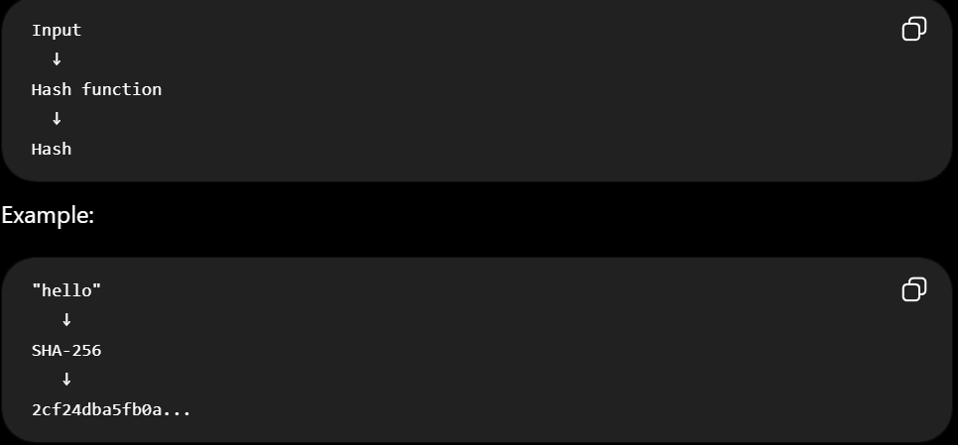
7. Hashing vs Encryption
Hashing | Encryption
One-way transformation | Reversible with the appropriate key

8. What is a Digital Signature?
A digital signature is a cryptographic signature created using cryptographic mechanisms used to verify the user identity

9. Why should passwords be hashed instead of encrypted?
If an attacker steals the database, properly stored password hashes make recovering the original passwords substantially harder.

10. What is HTTPS and how does it provide security?
By encryption

13. What is a Proxy Server?
A proxy server acts as an intermediary between a client and another server.
SECURITY
Company Web Filter: An office routes worker web traffic through a corporate proxy server. The proxy blocks social media sites and logs visited pages

14. What is a Man-in-the-Middle (MITM) Attack?
A Man-in-the-Middle attack occurs when an attacker positions themselves between two communicating parties to intercept or potentially modify their communication.

15. What is Malware?
Malware = Harmful Software
It is software intentionally designed to perform harmful or unauthorized actions.
Examples:
- Virus
- Worm

17. What is Phishing?
Phishing is a social-engineering attack where an attacker tricks a person into revealing information
Common types
- Email phishing
- SMS phishing (smishing)

18. What is a Brute-Force Attack?
A brute-force attack repeatedly tries possible passwords or credentials until one works.

19. What is a DoS Attack?
DoS = Denial of Service
The goal is to make a service unavailable or difficult for legitimate users to access

20. DoS vs DDoS
DoS
Attack comes from one source or a limited number of sources.
DDoS
Distributed Denial of Service
Attack traffic comes from many compromised or coordinated devices.

21. What is SQL Injection?
SQL Injection is a security attack where the attacker trick to execute the harmful sql code so that attacker gets access

22. What is a Vulnerability?
A vulnerability is a weakness in a system that could potentially be exploited by an attacker.

24. How do you secure an API?
1. Authentication
2. Authorization
3. HTTPS

