
IST 693
IST 693: Special Topics in IST - Data Visualization: Theory and Practice
Monte Ahuja College of Business, Cleveland State University, Fall 2025
Name: Lokesh Sivaprakash, Sruthi Sivaraman
E-mail: 2904333@vikes.csuohio.edu, 2910671@vikes.csuohio.edu
Instructor: Dr. Tseng

Final Project: Tableau Story & Dashboard Narrative
Introduction
The dashboards are organized in a logical sequence to guide the viewer from carrier-level insights to airport-level geographic patterns, and finally into detailed operational impact at Tier‑1 and Tier‑2 airports. This structure moves the analysis from broad national patterns down to specific airport contributors, supporting a clear narrative flow.
Dashboard 1: Carrier Performance – Arrival Delay Analysis
This dashboard answers Research Question 1: Which U.S. airline carrier experiences the highest average arrival delay time? It uses KPIs for worst carrier, best carrier, and overall delay to summarize performance. A horizontal bar chart shows Average Arrival Delay by Carrier using an LOD expression for accurate carrier-level aggregation. A dynamic parameter allows switching delay types for deeper insight. The lower chart shows average delay by selected delay cause, enabling a comparison across carriers.
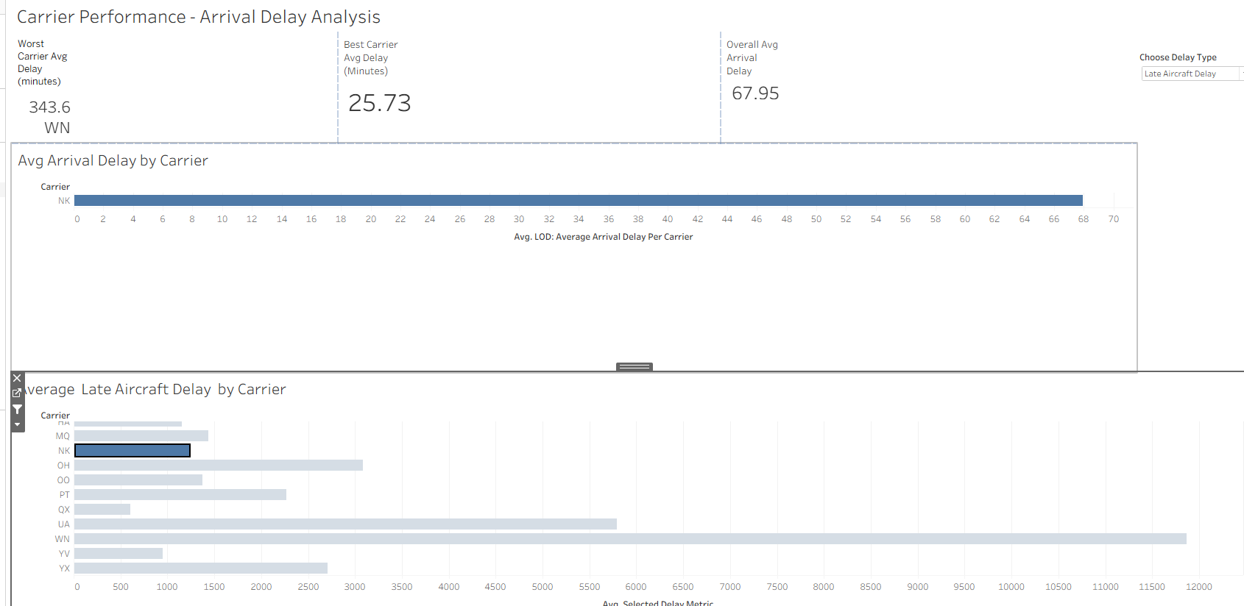
Dashboard 2: Airport Delay Patterns – Geographic & Operational Insights
This dashboard answers Research Question 2: Which airports have the highest average delays, and what geographic patterns emerge? A map visualizes airport‑level delays using color intensity. A Top‑10 airport bar chart provides operational clarity on the most delay‑affected airports. The Airport‑vs‑Delay Cause scatter plot compares delay metrics across multiple causes. The dynamic delay‑type parameter updates all visuals, supporting interactive analysis. The dashboard uses conditional formatting to highlight severe delays.
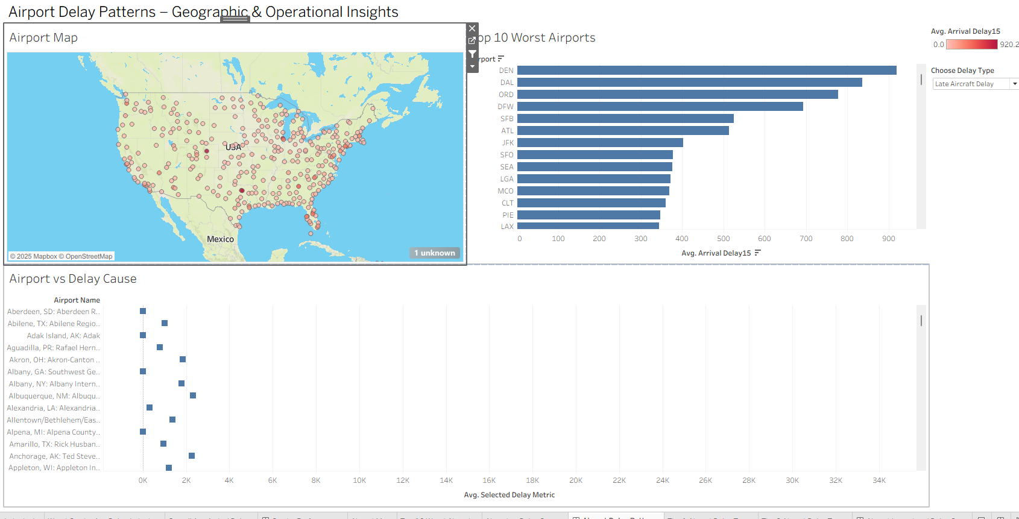
Dashboard 3: Airport Impact Analysis – Tier 1 vs Tier 2 Airports
This dashboard addresses Research Question 3: Which delay cause (weather, carrier, NAS, security, late aircraft) contributes the most to overall delay minutes across the industry? Tier‑1 and Tier‑2 airports are separated using a calculated field. A dynamic Top‑N and Bottom‑N parameter allows the user to filter airports by impact level. The Selected Delay Metric calculation ensures all charts respond interactively. This view clearly shows how operational load differs between major hubs and regional airports.
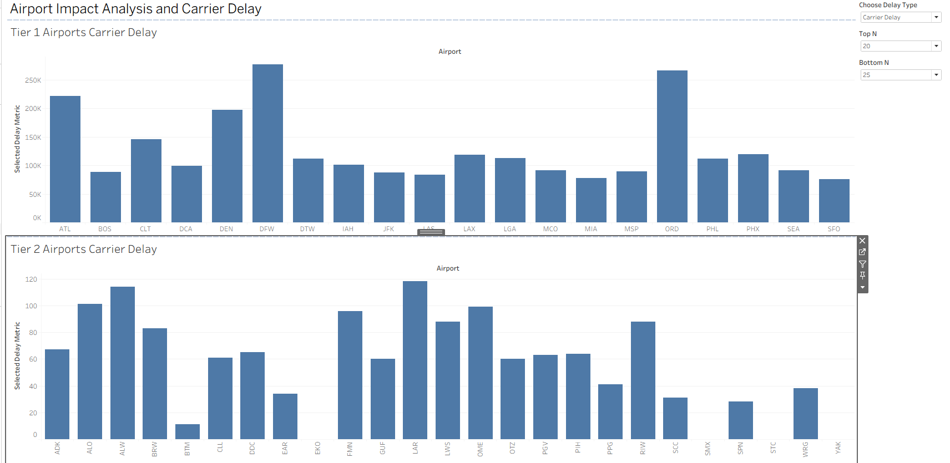
Data Source
Dataset: https://www.transtats.bts.gov/OT_Delay/OT_DelayCause1.asp

