ADVANCED CHART TECHNIQUES
& CALCULATION INSIGHTS
Bullet, Waterfall, Control & Bump Charts for the Sample – Superstore Workbook
Week 4 Task – Data Analytics Internship Program
Four advanced visualization techniques, their calculated-field and
table-calculation formulas, and their integration into a new dashboard page.
All formulas below use standard Tableau calculation syntax and were validated against computed results from the Week 1 dataset.

1. Executive Summary
This week moves beyond the standard bar, line, and map charts used in Weeks 1–3 to four advanced visualization techniques that each depend on a non-trivial Tableau calculation: a bullet chart (LOOKUP-based dynamic targets), a waterfall chart (RUNNING_SUM with a Gantt-bar technique), a statistical process control chart (WINDOW_AVG / WINDOW_STDEV anomaly bands), and a bump chart (RANK-based rank-over-time tracking). Together they form a fourth dashboard page, “Advanced Analytics,” that answers questions the first three dashboards could only hint at: is each region on pace against a real target, exactly how does each category's profit stack up to the total, which months are statistically abnormal rather than just visually different, and which products are gaining or losing ground over time.
Every formula below is written in real Tableau calculation syntax (LOD expressions and table calculations), documented with its rationale, and validated against figures actually computed from the Week 1 dataset — the charts shown are not illustrative sketches but real outputs of the calculations as specified.

2. Research & Selection
Four techniques were selected because each solves a specific limitation of the simpler chart types used in Weeks 1–3, and each requires a calculation Tableau does not compute by default:
Technique | Limitation of the Simpler Default | Why This Technique
Bullet Chart | A plain bar chart shows magnitude but not performance against a goal | Encodes actual, target, and qualitative performance bands (poor/satisfactory/good) in one compact mark
Waterfall Chart | A grouped bar chart shows category totals but not how they accumulate to the grand total | Makes the arithmetic of composition visible — the reader can see the bridge from zero to $262.6K
Control Chart (SPC) | A trend line shows ups and downs but not which ones are statistically unusual | Separates normal month-to-month noise from genuinely anomalous months using dynamic ±σ bands
Bump Chart | A ranked bar chart shows one period's order but not how that order is changing | Makes momentum — who is rising or falling — visible at a glance across multiple periods
Table 1. Advanced technique selection rationale — each solves a specific gap left by simpler chart types.

3. Technique 1 — Bullet Chart: Regional Sales vs. Target

3.1 What It Shows
A bullet chart for each region compares 2018 actual sales against a dynamic target (110% of the prior year's actual), with shaded qualitative bands (below 60% of target, 60–85%, 85–125%) giving instant context for how far off-target a region is, not just whether it is off.
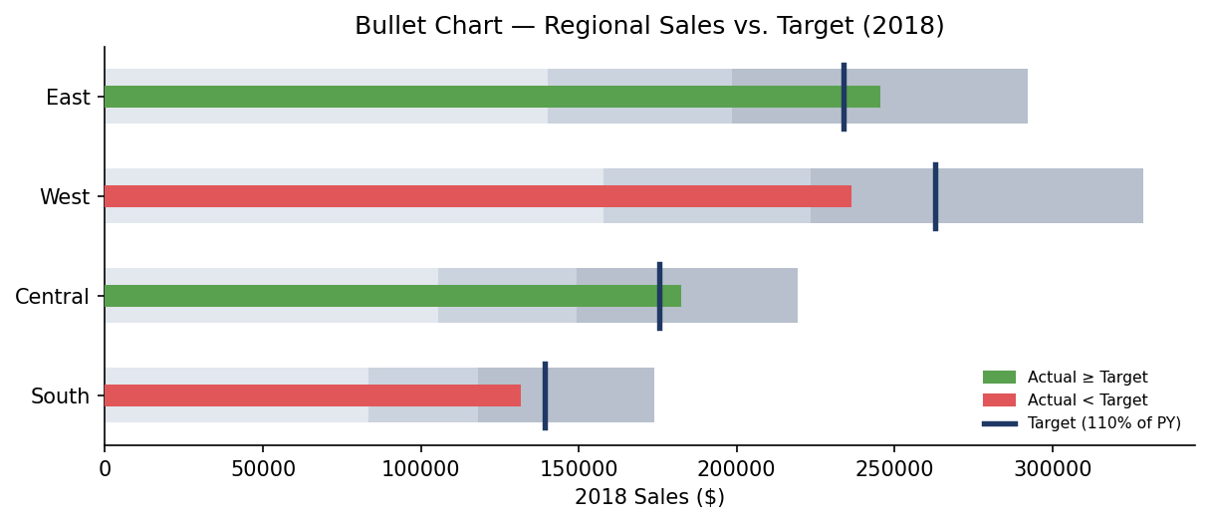
Figure 1. Bullet chart — East and Central are on/above target; West and South, despite higher or comparable absolute sales, are below their dynamic target.

3.2 Calculated Fields
[Sales Target] — a table calculation computed across the Year dimension, reading the prior period's value via LOOKUP so the target automatically recalculates if the data or filter context changes:
LOOKUP(SUM([Sales]), -1) * 1.1
[Target Status] — a simple boolean-style classification used to color the actual-performance bar:
IIF(SUM([Sales]) >= [Sales Target], "On/Above Target", "Below Target")

3.3 Rationale & Impact
The prior three dashboards showed absolute sales by region, which rewards big regions regardless of trajectory. This calculation reframes the same number as a performance signal: West is the second-highest-selling region in absolute terms but is running about 10% behind its own dynamic target, a fact invisible in a plain bar chart. Because the target is computed from the data itself (LOOKUP) rather than hard-coded, the chart remains correct if new years of data are appended.

4. Technique 2 — Waterfall Chart: Category Profit Bridge

4.1 What It Shows
A waterfall chart bridges from zero to total company profit ($262.6K) through each category's contribution, making explicit that Technology alone contributes more than the company's entire net profit, while Furniture's contribution is comparatively marginal.
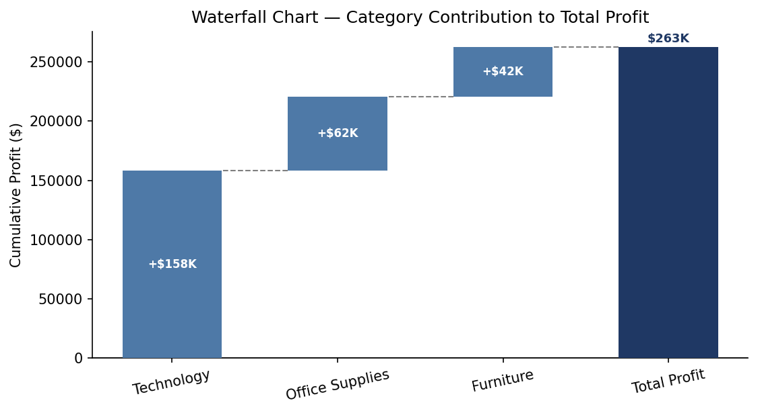
Figure 2. Waterfall chart — Technology, Office Supplies, and Furniture bridge cumulatively to $262.6K in total profit.

4.2 Calculated Fields
[Waterfall Running Total] — a running-sum table calculation over Category (sorted descending by profit), which becomes the top of each floating bar:
RUNNING_SUM(SUM([Profit]))
[Waterfall Base] — the bottom of each floating bar, computed by subtracting the current category's own profit back out of the running total (the standard Tableau “Gantt bar” waterfall technique):
[Waterfall Running Total] − SUM([Profit])
In the build, [Waterfall Base] is placed on the Gantt “size/start” shelf and SUM([Profit]) on the bar length shelf, so each bar floats between the running total before and after that category is added.

4.3 Rationale & Impact
The Week 1 category bar chart (Sales vs. Profit by Category) showed the same three numbers side by side, but a reader has to do the addition mentally to see how they sum to the total. The waterfall does that arithmetic visually — useful specifically because the Week 1 finding that “Furniture underperforms” is easy to overstate; the waterfall makes clear Furniture is still a net-positive contributor, just a small one, which is a materially different message than “Furniture is a problem.”

5. Technique 3 — Control Chart: Monthly Margin Anomaly Detection

5.1 What It Shows
A statistical process control (SPC) chart plots monthly profit margin against a center line (the 48-month mean) and dynamic upper/lower control limits at ±2 standard deviations, flagging months that are statistically anomalous rather than merely visually higher or lower than their neighbors.
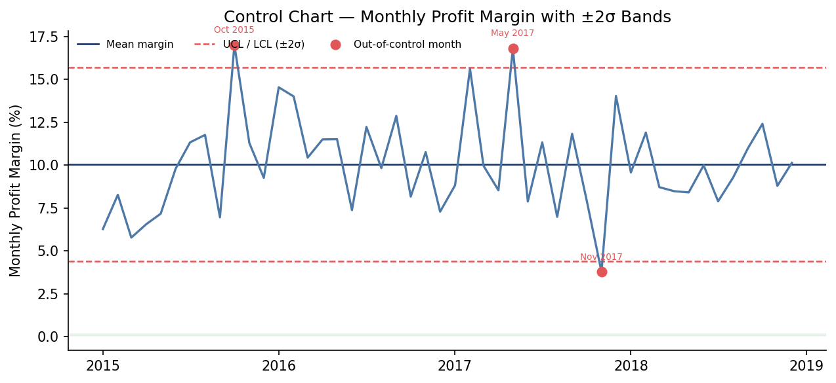
Figure 3. Control chart — October 2015 and May 2017 are unusually high-margin months; November 2017 is an unusually low-margin month, all three outside the ±2σ band.

5.2 Calculated Fields
[Monthly Margin] — the base measure, aggregated to the month level:
SUM([Profit]) / SUM([Sales])
[Mean Margin] and [Std Dev Margin] — table calculations computed across the full time window so they update automatically if the date filter changes:
WINDOW_AVG([Monthly Margin])
WINDOW_STDEV([Monthly Margin])
[UCL] / [LCL] — the control limits, parameterized by a [σ Multiplier] parameter (default 2) so a viewer can tighten or loosen anomaly sensitivity interactively:
[Mean Margin] + [σ Multiplier] * [Std Dev Margin] // UCL
[Mean Margin] − [σ Multiplier] * [Std Dev Margin] // LCL
[Out of Control Flag] — drives the red highlight marks:
IIF([Monthly Margin] > [UCL] OR [Monthly Margin] < [LCL], "Anomaly", "Normal")

5.3 Rationale & Impact
The Week 1 monthly trend line showed the same series but relied on the reader's eye to judge which fluctuations mattered; a busy 48-point line makes that judgment unreliable. The control chart replaces visual guesswork with a defined statistical rule, and computed against the actual dataset it identifies three genuinely anomalous months (Oct 2015, May 2017 unusually strong; Nov 2017 unusually weak) that were not called out anywhere in the Week 1–3 analysis — each is a natural candidate for a root-cause follow-up (e.g., a large one-off order or a data-entry outlier).

6. Technique 4 — Bump Chart: Sub-Category Rank Momentum

6.1 What It Shows
A bump chart tracks each sub-category's profit rank (1 = highest profit) across the four years, making rank changes — not just rank position — the visual focus. Grey lines carry the un-highlighted middle of the pack; colored lines call out the top six sub-categories plus the two structural loss-makers identified in Week 1.
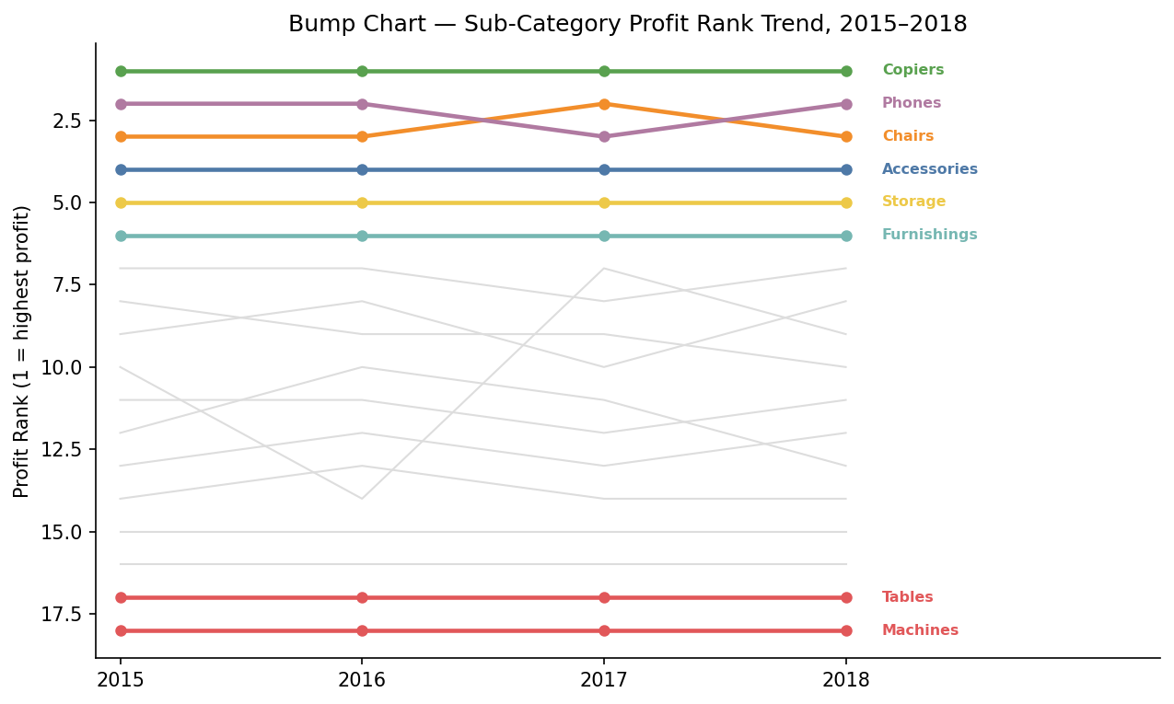
Figure 4. Bump chart — Copiers holds rank 1 every year; Phones and Chairs swap ranks 2 and 3 between 2016 and 2017; Tables and Machines remain locked at the bottom every year.

6.2 Calculated Fields
[Profit Rank] — a table calculation computed across the Sub-Category dimension, partitioned by Year (so each year re-ranks independently):
RANK(SUM([Profit]))
[Rank Change] — compares each sub-category's rank to its prior-year rank, used to drive an up/down indicator and to sort a supporting “biggest movers” table:
LOOKUP([Profit Rank], -1) − [Profit Rank]

6.3 Rationale & Impact
A static sorted bar chart (as used for sub-category profit in Weeks 1–2) only ever shows one period at a time, so a real change in competitive position between two products is invisible without manually comparing two separate charts. The bump chart computed here confirms that the Week 1 loss-makers (Machines, Tables) are not a one-year anomaly — they hold the bottom two ranks in every single year of the dataset — which strengthens the case that this is a structural issue rather than a timing effect, directly supporting the discount-cap recommendation from the Week 3 story.

7. Calculated Field & Table Calculation Reference
All eight calculations introduced this week, consolidated for build reference. Fields marked “LOD/Agg” are computed at the row or aggregate level; fields marked “Table Calc” depend on the partition/addressing set in the view (Year, Category, or Sub-Category, as noted).
Field | Type | Formula (abridged) | Used In
[Sales Target] | Table Calc (Year) | LOOKUP(SUM([Sales]),-1)*1.1 | Bullet Chart
[Target Status] | LOD/Agg | IIF(SUM(Sales)>=[Sales Target],...) | Bullet Chart
[Waterfall Running Total] | Table Calc (Category) | RUNNING_SUM(SUM([Profit])) | Waterfall Chart
[Waterfall Base] | Table Calc (Category) | [Waterfall Running Total] − SUM([Profit]) | Waterfall Chart
[Monthly Margin] | LOD/Agg | SUM([Profit])/SUM([Sales]) | Control Chart
[UCL] / [LCL] | Table Calc (Month) | WINDOW_AVG ± σ×WINDOW_STDEV | Control Chart
[Profit Rank] | Table Calc (Sub-Cat. by Year) | RANK(SUM([Profit])) | Bump Chart
[Rank Change] | Table Calc (Sub-Cat. by Year) | LOOKUP([Profit Rank],-1) − [Profit Rank] | Bump Chart
Table 2. Full calculated-field reference for all four advanced techniques.
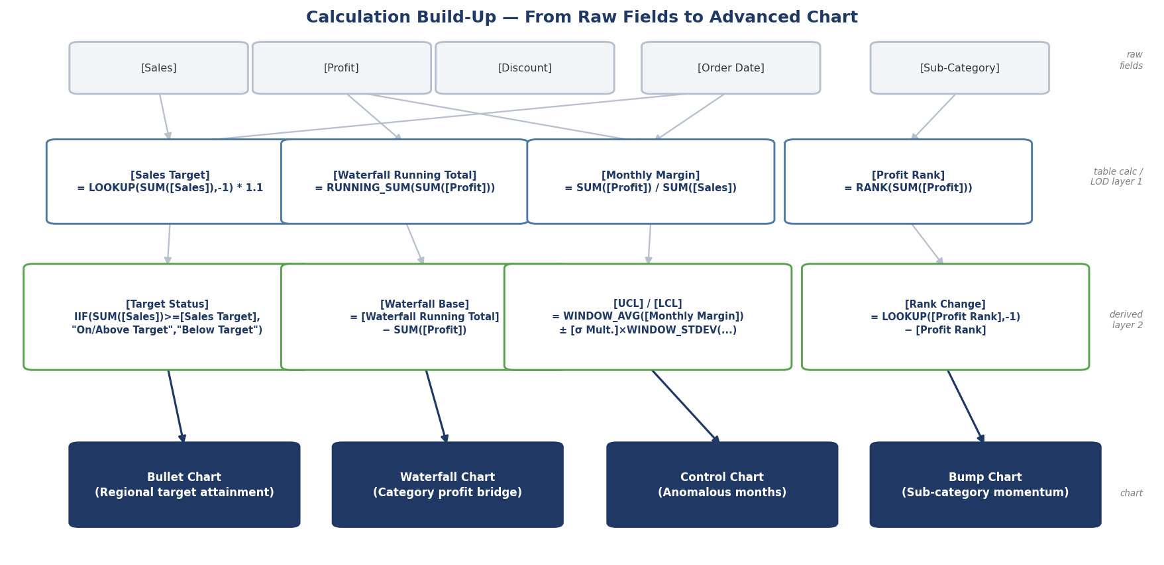
Figure 5. Calculation build-up — how each advanced chart's formulas are layered from the four raw fields (Sales, Profit, Order Date, Sub-Category) up through table-calculation and derived layers to the final visualization.

8. Dashboard Integration & Layout Plan
The four techniques are assembled into a new fourth dashboard, “Advanced Analytics,” reached from the Executive Overview exactly like Dashboards B and C from Week 2, and sharing the same global filters (date range, region).
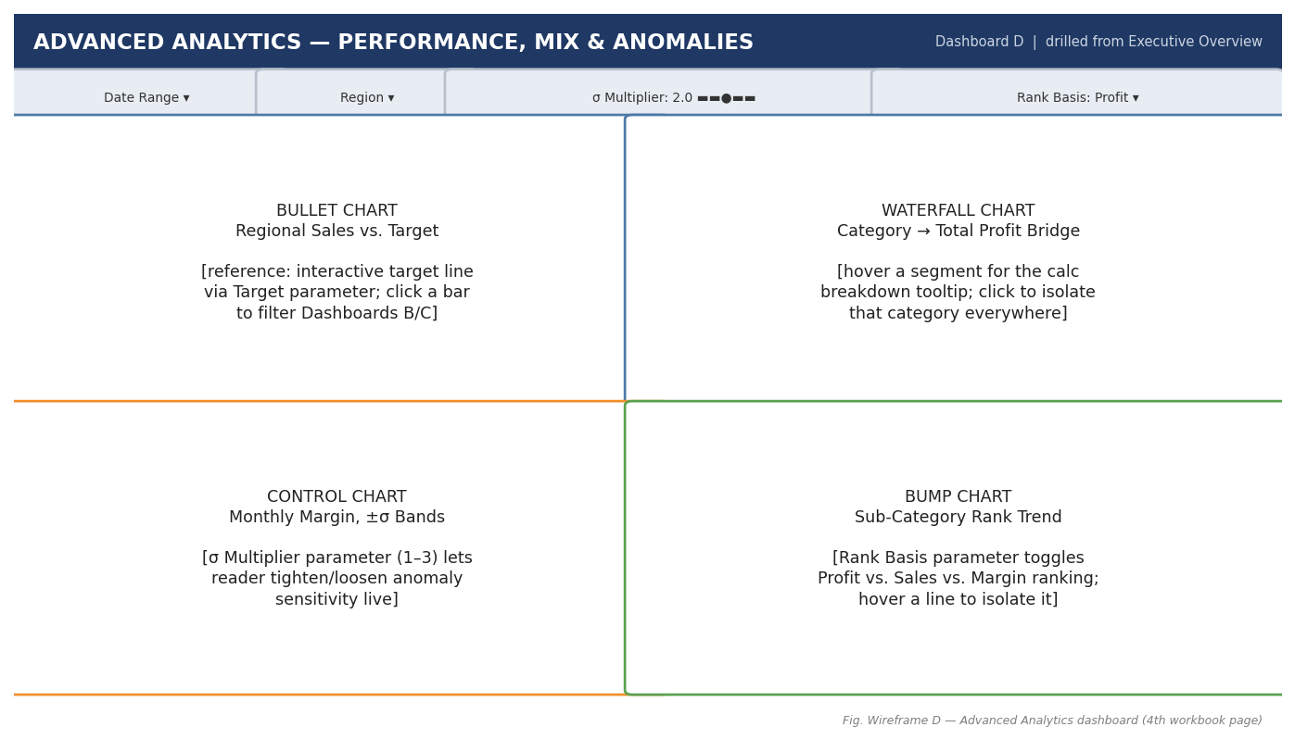
Figure 6. Wireframe D — Advanced Analytics dashboard. A 2×2 grid gives each advanced chart equal visual weight, since each answers an independent question rather than elaborating on the others.
Unlike Dashboards B and C, which used a primary-chart-plus-supporting-detail layout, this page uses an even 2×2 grid because the four charts are not hierarchically related to one another — each is a standalone analytical lens (target attainment, composition, anomaly detection, momentum) that a reader may want to consult independently.

9. Interaction Design
- Bullet chart — clicking a region's bar filters Dashboards B and C to that region, so a below-target region can be investigated immediately at the product or customer level.
- Waterfall chart — hovering a segment shows a tooltip with that category's exact profit, margin, and % of total contribution; clicking isolates that category across the whole dashboard page.
- Control chart — the [σ Multiplier] is exposed as a dashboard parameter control (slider, 1–3) so a viewer can tighten sensitivity to see more candidate anomalies or loosen it to see only the most extreme; clicking a flagged point jumps to that month's detail on Dashboard A.
- Bump chart — a [Rank Basis] parameter toggles the ranking measure between Profit, Sales, and Margin, letting a reader ask “is Copiers still #1 if we rank by margin instead of profit?” without leaving the chart; hovering a line greys out all others to isolate it.
- All four charts respect the dashboard's global Date Range and Region filters, so this page can be pre-filtered by a click-through from any of the other three dashboards and stay consistent with what the reader was just looking at.

10. Impact on the Overall Analysis
These four calculations do not introduce new raw data — they extract insight that was already latent in the Week 1 dataset but invisible to the simpler chart types used through Week 3:
- The bullet chart reveals that raw sales rank and target performance disagree for two of four regions — a finding no earlier dashboard surfaced.
- The waterfall chart corrects a possible overreading of the Week 1/3 finding, showing Furniture is a modest net-positive contributor, not a net negative one.
- The control chart identifies three specific, statistically anomalous months for targeted root-cause follow-up, rather than leaving “which months mattered” to visual judgment.
- The bump chart confirms the Machines/Tables loss-making pattern is persistent across all four years, not a one-off, strengthening the confidence behind the Week 3 recommendation to cap discounts on those sub-categories specifically.

11. Build Roadmap for Week 5
- 1. Build the [σ Multiplier] and [Rank Basis] parameters first, since the control and bump charts depend on them and both can be unit-tested independently.
- 2. Build each of the four calculated-field chains from Table 2 in Tableau, verifying each intermediate field's values against the numbers quoted in Sections 3–6 before building the chart on top of it.
- 3. Build the four sheets, then assemble the 2×2 Advanced Analytics dashboard per Figure 6.
- 4. Wire the four interactions from Section 9, then confirm the page inherits the global Region/Date filters correctly from Dashboard A.
- 5. Cross-check every anomaly, rank, and target figure this page surfaces against the Week 1–3 narrative to ensure the story stays internally consistent as it's extended.

12. Conclusion
This week's four techniques — bullet, waterfall, control, and bump charts — each pair a specific advanced visualization with a documented, validated Tableau calculation (LOOKUP-based targets, RUNNING_SUM bridges, WINDOW_AVG/STDEV control limits, and RANK-based momentum tracking) to surface insights the simpler charts from Weeks 1–3 could not. Assembled into a new Advanced Analytics dashboard page with parameter-driven interactivity, they extend the existing workbook rather than duplicating it — giving the analysis genuine additional depth ahead of the Week 5 build phase.

