***Annexure-1***

Battle Ground Game

### A Project Work

*Submitted in the partial fulfilment for the award of the degree of*

# BACHELOR OF ENGINEERING

### IN

**ARTIFICIAL INTELLIGENCE AND MACHINE LEARNING**

### Submitted by: LOKESH DEHSWAL 18BCS6219

**Under the Supervision of:**

**Prof. YOGIRAJ BHALE**



# DEPARTMENT OF COMPUTER SCIENCE AND ENGINEERING APEX INSTITUE OF TECHNOLOGY

### CHANDIGARH UNIVERSITY, GHARUAN, MOHALI - 140413, PUNJAB

**MAY, 2021**

***Annexure-2***

# DECLARATION

I, **Lokesh Deshwal**, student of **Bachelor of Engineering in Artificial Intelligence and Machine Learning**, **session: 2018-2022**, Department of Computer Science and Engineering, Apex Institute of Technology, Chandigarh University, Punjab, hereby declare that the work presented in this Project Work entitled ‘**Battle Ground Game’** is the outcome of our own bona fide work and is correct to the best of our knowledge and this work has been undertaken taking care of Engineering Ethics. It contains no material previously published or written by another person nor material which has been accepted for the award of any other degree or diploma of the university or other institute of higher learning, except where due acknowledgment has been made in the text.

### (Lokesh Deshwal) Candidate UID:18BCS6219

**Date: 25th April, 2021 Place: Chandigarh**

# Abstract

Battle Ground Games (BGG) such as Counter Strike are often the subject of public concern. Surprisingly, there is no published research available about playing these games. We conducted an exploratory Internet survey (n 5 751) in order to gather information about who the players of online first person shooters are, and why they spend time on playing this particular kind of video game. The results of our survey on the one hand confirmed the stereotype of the gamer as it is often presented in popular media: the players of online BGG were indeed almost exclusively young men (mean age about 18 years) who spend a lot of their leisure time on gaming (about 2.6 h per day). We also found that the most committed gamers, that is, the ones who were members of a (semi)professional clan, scored highest on motives with respect to competition, and challenge in comparison with members of amateur clans and online gamers who had not joined a clan. On the other hand, our results cast doubt on the accuracy of the stereotype. This study showed clearly that online BGG are not played in isolation. More than 80% of our respondents were member of a clan. Also, the regression analysis showed that the social interaction motive was the strongest predictor of the time actually spend on gaming. And in the result of the survey we find out that a lots of youngster would like to play the multiplayer game .

# Acknowledgement

I have taken efforts in this project. However, it would not have been possible without the kind support and help of many individuals and organizations. I would like to extend my sincere thanks to all of them.

I take this opportunity to express my profound gratitude and deep regards to my teacher **Prof. Yogiraj Bhale** (Chandigarh University, Gharaun, Punjab) for their exemplary guidance, monitoring and constant encouragement throughout the course of this project. The blessing, help and guidance given by them time to time shall carry me a long way in the journey of life on which I am about to embark.

I would also like to thank my parents and friends who helped me complete this project within the deadline

***List of Figures***

***Figure Title Page***

*Fig 3.1 Illustrating the steps that explains the major parts of the 10*

*projects mainly depicting the working of the projects.*

*Fig 3.2 Output of the project with box 11*

*Fig 3.3 Another output of game result 11*

**Gantt Chart**

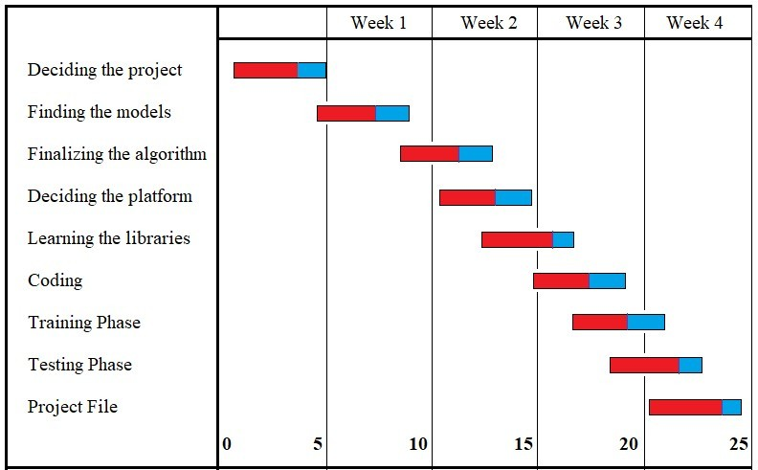

***Annexure-3***

**TABLE OF CONTENTS**

Title Declaration Abstract

Acknowledgement List of Figures Gantt Chart

i ii iii iv v vi

1: INTRODUCTION 8

* 1. Problem Definition 8
  2. Whom it may help? 8
  3. Project Overview/Specification 8
  4. Hardware Specification 9
  5. Software Specification 9

2: LITERATURE SURVEY 10

* 1. Existing System 10
  2. Proposed System 10

3: PROBLEM FORMULATION 11

4: OBJECTIVES 13

* 1. General Objective 13
  2. Specific Objective 13
  3. Immediate Objective 13

5: METHODOLOGY 14

6: CONCLUSION 15

7: REFERENCES 16

## INTRODUCTION

* 1. **PROBLEM DEFINITION**

The computer market for shooter games is moving towards complex, photo-realistic 3D car simulation games. The problems are long startup times and high learning curves for the player. Furthermore these games require a large amount of cpu time, which forces the players to upgrade their mobile phones to cope up with the hardware needs for these games. The goal of BGG is to provide a simple, fast and cheap shooter game, which has a high fun factor by fighting with enemy and fighting with our own friends at a same time together. It should not need special hardware requirements.

* 1. **WHOM IT MAY HELP?**

Gaming is really a workout for your mind disguised as fun. Studies have shown that playing video games regularly may increase gray matter in the brain and boost brain connectivity. Gray matter is associated with muscle control, memories, perception, and spatial navigation. The stereotype of a shy person who uses video games as a way to escape is not what the average gamer looks like. Past research involving children found that those who played more video games were more likely to have good social skills, perform better academically, and to have built better relationships with other students because of the social and collaborative component to some types of games. Anyone from any age can play this game as it is a mood booster .

**PROJECT OVERVIEW/SPECIFICATIONS**

This project Battle Ground Game aims at playing online game on the Internet is an increasingly popular kind of mediated entertainment, but it has not yet led to a body of scientific research. In this we will create a multiplayer game where more than 4 people can play within a single room and it will support 25 players to play simultaneously online. In this we are going to use mirror networking to support the multiplayer functionality in the game .It is a android based app where we can move our player with the help of joystick and can attack the enemy with the gun.

* 1. **HARDWARE SPECIFICATION**

1: Camera (High resolution)

2: CPU – i3 and above.

3: Min Ram 3gb

4: Android Phone

* 1. **SOFTWARE SPECIFICATION**

1: Windows 10 and above.

2:Unity 3D game engine.

3: Mirror networking

4:Android Support

5:Blender

6:Adobe fuse

## LITERATURE SURVEY

* 1. **EXISTING SYSTEM**

Some of the earliest video games were two-player games, including early sports games (such as 1958's Tennis For Two and 1972's Pong), early shooter games such as Spacewar! (1962) and early racing video games such as Astro Race (1973). The first examples of multiplayer real-time games were developed on the PLATO system about 1973. Multi-user games developed on this system included 1973's Empire and 1974's Spasim ; the latter was an early first-person shooter. Other early video games included turn-based multiplayer modes, popular in tabletop arcade machines. In such games, play is alternated at some point (often after the loss of a life). All players' scores are often displayed onscreen so players can see their relative standing.

* 1. **PROPOSED SYSTEM**

Our model/project used the Unity 3D game engine for the multiplayer shooting functionality .In this game we can play it in both mode offline as well as online .It support both the function. The menu system is created using the Slate UI framework . It consists of menus, menu widgets, and menu items. Each menu has a single menu widget (SSHooterMenuWidget) that is responsible for layout, internal event handling, and animations for all of the menu items. Menu items (SSHooterMenuItem) are compound objects that can perform actions and contain any number of other menu items. These can be as simple as a label or button or "tabs" that contain complete submenus made up of other menu items. This menu can be operated using mobile phones .

In first-person mode, the Pawn's mesh is hard-attached to the camera so that the arms always appear relative to the player's view. The downside of this approach is that it means the legs are not visible in the player's view, since the entire mesh rotates to match the camera yaw and pitch.

## PROBLEM FORMULATION

**As** in the existing model we could not be able to play the mode i.e online and offline mode .In this the project will help us to solve the mode changing problems .And another factor in the exiting model that differentiate our model is that we could be able to target the enemy in the offline mode .And the AI enemy support will be their in the online mode too. first-person shooter” (FPS) game refers to a game where the game play involves shooting enemies and other targets (usually with firearms). The player views the action from the perspective of the character (i.e., “first person”). FPS games may involve story and adventure elements, but these games are most known for being competitive, violent, and fast-paced. Many of the most popular online FPS games are played in teams and some are played within e Sports (e.g., Counterstrike: Global Offensive, Team Fortress 2, and Call of Duty). “Third-person shooters” are similar in design to FPSs, but the player views the action from behind (or “over the shoulder”) of the onscreen character.

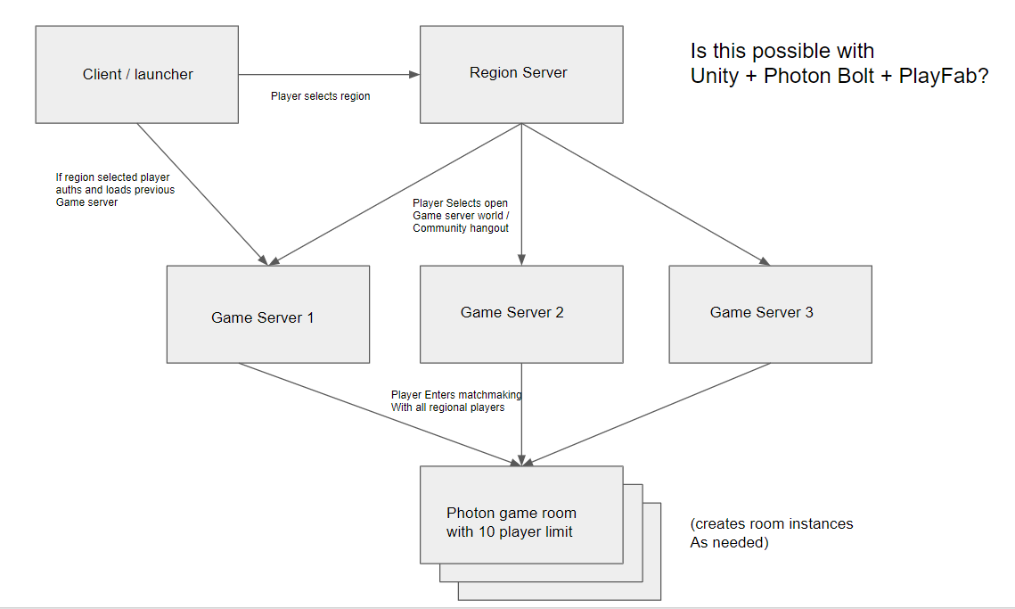

Fig 3.1

The steps for the model as illustrated in fig 3.1 are followed as a framework for the model working. This model is the need of the hours as it can be implemented almost every where wherever one want to provide multiplayer functionality.

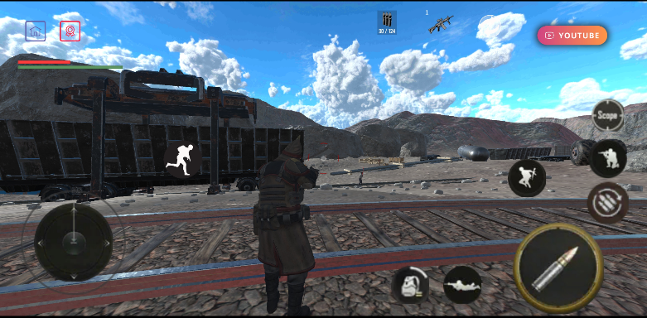

## OBJECTIVES

The research objectives for the Battle Ground Game can be defined as:

**4.1: General Objective:** Battle Ground Game aims at providing accurate results of the given input stream by effectively moving the player in the direction does the user wants to move with the help of joystick .

**4.2: Specific Objectives:** The model is based on basically three steps that are

* Object detection (enemy only)
* Computing pairwise distance between the centroids of the objects (player) detected and after that the enemy will run towards to shoot player.
* Checking the distance, if < n then enemy will run towards the player else will move in the default position.

**4.3: Immediate Objectives:** We have proposed this model and this model is the need of the youngsters. It helps in mental health benefits, better problem solving .

## METHODOLOGY

The following methodology will be followed to achieve the objectives defined for proposed research work:

Extensive research has shown that the act of play is extremely important in the lives of human beings. It is thus not surprising that games have a long and continuing history in the development of almost every culture and society. The advent of computers and technology in general has also been akin to the need for entertainment that every human being seeks. However, a curious dichotomy exists in the nature of electronic games: the vast majority of electronic games are individual in nature whereas the non electronic ones are collective by nature. On the other hand, recent technological breakthroughs are finally allowing for the implementation of electronic multiplayer games. Because of the limited experience in electronic, multiplayer game design, it becomes necessary to adapt existing expertise in the area of single-player game design to the realm of multiplayer games. This work presents a model to support the initial steps in the design process of multiplayer games. The model is defined in terms of the characteristics that are both inherent and special to multiplayer games but also related to the relevant elements of a game in general. Additionally, the model is used to assist in the design of two multiplayer games. “One of the most difficult tasks people can perform, however much others may despise it, is the invention of good games.We are making use of photons for networking. The Photon Realtime SDK is the lean and core API to access all Photon Cloud Services. It is the base for the higher level multiplayer SDKs: PUN, BOLT and QUANTUM. The communication SDKS - Photon VOICE, VIDEO and CHAT - base on it as well.

## CONCLUSION

It is forecasted that the gaming industry will generate great opportunities for game developers over the next two years. The gaming industry has grown its presence over various platforms – mobile, console, PC, online gaming and the industry is growing really fast along with the presence on all these platforms. Most of the other sectors stick to only one platform and then move to the another, once they have established their presence on the same. However the ‘Gaming Industry’ has a different story to tell.

## REFERENCES

1. Griffiths, M.D., Davies, M.N.O., & Chappell, D.(2004b). Demographic factors and playing variables in online computer gaming. Cyber Psychology & Behavior 7:479–487.

2. Griffiths, M.D., Davies, M.N.O., & Chappell, D.(2003). Breaking the stereotype: the case of online gaming. Cyber Psychology & Behavior 6:81–91.

3. Griffiths, M.D., Davies, M.N.O., & Chappell, D. (2004a).Online computer gaming: a comparison of adolescent and adult gamers. Journal of Adolescence 27:87–96.

4. Kolo , C., & Baur, T. (2004). Living a virtual life: social dynamics of online gaming. Game Studies. Available at: www.gamestudies.org/0401/kolo/.Accessed November 1, 2006.