Module - I

Introduction to Database Systems: Applications and Purpose
In the realm of modern computing, Database Systems play an integral role, acting as the foundational bedrock for managing and organizing vast amounts of data efficiently. A Database System encompasses a structured collection of data that is organized, stored, and accessed electronically, often through a set of software applications.

Database System Applications
The applications of Database Systems are ubiquitous and diverse, permeating numerous sectors and industries:
- Business Management: Businesses employ Database Systems to store, retrieve, and manage data pertaining to customers, inventory, transactions, and various operational aspects. These systems facilitate smoother operations, accurate analysis, and informed decision-making.
- Healthcare: Within healthcare, Database Systems securely store patient records, medical histories, test results, and administrative information. They streamline processes, ensuring quick access to critical information for medical professionals while upholding data security and privacy.
- Education: Educational institutions utilize Database Systems to manage student records, academic progress, administrative data, and resource allocation. These systems assist in maintaining organized records and enhancing educational processes.
- Finance: Banking and financial sectors rely heavily on Database Systems for managing transactions, customer accounts, loans, and financial records. These systems ensure accuracy, security, and compliance with regulatory standards.
- E-commerce and Retail: Online shopping platforms utilize databases to manage product catalogs, customer profiles, purchase histories, and logistics, enhancing user experience and enabling targeted marketing strategies.

Purpose of Database Systems
The primary objectives of Database Systems encompass several key purposes:
- Data Organization and Storage: Database Systems organize data in a structured manner, ensuring efficient storage and retrieval. Information is stored in tables, enabling easier access, manipulation, and retrieval of specific data elements.
- Data Integrity and Security: Maintaining data accuracy, consistency, and reliability is crucial. Database Systems enforce data integrity rules, ensuring that data remains accurate and reliable over time. Additionally, they implement security measures to safeguard sensitive information from unauthorized access or breaches.
- Efficient Data Retrieval and Manipulation: These systems provide query languages and interfaces that allow users to retrieve and manipulate data according to their requirements. Indexing, querying, and data manipulation capabilities optimize the efficiency of operations performed on the data.
- Concurrency Control and Transaction Management: In multi-user environments, Database Systems ensure that multiple users can access and modify data concurrently without compromising its integrity. Transaction management mechanisms guarantee that changes made to the database occur reliably and consistently.
- Scalability and Performance: Database Systems are designed to handle increasing volumes of data while maintaining performance. They offer scalability options, allowing for the expansion of storage and processing capabilities to accommodate growing data needs.
In conclusion, Database Systems serve as the backbone of modern information management, offering a structured approach to store, manage, and utilize data across diverse applications, contributing significantly to organizational efficiency, decision-making, and innovation in various sectors.

View of Data in Database Systems

Data Abstraction
Data abstraction refers to the process of hiding complex implementation details and presenting users with a simplified and understandable view of the data. It allows users to focus on essential aspects while concealing unnecessary complexities, enhancing the efficiency and usability of the system.

Instances and Schemas
Instances and schemas are fundamental concepts in database systems:
- Instances: An instance represents the actual data stored in a database at a specific point in time. It is the collection of all current data contained within the database. For instance, if a database contains a table of employees, an instance would be the current set of all employees and their details.
- Schemas: A schema defines the structure, organization, and relationships within a database. It represents the overall design blueprint, outlining the tables, fields, relationships, constraints, and data types used in the database. Schemas provide a framework for understanding how data is organized and stored without revealing the actual data values.

Data Models
Data models serve as conceptual tools used to represent the structure, relationships, constraints, and semantics of the data in a database. They enable a clear understanding of how data is organized and manipulated within the system. Commonly used data models include:
- Relational Model: Organizes data into tables (relations) consisting of rows (tuples) and columns (attributes). It establishes relationships between tables through keys, facilitating data retrieval and manipulation using SQL.
- Entity-Relationship Model (ER Model): Represents entities (objects) and their relationships using entities, attributes, and relationships. It helps in visualizing the logical structure of the database.
- Object-Oriented Model: Represents data as objects, allowing the storage of complex data types and supporting inheritance and encapsulation.
- Hierarchical Model and Network Model: Older data models that organize data in hierarchical or network-like structures, which have been largely replaced by more modern models like the relational model.
Data models act as a bridge between the real-world entities and the database structure, providing a logical framework for designing and implementing a database system.

Database Languages in Database Systems

Data Definition Language (DDL)
Data Definition Language (DDL) is a subset of SQL (Structured Query Language) used to define and manage the structure and schema of a database. It allows database administrators and users to perform operations that define and modify the structure of the database.
Key functionalities of DDL include:
- Creating Database Objects: DDL commands such as CREATE TABLE, CREATE INDEX, and CREATE VIEW enable the creation of tables, indexes, views, and other database objects.
- Altering Database Objects: DDL commands like ALTER TABLE, ALTER INDEX, and ALTER VIEW allow modifications to the structure of existing database objects, such as adding or dropping columns, changing data types, or renaming objects.
- Dropping Database Objects: DDL provides commands like DROP TABLE, DROP INDEX, and DROP VIEW to remove or delete database objects from the schema.

Data Manipulation Language (DML)
Data Manipulation Language (DML) is a subset of SQL responsible for managing and manipulating data within the database. It enables users to retrieve, insert, update, and delete data from the database tables.
Key functionalities of DML include:
- SELECT: The SELECT statement is used to retrieve data from one or more tables based on specified criteria. It allows users to query and retrieve specific information from the database.
- INSERT: The INSERT statement is used to add new rows of data into a table, specifying the values for each column or selecting values from another table.
- UPDATE: The UPDATE statement modifies existing data in a table by changing the values of specific columns based on specified conditions.
- DELETE: The DELETE statement removes rows from a table based on specified conditions, effectively deleting data from the database.

Importance
DDL and DML are essential components of database languages, providing users with the capability to define the database structure and schema using DDL, while manipulating and managing the stored data using DML. Together, these languages empower users to interact effectively with the database, enabling data definition, modification, retrieval, and deletion operations.

Database Architecture
Database Architecture refers to the arrangement of components that constitute a Database Management System (DBMS). It outlines the structure, organization, and interaction of various modules within the DBMS, defining how data is stored, accessed, and managed.

Components of Database Architecture:
- Storage Structures: This component deals with how data is physically stored on storage devices like hard drives or SSDs. It includes mechanisms for organizing data into files, pages, and blocks for efficient storage and retrieval.
- Query Processor and Optimizer: The query processor interprets user queries written in a database language (like SQL) and converts them into an execution plan. The optimizer chooses the most efficient way to execute the query by considering various factors such as indexes, join methods, and access paths.
- Transaction Manager: It ensures the ACID properties (Atomicity, Consistency, Isolation, Durability) of transactions. It oversees the execution of concurrent transactions, managing their execution and ensuring data integrity.
- Database Buffer and Cache Manager: These components manage the memory buffers that store frequently accessed data and control caching strategies to optimize data retrieval.
- Database Communication Interfaces: These interfaces facilitate communication between applications or users and the database system. They allow external programs to interact with the database through APIs or network protocols.
- Security and Authorization: Database architecture includes mechanisms to control access to the database, ensuring that only authorized users have the appropriate permissions to perform specific operations on the data.

Database Users and Administrators
Database Users and Administrators play distinct roles in utilizing and managing a Database System.

Database Users:
- End Users: They are the individuals who interact directly with the database through applications or interfaces to retrieve, modify, or input data. End users can include employees, customers, or any individuals using applications that access the database.
- Application Programmers: These users design and develop applications that interact with the database. They write code, queries, and scripts to enable functionality and data retrieval from the database.

Database Administrators (DBAs):
Database Administrators are responsible for managing, configuring, and maintaining the database system. Their roles and responsibilities include:
- Database Design: Designing the database schema, defining structures, relationships, and constraints.
- Security Management: Setting up user access permissions, roles, and ensuring data security.
- Performance Tuning: Monitoring and optimizing database performance, indexing, and query optimization.
- Backup and Recovery: Creating and maintaining backups of the database and planning for disaster recovery.
- Routine Maintenance: Performing routine tasks like software updates, patches, and ensuring data consistency and integrity.

Database Design and ER Diagrams
Database Design is the process of structuring and organizing data to create a blueprint for an efficient and well-organized database system. One of the key tools used in this process is the Entity-Relationship (ER) model, which provides a visual representation of the database's logical structure.

Entities, Attributes, and Entity Sets
- Entities: In a database, entities are objects or concepts with distinguishable characteristics. They can be physical objects (like a person or a book) or abstract concepts (like an order or a course). Each entity has attributes that describe its properties. For example, in a library database, "Book" is an entity with attributes such as Title, Author, and ISBN.
- Attributes: Attributes are the properties or characteristics of entities. They define the features or qualities that describe an entity. Attributes of a "Customer" entity might include Name, Address, Email, etc.
- Entity Sets: An entity set is a collection of similar entities. For instance, the set of all "Customer" entities in a database forms the "Customer" entity set. Similarly, "Employee" or "Product" can be entity sets.

ER Diagrams
ER diagrams use visual representations to illustrate the relationships between entities in a database. They consist of:
- Entities depicted as rectangles: Each rectangle represents an entity, with the entity name written inside.
- Attributes shown within entities: Attributes are listed within the respective entity rectangles.
- Relationships represented by lines connecting entities: These lines indicate how entities are related. For instance, a line connecting "Customer" and "Order" entities might represent the relationship "Places Order."
- Cardinality and Connectivity: ER diagrams show the cardinality (how many) and connectivity (how entities are connected) of relationships. For example, a "One-to-Many" relationship between "Department" and "Employee" indicates that one department can have many employees.

Importance in Database Design
ER diagrams serve as a visual tool to help designers and stakeholders understand the structure and organization of a database. They aid in:
- Clarity and Communication: ER diagrams facilitate clear communication between stakeholders, including database designers, developers, and business users, ensuring a shared understanding of the database structure.
- Logical Design: They assist in the logical design phase by visually representing entities, attributes, relationships, and constraints, which are crucial in mapping the real-world scenario into a structured database.
- Identification of Requirements: ER diagrams help identify and define the requirements of the database system, providing a foundation for building a functional and efficient database.

Relationships and Relationship Sets
Relationships in the Entity-Relationship (ER) model establish connections between entities. They illustrate how entities are associated or linked within a database.
- One-to-One Relationship: A single entity in one entity set is related to exactly one entity in another entity set.
- One-to-Many Relationship: A single entity in one entity set is related to multiple entities in another entity set.
- Many-to-Many Relationship: Multiple entities in one entity set are related to multiple entities in another entity set.
Relationship Sets group similar relationships together. For instance:
- If "Employee" is related to "Department" through "Works In" relationship, the set of all "Works In" relationships forms the "Works In" relationship set.

Additional Features of the ER Model
Weak Entities:
- Represent entities that cannot be uniquely identified by their attributes alone and depend on a related entity for identification. They typically have a partial key, requiring a strong entity for identification.
Subtypes and Supertypes:
- Allow entities to be classified into subtypes based on specific attributes or characteristics. This feature supports hierarchy, inheritance, and specialization within the database.
Aggregation:
- Enables the representation of a higher-level entity that is composed of multiple related entities or relationships. It simplifies complex relationships by treating them as a single unit.

Conceptual Design with ER Model
The ER model serves as a vital tool in the conceptual design phase of database development.

Steps in Conceptual Design:
- Requirements Gathering: Gather and analyze business requirements, identifying entities, attributes, relationships, and constraints.
- Entity Identification: Identify relevant entities, attributes, and their relationships based on the analyzed requirements.
- ER Modeling: Create an ER diagram depicting entities, attributes, relationships, and any additional features based on the identified business rules.
- Normalization: Apply normalization techniques to ensure data integrity, reducing redundancy and anomalies in the database design.
- Refinement and Validation: Review and refine the ER model, ensuring it accurately represents the business domain. Validate against business rules and stakeholders' feedback.

Importance in Database Design
- Clarity and Understanding: The ER model provides a clear visual representation that aids stakeholders in understanding the structure and relationships within the database.
- Blueprint for Implementation: It serves as a blueprint for implementing the database structure, guiding developers in creating an efficient and functional database system.
- Requirement Validation: Helps in validating and refining requirements by visualizing entities, relationships, and constraints, ensuring they align with business needs.

Module – II

Creating Relations
In the Relational Model, a relation corresponds to a table consisting of rows and columns. Key steps involved in creating relations include:
- Defining Schema: This involves specifying the structure of the table by defining column names, data types, and constraints for each attribute. For instance, creating a "Students" table with columns like StudentID, Name, Age, and Grade.
- Using Data Definition Language (DDL): In SQL, the DDL statements like CREATE TABLE are employed to create relations. For example: 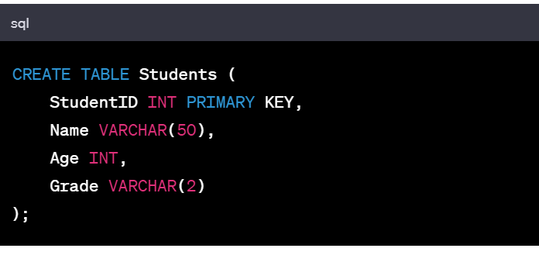

Modifying Relations
Modifying relations involves operations such as adding, modifying, or deleting data from existing tables.
- Inserting Data: Use the INSERT INTO statement to add new rows of data into a table. For instance:
- Updating Data: The UPDATE statement modifies existing data in a table based on specified conditions. For example: 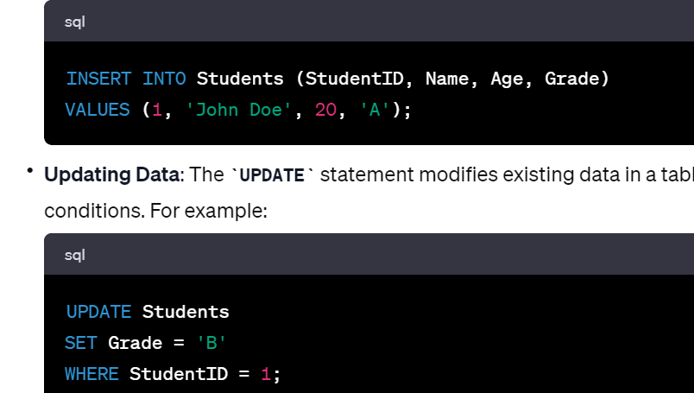

- Deleting Data: The DELETE FROM statement removes specific rows from a table based on given conditions. For example: 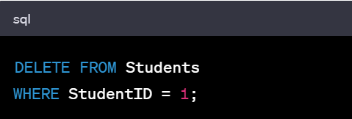

Integrity Constraints over Relations
Integrity constraints maintain the accuracy, consistency, and validity of data within relations.

Types of Integrity Constraints:
- Primary Key Constraint: Ensures each row in a table is uniquely identifiable. A primary key uniquely identifies each record in the table.
- Foreign Key Constraint: Establishes a relationship between two tables. It ensures referential integrity by matching the values in one table with those in another.
- Unique Constraint: Ensures that values in a column or a set of columns are unique among all the rows in a table.
- Not Null Constraint: Ensures that a column does not contain any NULL values, requiring it to have a value for every row.
- Check Constraint: Enforces specific conditions on the values allowed in a column.

Importance of Integrity Constraints:
- Data Accuracy: Integrity constraints maintain data accuracy by preventing inconsistencies or invalid data.
- Data Reliability: They ensure that data adheres to predefined rules, making the database more reliable.
- Data Consistency: Constraints maintain data consistency by enforcing relationships between tables and preserving referential integrity.
- Preventing Data Corruption: By restricting invalid or inappropriate data, integrity constraints prevent data corruption within the database.

Enforcing Integrity Constraints

Importance of Integrity Constraints Enforcement:
- Data Accuracy: Integrity constraints maintain the accuracy and consistency of data stored in the database.
- Data Reliability: By ensuring that data adheres to predefined rules, constraints enhance the reliability of the database.
- Data Consistency: Constraints maintain data consistency by enforcing relationships between tables, preserving referential integrity, and preventing conflicting or invalid data.

Enforcing Integrity Constraints in the Relational Model:
- Primary Key Constraint: Ensures the uniqueness of a column or set of columns in a table. It identifies each record uniquely.
- Foreign Key Constraint: Maintains referential integrity by establishing links between tables based on primary key and foreign key relationships.
- Unique Constraint: Ensures that values in a column or a set of columns are unique among all the rows in a table.
- Not Null Constraint: Requires that a column must have a value for every row and cannot contain NULL values.
- Check Constraint: Defines specific conditions that values in a column must meet.
- Triggers: Automated actions executed in response to specific database events, such as data modifications, to enforce further business rules.

Querying Relational Data

SQL for Querying Relational Data:
- SELECT Statement: Retrieves data from one or multiple tables based on specified criteria.
- JOIN Operation: Combines rows from two or more tables based on related columns between them.
- Aggregate Functions: Functions like SUM, AVG, COUNT, MAX, MIN to perform calculations on groups of rows.
- Filtering and Sorting: Using WHERE clause for filtering and ORDER BY clause for sorting results. 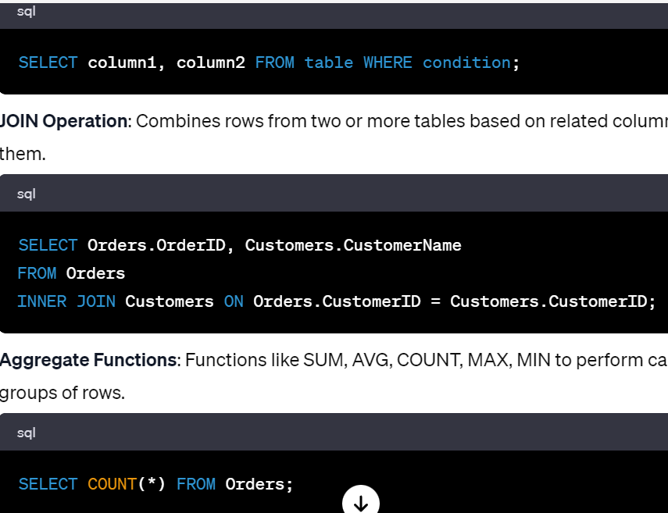

Logical Database Design

Steps in Logical Database Design:
- Convert ER Model to Tables: Translate the Entity-Relationship (ER) model into tables in the relational database, considering entities, attributes, relationships, and constraints.
- Normalization: Apply normalization techniques to eliminate redundancy and improve data integrity by organizing tables into normalized forms (1NF, 2NF, 3NF, BCNF).
- Define Keys and Relationships: Identify primary keys for tables and establish relationships using foreign keys to ensure referential integrity.
- Refinement and Optimization: Fine-tune the design for performance, scalability, and efficiency.

Importance of Logical Database Design:
- Efficient Storage: A well-designed logical model helps in efficiently storing data by reducing redundancy and ensuring consistency.
- Data Integrity: It enhances data integrity by organizing data in normalized forms and enforcing relationships and constraints.
- Improved Query Performance: A well-designed database schema contributes to better query performance and database management.

Introduction to Views

What are Views?
Views in a database system are virtual tables derived from the result of a stored query. They do not store data themselves but provide a dynamic and customized presentation of data from one or multiple tables based on defined criteria.

Characteristics of Views:
- Virtual Tables: Views are not physical tables; they are created on-the-fly when queried and display data according to predefined criteria.
- Customized Perspective: They offer a customized perspective of data, showing specific columns or rows from one or multiple tables.
- Data Security: Views can restrict access to sensitive data by showing only specific columns or rows to certain users, enhancing data security.

Creation of Views:
- Using SQL's CREATE VIEW statement, a view can be created based on a SELECT query.
- CREATE VIEW view_name AS
- SELECT column1, column2
- FROM table
- WHERE condition;
- Views can join tables, perform calculations, or filter data, presenting a tailored dataset to users without altering the underlying tables.

Destroying/Altering Tables and Views

Dropping Tables and Views:
- Dropping Tables: The DROP TABLE statement deletes an entire table and its data.
- Dropping Views: The DROP VIEW statement removes a view, making it unavailable for querying.
- DROP TABLE table_name;

Altering Views:
- Altering Views: Views can be altered to redefine the query used to create them.
- ALTER VIEW view_name AS
- SELECT new_column1, new_column2
- FROM different_table
- WHERE new_condition;
_condition;
- The ALTER VIEW statement allows modifying the underlying query of a view to change its displayed data without affecting the original tables.

Importance of Destroying/Altering Tables and Views:
- Database Management: Deleting unnecessary tables or views helps manage database resources efficiently.
- Data Consistency: Removing or altering obsolete views ensures that users access updated and relevant information.
- Data Security and Access Control: Modifying or dropping views allows for the adaptation of security measures, controlling user access to sensitive data.
- System Performance: Removing unnecessary views or tables can improve system performance by reducing the overhead on database operations.

MODULE – III

Basic SQL Query Structure:
A basic SQL query is constructed with fundamental clauses to retrieve, manipulate, or manage data within a database.
- SELECT: Specifies the columns to retrieve data from.
- FROM: Identifies the table(s) from which data is retrieved.
- WHERE: Filters rows based on specified conditions.
- GROUP BY: Groups rows sharing common values into summary rows.
- HAVING: Filters groups based on specified conditions.
- ORDER BY: Sorts the result set based on specified columns.
Example of a basic SQL query:
SELECT column1, column2
FROM table_name
WHERE condition
ORDER BY column1;

Nested Queries in SQL:
Nested Queries involve embedding one SELECT statement within another, allowing for more complex data retrieval or condition checking.
Example using IN clause:
SELECT column1, column2
FROM table_name
WHERE column1 IN (SELECT column1 FROM another_table WHERE condition);
Nested queries can also utilize EXISTS, NOT IN, or ANY/ALL operators for various conditions.

Benefits of Nested Queries:
- Subquery Execution: Allows execution of queries based on the result of another query.
- Data Filtering: Facilitates more precise data retrieval by using conditions from the inner query.
- Enhanced Readability: Sometimes simplifies complex operations by dividing them into smaller, manageable parts.

Use Cases:
- Data Filtering: Retrieving records based on specific conditions from related tables.
- Subquery as Column Value: Using subqueries to retrieve specific values for column calculations or comparisons.

Considerations:
- Performance: Complex nested queries might impact performance due to multiple query executions.
- Readability: Extremely complex nested queries might reduce code readability and maintainability.

Key Points:
- Nested queries are a powerful feature in SQL, providing flexibility in data retrieval and enabling advanced data analysis by leveraging subqueries within SQL statements.
- They allow for tailored and precise data extraction, especially in scenarios where simple queries are insufficient to fulfill complex conditions.

Aggregate Operators in SQL:
Aggregate functions perform calculations on sets of values and return a single result.
- SUM: Calculates the sum of values in a column.
- AVG: Computes the average of values in a column.
- COUNT: Counts the number of rows or non-null values in a column.
- MAX: Retrieves the maximum value from a column.
- MIN: Retrieves the minimum value from a column.
Example:
SELECT SUM(column1), AVG(column2), COUNT(*)
FROM table_name
WHERE condition;

Null Values in SQL:
NULL represents missing or unknown data in SQL.
- IS NULL: Checks for null values in a column.
- IS NOT NULL: Checks for non-null values in a column.
Example:
SELECT column1
FROM table_name
WHERE column2 IS NULL;

Complex Integrity Constraints in SQL:
Integrity Constraints maintain the accuracy and consistency of data in databases.
- Check Constraints: Ensure values inserted into a column meet specified conditions.
- Foreign Key Constraints: Maintain referential integrity between tables.
- Unique Constraints: Ensure uniqueness of values in a column or combination of columns.
Example:
ALTER TABLE table_name
ADD CONSTRAINT constraint_name CHECK (column_name > 0);

Triggers in SQL:
Triggers are automated actions executed in response to specific events in a database.
Example:
CREATE TRIGGER trigger_name
AFTER INSERT ON table_name
FOR EACH ROW
BEGIN
-- SQL statements to be executed
END;

Active Databases:
Active Databases utilize triggers and rules to automatically react to changes in the database, allowing continuous monitoring and actions based on predefined conditions.
- Continuous Monitoring: Triggers enable automatic actions in response to specified events without manual intervention.
- Data Integrity Maintenance: Triggers ensure that data changes adhere to predefined rules, maintaining data integrity.
- Enhanced Security and Logging: Active databases can be designed to log activities, enforce security measures, and respond to potential threats.

Importance:
- Data Consistency: Integrity constraints ensure data is accurate and consistent.
- Automated Responses: Triggers and active databases automate processes based on predefined conditions, reducing manual efforts.
- Data Security: Active databases can enforce security measures and respond to unauthorized attempts or data breaches automatically.

In SQL, aggregate operators perform calculations, null values represent missing data, integrity constraints maintain data consistency, triggers enable automated actions, and active databases utilize triggers for continuous monitoring and automated responses.

1. Generic PL/SQL Block:
PL/SQL (Procedural Language/Structured Query Language) is Oracle's proprietary extension to SQL. A generic PL/SQL block typically follows this structure:
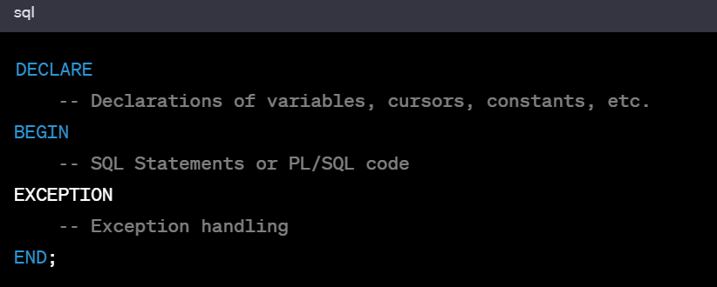

2. PL/SQL Data Types:
PL/SQL supports various data types, including:
- Scalar Data Types: Such as NUMBER, VARCHAR2, DATE, BOOLEAN.
- Composite Data Types: Like RECORD and TABLE.
- Reference Data Types: Such as REF CURSOR and REF.
- LOB Data Types: Such as CLOB, BLOB, NCLOB, and BFILE.
- Large Object Data Types: Like LONG and LONG RAW.

3. Control Structures:
PL/SQL provides control structures for conditional and iterative processing:
- IF-THEN-ELSE: Conditional branching.
- CASE Statements: A more versatile form of conditional logic.
- LOOP: Iterative processing using LOOP, WHILE, and FOR.
- GOTO Statement: Directs the flow of control to a labeled statement.
- EXIT and CONTINUE: For controlling loop execution.

4. Procedures and Functions:
- Procedures: They are named PL/SQL blocks that can accept parameters, perform tasks, and return values.
Example:
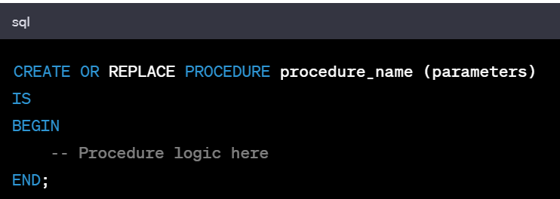
- Functions: Similar to procedures but return a value.
Example:
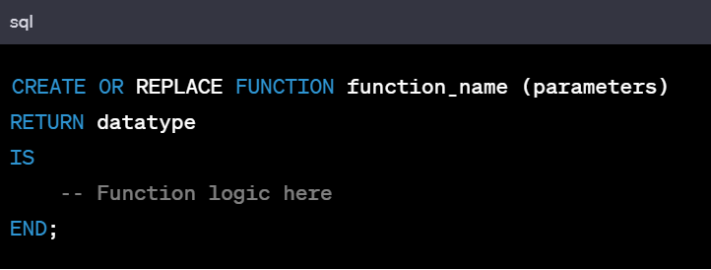

5. Cursors:
Cursors enable traversal over the records in a result set.
- Implicit Cursors: Automatically created by Oracle for SQL statements.
- Explicit Cursors: Defined by the programmer for more control over data retrieval.
Example of an explicit cursor:
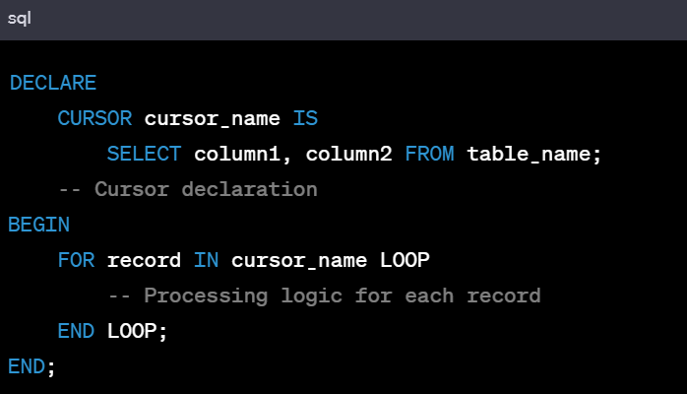

6. Database Triggers:
Database triggers are PL/SQL blocks that automatically execute in response to specific events occurring in the database. There are two types of triggers: BEFORE triggers and AFTER triggers.
Example:
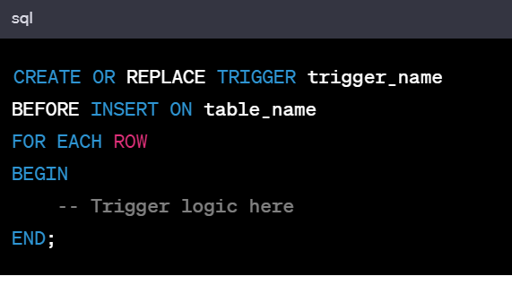
Triggers can respond to various events like INSERT, UPDATE, DELETE, etc., and can be set to execute BEFORE or AFTER the triggering event.
Each of these elements in PL/SQL serves a specific purpose, enabling developers to create robust and efficient database applications within the Oracle environment.

MODULE – IV

Problems Caused by Redundancy:
Redundancy in a database schema leads to several problems:
- Data Inconsistency: Redundant data can cause inconsistencies because an update made to one instance of data might not be reflected in all copies.
- Wastage of Storage: Storing redundant data unnecessarily consumes extra disk space.
- Update Anomalies: Redundant data can lead to update anomalies, where inconsistencies arise due to partial updates.
- Insertion and Deletion Anomalies: These anomalies occur when adding or removing information in a table causes unintended side effects or loss of related data.

Decompositions:
Decomposition is the process of breaking down a relation/table into multiple relations/tables to minimize redundancy and eliminate anomalies. It involves techniques such as normalization, splitting tables into smaller ones, and managing relationships between these smaller tables.

Problems Related to Decomposition:
- Loss of Information: Decomposition may lead to loss of information if not done carefully, resulting in the need to join tables to retrieve the original data.
- Join Operations Overhead: Frequent joins between decomposed tables can affect query performance.
- Over-normalization: Overly aggressive decomposition can lead to excessive small tables, complicating query execution and maintenance.

Functional Dependencies (FDs):
Functional dependencies are constraints that define the relationships between attributes within a relation. An attribute B is functionally dependent on attribute A if, for every value of A, there is a unique corresponding value of B.

Reasoning About FDs:
- Closure of Attributes: It involves determining all attributes that are functionally dependent on a given set of attributes. Closure helps in understanding the complete set of attributes that can be derived from a given set of FDs.
- Normalization: Functional dependencies play a vital role in normalization by ensuring that relations are broken down into smaller, well-structured relations to minimize redundancy and anomalies.
- Keys and Superkeys: Understanding FDs helps in identifying keys (minimal superkeys) within relations, which are crucial for ensuring uniqueness and integrity constraints.
Overall, schema refinement involves careful analysis of redundancy, decomposition of relations, management of functional dependencies, and normalization techniques to create an optimized database schema that minimizes data redundancy and ensures data integrity and consistency.

1. First Normal Form (1NF):
First Normal Form requires that each column in a table contains atomic (indivisible) values, and there are no repeating groups or arrays within a row.
Example: Consider a table that violates 1NF:
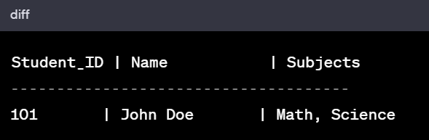
To achieve 1NF, the table should be restructured to eliminate the multivalued column:
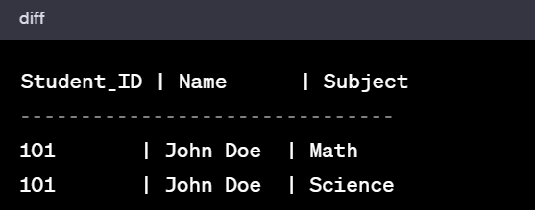

2. Second Normal Form (2NF):
Second Normal Form states that a table should be in 1NF and all attributes must depend on the whole primary key, eliminating partial dependencies.
Example: Suppose we have a table with composite primary key and a partial dependency:
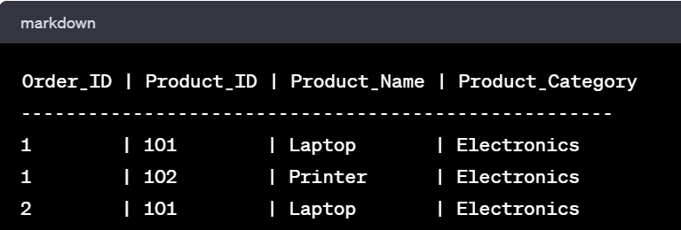
101 | Laptop | Electronics 1 | 102 | Printer | Electronics 2 | 101 | Laptop | Electronics
To achieve 2NF, separate the table into two to eliminate partial dependencies:
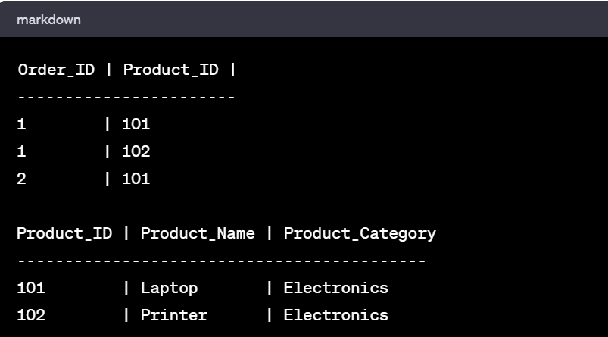
Product_Category ------------------------------------------- 101 | Laptop | Electronics 102 | Printer | Electronics

3. Third Normal Form (3NF):
Third Normal Form extends 2NF by eliminating transitive dependencies, ensuring that non-primary key columns are not dependent on other non-primary key columns.
Example: Consider a table with a transitive dependency:
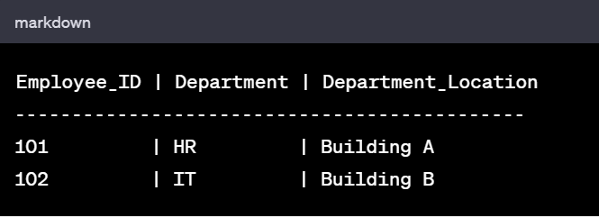
Building A 102 | IT | Building B
To achieve 3NF, create a separate table for departments:
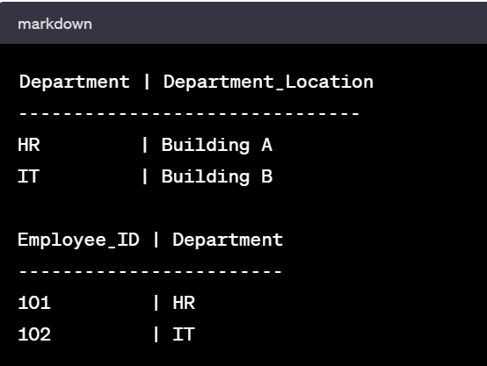
Department ------------------------ 101 | HR 102 | IT

4. Boyce-Codd Normal Form (BCNF):
BCNF is a stricter version of 3NF where every determinant is a candidate key. It eliminates all non-trivial functional dependencies.

5. Multivalued Dependencies:
Multivalued Dependencies (MVDs) arise when one attribute in a table uniquely determines multiple values in another attribute, independent of each other.

6. Fourth Normal Form (4NF):
Fourth Normal Form addresses multivalued dependencies by organizing data so that it is not affected by non-trivial MVDs.

7. Join Dependencies:
Join Dependencies are constraints on a database involving multiple tables. They occur when a table can be reconstructed by joining multiple tables together based on certain conditions.

8. Fifth Normal Form (5NF):
Fifth Normal Form further addresses redundancy and anomalies by decomposing tables to remove join dependencies.
Each normal form serves to minimize data redundancy, dependency, and anomalies, ensuring efficient database design and maintenance. Progressing through these forms involves careful restructuring of tables to achieve a well-organized database schema.

Transaction Concept:
In the context of databases, a transaction is a logical unit of work that consists of a sequence of database operations (such as reads or writes) performed as a single unit. Transactions help maintain data integrity by ensuring that either all operations within the transaction complete successfully or none of them take effect.

Transaction Atomicity and Durability:
- Atomicity: Atomicity ensures that either all the operations within a transaction are executed successfully, or if any operation fails, the entire transaction is rolled back, ensuring consistency.
- Durability: Durability guarantees that once a transaction is committed, the changes made by that transaction persist even in the event of a system failure. These changes are stored permanently in the database.

Concurrent Executions – Serializability:
- Serializability: It ensures that the execution of concurrent transactions produces the same results as if they were executed serially (one after the other), maintaining data consistency and correctness.
- Recoverability: It refers to the ability of a system to recover the database to a consistent state after a failure, ensuring committed transactions' changes are applied and uncommitted changes are undone.

Implementation of Isolation:
- Isolation Levels: Isolation levels define the degree of isolation among concurrent transactions:
  - Read Uncommitted: Allows dirty reads, where a transaction can read uncommitted changes made by other transactions.
  - Read Committed: Prevents dirty reads but allows non-repeatable reads and phantom reads.
  - Repeatable Read: Ensures a transaction sees the same data throughout its duration but allows phantom reads.
  - Serializable: Provides the highest level of isolation by preventing all anomalies but might affect performance due to increased locking.

Testing for Serializability:
- Conflict Serializable: A schedule is conflict serializable if it can be transformed into a serial schedule by swapping non-conflicting operations while maintaining the same order of conflicting operations.
- Precedence Graph: A method used to test for conflict serializability. It involves creating a graph where each transaction is a node, and edges represent conflicts between transactions. If the graph is cycle-free, the schedule is conflict serializable.
- Transaction Control Statements: Utilizing control statements like BEGIN TRANSACTION, COMMIT, and ROLLBACK to manage and test transactions' atomicity and isolation.
Testing for serializability involves ensuring that concurrent execution of transactions adheres to rules that maintain consistency and correctness, preventing issues like lost updates, dirty reads, and inconsistent data states.

MODULE – V

1. Lock-Based Protocols:
- Exclusive Locks: Transactions acquire exclusive locks on data items they intend to modify, preventing other transactions from accessing those items until the lock is released.
- Shared Locks: Transactions acquire shared locks on data items they intend to read, allowing multiple transactions to access the same data for reading simultaneously.
- Two-Phase Locking (2PL): Transactions follow a strict protocol of acquiring locks (growing phase) and then releasing locks (shrinking phase). Once a transaction releases a lock, it cannot acquire new locks.
- Deadlock Avoidance: Techniques like deadlock detection and timeout mechanisms are used to prevent and resolve deadlocks caused by conflicting lock acquisitions.

2. Timestamp-Based Protocols:
- Timestamp Ordering: Transactions are assigned unique timestamps indicating their order of execution. Read and write operations are permitted based on these timestamps to maintain serializability.
- Concurrency Control using Timestamps: Older transactions are given precedence over newer ones. Conflicts are resolved based on the timestamps, ensuring a serializable execution sequence.

3. Validation-Based Protocols:
- Optimistic Concurrency Control: Transactions proceed without acquiring locks initially, performing read and write operations. During commit time, a validation phase checks for conflicts. If conflicts are detected, the transaction is rolled back and re-executed.

4. Multiple Granularity:
- Lock Granularity: Refers to the level at which locks are applied. It can be at the level of an entire database, tables, pages, or even individual records.
- Hierarchical Locking: Allows different levels of granularity, ensuring efficient locking by locking at the appropriate level based on the operation being performed.

5. Deadlock Handling:
- Deadlock Prevention: Techniques involve careful scheduling and resource allocation to prevent deadlocks from occurring in the first place.
- Deadlock Detection: Systems periodically check for circular wait conditions among transactions. Once detected, a deadlock resolution strategy is implemented, such as aborting one or more transactions involved in the deadlock.
Concurrency control mechanisms ensure that transactions execute correctly and maintain the ACID (Atomicity, Consistency, Isolation, Durability) properties of a database. They manage the simultaneous access of transactions to data, preventing interference and ensuring data consistency and integrity in a multi-user environment.

Data on External Storage:
Data in a database is typically stored on external storage devices like hard drives, solid-state drives (SSDs), or network-attached storage (NAS). This data is organized into files and pages, and the database management system (DBMS) retrieves and manages this data when requested by queries or transactions.

File Organizations and Indexing:
- Clustered Indexes: In a clustered index, the physical order of the data in the storage corresponds to the order of the index. It's usually created on the primary key column(s) and sorts the actual data rows based on the index key.
- Primary and Secondary Indexes:
  - Primary Index: Created on the primary key of a table and determines the physical order of data.
  - Secondary Index: Created on non-primary key columns to enhance the retrieval speed, allowing multiple access paths to the data.

Index Data Structures:
- Hash-Based Indexing: Utilizes a hash function to map keys to locations where data is stored. It enables direct access to records based on their hash value, offering rapid retrieval for exact match searches.
- Tree-Based Indexing:
  - B-Tree: A self-balancing tree data structure where each node can have multiple child nodes and multiple keys. It's efficient for both insertion and retrieval operations.
  - B+ Tree: Similar to a B-Tree but with some variations like having the data only in the leaf nodes, making range queries more efficient due to sequential access.

Comparison of File Organizations:
- Sequential File Organization: Data is stored sequentially based on a primary key or an ordered field. It's efficient for range queries but less suitable for random access.
- Heap File Organization: Records are stored in an unordered manner, suitable for append-only operations but less efficient for searches.
- Hash File Organization: Ideal for direct access, particularly when there's a need for equality searches, but may suffer from clustering when data grows.
Choosing the appropriate file organization and index structure depends on factors like the nature of data, access patterns, query types, and system requirements. Each method has its advantages and limitations in terms of storage efficiency, retrieval speed, and maintenance overhead.
Efficient storage and indexing strategies are crucial for optimizing database performance, enabling quick data retrieval, and supporting various types of queries in a database system.

