Module-2
Electrical Systems

A DC (direct current) motor is a type of electric machine that converts electrical energy into mechanical energy. It operates based on the interaction between current-carrying conductors in a magnetic field, resulting in the production of rotational motion.
DC Motor Types Based on Excitation:
Separately Excited DC Motor: The field winding is supplied by an independent external voltage source.
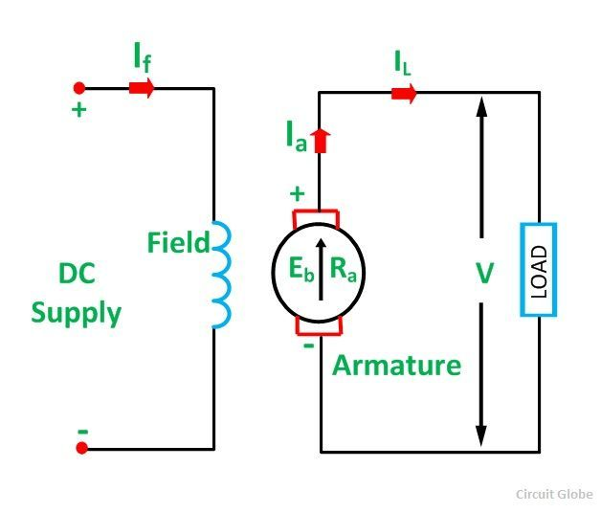
Shunt Wound DC Motor: The field winding is connected in parallel (shunt) with the armature winding, sharing the same voltage.
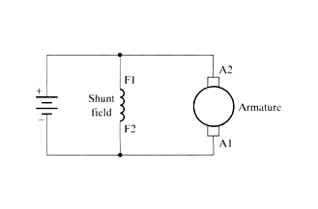
Series Wound DC Motor: The field winding is connected in series with the armature winding, so the current passes through both windings.
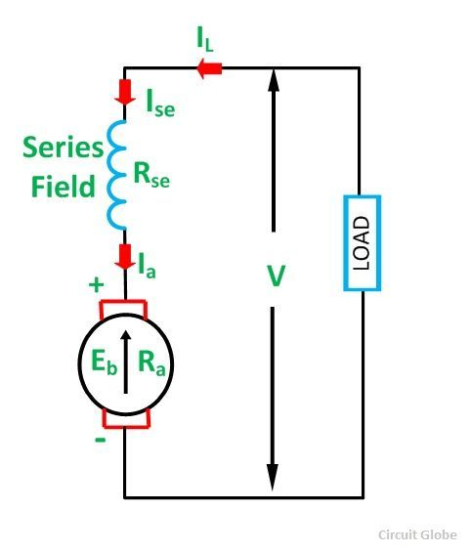
DC Motor Types Based on Field Winding Connection:
Cumulative Compound DC Motor: Combines both series and shunt field windings, resulting in additive effects. Differential Compound DC Motor: Combines both series and shunt field windings, but the effects are subtractive.
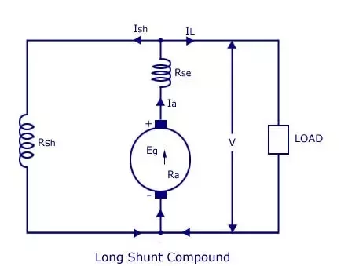

DC Motor Types Based on Armature Winding Connection:
Lap Wound DC Motor: The armature winding is connected in such a way that the end of one coil is connected to the start of the next coil.
Wave Wound DC Motor (Wave Winding): The armature winding is connected in a wave-like fashion, where each coil spans multiple armature slots.
Permanent Magnet DC Motor: Instead of an electromagnetic field produced by field windings, these motors use permanent magnets to create the magnetic field.
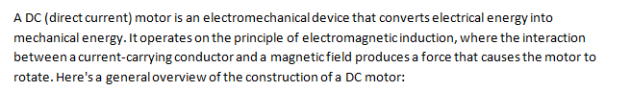Construction of DC motor:
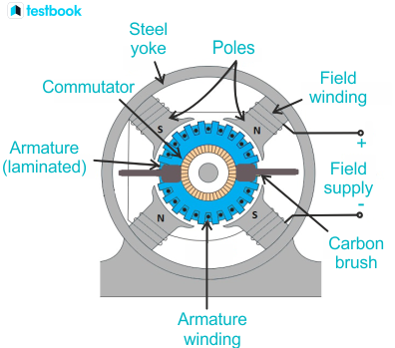
Stator: The stator is the stationary part of the motor and provides a magnetic field. It typically consists of a frame or casing, pole cores, and field windings. The pole cores are usually made of iron and are magnetized by the field windings.
Rotor: The rotor is the rotating part of the motor and is connected to the load. It consists of a coil (armature) wound on an iron core. The armature carries the current and experiences the force that causes it to rotate.
Armature: The armature is a core made of iron laminations that are mounted on the rotor. Conductors (usually copper) are wound around the armature core to form coils. When a current flows through these coils, a magnetic field is produced, and the armature experiences a force that causes it to rotate.
Commutator: The commutator is a rotary switch mounted on the rotor. It consists of segments that are connected to the armature coils. The commutator reverses the direction of the current in the armature coils as they rotate, ensuring that the magnetic force on the armature remains in the same direction, causing continuous rotation.
Brushes: Brushes are stationary contacts that maintain electrical contact with the rotating commutator. They are usually made of carbon or graphite and provide a path for the current to flow from the power source to the armature.
Brush Holder: The brush holder holds the brushes in place and allows them to maintain contact with the commutator as it rotates.
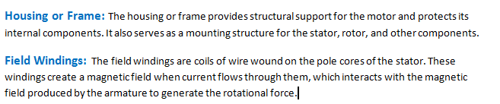
.
Applications of series motor:
- Traction Systems
- Hoists and Cranes
- Electric Shavers and Hair Clippers:
Applications of shunt motor:
- Battery charging
- Textlile machinery
- Woodworking equipment
Applications of compound motor:
- Wire drawing machines
- Fans and blowers

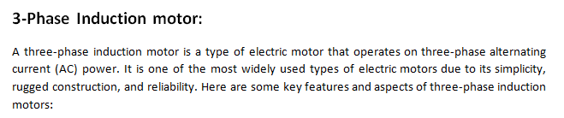
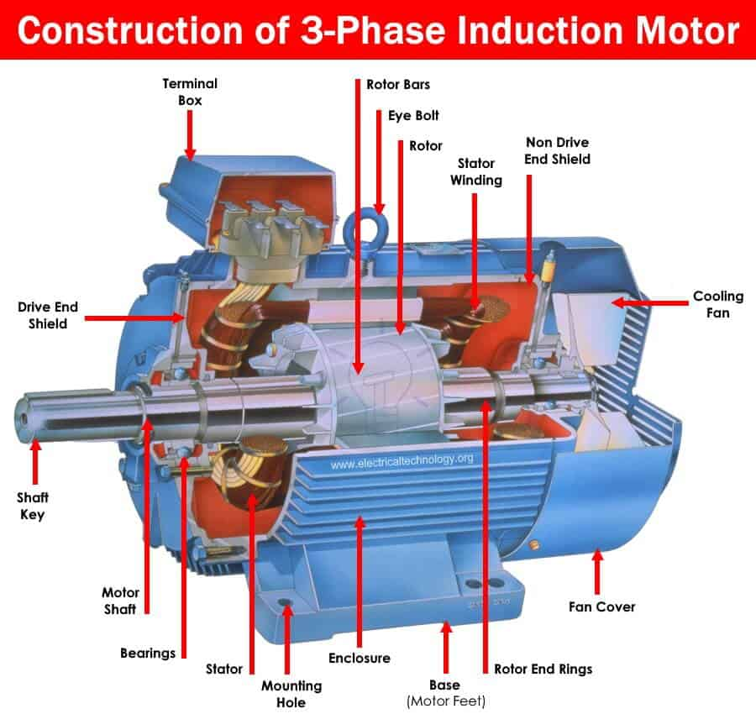
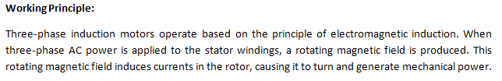Stator and Rotor:
The stator is the stationary part of the motor and contains three sets of windings that are spatially displaced by 120 degrees, creating a rotating magnetic field when energized. The rotor is the rotating part of the motor, typically made of laminated iron cores or conductive bars.
Types of Rotors:
There are two main types of rotors in three-phase induction motors: squirrel cage and wound rotor. The squirrel cage rotor is a common design with short-circuited conductive bars, while the wound rotor has external connections for additional control, such as using external resistors.
Applications:
Three-phase induction motors are widely used in various industrial and commercial applications due to their reliability and robust design. Common applications include pumps, fans, compressors, conveyor systems, crushers, and many other types of machinery.
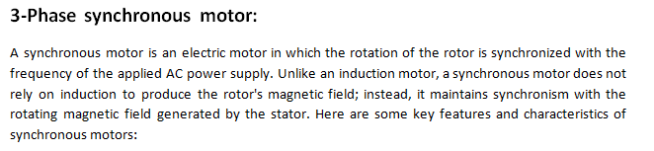
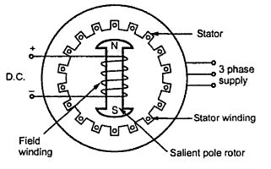
Synchronous Speed:
The synchronous speed of a synchronous motor is directly proportional to the frequency of the AC power supply and inversely proportional to the number of poles in the motor. The relationship is given by the formula:
Ns=120f/P
Stator and Rotor:
Similar to other AC motors, a synchronous motor has a stator and a rotor. The stator contains the winding that is connected to the AC power supply, producing a rotating magnetic field. The rotor, often equipped with a field winding, maintains synchronization with the stator's magnetic field.
Synchronous Operation:
In a synchronous motor, the rotor turns at the same speed as the rotating magnetic field of the stator, achieving synchronism. This synchronous operation allows for precise control of speed and is essential for applications where constant speed is crucial.
Applications:
Synchronous motors are used in applications where constant speed and precise control are required. Common applications include power factor correction, synchronous condensers, industrial processes requiring constant speed, and certain types of machinery in power plants.
Stepper Motor:
A stepper motor is a type of electric motor that converts digital pulses into mechanical shaft rotation. It is called a "stepper" motor because it moves in discrete steps. Each step represents a fixed angular rotation, and the motor's position can be controlled precisely without the need for feedback mechanisms.
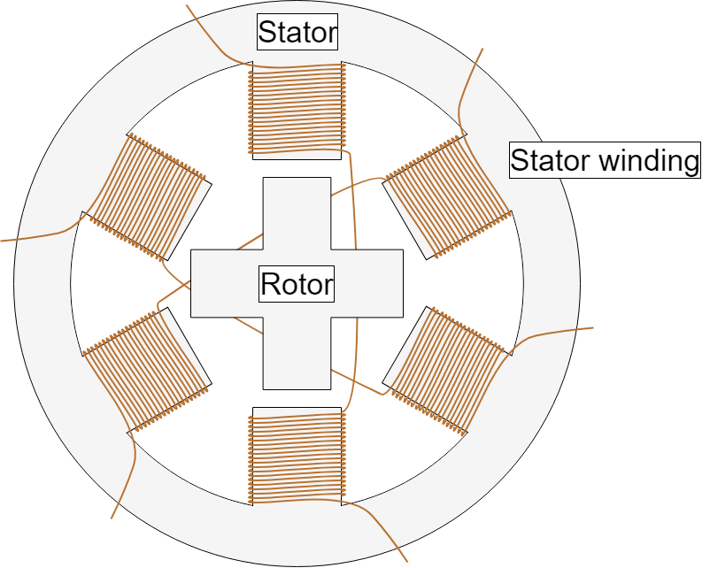
Here are some key features of stepper motors:
Step Angle: This is the angle through which the motor shaft rotates for each step. Stepper motors come in various step angles, commonly ranging from 0.9 to 90 degrees. Smaller step angles provide finer resolution but may require more pulses for a complete rotation.
Phases: Stepper motors can have multiple phases, typically bipolar (two phases) or unipolar (four or more phases). Each phase corresponds to a winding in the motor. Bipolar stepper motors are more common in industrial applications.
Drive Modes:
Full Step: The motor moves one step at a time, energizing both phases.
Half Step: The motor moves in smaller increments, energizing one phase at a time and then both phases.
Micro stepping: This involves using intermediate step positions, achieved by partially energizing the motor phases. Micro stepping provides smoother motion and higher resolution but requires more complex control circuits.
Control Circuits: Stepper motors are often controlled by stepper motor controllers or drivers, which convert digital signals from a microcontroller or other control system into the necessary current pulses to drive the motor.
Applications: Stepper motors find applications in a wide range of devices and systems, including 3D printers, CNC machines, robotics, disk drives, camera lenses, and more. Their ability to move in precise steps makes them suitable for applications requiring accurate positioning.
Construction of a Transformer:
Core: The core is a key component and is typically made of laminated iron or steel. The laminations reduce eddy current losses and improve the efficiency of the transformer. The core provides a low-reluctance path for the magnetic flux.

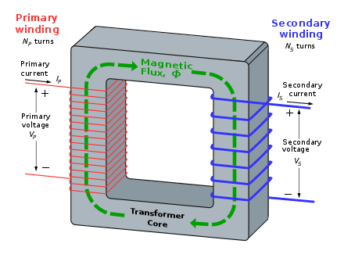
Windings:
Primary Winding: This is the winding connected to the input voltage source. It produces the magnetic flux when current flows through it.
Secondary Winding: This winding is connected to the load and is where the induced voltage is measured.
Insulation: To prevent short circuits and ensure electrical safety, both the primary and secondary windings are insulated from each other and from the core. Insulating materials like paper, oil, or synthetic materials are used.
Transformer Tank: Transformers are often housed in a tank filled with oil. The oil provides insulation, dissipates heat generated during operation, and protects the transformer from environmental factors.
Cooling System: Large transformers often have cooling systems, such as oil pumps or radiators, to maintain optimal operating temperatures.
Tap Changer: Some transformers have tap changers that allow the adjustment of the turns ratio to regulate the output voltage. This is particularly useful in distribution transformers to compensate for variations in the input voltage.
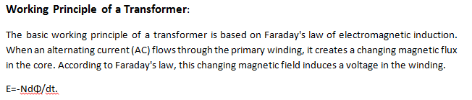In summary, a transformer converts electrical energy at one voltage level to electrical energy at another voltage level through the principles of electromagnetic induction, making it a fundamental component in the electrical power infrastructure.
EMF equation of a transformer:
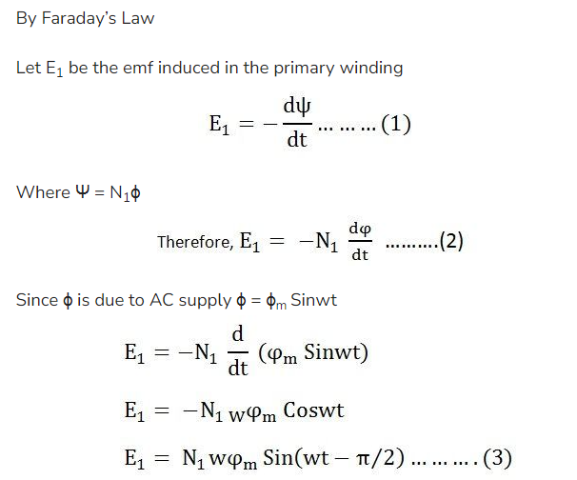
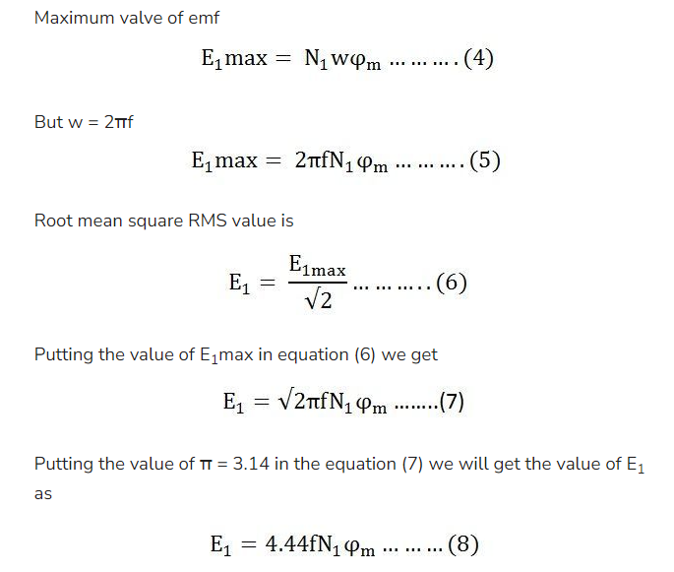
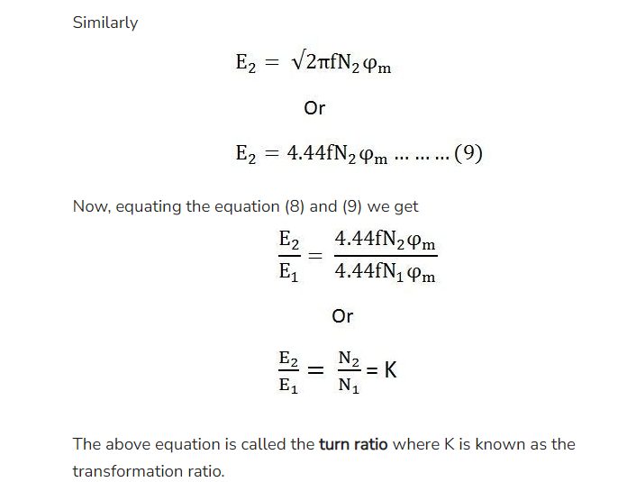
Electric wiring systems:
Electric wiring systems are crucial for distributing electrical power within buildings and structures. There are several methods of electric wiring systems, each with its own advantages and applications. Here are some common methods:
Cleat Wiring:
In cleat wiring, insulated wires are laid in the grooves of wooden or metal cleats.
Cleat wiring is simple and inexpensive, but it's not commonly used in modern construction due to safety concerns.
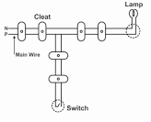
Casing and Capping Wiring:
In casing and capping wiring, insulated wires are run through conduits that are covered by a protective casing and capped at both ends.
This method is more secure and aesthetically pleasing than cleat wiring, and it provides some protection against mechanical damage.
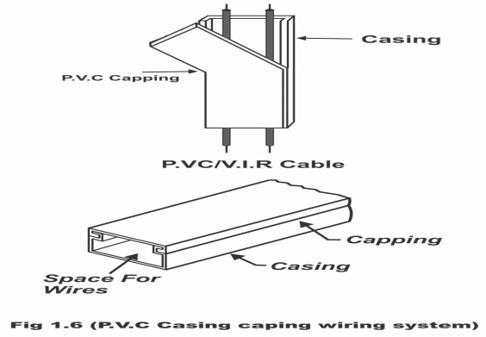
Conduit Wiring:
Conduit wiring involves running insulated wires through metal or PVC conduits.
It provides better protection compared to casing and capping, making it suitable for both surface and concealed wiring.
Conduit wiring is widely used in commercial and industrial buildings.
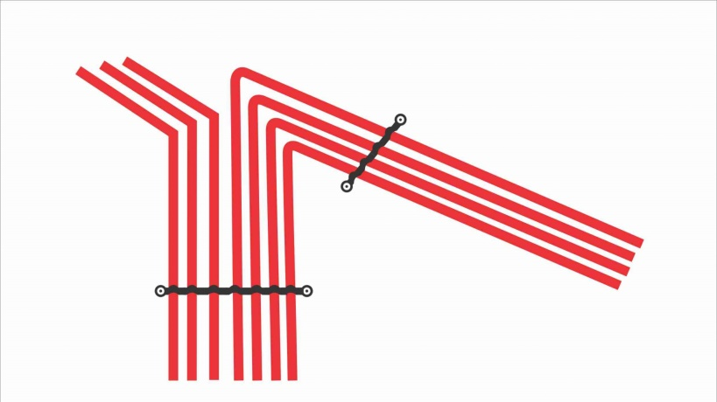
Surface Conduit Wiring:
In surface conduit wiring, conduits are mounted on the surface of walls or ceilings.
This method is convenient for renovations or situations where concealed wiring is not feasible.
Concealed Conduit Wiring:
Concealed conduit wiring involves running conduits within the structure of walls or ceilings.
It offers a clean and aesthetically pleasing appearance as the wiring is hidden from view.
Common in residential and commercial buildings.
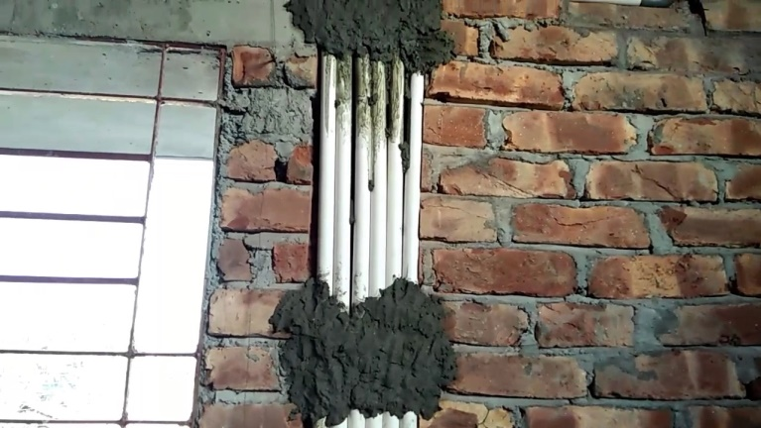
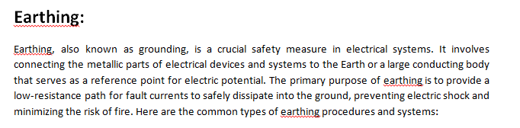 Plate Earthing:
A copper or galvanized iron plate is buried vertically in the ground.
The plate is typically 60 cm x 60 cm x 3.18 mm for copper or 60 cm x 60 cm x 6.35 mm for galvanized iron. It is buried in a pit filled with charcoal and common salt to improve conductivity.
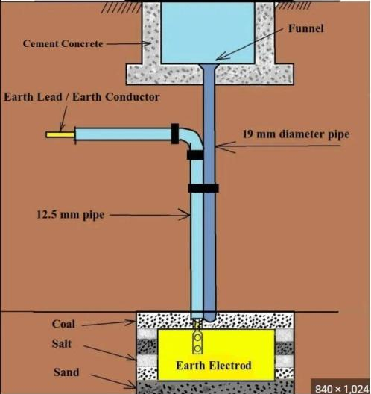
Pipe Earthing:
A galvanized iron or copper pipe is driven into the ground.
The pipe is filled with charcoal and salt for better conductivity.
This type is more suitable for rocky or hard soil conditions.
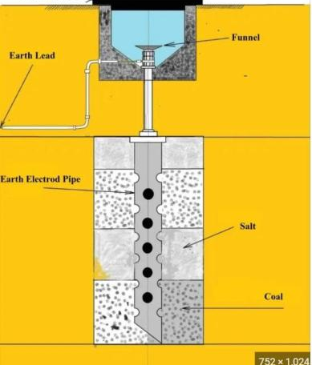
Rod Earthing:
A metal rod (usually copper or galvanized iron) is driven vertically into the ground.
The rod is generally 2.5 to 3 meters in length.
It is surrounded by a mixture of charcoal and salt to enhance conductivity.
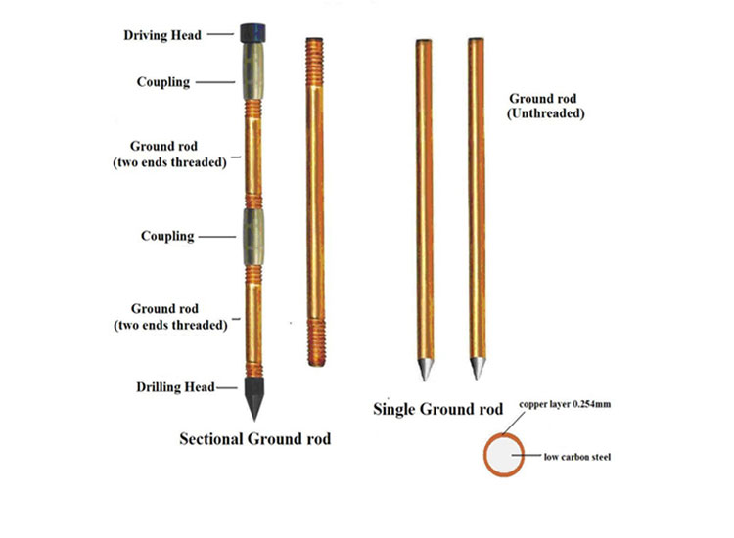
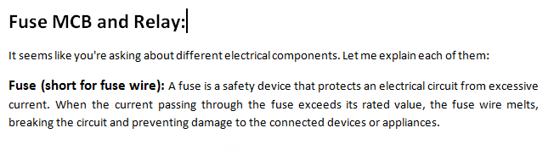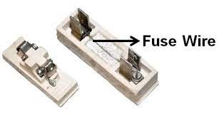
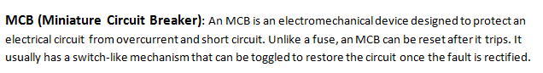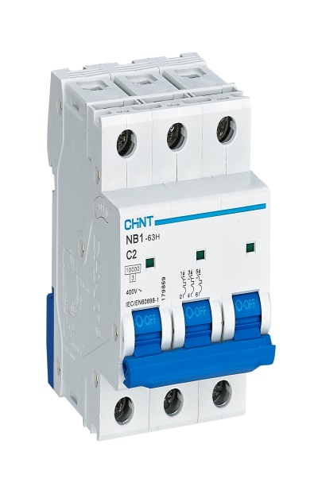
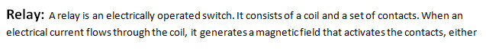opening or closing the circuit. Relays are often used to control high-voltage circuits with low-voltage signals, providing isolation between the control circuit and the circuit being controlled.
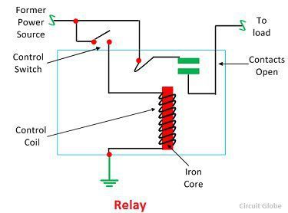

application. For example, a relay could be used to control the activation or deactivation of a circuit, an MCB could provide overcurrent protection within that circuit, and a fuse might be used as an additional layer of protection.

