WEEKLY ASSIGNMENT 1
Lokesh Bhatta
FODS
Cyber Security and DF
UID: 24071110

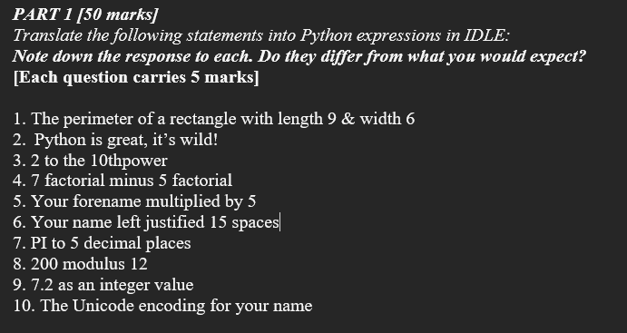
Questions:

Disclaimer:

Answers:

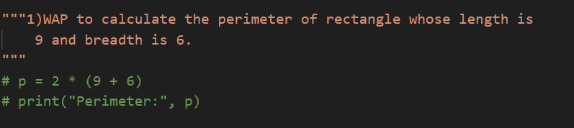1)

Output:
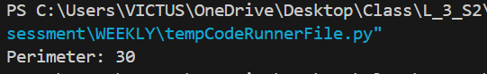

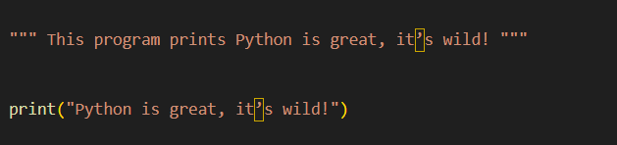
2)

Output:

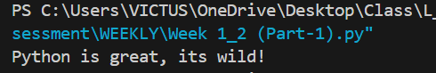

3)
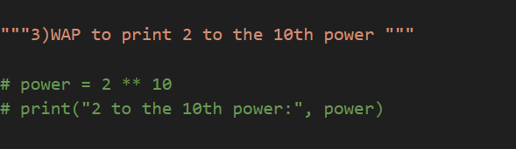

Output:
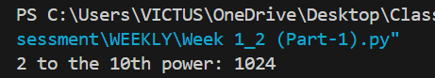

4)
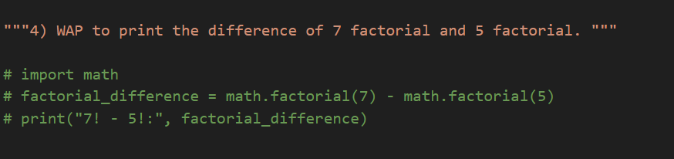

Output:

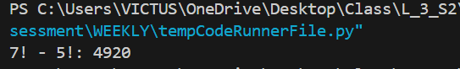

5) 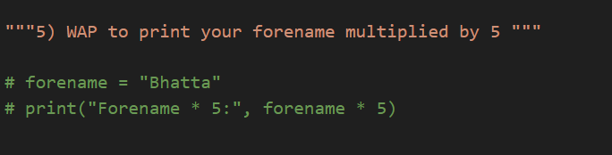

Output:

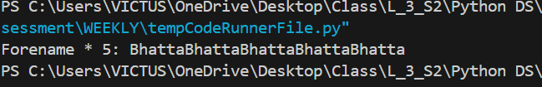

6)

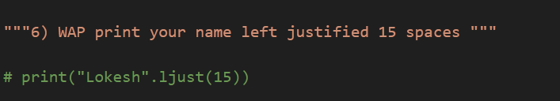

Output:

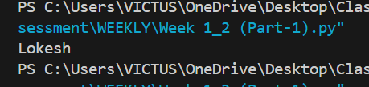

7)
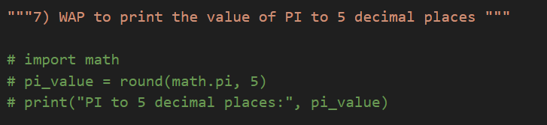

Output:
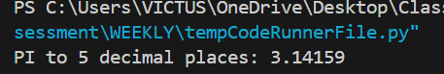

8)
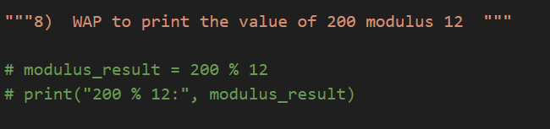

Output:
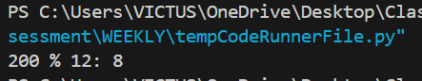

9)
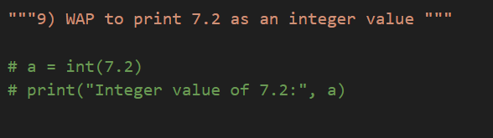

Output:
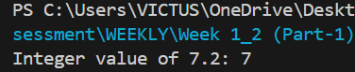

10)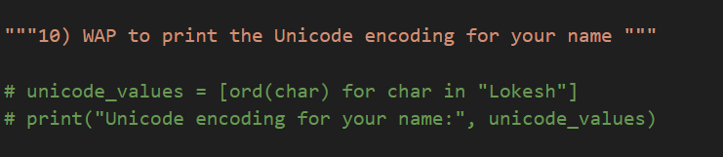

Output:
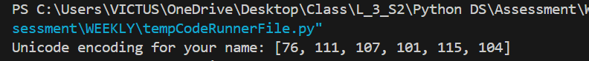

PART 2

Questions:

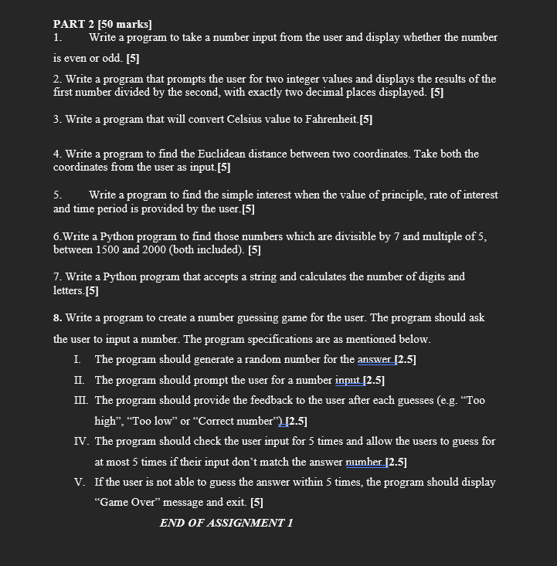
Answers:

1)
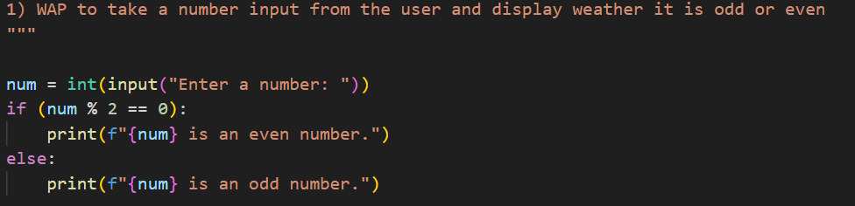

Output:

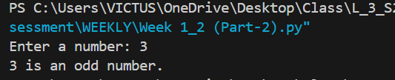

2)

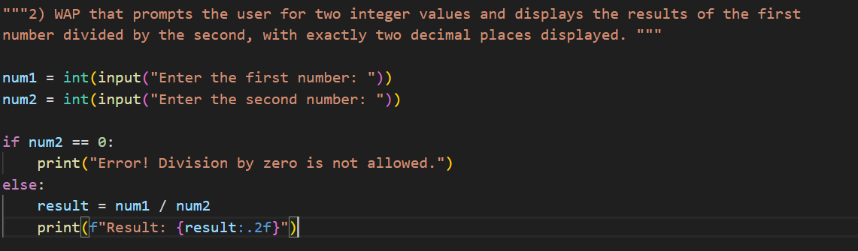

Output:
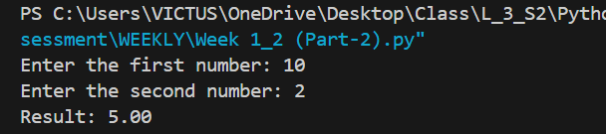

3)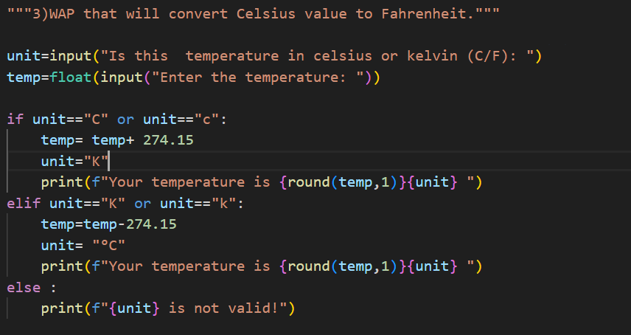

Output:
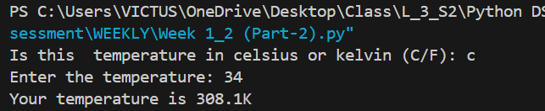

4)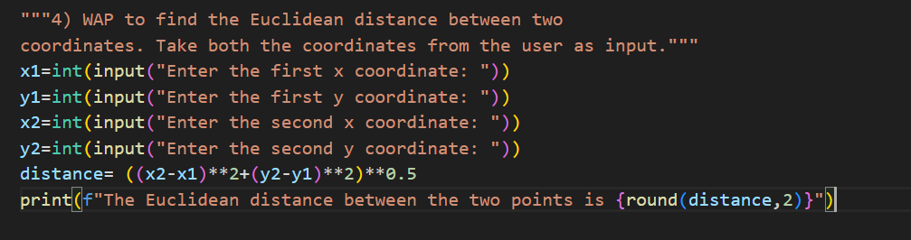

Output:
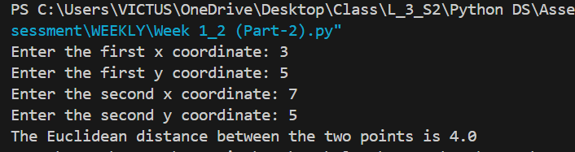

5)
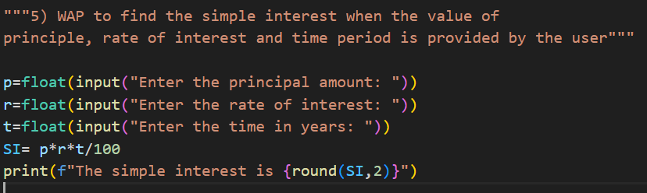

Output:
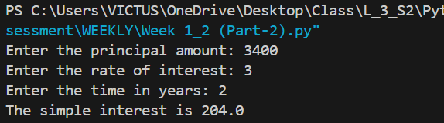

6)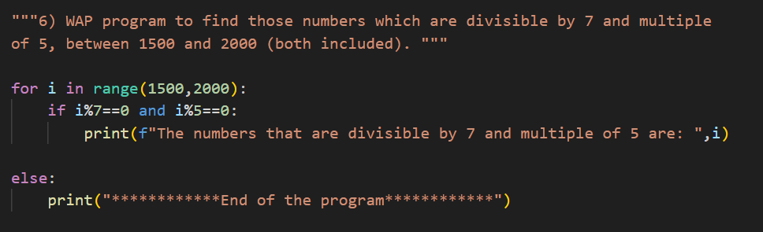

Output:
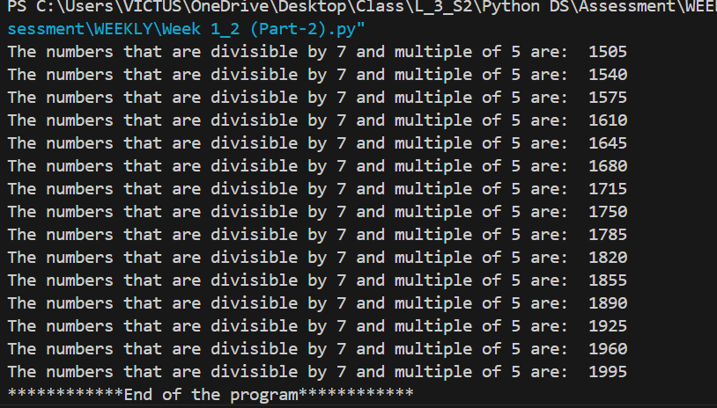

7)
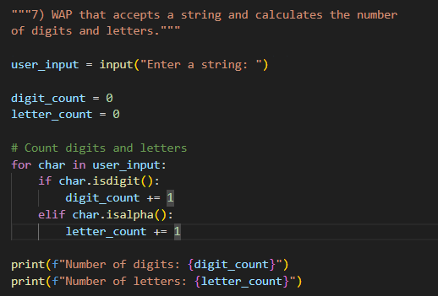

Output:
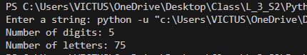

8)
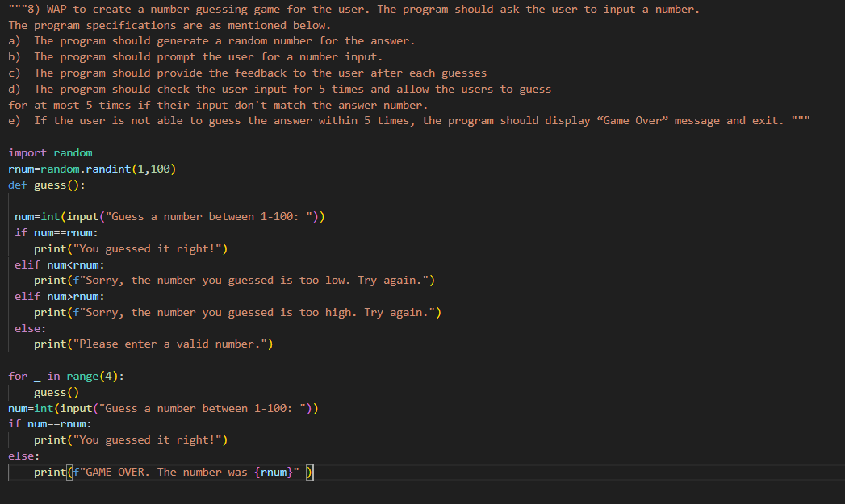

Output:
