DDOT Public Space Occupancy Permit FHWA Roadway Class Enrichment
  - End-to-end methodology, implementation decisions, validation results, and stopping rationale.
Technical narrative prepared for a GIS Data Scientist take home assessment.
Work status: Python pipeline executed; manual review demonstrated for two representative exceptions; remaining exceptional cases intentionally retained due to time constraints.

Executive summary
The assessment asked for a CSV containing each eligible permit application location, its associated FHWA road functional class, and the highest-priority FHWA class across the locations of each application. I built a repeatable Python workflow to extract permit records from DDOT TOPS, spatially enrich them using roadway/LRS services, validate the results, investigate exceptions, and manually assess representative ambiguous features in ArcGIS Pro.
Metric | Observed result
Eligible extracted location rows | 4,926
Distinct applications (TrackingNumber) | 3,102
Locations assigned an FHWA class | 4,647 (94.3%)
Unresolved location records | 279 (5.7%)
Distinct unresolved applications with no classified locations | 243
Partially classified applications | 18
Manual-review examples investigated | 2: Roosevelt Bridge; 3333 Georgia Avenue NW

1. Data discovery and extraction - why each step mattered

Step 1 - Inspect the TOPS MapServer layer
I Explored DDOT TOPS MapServer/24 schema, field aliases, point geometry, query parameters, dates and pagination. This was necessary because no data dictionary was supplied and we needed to discover the row grain and correct attributes rather than assume one row equals one permit.

Step 2 - Define the eligibility filter
I Used Application Date >= 2026-01-01 OR Issue Date >= 2026-01-01; restricted event descriptions to the two requested values; matched utility aliases across OwnerName, PermitteeName, and ApplicantCompany.

Step 3 - Verify the row grain and paginate
The Test queries showed several location rows sharing one TrackingNumber. The extraction paginated by OBJECTID and retained LocationID and source OBJECTID, avoiding a mistaken DISTINCT by permit number. PermitNumber was frequently missing, so TrackingNumber was selected as the application grouping key.

Step 4 - Preserve geographic coordinates and dates
Then I Retrieved all available attributes with original geographic coordinates, kept returned feature geometry separately, and converted millisecond epoch dates to readable timestamps. Keeping both coordinate sources allows later audit of location discrepancies.

Step 5 - Validate exported records
Confirmed 4,926 unique source OBJECTIDs and 4,926 LocationIDs, 3,102 TrackingNumbers, no duplicated application/location pairs, and no missing source coordinates. Kept legitimate multi-location applications and unissued applications with null PermitNumber or IssueDate.

2. Why there are no Mobile Crane records in the current subset
I identified 256 Mobile Crane Work Zone location rows satisfying the date filter. We inspected the full 256-row set for explicit DC Water, PEPCO, or Washington Gas matches in the three company fields; none were identified. They were not added to the utility dataset. This does not rule out work submitted by third-party contractors whose records do not explicitly name the utility.

3. Selecting the roadway enrichment method
The assignment suggested a nearest-roadway LRS operation (getPointOnSubBlock) or Master Address Repository lookup followed by Roadway SubBlock/162. During exploration I used DDOT’s getPointOnRoute operation to identify streets, alleys, route IDs, and block keys; I then queried the dedicated Roadway Functional Classification layer (MapServer/48), which explicitly exposes FHWAFUNCTIONALCLASS. This is an alternative implementation choice relative to the two approaches named in the assessment, and should be explained as such.
The LRS response contains DC functionalClassCode (e.g., 19 = Local), which must not be confused with FHWA code 7. The classification layer provides the FHWA code used in the deliverable.
FHWA code | Meaning | Priority
1 | Interstate | Highest
2 | Other freeway / expressway
3 | Other principal arterial
4 | Minor arterial
5 | Major collector
6 | Minor collector
7 | Local | Lowest

Since smaller valid FHWA code numbers represent higher functional importance, the permit-level highest class is the minimum non-null code across its locations. An application with any unresolved location is flagged as provisional because an unresolved segment may change the result.

4. Service testing and a key debugging lesson
I selected the Kalorama Road NW permit (source OBJECTID 977165, TrackingNumber 11182457) provided a controlled test as suggested by AI and I’m not much familiar about the place so went with the AI decision. Nearby-road geometry identified KALORAMA RD NW; LRS returned ROUTEID 11051152 and BLOCKKEY 16abed146439adcf3fc79f69cdf896e5; a block-key query returned one functional-class feature (roadway OBJECTID 4665028), FHWA class 7. Street LRS offset was 0 m. An Alley route search at the same point found Alley-41055772 at 5.34 m and no block key or functional code, proving why the closest alley must not automatically override a documented street address.
The first Python API diagnostics returned HTTP 200 with only Name/Description/Usage metadata and no pointOnRoutes. The cause was calling the documentation path /pointOnRoute instead of the executable /getPointOnRoute path. After correcting the URL, POST responses contained inputParameters and pointOnRoutes. The script was changed to reject unexpected response structures as API errors, rather than silently claiming no road exists.

5. Python implementation and quality controls
- `extract_permits.py`: page through the TOPS REST service, normalize attributes/dates, export permits_extracted.csv, check expected count and uniqueness.
- `enrich_road_classes.py`: call street/alley LRS routes, check address and block evidence, query classification by BLOCKKEY, record match status, and calculate the permit-level minimum class only on the full dataset.
- Improved matcher: permit address-number-range comparison; special handling for bridges; ambiguity flags when alley/street evidence conflicts; 15-metre initial street offset acceptance threshold (heuristic, not a statutory rule).
- Operational resilience: save atomic checkpoints after configurable batches and support --resume for a long job. Retry transient errors without reprocessing the whole dataset.
- `resolve_exceptions.py`: investigate only unresolved locations with LRS and nearby functional-class centerlines; rank candidate roads; output candidate, summary and follow-up CSVs without mutating validated results. So that we can update the records by manual verification. 2 lines were manually verified from 279 records. And stopped the manual verification due to time constraints.

6. Progressive validation results
Execution | Main result | Decision
10-location preview | 10/10 classified | Proceed to bigger sample
100-location preview, initial | 97/100 classified | Improve address matching and exceptions
100-location preview, improved | 98/100 classified | Proceed with checkpointed full run
Full run, initial | 4,622 classified; 304 unresolved; 27 API errors | Retry failures only
Full run, after recovery | 4,647 classified; 279 unresolved; 0 API errors | Preserve as validated baseline
Exception investigation, first 10 | 44 ranked roadway candidates, 0 follow-ups | Run all unresolved
Exception investigation, all 279 | 1,113 ranked candidates; 277 with candidates, 2 without | Create manual-review queue

Final automated match status distribution: MATCHED 4,647; REVIEW_ADDRESS_MISMATCH 164; REVIEW_NO_STREET 59; REVIEW_STREET_OFFSET 38; NO_LRS_ROUTE 9; REVIEW_SPECIAL_STRUCTURE 6; REVIEW_ALLEY_CLOSER 3. Only matched rows have FHWA classes; all source records remain in output.
Final automated FHWA class counts among 4,647 matched locations: class 3 = 449; class 4 = 1,058; class 5 = 757; class 6 = 106; class 7 = 2,277. Classes 1 and 2 were not automatically assigned in this version, partly because special-structure cases remain flagged.

7. Exception review workflow and selection rationale
The script found candidates for 277 of 279 unresolved locations and emitted 1,113 ranked candidate records. Ranking combines distance, street-name agreement, address/block-number agreement, ROUTEID and BLOCKKEY consistency, and alley/special-structure indicators. A ranking score is a triage tool, not a probability or verified classification. Cases with competing road classes, mismatched addresses, bridges, or nearby alleys require stronger evidence.
A separate exception_review_queue.csv was generated, containing each unresolved permit location, top two proposed roads, class/distance/evidence, and blank columns for reviewer decision, approved road OBJECTID, approved FHWA class, reviewer notes and evidence reference. This protects the 4,647 existing classifications from unreviewed changes.

8. Two ArcGIS Pro manual review examples

Case A - Theodore Roosevelt Bridge, permit OBJECTID 995830
The permit describes ROOSEVELT BRIDGE. The top candidate was INTERSTATE 66 BN (FHWA 1), with very close geometric and LRS/block-key support. In ArcGIS Pro, I converted permit CSV coordinates to points, connected Roadway Functional Classification layer 48, selected the permit, and inspected a roadway pop-up on the bridge. The displayed route was INTERSTATE 66 BN; the FHWA Functional Class displayed “Interstate”. The screenshot also showed directional roadway features. The candidate is strongly supported, but a final approval should identify the exact roadway OBJECTID corresponding to the permit point/carriageway. No correction has yet been applied to the master CSV.
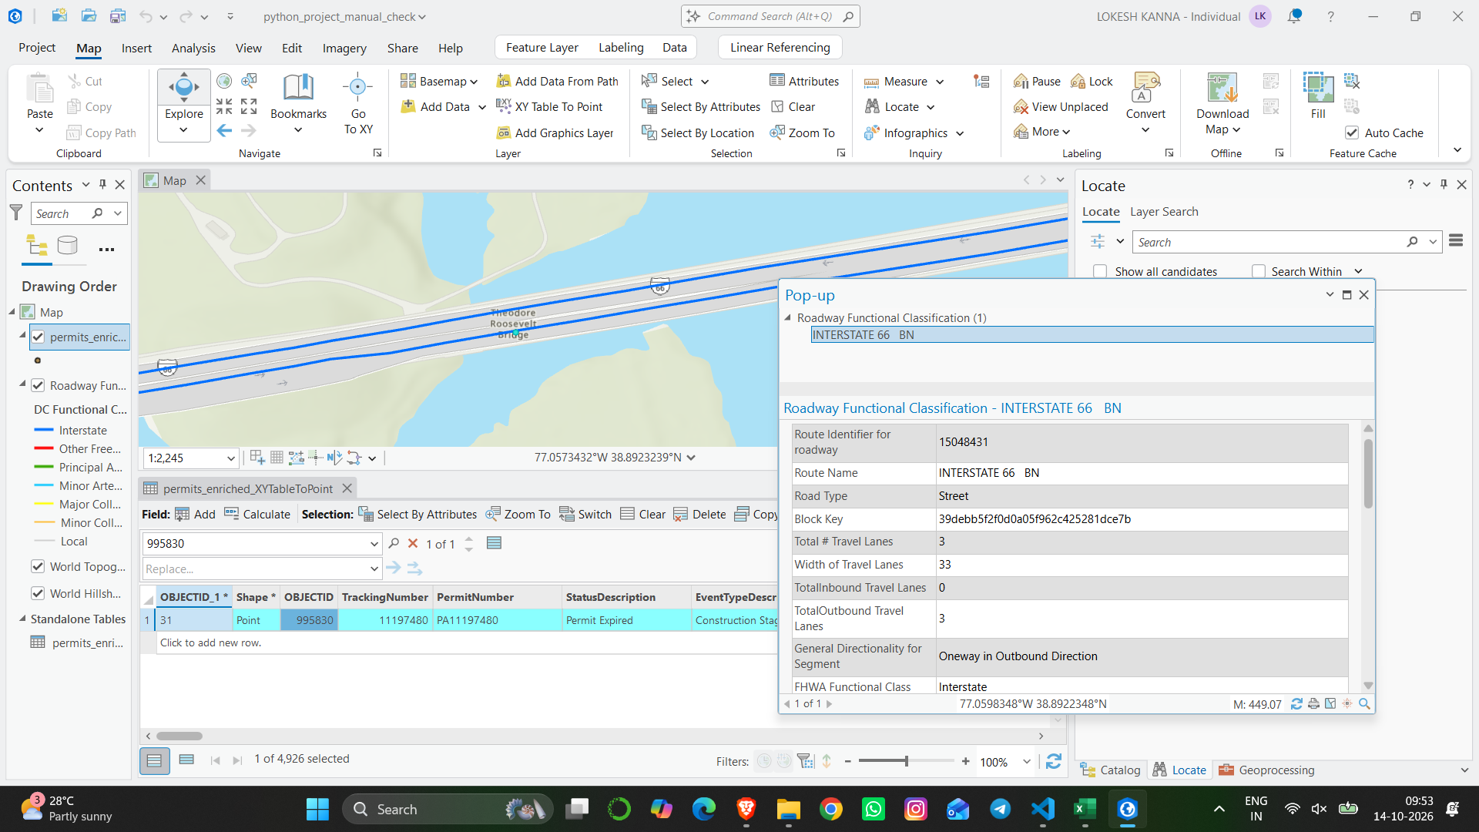
Figure 1. ArcGIS Pro inspection of the Roosevelt Bridge and INTERSTATE 66 roadway layer. Evidence: manually captured map and attribute pop-up.

Case B - 3333 Georgia Avenue NW, permit OBJECTID 999231
The permit address is 3333 GEORGIA AVENUE NW. The first clicked Georgia Avenue segment had roadway OBJECTID 4662349 and BLOCK_NAME 3400–3499, which does not include the permit house number. A targeted ArcGIS Pro selection then found roadway OBJECTID 4662115, BLOCK_NAME 3301–3399 BLOCK OF GEORGIA AVENUE NW, with FHWA Class 3 (“Principal Arterial - Other”). Thus the address-to-roadway-block match is supported.
However, the permit point is offset toward a nearby north–south alley and Morton Street NW; the original LRS returned Morton Street, FHWA 7, and an alley with 0-metre offset. The aerial map confirms the point appears near this alley east of Georgia Avenue. Permit occupancy fields show CurbLaneLength = 88 and TravelLane1Length = 88, with AlleyLength and SidewalkLength null. These fields support roadway occupancy but do not identify with certainty which roadway was occupied. Accordingly, I documented Georgia Avenue as a candidate, but retained the permit as UNRESOLVED rather than automatically assigning class 3.
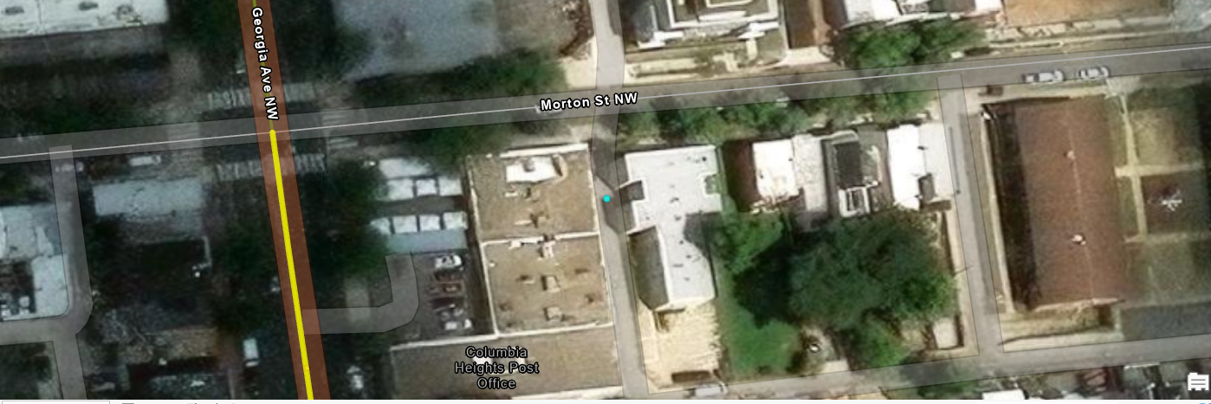
Figure 2. Aerial comparison of Georgia Avenue NW, Morton Street NW, alley, and permit point (cyan).

9. Assumptions, tradeoffs, and boundaries
- Eligibility date: implement “ApplicationDate OR IssueDate >= 2026-01-01” literally. The document says “calendar year 2026” but does not explicitly supply an upper bound; a production implementation should confirm whether 2027+ records must be excluded.
- Utility attribution: name and alias matches across three fields are observable signals, but third-party-submitted work could be missed. The 256 Mobile Crane Work Zone records had no explicit utility match.
- Row grain: one row per application location. TrackingNumber groups the application; source OBJECTID/LocationID distinguish individual locations even when coordinates repeat.
- Functional-class hierarchy: minimum valid FHWA numerical code = highest-priority roadway. DC functional codes and FHWA codes are not interchangeable.
- Roadway association: neither nearest segment nor address match is sufficient alone, particularly near intersections, alleys and parallel carriageways; mark ambiguous results instead of guessing.
- Unclassified cases: alleys lack FHWA classification. Null values may also reflect uncertain matching or missing service coverage and must carry a clear MatchStatus.
- Potential statistical bias: 94.3% is the observed automated match coverage, not a validated accuracy estimate. No field-based gold-standard sample was constructed.
- Service and time: live ArcGIS REST data can change; reproducible results require a query date/snapshot and documented service endpoint.

10. Why we stop manual checks after two examples
This is a conscious scope and time-management decision, not a claim that all exceptions have been resolved. The two cases demonstrate different failure modes: a special structure where a highway route name differs from the permit name (Roosevelt Bridge), and a plausible address match that conflicts with the mapped location and an alley (Georgia Avenue). Together they show practical ArcGIS Pro skill - XY point conversion, service-layer connection, attribute selection, route/class verification, aerial inspection, and responsible treatment of ambiguity.
Manual verification of all 279 exceptions would require additional time and potentially original permit work-zone details, higher-resolution map inspection, and coordination with DDOT subject matter experts. The assessment explicitly permits partial work with an explanation of planned steps. Stopping here protects the credibility of the reported classifications: we demonstrate a reproducible pipeline and a documented review procedure while refusing to create unsupported FHWA values.

11. What I would do next with more time
- Prioritize records affecting permit-level conclusions: 243 applications with no classified locations and 18 applications with partial classifications; prioritize class-conflicting candidates.
- Investigate the two locations with no candidates (source OBJECTID 1021039 and 1029348) with alternate geometry sources, MAR/subblock or geocoding, and coordinate validity checks.
- Review exception cases in ArcGIS Pro using point locations, road centerlines, imagery, nearest-route diagnostics, roadway block attributes, and occupancy fields. Obtain the original permit work-zone geometry where possible.
- Capture approved matches in the manual-review queue only when sufficiently supported (road OBJECTID, class, rationale, screenshot/reference). Preserve explicit unresolved outcomes.
- Build apply_approved_corrections.py: validate decisions, merge only approved classifications, recompute HighestPermitFHWAClass, and output an audit/change log and final unresolved list.
- Confirm the calendar-year cutoff and contractor attribution rules with the hiring team; add an optional cross-check using DDOT getPointOnSubBlock or MAR + Roadway SubBlock (layer 162), as originally suggested in the assignment.

12. Handling Missing FHWA Functional Classes
The final dataset preserves all 4,926 permit application locations, including records for which a reliable roadway functional classification could not be established.
Of these, 4,647 locations (94.3%) received an FHWA functional class, while 279 locations (5.7%) remained unresolved.
Unresolved records were retained to preserve source-data completeness. Missing FHWA classifications were not replaced with estimated values because some permit coordinates were associated with multiple nearby roadways, intersections, bridges, or alleys, potentially having different functional classes.
The ReviewReason and ClassificationStatus columns document why a classification remains blank.
The HighestPermitFHWAClass field represents the highest-priority available functional class among the classified locations belonging to each application. For applications with unresolved locations, this value may be provisional. Where no location has a verified class, the application-level class remains blank.
The exception-resolution workflow generated candidate roadway matches for additional investigation. Candidate classifications were not automatically accepted without sufficient supporting evidence.
Further work would involve manual GIS verification of unresolved locations, incorporating approved corrections, and recalculating application-level classifications.

13. Reproducibility
Windows 11 commands used during development (run inside the project folder):
py -m pip install -r requirements.txt
py extract_permits.py
py enrich_road_classes.py --limit 100
py enrich_road_classes.py --all --checkpoint-every 25
py enrich_road_classes.py --all --resume --checkpoint-every 25
py resolve_exceptions.py --limit 10 --checkpoint-every 5
py resolve_exceptions.py --all --checkpoint-every 10

Source references and artifacts
- Assessment: Python Test - CS12 Data Scientist.pdf (provided assessment statement).
- Occupancy permit source: https://maps2.dcgis.dc.gov/dcgis/rest/services/DCGIS_APPS/DDOT_TOPS/MapServer/24
- DDOT LRS service: https://rh.dcgis.dc.gov/dcgis/rest/services/DDOT/RoadwayBlocks/MapServer/exts/DdotLrsExtensions/getPointOnRoute
- Roadway Functional Classification: https://maps2.dcgis.dc.gov/dcgis/rest/services/DCGIS_DATA/Transportation_WebMercator/MapServer/48
- Assessment alternative roadway subblock service: https://maps2.dcgis.dc.gov/dcgis/rest/services/DCGIS_DATA/Transportation_WebMercator/MapServer/162
- Outputs examined: permits_extracted.csv; permits_enriched(1).csv; permits_enriched_review(1).csv; exception_candidates(1).csv; exception_investigation_summary(1).csv; exception_followup.csv; exception_review_queue.csv.
- Screenshots: Roosevelt Bridge ArcGIS Pro map; Georgia Avenue/Morton Street aerial view and roadway pop-ups from interactive manual review.

